

Task 2: A REFLECTIVE ACCOUNT OF MY LEARNING JOURNEY

Module code: Academic and Employability Skills

Student Name: Sana Arif
Student ID: (2116663)
Lectures name: Mr M.Zuwirai
Date: 30/03/2022

A REFLECTIVE ACCOUNT OF MY LEARNING JOURNEY: GIBBS REFLECTION
This essay aims to critically reflect on writing my first assignment about employee motivation challenges and encapsulate the experience of working as a team. The reflection will follow the Gibbs reflective cycle, considering that it is one of the most popular reflection tools. Additionally, reflection is considered one of the most important approaches to professionals that embrace long-term learning (All Answers Ltd, 2018). In essence, reflective learning is the process through which people learn through past experiences or, at times, activities that lead to gaining new understandings about themselves or their practice. Reflection is considered a way to promote personal and professional developments that, in the long run, stimulate both personal and professional growth. The Gibbs reflective cycle was first used in 1988. It encapsulates six key stages of reflection that aid the reflector to have a critical look at all the crucial phases of an experience or activity. Ideally, the uniqueness and fame of the model are because it includes feelings, emotions, knowledge, and actions and offers suggestions on repeated experiences that are not included in Kolb’s reflective model. For this reason, Gibbs's reflective model is wider and more comprehensive, thus offering a more flexible approach in the examination of a situation through a critical lens to enable future changes (Burnapp 2009). Figure 1 show the Gibbs’ model structure which I used.

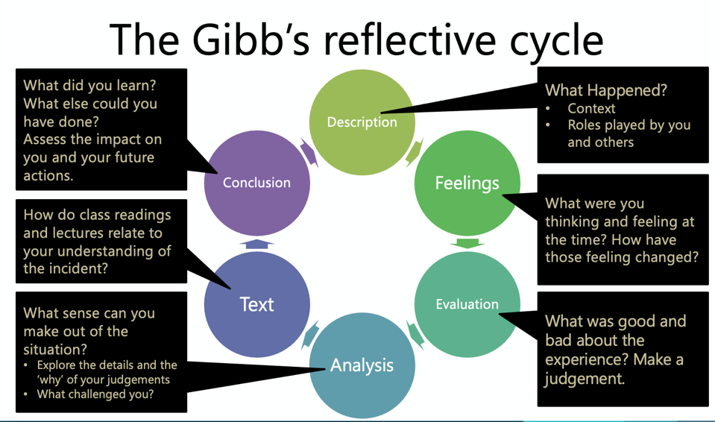
Figure 1: Gibb's reflective cycle chart

DESCRIPTION
Having read the task requirements, the first thing was to make sure that I understood all the instructions. The task was like no other because it had unique job instructions like font and spacing, and type of reference. Having understood everything, planning was the next step in that I had to come up with a schedule to complete the task and make sure that the necessary tools were readily available. I scheduled to tackle the assignment on 9th and 10th February to have ample time for research and writing. I do all my work in the local library since it is a serene, quiet environment and embraces the study atmosphere. It all started with research. Research, the most crucial part of writing, encapsulates an analysis of all relevant resources to have all the necessary information to complete the assignment. Having gathered all the relevant information then, I summarized the different documents to plan my work and make sure that my assignment would be coherent, failure to which then points would have been haphazardly organized. The next step was now writing, which was the most time-consuming assignment activity. However, with ample research then, writing the assignment becomes a simple task.
I have worked with groups in the past. However, unlike working alone, working with a group introduces a new motivation whereby the entire task becomes easy to accomplish through sharing of tasks. On the contrary, sometimes working as a group is energy-consuming. This occurs when some group members are unwilling to corporate, thus forcing other group members to work an extra mile to cover their gaps. Moreover, most group works have chaos that risks breaking group coherence when the members share different perspectives on the topic. Groups need a strong leader who leads and takes part in the group work. One key thing that I noted was that leaders have the most crucial part in dealing with a group because, without them, the entire group may never achieve their goals. Additionally, group leaders ought to remain imperial so that the group can remain coherent since, with favors, most groups veer of their goals to deal with their issues. With a good leader, there is no doubt that the group or the team will achieve their goals. When tackling the assignments alone or with a team, one thing remains clear; planning streamlines the entire process. As a result, it becomes prudent for anyone or any group to plan before starting any task to save time and ensure that everyone is on the same page. Dealing with a group entails a commitment towards the team objective, and with strong leadership and cooperating team members, everything runs smoothly. Without this, most of the time will be spent mending fences rather than tackling the issues at hand.

FEELINGS

Before tackling the assignment, there was this anxiety about what was expected of me. As a result, I was not even sure about myself and whether I would complete the assignment on time. However, I psyched myself up because my life depended on this assignment and many more to come. However, upon starting the assignment, I noted a decreased anxiety as I became more and more familiar with what the lecturer needed. It was a relief knowing that having done my research and now have the full picture of what was needed was calming. When writing the assignment, it became clear that everyone is different is not always a benefit; at times, it comes at a cost. For example, although money has always been considered the most resource towards motivating people, some do not share this perception. As a result, to motivate them, organization leaders ought to develop new ways. I also learned that motivating employees presents newer challenges to the organization and that when not well-strategized, staff motivation comes at a high cost.
After completing the assignment, it was evident that I had little to no concept of the topic. I learned that psychology could be used as a motivating factor and that, to some extent, understanding human psychology is the best staff motivator. My research is an eye-opener to many people, including scholars, employers, employees, and organization leaders. For example, my research pinpoints most of the things that organization leaders have wrong. For example, most organization leaders consider money the best motivating factor, which is not always the case. Additionally, some of the strategies that organization leaders adopt to motivate their employees are not always motivating but rather reduce dissatisfaction. When it comes to scholars, it is through the research that they can understand the gap between organization performance and employee motivation which is organization leaders. I believe that it is through the research that I was able to shed more light on how employees need to be motivated. I believe I was the light at the end of the motivation tunnel. I often find it difficult to share my arguments when working as a group because of my personality. Furthermore, I do not embrace negative critics; thus, I try as much as possible to avoid it. In the group discussion held a week before assignment two, one of my points that I thought was a strong point was not included in the presentation, and that caught a nerve. I prefer working alone because of these mundane issues that I often magnify. When working alone, I often spend a considerable amount of time ensuring that I have all the points straight, unlike in a group discussion where most of my points are never considered.

EVALUATION

One of the things that went well was the research part. Over the years of being a student, I have always embraced research as part of my daily activities. I have always made sure that I can scour through the internet searching for journals, and this has yielded the best results as I am aware of how to search keywords in a question. When handling task one, with already four sources issued, then there was only need to look for the other four, which was not a hard hustle. Ample research simplified the entire process of tackling the assignment. On the other hand, when working as a group, then discussions before starting a task ensure that the group gets the assignment framework and that all the necessary points are well noted before starting the assignment. It also ensures that everyone is at par with how the assignment will be handled.
When handling the task, one thing was amiss. Ideally, I had always thought that salary and pay increments were the best motivators. As a result, I spared quite a considerable amount of time researching salary increase as the best employee motivator. But I couldn't be more wrong. As a result, I wasted more time because of my perceptions rather than strictly focusing on the research. When working under prejudice, the mind limits itself within the prejudice; thus, thinking outside the box is not an option. When dealing with a group, I understood that everyone has a crucial role to play, without which the team may not achieve its goals. The last time I worked with a team, I was reluctant to attend the meetings because there were unsolved issues between the group leader and me. As a result, the team's effectiveness was greatly reduced, and the goals were never met. I owned up my actions and considered the lessons well learned. However, even so, as a leader, knowing of the situation, she should have addressed it so the group could remain united and proceed to pursue their goal.

ANALYSIS
I learned that when tackling an assignment, planning is the first and most fundamental step, without which one will waste a lot of time and may end up writing outside the scope of the topic. Then comes research, whereby one should do as much research as possible before writing up an assignment. Research ensures that one has the necessary information to write the task. When working with a team, I tyrant that it is prudent to have a strong leader who oversees the entire group work and takes part in it. The group leader needs to be steadfast in ensuring that everything runs smoothly and that any qualms are addressed in time to ensure group coherence. As a group member, I learned that everything should be left aside and focused on achieving the group objectives more so if these issues are not a result of working in the team. Teamwork is only achieved through coherence and team unity.

CONCLUSION

Having been through the experiences then in future assignments and team works, I am well aware of what is expected. For example, although not advised, it is better to be down to earth when dealing with a team. The rationale is that the team objectives are more necessary than a personal issue. As a result, rather than maintaining the grudge and unnecessary qualms, it is necessary to bury the hatchet for the sake of the group. However, one positive experience emerged when dealing with a group; one gets a deeper concept of the topic. As a result, then, because of the discussions, you also learn how different people approach a problem and how they aim to achieve their objectives. I am, however, a solo person; I achieve more when alone and get a better understanding of my streets and weaknesses while alone. When working on an assignment, I am always present rather than when working as a team, whereby I over-rely on others to complete the bigger portion of the tasks.

ACTION PLAN
I believe that my perceptions about working with a team can always change. When it comes to working on an assignment alone, I believe that it is better to start as if everything is new to me rather than working based on my perceptions. With this in mind, there is no doubt that I will not waste time convincing myself that I know the topic well enough, but rather, I will be more willing to learn. When it comes to group, then one thing that I would advocate is me being a leader rather than a member. When this happens, then since I am well aware of the roles of a leader in a group, I believe that I am in a better position to ensure that the best is achieved from the discussion. One of the main weaknesses that I aim to overcome is overthinking, whereby I look at a task and assume that it is hard but instead approach it with a calm mindset ensures that I can concentrate and believe in myself.

REFERENCES

All Answers Ltd, 2018. Gibbs' Reflective Cycle. Reflective Guides, 1(2), pp. 1-5.
Burnapp, D. (2009, p.76, p.144 p.129) Getting ahead as an international student: Mc Graw – Hill Education, England.

