Learning in the digital era
academic Writing
E- Portfolio

klaudia soskova
2217918
8th March 2023

Contents

Introduction
Main findings
Task 2 – Academic Writing
Task 3 – Critical Thinking
Task 4 – Video
Conclusion
Reference list

Introduction

In this introduction will be explain, what is Academic Writing, importance of Academic writing, critical evaluation, analytical thinking and improvement of formal style of writing. According to Murray and Moore[2019], academic writing involves following certain conventions and structures that are unique to the academic environment. These conventions include the use of formal language, a structured and logical argument, evidence from credible sources, and the use references and citation.
Writing assignments in higher education regularly call for students to use outside sources and imitate the discourse habits and subject of the academy. Researching, summarising, quoting, citing sources, adopting style, conventions that satisfy expectations, and choosing language and grammar that are typical of less informal and more formal forms of writing are all required.

Main findings

In my main finding I want to explain that academic writing and critical thinking are closely linked, and both are critical components of higher education and research. Critical thinking involves the use of evidence and logical reasoning to support arguments and make informed decisions. It also involves evaluating and analysing information from a variety of sources recognising discrimination and speculation and recognising the limitation of ones own knowledge and understanding. “The researchers found that students who demonstrated higher levels of critical thinking in their writing were also more likely to score higher on exams in their courses. This suggest that critical writing skills are closely related to academic success” [ Marsh and Roche, 2013].

Task 2
Academic Writing.

Academic writing is formal style of writing for students at university, schools and colleges. This formal style of writing must be planned, focused, structured and evidenced from some books, news or academic general Wikipedia. “To write well, you must pay attention to your prose. You must write sentences hat are clear, concise, and engaging. You must consider the rhythm of writing, the cadence of your phrases, the length and structure of your sentences.” [Eric Hayot]. Objective of academic writing is your opinion and is using from paraphrasing, which is writing idea of others written in your own words. Also, must be including their citate. In your report or some academic work important is referencing. Reference plays a significant role in academic writing. It discusses your work, highlights in the range and depth in your study and acknowledges the contributions of others. Every time you borrow an idea from someone else, give you credit. Features of academic writing are an argument, interpretation of findings and recommendations. Your understanding of what you are doing while you write and how you approach the writing task will decide how effective you are with academic writing. “An exploration of relationship between students’ writing skills, critical thinking, and academic achievement” [Marsh, H.W., Roche, L.A. [2013]. Academic writing is flexibility, allowing students to work themselves or by the lecture and practise those aspects which are most relevant for their courses, and it is especially difficult for overseas students. Important aspect of academic writing is the use of evidence – based arguments. This means that argument should be based on verifiable evidence, such as data, statistics, and research studies. Academic writing is an important skill for students and research to develop. It requires a structured approach, clear language, arguments to communicate ideas and research finding in a scholarly manner. “Effective academic writing is a combination of many skills: planning, drafting, revising, editing and proofreading.” [ Stephen Bailey].

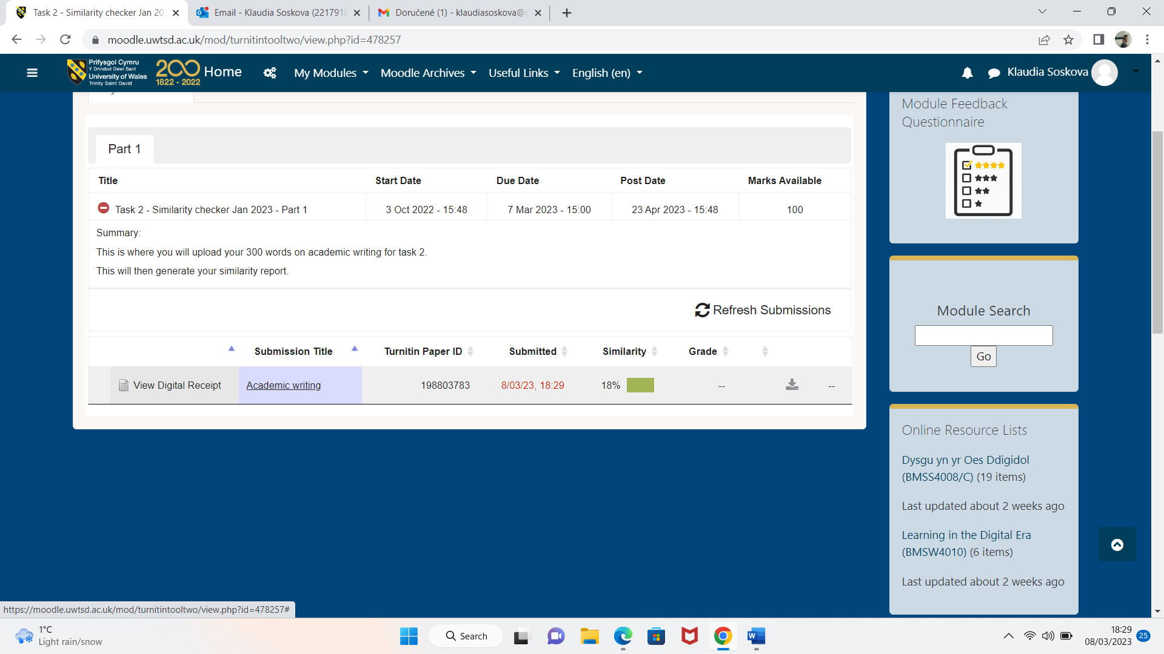

After this similarity check, I know that I must improve my paraphrasing, referencing and better understanding the contents of all sources. Combination of these methods to create sentences that I must put same idea but in different language, and after I can get effective technique. I see this Task 2 as very important, especially because I am an international student, so it helps me for better understanding and communication in a writing. Even though I perceived it quite easily, it was quite laborious to translate and paraphrased it. Similarity helps us to find out how many copies we have. I think that this Task 2 is also instructive because we must develop and replace more words and through this, we will improve our goals. In my case I think, my similarity check is 18%, because I did not paraphrase the original citates.

Task 3.
Critical Thinking

Critical thinking is a process of analysing evaluation and interpreting information to make informed decisions and solve problems. it is an essential skill for success in academic and professional settings as it allows individuals to approach complex issues with a rational and logical attitude. Critical thinking also involves being open minded and willing to consider different perspectives and viewpoints the importance of critical thinking cannot be overstated as it is essential for success in all areas of life. in academic settings critical thinking is necessary for analysing complex texts and data developing research questions and writing arguments in professional settings critical thinking is critical for making informed decisions identifying problems and developing creative solutions. in our daily lives we all have the chance to approach decisions and problems with strong critical thinking everyone must plan make decisions and solve problems. As Richard Paul, a leading expert in critical thinking, note “Critical thinking is the art of analysing and evaluating thinking with a view to improving it.” Being critical at university does not necessarily mean criticising negatively. Instead, it calls for you to challenge the facts and viewpoints in a text and then offer your assessment or opinion of it. Critical thinking is in of the basic abilities needed for people to succeed today. Education is the practise of the mind’s ability to reason, not the learning of facts [A. Einstein]. My example for critical thinking: my daughter can use in her science class to work out the best way to approach her group project. After she can make decision such as who can complete each task. After they can solve the problem with their working together when they will meet.

Task 4 – Video

Link to video can be found here – Recording [Microsoft stream] – 20230310 - 223143.

Conclusion.
The conclusion of academic writing and critical thinking is that they are two essential skills that are closely connected and necessary for success in higher education and beyond. Academy writing involves the ability to express ideas clearly and continuously using appropriate language and citation methods, while critical thinking involves the ability to analyse and evaluate information, arguments and evidence.
By developing and practising these skills, individuals can become more effective communicators, thinkers and problem solvers, and better equipped to navigate complex academic and professional environments.
Lipson and Reindl [2003] suggest that writing centres can play a valuable role in teaching academic writing ad critical thinking, by providing individualized support and feedback to student.

Reference List

S. Bailey/ A handbook for international students
A. Einstein
E. Hayot/ “The Elements of academic style: writing for humanities
Lipson and Reindl [ 2003]
Marsh and Roche [ 2013]
Mc Millan and Weyers [ 2016]
Murray and Moore [2019]
R. Paul
Video
https://uowtsd-my.sharepoint.com/:v:/r/personal/2217918_student_uwtsd_ac_uk/Documents/Recording-20230311_203838.webm?csf=1&web=1&e=gcByhJ

