UNIVERSITY OF WALES TRINITY SAINT DAVID
LONDON CAMPUS
Assignment 2
Learning in the Digital Era
Video Link: https://youtu.be/zrA8IFqdE84
Module Name: Learning in the Digital Era
Module Code: ACCA 4025

Student Name: Muhammad Ashir Rehman
Student ID: 2533747

Lecturer’s Name: Koushik Modak

Table of Contents
Introduction 2
Main Body 2
Conclusion 11
References 11

Introduction
This report is to be used in conjunction with the video presentation to accompany Assignment 2 for the ACCA4025 Learning in the Digital Era module. It outlines a structured Professional Development Plan (PDP) to further move towards the target career of Cybersecurity Analyst as the backbone of this plan is the Gibbs' (1988) reflective cycle [1]. Each slide of the accompanying presentation is briefly explained, including the SMART development goals and a summary of Unit 4 Topic 3 'Unpacking Experiences' [3] [10]. IEEE referenced sources are used to support all claims and are selected from the essential reading list provided for the module, and authoritative cyber security guidance.

Main Body
The main part below summarizes each of the eleven slides in the video presentation and provides a short description of the purpose of each slide, literature for support, and how the slide contributes to the overall Professional Development Plan.
Video Link: https://youtu.be/zrA8IFqdE84
Slide 1 COVER PAGE
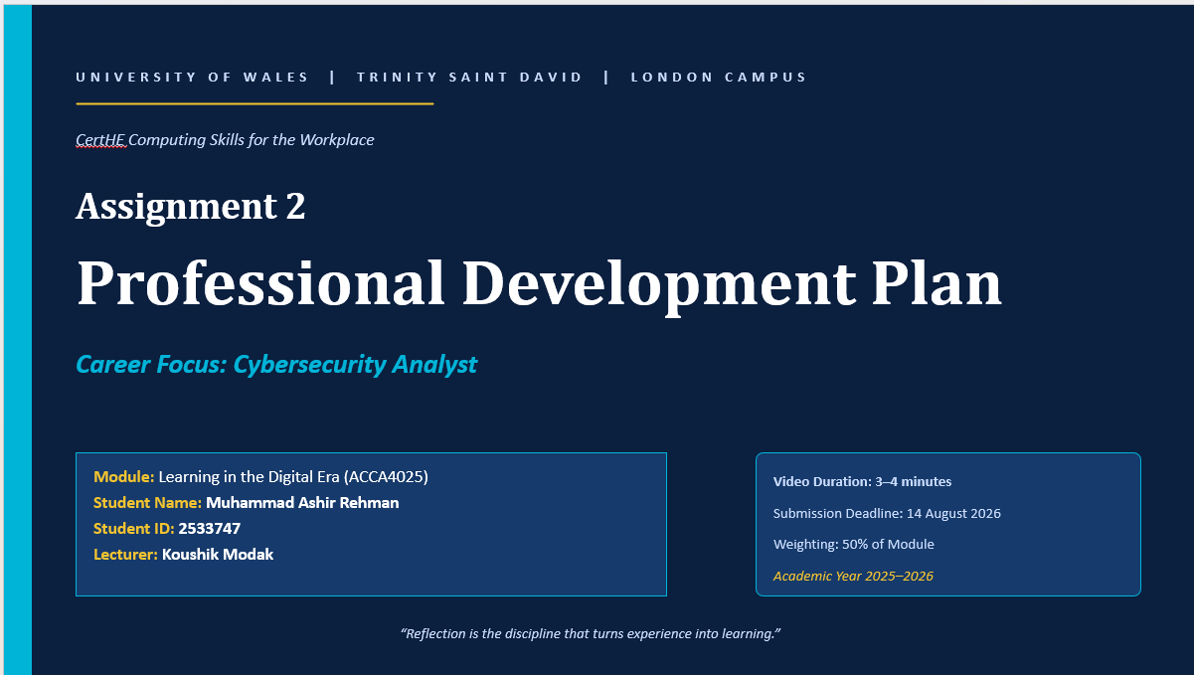

Slide 2 CONTENTS
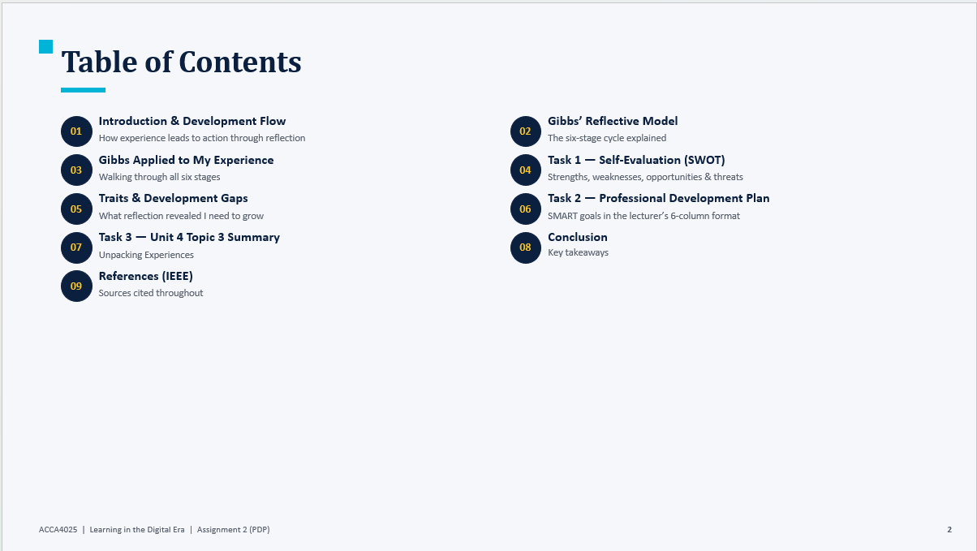
Slide 3 INTRODUCTION
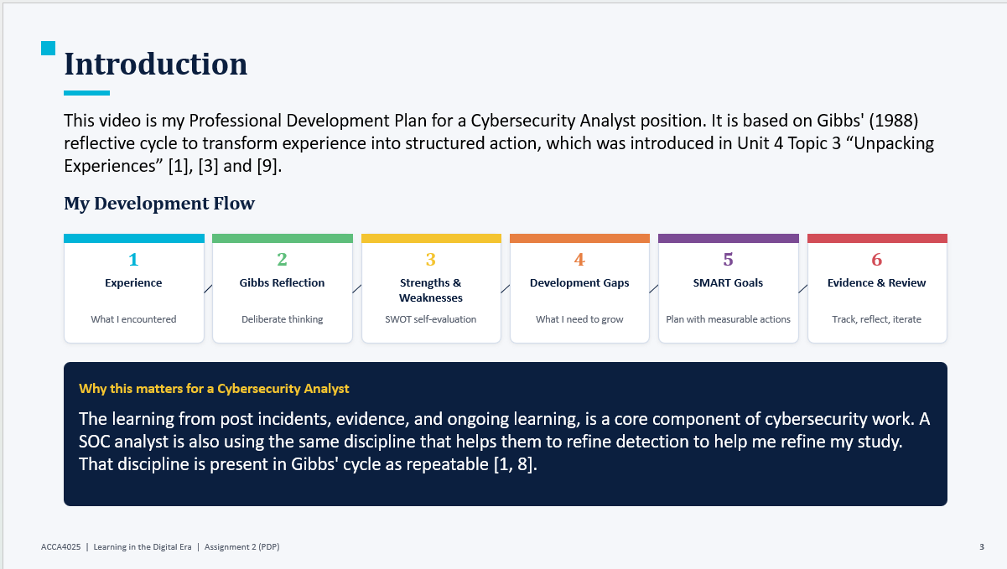

Slide 4 MAIN BODY
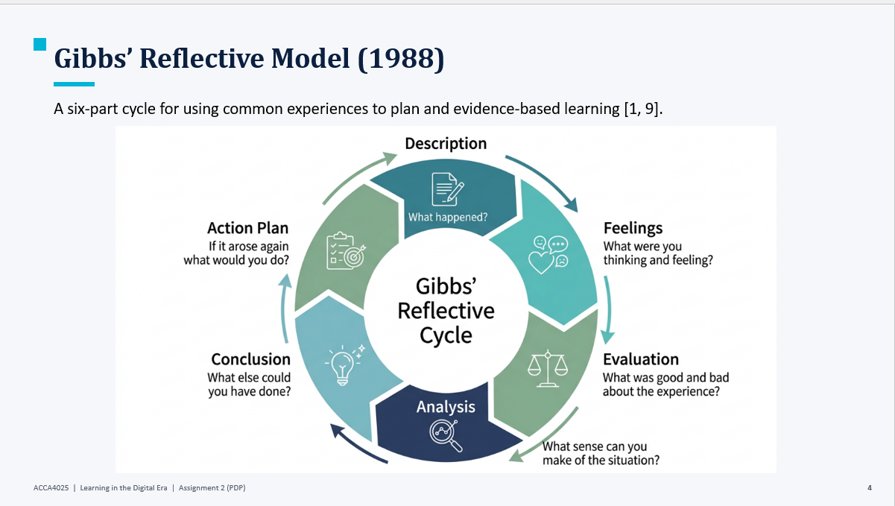

Slide 5 GIBB’s REFLECTIVE MODEL
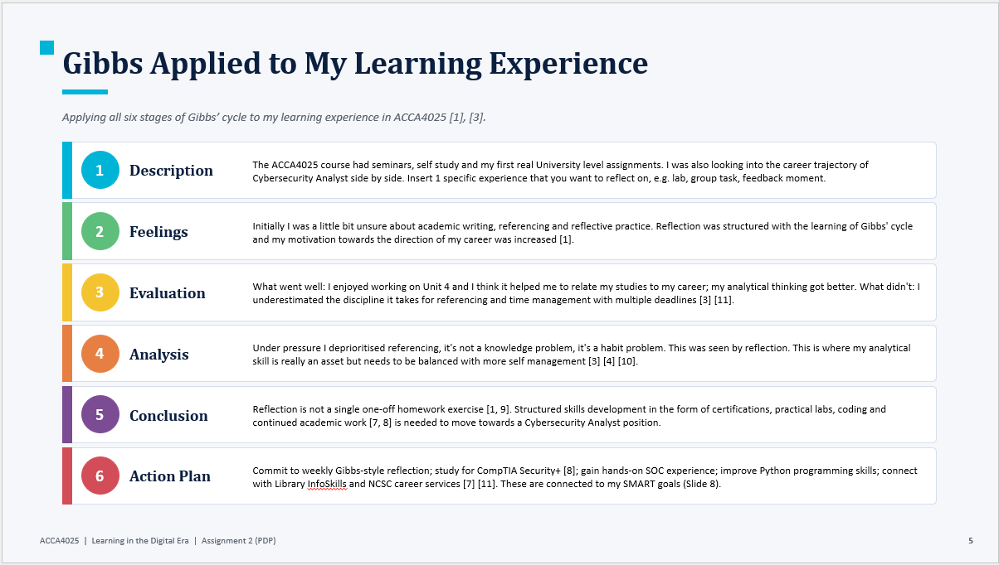
Brief explanation: Gibbs' (1988) reflective cycle is a six-stage model which provides a framework for turning everyday experience into structured, evidenced learning [1] and consists of: Description, Feelings, Evaluation, Analysis, Conclusion, Action Plan. It builds upon Kolb's previous four stage concrete experience, reflective observation, abstract conceptualisation and active experimentation [2] and relates to Schön's later separation of reflection-in-action and reflection-on-action [13]. In this assignment we will be using Gibbs' model to reflect on my first term on the CertHE Computing Skills for the Workplace programme and the actions I am taking to pursue a Cybersecurity Analyst career. Slide 5 of the video is the step-by-step process; starting with a factual description of my early academic and technical experiences, an honest evaluation of what works and what doesn't, and a concrete action plan that directly feeds into the SMART goals on Slide 8 [3], [10]. Deliberate application of Gibbs' cycle in the manner proposed in this paper represents the post incident review process in a Security Operations Centre (SOC), where each alert is debriefed to enhance future detection [7] [8].

Slide 6 TASK 1: SELF EVALUATION
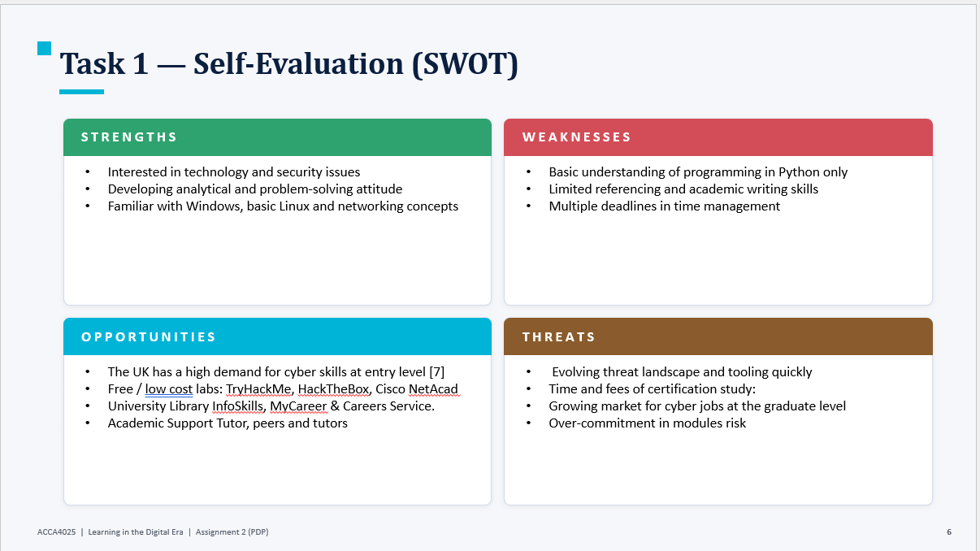
Brief explanation: This slide shows a SWOT analysis of my current position and how it relates to a career pathway in Cybersecurity [3]. My strengths inside include an inherent curiosity and passion for cybersecurity, a growing analytical and problem-solving approach, and having some previous experience in the use of Windows, basic Linux and networking concepts from the Computer Architecture and Networks modules. I am weak at only basic Python programming, at the writing and referencing of academic papers, and at juggling multiple deadlines of modules [3] [12]. Opportunities outside the University include the reported shortage of entry-level cyber talent in the UK [7] and free hands-on training platforms like TryHackMe, HackTheBox and Cisco Networking Academy and support from the University through the Library InfoSkills programme, Academic Support Tutor and MyCareer. Threats are the fast-changing threat landscape and tooling churn, the cost of certification study in both time and money, competition for graduate jobs, and the potential for over-commitment in concurrent modules. This honest audit is by no means a final goal: it is merely the raw input for the reflection captured on Slide 5 and the goals defined on Slide 8 [4], [10].

Slide 7 TRAITS GAINED FROM THE SELF EVALUATION
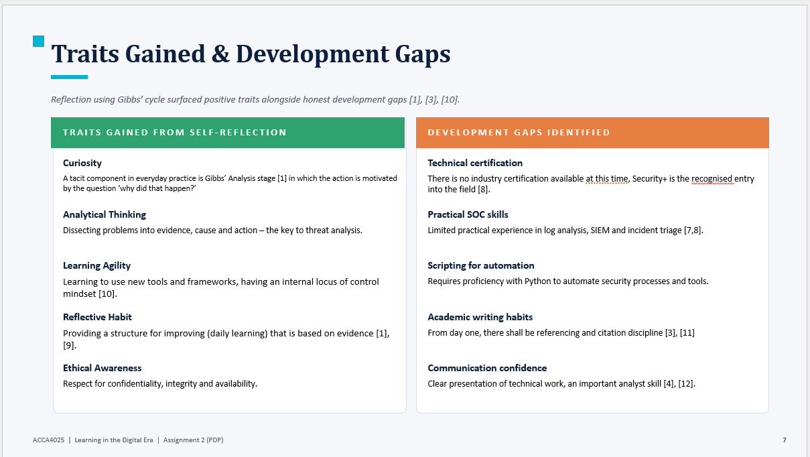

Brief explanation:
When I did my SWOT, I came up with 5 positive traits and 5 honest development gaps [10] using Gibbs' cycle. The attributes I have already started to develop are: curiosity which underpins the questioning "why did that happen?," at Gibbs' Analysis stage [1]; analytical thinking which is the ability to break down a problem into evidence, cause and action and is the main skill required in threat analysis [8]; learning agility, a mindset of adaptability and having an internal locus of control to support this [14]; a reflective habit that provides a repeatable structure for daily improvement [1],[9]; and ethical awareness, expressed through respect for confidentiality, integrity and availability.
The identified development gaps are lack of any industry certification (CompTIA Security+) is recognized as the entry level credential [8]; lack of hands on experience in log analysis, SIEM operation, and incident triage [7], lack of Python programming skills in the area of security automation; lack of academic writing and referencing skills [3, 11] and lack of confidence in communication, when presenting technical work [4, 12]. Having the traits and gaps side by side provides the self-awareness as concrete input for the Professional Development Plan on Slide 8.
Slide 8 PROFESSIONAL DEVELOPMENT PLAN
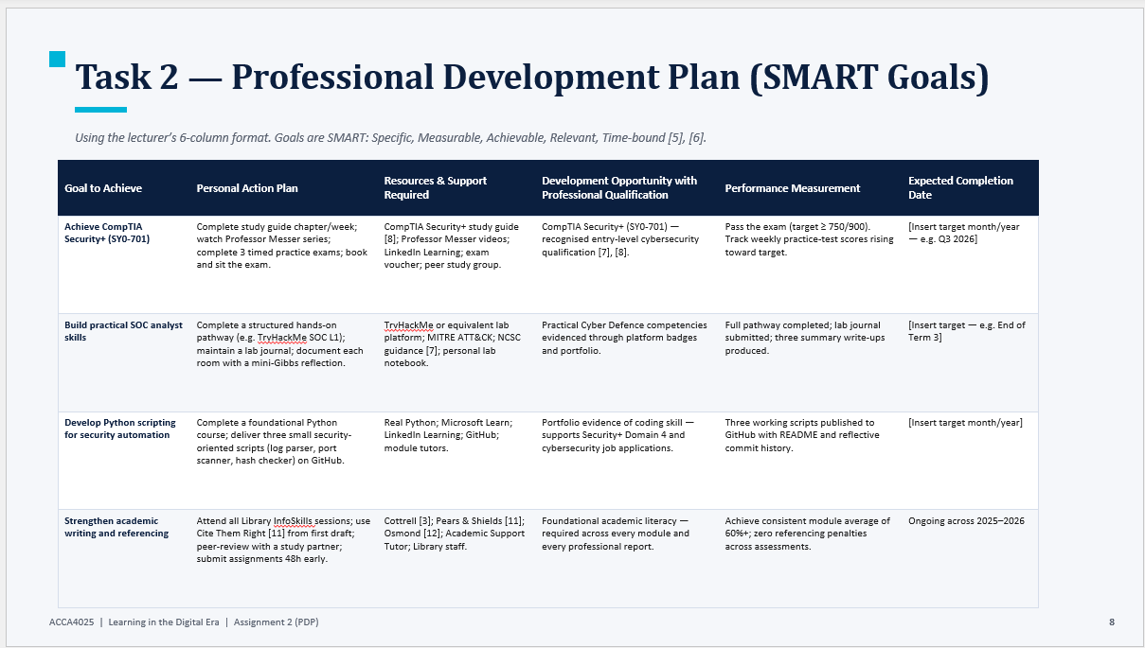
Brief explanation:
The Professional Development Plan on Slide 8 applies the lecturer's six column SMART format Goal to Achieve, Personal Action Plan, Resources & Support Required, Development Opportunity with Professional Qualification, Performance Measurement, and Expected Completion Date [5], [6]. The four goals were based on the traits-and-gaps analysis presented on Slide 7.
Goal 1 is to successfully pass the CompTIA Security+ (SY0-701), a recognised entry-level cybersecurity certification, with a score of 750/900 or higher. Goal 2 is to develop SOC practical skills which are demonstrated by a structured path of practical skill development, such as TryHackMe SOC Level 1, with platform badges, a lab journal and mini-Gibbs reflection [1] after each room completed. Goal 3: Python scripting for security automation, publish 3 scripts in a public git repository to a public GitHub with reflective commits – log parser, port scanner and hash checker. Goal 4: Improve academic writing and referencing through participation in all Library InfoSkills and use Cite Them Right [11] in the initial draft of each assessment.
Every goal meets the SMART criteria: Specific the goal is clearly defined, Measurable – the goal can be measured by named artefacts, Achievable the goal is realistic given time and resources, Relevant the goal is applicable to the Cybersecurity Analyst pathway, Time-bound, the goal has an explicit completion date [5, 6].

Slide 9 UNIT 4 TOPIC SUMMARY
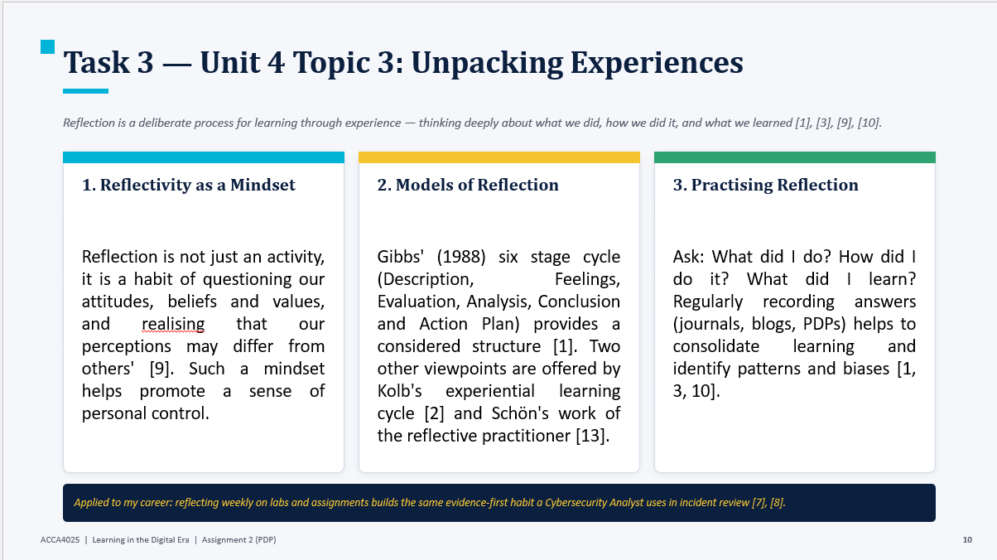
Brief explanation: The selected subject is the 4th unit – topic 3: Unpacking Experiences, which is a reflection as a conscious process for learning from experiences, not as a byproduct of doing it [1] [9] [10]. Slide is a summary of 3 interlinked ideas.
Firstly, reflection as attitude: reflection is considered as a habit of questioning attitudes, beliefs and values and of realising that one's perceptions can be different than others without being wrong [9]. Second, models of reflection: Gibbs' six stage cycle gives the most detailed model for a novice reflective practitioner [1] and is supplemented by Kolb's experiential learning cycle [2] and Schön's differentiation of reflection-in-action and reflection-on-action [13]. Third, practising reflection: the regular documentation in journals, blogs or PDP entries – of the questions ‘What did I do? How did I do it? What did I learn?" consolidates learning and exposes patterns and biases [1,3,10].
This same habit of reasoning from evidence to a conclusion is the basis of the post-incident review process in a Security Operations Centre (SOC) [7],[8] and so is professionally relevant to the reflective discipline learned in this module when applied to a Cybersecurity Analyst career.

Slide 10 CONCLUSION

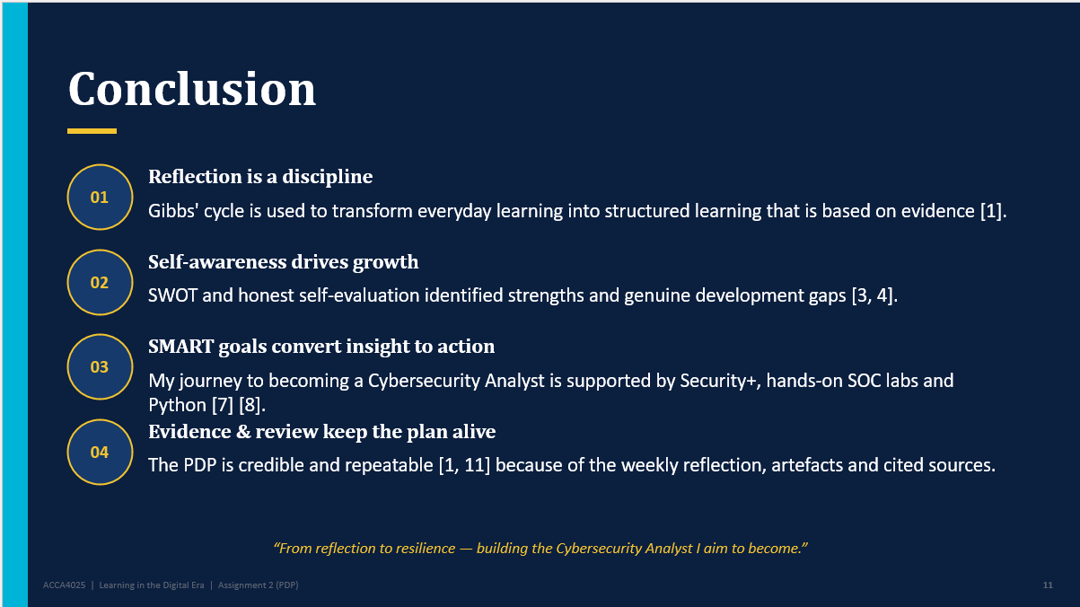

Brief explanation:
A summary slide is a last slide that summarizes the four key points from the presentation. Firstly, reflection is a discipline, and Gibbs' cycle has been used throughout to transform everyday experiences into structured, evidenced learning, rather than passive recollection [1]. Second, self-awareness is a driver for growth: the SWOT audit, honest self-evaluation, brought true strengths and honest gaps of development into the plan [3] [4].
Third, SMART goals transfer insight into action: the four goals (Security+ certification, hands-on SOC training, Python scripting for automation, and academic writing discipline) provide my Cybersecurity Analyst pathway measurable milestones [7][8]. Fourth, evidence and review keep the PDP alive: weekly reflection, published artefacts, cited sources make the PDP credible, auditable and iterable [1], [11]. The overall message is that, when done on purpose, reflection is not a one-shot evaluation activity, but an activity that can be repeated, as a professional habit [1, 9].

Slide 11
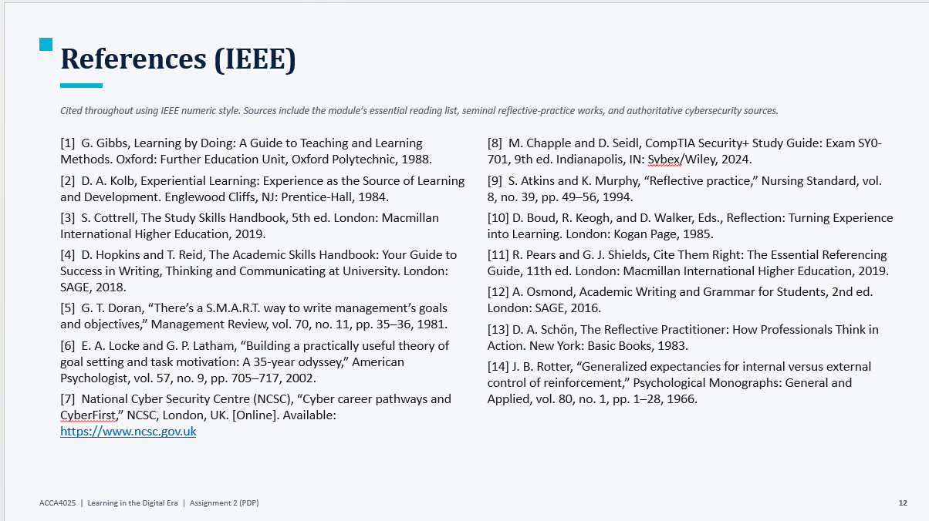

Conclusion
The following report is a self-evaluation; Professional Development Plan and a summary of the topic covered in Unit 4 (The video presentation) for the assignment ACCA4025. It has adopted the reflective cycle as its backbone that Gibbs used [1]: identifying strengths and weaknesses, identifying strengths and matching them with identified areas for development, and finally: four SMART goals that are centered on the target career Cybersecurity Analyst [5] [6]. This report demonstrates that, with a conscious effort, reflection is a credible and repeatable approach to professional development [3, 11] and authoritative cybersecurity guidance [7, 8].

References

[1] G. Gibbs, Learning by Doing: A Guide to Teaching and Learning Methods. Oxford: Further Education Unit, Oxford Polytechnic, 1988.
[2] D. A. Kolb, Experiential Learning: Experience as the Source of Learning and Development. Englewood Cliffs, NJ: Prentice-Hall, 1984.
[3] S. Cottrell, The Study Skills Handbook, 5th ed. London: Macmillan International Higher Education, 2019.
[4] D. Hopkins and T. Reid, The Academic Skills Handbook: Your Guide to Success in Writing, Thinking and Communicating at University. London: SAGE, 2018.
[5] G. T. Doran, “There’s a S.M.A.R.T. way to write management’s goals and objectives,” Management Review, vol. 70, no. 11, pp. 35–36, 1981.
[6] E. A. Locke and G. P. Latham, “Building a practically useful theory of goal setting and task motivation: A 35-year odyssey,” American Psychologist, vol. 57, no. 9, pp. 705–717, 2002.
[7] National Cyber Security Centre (NCSC), “Cyber career pathways and CyberFirst,” NCSC, London, UK. [Online]. Available: https://www.ncsc.gov.uk
[8] M. Chapple and D. Seidl, CompTIA Security+ Study Guide: Exam SY0-701, 9th ed. Indianapolis, IN: Sybex/Wiley, 2024.
[9] S. Atkins and K. Murphy, “Reflective practice,” Nursing Standard, vol. 8, no. 39, pp. 49–56, 1994.
[10] D. Boud, R. Keogh, and D. Walker, Eds., Reflection: Turning Experience into Learning. London: Kogan Page, 1985.
[11] R. Pears and G. J. Shields, Cite Them Right: The Essential Referencing Guide, 11th ed. London: Macmillan International Higher Education, 2019.
[12] A. Osmond, Academic Writing and Grammar for Students, 2nd ed. London: SAGE, 2016.
[13] D. A. Schön, The Reflective Practitioner: How Professionals Think in Action. New York: Basic Books, 1983.
[14] J. B. Rotter, “Generalized expectancies for internal versus external control of reinforcement,” Psychological Monographs: General and Applied, vol. 80, no. 1, pp. 1–28, 1966.

