
Data Mining in the Online News Popularity

Wu Pengchun 2006606

Contents
1. Introduction 2
2. The Data Set 2
2.1 The Origin of the Data 2
2.2 About the Dataset 4
3.Data Pre-Processing 7
4.Data Visualization in Weka 9
5.Data Analysis 11
5.1 Is it possible to predict the popularity for an online article based on the existing records in the dataset? 11
5.2 Is it possible to predict the popularity for an online article according to average shares per day? 15
6.Reflection 17
7.References 17

Introduction
With the development of mobile Internet, more and more users are used to reading all kinds of information through mobile phones and other terminal devices. Online news services have developed rapidly. Traditional newspapers and magazines are bound with many news and advertisements. Even if readers want to read only a part of them, they have to buy the whole newspaper or magazine. But for online news, people often just click and read what they like, and online news service providers are benefiting from these popular content. Therefore, it is necessary to study the online reading behavior model of readers. At the same time, it is very helpful to predict the popularity of news, that is, how many readers will click and read, which supports online news media to provide better content and service. For this reason, I find a relevant data set, and analyze and mine it, hoping to find the reasons why online news is popular. All significant findings will then be discussed and reported and finally a conclusion will be drawn on the overall process.

The Data Set

2.1 The Origin of the Data
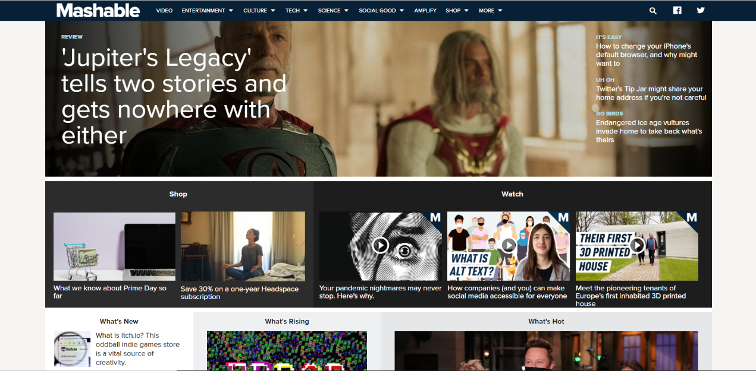
This dataset that I select for analysis and investigation summarizes a heterogeneous set of features about articles published by Mashable in a period of two years, from 2013 to 2015 [1]. Mashable is an Internet News blog founded by Pete Cashmore in July 2005. After more than ten years, the company has made great progress. With more than 45 million monthly visits and Alexa ranking up to 1144, now it is one of the most visited blogs in the world. It’s social media followers and monthly shares reach 28 million and 7.5 million respectively. These statistics are depicted in Figure 2. Moreover, as we can see the home page of Mashable in Figure 1, there are plenty of articles concerning over different types of subjects. Therefore, the popularity data about articles collected from this platform, such as clicks and shares, are very suitable for my research work.
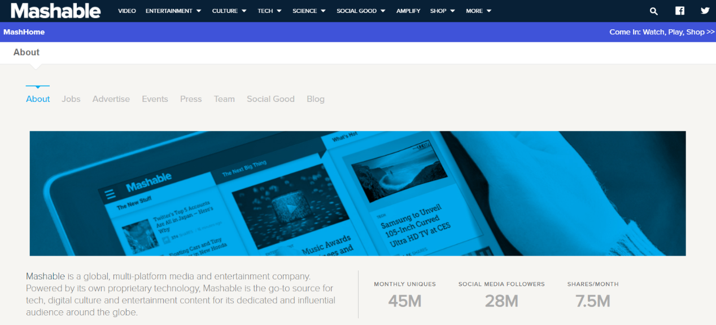
Figure 1: Home page of Mashable
Figure 2: Statistics on Popularity of Mashable
This (Mashable news) dataset is publicly available on UCI, which is a very famous public dataset repository. The website address is shown below, and you can upload it if necessary. http://archive.ics.uci.edu/ml/datasets/Online+News+Popularity
Kelwin Fernandes et. al. uploaded it in the year of 2015 [4]. The specific author menu is as follow.
- Kelwin Fernandes - INESC TEC, Porto, Portugal/Universidade do Porto, Portugal.
- Pedro Vinagre, Paulo Cortez, Pedro Sernadela - ALGORITMI Research Centre, Universidade do Minho.

2.2 About the Dataset
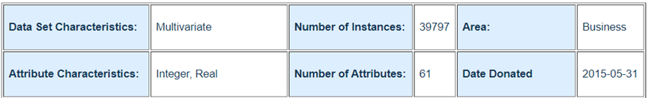
We can see the brief information of the dataset according Figure 3 shown as follow. The dataset contains 39797 instances and its amount of attributes is 61 [3]. Two of all attributes are non-predictive, i.e., URL and Timedelta. URL is the website address of an article and Timedelta stands for the days that an article has been published, ranging from 8 to 731. The last attribute, Shares, represents times that an article has been shared, which is regarded as the target.
Figure 3: Brief information of the dataset
The others are all numeric and predictive. Their specific names and description are listed in Table 1.
Table 1: Description of all features
Label | Description
ntokenstitle | Number of words in the title
ntokenscontent | Number of words in the content
nuniquetokens | Rate of unique words in the content
nnonstop_words | Rate of non-stop words in the content
nnonstopuniquetokens | Rate of unique non-stop words in the content
num_hrefs | Number of links
numselfhrefs | Number of links to other articles published by Mashable
num_imgs | Number of images
num_videos | Number of videos
averagetokenlength | Average length of the words in the content
numkeywords | Number of keywords in the metadata 13
datachannelis_lifestyle | Is data channel 'Lifestyle'?
datachannelis_  entertainment | Is data channel 'Entertainment'?
datachannelis_bus | Is data channel 'Business'?
datachannelis_socmed | Is data channel 'Social Media'?
datachannelis_tech | Is data channel 'Tech'?
datachannelis_world | Is data channel 'World'?
kwminmin | Worst keyword (min. shares)
kwmaxmin | Worst keyword (max. shares)
kwavgmin | Worst keyword (avg. shares)
kwminmax | Best keyword (min. shares)
kwmaxmax | Best keyword (max. shares)
kwavgmax | Best keyword (avg. shares)
kwminavg | Avg. keyword (min. shares)
kwmaxavg | Avg. keyword (max. shares)
kwavgavg | Avg. keyword (avg. shares)
selfreferencemin_shares | Min. shares of referenced articles in Mashable
selfreferencemax_shares | Max. shares of referenced articles in Mashable
selfreferenceavg_shares | Avg. shares of referenced articles in Mashable
weekdayismonday | Was the article published on a Monday?
weekdayistuesday | Was the article published on a Tuesday?
weekdayiswednesday | Was the article published on a Wednesday?
weekdayisthursday | Was the article published on a Thursday?
weekdayisfriday | Was the article published on a Friday?
weekdayissaturday | Was the article published on a Saturday?
weekdayissunday | Was the article published on a Sunday?
is_weekend | Was the article published on the weekend?
LDA_00 | Closeness to LDA topic 0
LDA_01 | Closeness to LDA topic 1
LDA_02 | Closeness to LDA topic 2
LDA_03 | Closeness to LDA topic 3
LDA_04 | Closeness to LDA topic 4
global_subjectivity | Text subjectivity
globalsentimentpolarity | Text sentiment polarity
globalratepositive_words | Rate of positive words in the content
globalratenegative_words | Rate of negative words in the content
ratepositivewords | Rate of positive words among non-neutral tokens
ratenegativewords | Rate of negative words among non-neutral tokens
avgpositivepolarity: | Avg. polarity of positive words
minpositivepolarity | Min. polarity of positive words
maxpositivepolarity | Max. polarity of positive words
avgnegativepolarity | Avg. polarity of negative words
minnegativepolarity | Min. polarity of negative words
maxnegativepolarity | Max. polarity of negative words
title_subjectivity | Title subjectivity
titlesentimentpolarity | Title polarity
abstitlesubjectivity | Absolute subjectivity level
abstitlesentiment_polarity | Absolute polarity level
More precisely, most of all features are extracted from HTML code and classified into 4 different categories, including Links, Words, Keywords, and NLP. From Words aspect, the dataset counts number of words of the title and that of the content. The rates of unique words as well as non-stop words in each content are also recorded. For Links aspect, both number of links and that to other articles published by Mashable are counted. As for key words, the amount of keywords is necessary to count. Moreover, article channel is divided into 6 categories: Lifestyle, Entertainment, Business, Social Media, Tech, as well as World. Different kinds of key words such as worst, best and average are also counted. Their numbers can be further divided into three parts: minimal shares, maximal shares and average shares. Hence the total features about the nature of keywords is as many as nine. We can see those features in Table 2.
Table 2: Description of Keyword features
Keyword Label | Description
kwminmin | Worst keyword (min. shares)
kwmaxmin | Worst keyword (max. shares)
kwavgmin | Worst keyword (avg. shares)
kwminmax | Best keyword (min. shares)
kwmaxmax | Best keyword (max. shares)
kwavgmax | Best keyword (avg. shares)
kwminavg | Avg. keyword (min. shares)
kwmaxavg | Avg. keyword (max. shares)
kwavgavg | Avg. keyword (avg. shares)
Last but not least, the dataset records lots of NLP features, including title and text polarity/subjectivity, as well as rate and polarity of positive/negative words. Besides, closeness to five LDA topics are also counted. Herein, LDA is the Latent Dirichlet Allocation algorithm in order to first identify the five top relevant topics, which is also a typical bag of words model and an unsupervised Bayesian model [4,5].
By the way, the unbounded numeric features like the number of words in the article were scaled by logarithmic transformation as well as they transformed the nominal features with the common one-hot encoding. They also extracted the statistical summary of the number of shares of all Mashable links cited in articles that were known before the release of articles. Three types of keywords such as worst, average and best were captured by ranking all articles keyword average shares that were also known before release.

Data Pre-Processing
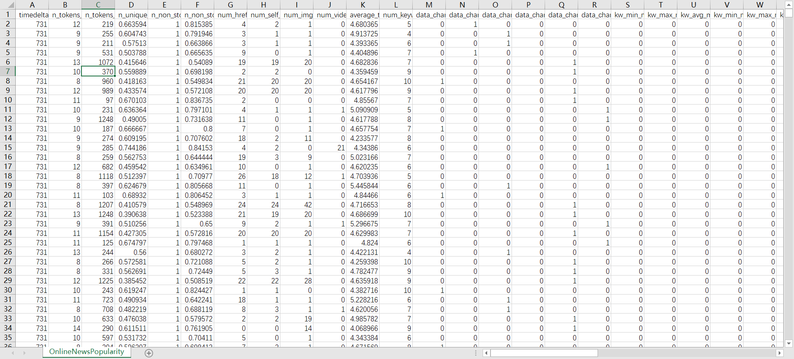
The original format of the data is CSV as shown in Figure 4, so I need to convert it into ARFF, which is specifically used for Weka. However, it is necessary to remove several attributes first before its conversion of file type. In addition, there are other pre-processing steps in demand.
Figure 4: The dataset in CSV file
The first step in my pre-processing task is to remove all unsuitable attributes. Therefore, I scan data types of all attributes and find that only URL attribute has nominal data, which is difficult to be used in data analysis. That attribute is string format although some other attributes may be extracted from it, as shown in Figure 5. Hence I remove that attribute and data of remaining attributes is numeric.
Then I search attributes with missing values and illegal characters such as ‘?’ and ‘!’. However, I didn't seek out missing values and exceptional characters.
The next step is to check the dataset for attributes needed to be split into separate groups.
Fortunately, all category attributes have been converted into one-hot code format. These
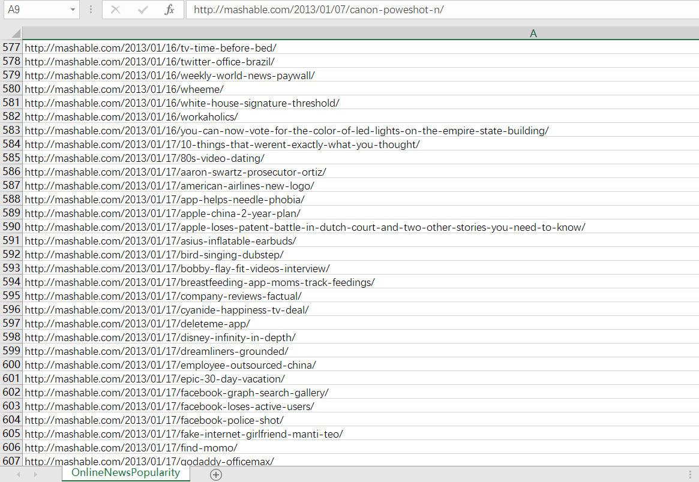
Figure 5: The data of URL attribute
types of attributes include LDA topic and the published day in a week. The defect of one-hot encoding is inevitably making feature space much larger.
My main work is to add several attributes for better data analysis. The first one is
IsPopular attribute, which is a category one. Via adding the feature, the data mining task can be a binary classification problem in which the goal was to classify whether an article was popular or unpopular by predicting whether users share that article or not.
Herein, I define the popularity of an article based on a decision threshold D. For instance, when an article is shared more than 1300 times e.g. D ≥ 1300, I label the article as Popular; otherwise, I label the article as Unpopular.
The second one is AvgShares attribute, which means daily shares of each article. The release time of many instances varies greatly, so the number of shares is also greatly affected. This feature can be used to analyze the relationship between article popularity and article content.
The last one is AvgSharesLevel attribute. More precisely, I divide the average shares of each article into 5 level because AvgShares values vary from 0 to 10000. Specific level division rules are shown in Table 3.
Table 3: Division rules of AvgSharesLevel
Level | Range
0 | 0 <= AvgShares < 1
1 | 1 <= AvgShares < 10
2 | 10 <= AvgShares < 100
3 | 100 <= AvgShares < 1000
4 | 1000 <= AvgShares < 10000

The last step of my pre-processing task is to create the ARFF file for Weka, which is not hard. After that, the whole pre-processing is done.

4. Data Visualization in Weka
After successfully importing the dataset into Weka, I would like to create a visualization to see if any interesting patterns could be found prior to the data mining processes being run.
The initial visualization of all attributes is presented in Figure 7. The reason why I use three figures is that the distribution data of more than 60 attributes is too hard to be displayed in one figures.
Due to quite different distribution of each feature, I cannot directly observe any conclusion or correlation. But I analyze the distribution of popularity categories in detail in Figure 6. Firstly, I find the amount of instances in each time delta is relatively uniform so that published interval will have slight impact on popularity classification. What’s more, the numbers of popular articles and unpopular articles are also relatively equal, which is also beneficial to our classification experiment.
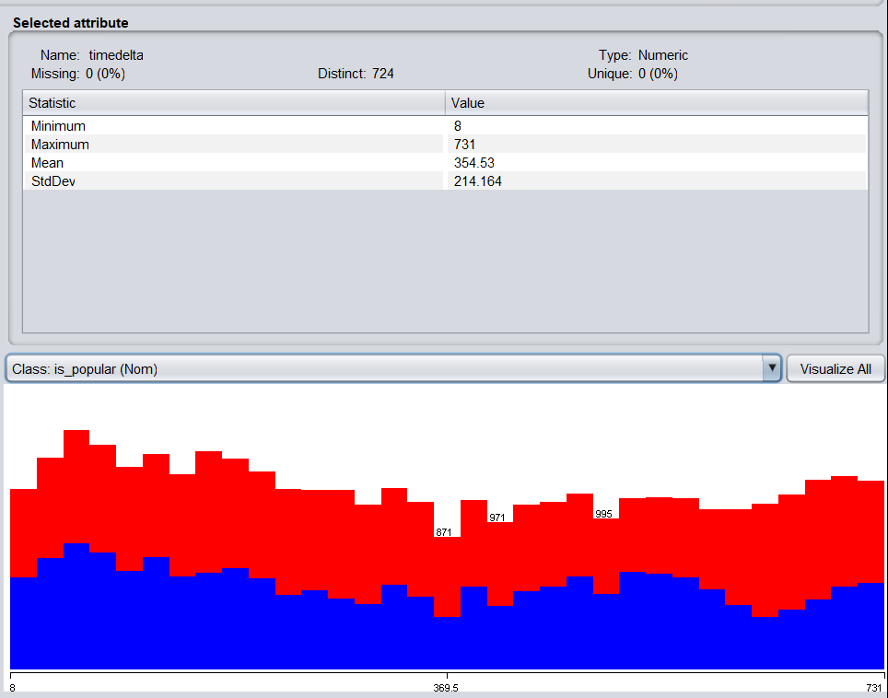

Figure 6: The distribution of popularity categories
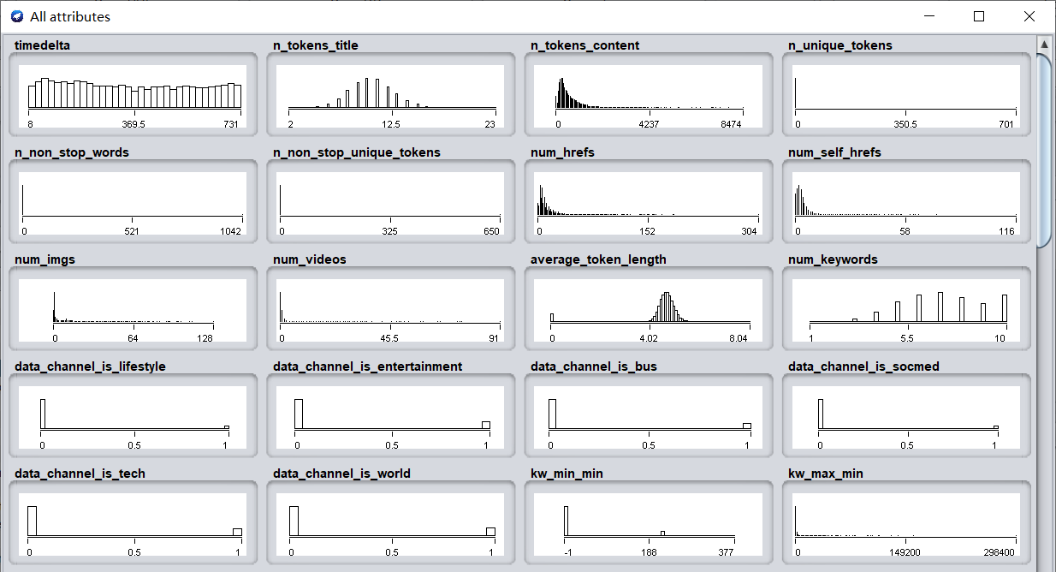
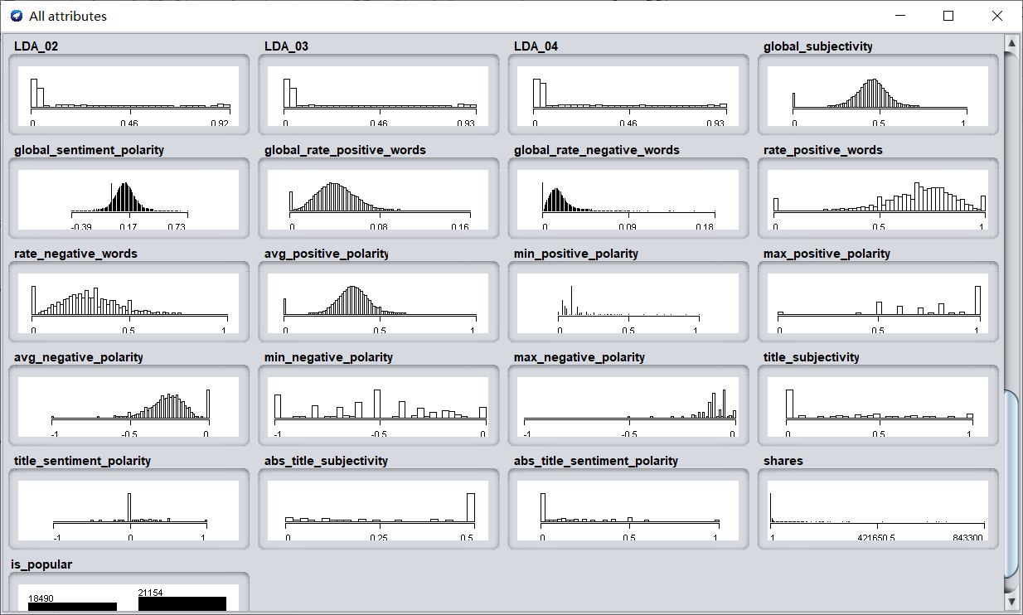
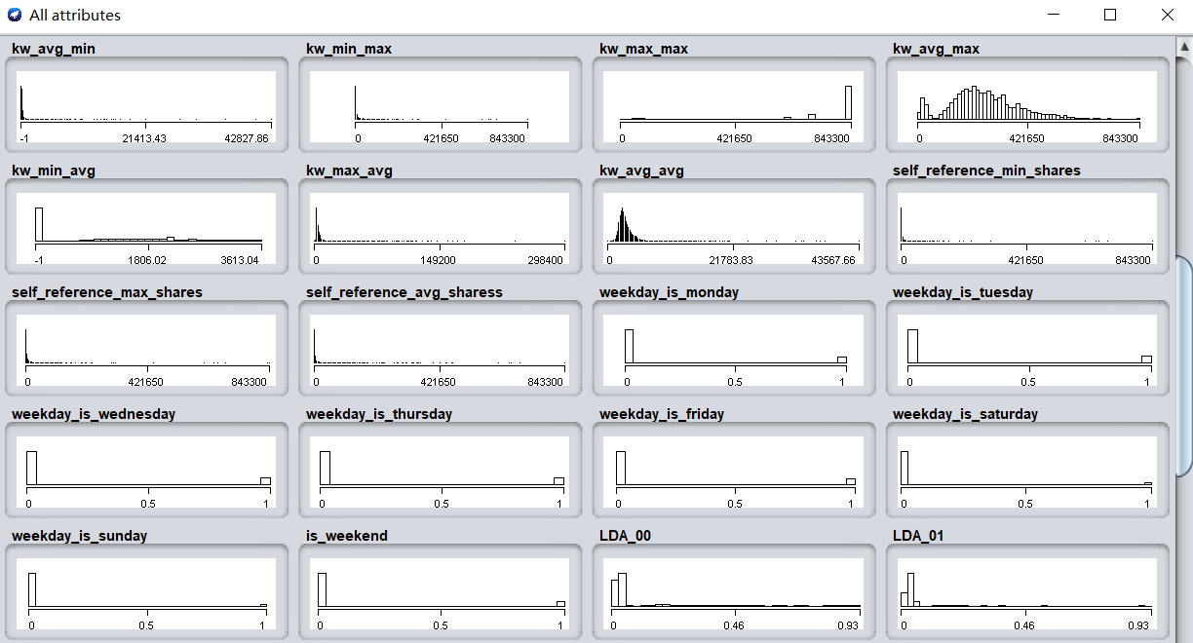

Figure 7: The distribution of all attributes

5. Data Analysis
There are 3 interesting and valuable questions that will attempt to be answered by investigating the dataset. The details are listed Table 4 as follow.
Table 4: Three research questions
No. | Question
1 | Is it possible to predict the popularity for an online article based on the existing records in the dataset?
2 | Is it possible to predict the popularity for an online article according to average shares per day?

5.1 Is it possible to predict the popularity for an online article based on the existing records in the dataset?
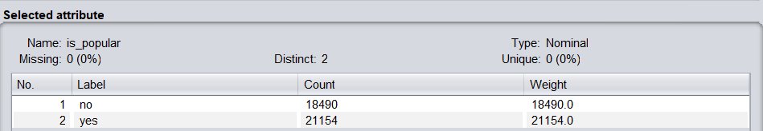
According to Figure 8, we can observe that there are 18490 unpopular news and 21154 popular ones.
Figure 8: The distribution of popularity of articles
I use these instances to test whether I can predict the popularity of articles. The main method I use is Random Forest, an algorithm that performs well in classification and regression scenarios [2,9]. It is worth mentioned that I apply with 5-fold cross validation to get more available experiment results. The process of training and testing is also very fast. The classification performance of Random Forest is shown in the figure below.
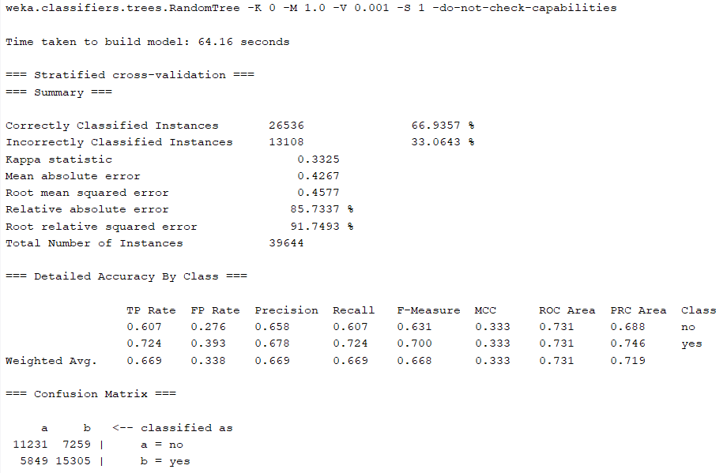
The overall accuracy rate is 67%, which is equivalent to two-thirds of the instances are predicted correctly. The precision of popular articles is 72.4%, which is much higher than that of unpopular articles (60.7%). Based on this data, it can be considered that the prediction of popular articles is better than that of unpopular articles. But it is also possible that the threshold is not set very reasonable, if set the value smaller, the experimental results should be better.
Figure 9: The experiment results of Random Forest
However, this threshold is set based on common sense. If it is reduced, it may lose its practical significance. In addition, I think that there is a huge gap in the number of shares of different articles, so it is not reasonable to only classify two articles. We can get better results if we regard this problem as a multi classification problem.
In addition to Random Forest, I also used many other algorithms to predict the popularity of articles, including J48 Tree, REP Tree, Bayes Net, Naïve Bayes, Logistic Classifier and SGD Classifier [2,6,7,8,10,11]. Before the experiment, I randomly selected 66% of the instances for training and the remaining 34% for testing. The parameter settings of each method are different. I list their commands in Table 5.
Table 5: The parameter settings of each method
Alogrithm | Parameter Configuration
Random Forest | RandomForest -P 100 -I 100 -num-slots 1 -K 0 -M 1.0 -V 0.001 -S 1
J48 Tree | J48 -C 0.25 -M 100
REP Tree | REPTree -M 2 -V 0.001 -N 3 -S 1 -L -1 -I 0.0
Bayes Net | BayesNet -D -Q search.local.K2 -- -P 1 -S BAYES -E SimpleEstimator -- -A 0.5
Naïve Bayes
Logistic | Logistic -R 1.0E-8 -M -1 -num-decimal-places 4
SGD | SGD -F 0 -L 0.01 -R 1.0E-4 -E 500 -C 0.001 -S 1
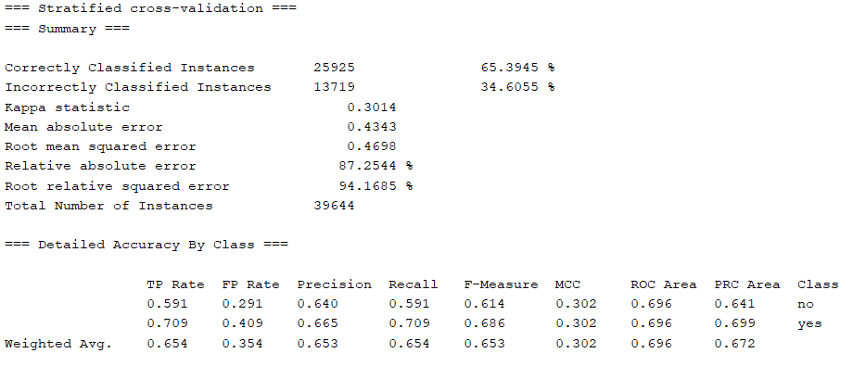
The prediction performance of these methods is not as good as that of Random Fores, but the gap is not big. Their specific training and test results are shown in Figure 10-15.
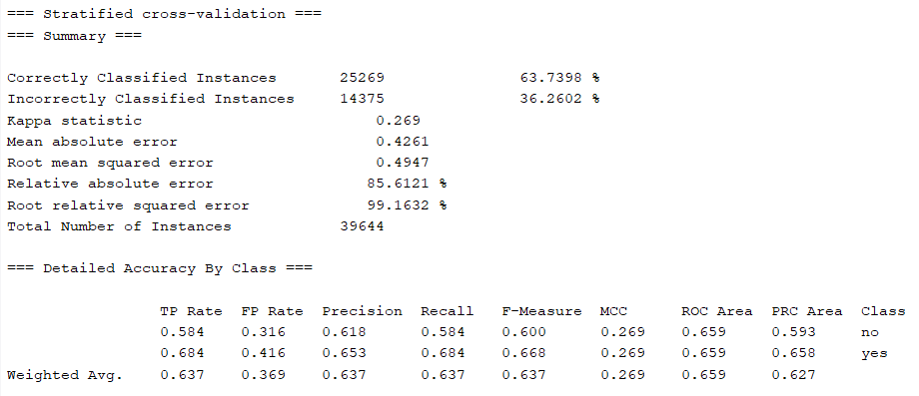
Figure 10: The experiment results of J48 Tree
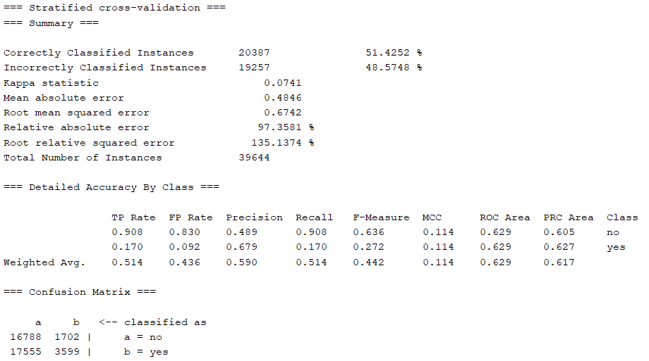
Figure 11: The experiment results of REP Tree
Figure 12: The experiment results of Bayes Net
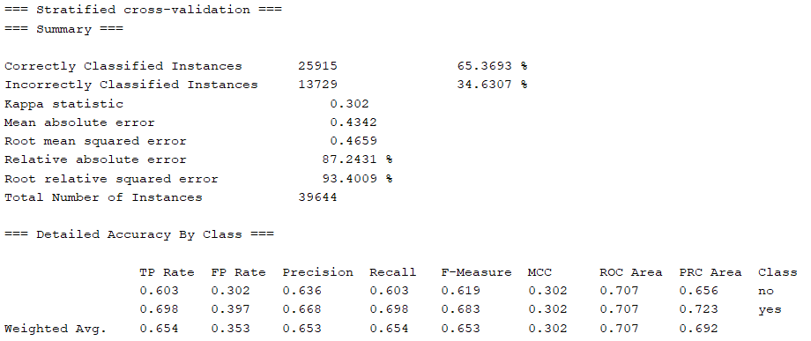
Figure 13: The experiment results of Naïve Bayes
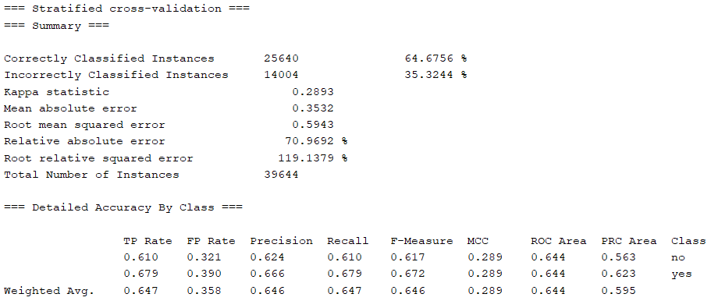
Figure 14: The experiment results of Logistic
Figure 15: The experiment results of SGD

5.2 Is it possible to predict the popularity for an online article according to average shares per day?
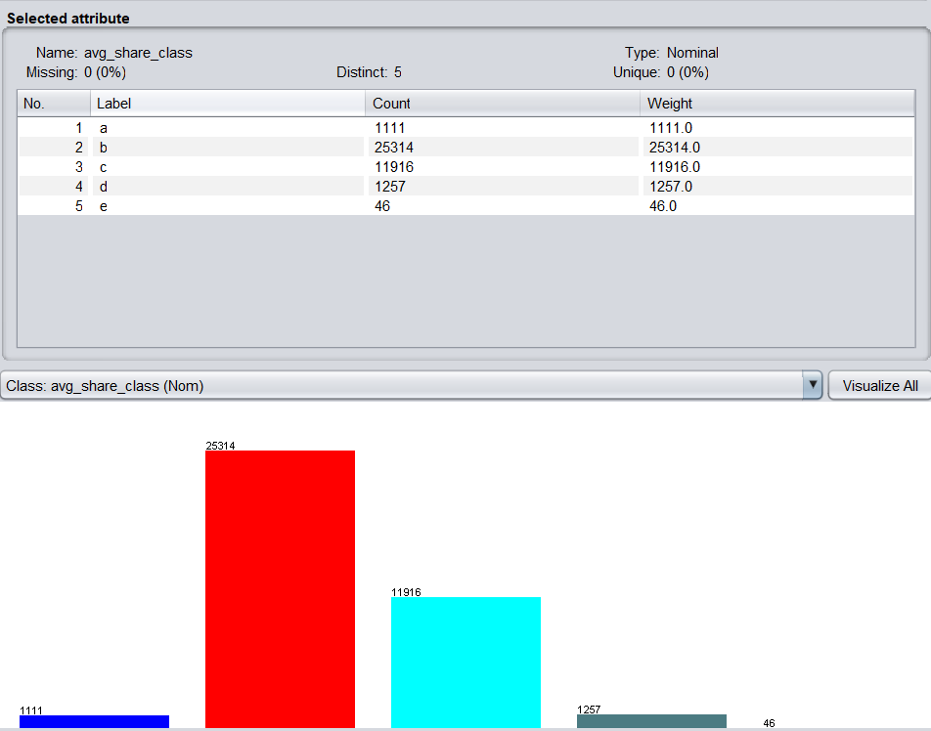
As mentioned earlier, I added AvgSharesLevel feature. Here I will predict the popularity of the article with the target of AvgSharesLevel. I divide the average number of shared articles into five levels, and the number of samples in each level is quite different, especially the low-level and high-level types. The specific data is shown in Figure 16.
Figure 16: The distribution of popularity level of articles
It's worth noting that I removed the Timedelta feature to avoid the effect of time length. In addition, I apply three methods: Random Forest, J48 Tree, and REP Tree.
According to Figure 17-19, the experimental results of multi-classification are better than that of binary classification because the prediction performance of all methods is improved [12].
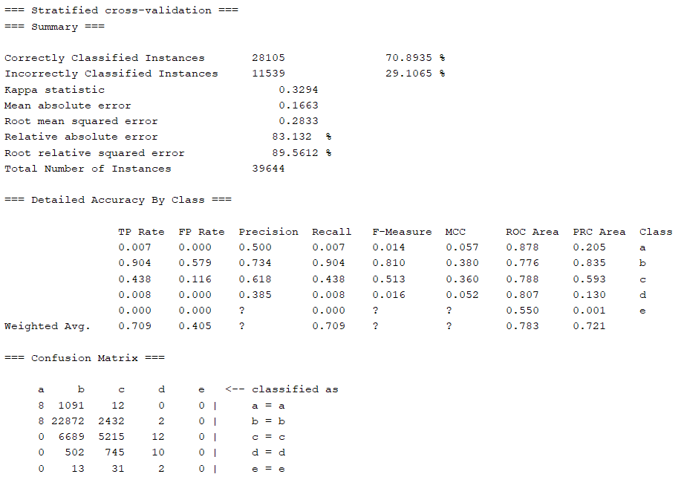
The overall accuracy of Random Forest was improved to 70%. The performance of J48 Tree is similar to that of Random Forest. REP Tree is a little worse than that of the two.
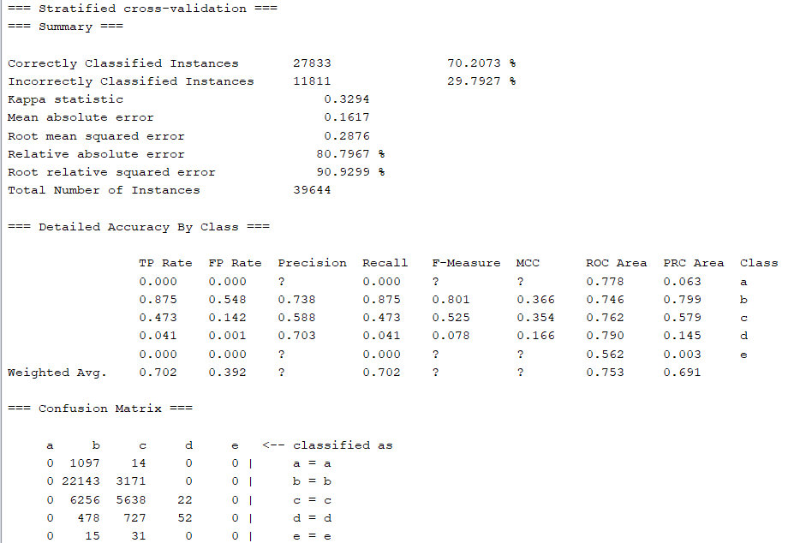
Figure 17: The experiment results of Random Forest
Figure 18: The experiment results of J48 Tree

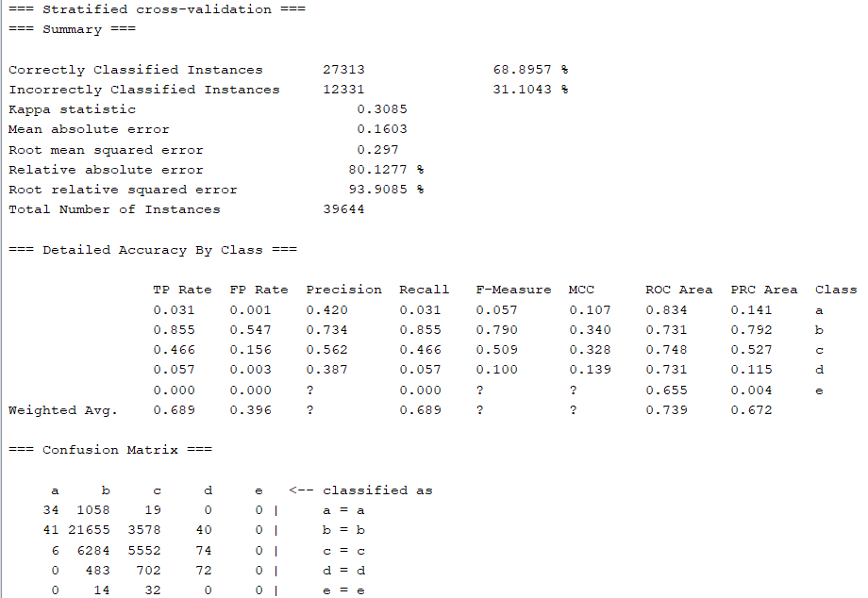
Figure 19: The experiment results of REP Tree

6. Reflection
The above prediction of the popularity of online articles has basically reached the predetermined goal, and I have achieved a significant performance improvement through more detailed division. But the whole process is still relatively rough, many analysis is not detailed. There are at least two issues that I should continue to explore. The first is to analyze and compare the influence of different types of features on the popularity of articles. The another one is that I divide the samples according to different release times, and then carry out experiments respectively to compare whether the experimental results are quite different. If the difference is obvious, it means that the publishing time has a great influence on the popularity of online articles.
However, I have at least verified that this problem is more suitable to be studied as a multi classification problem.

7. References
[1] Anon, 2016. UCI Machine Learning Repository: Online News Popularity Data Set. Archive.ics.uci.edu.
[2] Crisci, C., Ghattas, B. and Perera, G., 2012. A review of supervised machine learning algorithms and their applications to ecological data. Ecological Modelling, 240, pp.113-122.
[3] Ren, H. and Yang, Q., 2012. Predicting and Evaluating the Popularity of Online News.
[4] Fernandes, K., Vinagre, P. and Cortez, P., 2015. A Proactive Intelligent Decision Support System for Predicting the Popularity of Online News. Progress in Artificial Intelligence, pp.535-546.
[5] Blei, D., Ng, A. and Jordan, M., 2003. Latent dirichlet allocation. Journal of machine Learning research, 3(Jan), pp.993-1022.
[6] Zanaty, E., 2012. Support Vector Machines (SVMs) versus Multilayer Perception (MLP) in data classification. Egyptian Informatics Journal, 13(3), pp.177-183.
[7] Dietterich, T., 2000. Machine Learning, 40(2), pp.139-157.
[8] Mathanker, S., Weckler, P., Bowser, T., Wang, N. and Maness, N., 2011. AdaBoost classifiers for pecan defect classification. Computers and Electronics in Agriculture,
77(1), pp.60-68.
[9] Rodriguez-Galiano, V., Ghimire, B., Rogan, J., Chica-Olmo, M. and Rigol-Sanchez, J., 2012. An assessment of the effectiveness of a Random Forest classifier for land-cover
classification. ISPRS Journal of Photogrammetry and Remote Sensing, 67, pp.93-104.
[10] Ray, S., 2016. 6 Easy Steps to Learn Naive Bayes Algorithm (with code in Python). Analytics Vidhya.
[11] Denoeux, T., 1995. A k-nearest neighbor classification rule based on Dempster-Shafer theory. IEEE Transactions on Systems, Man, and Cybernetics, 25(5), pp.804-813.
[12] Lemon, S., Roy, J., Clark, M., Friedmann, P. and Rakowski, W., 2003. Classification and regression tree analysis in public health: Methodological review and comparison with logistic regression. Annals of Behavioral Medicine, 26(3), pp.172-181.

