EFFECTIVE EMERGENCY LEADERSHIP: AN EXPLORATION OF EMERGENCY LEADERSHIP BEHAVIOURS IN THE CRISIS MANAGEMENT PROFESSION



Jessica Williams
University of Wales Trinity Saint David
School of Engineering
Wales Institute of Science and Art (WISA)

A thesis submitted for the degree of Bachelor of Engineering: Advanced Manufacturing Operations
2023

Declaration Of Authenticity

This thesis is the result of the author’s original research. It has been composed by the author and has not been previously submitted for examination which has led to the award of a degree.

Signed:  Date: 19/05/2023

Abstract

Emergency leadership includes the role of evaluating the circumstance and establish an order of objectives as soon as you can. According to Klann (2003), during a time of crisis, managers should focus on three critical influencing abilities: communication, goal and judgement clarity, and empathy for people. These persuasion techniques meet the criteria for transformative leadership. Accordingly, there is a need for training methods to improve and to take advantage of the power management techniques hold within safety. This thesis highlights what contributes to effective emergency leadership, looking at a range of research surrounding the topic. One objective is to carry out analysis on current TATA Steel procedures and other case studies using research to aid the analysis. In the future, a training plan for leaders can be developed using discoveries from this thesis, as well as some other tools that can further improve preparedness for crisis management.

Table of Contents

1. Introduction 4

2. Aims and Objectives 5

3. Timing Plan 6

4. Literature Survey 6

5. Work carried out: Local emergency plan and Case Studies 14

6.Recommendations for further work 25

7. Conclusion 28

8. References 30

9. Appendices 35

Introduction

Leadership is a widely researched topic with many different theories on what makes the most effective leader, however facing an unexpected crisis requires a different form of leadership which is not as widely researched. Based on the nature of the steelmaking industry, TATA Steel has experienced such events at many different levels. These crisis’ refer to an event that can cause serious threat to the environment, local community, serious body injuries, loss of life or plant structure ( described as a major emergency). As shown in Appendix A, over a 5 week period the company experienced several safety incidents from loss of containments, near misses and high potential incidents at the heavy end in TATA. This is displayed in a safety timeline, not only looking at the incidents but the positive safety movements such as investigations and actions closed, a safety engagement day and the forward safety focus for the company over the next couple of weeks. TATA Steel Port Talbot is registered as a COMAH tier 1 site which means controls must be in place to stop significant incidents involving hazardous materials before they have a chance to seriously injure or endanger people and/or the environment (HSE, 2015).
This thesis addresses and brings the literature together on this topic, not just leadership but emergency leadership, building on existing research and how it can propose a new understanding of leadership in such an industry. While there has been research on leadership qualities (DuBrin, 2021; Barr and Dowding, 2022), little focuses on the understanding of leadership in a crisis and responding to what is most effective in an emergency. As Hershkovich et al (2016) states, leadership in a crisis scenario includes recognising demands, organising learning, and developing more than just the fundamental skills. This thesis is structured to include an abundance of literature revealing the current state of knowledge on this topic, an in depth look and analysis of TATA’s current emergency plan, case studies and recommendations for the future of emergency leadership in TATA and other industries.

Aims and Objectives

It is generally accepted that emergency managers must make decisions in circumstances that involve some degree of ambiguity. If there is a negative response to a crisis, it is inevitably the result of the leader's efforts. Unfavourable results are typically attributable to the leader's poor decision-making. The purpose of this study is to determine whether recognized leadership qualities in emergency management are compatible with established leadership theory and how leadership behaviours impact the effectiveness of emergency leadership. In order to investigate successful emergency leadership, this thesis will use case study analysis.
The objectives of this thesis are:
- Construct analysis on current emergency leadership research
- Develop analysis of case studies and emergency procedures
- Devise recommendations to support emergency leadership at TATA Steel
For objective 1 the purpose is to assess emergency leadership meticulously in terms of characteristics, conditions that influence leadership qualities, and the influence of actions on situational management. Objective 2 looks at the relevancy to TATA and investigates the present safety procedures, learn why they are important, identifying the factors that lead to the activation of a major emergency, and to determine the training requirements. Finally, objective 3 is to suggest recommendations, whether they be in training, how processes are documented/communicated, or how they are the company show more preparedness for such events.

3. Timing Plan

This following section discusses the timing plan for the thesis. The timeline for this project is shown in Appendix B using a Gantt chart. In relation to this thesis, the undertaking is divided into important tasks and components that must be finished. Each job or project component has a start and end date that are specified. Some jobs have concurrent or possible conflict schedules.
The thesis is divided into manageable phases to finish (for example, conduct a literature search, gather data, and compose a section on the literature review, etc.). Also, establishing a plan, Appendix B displays a schedule for finishing each step and the due dates. It allows a particular focus rather than undertaking all tasks at once giving enough time to proof read, organise and finish the reference list. As well as a timing plan, scheduled meetings regularly with a supervisor throughout the project made sure the project was on track.

4. Literature Survey

This next section of the thesis will focus on a review of literature around emergency leadership. It will concentrate on safety engineering, risk management, leadership styles, team building and risk identification. The purpose is to develop an understanding of the current state of research, stating the arguments to be made and the fundamental rational that reinforces the claims.
4.1 Safety Engineering
Safety engineering is a branch of engineering that focuses on preventing accidents, lowering the dangers brought on by human error, and maximising the safety of engineered systems and structures. In order to integrate safety into processes, it is linked with industrial engineering and utilized in manufacturing. As Leveson (2002) states, one advantage of using system-safety engineering methods is that an individual is given the responsibility of making sure that specific dangerous behaviours are avoided and whenever feasible, their likelihood is decreased, and their effects are minimised in the design. Almost all of the consideration paid during development is directed towards the intended functionality of the system and programme. A system safety engineer is in charge of making sure that enough consideration is given to what the system is not meant to do and confirming that potentially dangerous behaviour will not happen. This distinct emphasis has been the key differentiator in systems where safety engineering has effectively discovered issues that other methods of engineering had missed.
Numerous factors conspire in practise to prevent the implementation of innately secure design. Production facilities, transportation networks, and other human-made structures have made an effort to manage hazards rather than completely eliminate them out of considerations of productivity and expense (Moller and Hansson, 2008). Additionally, the hazardous factor is frequently an essential element of the system, either as the substance that drives the system itself (such as nuclear power facilities) or in other ways (such as fuel in different transportation systems) that are required for the system. The 'necessity' of many of these arrangements has been called into doubt by focusing on the idea of innately secure design, though. For instance, even if gaseous nitrogen is required for a process step, the nitrogen canisters can be relocated outside rather than being placed in the operators' workspace, lowering the chance of asphyxiation. However, as Bahr (2014) suggests, technology is changing and developing at high-speed, so building goods that are high quality, affordable, and quick to produce but still safe becomes more challenging as a result.
In a study by Lindhout et al (2020), unknown risks are contemplated relating to safety engineers and some conclusions were made from their studies. It appears that present safety procedures are insufficiently effective to break the long-term incident rate trend's current level. To further lower the significant accident rate, businesses and authorities must not only improve upon their present practises but also demonstrate greater eagerness in the systematic mitigation of risks that are currently unclear and unidentified. Although there is no definitive inference to be drawn at this time, the key finding is that neither the safety engineer nor safety management can ever be prepared with regard to hazard detection and risk evaluation. The combined power of new "multi-paradigm" systems thinking and "old school" philosophical inquisitiveness may be necessary to find a solid, secure, and systematic course of action. The basic issue of whether any risk assessment will ever be finished is still open.
Another study looking to improve their safety management system uses behavioural-based safety (Nadakkavil, Hareendran and Kanjiyangat, 2020). According to the research, feedback from management is the most effective attitude modification strategy for people who exhibit high levels of conscientiousness and agreeableness. For those who are receptive, training as an intervention is most effective. For those who possess the extraversion personality characteristic, rewards as a solution are most effective. The study however, only considered one industry and did not take into account the workers experience or job role. This study links into the team building and leadership styles section of the literature survey as discussed below.
4.2 Risk Management
Risk management very much links to safety management and in the workplace has triggered a lot more interest since the 2020 pandemic. Managers can make more deliberate and well-informed choices by understanding the nature and kinds of business risks, as well as establishing a method for spotting risks and controlling risks.
Leaders can choose which risks can be handled with a rule-based strategy and which demand an alternative strategy using the new risk classification that has been suggested by Kaplan and Mikes (2012). Preventable (internal) risks are among the risks that a rule-based approach can be utilized to control (risks of unethical, unacceptable actions of employees and managers, operational hazards). Strategic risks, which are desirable for the company because businesses knowingly accept the existence of these risks to accomplish their goals, are among the risks that can be managed through management systems. Organizations cannot control external threats because they are outside of their area of influence. Additionally, a risk management strategy that encourages reasonable risk should be used for strategic risk management in order to debate risk scenarios and make choices about how to deal with them. Moreover, risk is a tool that helps the business create and accomplish its strategic objectives, both of which could result in increased profits in the future (Polinkevych et al 2021).
Furthermore on uncertainty of the risks, a new viewpoint on issues, difficulties, and future paths for capturing and expressing uncertainty in risk assessment is offered by Flage et al (2014). The most common approach for dealing with risk analysis' aleatory (representing variance) and epistemic (due to absence of information) errors is probabilistic analysis. There is widespread consensus regarding the use of probabilities with a restricted relative frequency meaning for aleatory ambiguity. According to a common logic, it will be challenging or unattainable to give an imprecise probability with some degree of certainty if the background information is limited. A subjective possibility can, however, always be determined. The issue is that a given probability is often thought to reflect more information than is actually necessary (Aven, 2016).
Research on risk management in the public sector reveals a number of key findings. As Ahmeti and Vladi (2017) concluded, risk management is a necessary component of an organisation's overall management, not an elective or volunteer one. This is true for all types of organisations if they want to ensure the accomplishment of their strategy goals and objectives. Risk is a danger or a chance that cannot be fully eliminated but needs to be managed well. As a result, even if we are not conscious of it, a number of variables may have an impact on our risk attitudes and risk perceptions.
Additionally, risk management in the public sector can be more difficult than risk management in the private sector due to the high level of legislation, complexity, and broad variety of involved parties. In the construction industry, risk management plays a big part in lowering the dangers that are present in the industry because it offers a methodical way to allocate risk to projects, enabling projects to be managed with a higher level of anticipation and expectation (Olamiwale, 2014). Organizations may acquire knowledge about the parts that are susceptible to risk through risk identification, Renault and Agumba (2016) suggest it serves as the foundation for the subsequent stages of risk analysis and management. Risk identification, if done correctly, guarantees effective risk management as unidentified sources of losses that grow into uncontrollable events with unexpected outcomes. The implicit and explicit models that leaders employ are crucial to risk detection. Models are presumably accurate in fields like the prevention of workplace incidents, where events are well-defined, repeated, and thoroughly studied. On the other hand, managers are forced to use their own judgment because they lack explicit theories, data, or opportunity to determine parameters for many significant risks (Bromiley et al, 2015).
4.3 Leadership Styles
Leadership is generally understood to be the practice of motivating people to work toward their highest potential in order to complete any job, goal, or endeavour. Leadership ideas have a long history and have evolved over time, exhibiting various traits as societies and historical conditions shifted (Middlehurst, 2008). The prevalent traits of servant leadership (humility, successful communication, and dedication to the advancement of workers) demonstrate a strong correlation between worker engagement and fulfilment at work. Similar to this, authentic leadership has positively correlated with work satisfaction, however only in a single study investigated. This is shown in a study of nurse job satisfaction and leadership styles by Specchia et al (2021). It was discovered in relation to resonant leadership that the capacity to inspire workers has both a direct and indirect effect on nurses' job happiness. The manager's backing and encouragement of collaboration had the biggest effect on the study's findings and was highly valued by the nursing staff. This emphasises how crucial it is to create a sense of unity among the employees, encourage commitment, and promote the exchange of shared objectives.
In contrast to the sense of unity that employees should feel, bureaucratic leadership is regarded as ineffective since it only follows the regulations a company has in place. However, this leadership style may respond to and assess employee feedback. In contrast to autocratic leadership, bureaucratic leadership tends to refuse input from staff members if it contradicts business policy or prior practises (Mansaray, 2019). Workers may not feel as constrained as they would under authoritarian leadership, but there is still an absence of independence in terms of how much people can do in their jobs. This style of leadership can rapidly discourage growth and shouldn't be employed for businesses pursuing ambitious goals and rapid development. Furthermore, a study on employee burnout examines the impact of leadership styles and as Kelly and Hearld (2020) suggest studies carried out in the past that looked at the connection between leadership style and burnout among employees have discovered that methods of leadership are characterised by the leader's capacity for direct communication and attentive listening, compassion with workers and colleagues, adoption of sympathetic and ethical dispute resolution approaches, and displaying willingness to accept proposals corresponding with a decreased likelihood of burnout.
Leadership styles can have an impact on the continuing success of an organisation, for example, managing innovation, considering attitudes, mentality, confidence, behaviour, the development of competency, etc., there are pertinent lessons on how to create particular impacts. For instance, extensive research exists on how to inspire people to innovate; this research can be clearly linked to engaging, charismatic, and transformational leadership (Kesting et al, 2015). Additionally, there are insightful observations about unfavourable outcomes, especially in relation to high conflict possibilities, dedication, and information intake. Transformational leadership does not represent the only suitable style for leading creativity, but various leadership styles work well with varying kinds and stages of innovation.
On the other hand, there is research looking at the impact of destructive leadership styles. As Burns (2017) states, the three damaging leadership pathways are primarily linked by shared leader behaviours (abusive, bullying and toxic). These styles all show commonalities between the three such as degrading, blaming others for mistakes, social exclusion and even mocking. When it comes to achieving specific goal objectives, toxic leaders are typically neither incompetent nor ineffectual. Steel (2011) repeatedly stated that these individuals are capable leaders who possess the necessary qualities, but who are only working towards the wrong goals, such as promotion of oneself above all else and in the wrong manner. There is an abundance of research on leadership styles and which ones are effective or ineffective, however when a crisis occurs which styles would be most suitable? This thesis will develop on this research as a result of looking at case studies and the learnings from these.
4.4 Team Building
Team building is an essential subject in the contemporary workplace, as organisations seek to improve their efficiency, revenue, and service quality through team-based frameworks. Supervisors and employees of organisations everywhere are looking for methods to enhance company outcomes and revenue. When inputs and assets are combined to accomplish organisational objectives, responsibilities are established for each organisation member, challenges are shared, and continuous small changes are pursued, this is known as teamwork (Fajana, 2002). In order to better the dynamics of the company, leaders typically devise a process using an assessment of the group's strengths and difficulties. As Munir and Fatima (2023) suggest, leaders can make wise decisions that drive organisational objectives by having a thorough understanding of the team's traits, skills, and encounters.
Teams frequently experience problems that can reduce the efficacy of the team, and particularly, its capacity for decision-making. Determining precise goals is crucial because the team might lack a common set of objectives. Team choice-making may require time away from work due to the time compromises involved. As Fapohunda (2013) states, there may be issues with pressure from peers, in addition to the possibility for more disagreement in the decision-making process. Groups are unlikely to function successfully to create and realise a shared goal without sufficient teamwork preparation and instruction. There are additional difficulties brought on by a lack of dialogue, interpersonal conflict, and an excessive focus on a relationship that is mutually beneficial.
The success rate of teams has been shown to rise following measures intended to promote teamwork behaviours in a variety of contexts, including medical, the armed forces, transportation, and academia. Strategies for teamwork have mainly concentrated on encouraging a feeling of unity within the group. The degree to which a group is cohesive while engaging in social or job-related task is referred to as cohesion (Beauchamp, McEwan and Waldhauser, 2017). A key concept of team building approaches that focus on cohesion is the belief that if employees can promote an environment of cooperation or solidarity, this has a promoting effect on boosting one's own efforts (increased incentive), guiding them towards shared goals, and enhancing collaborative effects.
With regards to communication and team building, it takes dedication to motivate, providing a knowledgeable and bold advocate voice to support team decision-making. According to research by Baton, Bruce and Schreiber (2018), team leadership practises that promote open communication in organizations allow helpful followership behaviour. Healthcare decision-makers at the top of the organization need to be morally self-aware of how their own guidance impacts the capable nursing communication necessary for effective collaboration. To assist team decision-makers, all nurses must possess these verbal expertise and abilities (supportive followership). In any contemporary organization, the two activities of efficient communication and team development are essential. Irrespective of the degree of diversity in the work environment, the application of these procedures encourages employee growth and fosters confidence among them (Cletus et al, 2018). Successful communication decreases the likelihood of disorganization and the ensuing mistakes, as well as allowing workers to easily connect with the organisation's mission and leadership and to work more productively. This in turn lowers the likelihood of conflict, discontent, or unhappiness and promotes a positive workplace atmosphere (Nithya and Mohamed, 2018). Effective leadership is made possible by good communication, which increases managers' awareness of the constraints that exist both inside and outside the organisation. Employees add to the general success of the organisation in a collaborative setting. To get these outcomes, by collaborating with other organisation members. Even though people work in a particular area and have a particular job role, they work together with other organisation employees to achieve the organisation's overall goals, activities are guided by the bigger image, and you perform your role to further the broader vision (Heathfield, 2008).
4.5 Risk Identification
Much like risk and safety management, successful risk control necessitates thorough risk detection, with no element left out that could have a significant impact on operations. As a result, a broad risk categorization is simply guidance to risk detection and categorization. As Sanchez-Cazorla, Alfalla-Luque and Irimia-Dieguez (2016) state, this is the initial stage in a risk management process that will continue by designating possibilities of occurrence and effect on operations in an effort to determine what measure should be performed to handle each of the threats.
The use of reactive techniques are common and shown throughout the literature. Initially, efforts were concentrated on engineering areas such as machines and facility maintaining. Nonetheless, once the models were stable, scholars used them in later years in practical computing areas such as analysing epidemic breakouts (Aboutorab et al, 2021). More modern reactive risk detection methods were mainly an expansion or enhancement of methods from earlier years. For instance, the analytical model method HAZOP was used to identify hazards in chemical mixing facilities (Gallop et al, 2016). Studies used fault tree analysis (FTA) in the field of logic diagrams to explore why a result varied from its anticipated trend. As Yin and Xie, (2010) suggest, the occurrences that cause a deviation are referred to as risk events. FTA has been used to identify risks in areas such as water purification, highway building, etc.
Supply chain risk management is divided into three stages but is relevant to other parts of organisations, the first of which includes risk detection, risk measurement, and risk evaluation. The second step includes risk assessment, risk reduction, and emergency preparedness. The third and final step focuses on risk management and tracking (Tummala and Schoenherr, 2011). It can be seen that risk detection is the foundation for all subsequent supply chain risk mitigation methods. Risk management is unable to be viewed as a way of forecasting the future because that is impossible. Smith et al (2006) define it as a way to enable projects so that improved choices can be made based on the knowledge from investment while in the construction industry. Decisions based on incomplete knowledge can thus be prevented, resulting in improved performance. When dealing with a situation that is unknown in industries it is not always easy to prepare but identifying that the risk knowledge we already have can be used is important.
The main goals of project risk management are to recognize, evaluate, and handle project hazards. Evaluating the success of the initiative is also difficult because various stakeholders have different standards for determining its success. Projects must be implemented successfully, and the first stage in risk management is recognize hazards (Khalilzadeh, Katoueizadeh and Zavadskas, 2020). Risk management application cannot be practical without contemplating the concept of risk, particularly considering the significance of threat for stakeholders. As Pradesa (2021) states, this takes into consideration the notion that organisational strategy will imply extensive contact with important players in the organisational environment. Furthermore, analysing organisational performance requires a comparative reading of performance metrics along with risk indicators that identify the different important stakeholders.
It is critical for industries to address safety and enhance their performance of safety. As Aulia and Qurtubi (2019) previously claimed, if risk control is carried out correctly, 84% of incidents could have been anticipated and prevented. Many areas are vulnerable to risks, including heat injury, impaired vision, noise pollution, confined spaces and movement restriction (ergonomics), as well as other inconvenient settings such as electricity, spill, and mechanical dangers associated with tools. The nature of heavy industry such as the steel industry can pose many risks and if these are identified beforehand controls can be put in place to reduce the risk of injury.
4.6 Hazard Identification
The first phase in the risk evaluation process, hazard identification, covers two issues:
(1) Is the substance in question potentially hazardous?
(2) What kind of negative effects on wellbeing is it probable to have? Is it, for instance, potentially carcinogenic, neurotoxic, or developmental hazardous?
A comprehensive scientific review of multiple distinct forms of information is necessary for hazard detection as stated by Kamrin (2005). Eliminating a hazard completely is the best approach to address it. The following solutions which are included in most safety management should be considered by your company in order to reduce dangers whenever feasible.
- Eradication
- Replacement
- Isolation
- Precautions
- Using personal protective equipment (PPE)
To successfully decrease exposure to dangers, it may occasionally be necessary to combine more than one of the aforementioned risk control techniques. In this literature survey, it is also important to remember all of these subject areas link together to build safety management.

5. Work carried out: Local emergency plan and Case Studies

This next section of the thesis will focus on the current emergency plan and case studies of events in the company and outside. This contains a factual discussion on TATA Steel’s local emergency plan (Szafnauer and Taylor, 2019), the explosion of No. 5 Blast Furnace in 2001 and also the Piper Alpha Disaster. After the facts are discussed, an analysis is conducted on all three specifically looking at potential leadership flaws, what was effective and what could have been done better in terms of leadership.
Local Emergency Plan (TATA Steel)– The Facts
The Local Emergency Plan (Szafnauer and Taylor, 2019) explains the responsibilities taken by personnel in the event of a major emergency affecting the steelworks, the writing was supported by the University of Lancashire and contains 7 chapters. A plan can aid leaders to effectively respond to any safety incident and any other difficulties that may occur at the time of an event, however it is difficult to prepare for an event that may not have happened before so, general information is given with known potential causes of disasters highlighted. These chapters will be discussed below with analysis presented later on in the thesis.
5.1 General
The first chapter discusses the aims and objectives, to minimise the effects of incidents, implement the measures necessary to protect persons, communicate information, provide restoration and clean-up following the incident. Definitions specific to the plan are clearly stated with two wide-ranging flow charts on decision making and response as shown in Appendix C and Appendix D. There are also some major accident scenarios specific to the department which are placed under different severity levels to be considered (0 Negligible, 1 Minor, 2 Moderate, 3 Severe, 4 Major, 5 Catastrophic). Additionally, there is information on other significant risks such as a cyber attack or a phishing attack and what to do in these situations.
The key positions of personnel are discussed in this plan with details of what their job role is and where they would be based, all roles depend on the emergency controllers (usually shift managers) appointment. The levels of command are shown in Appendix E. The plan is usually activated by the shift manager at different control levels (Bronze- operational, Silver- tactical and Gold- strategic). Lastly, in this chapter are details of communication of activation plan. The objectives include verification of information, responding to media and external audiences, coordinating press releases and monitoring media.
5.2 Assembly Points
The main assembly points are stated with pictures in this chapter. All permit rooms have access to site attendance registers and any contractors have their own emergency plan. There are also back up emergency points that can be used with the Local Control Centre (LCC) based in the safe haven at the shift managers office. Muster point lockers are available with equipment to support the team such as site drawings, visibility vests, pens, clipboards etc. Lastly, there are details considering a gas situation and how the exit route depends on wind direction, the safest way to identify the source but always assume the gas has potential to become higher level.
5.3 Scene control point and local control centres
The scene control point (SCP) is the location that manages the access to the scene of the incident whether it be the fire and rescue services or the local authority emergency services. Emergency control centres are situated around the works, such as the works protection control room for the initial response to the emergency, the tactical response control centre and the LCC which is the operational control centre. As stated before the LCC is situated in the shift managers office next door to the main control room for both blast furnaces. In this chapter there is a breakdown of approximate staffing levels at certain times of the day. There are 5 shifts that rotate on a 12hr basis, in 2019 on weekdays there would be approximately 400 employees in the iron and burdening department depending on the shift in at the time.
5.4 Responsibilities
This chapter is responsible for providing the information on the key players and their roles in an emergency. These are not set and can be changed on shift personnel availability. There are contact numbers for all of the departments associated with the heavy end including security, it is also highlighted which ones are manned 24hrs (blast furnace control room/sinter plant control room). Key personnel are required to wear a fluorescent jacket and all the details showing which colour is required for certain services are shown, see Appendix F. The numbers for any neighbouring plants are provided in this chapter, mostly direct numbers to managers or shift coordinators.
5.5 Specific Arrangements
This chapter details procedures for specific emergencies. For example:
- Gas escape- a major toxic release of gas. Report the incident, ensure alarms are activated, personnel to evacuate and roll call taken.
- Hot metal release- Alarm raised, identify the source, evacuate non-essential personnel, emergency drench showers to be used on injured persons.
- Fire and explosion- secondary damage is likely and needs to be checked, there could be a gas system fire, conveyor belt fire.
- Bomb threat- Operations must be stopped immediately, personnel evacuated. Search teams will assess areas.
There are also important details in this chapter on when to stand down and carry out recovery. The emergency controller declares the end of an emergency. A debriefing would then take place with investigations to follow, also releasing a full statement to the media if it is required.
5.6 Departmental areas
This next chapter covers risks including environmental, evacuation, emergency shutdown. The risks of different scenarios are assessed and the layers of protection for each are shown. Any vulnerable areas are highlighted with a list of environmental harm including noise, odour, asbestos, waste, radiation etc. Access to all departmental areas is shown in an emergency, all rail traffic is stopped if plant is to be evacuated. In terms of isolation, affected areas are electrically isolated if possible and gas isolations can be requested. An evacuation alarm is in place across site and any missing people must be reported to the furnace control room so appropriate people are aware of the missing person. If the blast furnace control room or sinter plant control room need to be evacuated an emergency shut down must be undertaken, details of this including the procedures are found in the plan.
5.7 Appendices
This is a useful chapter that contains lots of helpful tools. For example there is a tick box checklist for several roles in an emergency scenario (emergency controller, energy liaison officer, scene liaison officer, muster coordinator officer, communicator officer, LCC recorder/ listener). A site drawing can be found in this chapter, a map of the toxic gas alarm coverage and also the location of breathing air apparatus. The holders of the emergency plan are also named along with a list of inventory for the plan including; plans, internal telephones, COMAH charts, radios, drawings etc. A mnemonic that is commonly used at TATA is “methane” when first responding to an emergency, this is shown in Appendix G and explained in more detail in the analysis below.
5.8 Local Emergency Plan (LEP) (TATA Steel)– The Analysis
The analysis for the LEP will focus on leadership behaviours and breakdown sections of the plan to evaluate the leadership involved when a disaster occurs. The sections that will be focused on are the decision making process, the actions of the emergency controller and the stakeholders involved.
Being ready to analyse and react to the circumstance, having the ability to restore communications, being prepared to make any sort of decision, and encouraging cooperation between government and other parties' reactions to crises or catastrophes are all necessary for being an effective leader in a catastrophic event (Demiroz and Kapucu, 2012). There are custom functionalities which aid managing disasters and one of these is having procedures for making decisions that have been pre-planned. As shown in Appendix C, the plan provides a decision making flow chart that is applicable for the most common major emergencies in the department which allows a step by step set of guidance for the situation. Some academics have investigated the evolutionary interactions among crisis decision makers in crisis management of unanticipated disasters using the dynamic game model. As Zhou et al (2018) states, the technique by which emergency plans are modified by decision-makers in light of each stage's outcomes and the information that is continually changing can be generally compared to a dynamic "game" between the topic and the goal of disaster control.
In exceptionally challenging situations, leaders are required to make quick decisions based on situational assessment, expertise, and experience. A leader who is underqualified is more likely to make poor judgements under pressure or to react slowly and untimely (Hershkovich et al 2016). Decisions of all kinds must be made during an emergency, both at the individual and leader levels. Unplanned and unforeseen circumstances are frequently managed through this type of decision-making, which also leads in the establishment of risk guidelines to provide framework in handling the various events. As a result, crises are frequently managed using step-by-step methods, guidelines, and suggestions. The decision making process as guided by in the plan provided a step by step method of most likely scenarios which is fitting preparation for unplanned crises.
Frequently, processes are developed, regulations are drafted, and plans are put together without taking the decision maker into account. In order to handle disastrous events effectively, systems, strategies, and plans must be developed by posing the following questions:
- Who makes the decisions?
- What circumstances are these choices taking place in?
- What elements endanger making the best judgements the most?
- How can the most complex barriers to making decisions be removed from a system's design? (White and Turoff, 2010)
Also, because emergency decision management is difficult and risky, decision makers must make judgements in the least amount of time. The information processing ability is restricted, so on the other hand, will leaders take the time to read through a flow map. However, some decision makers fail to provide full decision information, resulting in a problem: how to deal with the incompleteness of decision makers' assessment information and step by step structure can help with this. Furthermore, Su, Chen and Gao (2022) state, separate decision makers may hold opposing views on certain criteria, and the criteria established in the emergency may be qualitative or quantitative. As a result, depending on their expertise, knowledge, and the content of the criteria, decision makers may utilise various sorts of information to communicate their judgements or decisions.
The emergency controller is the leader in the emergency and there is a checklist provided in the plan of actions to be considered when a shift manager becomes the emergency controller. The first suggestion is to promote your authority and as United Nations (2015) states, it is important to try to obtain the official authority you need to guide people in a crisis scenario. Defining your authority might help others feel more confident in your ability to lead. However, you must also be aware of the boundaries of your power and follow all safety protocols. Also, making sure decision making and authority is distinctly understood is a characteristic of a well-performing team. Leadership should promote cooperation and openness across their team network. One way they accomplish this is by delegating authority and exchanging information: by displaying how the teams must operate. In a time of difficulty, a leader's tendency may be to centralise decision-making authority and restrict information, delivering it only to those who need to know (D’Auria and De Smet, 2020).
The next actions link together as it is to limit the escalation of the emergency and protect people, the environment and assets. When referring to the potential of loss and damage, building and maintaining relationships with those they are tasked with protecting needs leaders to notice potential or present loss and suffering and act with sensitivity. As Crosweller (2022) suggests, consequently, these qualities of leadership may serve as strong motivators for pro-social and environmental conduct in addition to ethical requirements and pledges to compassionate activities and methods to counteract anthropogenic climate change. Leaders must build relationally responsive conversation and relationships with individuals they are expected to lead and protect in order to fulfil their moral obligations to others.
Another suggested action is to use the methane mnemonic to collect information as shown in Appendix G. The METHANE model is a well-known reporting system that offers a uniform platform for sharing event information between responders and their control rooms. It is advised that this structure be applied to all incidents and modified as necessary. In a report by Saunders (2022), there was an investigation into the Manchester Arena attack in 2017. The report focused on emergency response and the METHANE model was used in the response. It was found that there were issues with the communication of the METHANE message, as the transport police requested numerous times and it was not communicated straight away. There was no METHANE message sent from emergency training UK to the ambulance service. It is important to stress that when the emergency controller collects this information, that it is passed onto the relevant personnel immediately.
The last action is to declare the emergency is over, this requires lots of factors to be considered first; personnel accounted for, dangers controlled and fire/ rescue confirm the emergency is over. The issues with following a checklist is the idea that no level of leadership concept would allow leaders to be successful under all circumstances therefore they ought to be ready to adapt their leadership style to the circumstance (Knebel, Toomey and Libby, 2012). It is a fundamental premise of emergency leadership and future theoretical research should examine the efficiency of various leadership philosophies in a variety of catastrophic scenarios.
Stakeholder influence is shown throughout the plan, so it is important to analyse the involvement of the stakeholders. These include the assistance from neighbouring plants, emergency services, new/media, local community and personnel (contractors). Stakeholders can have a big impact on an organisation, thus Ulmer (2001) suggests that it's important to engage in their connections before a crisis occurs since they can serve as an additional source of support during disaster. Stakeholders also have an ownership stake in the success of the organisation. Stakeholders, for instance, might act as advocates for organisations in need by offering political assistance and crisis-resolution tools. However, stakeholders can end their assistance during a crisis, even extending the consequences of a crisis, or increase the threat connected with the event if stakeholder ties are weak (Nyenswah, Engineer and Peters, 2016). Hence, political or organisational leadership is crucial in identifying important internal and external players as well as in building connections and establishing values prior to and after a crisis occurs.
The media is discussed as a stakeholder in the plan and leaders are responsible for major emergency press and television releases if needed. It is a significant participant in disaster management from one location to the next, as noted in the literature (Mojtahedi and Oo, 2017).The media has been actively involved in transmitting news, particularly on the aftermath of incidents. The media's communication of information about disaster preparedness has made some progress. Also, the significance of ensuring public knowledge has been addressed previously in literature in the setting of emergency response; it is equally significant in the preparations for hazard prevention. As Hughes and Palen (2012) state, safety coordinators employ a range of communication channels, such as social media, newspapers, and in-person meetings, to inform the public.
The community is an important stakeholder and when a leader is making decisions, the risk to the local community is of high priority. Communities have a significant role in recovery from disasters. The degree of catastrophe risk will ultimately depend on how well they cooperate with the system and how quickly they respond (Polcarová and Pupíková, 2020). The communities' geographical position in this scenario is an important consideration and at TATA Steel a gas release or explosion can have a significant impact on the nearby town. By using visual representations of data to highlight trends, community mapping may be used to determine a community's capability and requirements. The location of essential facilities, demographics, dependence on public transportation, the availability of resources and assets (such as warehouses that can serve as distribution centres), and companies that can continue to provide food or water following catastrophes are a few examples of developments that may be taken into consideration. Since patterns may alter, understanding networks is a dynamic process. Community mapping is frequently used by emergency managers and local organisations to collect factual information on regional patterns (FEMA, 2011). By highlighting the dynamics of people, how they collaborate, and the amenities that are available, trends can assist leaders in better engaging communities, understanding and meeting the needs of individuals and planning for the future.
5.9 Case Studies-
BF5 Explosion (2001)
On November 8, 2001, at around 17.13 p.m., No. 5 Blast Furnace exploded at the Corus UK Ltd. facility in Port Talbot. A little over 200 tonnes of hot materials—mostly solid particles with a small amount of molten metal—and gases were released violently into the cast house as a result the lap joint of the whole furnace lifting, alongside its contents measured about 5000 tonnes. Len Radford, Stephen Galsworthy, and Andrew Hutin were three workers that passed away. Another 12 workers and contractors were seriously hurt. Many more people had shock and small wounds.
This next section will highlight the key details from blast furnace number 5 explosion in 2001 as stated by the Health and Safety Executive (2001) with analysis discussed below in the thesis. The result of the disaster was abnormal for the steel-making business, but it was the consequence of several safety management shortcomings on the part of the corporation over a lengthy period of time causing 3 deaths and many severe injuries. After two days of trying to rescue the furnace from a chilled-hearth condition brought on by cooling water intrusion, an explosion ultimately happened. Hot material and water mixing together in the bottom half of the furnace was the direct cause. The management structure is clearly stated in the report explaining events before, after and during the explosion with many learnings to be taken from the catastrophic event.
In terms of the emergency plan, the major emergency plan was instantly activated following the explosion. The leftover furnace contents remained 'active,' producing massive amounts of blast furnace gas, primarily carbon monoxide. To eliminate the effects of these active components, in just minutes after the incident, blast furnace employees had placed a vast water seal in the gas system, isolating the furnace from the work main gas supply main. Water from the gas plant supplying other departments was also cut off, the furnace was also vented through the furnace stack and bleeder valves at the top of the furnace. The furnace's and its related plant's structural integrity was of immediate significance. After an engineering examination, corrective actions were taken to guarantee stability and safety. In anticipation for "quenching," the furnace was generally in a sealed position. In order to inhibit the internal reactions, gas production, and other processes, this required the carefully timed injection of thousands of tonnes of water to the furnace's contents over the course of many weeks and prepared the furnace for destruction in a safe manner. The "quenched" load and the refractory components inside the furnace structure were taken out when the appropriate forensic investigations were finished. The outer layer of the furnace was divided into pieces and disassembled. After the majority of the furnace construction had been taken apart, the bottom bosh and hearth material was eventually removed.
One of the important recommendations as a result of this explosion was to review safety management and decision making. There was relatively very little evidence that the organization, or in fact the steel industry as a whole, at the time employed any of the widely recognized predictive technologies used in other high-hazard businesses. Also, regardless of how skilled or competent a person is, they are more likely to make mistakes while under pressure. The top operators and supervisors managing the furnace recovery were working under challenging, atypical process circumstances. These people relied heavily on experience and "informed judgement" since there were insufficiently specific decision-making methods available to assist them. There is evidence to suggest that this was eventually insufficient, therefore mistakes were likely executed.
BF5 Explosion (2001)-The Analysis
The analysis of the BF5 explosion in 2001 will look at the positive leadership actions and where leadership went wrong using the investigation by the Health and Safety Executive (2001). The key management failings in health and safety that led up to the disaster occurred over a long period of time. The Blast Furnace department became subject to COMAH regulations in 1999, with the application of predictive techniques and approaches in the steel sector being rather restricted. The steel industry along with other process sectors ought to utilise predictive techniques for risk assessment and management more frequently. Hazard identification methods could have identified the risk of disaster sooner.
The relationship between dangerous chemicals and detrimental effects is complicated, with numerous interactions and sometimes long intervals between exposure and consequences. International guidelines for undertaking hazard identification are not yet established. The general public's degree of trust in the evaluations may be lowered and the decision-making process could be impeded by the use of diverse approaches to detect health risks caused by environmental hazards (Chartres, Bero and Norris, 2019). After two days of trying to rescue the furnace from a cooled-hearth condition brought on by cooling water intrusion, an explosion ultimately transpired. Design defects are often a major cause of accidents and as Pasman, Rogers and Mannan (2018) state, although requirements, technical standards, and best practises must be ensued, it should go without saying that an engineer's top priorities are plant cost and efficiency. It is not always clear what decisions will mean in terms of dependability, stability, and safety.
A suggestion of predictive tools that could have been implemented are fault tree analysis; when the COMAH safety report was prepared there were available expertise but it failed to predict the explosion. Failure Modes and Effect Analysis; this technique is widely taught to engineers and discusses consequences of failure. Hazard and Operability Studies; this method was known in the company as it was used previously to evaluate the cooling system on BF4. Layers of Protection Analysis; this may have offered some insight into the potential that the No. 5 furnace and associated systems may experience an adverse scenario, especially in light of the Energy Department's failure trend in the incident.
Communication had a significant impact on the disaster, especially during the recovery of the furnace. The networks of communication were insufficiently solid, and blast furnace operators were consequently uninformed for the loss of water for cooling on November 7th. When an intended service project or other activity that might possibly influence the dependability or safe operation of a facility is made, there should be enough prior communication between the various work divisions. Managers must be able to come to quick judgements with scarce or inaccessible information owing to communication channel interference. Managers' ability to communicate, particularly in times of crisis, are equally critical (Mahmud, Mohammad and Abdullah, 2020). However, if this lack of communication caused blast furnace personnel to be unprepared for the loss of cooling water due to maintenance not communicated, it forces leaders to use their communication skills prior to the disaster occurring when more information could have been available pre-disaster.
On the cast house floor, there was also substantial misunderstanding over who was in command. Several persons were in danger throughout the recovery because lines of communication were ambiguous, and they should not have been at risk had communication regarding the risk level been appropriate and individuals recognised the true status of the furnace at the time. As part of emergency leadership, personnel need to be provided with appropriate training, procedures, additional work tools and have a clear understanding of their duties and responsibilities. As Tuler and Kasperson (2013), state the communicator's position is critical for successful communication of risks. Adoption of risk information is influenced by people's judgements of the communicator's competence, lack of prejudice, concern for the audience, and commitment to confronting and conquering the risk.
While there are lots of negatives highlighted in the investigation, it is important to highlight the positive actions taken by the company. Two people are currently undertaking the part of team leader: one is in the control room and the other is in the cast house area this allows an extra level of communication with clarity on who is in command. Operator protection has improved as the control room is situated remotely allowing direct communication with other parts of plants and outside lines. The processes for handling water intrusion have undergone a comprehensive examination. The furnace is now shut off blast for official risk assessment evaluations in a chilled hearth scenario.
Piper Alpha (1988)- The Facts
Occidental Petroleum (Caledonia) Limited ran the North Sea oil extraction platform known as Piper Alpha. Although it started producing in 1976, it became the scene of the world's worst offshore catastrophe on July 6, 1988. The structure was devastated by a blast and the oil and gas fires that followed, killing 167 people, including two members of a recovery vessel's crew. Only 61 people managed to flee. Thirty bodies were never found. The platform in question was responsible for around 10% of North Sea oil and gas production at the time of the tragedy, and its overall insured damage was nearly $3.4 billion.
The Piper Alpha disaster is discussed in a thorough report containing two volumes led by Cullen (1990). The first was to determine what caused the accident. The second made improvements to the safety regime guidelines which will be discussed further in the analysis. On July 6, 1988, an incident occurred where a significant escape of gas condensate on Piper Alpha ignited, resulting in an explosion and vast oil fires. The heat caused a gas pipeline from another site to burst. This resulted in another colossal explosion and flames engulfing the Piper Alpha platform which took around 22 minutes. For repair and servicing, a safety valve was recently taken out of this pipe work. The pump related to this valve was getting routine maintenance. The leak occurred when the pipework was pressurised on start up with no safety valve.
The Piper Alpha was the first offshore platform that was ultimately lost to tragedy after 12 years of successful use. The horrific sequence of circumstances that caused the accident were made clear by the thorough inquiry. Over the course of a two-year inquiry, the disaster's primary cause was discovered largely through fragmented eyewitness testimonies and coincidental photos acquired from nearby vessels (Reid, 2020).Crude oil, natural gas, and petroleum condensate were the potential sources of ignition found on this rig. Among the primary findings following Cullen (1990) public inquiry was to shift the agency in charge from the Department of Energy to the Health and Safety Executive, as well as to implement the redesigned accomplishing objectives regime. The Offshore Installations (Safety Case) Regulations (1992) were enacted as a direct result of the Cullen Inquiry, signalling an entire shift in industry mindset compared to the prior restrictive framework. The Safety Case Regime required operators to submit a document demonstrating their knowledge of the dangers and risks connected with an offshore site, as well as the existence of acceptable risk management methods to limit or eliminate the risks.
The 106 suggestions given by Lord Cullen in his paper had all been taken up by the industry, with many of them coming directly from company records. Both the government and the industry shared accountability for putting them into action. 57 were within the control of the Health and Safety Executive (HSE). For 40, those who operated were in charge. While the other 8 came for the whole industry, the final one was aimed at the Standby Ship Owners Association. The assumption was that the failing would be from assets, which to an extent it was but through investigation there were other issues such as management.
Different types of leadership flaws were discovered. For instance, the shift handover process was not well defined. The process for work permits was insufficient and had been routinely broken. Poor training, monitoring, and auditing had occurred, and the lessons learned from a prior disaster that was pertinent had not been applied. Procedures for evacuation had not been thoroughly practised and the primary dangers and techniques for controlling them had not been adequately assessed.
Piper Alpha (1988)- The Analysis
The focus of Cullen's (1990) investigation on Piper Alpha disaster was in relation to the inadequacy of safety laws. The Offshore Installation Regulations (Safety Case) were eventually introduced as a result in 1992. The law requires the leaders to demonstrate that the particular risks and ensuing hazards linked to new construction have been identified, as well as that the necessary steps have been implemented to minimise these dangers for facility workers (Ojuola, Mostafa and Mohamed, 2017). Inconsistencies in the permit procedure for Piper Alpha were the primary contributors to the greatest oil rig accident in history in addition to being the cause of ongoing difficulties for both survivors and the relatives of the deceased. In the field of behaviour-based safety, it is now commonly understood that the setting at work, rather than the individual, bears responsibility for 90% of acts that lead to safety malfunctions, as Marsh (2017) explains. This suggests that safety leadership has to be reactive to the work environment, this is why hazard analysis is so important to recognise the potential risks in the work environment.
A highlighted issue from the Piper Alpha disaster is the lack of planning. In modern organisations, learnings from incidents such as this allowed the development of risk analysis and preparing as much as possible for leaders confronted will catastrophe situations. There was a degree of confusion, no organised reaction, and no sense of duty or authority. Similar to many other critical circumstances, leaders were formed based on personality, understanding of the situation, and chance, but without any preparation or training in crisis response (Pate-Cornell, 1992). In comparison to an organisation like TATA Steel currently, during the point of disaster, there was insufficiently competent and trained crew members on board. Interim promotions made it possible for those who were available to do important tasks. Consequently, at a moment when high-level activity needed specialised diligence, focus, and the capacity to recognise abnormal indicators in order to identify and resolve problems promptly, some less competent contract repair teams, operators, and other production individuals were permitted to operate Piper Alpha.
The human aspect is crucial, particularly when supplying an efficient safety management system. In fact, as Broadribb (2015) states, the Cullen report acknowledged that Offshore Installation Managers (OIMs) needed to have stronger leadership skills, particularly in times of crisis. In contrast to the Tartan and Clay-more platform workers, that believed they possessed the authority to cease production despite the fact they were aware that Piper was on fire, it is crucial that OIMs, managers, and operators have the authority to halt operations in an incident of serious safety concerns. Every choice needs to be often questioned because of how quickly the circumstances might change. An iterative process of continual analysis of the surroundings and situations results in the development of situational awareness. 'Adaptive leadership' describes this. The four A's can be used as a memory aid (Beilstein et al, 2021). They represent : Expectation of probable future requirements, patterns, and choices; Communication of these requirements to promote group comprehension and encouragement for action; Adaptation so that there is constant development and modification of responses as required; and Accountability, which includes full disclosure in the process of making decisions and openness to alterations and criticism.
Broadribb (2014) also states, accidents on offshore manufacturing systems, inshore oil refineries, and chemical facilities are still occurring in the North Sea and in other locations in the world. These incidents are characterised by a similar mixture of leadership and organisational failures, inadequate actions as well as operational control, inadequate asset integrity, along with a lack of pertinent safety management. All of those incidents could have been predicted and avoided. But if incidents have not been avoided, using Piper Alpha as the example, leaders are crucial in creating new standards following crises because of the chances for educating they provide. It is impossible to do this just by giving orders or imposing new policies and procedures. Instead, adaptable and desirable conduct has to be modelled, acknowledged, and reinforced by leadership (Riggio and Newstead, 2023). Going forward, it will be crucial for leaders to assist in reframing crises, not just concentrating on the bad elements but also seeing them as chances for organisations (and leaders) to develop their capacity for change and resilience. Additionally, crises may consume both organisational and individual resources, so it's critical for leaders to support communities in replenishing its physical assets along with people's mental well-being.

6.Recommendations for further work

The last section of the thesis recognises potential recommendation for further work based on discussions throughout. These recommendations include designing a training programme specifically to emergency leadership, the communication of the major emergency plan, creating a toolkit for leaders and event simulations.
6.1 Training Course
A training course gives leaders the skills, knowledge, and mindsets necessary to organise and lead groups of people before, during, and following a disaster or crisis. This thesis contains details about disasters and emergencies that required leaders to make instantaneous choices, often without all of the essential up-to-date information, while embracing significant danger and trying to accomplish an advantageous result for themselves, their workers, their company, as well as all stakeholders. The recommendation is to present an overview of the ideas, challenges, procedures, and structures involved in risk management during the critical phases of a crisis in a classroom setting and online. Appendix I shows, all injury accidents, recordable accident (Reportable to the HSE) and lost time accidents from 2022/23. Also, displayed is the accident trend over the years which is erratic, the company would hope to see a downward trend of accidents but this is not the case and with a goal of zero accidents this justifies for as much emergency preparedness training as possible.
Appendix H shows a straightforward training plan that includes content that would be presented to team leaders, shift managers and importantly future leaders who would all be involved in emergency situations. Industries want to improve leadership skills among their experienced catastrophe coordinators and improve the amount of developed team members with the goal to assure an immediate and efficient reaction to catastrophes with a broad and adaptable strategy for dealing with disasters and a productive relationship within each of the preparedness tools. This thesis has demonstrated that strong leadership constitutes one of the most important components of an efficient emergency response.
The training course can be a day training or online if it needs to be more accessible, the target audience as stated above includes mainly leaders but would be open to all employees as everyone could be involved in an emergency. Learning out comes would include the key concepts of emergency leadership, providing strategies for preparation including risk management, employees would take practical applications for the particular roles they would play, roles and responsibilities clearly defined and provide tools to lead and get the best out of the team. A training course like this should be a requirement especially when working in a company like TATA Steel for emergency leaders professional development and optional for all other employees.
6.2 Communication using technology
Another improvement would involve the communication of the major emergency plan in the department. It is made easily accessible to shift managers as there are paper copies in the shift managers office, however there are limited numbers of copies. The plan would have been created online on a document nevertheless it is not available to everyone to access. The recommendation would be to use a mobile resource, it seems a shame not to utilise smartphones for emergency preparedness. The mobiles of employees could hold any important documents that can be easily accessed from a link and an alert could be sent out to mobile devices when a major emergency plan is activated. At TATA Steel a new project is helping to identify all employees that are on site using ID cards to badge in and out of site, this could be used to send an alert to those on site at the time of emergency or when the emergency is over.
6.3 Emergency Leadership Toolkit
The next recommendation would be to create a toolkit for leadership in emergencies, differing from a plan but would allow to simplify the local emergency plan currently in use and allow the toolkit to include the tools to aid leadership in times of crisis instead of having everything in one plan. The United Nations (2015) has a toolkit for leaders in emergencies and this could be used as a guideline for more specific emergencies and leadership that would occur at TATA Steel.
The purpose of the toolkit is that when a catastrophic event occurs and employees are preoccupied with engaging in the immediate response, providing continuing services with fewer resources, and/or aiding people in need may mean the necessity of caring for yourself could be overlooked. It is critical to remain mindful that the assistance that individuals offer for others is limited to being as good as the treatment that they give to themselves. The same is true whether employees are immediately participating in response operations, assisting the administration of the plan or out on site shutting down hazardous processes. Several members of the team may be immediately hit by the disaster (hurt or dead), while others will require assistance. The document would offer TATA Steel management and employees an overview of the occupational hazards and opportunities of working in complicated events, including warning indicators that employees are acquiring indirect trauma or other significant impacts. As a leader, the objective should be to lower the dangers of these work-related risks while increasing the opportunity for yourself and your employees to feel relevant and successful in their employment. Staff can be more equipped to handle emergency circumstances if they engage in regular self-care practises.
6.4 Event Simulation
An event simulation can allow the local emergency plan to be worked through using some of the major emergency situations that have the most potential to occur such as gas release, hot metal release etc. This would help employees recognise their roles and involve site emergency services by simulating a gas release. This activity can also help recognise any equipment missing or flaws in the current plan when evacuating areas or isolating out on plant. Usually the furnace is shut down on the computer system, however in a rare occasion the furnace is shutdown manually out on plant, meaning some valves, handwheels, buttons etc are only used in these circumstances thus should be tested so they would work as designed in an emergency.
A training exercise's goal is to improve and verify response and readiness systems, protocols, and plans for every risk and competencies. The World Health Organisation (2023) specifies many sorts of simulations, which include discussion-based activities and operations exercises which include simulations, practical exercises, and full range exercises.
Simulation tasks primarily seek to:
- Examine and evaluate operational strategies, instructions, operational preconceptions, and safe working procedures;
- Review and verify the compatibility of these plans and practises;
- Highlight planning flaws and resource shortages;
- Boost cooperation and teamwork;
- Define positions and duties; formally define the order of authority;
- Acquire information and abilities for responding to emergencies;
- Educate personnel about new features and tools;
- Obtain acceptance and confidence in the emergency management procedures.
Emergency response plans are usually based around phases. Preparedness is important to have the capability to react efficiently to an emergency. For example, as discussed above learnings from the Piper Alpha disaster highlighted flaws in training, auditing and monitoring which are all actions that should take place to be prepared for the potential of crisis occurring.

7. Conclusion

The goal of this thesis is to understand effective emergency leadership and analyse how leadership behaviours affect the efficacy of emergency leadership including whether or not the recognised leadership traits in emergency management are consistent with accepted leadership theory. The exploration of leadership in the current major emergency plan and case studies allowed the discovery of recommendations for the company, working with the information and data gathered in the literature survey to understand the preparedness that goes into identifying the potential for crisis. The objectives were met by analysis using research and ultimately provides support for emergency leadership at TATA Steel and other industries that have to respond to emergency situation. This thesis has looked at emergency leadership from a number of perspectives showing the continuous drive to improve emergency leadership.

8. References
Aboutorab, H., Hussain, O. K., Saberi, M., Hussain, F. K., & Chang, E. (2021) ‘A survey on the suitability of risk identification techniques in the current networked environment’, Journal of Network and Computer Applications, 178 (10298), pp.1-23.
Aditya Pradesa, H., Agustina, I., Imam Taufik, N., & Mulyadi, D. (2021) ‘Stakeholder Theory Perspective in the Risk Identification Process in Village Government, Jurnal Ilmu Manajemen Advantage, 5(1), pp.17–27.
Ahmeti, R. & Vladi, B (2017) ‘Risk management in public sector: A literature review’, European Journal of Multidisciplinary Studies, 2, pp. 323–329.
Aulia, R., & Qurtubi. (2019) ‘Hazard identification, risk assessment, and risk controlling using hazard identification and risk assessment method’, IOP Conference Series, Materials Science and Engineering, 598(1), pp.1-8.
Aven, T. (2016) ‘Risk assessment and risk management: review of recent advances on their foundation’, European Journal of Operational Research. 253, pp. 1–13.
Bahr, N. (2014) System Safety Engineering and Risk Assessment: A Practical Approach. 2nd edn. Florida: CRC Press.
Barr, J. & Dowding, L. (2022) Leadership in Health Care. 5th edn. London: SAGE publications.
Barton, G., Bruce, A., & Schreiber, R. (2018) ‘Teaching nurses teamwork: Integrative review of competency-based team training in nursing education’, Nurse Education in Practice, 32, pp. 129–137.
Beauchamp, M. R., McEwan, D., & Waldhauser, K. J. (2017) ‘Team building: Conceptual, methodological, and applied considerations, Current Opinion in Psychology, 16, pp.114–117.
Beilstein, C.M., Lehmann, L.E., Braun, M., Urman, R.D., Luedi, M.M. & Stüber, F. (2021) ‘Leadership in a time of crisis: Lessons learned from a pandemic’, Best Practice & Research Clinical Anaesthesiology, 35(3), pp. 405-414.
Broadribb, M.P. (2015) ‘What have we really learned? Twenty five years after Piper Alpha’, Process Safety Progress, 34(1), pp. 16-23.
Bromiley, P., McShane, M., Nair, A,. & Rustambekov, E. (2015) ‘Enterprise risk management: review, critique, and research directions’, Long Range Planning, 48, pp. 265-276.
Burns, W.A. (2017) ‘A descriptive literature review of harmful leadership styles: Definitions, commonalities, measurements, negative impacts, and ways to improve these harmful leadership styles’, Creighton Journal of Interdisciplinary Leadership, 3 (1, July), pp.33–52.
Chartres, N., Bero, L.A. & Norris, S.L. (2019) ‘A review of methods used for hazard identification and risk assessment of environmental hazards’, Environment International, 123, pp. 231–239.
Cletus, H. E., Mahmood, N. A., Umar, A., & Ibrahim, A. D. (2018) ‘Prospect and challenges of workplace diversity in modern day organization: A critical review’, Holistica, 9 (2), 35-52.
Cullen, W. (1990) The Public Inquiry into the Piper Alpha Disaster. London: HMSO.
D’Auria, G. & De Smet, A. (2020) Leadership in a crisis: Responding to the coronavirus outbreak and future challenges. McKinsey Company: Dubai.
Demiroz, F. & Kapucu, N. (2012) ‘The Role of Leadership in Managing Emergencies and Disasters’, European Journal of Economic and Political Studies, 5(1), pp. 91-101.
DuBrin, A. (2022) Leadership: Research Findings, Practice, and Skills. 10th edn. Boston: Cengage Learning.
Fajana S. (2002) Human Resources Management: An Introductory. Lagos: Labofin and Company.
Fapohunda, T. (2013) ‘Towards Effective Team Building in the Workplace’, International Journal of Education, 1 (4, April), pp. 1-12.
FEMA (2011) A Whole Community Approach to Emergency Management: Principles, Themes, and Pathways for Action. FEMA: USA.
Flage, R., Aven, T., Baraldi, P., & Zio, E. (2014) ‘Concerns, challenges and directions of development for the issue of representing uncertainty in risk assessment’, Risk Analysis, 34(7), pp. 1196–1207.
Gallop, D., Willy, C., Bischoff, J. (2016) ‘How to catch a black swan: measuring the benefits of the premortem technique for risk identification’, J. Enterp. Transform. 6 (2), pp. 87–10.
Health and Safety Executive (1992) A Guide to the Offshore Installations (Safety Case) Regulations. HMSO: London.
Health and Safety Executive (2001) The explosion of No. 5 Blast Furnace, Corus UK Ltd, Port Talbot. United Kingdom: HSE.
Heathfield, S. (2008) Twelve tips for team building: how to build successful work teams. Microsoft Word - Twelve Tips for Team Building.doc (pbworks.com) (Accessed: 23rd March 2023).
Hershkovich, O., Gilad, D., Zimlichman, E. & Kreiss, Y (2016) ‘Effective medical leadership in times of emergency: A perspective’, Disaster and Military Medicine, 2(4), pp.1-5.
HSE (2015) Control Of Major Accident Hazards Regulations 2015 (COMAH). 3rd edn. HSE Books: London.
Hughes, A. L. & Palen, L. (2012) ‘The evolving role of the public information officer: an examination of social media in emergency management’, Journal of Homeland Security and Emergency Management, 9(1).
Kamrin, M. (2005) ‘ Hazard Identification’, Encyclopedia of Toxicology, pp. 479-481.
Kaplan, R.S., Mikes A. (2012) ‘Managing Risks: A New Framework’, Harvard Business Review, June, https://hbr.org/2012/06/managing-risks-a-new-framework (Accessed: 17/03/2023).
Kelly, R.J., Hearld, L.R. (2020) ‘Burnout and Leadership Style in Behavioral Health Care: A Literature Review’, Journal of Behavioral Health Services & Research, 47, pp. 581–600.
Kesting, P., Ulhoi, J. P., Song, L. J., & Niu, H. (2015) ‘The impact of leadership styles on innovation management - a review and a synthesis’, Journal of Innovation Management, 3(4), pp. 22–42.
Khalilzadeh, M., Katoueizadeh, L. & Zavadskas, E.K. (2020) ‘Risk identification and prioritization in banking projects of payment service provider companies: an empirical study’, Frontiers of Business Research in China, 14(15), pp. 1-27.
Klann, G. (2003) Crisis leadership using military lessons, organizational experiences and the power of influence to lessen the impact of chaos on the people you lead. Greensboro, NC: CCL Press.
Knebel, A. R., Toomey, L., and Libby, M. (2012) ‘Nursing leadership in disaster preparedness and response, Annual Review Of Nursing Research, 30, pp. 21–45.
Leveson, N. G. (2002) ‘System Safety Engineering: Back to the Future. Aeronautics and Astronautics Department’, Massachusetts Institute of Technology, Cambridge, MA: MIT. http://sunnyday.mit.edu/book2.pdf (Accessed: 16/03/2023).
Lindhout, P., Kingston-Howlett, J., Hansen, F.T., Reniers, G. (2020) ‘Reducing unknown risk: The safety engineers’ new horizon.’ Journal of Loss Prevention in the Process Industries, 68, pp. 2-11.
M. Mojtahedi, B.L. Oo. (2017) ‘Critical Attributes For Proactive Engagement Of Stakeholders In Disaster Risk Management’, International Journal of Disaster Risk Reduction, 21, pp. 35-43.
Mahmud, A, Mohammad, Z & Abdullah, K.A. (2020) ‘Leadership in disaster management: Theory versus reality’, Journal of Clinical and Health Sciences, 5(1), pp. 4-11.
Mansaray, H. E. (2019) ‘The role of leadership style in organisational change management: a literature review’, Journal of Human Resource Management, 7(1), pp. 18-31.
Marsh, T. (2017) A Definitive Guide to Behavioural Safety. Routledge: New York.
Middlehurst, R (2008) ‘Not enough science or not enough learning? Exploring the gaps between leadership theory and practice’, Higher Education Quarterly, 62, pp. 322–339.
Moller, N., & Hansson, S. (2008) ‘Principles of engineering safety: Risk and uncertainty reduction’, Reliability Engineering & System Safety, 93(6), pp. 798– 805.
Munir, H. & Fatima, Q. (2023) ‘ROLE OF LEADERSHIP AND DEVELOPMENT TOWARDS TEAM BUILDING’, Pakistan Journal of Social Research, 5, (1, March), pp.431-440.
Nadakkavil, K., Hareendran, M., & Kanjiyangat, V. (2020) ‘Study on effectiveness of interventional measures in BBS using personality traits’, Life Cycle Reliability and Safety Engineering, 9, pp. 353-358.
Nithya, C. & Mohamed, N. (2018) ‘ROLE OF EFFECTIVE COMMUNICATION ON QUALITY OF WORK LIFE OF EMPLOYEES’, Shanlax International Journal of Commerce, 6(5, February), pp. 25-31.
Nyenswah, T., C. Y. Engineer, & D. H. Peters. (2016) ‘Leadership in Times of Crisis: The Example of Ebola Virus Disease in Liberia’, Health Systems & Reform, 2(3), pp.194–207.
Ojuola, J., Mostafa, S. & Mohamed, S. (2017) ‘Investigating the role of leadership in safety outcomes within oil and gas organisations’, Griffith School of Engineering and Built Environment, 1, pp. 1-11.
Olamiwale, I.O.(2014) ‘Evaluation of Risk Management Practices in the Construction Industry in Swaziland’, Master of Quantity Surveying Thesis, 9 (12, December), pp.986-1002.
Pasman, H.J., Rogers, W.J. & Mannan, M.S. (2018) ‘How can we improve process hazard identification? What can accident investigation methods contribute and what other recent developments? A brief historical survey and a sketch of how to advance’, Journal of Loss Prevention in the Process Industries. 55, pp. 80–106.
Pate-Cornell (1992) ‘Learning from the Piper Alpha Accident: A Postmortem Analysis of Technical and Organizational Factors’, Risk Analysis, 13(2), pp. 215-232.
Polcarová, E. & Pupíková, J. (2020) ‘Stakeholders Engagement in the Disaster Recovery Phase as a Means of Increasing Resilience Community’, Safety Engineering Series, 15 (10), pp. 73-80.
Polinkevych, O., Khovrak, I., Trynchuk, V., Klapkiv, Y. & Volynets, I. (2021) ‘Business risk management in times of crises and pandemics’, Montenegrin Journal of Economics, 17 (3, September), pp. 7-205.
Ram, C. & Montibeller, G. (2013) ‘Exploring the impact of evaluating strategic options in a scenario-based multicriteria framework’, Technological Forecasting and Social Change, 80(4), pp. 657-72.
Ramachandran, K. &. Karthick, K. (2019) ‘Gantt chart: An important tool of management’, International Journal of Innovative Technology and Exploring Engineering, 8 (7, May), pp. 140-142.
Reid, M. (2020) ‘The Piper Alpha Disaster: A Personal Perspective with Transferrable Lessons on the Long-Term Moral Impact of Safety Failures’, ACS Chemical health and safety, 27, pp. 88-95.
Renault, B.Y. & Agumba, J.N. (2016) ‘Risk management in the construction industry: a new literature review’, MATEC Web of Conferences, 66, pp. 1-6.
Riggio, R.E,. & Newstead, T. (2023) ‘Crisis Leadership’, Annual Review of Organizational Psychology and Organizational Behavior, 10, pp. 201-224.
Sanchez-Cazorla, A., Alfalla-Luque, R., & Irimia-Dieguez, A. I. (2016) ‘Risk identification in megaprojects as a crucial phase of risk management: A literature review’, Project Management Journal, 47(6), pp. 75–93.
Saunders, J. (2022) ‘ Report of the Public Inquiry into the Attack on Manchester Arena on 22nd May 2017, Manchester Arena Inquiry, 2 (1, November), pp. 1-695.
Smith, N.J., Merna, T., & Jobbling, P. (2006) Managing Risk in Construction Projects. 2nd edn. Oxford: Blackwell Publishing.
Specchia, M.L., Cozzolino, M.R., Carini,E., Di Pilla, A., Galletti, C., Ricciardi W. & Damiani, D. (2021) ‘Leadership styles and nurses’ job satisfaction. Results of a systematic review’, International Journal of Environmental Research and Public Health ,18(4). Pp.1-15.
Steele, J. P. (2011) ‘Antecedents and consequences of toxic leadership in the U.S. Army: A two year review and recommended solutions’, Center for Army Leadership, (June), pp.1-37.
Su, W., Chen, L. & Gao, X. (2022) ‘Emergency Decision Making: A Literature Review and Future Directions’, Sustainability, 14, pp. 1-25.
Szafnauer, J. & Taylor, W. (2019) Local Emergency Plan: Iron and Burdening. South Wales: TATA Steel.
Tuler, S.P. & Kasperson, R.E. (2013) Social distrust and its implications for risk communication. In: Arvai, J. & Rivers, L. (eds), Effective Risk Communication. London: Routledge, pp. 91-107.
Tummala, R. and Schoenherr, T. (2011) ‘Assessing and managing risks using the Supply Chain Risk Management Process (SCRMP)’, Supply Chain Management, 16(6), pp. 474-483.
Ulmer, R. R. (2001) ‘Effective crisis management through established stakeholder relationships Malden Mills as a case study’, Management Communication Quarterly, 14(4), pp. 580-615.
United Nations (2015) Toolkit for United Nations Leadership in Emergencies. United Nations: New York.
White, C. &Turoff, M. (2010) ‘Factors that influence crisis managers and their decision-making ability during extreme events’, International Journal of Information Systems for Crisis Response and Management, 2(3), pp. 25- 35.
World Health Organisation (2023) Simulation Exercises. https://www.who.int/emergencies/operations/simulation-exercises (Accessed: 11th May 2023).
Yin, Y., Xie, Q. (2010) The Risk Factors Identification and Management of Engineering Changes Based on Fault Tree Analysis Method, International Conference on E-Product E-Service and E-Entertainment, pp. 1-4.
Zhou, L., Wu, X., Xu, Z. &Fujita, H. (2018) ‘Emergency decision making for natural disasters: An overview.’ ,International Journal of Disaster Risk Reduction, 27, pp. 567–576.

9. Appendices

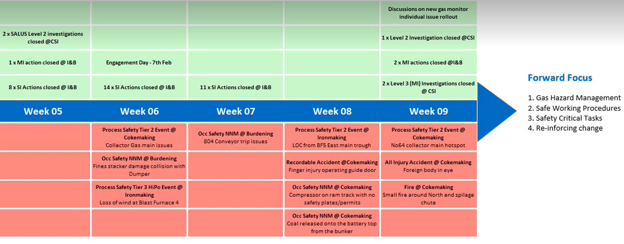
Appendix A: Safety Incidents TATA

Appendix B: Timing Plan
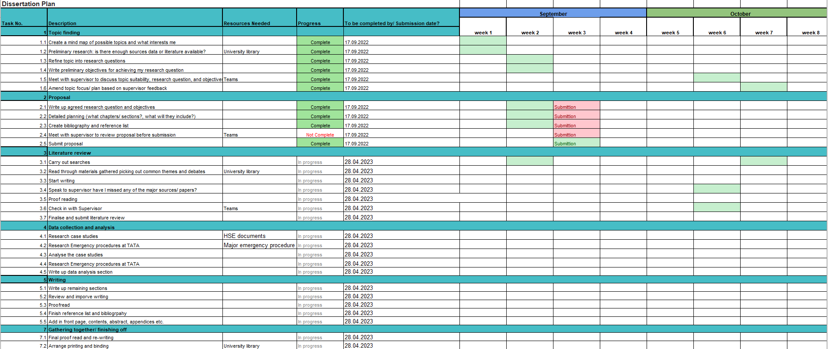

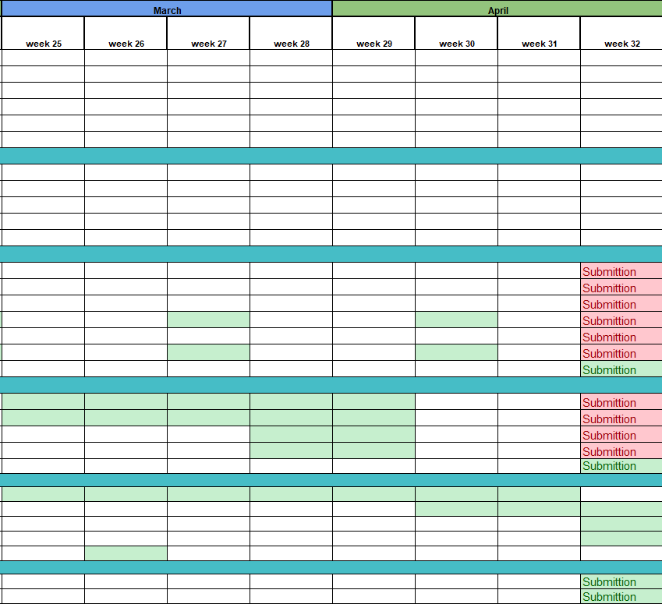
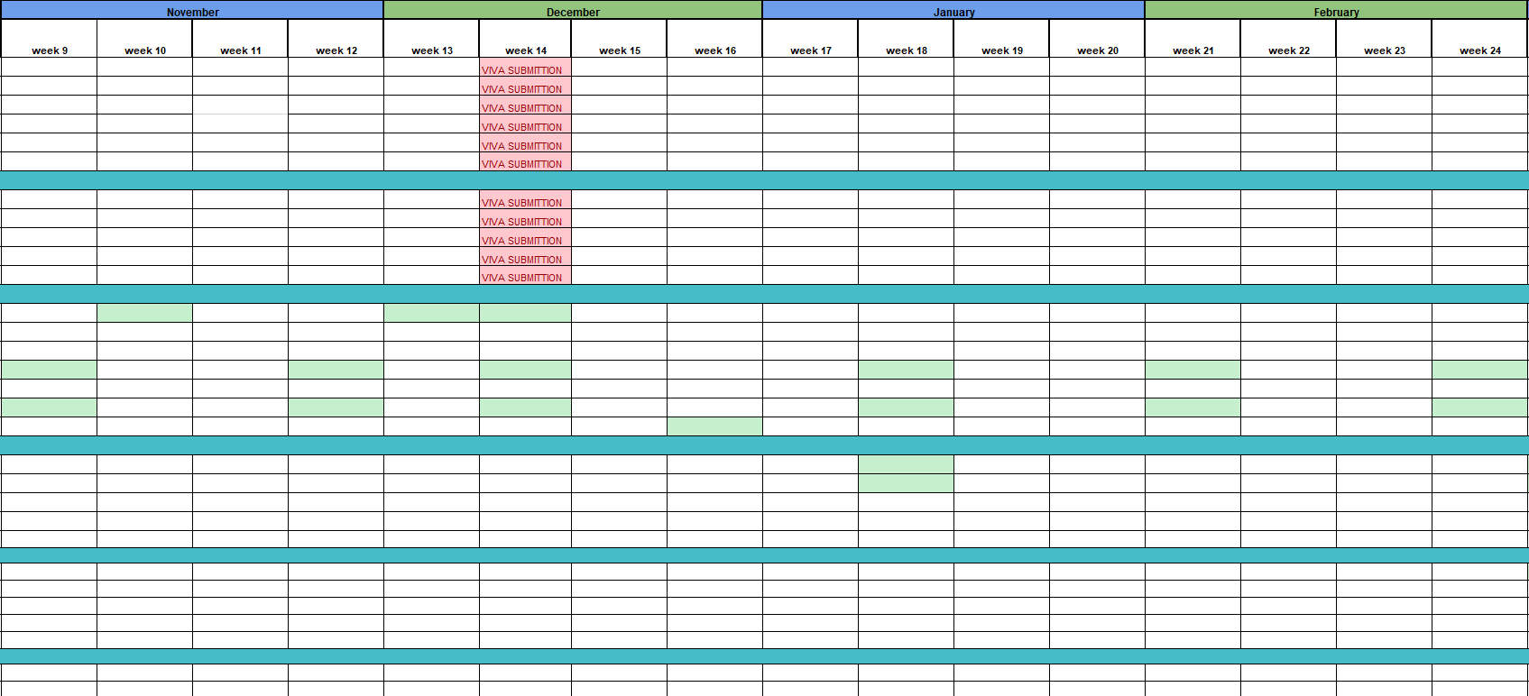

Appendix C:Emergency decision making process

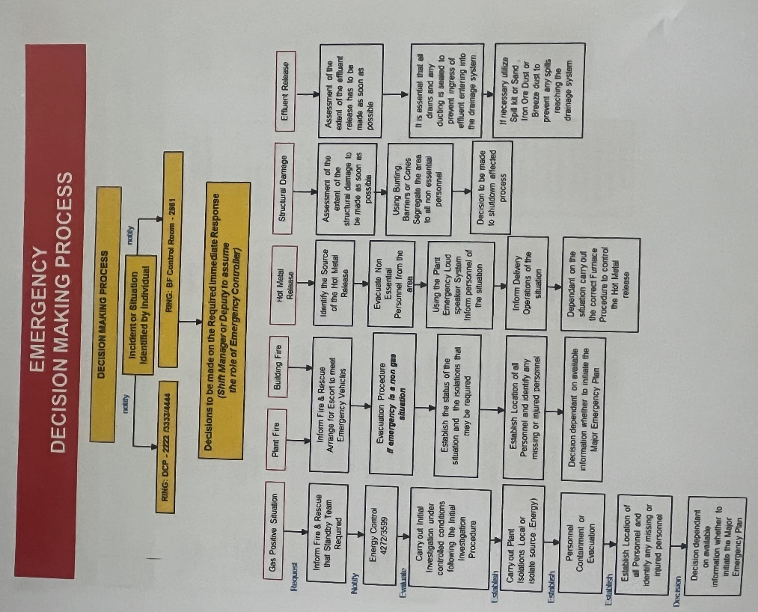

Appendix D:Emergency situation response

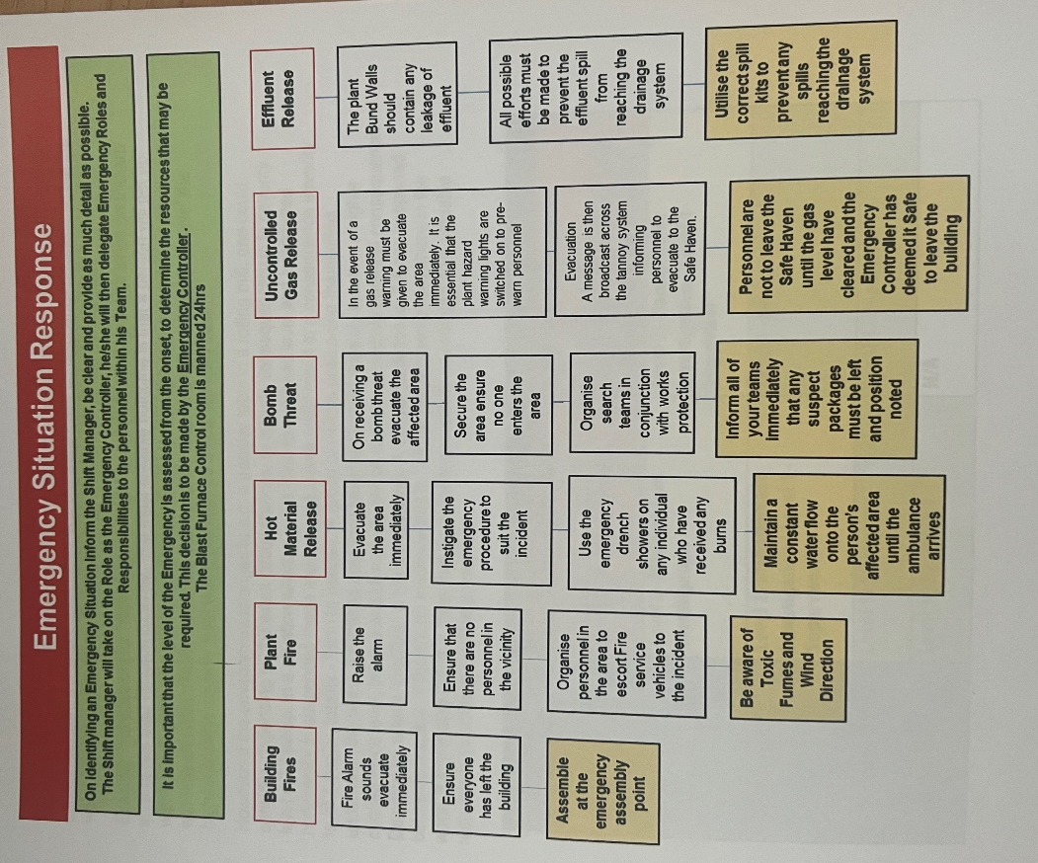

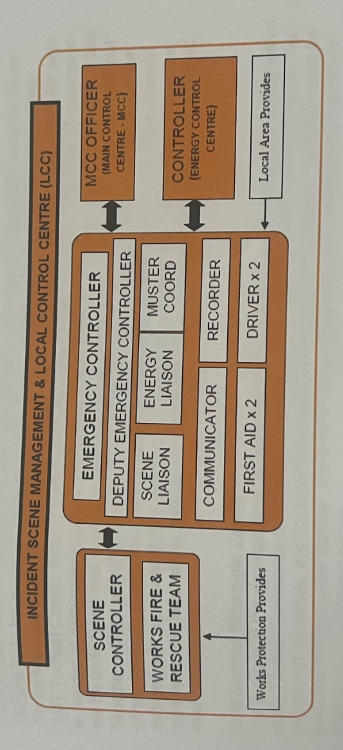
Appendix E: Levels of command

Appendix F: Coloured Fluorescent Jackets
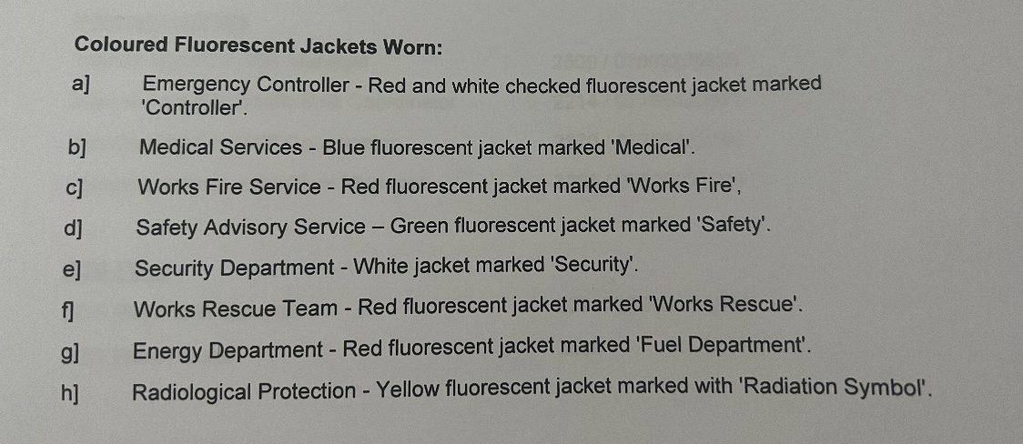

Appendix G: Methane mnemonic

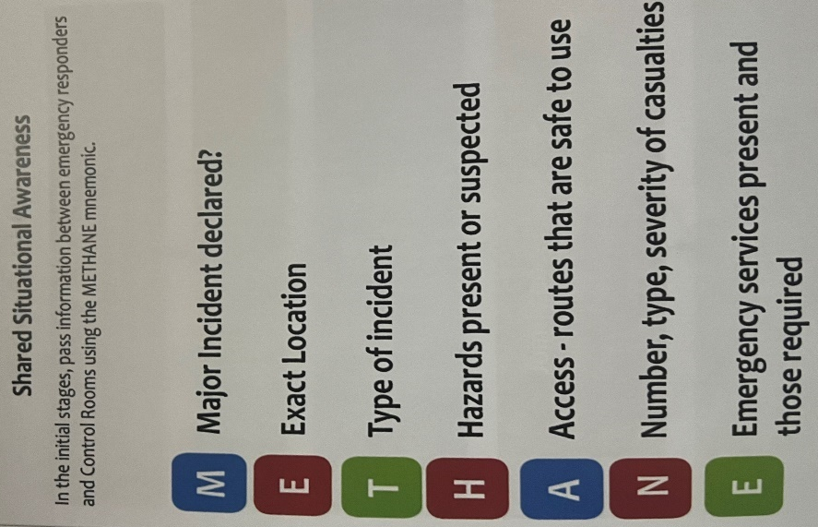

Appendix H: Training programme
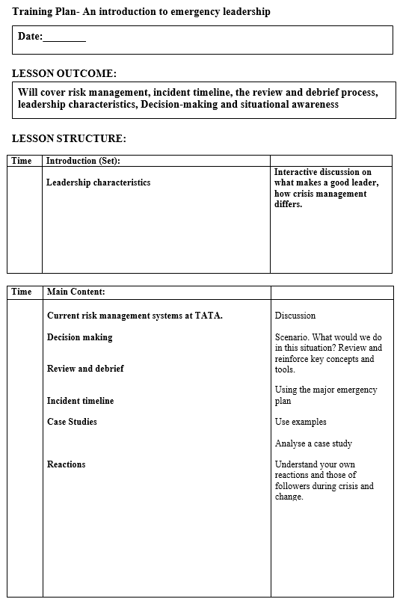

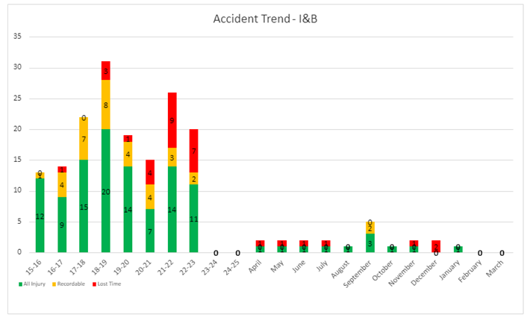
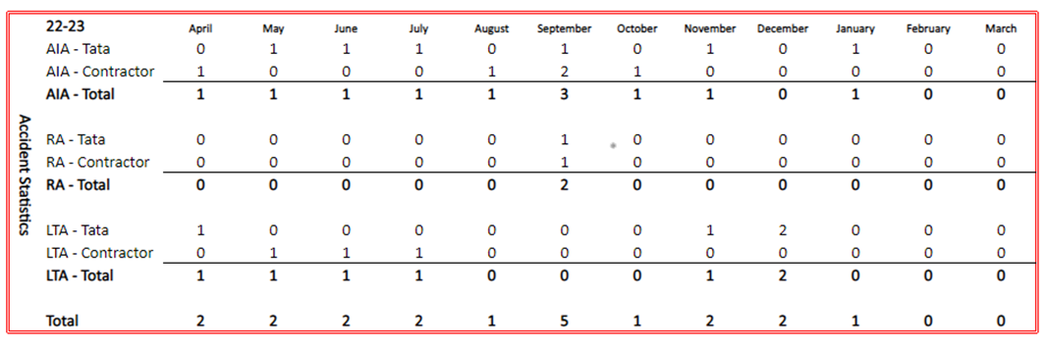
Appendix I- Accident Statistics

