Estimating Techniques in Building Estimation

Bethan Stroud
1702210

Dr Ndibarafina Tobin
Assignment 1
Contents Page
- – Introduction
  - – Aims
  - - Assumptions
- – NRM1
  - – BCIS
  - – Cost Estimate
- – Overheads
  - – Labour Costs
- – Data Sources
  - – Limitations to the Sources
- – Conclusion
- – References

- – Introduction
CALA homes, the client, requires a cost estimation for a proposed semi-detached dwelling. Mcleod + Aiken Cost Consultancy LTD has been appointed to carry out this estimation for the building to be constructed in Townhill, Swansea.
1.1 - Aims
The aims are to complete an accurate and reliable cost estimate for CALA homes, to give a true representation of the cost of construction, overheads and labour. As well as using the New Rule of Measurement 1 which “provides guidance on the quantification of building works for the purpose of preparing cost estimates and cost plans” (RICS, 2018).
1.2 – Assumptions
It is assumed that the GIA of the three bedroom, semi-detached dwelling is 1033sq.ft. Approximately 95m2. (This is according to David Wilson Homes’ average measurement for a semi-detached dwelling.)
It is also assumed that the ground floor will hold approximately 40% of the GIA, equating 38 m2, first floor to be 35% which will equate to 33.25 m2. Finally the second floor will be approximately 25%, equating to 23.75 m2. This has been represented in the cost estimate to assist calculating the substructure cost.
Another assumption is that the dwelling will be completed in 50 weeks. This will be from start to finish. The craftsmen included within the preliminaries will not be required on site for 50 weeks each during construction. They will be accounted for 6 months of the project, 24 weeks per person. The project manager will create a scheme of works for the duration of the project. These craftsmen will be onsite at differing times throughout the project e.g. carpenters, plumbers, electricians and decorators. It will also be assumed they will be hired as a sub-contracting business, meaning their businesses will account for employee national insurance, bonuses, tax and pension as they will not be directly employed. Each craftsman will also have a labourer or operative for assistance. This will be added to preliminary costs.

2.0 – NRM1
The New Rules of Measurement consists of three segments. NRM 1, NRM 2 and NRM 3. However, in this instance, NRM 1 will be applicable due to the nature of the other segments. NRM 1 enables “more effective and accurate cost advice to be given to clients and other project team members, as well as facilitating better cost control.” (RICS, 2018). NRM 1 is majorly guidance for formulating cost estimates and plans, as well as correctly measuring items and comparing historic cost data.
2.1 - BCIS
The Building Cost Information Service, is the supplier of cost and value data for the construction industry in the UK. It assists with benchmarking data, approximate build costs and allow a broader interpretation of the market. The BCIS can assist with this project to create an approximate build cost and cost per square metre, to complete the construction of the given semi-detached dwelling. It can provide the most up to date indices for predicted inflation and cost differences based on location.
2.2 – Cost Estimate
The cost estimate will provide an estimated cost based upon similar projects, of similar size, rebased to approximate costs in Wales and rebased to the year 2019.
The BCIS produces the cost estimate based upon building two semi-detached dwellings, resulting in the accurate build cost needing to be half of the BCIS cost to represent the single dwelling.
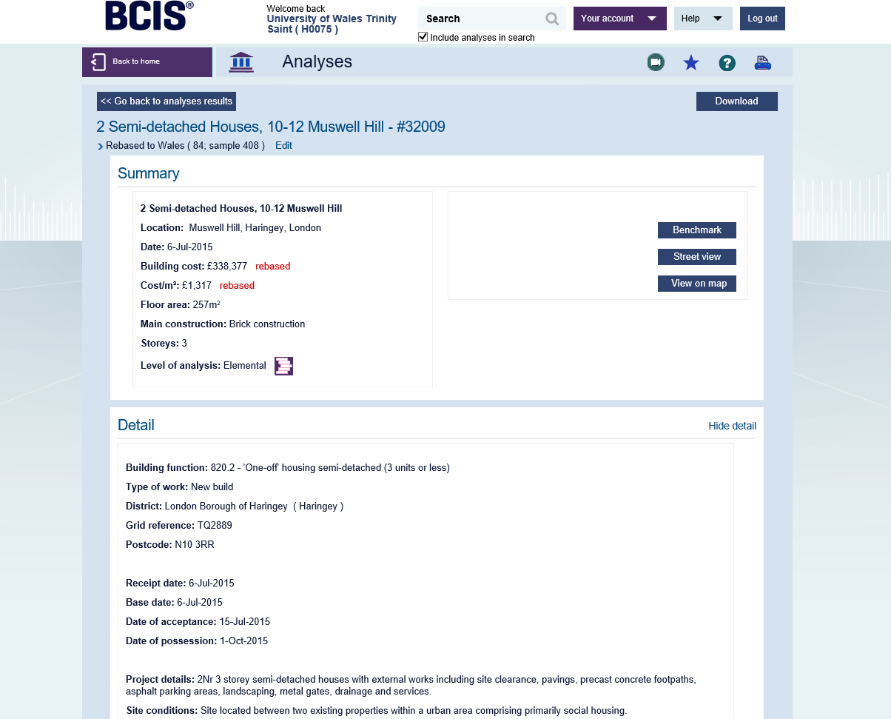

Due to the original dwelling being constructed in London, the BCIS has allowed the cost to be rebased to Wales for a more accurate figure. This is due to the location factor and price increase in London.

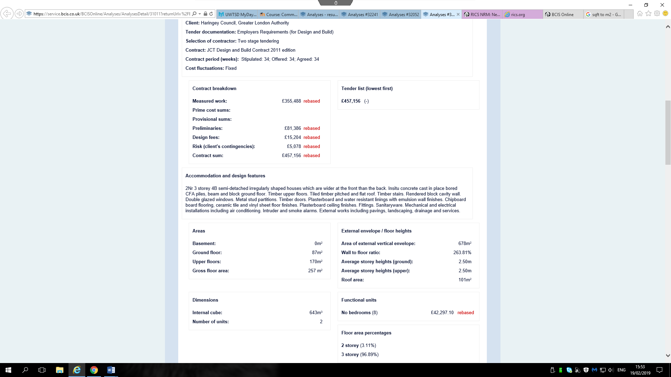
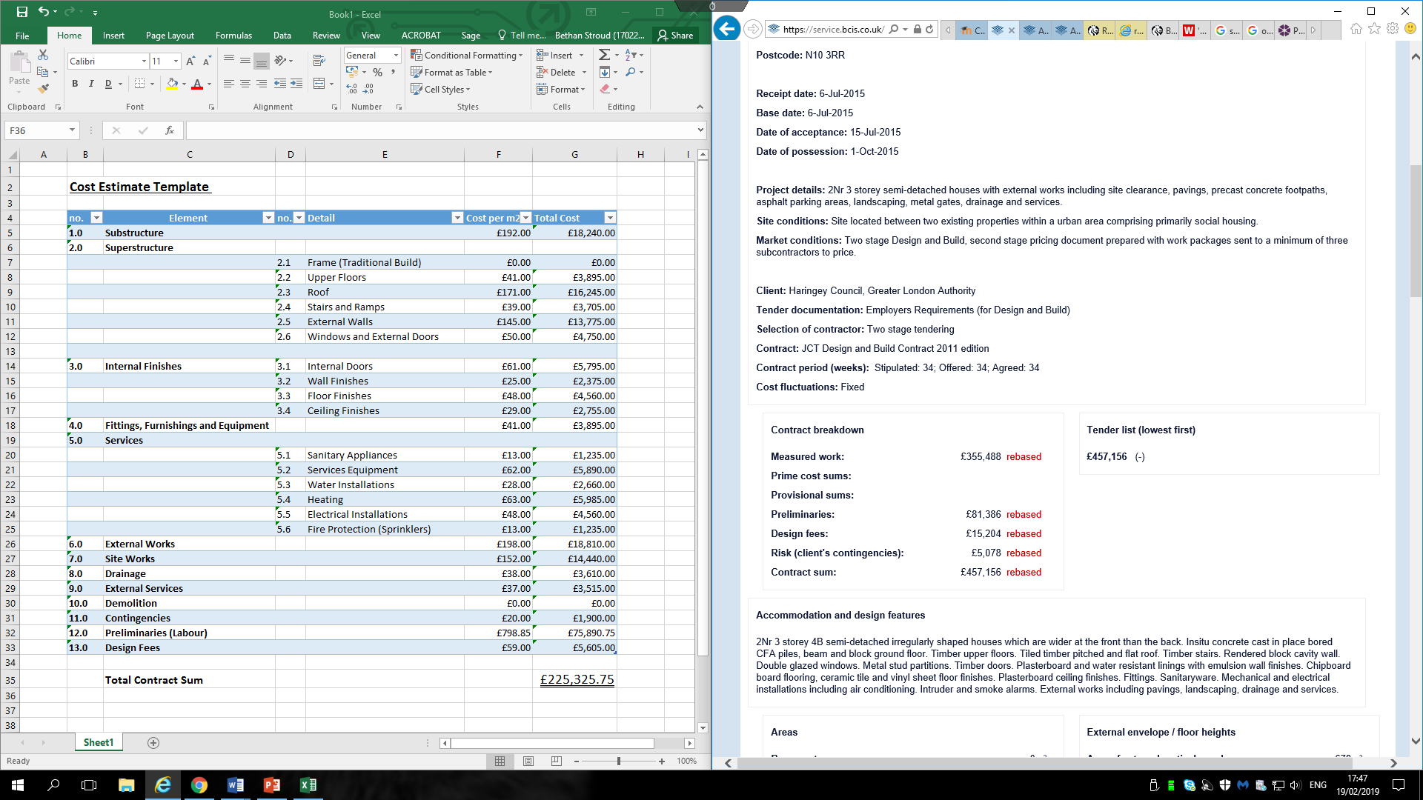
Based upon the RICS outlined cost estimate template, a relevant model has been created in relation to the needs of CALA Homes. Due to the works being for a small dwelling, many items such as ‘Lifts and Ramps’ and ‘Fuel Installations’ are not required. Fire Protection however is still needed. This is due to Wales’ law on all new homes having to contain sprinkler systems, costing around £1200.00 per dwelling (Wales Online, 2017). This will be included within the cost estimate.

3.0 – Overheads
During the construction process, CALA homes will be viable for paying overhead costs during the project. This will include items such as hoarding fencing, site compound costs, labour and plant hire. These items are also known as the preliminaries. It appears within the cost estimate as these items are essential to the works carried out. Within the contract, the preliminaries will be described and broken down in to itemised costs for the client to gain an understanding of all the extra costs involved with the project. “Preliminary and general information and information relating to the Works as a whole; items for the Contractor’s general costs; provisional sums and other items for work by others or subject to later instruction.” (NBS, 2019). Together they portray what is required to finish the works as per the contract.

3.1 – Labour Costs
With the average craftsman earning £12.44 per hour according to PayScale 2019, the approximate cost of four craftsmen can be estimated to add in to the contract preliminaries.
£12.44 x 39 hours per week = £485.16.
£485.16 x 24 weeks = £11,643.84.
£11,643.84 x 4 = £46,575.36.
The total figure of £46575.36 will be added to the preliminary costs in the contract. This will be added to an operative or labourer for each craftsman. They will be on minimum wage as they are usually young learning people, often a part of an apprenticeship.
£7.83 x 39 = £305.37.
£305.37 x 24 = £7,328.88.
£7,328.88 x 4 = £29,315.52.
Total labour costs will equate to £75,890.88 for labour.

4.0 – Data Sources
The data sources used to create this cost estimate and predicted preliminary costs are BCIS, RICS and PayScale. Data sources are important during the estimation phase, as they give indication of the figures which should be reached. They give costs for previous work and similar construction projects to compare possible quotes and comparing own estimation costs.
4.1 – Limitations
Limitations of the BCIS are that indices may be incorrect for dates and locations. This can have a massive impact on predicted costs due to the large cost difference between e.g. Swansea and London. Costs in London will be extremely higher than those in Swansea due to salary rates and price of materials/suppliers.
Another limitation of the BCIS is that they may not have a similar project to compare to. Not all projects are uploaded on to the BCIS to view, resulting in the inability to compare to other projects within interest.
Although this data is available to compare and view, this data may not be accurate and correct. The surveyor on the project may have not disclosed extra variations or costs which were unforeseen. It will also not disclose if it was a successful project, or staying within any given budgets.

5.0 – Conclusion
To conclude, CALA homes’ approximate estimate to build the semi-detached dwelling is £225,325.75. If they were to build this, consisting of the two dwellings to sell, the cost would be approximately £450,651.50. With all assumptions included it is predicted that this will be an accurate price in line with the BCIS index, as well as comparing to other projects rebased to Wales.
6.0 - References
- RICS, 2018. www.rics.org/uk/upholding-professional-standards/sector-standards/construction/rics-nrm-new-rules-of-measurement/ (Last Visited 01/02/19).
- David Wilson Homes, 2019. www.dwh.co.uk/library/Average-UK-house-sizes/ (Last Visited 01/02/19).
- Ruth Mosalski, Wales Online, 2017. www.walesonline.co.uk/news/wales-news/thousands-new-homes-wont-sprinklers-13684910 (Last Visited 01/02/19).
- NBS, 2019. www.thenbs.com/our-tools/preliminaries-and-general-conditions (Last Visited 02/02/19).
- PayScale, 2019. www.payscale.com/research/UK/Job=Carpenter/Hourly_Rate (Last Visited 02/02/19).

