

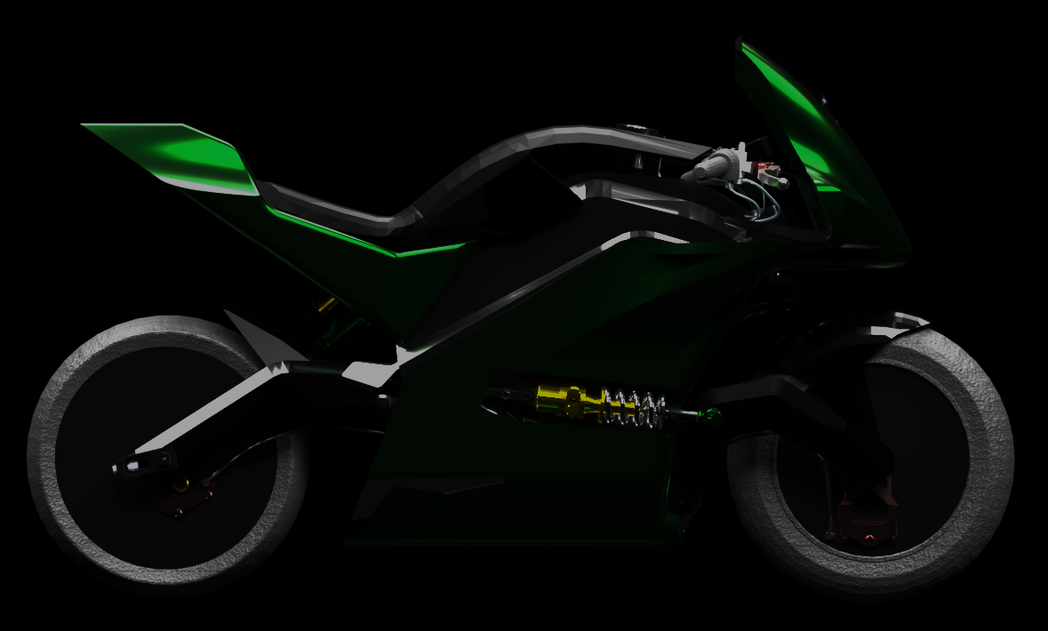
VEHICLE
THROTTLE. BRAKE. LEAN. APEX.

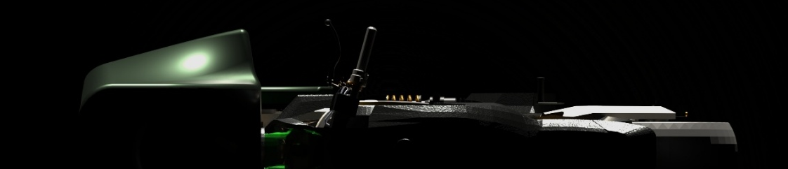
VEHICLE
CHARGING. RE-ENERGISED.
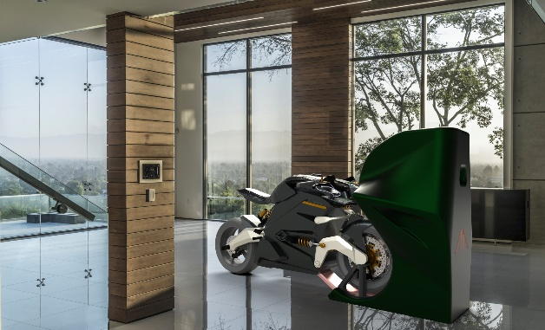
Some find their companion at the end of the aisle.
Others find it in the garage.
Taking centre stage when no one else will, the ARC COMPANION is all you need. the easiest way to charge your most prized possesion and store the essentials for the life you live for. theres more to arc.
THE ARC VECTOR SYNERGY COMPANION

VEHICLE
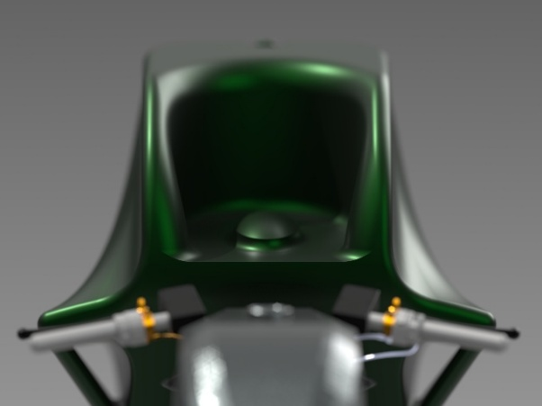
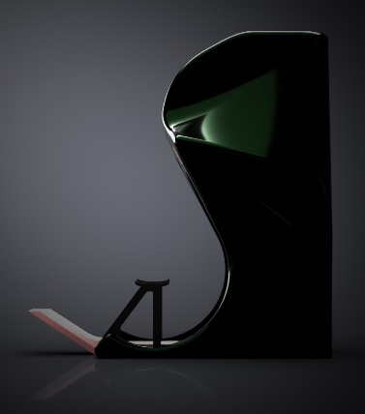
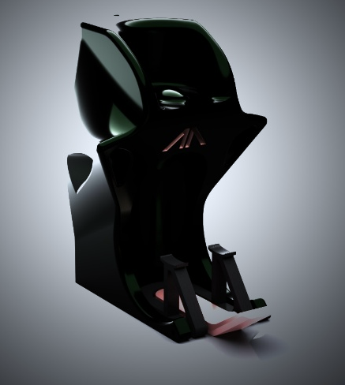
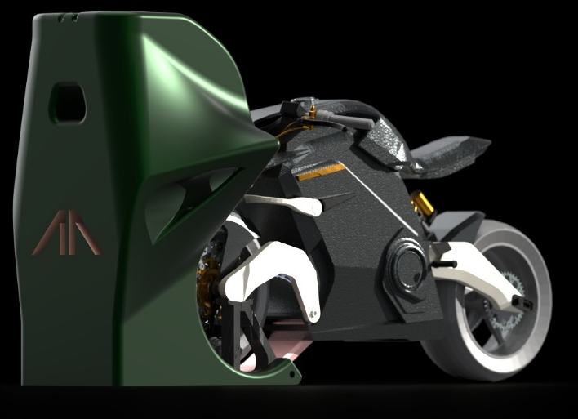
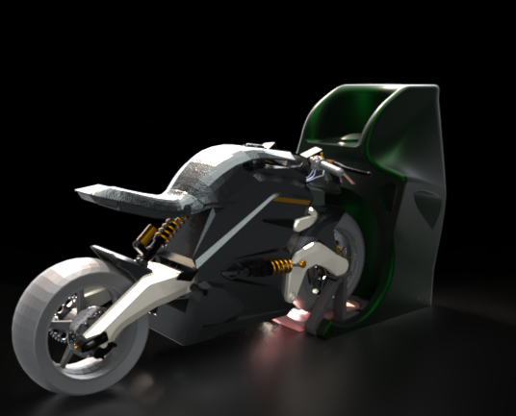
Seamless charging
helmet DOCK
jacket hanger
glove compartment
Everything you need in one place for the live you live on two wheels. Hassle free charging, never forget your essentials, always ready to go.
VECTOR CHARGING RECEPTICLE
SYNERGY CHARGER
What does it mean to own an ARC VECTOR ?
The ARC Vector embodies INNOVATIVE DESIGN AND FUTURISTIC VISIONS TO ENCAPSULATE WHAT IT MEANS TO motorcycle rider.
WHEN GOING FROM A TO B IS SIMPLY NOT ENOUGH, THE SYNERGY COMPANION IS THE ADDITION TO YOUR MOTORCYCLING EXPERIENCE THAT YOU didn’t KNOW YOU WERE MISSING.
when you can no longer hold on, and your arms need a REST, THE SYNERGY COMPANION WILL HOLD THE VECTOR – giving you both time to recharge.
AND INNOVATION
BLUE SKY THINKING

