

University of Wales Trinity Saint David
UWTSD

BEng Energy and Environmental Engineering

Oliver R D Turner
1805585

Environmental Engineering and Sustainable Energy
Plant and Asset Engineering
ACMA6007

January 2024

Contents
Intro 4
What are Heat Exchangers? 4
Introduction to Shell and Tube Heat Exchangers 5
How do STHXs work? 6
Fouling 8
Introduction to Fouling 8
Maintenance 9
Proactive 9
Reactive 9
The Threshold Fouling Model 10
Ebert and Panchal 10
The Helical-Baffle idea 12
Summary 14
References 15

Figure 1: Heat Exchanger Flow Configurations (Thomas, 2023) 3
Figure 2: Fixed-tubesheet Heat Exchanger (Mukherjee, 1998) 4
Figure 3: U-Tube Heat Exchanger (Mukherjee, 1998) 4
Figure 4: Simplified STHX diagram showing flow. (The Engineering Mindset, 2023) 5
Figure 5: CFD temperature analysis of primary flow configurations (Dwivedi et al., 2018) 6
Figure 6: Direct comparison of Parallel and Counterflow Efficiency (Zohuri, 2017) 6
Figure 7: STHX with fouling. (Ward Vessel and Exchanger Corp, 2020) 7
Figure 8: Worker Mechanically cleaning a STHX. (Ward Vessel and Exchanger Corp, 2020) 8
Figure 9: Timeline of Chemical Reaction Fouling Studies. (Wilson et al, 2017) 9
Figure 10: Ebert and Panchal's Equation for Threshold Fouling. (Wilson et al, 2017) as proposed by (Ebert and Panchal, 1995) 9
Figure 11: The Ebert-Panchal model (Figure 10) as fitted to the work of Scarborough et al, 1979 (Wilson et al, 2017), as proposed by (Ebert and Panchal, 1995) 10
Figure 12: US Patent picture for Helical Baffle Geometry (ABB Lummus Global, Inc., 2004) 11
Figure 13: Baffle designs for CFD Flow Testing comparison (Bichkar, 2018) 12
Figure 14: Fluid Path generated by ANSYS Fluid Modelling (Bichkar, 2018) 12

Intro

What are Heat Exchangers?
Heat exchangers are devices in which the heat in one fluid or gas flows onto another fluid or gas with the intention of heating or cooling either one or both of said liquids/ gases (Dogra and Chauhan, 2019; Kreith et al., 2011). There are exceptions in which more than two liquids or gases are present, these shall not however be addressed within this document. The applications vary on sector and there are many different types of heat exchanger depending on the system requirements. Heat Exchangers are used in many different industries from small scale applications such as refrigerators and car engine cooling to heavy industry applications such as gas and oil production.
Sometimes it is possible for devices to act as Heat Exchangers, even-though this is not their intended primary function. For the sake of this paper, it shall be assumed that Heat Exchangers are intentional Heat-Transfer devices.
Refer to Figure 1 for a simplified example of how heat exchangers work. This visualises the four different flow scenarios that are used for heat exchangers and demonstrates how the heat is transferred from one medium to another. These flow scenarios will be visited in more detail in the following chapters, along with their individual positive and negative traits. The Fluids never come into physical contact with one-another as they are separated by a Conductive material.

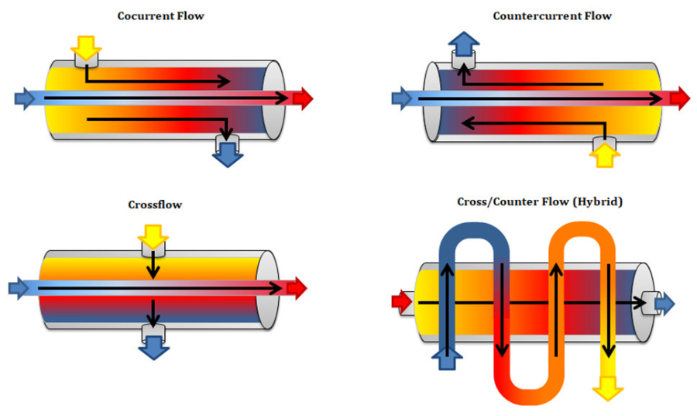
Figure 1: Heat Exchanger Flow Configurations
(Thomas, 2023)

Introduction to Shell and Tube Heat Exchangers
Although many heat exchangers are used in consumer goods, they are crucial to heavy industries such as Energy production, Petrochemical operations and the food and beverage industry. For these heavy industry applications, the most prevalent type of heat exchanger is the Shell-and Tube Heat exchanger (STHX) (Mukherjee, 1998). Due to their cheap construction, high efficiency and adaptability, it is thought that approximately 35% - 40% of all Heat Exchangers are of the Shell and Tube classification. (Ji et al., 2011; Master et al., 2003; Wang et al, 2010). There are several different classifications of shell and tube heat exchanger depending on its application. Mukherjee and Thomas define the Components and primary Applications of a STHX to be as following:

Components
- Shell Channel
- Channel Cover
- Tubesheet
- Baffles
- Nozzles
- Tubes
- Shell Cover

Applications
- Oil Refining
- Preheating
- Oil Cooling
- Steam Generation
- Boiler Blowdown Heat Recovery
- Vapor Recovery Systems
- Industrial Paint systems

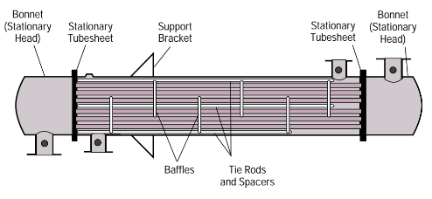
It is important to note that not all STHXs always use all of the above Components. Below are two examples of different configurations of STHX. Information is provided in reference to the work of Mukherjee.
Figure 2: Fixed-tubesheet Heat Exchanger
(Mukherjee, 1998)
Fixed-tubesheet heat exchangers have the advantage of being cheap to produce. They are a simple, one-pass design, this causes them to be less efficient than more complicated versions of STHXs, however the advantage of simplicity also extends into their ease of cleaning. 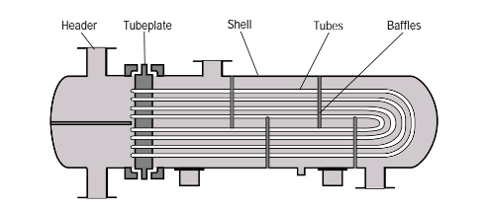
Figure 3: U-Tube Heat Exchanger
(Mukherjee, 1998)
U-Tube heat exchangers operate with one header, forming a double pass of the shell. This effectively doubles the length of the tubes. This does however cause the fluid to flow in a hybrid flow scenario, as it changes direction halfway through the pass.

How do STHXs work?
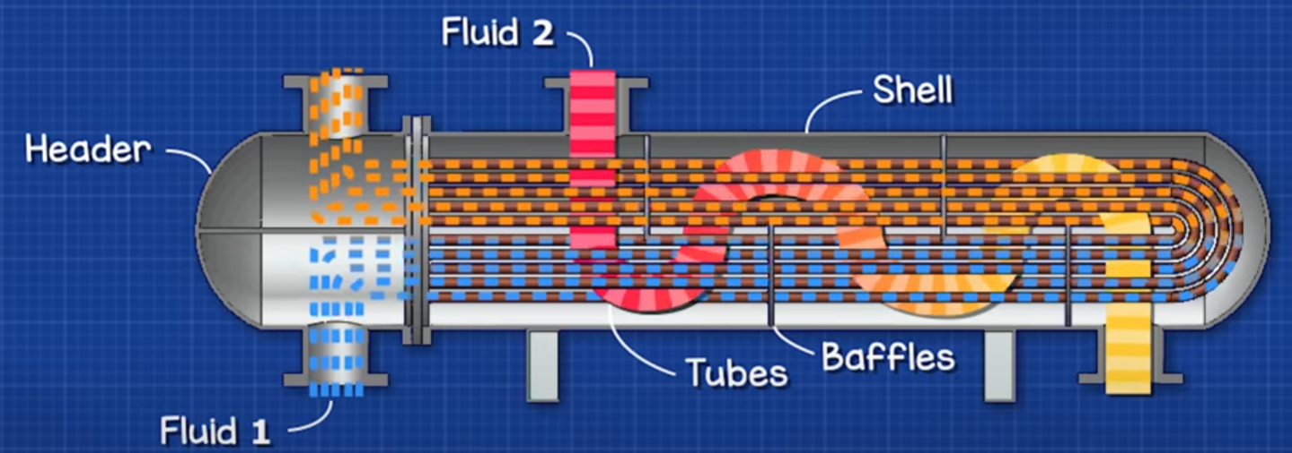
Figure 4: Simplified STHX diagram showing flow.
(The Engineering Mindset, 2023)
Figure 4 shows a simple case of a STHX in operation, please note that Fluid 2 flows freely within the shell, and not in a cylindrical form such as in the diagram. In this case, Fluid 1 enters the STHX on the bottom of the Header and exits on the top of the Header. Fluid 2 enters the top of the shell and exits on the bottom of the shell. Fluid 2 Inlet is the hottest point of the heat exchanger and Fluid 1 Inlet is the coldest. Due to the U-bend, this example of a Heat Exchanger is dual pass, as Fluid 1 flows within the multitude of tubes (the Tube Stack) through the shell twice (Once to the right, and then to the left). Fluid 1 flows from the inlet to the outlet, first in parallel-flow (in relation to fluid 2), and after the U bend, in counter-flow, hence it is said to be in hybrid flow (See figure 1). As Fluid 1 reaches the Header outlet, it has gained heat energy from Fluid 2. Fluid 2 loses the same amount of energy by the time it reaches the Shell outlet, assuming ideal conditions. If not for the Baffles, Fluid 2 would flow straight from the Shell Inlet to the Shell outlet. Instead, Fluid 2 must path around the Baffles, increasing the contact time with the Tubes. The Baffles also create turbulence, which increases Heat Transfer efficiency. This design is known as Segmented Baffle Geometry, see page 7 for further discussion on the advantages and disadvantages.
Modern Heat Exchangers are designed using Computer-Aided Engineering (CAE). It is however possible to calculate the basic functionality characteristics of a heat exchanger with some simple core equations. According to (Abdelhamid et al., 2022; Bhatt et al., 2014), the general equation for the rate of Heat Transfer in a Heat Exchanger is as follows.
This equation describes the Heat Transfer rate.
Due to the changing rate of temperature, this equation can only be used to calculate the heat transfer rate at a singular point within the system.
ΔT can be substituted with ΔT_{LMTD} to work out the heat transfer for the system as a whole.

Q̇ = U . A . ΔT

Where:
Q̇ = Heat Transfer Rate (J/s or W)
U = Overall heat transfer coefficient
A = Heat Transfer Area (m²)
ΔT = Temperature Differential (C or K)
For the system, ΔT_{LMTD} (Log mean Temperature Difference) describes the average Temperature Differential across the system, substituting this produces the following equation.
Q̇ = U . A . $\dot{ \frac{{(t}_{h1}- t_{c1})-{(t}_{h2}- t_{c2})}{LN(\frac{{(t}_{h1}- t_{c1})}{{(t}_{h2}- t_{c2})})} }$
Where:
t_{h1} = Hot Fluid inlet t_{h2} = Hot Fluid outlet t_{c1} = Cold Fluid inlet t_{c2} = Cold Fluid outlet
LN = Log Natural
The flow direction has a strong effect on the efficiency of the Heat Exchanger as shown in the following graphs.
For the comments, assume the Shell Fluid (Th) is heating the Tube Fluid (Tc). (Dwivedi et al., 2018; Mukherjee, 1998, pp 14-15)
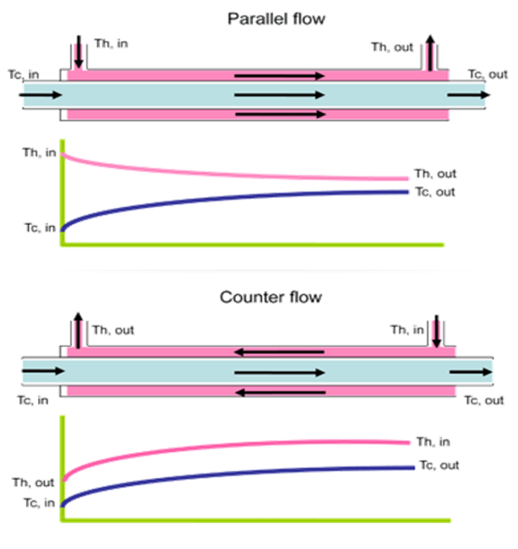
In Counter flow, the hottest part of the Shell Fluid heats the hottest part of the Tube Fluid meaning the temperature can theoretically increase to, or close to the maximum temperature of the Shell Fluid.
This also results in a higher overall efficiency due to the temperature differential remaining greater on average through the course of the Heat Exchanger.
In Parallel flow, the Shell liquid is being cooled at the same rate as the Tube liquid is being heated. This means that the temperature differential reduces over the length of the Heat Exchanger resulting in less overall heat transfer and therefore, reduced efficiency.
This also means that in a Parallel Heat Exchanger even of unlimited length, the tube side Fluid can never reach the maximum temperature of the shell side Fluid.
Figure 5: CFD temperature analysis of primary flow configurations
(Dwivedi et al., 2018)

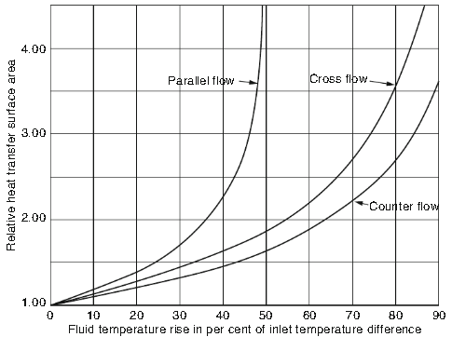
Figure 6: Direct comparison of Parallel and Counterflow Efficiency
(Zohuri, 2017)

Fouling

Introduction to Fouling
Segmented Baffle Geometry has been shown to increase the overall efficiency of STHXs; it does however, come with its own flaws. One of these issues is an increased rate of Fouling. Fouling can act on both the Tube Stack and the Shell. The stagnation effect from the Segmentation Baffle Geometry exacerbates this effect on the Shell side. (Dey et al., 2018) states that Fouling is the accumulation of unwanted deposits on Heat Transfer Surfaces. They state six classifications of fouling, as follows:
- Crystallization
  - The deposition of dissolved salts crystallizing onto the Heat Transfer surfaces. Commonly known as ‘Scaling’.
- Particulate
  - Solid particles transferring from the Fluid to the Heat Transfer Surface.
- Biological
  - Accumulation of living Macro or Micro Organisms, such as algae, bacteria, fungi, yeasts or even small animals.
- Chemical Reaction
  - Chemical reaction either of the Fluid or the process upstream can leave chemical deposits on the Heat Transfer Surface.
- Corrosion Fouling
  - Usually the reaction of the Fluid (or possibly Gas) and the Heat Transfer Material itself. For example, Rusting of the Tube Stack.
- Freezing Fouling
  - In cooling applications, the Fluid can freeze onto the Heat Transfer material.
Depending on the classification or combination of classifications of fouling, it is possible to estimate the influence that fouling will have on the STHX. As (Dey et al., 2018) states, however, there is no single model that can accurately predict the combinations of fouling mechanisms, although CFD prediction continues to model the mechanisms increasingly closely.
On a base level, fouling in a Heat Exchanger is expressed as R_{f} or Fouling Resistance. This correlates to the reduced Heat Transfer. Fouling also reduces the flow velocity within the Heat Exchanger due to its increased resistance to flow and reduces the overall internal area of the Heat Exchanger. The additional resistance causes a pressure drop which negatively affects flow velocity, overall efficiency and energy consumption, whilst also leading to further fouling.
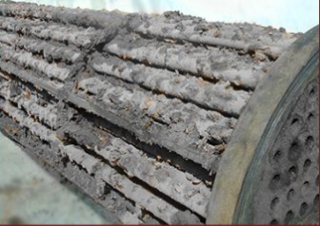
Figure 7: STHX with fouling.
(Ward Vessel and Exchanger Corp, 2020)

Maintenance
STHXs reach a point where they must be cleaned. This can either be by reactive or proactive means. Proactive methods are preferrable as they do not usually result in stoppage of the machinery.
Proactive
These include smart design, in which STHXs are designed not to build up Fouling factors (See page 11-12). They can also include additives in the Fluids which either reduce the formation of Fouling or Remove Fouling that has already formed.

Reactive
Reactive methods generally involve stoppage leading to downtime and are less desirable. These measures generally involve Mechanical cleaning processes such as Jet Washing (either by personnel or robots)(see Figure 8) or Ultrasound cleaning. This can also involve chemical cleaning of the equipment.

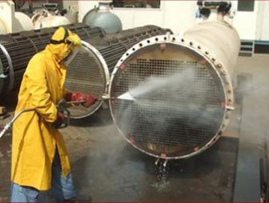
Figure 8: Worker Mechanically cleaning a STHX.
(Ward Vessel and Exchanger Corp, 2020)

The Threshold Fouling Model

Ebert and Panchal
In the petrochemical industry, Chemical Fouling is a particular issue due to the nature of the Fluids involved. Crude oil is particularly susceptible to cause several classifications of Fouling causing downtime and significant revenue loss (Watkinson et al, 1997). In this multi-billion-dollar industry, Ebert and Panchal saw an opportunity to improve the efficiency of this machinery in order to reduce these costs and downtime. Building on the work of Scarborough et al, 1979 (See figure 9), Ebert and Panchal developed the Threshold Fouling Model which would revolutionise the field.
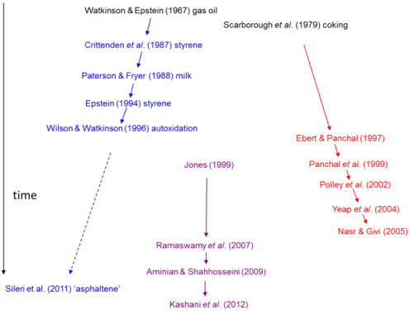
Top (Black), Crude Oil Testing
Left (Blue), Deterministic Models.
Right (Red), Threshold Models
Centre (Purple), Artificial Neural Network Approaches
Figure 9: Timeline of Chemical Reaction Fouling Studies.
(Wilson et al, 2017)
Due to the complexity of working with Crude oils, Deterministic testing all but died out to be replaced by Ebert and Panchal’s Threshold Fouling Model.
The basic premise of the model is that the derivative of the fouling rate can be defined as the deposition (formation of Fouling Factors) rate minus the suppression (Removal or Mitigation of Fouling Factors) rate; giving the following equation:
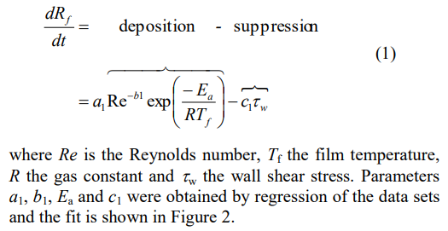
Figure 10: Ebert and Panchal's Equation for Threshold Fouling.
(Wilson et al, 2017) as proposed by (Ebert and Panchal, 1995)

By incorporating the Reynolds number of the fluid to encompass Laminar and non-Laminar flow, the model can more accurately predict the build up and removal of Fouling Contaminants. In Figure 11, the effect of Film Temperature on the Fouling Rate can clearly be observed, in the proof-of-concept model that Ebert and Panchal adapted to the data gathered by Scarborough et al’s work from 1979.
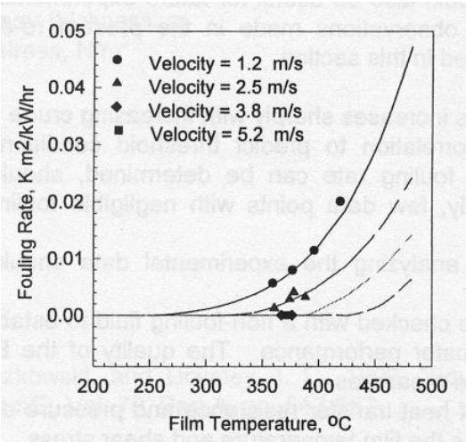
Figure 11: The Ebert-Panchal model (Figure 10) as fitted to the work of Scarborough et al, 1979
(Wilson et al, 2017), as proposed by (Ebert and Panchal, 1995)
From this example, it is clear that while Fouling rate is dependant on the Film Temperature and the Velicity, there is a point below which that Fouling is negligible, as shown by the horizontal line from 0,0 along the X axis to approximately 265C. This is the point now know as the Fouling Threshold.
With a clear new model showing that a) Fouling Rates Increase with temperature and b) Fouling Rates Decreased with increasing velocity (Gautam et al, 2017), new Segmented Baffle Geometry design has been made possible when designing with an emphasis on Fouling Deposition reduction and Suppression improvement.
Referring once again to Figure 9, the continued research building on the Ebert-Panchal model is clearly visualised.
The Helical-Baffle Theory
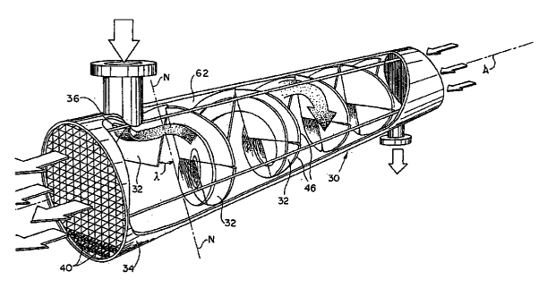
Figure 12: US Patent picture for Helical Baffle Geometry
(ABB Lummus Global, Inc., 2004)
Segmented Baffle Geometry has inherent flaws including Large Back Mixing, High Fouling Rates, High Leakage Flow and Large Cross Flow (Ji et al, 2011). These flaws lead to a high degree of Pressure Drop, where the flow pressure is lost due to preliminarily Shell Side Resistance. This means higher pumping power is required, which uses more energy to do the same work, as well as increasing Fowling rates as the Fluid velocity is reduced.
Ji refers to the work of Lutcha and Nemansky in 1990, which first establishes the idea of Helical Baffle Geometry (figure 12); stating that this new Theory of Baffle Geometry increased Heat-Transfer-Rate-compared-to-pressure-Drop ratio, reduced Bypass Effects, and drastically reduced Flow-Induced Vibration. This is attributed to two factors:
- “Near-Plug Flow”, where the shell fluid flows linearly in an idealized pattern of near uniform velocity.
- “Rotational Flow induced by helical baffles creates a vortex which interacts with the boundary layer on the tube surface and favourably affects the heat transfer coefficient.”
The work of Wang et al in 2010 supports these findings.
This led to 2004, when ABB Lummus Global invented and patented the Helical Baffle Geometry Heat Exchanger (Helixchanger) quoting:
“ (1) improved shellside heat transfer rates/pressure drop ratio; (2) reduced bypass effects; (3) reduced shell-side fouling; (4) prevention of flow-induced vibration; and (5) reduced maintenance.”
(Wang et al, 2010)
In 2003, Master et al used the Threshold fouling model to compare Segmented Baffle Geometry to Helical Baffle geometry when processing crude oil. Master found that the Helixchanger had a 50% higher duty rate than the traditional Segmented Baffle Geometry Design. This was attributed to significant reduction in fouling resistance. In one case from 2002, a Helixchanger “showed little fouling on the heat transfer surface”, suggesting that Helical Baffle Geometry can produce a design capable of operating below the Fouling Threshold.

With the Inception of Computational Fluid Dynamics (CFD), it has been possible to incorporate Helical Baffle Design into the Threshold Fouling model using Flow Modelling software such as ANSYS. It has been possible to further refine the design process, as shown by the work of Bichkar in 2018.
By running CFD on three different Baffle designs, the software shows without doubt that the Helical Baffle Geometry produces better mixing and less stagnation within the Shell of a Heat Exchanger.
- Segmented Baffles (B) Double segmental Baffles (C) Helical Baffles
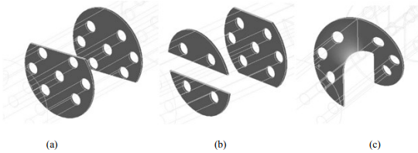
Figure 13: Baffle designs for CFD Flow Testing comparison
(Bichkar, 2018)

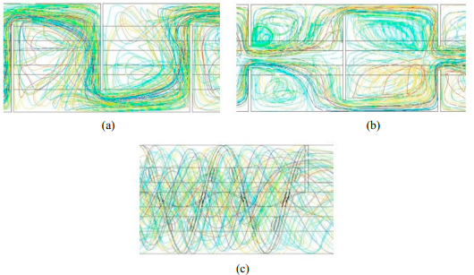
Figure 14: Fluid Path generated by ANSYS Fluid Modelling
(Bichkar, 2018)
The study concluded that Pressure Drop across the Shell was reduced significantly.

Summary
In summary, the development of Helical Baffle Geometry with regards to Ebert and Panchal’s Threshold Fouling Methodology allows for the design of a heat exchanger which can continue to operate either close to, or below the Threshold for Fouling; reducing downtime and maintenance needs, increasing Efficiency, and therefore reducing operating costs.

References

ABB Lummus Global, Inc. (2004). Helical Baffle Geometry Heat Exchanger. US6827138B1. United States Patent and Trademark Office.
Abdelhamid, H.R.M., Bakry, A.I., & Mohamad, H.A.E., 2022. A Review on Comparative Performance of Shell-and-tube Heat Exchangers with Various Design Configurations. Journal of Engineering Research (ERJ), 6(3), p.159.
Bhatt, D., & Javhar, P. M. (2014). Shell and Tube Heat Exchanger Performance Analysis. International Journal of Science and Research (IJSR), 3(9), pp. 1874 - 1876.
Bichkar, P., Dandgaval, O., Dalvi, P., Godase, R., & Dey, T. (2018). Study of Shell and Tube Heat Exchanger with the Effect of Types of Baffles. Procedia Manufacturing.
Dey, A. K., Das, P. S., Pradhan, S. R., & Sahu, G. (2018). Investigation of Fouling and its Impact in Heat Exchangers. J. Mech. Cont. & Math. Sci., 13(4), pp. 100-111.
Dogra, S. and Chauhan, N., 2019. A Review on Different Types of Heat Exchangers. Journal of Emerging Technologies and Innovative Research, 6(3), p.623.
Dwivedi, H., Goswami, H., Singh, D., & Singh, S. P. (2018). CFD Analysis of Fluid Flow in a Heat Exchanger Using ANSYS Software. NIET Journal of Engineering & Technology.
Ebert, W. and Panchal, C. B., 1995. Analysis of Exxon Crude-Oil-Slip Stream Coking Data. Chevron Research and Technology Company, Richmond.
The Engineering Mindset. (2023). Shell and Tube Heat Exchanger Basics Explained: STHX Flow Diagram. [Screenshot]. Available at: https://www.youtube.com/watch?v=8rGLrhVeZvw.
Gautam, R. K., Parmar, N. S., & Vyas, B. G. (2017). "Effect of fouling on thermal and hydraulic parameters of Shell and Tube Heat Exchanger.".
Ji, S., Du, W.-j., Wang, P., & Cheng, L. (2011). Numerical Investigation on Double Shell-Pass Shell-and-Tube Heat Exchanger with Continuous Helical Baffles. Shandong University.
Kreith, F., Manglik, R. M., Bohn, M. S., & Tiwari, S. (2011). Principles of Heat Transfer (7th ed., SI ed.). Cengage Learning.
Lutcha, J., & Nemcansky, J. (1990). Performance improvement of tubular heat exchangers by helical baffles. Chemical Engineering Research and Design, 68(3), 263–270. (as cited in Ji, S., Du, W.-j., Wang, P., & Cheng, L., 2011)
Master, B. I., Chunangad, K. S., & Pushpanathan, V. (2003). Fouling Mitigation Using Helixchanger Heat Exchangers. In Heat Exchanger Fouling and Cleaning: Fundamentals and Applications. Engineering Conferences International.
Mukherjee, R., 1998. Effectively Design Shell-and-Tube Heat Exchangers. Chemical Engineering Progress, February. Copyright 1997 American Institute of Chemical Engineers.
Scarborough, C. E., Cherrington, D. C., Diener, R., & Golan, L. P. (1979). Coking of crude oil at high heat flux. Chemical Engineering Progress (CEP), 75(7), 41-46.
Thomas 2023, 'Understanding Heat Exchangers', Thomas, 6 March, Available at: https://www.thomasnet.com/articles/process-equipment/understanding-heat-exchangers/ (Accessed: 31 January 2024).
Wang, Q., Chen, G., Chen, Q., & Zeng, M. (2010). Review of Improvements on Shell-and-Tube Heat Exchangers With Helical Baffles. Heat Transfer Engineering, 31(10), 836-853.
Ward Vessel and Exchanger Corp. (2020). Top Seven Shell and Tube Heat Exchanger Failure Mechanisms (#2 – Fouling). [Screenshot]. Retrieved from https://wardvesselandexchanger.com/2-fouling-top-seven-shell-and-tube-heat-exchanger-failure-mechanisms/.
Watkinson, A. P., & Wilson, D. I. (1997). Chemical Reaction Fouling: A Review. Experimental Thermal and Fluid Science, 14, 361-374. Elsevier Science Inc.
Wilson, D. I., Ishiyama, E. M., & Polley, G. T. (2017). Twenty Years of Ebert and Panchal-What Next? Heat Transfer Engineering, 38(7-8), 669-680. Taylor & Francis.
Zohuri, B. (2017). Heat Exchanger Types and Classifications. In Galaxy Advanced Engineering. Springer International Publishing Switzerland.

