Digital Business (BMSP6002)

Dr Roisin Mullins

Report

Joaquim Anthony Fernandes

Executive Summary

This summary is so that the author of this report systematically understands the existing and emerging digital business themes or applications and the impact of their use in organisations. This will be done by writing up a professional academic report that critically examines Airbnb as an example of the sharing economy.

Contents

Introduction

Airbnb’s Background

Business Model Canvas

Strategic Formulation Framework

Digital Business Tools/Systems

Conclusion

References

Appendix

Introduction

The purpose of this report is set out to understand the digital business themes or applications which will consist of the business model canvas, strategic formulation framework and the digital business tools/systems. This is going to be done by critically examining Airbnb as an example of the sharing economy, which will consist of evaluating the Airbnb business model which will allow the report to examine the existing information about the nature of the business, their current situation, and their financial position. With the business model canvas, the author of this report will be creating and evaluating Airbnb’s business model canvas. Then the author of this report will be explaining what is involved in the strategic formulation framework by deciding where Airbnb will go in the Grand Strategy Matrix, there will also be a brief discussion about the digital business tools/systems and how Airbnb fit into them.

Airbnb’s Background

The nature of Airbnb is that they are a community built marketplace that are built on sharing, so that it can allow people to list, find and book exclusive accommodations around the world, which can be done by going online, from a mobile phone or even from a tablet. Airbnb lets people monetise their extra space and promote it to a widespread, targeted audience (Airbnb, 2021). A business model is the structural design for product, service, and information flows, which can consist of an explanation of various business actors and their roles, a description of the possible benefits for the numerous business actors and will also consist of a description of the source of revenue. The business model can also be often cited as a favoured definition (Timmers, 1999). Another definition for the business model is that it is a theoretical structure that supports the viability f a business, including its purpose, its goals, and its ongoing plans for achieving them. Which basically means that a business model is a requirement that is describing how it can achieve its purpose (Wigmore, 2013).

Due to Airbnb being a community built marketplace that are built on sharing, they are therefore a peer-to-peer network facilitator that uses the business model design called the multi sided platform model. This multi sided platform model consists of two segments and they are called the buyers segment and the seller segment. The buyers segment consists of hosts that are offering unused or underutilised space and the seller segment consists of guests who are looking for an accommodation to stay at for a short period of time. However, the multi sided platform is only of value to one segment if the other segment is present as well (Lepers, 2017).

Due to the current situation of the global pandemic COVID 19 affecting all of the hospitality areas, Airbnb has had to adapt their policies so that they are following the governments rules and regulations. The way that Airbnb have adapted to this current global pandemic is by ensuring that their hosts around the world are committing to their updated COVID 19 safety and cleaning processes which include of guests and hosts wearing masks when interacting, hosts and guests are required to maintain a social distance of two metres or more as recommended by global health organisations and Airbnb have put in an enhanced cleaning process that their hosts around the world are committing to, the safety of Airbnb’s community is a top priority (Airbnb, 2021). The enhanced cleaning process that Airbnb has had to adapt to consists of five steps and they are Prepare, Clean, Sanitise, Check and Reset (see appendix 1 and appendix 2) (Airbnb, 2021). Airbnb doing something really nice throughout this horrendous global pandemic and the really nice thing that they are doing is that they are offering NHS and other frontline medical staff free places to stay through Airbnb’s Open Homes Platform and they are also waiving all fees associated with the stays (Airbnb, 2020). However, they have had an impact in financial crisis because Airbnb are committing to $250 million to put towards guests who have been affected by COVID 19. Which includes of a guest cancellation between March 14 and May 31 due to a COVID 19 reason. Airbnb will also pay the host 25% of what they would normally receive through cancellation policy (Dickie, 2020).

Another current situation that has happened recently is that Airbnb has made its initial public offering paperwork. Where investors have long been waiting for the filing with the U.S. Securities and Exchange Commission as Airbnb ascends towards the stock exchange in 2020, by planning to go public on the Nasdaq Exchange under the ticker symbol ABNB, that is when it is an IPO, initial public offer, which is where a Airbnb does this to release shares to gain investment. Therefore, Airbnb IPO will be one of the highest profile debuts in 2020 (Smith, 2020).

Business Model Canvas

The Business Model Canvas, which is also known as the BMC model, is a strategic management template that helps businesses to portray, design and evaluate their business models. The Business Model Canvas was created by Alex Osterwalder, who is a Swiss business theorist and entrepreneur as part of his PhD research. Alex Osterwalder chose the word canvas because a business could then paint out their existing business model or they could make a new one and make it tangible (33) Osterwalder explaining the Business Model Canvas in 6 Minutes - YouTube. The model is in the form of a visual chart with a number of variables that consist of the nine blocks that cover the four main areas of a business and they are customers, offer, infrastructure and financial viability (Mansfield, 2019). These nine building blocks consist of customer segments, value proposition, channels, customer relationships, revenue stream, key resources, key activities, key partners, and cost structure (see appendix 3).

Customer segments is the number of people or companies that are being target marketed and to identify who to sell the product and service to. Segmenting the customers can include similarities such as the geographical area, age, gender, behaviour and interests, there is a variety of customer segments a business model can target, and they are mass market which operates in a competitive market to all types of consumers. Niche market focuses more on a specific group of people with unique needs and traits, within this niche market the value proposition, distribution channels and customer relationships will all be customised to meet the customer specific needs. Segmented is based on different groups within the main customer segment, diversified market segment consists of customers with very different needs and multi-sided markets include of interdependent customer segments. (Creately, 2021).

Value proposition seeks to solve customer problems and satisfy customer needs with value propositions, which basically means what the companies are offering to their customers so that the companies can meet their customer’s needs (Strategyzer, 2021). Channels is how the company reaches out and communicates with their customers.
Customer relationships is where a company determines the type of relation they will have with each of their customer segments or it is how the company cooperates with their customers throughout their journey with the company. There are many types of customer relationships and they are personal where the company would interact with the customer in person, by email or through a phone call. For example, a private bank would have a very personal relationship with their customers that could last over generations. Self-service is the customers can provide what the customer needs to help themselves. Automated services consists of automated processes or machinery that helps customers perform services themselves. For example, Amazon have a personalised approach towards their customers, as they recommend products to their customers. Therefore, Amazon have an automated relationship but a personalised one that is based on systems, computers, and servers. Communities consist of online communities where customers can help each other out to so that they can solve their own problems that relates to the products or services. Co-creation allows the customer to participate in the designing or the development of the product. For example, YouTube has granted their users the opportunity to create content for their audience (Creately, 2021).

Revenue streams are the foundations in which a company generate money by selling their product or service to their customers. Key partners is the network of suppliers and partners that make the business model work. Vital information will be obtained by knowing in advance which partners may constitute a valuable relationship. Within key partnerships there are four different types of partnerships and they are strategic alliances between non-competitors, strategic partnerships between competitors, joint ventures to develop new businesses and the buyer-supplier relationships to assure reliable supplies. Key activities is to have a good understanding of the value proposition that can be required by gaining proper knowledge of the core activities of a company, when the company knows what the added values for the customer is, a better relationship can be developed with existing customers. This may be helpful in seeking out new customers and it makes it simpler to keep the competition at bay. Key resources are the assets that are required to offer and deliver the elements. Those assets can be categorized as physical, intellectual, financial, or human resources. Physical resources could consist of assets such as business equipment, intellectual resources consist of other things such as knowledge, brands, and patents. Financial resources consist of things such as fund flows and sources of income and human resources consist of the staffing aspect (toolshero, 2021). Cost structure is where a company will distinguish all the costs that are associated with operating the company’s business model. Businesses can either be cost driven or they can be value driven (Creately, 2021).

Shown below is Airbnb’s Business Model Canvas:

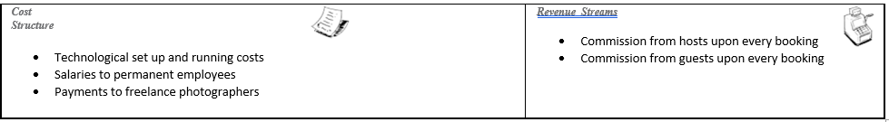
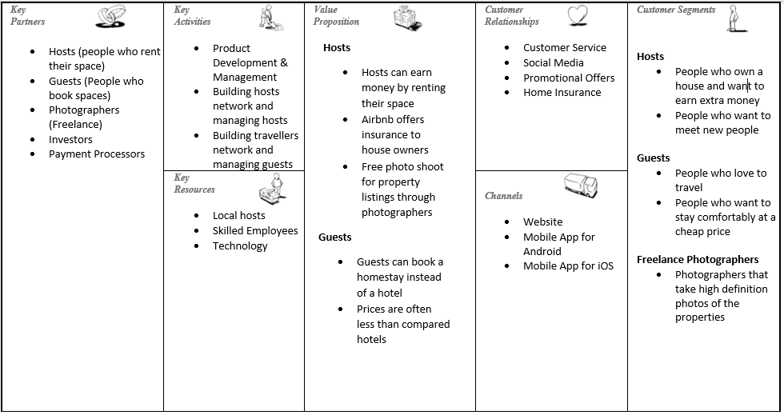
Airbnb and The Sharing Economy: Creating Value for Everyone - Technology and Operations Management (hbs.edu)

Strategic Formulation Framework (SFF)

The Strategic Formulation Framework is a process in which an organisation chooses the most appropriate plans of actions are so that the organisations can achieve their defined goals. This process is important to an organisations success because it provides a framework for the actions that will lead to the anticipated results (The Saylor Foundation, 2021). The Strategic Formulation Framework was designed by Fred David. Business organisation set out their objectives and Fred David argued that these should be “measurable, quantitative, challenging, realistic, consistent and prioritised”. That was the key reason for the development of the Strategic Formulation Framework. Fred David suggested that the SFF should be a formal structured tool and a method for strategic planning. The SFF has many methods for strategic planning such as the Internal Factor Evaluation (IFE) which is basically a SWOT analysis that analyses the strengths, weaknesses, opportunities, and threats of a business but with a quantitative scale, there is also the External Factor Evaluation (EFE) which is basically a PESTLE analysis that analyses the external factors such as the political factors, economic factors, social and cultural factors, technological factors, legal factors and the environmental factors but with a quantitative scale (Strategic Management insight, 2014).

However, the author of this report is mainly focusing on one method for strategic planning and that is the Grand Strategy Matrix. The grand strategy matrix is instrumental in aiding businesses to develop possible alternative strategies. This model includes a four quadrant graph and is based on two dimensions and they are the market growth vs the competitive position. This model catalogues the different strategic options available for businesses that have weal or strong competitive positions in markets that are undergoing slow or rapid growth. The four quadrants consist of strong competitive position and rapid market growth, quadrant 2 (weak competitive position and rapid market growth), quadrant 3 (weak competitive position and slow market growth) and quadrant 4 (strong competitive position and slow market growth) (Creately, 2021).

The Grand Strategy Matrix

Rapid Market Growth

Quadrant II Quadrant I

- Market development
- Market development
- Market penetration
- Product development
- Forward integration
- Backward integration
- Horizontal integration
- Related diversification
- Market penetration
- Product development
- Horizontal integration
- Divestiture
- Liquidation

Weak Competitive Position
Strong Competitive Position

Quadrant III Quadrant IV

- Retrenchment
- Related diversification
- Unrelated diversification
- Joint ventures
- Related diversification
- Unrelated diversification
- Divestiture
- Liquidation

Slow Market Growth

Airbnb resides in strong competitive position and rapid market growth. Airbnb are recommending a 5 year aggressive strategy from 2017 - 2021 as they reside in quadrant I, this is going to consist of the strategy related diversification, product development, market penetration, market development. Airbnb are going to execute related diversification by acquiring 3 small low cost hotels so that they can expand in Africa while adapting to culture difference, make a partnership agreement with Tui and FTI (tour operators), the tour operators will help arrange flights, transportation and local tours and excursions, Airbnb will also make partnership agreement with Uber. Airbnb are going to execute product development by adding an option which is called from Home to Home which will be utilizing its partnership with Uber and Tour Operators and they are going to be developing their programmes by inputting a culture exchange program for young people and an environmental awareness program for environmentally friendly people. The market penetration strategy is going to be executed by increasing the market shares from existing markets through greater marketing efforts, using all social media engagement tools and will be investing in Googe display advertising with banner advertisement campaigns which will include images from actual housing being offered on the Airbnb website. The market development strategy will be executed by executing the strategies that have been discussed so that they will be able to develop in the Middle East and Africa and take a good share from it (slideshare, 2021).

Digital Business Tools/Systems

The digital business tools/systems consist of Enterprise Resource Planning (ERP), Customer Relationship Management (CRM) and the Supply Chain Management (SCM). Enterprise Resource Planning signifies a type of software that businesses use to manage day to day business activities such as accounting, procurement, project management, risk management and supply chain operations. The future impact of ERP is cloud computing as it will allow businesses to free up resources, access new technologies, reduce third party dependencies, evolve financial systems and give businesses more robust security resources (Oracle, 2021). Airbnb use ERP as they participate in project management by going into property management which is a business model where the property owner outsources the management of their property listing on Airbnb and that is one of Airbnb’s projects (Zuo, 2019). CRM is the combination of practices, strategies and technologies that companies use to manage and analyse customer interactions as an approach to build and sustain long term business with their customers (Chai, 2021). Airbnb rely on their CRM software for almost every action they complete such as when a customer visits Airbnb’s website and completes an enquiry, when a room is booked and all the financial transactions they do. Airbnb also use their CRM to send out, keep track and the evaluate the performance of their attractive email campaigns, just so that they can keep tweaking them over and over again (Binns, 2016). SCM is the business function that coordinates all of the network links. The goals of SCM is to match demand with supply, maximise value and lower waste and to reduce operational costs, transferring the saved cost to add value to customers and to increase profitability (CIPS, 2021).

Conclusion

The purpose of this report has been met as the author of this report has written up a professional academic report that critically examines Airbnb as an example of the sharing economy. This has been done by critically examining Airbnb’s current situations such as how they have dealt with COVID 19 and how they have recently gone into stock exchange, the author of this report has shown how Airbnb go about their business and who and how they participate with their partners and customers through doing a business model canvas on Airbnb, Also, another purpose that has been met is the Strategic Formulation Framework as the author has briefly discussed the different analysis strategies that go into the SFF and critically analysed that Airbnb is on the first quadrant of the Grand Strategy Matrix which is strong competitive position and rapid market growth and the author of this report has briefly discussed about ERP, CRM and SCM and how Airbnb fit into them.

References
Airbnb. (2020, March 28). NHS and Frontline Medical Staff Get Free Places to Stay on Airbnb. Retrieved from https://news.airbnb.com/: https://news.airbnb.com/medicalstaysuk/
Airbnb. (2021). COVID 19 Safety. Retrieved from https://www.airbnb.co.uk/: https://www.airbnb.co.uk/d/covidsafety?_set_bev_on_new_domain=1614087698_MzJhMWExMDJiMGIy
Airbnb. (2021). How Airbnb works. Retrieved from https://www.airbnb.co.uk/: https://www.airbnb.co.uk/d/howairbnbworks
Airbnb. (2021). What is Airbnb’s 5-step enhanced cleaning process? Retrieved from https://www.airbnb.co.uk/: https://www.airbnb.co.uk/help/article/2809/what-is-airbnbs-5step-enhanced-cleaning-process
Binns, R. (2016, August 03). What CRM Does Airbnb Use? Retrieved from https://www.expertmarket.com/: https://www.expertmarket.com/crm/airbnb-crm
Chai, W. (2021). CRM (customer relationship management). Retrieved from https://searchcustomerexperience.techtarget.com/: https://searchcustomerexperience.techtarget.com/definition/CRM-customer-relationship-management
CIPS. (2021). What Does Supply Chain Management Mean? Retrieved from https://www.cips.org/: https://www.cips.org/knowledge/procurement-topics-and-skills/supply-chain-management/
Creately. (2021). Grand Strategy Matrix - Definition, Usage & Templates. Retrieved from https://creately.com/: https://creately.com/usage/grand-strategy-matrix/
Creately. (2021, February 22). The Easy Guide to the Business Model Canvas. Retrieved from https://creately.com/: https://creately.com/blog/diagrams/business-model-canvas-explained/
Dickie, M. R. (2020, March 30). Airbnb will pay guests $250 million to help cover cancellations due to COVID 19. Retrieved from https://techcrunch.com/: https://techcrunch.com/2020/03/30/airbnb-commits-250-million-to-helping-hosts-cover-cancellations-due-to-covid-19/?guccounter=1&guce_referrer=aHR0cHM6Ly93d3cuYmluZy5jb20v&guce_referrer_sig=AQAAAITumDp_HjQkaVs-VYh2WoIswdnN-dqinPq5wh65cpPhtIiKo4lWBJJ31hkvwN
Lepers, C. (2017, August 20). Airbnb Business Model: Here’s How It Works (+ Template). Retrieved from https://www.pptpop.com/: https://www.pptpop.com/airbnb-business-model/
Mansfield, D. T. (2019, July 26). Alex Osterwalder’s Business Model Canvas template: why use it and how. Retrieved from https://interaction.net.au: https://interaction.net.au/articles/business-model-canvas-template/#:~:text=The%20Business%20Model%20Canvas%20is%20a%20strategic%20management,entrepreneur%20as%20a%20part%20of%20his%20PhD%20research.
Oracle. (2021). Definition of Enterprise Resource Planning (ERP). Retrieved from https://www.oracle.com/: https://www.oracle.com/erp/what-is-erp/#:~:text=Enterprise%20resource%20planning%20(ERP)%20refers%20to%20a%20type,risk%20management%20and%20compliance,%20and%20supply%20chain%20operations.
slideshare. (2021). Strategic plan harvard business review case study airbnb company. Retrieved from https://www.slideshare.net/: https://www.slideshare.net/mohieismail9/strategic-plan-harvard-business-review-casestudy-airbnb-company
Smith, S. (2020, November 16). Airbnb IPO: 9 Things for Potential ABNB Stock Investors to Know. Retrieved from https://investorplace.com/: https://investorplace.com/2020/11/airbnb-ipo-9-things-for-potential-abnb-stock-investors-to-know/
Strategic Management insight. (2014, October 20). IFE & EFE Matrices. Retrieved from https://strategicmanagementinsight.com/: https://strategicmanagementinsight.com/tools/ife-efe-matrix.html
Strategyzer. (2021). Business Model Canvas. Retrieved from https://www.strategyzer.com/: https://www.strategyzer.com/canvas
The Saylor Foundation. (2021). Strategy Formulation. Retrieved from https://resources.saylor.org/: https://resources.saylor.org/wwwresources/archived/site/wp-content/uploads/2013/02/BUS208-7.3.1.1-Strategy-Formulation-FINAL.pdf
Timmers. (1999). List and explain briefly the business models identified by Timmers. Retrieved from https://www.ques10.com/: https://www.ques10.com/p/4146/list-and-explain-briefly-the-business-models-ident/
toolshero. (2021). Business Model Canvas (BMC). Retrieved from https://www.toolshero.com/: https://www.toolshero.com/strategy/business-model-canvas/
Wigmore, I. (2013). What is a business model. Retrieved from https://whatis.techtarget.com/: https://whatis.techtarget.com/definition/business-model
Zuo, S. (2019). Airbnb Property Management: Here is What You Need To Know. Retrieved from https://www.passiveairbnb.com/: https://www.passiveairbnb.com/airbnb-property-management-here-is-what-you-need-to-know/

Appendix

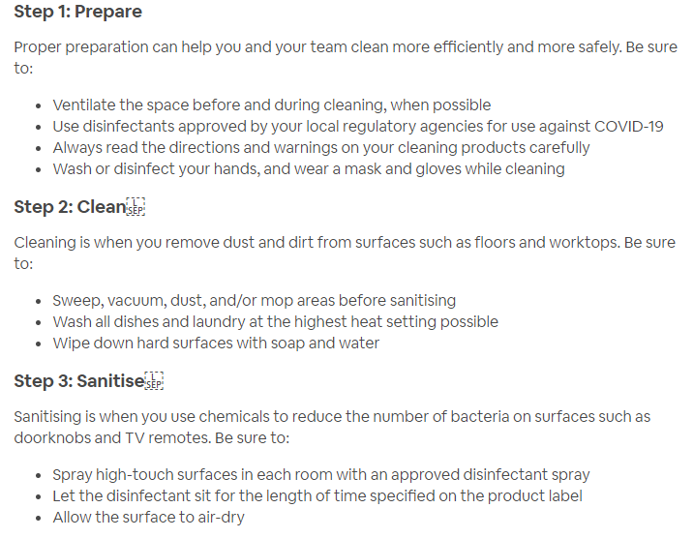
Appendix 1

Appendix 2

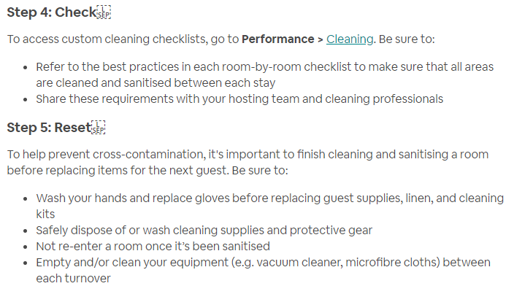

Appendix 3



