Qualification: CIPD Diploma in Applied Human Resources

Module Name:

Contributing to the Improvement of Individual and Organisational Performance

Word Count:

Student Name: Chloe Phillips
Student Number: 1919555
CIPD Membership Number: 56803356

By signing below, I confirm that the work/evidence presented is my own, unaided work. I understand the regulations pertaining to candidate malpractice and the action that may be taken as a result.

Signed: 
Date: 22nd August 2021

Contents

Page 1 Title Page

Page 2 Contents Page

Page 3-4 Evidence Matrix

Page 5 Introduction

Page 6-7 Personal Statement LO1: Be able to provide information on performance management activities within an organisation.

Page 8-9 Personal Statement LO2: Be able to support line managers to deliver performance management activities within the organisation

Page 10-12 Personal Statement LO3: Bea able to assess the impact of performance management activities on organisational performance and make recommendations for enhancement.

Page 13-39 Evidence

Page 40-41 Reference list

Candidate name: Chloe Phillips |  |  |  |  |  | CIPD Membership/registration No.: 56803356
Qualification title: CIPD L5 Diploma in Applied Human Resources |  |  |  |  |  | Unique Learner No. (ULN): 1919555
Unit code | Unit title |  | Assessment criteria no. | Evidence description |  | Evidence reference number | Assessor  initials | I/V initials if sampled
5AIOP | Contributing to Improving Organisational Performance |  | LO1 | Screenshot of Core Purpose, 7 Priorities, 6 Ways of Working and 5 ambitions |  | EV 1
5AIOP | Contributing to Improving Organisational Performance |  | LO1 | Screenshot of induction |  | EV2
5AIOP | Contributing to Improving Organisational Performance |  | LO1 | Screenshot of handbook performance management process |  | EV3
5AIOP | Contributing to Improving Organisational Performance |  | LO1 | Screenshot of probationary review template |  | EV4
5AIOP | Contributing to Improving Organisational Performance |  | LO1 | Screenshot of colleague’s paper based annual reviews |  | EV5
5AIOP | Contributing to Improving Organisational Performance |  | LO1 | Screenshot of managers mid and end of year online reviews |  | EV6
5AIOP | Contributing to Improving Organisational Performance |  | LO1 | Screenshot of feedback tool within managers online reviews |  | EV7
5AIOP | Contributing to Improving Organisational Performance |  | LO1 | Screenshot of PDP |  | EV8
5AIOP | Contributing to Improving Organisational Performance |  | LO1, LO2 | Screenshot of personal development toolkit including, Online handbook, online policy, flow chart, informal note paper, formal notepaper, and the Guide to Representation online policy |  | EV9
5AIOP | Contributing to Improving Organisational Performance |  | LO1 | Screenshot of performance improvement plan severance letter |  | EV10
5AIOP | Contributing to Improving Organisational Performance |  | LO1 | Screenshot of performance improvement plan invitation template |  | EV11
5AIOP | Contributing to Improving Organisational Performance |  | LO1 | Screenshot of performance improvement plan conclusion improvement made template |  | EV12
5AIOP | Contributing to Improving Organisational Performance |  | LO1 | Screenshot of performance improvement plan dismissal outcome letter template |  | EV13
5AIOP | Contributing to Improving Organisational Performance |  | LO1 | Screenshot of new colleague improvement program |  | EV14
5AIOP | Contributing to Improving Organisational Performance |  | LO1 | Screenshot of testimony email from Shaun bird |  | EV15
5AIOP | Contributing to Improving Organisational Performance |  | LO1, LO2 | Screenshot of testimony email from James Lloyd |  | EV16
5AIOP | Contributing to Improving Organisational Performance |  | LO2 | Screenshot Invite to one-to-one review and programme timeline |  | EV17
5AIOP | Contributing to Improving Organisational Performance |  | LO2 | Screenshot of Managers meeting agenda |  | EV18
5AIOP | Contributing to Improving Organisational Performance |  | LO2 | Screenshot of Root Cause Analysis training |  | EV19
5AIOP | Contributing to Improving Organisational Performance |  | LO2 | Screenshot of one-to-one managers conversations |  | EV20
5AIOP | Contributing to Improving Organisational Performance |  | LO3 | Screenshot of Store ‘Your Say’ Forum |  | EV21
5AIOP | Contributing to Improving Organisational Performance |  | LO3 | Screenshot of Regional ‘Your Say’ Forum |  | EV22
5AIOP | Contributing to Improving Organisational Performance |  | LO3 | Screenshot of Company ‘Your Say’ Forum |  | EV23
5AIOP | Contributing to Improving Organisational Performance |  | LO3 | Screenshot of Reward and Recognition Toolkit |  | EV24
5AIOP | Contributing to Improving Organisational Performance |  | LO3 | Screenshot of Pathways |  | EV25
Candidate declaration:
- I confirm that the work/evidence presented for assessment is my own unaided work.
- I have read the assessment regulations and understand that if I am found to have ‘copied’ from published work without acknowledgement, or from other candidate’s work, this may be regarded as plagiarism which is an offence against the assessment regulations and leads to failure in the relevant unit and formal disciplinary action.
- I agree to this work being subjected to scrutiny by textual analysis software if required.
- I understand that my work may be used for future academic/quality assurance purposes in accordance with the provisions of the Data Protection Act 1998.
- I understand that the work/evidence submitted for assessment may not be returned to me and that I have retained a copy for my records.
- I understand that until such time as the assessment grade has been ratified through internal and external quality assurance processes it is not final.
Signature: |  | Chloe Phillips |  |  | Date: |  | 22.8.21



Introduction
Morrisons Supermarket PLC is a private company and one of the 5 largest retailers in the UK. Morrisons is currently 4th with 500 plus stores nationwide, and a workforce of over 110,000 employees. The business prides itself on having skilled colleagues, preparing quality fresh food instore, a point of difference from the other large leading supermarkets. Morrisons prides itself on rearing and sourcing British meat to sell to customers, having their own distribution centers, abattoirs, and manufacturing plants within the UK.

The core values of Morrisons are the heartbeat within the business, consisting of priorities, values, and ambitions (EV 1). Performance Management is aligned to the seven priorities the six ways of working and the five ambitions (EV 1). This is clearly set out in all activities as an objective for all colleagues.

This will be my own view on Performance Management within the Morrisons business. In this report I will consider how Performance Management fits in with HPWM. I will consider a variety of evidence throughout and will provide material on how the organisation measures against their objectives. Evidence will be based on information gathered through internal data used within the company. My findings will comprise of images, spreadsheets, emails, and diagrams. The personal statements will discuss reviewing the organisations approach to performance management and improvements based on personal feedback gathered.

Personal Statement LO1: Be able to contribute to the delivery of performance management activities within the organisation.

Morrisons have a range of performance management tools included within the organisations policy. Job descriptions set out what is expected from a candidate within the role, these are created based on the companies’ frameworks and values (EV1), this is also echoed within the induction (EV2). Implementing these throughout the workplace starts within the induction and first couple of months of employment. All contents of how performance is measured is included within the handbook (EV3). Inductions clearly state the role and expectations keeping in line with expected behaviours to reflect the brand. Each new starter is expected to have a probationary review (EV4) week four, eight and twelve. This probationary review provides an insight into whether the candidate meets expectations or ascertain whether they are not reaching it. There is an opportunity to extend the probationary period at this point, this is the role of the Line Manager. The People Manager (HR advisor) can support to guide through the process, coaching prior or shadowing taking notes within the meeting. The probationary review takes into consideration, absence, learning and development progress and behaviours.

Morrisons colleagues have an annual review planned (EV5) with their Line Manager, this is based around the core values and is not performance pay related, although scored it can address poor performance to put plans in place to correct with clear objectives and next steps. Line managers have a mid, and end of year review (EV6) based on the same organisational values, scored, and is connected to financial reward. Managers are able to seek 360-degree feedback (EV7) within the review, which will help to self-evaluate when completing. A personal development plan (EV8) can be created alongside this and attached. PDP tend to be behavioural based rather than target KPI based.

As well as having an appraisal process, Morrisons also has a Performance Improvement Plan (EV9) process. The PIP process is designed to improve a candidate to achieve the expected level of performance but can be used to sever the under performers employment from the company (EV10).

Performance Improvement plans have specific timescales. Four weeks is recommended. The colleague is formally invited and offered representation (EV11). Review periods with one-to-one intervention is followed in a reasonable timescale. Weekly or bi-weekly. There is no requirement for representation in an informal setting. If sufficient improvement has been made a conclusion letter confirming the improvement can be issued (EV12), however, if there are further concerns the process can be picked back up within six months. If performance has not improved a letter can be issued with a warning which remains live for twelve months. The colleague has the right to appeal, and the colleague is moved to the next stage of the process. The objectives may be revised or amended. Two weeks is recommended for the second stage, if a colleague has not improved, the third stage is commenced. A decision to demote, move sites or dismissal can be considered at this stage (EV13). Dismissal is issued with Payment in lieu of notice with capability identified as the factor.

Specific roles are managed through the hierarchy. Regional Manager and Regional People Manager manage the Store Manager and People Managers for individual stores. Store Manager and People Manager manages Line Managers within the specific store sites, Line Managers manage colleagues and Team Leaders within individual departments. Morrisons has recently introduced Performance Improvement Programme for colleagues (EV14). Previously this solely managed within the annual review. The colleague improvement management has been a welcomed tool to implement consistency within the organisation.

Morrisons policies and procedures are at the heart and underpin the entire organisation, linked to, and adhere to legislation. The policies are written to fit in line with The Grocery Supply Code of Practice (Morrisons, 2021) The Equality Act 2010 (Gov, 2015), unfair dismissal (gov.uk,2021), Data Protection Act 2018, GDPR (Gov.uk, 2018) and have been discussed and agreed with National Union Agreements (Usdaw, 2021).

1:3, Please see evidence list for the below:

(EV15) A statement from the Store Manager, business partner to evidence that I have full involvement and have contributed to all aspects of Performance management

(EV16) A statement from a Manager on a Talent Succession programme Pathways for a more senior role, confirming I have supported him with performance management processes.

LO2 - Be able to support line managers to deliver performance management activities within the organisation.

Colleagues feel valued when recognised and developed. Development is a continuous activity throughout all colleagues’ journeys at all levels. Colleagues feel listened to and is a way of recognising a development need or skill gap. Improving performance comprises of training all colleagues, improving their learning and development skills while giving the confidence to implement at manager level for colleagues below them. Line managers often feel ill equipped to deal with performance as this comes with time and experience (EV16). Following a flow chart alone can be daunting and often harder to understand without coaching and guidance. Supporting managers throughout consists of training new initiatives and ensuring thorough understanding of processes, showing how to implement and shadowing if necessary. Explaining the importance of getting to know colleagues within their departments and using the performance tool will enhance confidence and give strength which, in turn ensures a positive psyche.

Explaining why we do it and what the benefits are can encourage managers not to shy away or see it as a tick-box exercise. Assistance can be provided in a blended capacity, talking through performance management, and giving examples of what questions may be asked, how the candidate may respond with different scenarios and making a checklist to cover points or a co-delivery approach, shadowing the managers, taking notes, listening, which enables feedback to be given at the end. Reflecting on what the managers could change, insert to add value or feedback on behaviours and positive posture (EV15).

All Line Managers reviews are conducted by the Store Manager and People Manager in partnership. All Line Managers are invited to their mid and end of year performance reviews, giving sufficient notice which enables them to collate information necessary reflecting on the past six months retrospectively (EV17). Engaging the managers prior to their review enables guidance, prompting what they have achieved as this can often be a struggle self-analysing when aligning to the core values. By asking probing questions managers are able to describe what they have done and how they have done it without answers dictated. Coaching to gain feedback from a range of peers and understudies can aid this process. Coaching regarding technicalities of the review is also beneficial, there may be a need for upskilling for an online platform. Colleagues that are less familiar with technology will benefit from showing Managers what good looks like and sharing personal experiences can lead them in the right direction.

Within the working week time is set aside for coaching and developing within the Managers Meeting (EV18). This creates an opportunity to cover any training needs. All managers attend the meeting which captures the wider audience. A follow up one-to-one meeting is held with each individual manager to check understanding of new or ongoing processes if unfamiliar. The Manager has the opportunity to inform of any further assistance needed regarding a particular process.

As the Business Partner of the Store Manager performance management plays an important part of the working week. Shoulder-to-shoulder coaching is provided while working on the shopfloor. This is done in an informal manner asking probing questions regarding performance or performance of their direct reports. ‘In the moment’ feedback is effective and imperative for continuous improvement of colleagues and the organisation. Root causing a solution to a problem is key to great performance (EV19). When poor performance continues, it can form part of a formal review where specific objectives are implemented, contributing to the performance improvement programme in an office-based setting (EV9).

One-to-one conversations are necessary for all colleagues, especially Line managers (EV20). ‘If you do what you’ve always done, you’ll get what you’ve always got’. Recommendations can be made to improve; this will ensure that there are ‘no surprises’ at the Performance Review stage. Open and honest conversations discussing what a colleague’s performance is by scoring them on a regular basis develops the colleague and aids achievement within the performance objectives.

There is limited capability within the management team regarding formal meetings, this is a concern. Managers need extensive training and exposure to these formal meetings. I have ensured that inexperienced managers are partnered to shadow and take notes to gain experience with guidance from myself if needed.

Personal Statement LO3: Be able to assess the impact of performance management activities on organisational performance and make recommendations for enhancement

Performance management processes support the organisation to achieve a HPW workforce. Engagement of all employees determines this (Armstrong, 2020). There is a need for a holistic approach of consistency which Morrisons framework connects to. The structured foundations are in place to align this. The organisations ways of working in corporate ‘Listening and Responding’. Colleagues have the opportunity to have their say in a monthly forum, represented from each department within the store (EV 21) This forum is called a Your Say listening group. Information and feedback are gathered at store level, which feeds in to the Quarterly Regional Your Say (EV22), which feeds into the Annual Company Your Say (EV23).

Morrisons also has an online platform made up of a qualitative and quantitative survey which is conducted annually. This monitors engagement levels; managers analyse results to put a plan in place to address any concerns.

HPW consists of a series of practices which contribute alongside the annual/mid-year review and also the performance management process, although I feel that Morrisons have a good foundation which also includes reward and recognition toolkit (EV 24) managers are very much task orientated and not leaders of behaviours.

Succession/Talent is recognised through performance reviews with a Talent Programme Pathways (EV25), this enhances the performance of the business, growing home-grown talent. This benefits performance in a top-down, bottom-up approach where new meets traditional.

I believe that the processes in place contribute to HPW, if followed, link in to KPI’s which feed into the overall vision which optimises potential.

One of the characteristics related to high performance working (HPW) is when ‘high performance is recognized and rewarded accordingly’ (Armstrong, 2010, P106). The organisations approach to performance management is a combination of traditional and a more evolved, recent concept. The six ways of working (EV1) are incorporated throughout, contributing to the KPI’s which underpin the business. A more holistic approach has been encouraged which comprises of weekly one to one coaching, learning needs analysis and two-way feedback within reviews and forum groups where behaviours are a key focus.

The Line Managers are encouraged to lead a top-down approach to performance management but often see this as a tick-box exercise. Completion rates for managers reviews are hight as this is delivered from a more senior leader, however, line managers who are responsible for level 1 colleagues review are minimal and harder to track. Often when colleague reviews are completed, do not have any, or very little valuable content. To overcome this, line managers need to role model and change their mindset regarding behaviours and understand the benefits of this element of performance management (McKinsey, 2019).

Development needs can be identified within the performance review. There is an opportunity to state what actions need to be put in place to further the individual’s competency. Timescales are often left out with no clear next steps identified which can leave colleagues feeling deflated, having the opposite effect to the review purpose. Line managers should follow the SMART objective process incorporating the OSCAR model to review (CIPD, 2020).

The performance review process is lead by the Line Manager and can sometimes be dictatorial instead of allowing the reviewee to open the review conversation. Line managers review retrospectively stating strengths and weaknesses which does not allow the reviewee to identify their own self-development needs. Colleagues should be encouraged to talk their reviews by using open questions in a two-way fashion.

Recommendations for the organisation would be:
- Update the Annual Performance Review

- Condense and revise the performance review as it is too long and cumbersome.

- Objectives should be agreed mutually at the start of the financial year instead of being dictated by the company consisting of sleeker SMART objectives which incorporate the ways of working (Mindtools, 2021). At present the objectives have not been received, therefore all mid-year reviews have had complications.

- Revise the scoring system, aligning to each specific role as is currently generic and vague which leads to under or overscoring inconsistencies. Specific scoring mechanism, e.g., if a manager does not complete their review prior to the review time an automatic low score is actioned as this shows lack of respect with poor behaviours. At present the scoring matrix is vague which can lead to a blanket approach.

- Clear reward programme to gain incentive as the current reward does not encourage managers to perform. Colleagues receive an annual pay increase regardless; this is not the case for salaried managers and is seen as unfair. A Full-time night colleague has an annual wage of only 6% less than the starting band for a Line manager. There are arguments against reward, however, I believe that within Morrisons reward would encourage better performance (CIPD 2020).

- Update Training

Quality training for all Managers. The expectation is managers coach and support yet do not provide any quality training on how to do this, therefore this aspect does not support HPW. A recommendation of leadership workshops for all management levels to complete in a trainer led setting to gain full understanding.

- Onboarding Process

First impressions of an organisation are crucial to the brand and an important introduction to unlocking the new employee’s potential. New managers are required to attend the training store within each region which can be a significant distance to travel for some sites for a six-week onboarding program. This can be costly to the business paying out travel expenses and can cause burnout to the colleagues traveling to the training store. The training store will often expect a new manager to drive their own self-led online training with no clear coaching and guiding. Colleagues can be deflated, unmotivated and disengaged.
A blended 2/3 approach would be a recommendation. Two days at the training store, shadowing a competent manager, followed by 3 days at the home store. I believe this will enable the new starter to familiarise themselves with colleagues/peers and complete any online training, be more productive and integrate to their team. This will save the organisation time, money, and potential labour turnover which will damage the organisations employer brand (CIPD, 2020).

Evidence
EV1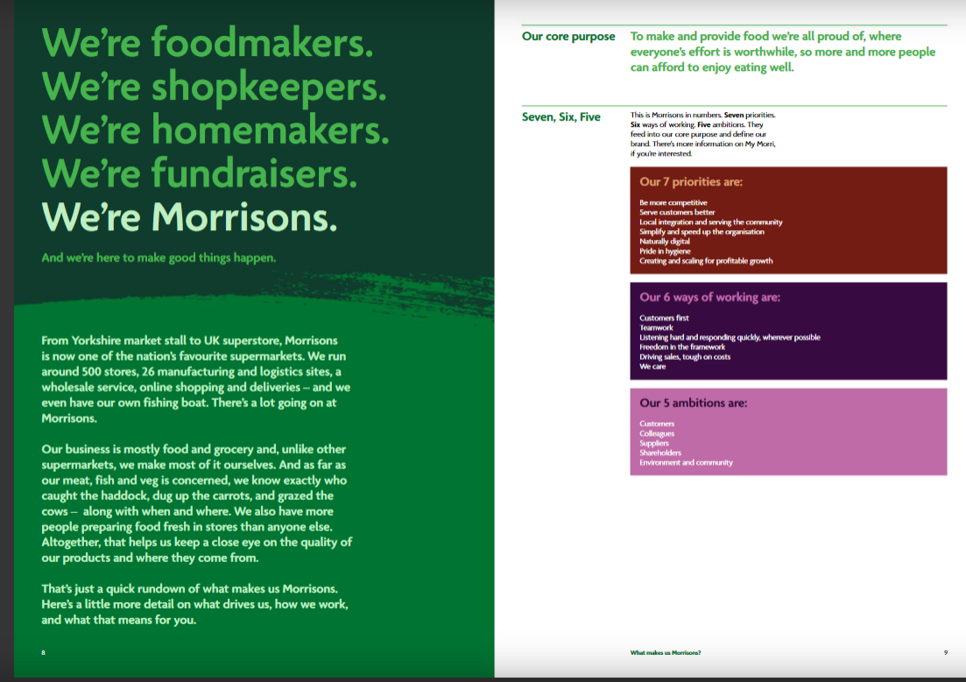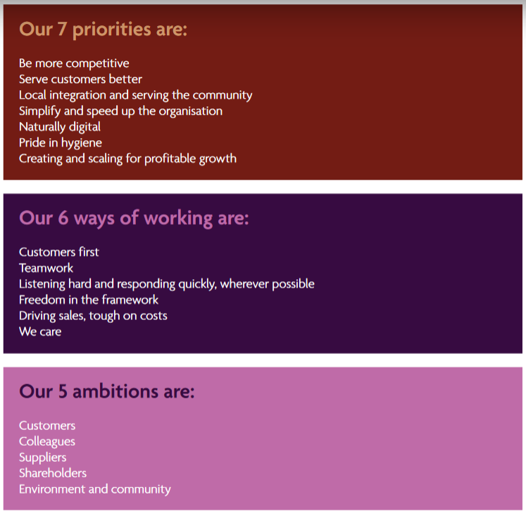

EV2

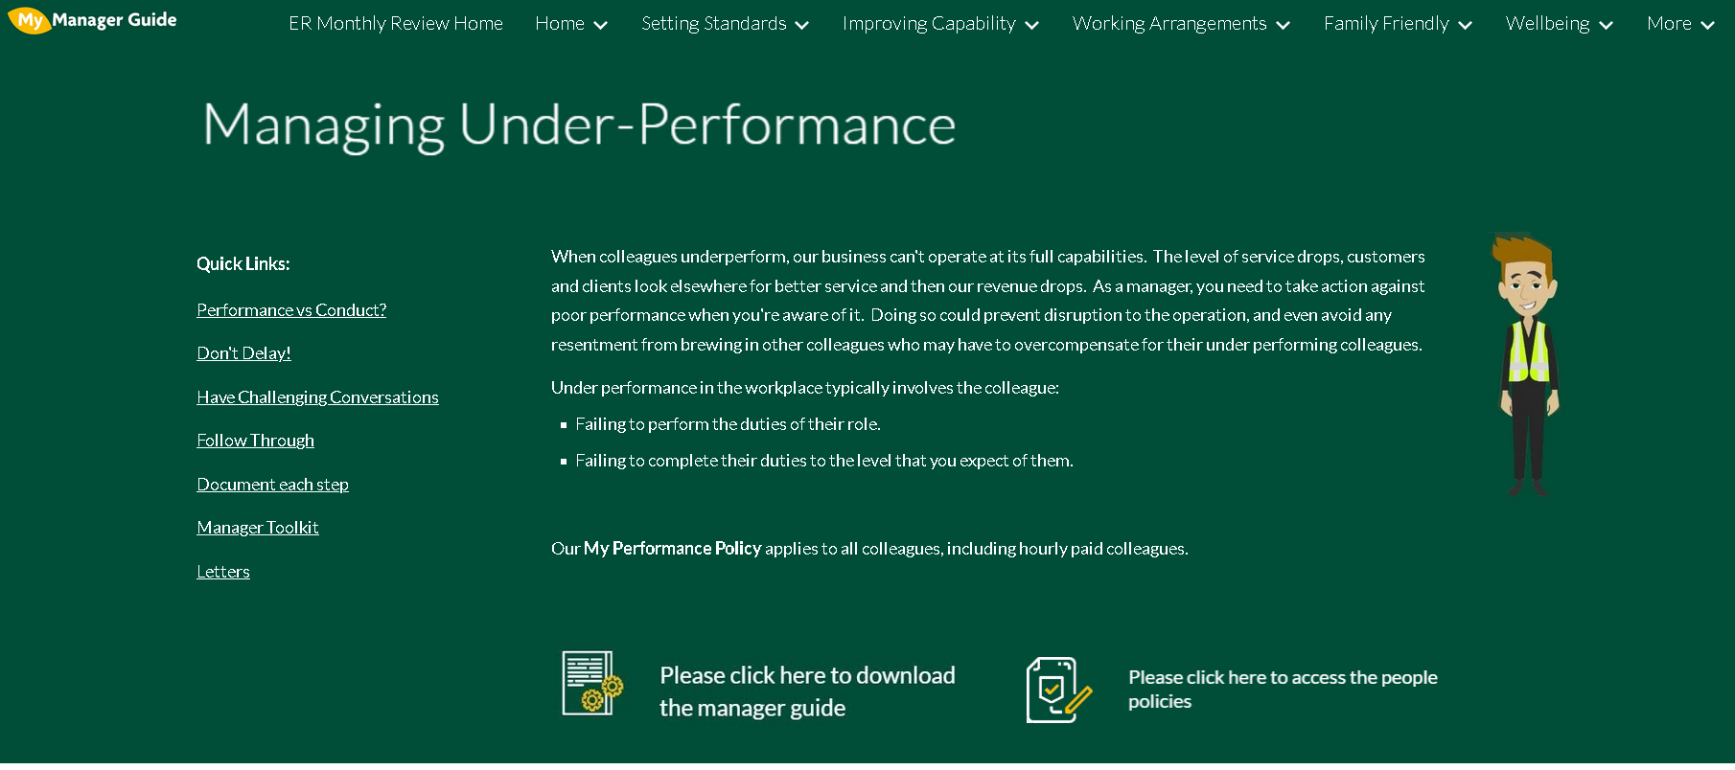
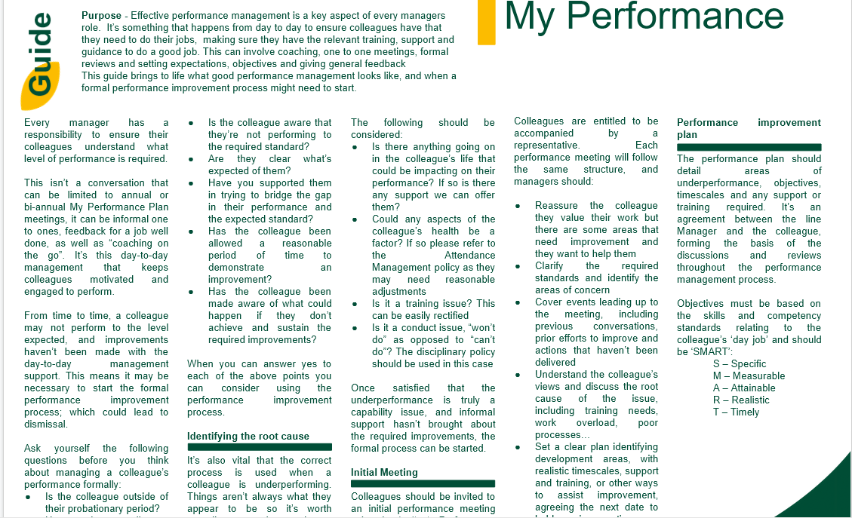

EV3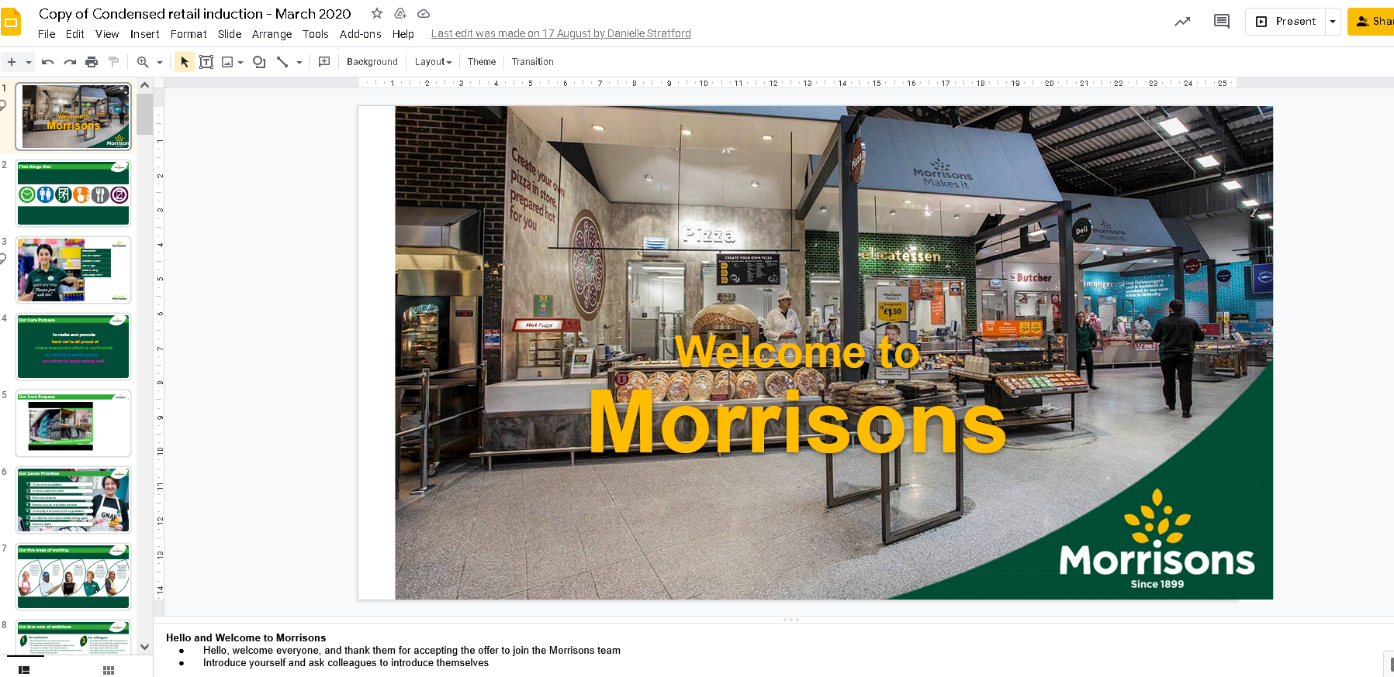

EV4
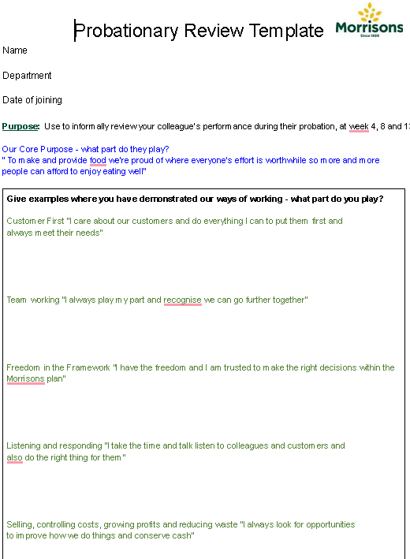
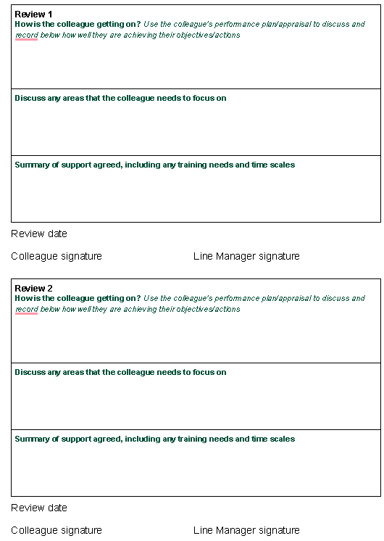

EV5

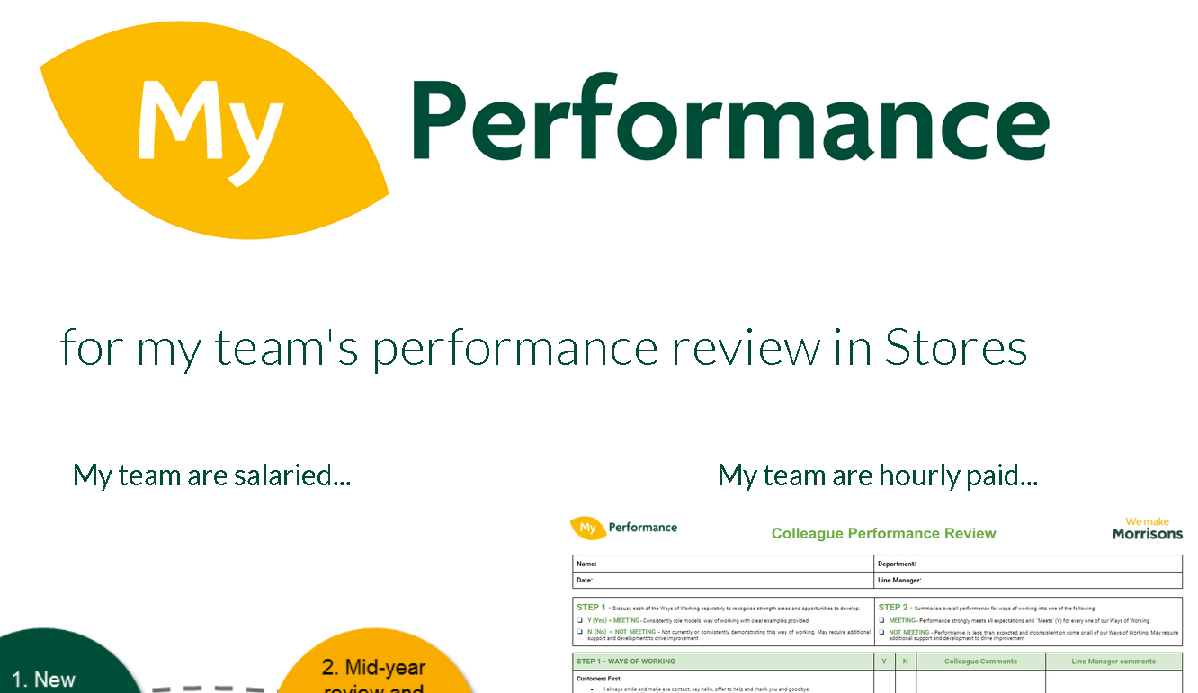
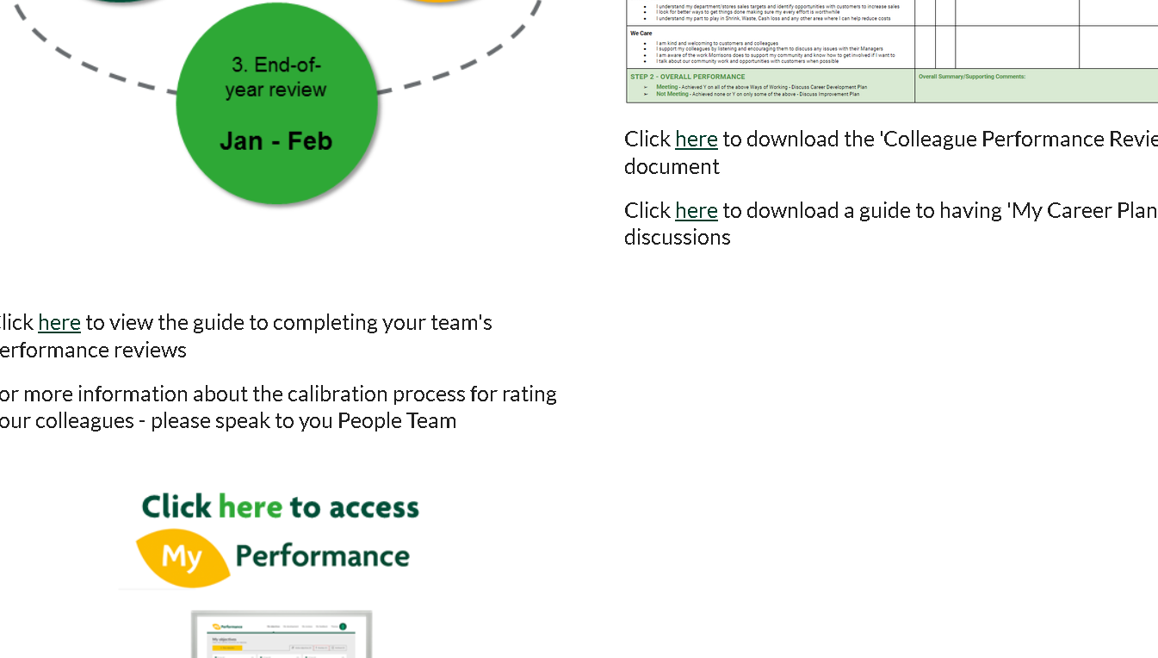
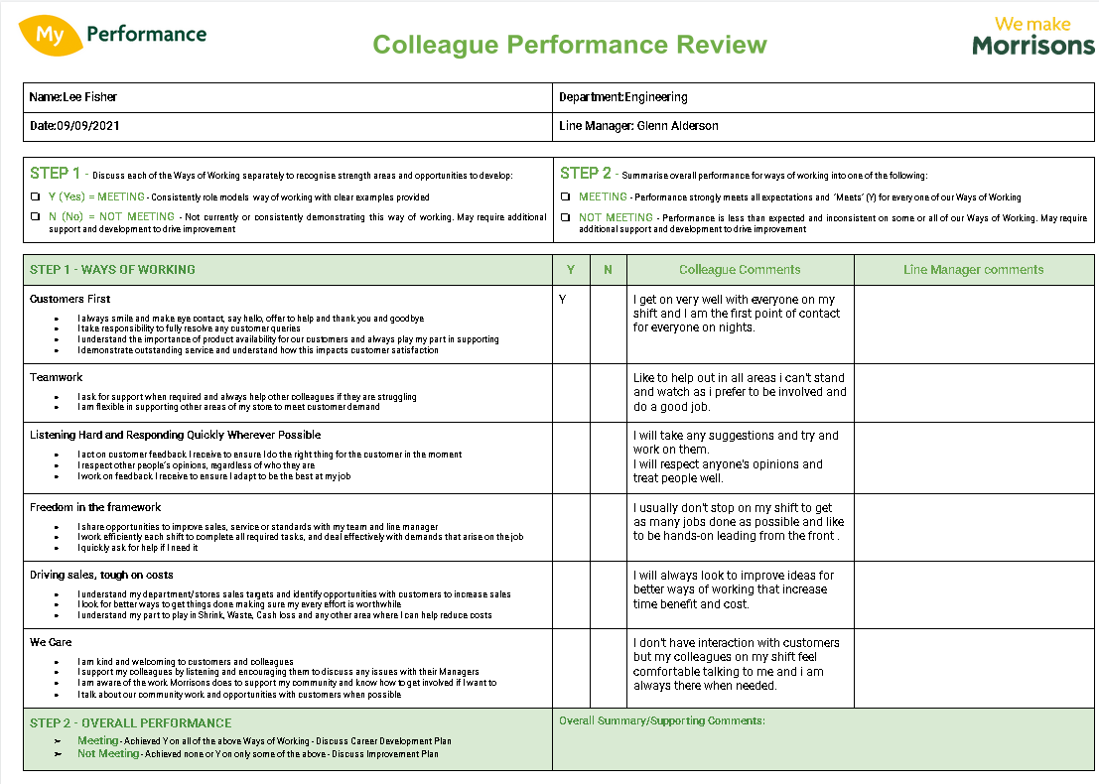
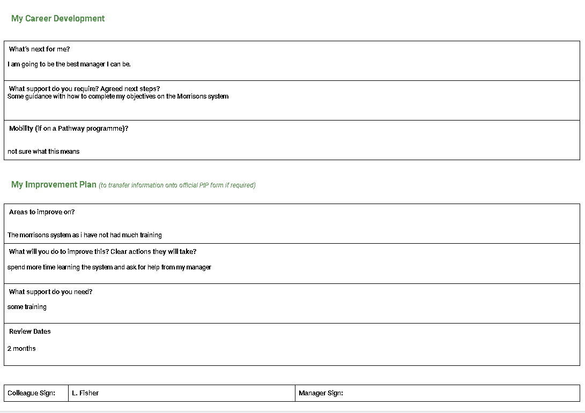

EV6
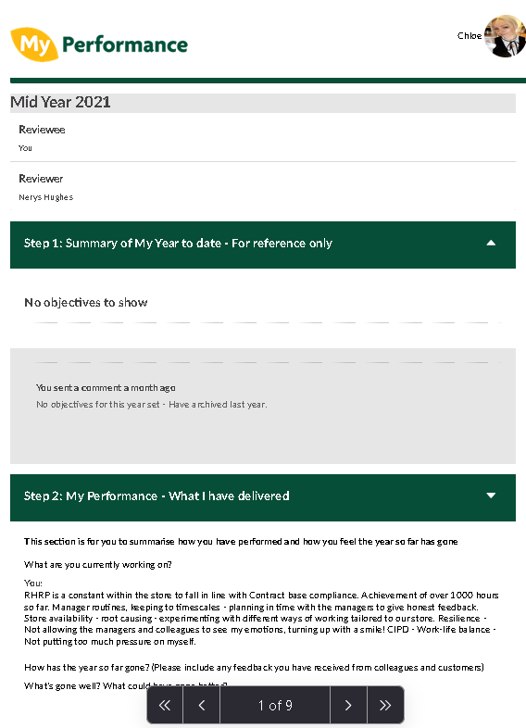
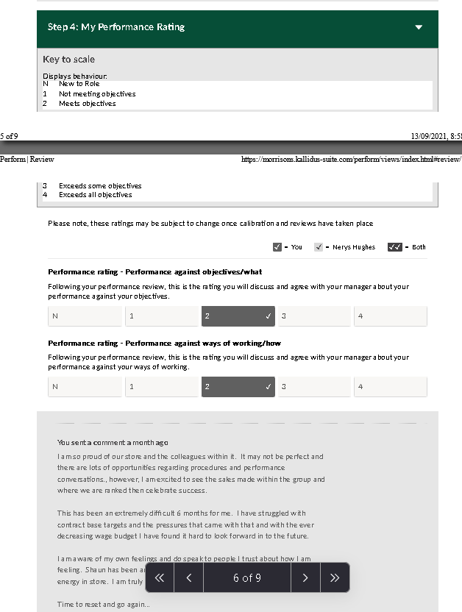
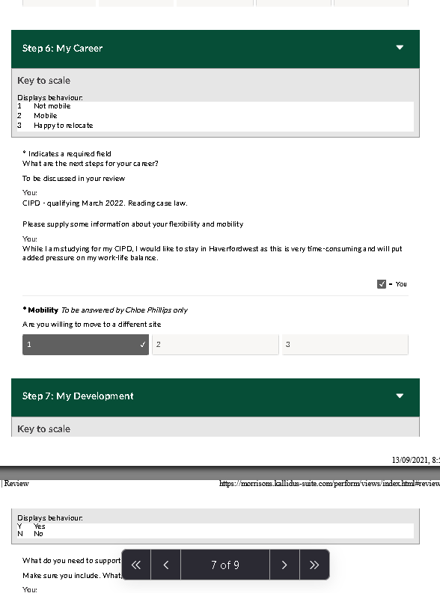

EV7
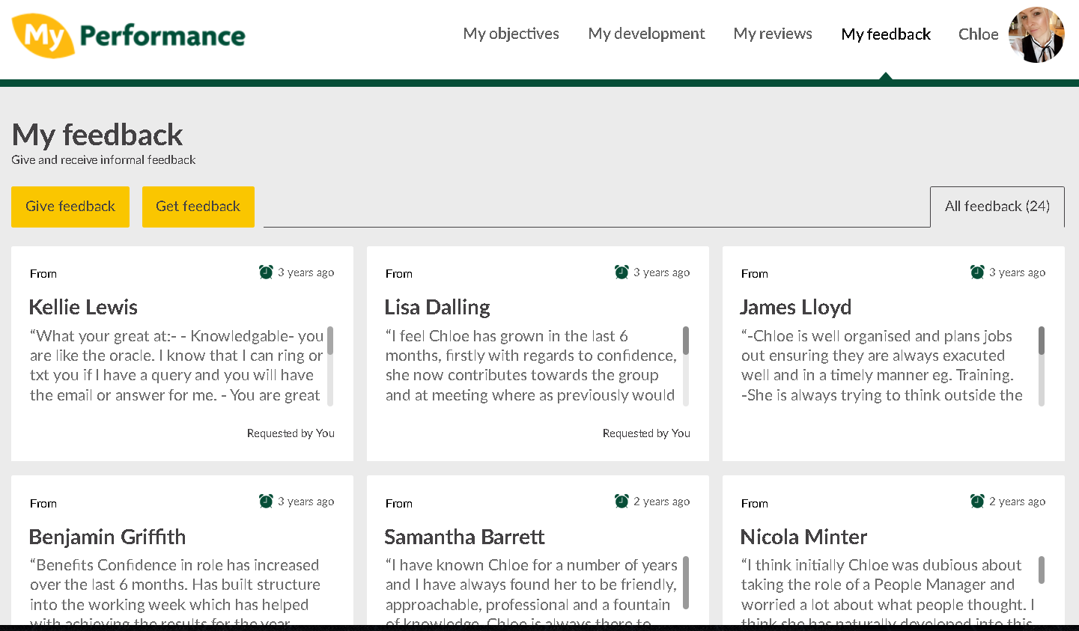

EV8
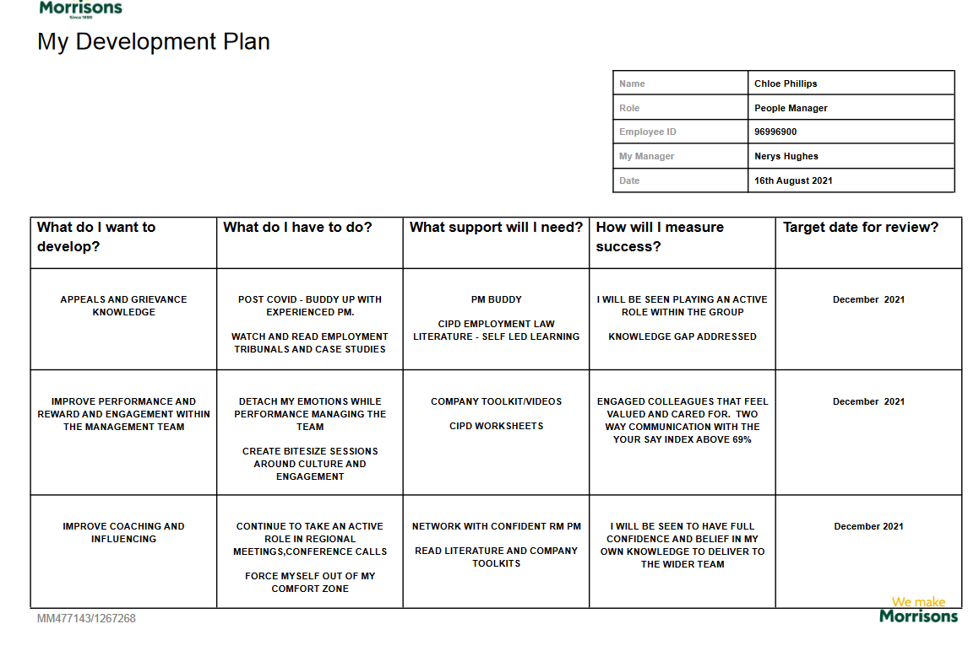

EV9
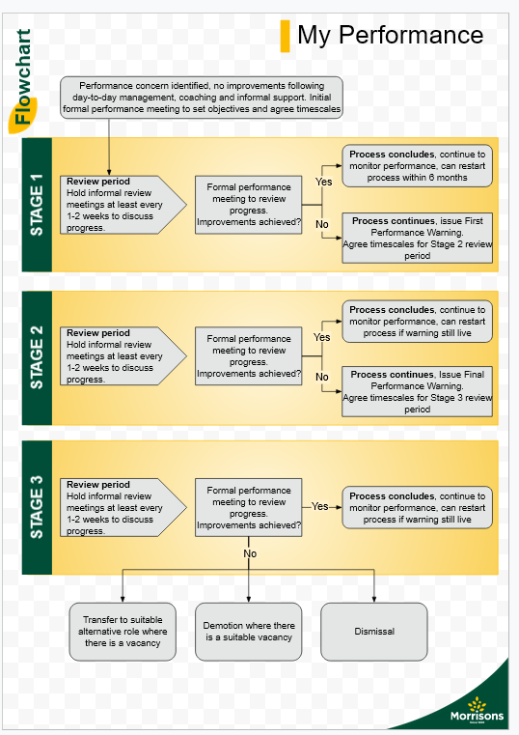

EV9
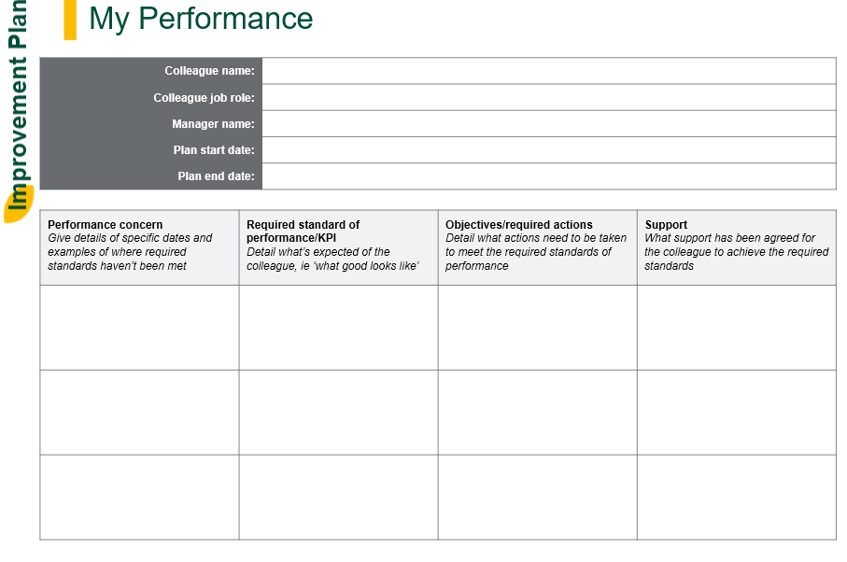

EV9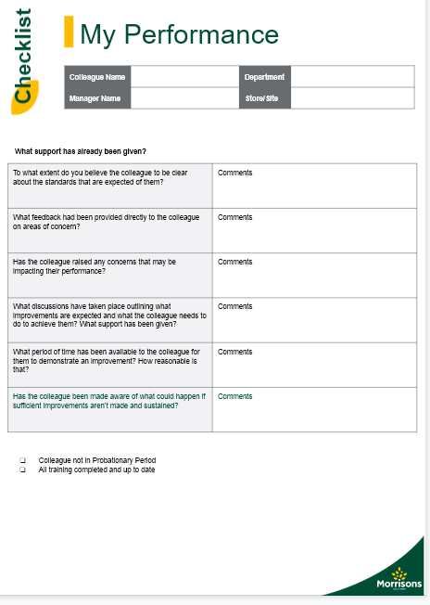
EV9
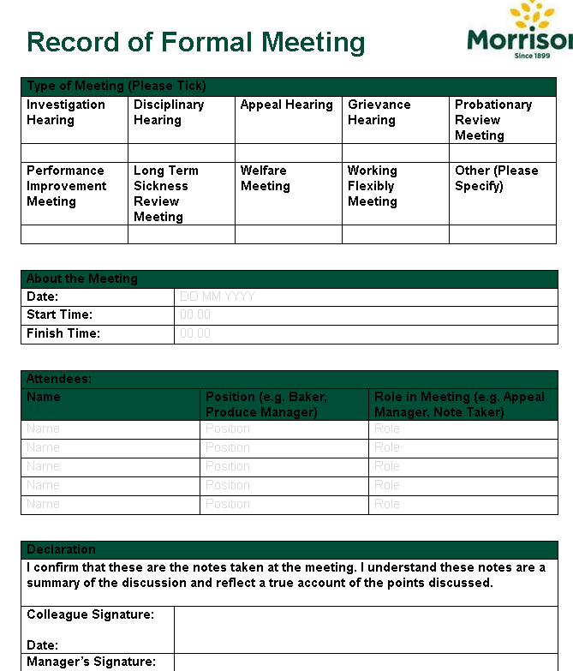

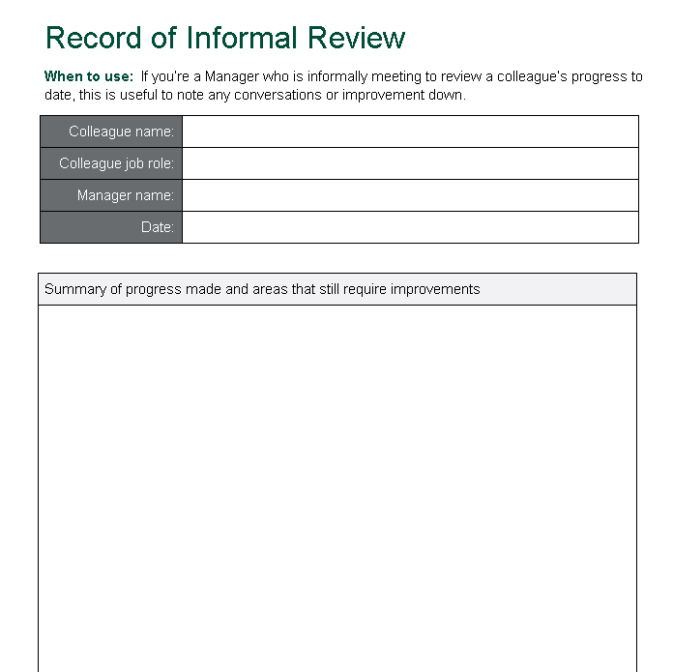

EV9
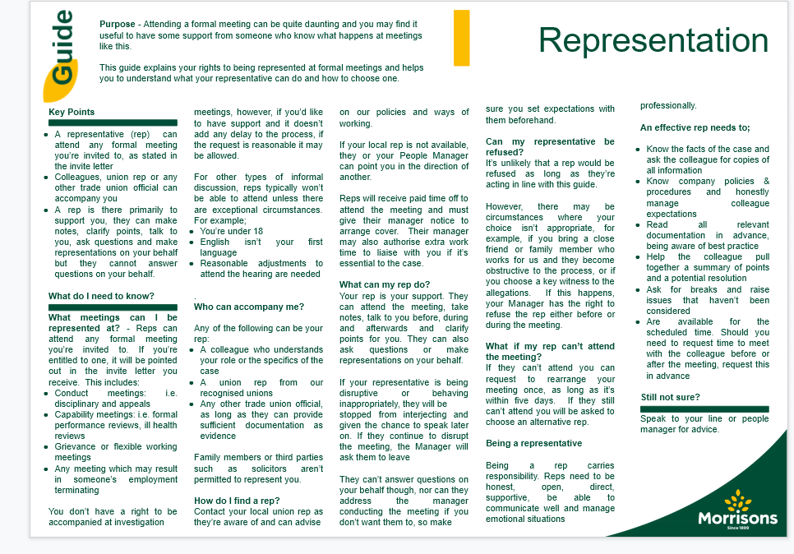

EV10
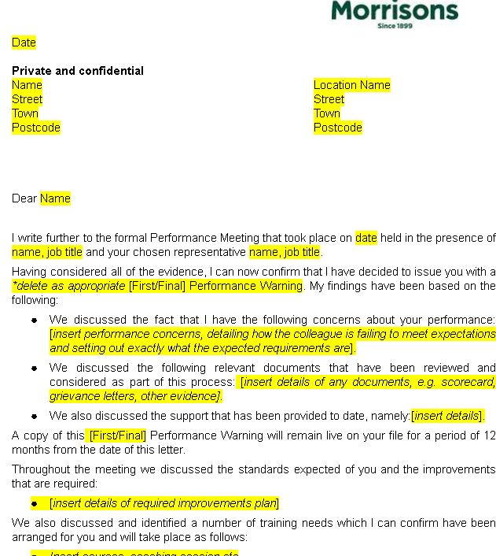

EV11

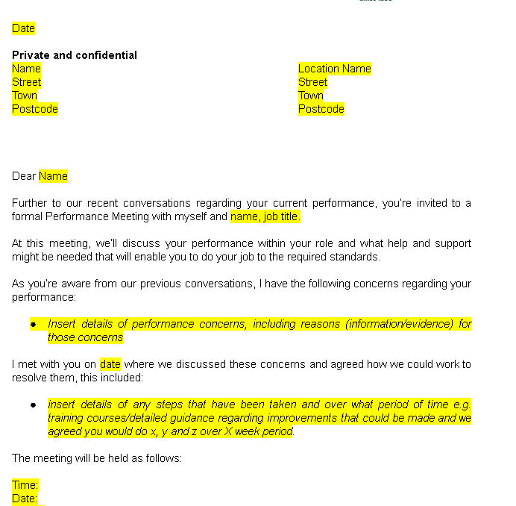

EV12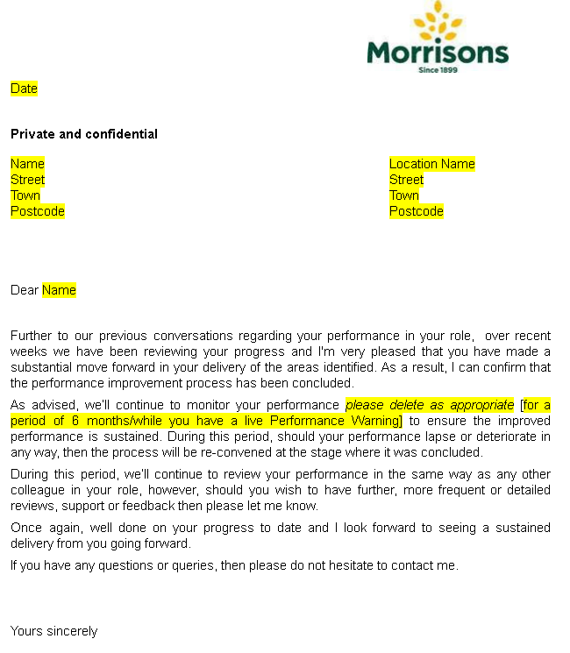

EV12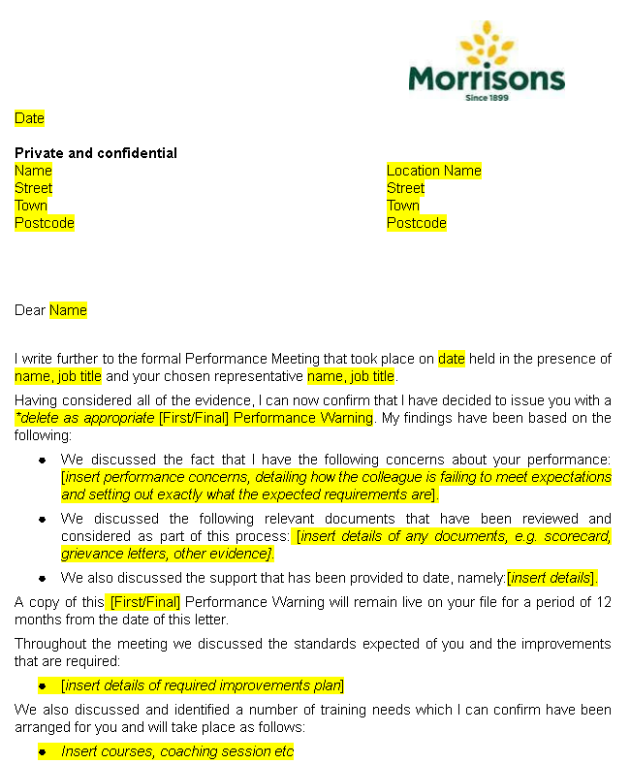

EV12
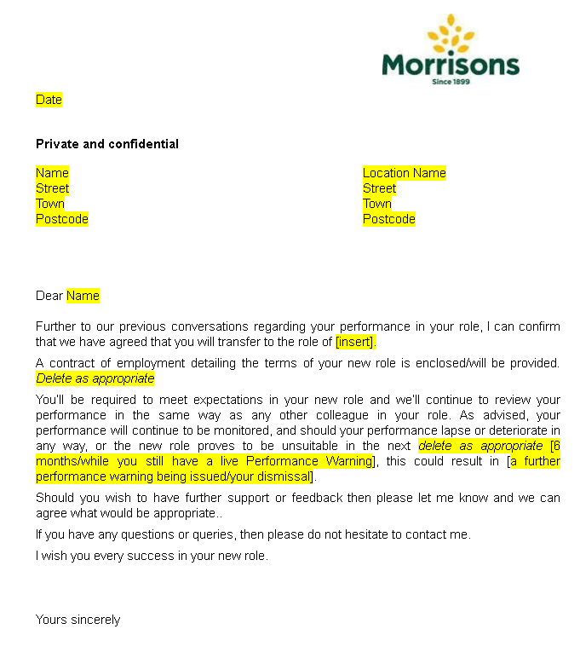

EV13
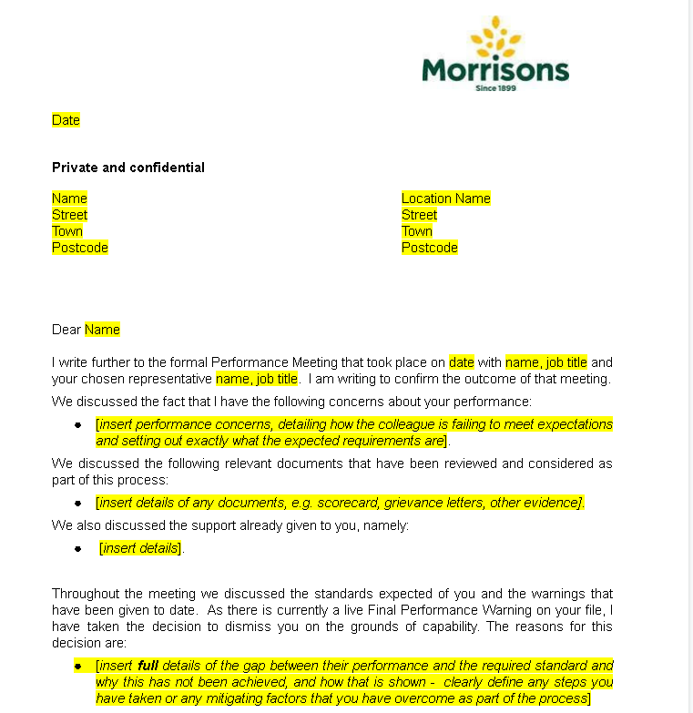

EV14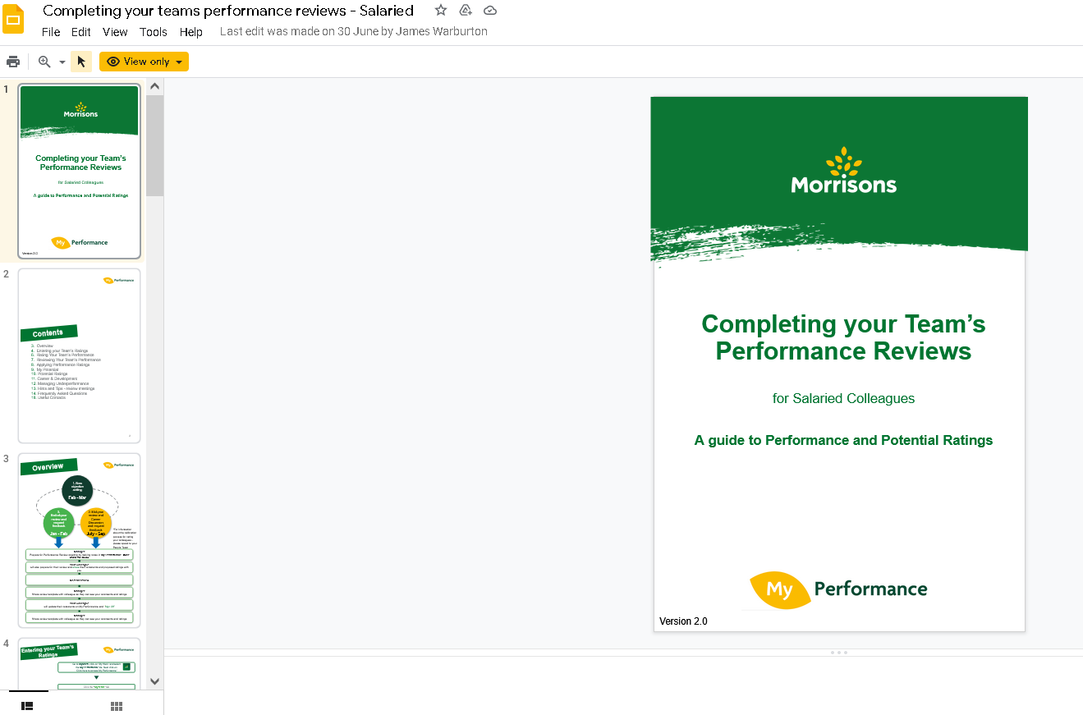
EV15
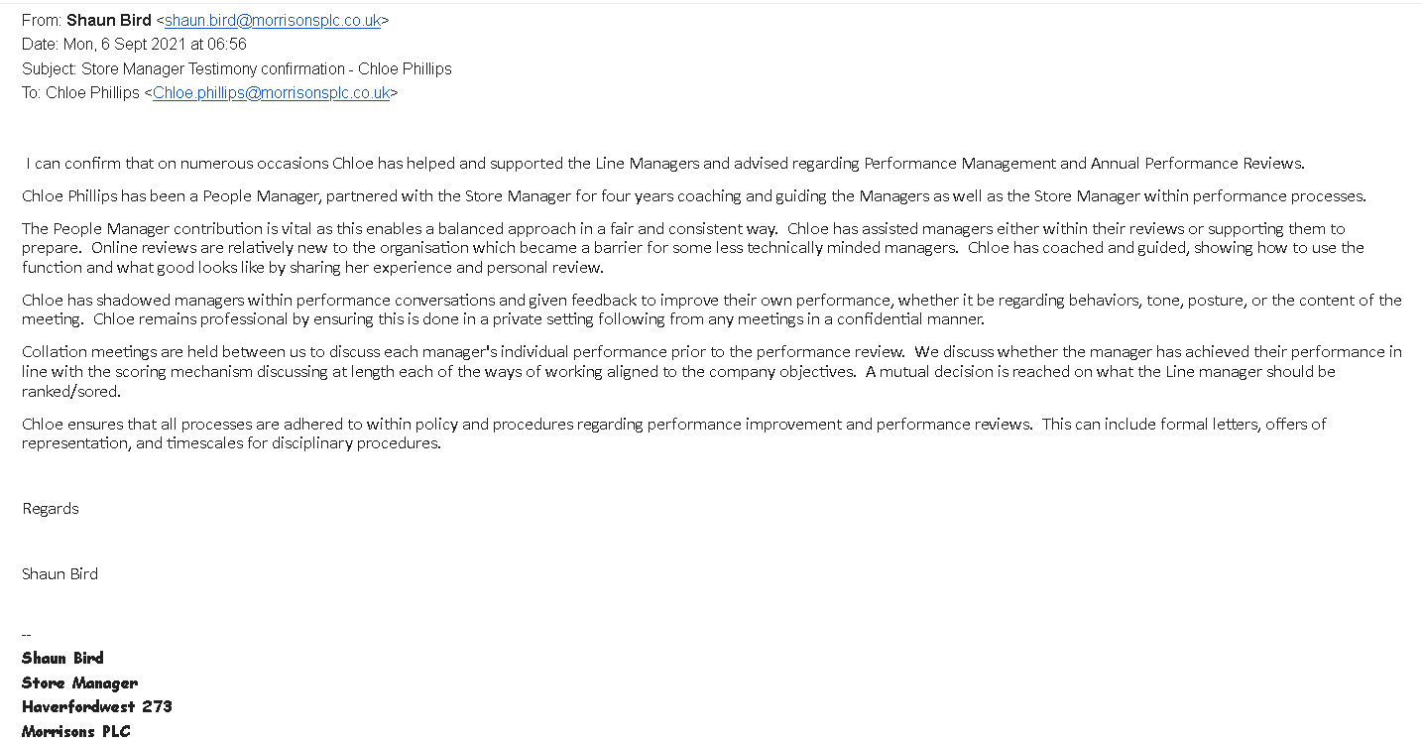
EV16
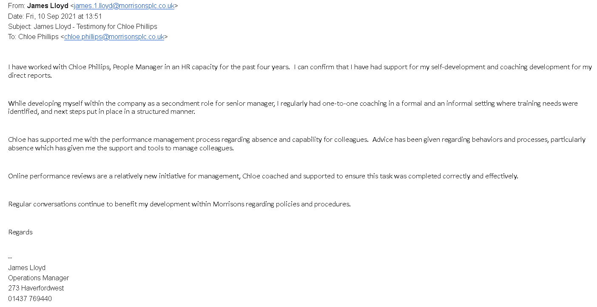
EV17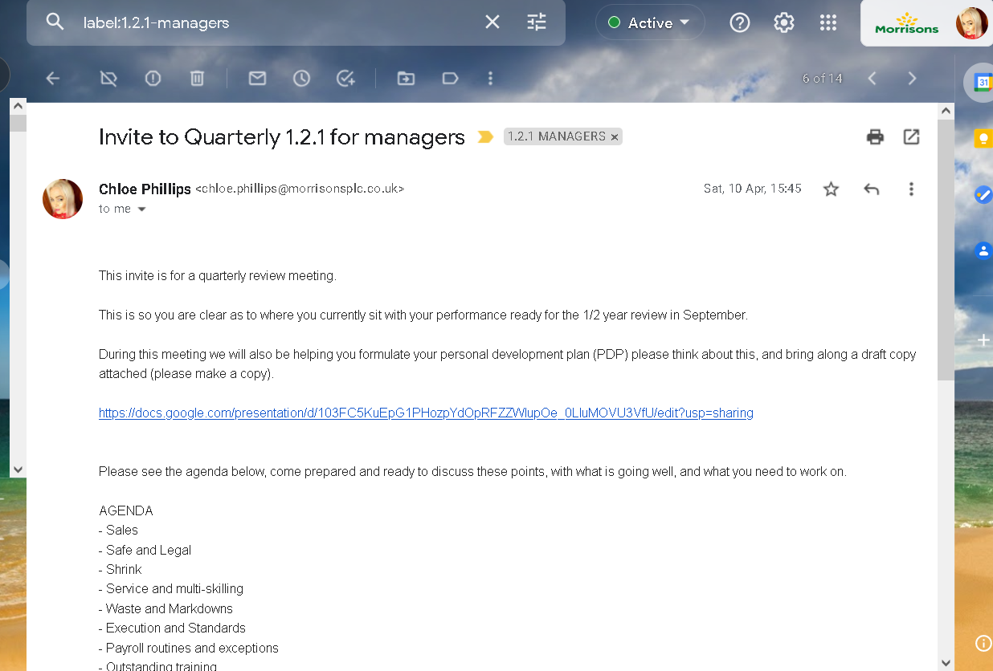
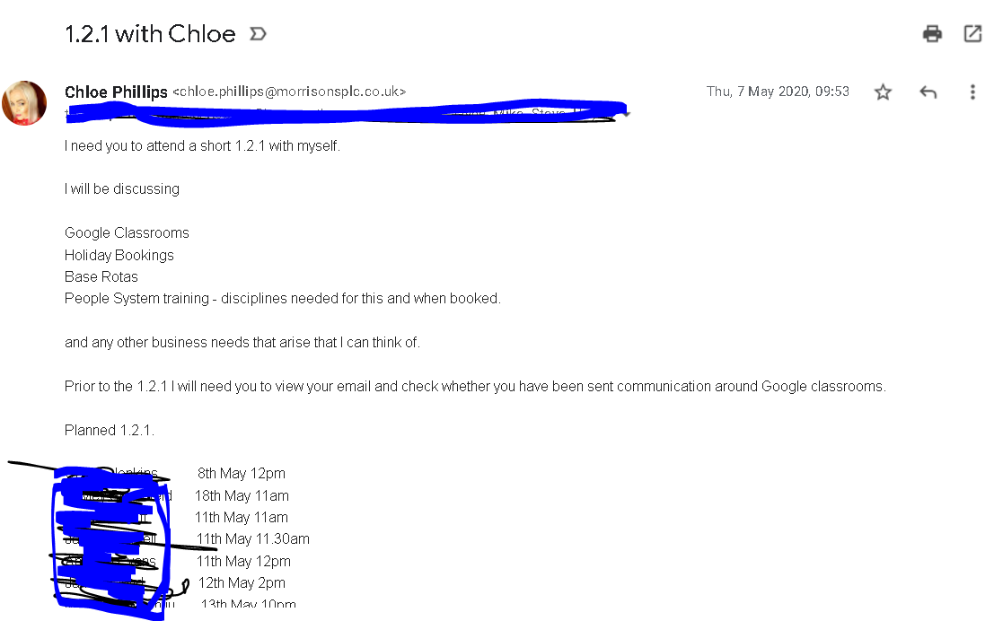

EV18
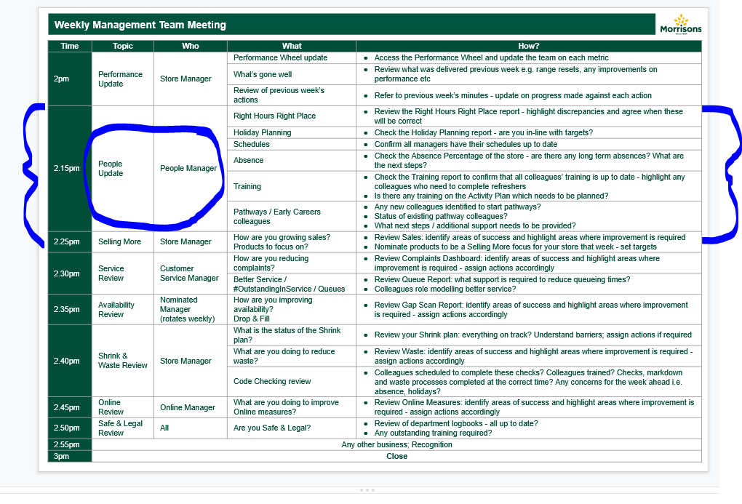
EV19
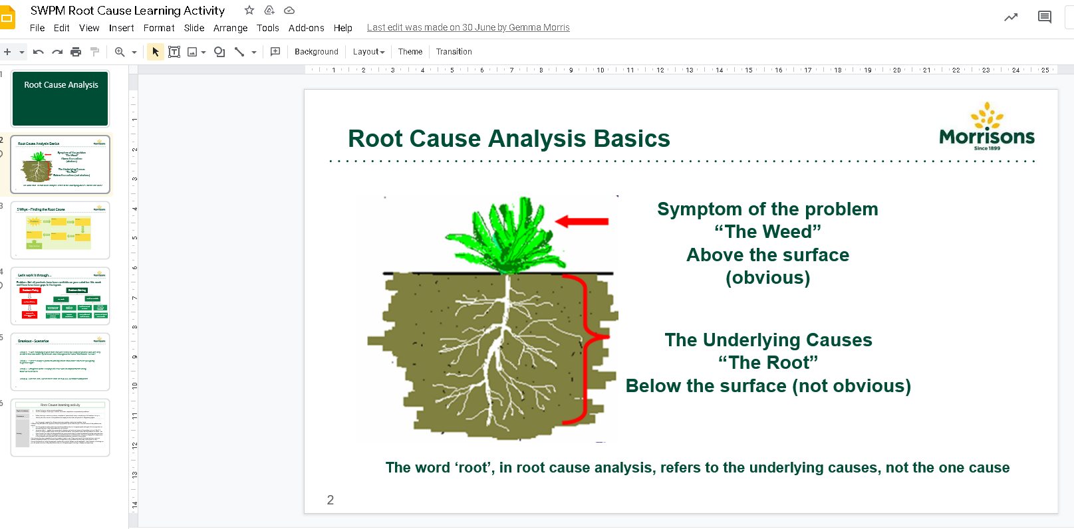

EV20
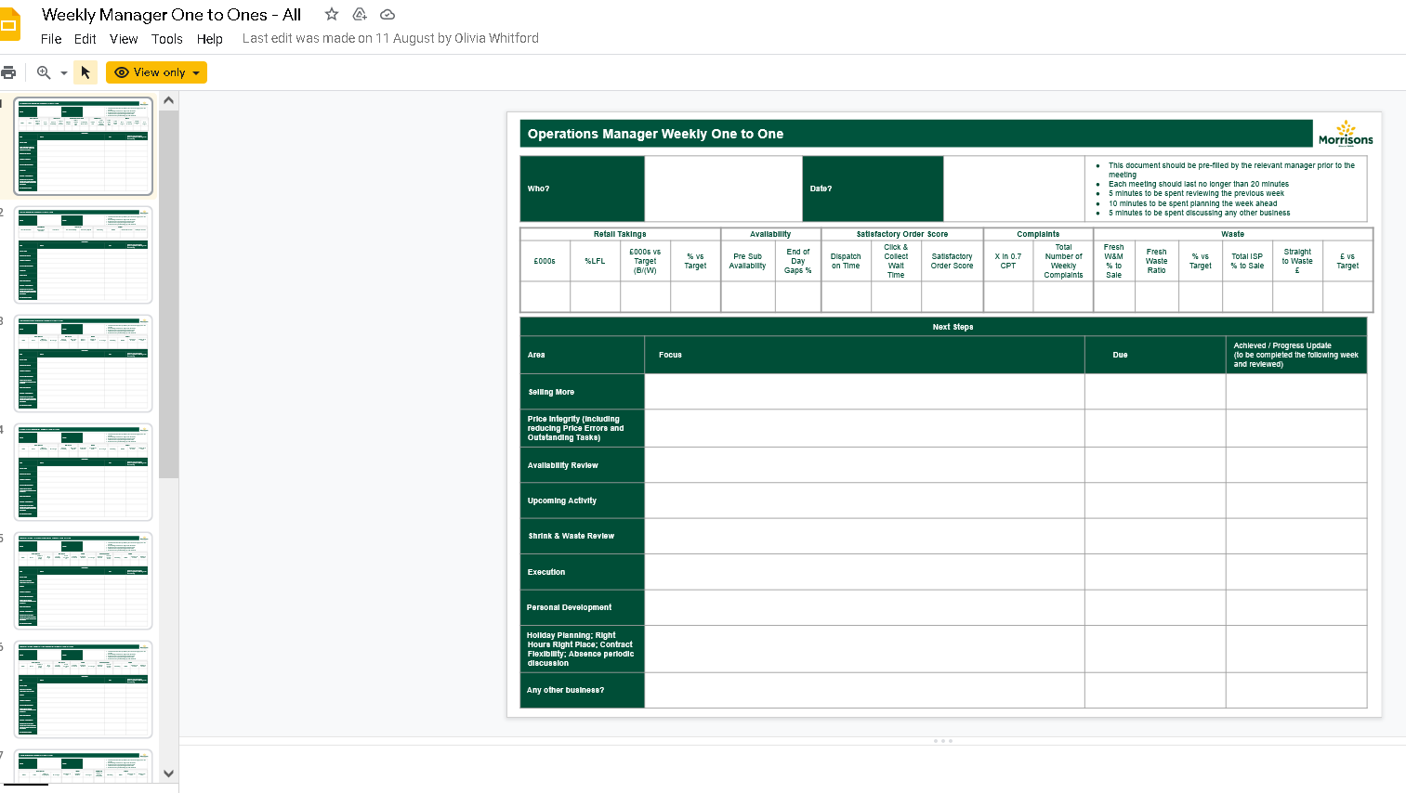
EV21


EV22
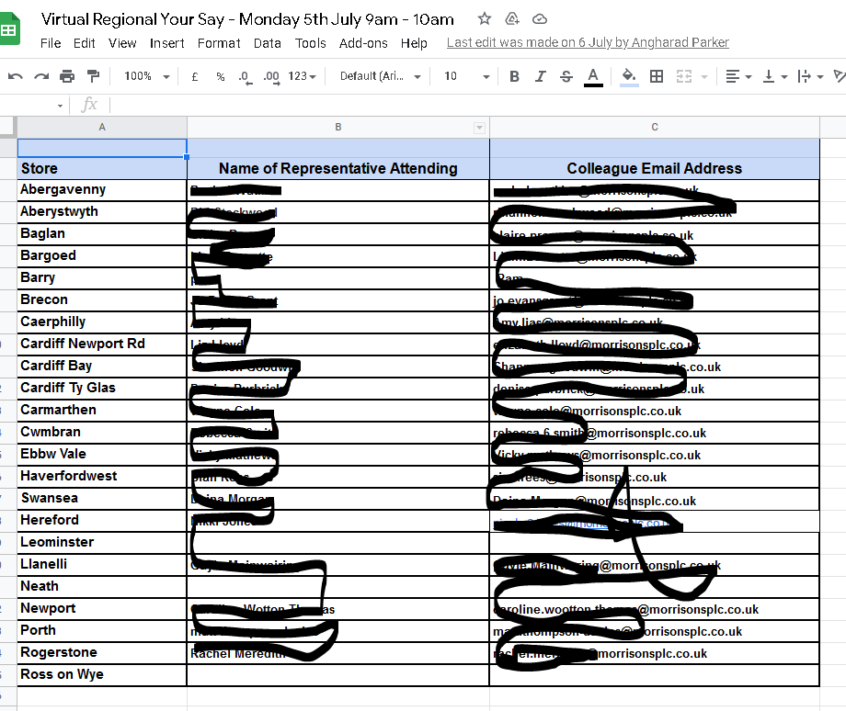

EV23
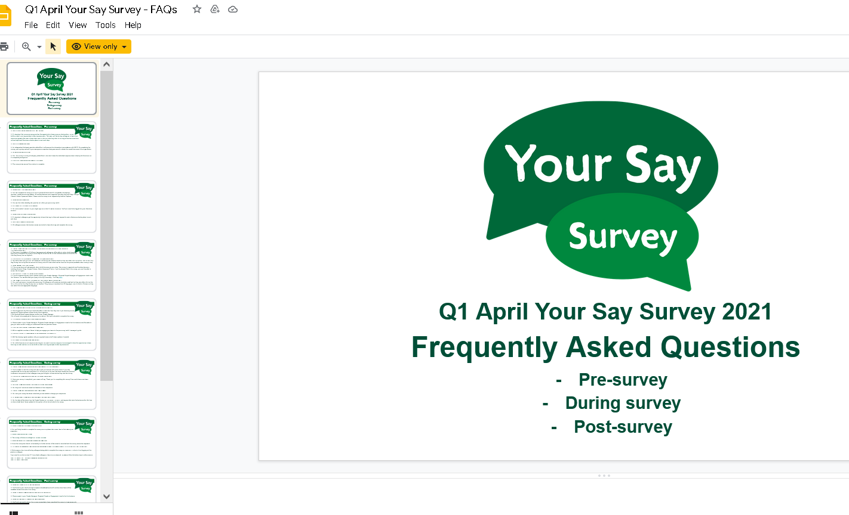

EV24
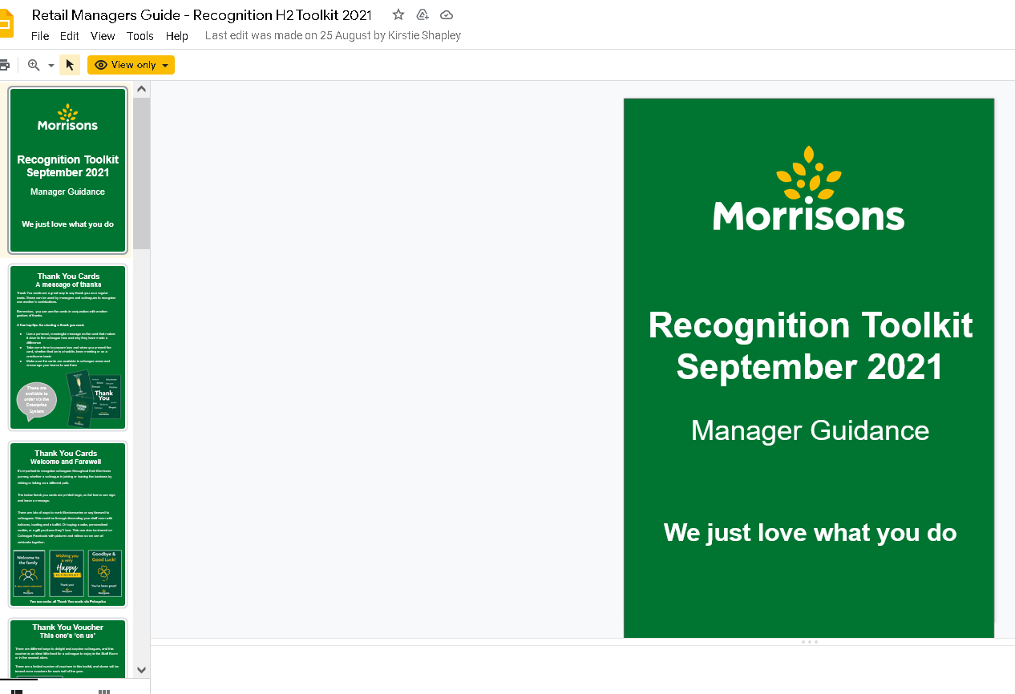

EV25
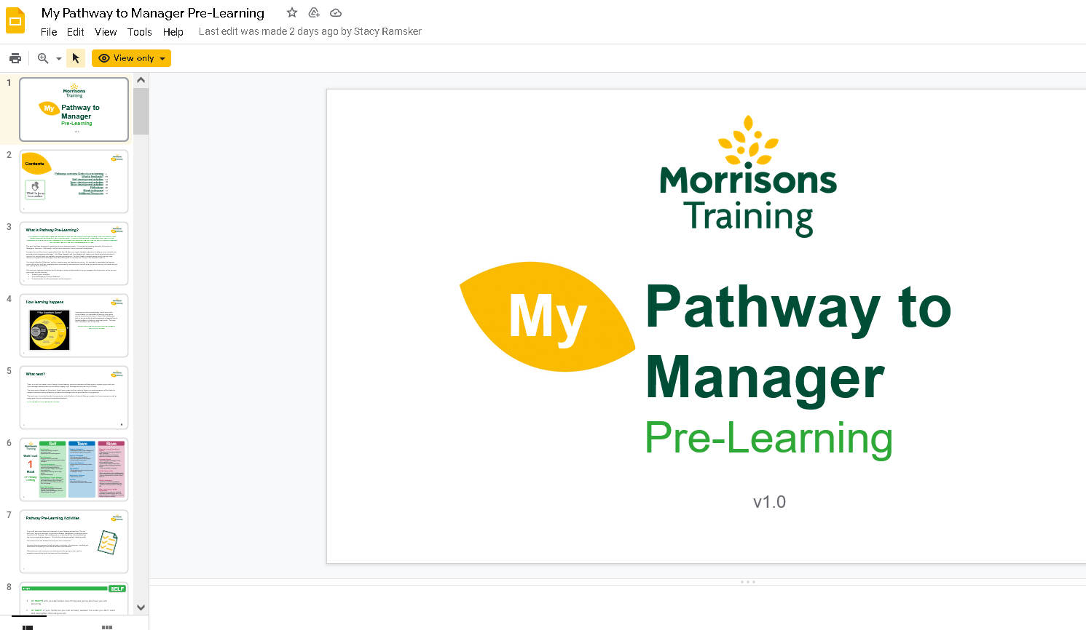

References

Armstrong, M. (2010) Armstrong’s handbook of reward management practise: Improving performance through reward. 3rd edn. London: Kogan Page

CIPD (2020) – Performance related pay, available at:
https://www.cipd.co.uk/knowledge/fundamentals/people/pay/performance-factsheet#8206 (accessed on: 11th September 2021)

CIPD (2021) – Leadership Factsheet, available at:
https://www.cipd.co.uk/knowledge/strategy/leadership/factsheet (accessed on: 11th September 2021)

CIPD (2020) – Induction, the importance of an induction factsheet, available at:
https://www.cipd.co.uk/knowledge/fundamentals/people/recruitment/induction-factsheet#7346 (accessed on: 11th September 2021)

Government – Equality Act, available at: -
https://www.gov.uk/guidance/equality-act-2010-guidance(Accessed on 3rd September 2021)

McKinsey & Company (2019) ‘Setting the ‘HOW’ in performance management’ Available at:
Setting the “how” in performance management | McKinsey & Company (accessed on: 11th September 2021)

Mind Tools (2021) Smart Goals, how to make your goals achievable, available at:
https://www.mindtools.com/pages/article/smart-goals.htm (accessed on: 11th September 2021)

Morrisons – Groceries Supply Code of Practice, available at: -
https://www.morrisons-corporate.com/suppliers/meet-our-buyers/(Accessed on 3rd September 2021)

Usdaw – Morrisons agreement, available at: -
http://www.usdaw.org.uk/morrisons (Accessed on 3rd September 2021)

Wales Gov – Data Protection Act, available at: -
https://www.gov.uk/data-protection (Accessed on 3rd September 2021)

Wales Gov – Codes of practice, available at: -
https://gov.wales/sites/default/files/publications/2019-09/code-of-practice-ethical-employment-in-supply-chains.pdf (Accessed on 3rd September 2021)

