AI acknowledgment
I acknowledged the use of ChatGPT https://chatgpt.com/ On the 14/10/25 to write my notes into submissions format using the prompt – best ways to structure an essay plan at university level?
I confirm that I have not presented any AI generated text as my own work, I confirm I have copies of my drafts, notes, and other resources I used before, and after the use of AI tools which I may be asked to provide in evidence
I acknowledged the use of ChatGPT https://chatgpt.com/ on the 22/10/25 to find critics on my key theorists using the prompts – who criticised the trait theory for individual differences?
I confirm that I have not presented any AI generated text as my own work, I confirm I have copies of my drafts, notes, and other resources I used before, and after the use of AI tools which I may be asked to provide in evidence.

Article summary
‘How does music make you feel’
(Zoe Nendick 2020)
In the article ‘how does music make you feel’ presented by Zoe Nendick (2020), Nendick explores the deep association between music and human emotions, as well as how music can be illustrated as an escapism, explaining that music can be paired with every sentiment. She discusses how ubiquitous music is in everyday lives and can follow us in personal and social events that may occur. Nendick questions how something so simple can easily move humans so deeply.

Nendick then discusses the importance of theories to framework, considering individual differences in determining emotional responses to a song. Throughout her time studying in university, she explains that most individuals will have memories intertwined with a certain song which will provide a strong impact on how their emotions are shaped (Belfi et al., 2016 cited by Nendick 2020), Nendick then analyses the impacts and rewards music has on the brain, such as amygdala and medial prefrontal cortex, which can alter ‘musical chills’ which can connect music to memory(Blood & Zatorre, 2001 cited by Nendick 2020)

Nendick dives deeper into the history of music and depicts the emotion and meaning of music (Meyers 1956, cited by Nendick 2020) This proposed the idea that individuals ‘feel emotions in response to the harmonic progressions of music’. Furthermore, Patrik Juslin and his associates soon then developed the term BRECVEMA, which was the idea that ‘music- induced emotions are thought to result in complex interactions between the learner, the music and the situation’ (Juslin & Vastfjall, 2008; Juslin 2013, cited by Nendick 2020) outlawing the idea that there is a ‘positive correlation between high neuroticism and nostalgia proneness’.(Barrett et al., 2010)

Nendick also explores the study of emotional responses, and how much of a deep connection can be formed with an individual and music. “The study of emotional responses to music is closely linked to the field of music therapy” (Suda et al., 2008). Nendick articulates the idea that music therapy can be significant to people with Alzheimer’s disease and can have impacts like stress relief (Fraile et al., 2019) and can articulate strong emotions that can recall a memory from the past.

Nendick finalised with the notion that ‘background music can affect consumption at the levels of cognition, emotion, and behaviour’ (Jain & Bagdare, 2011) with the concept that music influences cognitive, emotional and behaviour, subtly shaping how individuals act and think, depicting on the shaping on emotions.

Nendick. Z. (2022, September 12). How does music make you feel? https://www.bps.org.uk/psychologist/how-does-music-make-you-feel BPS

Referencing task

Davis, E. R. & Clarke, M. J (2022). Modern marketing strategies. Business Book publishing
Department for environment, Food & Rural Affairs (DEFRA) (2020). UK climate change risk Assessment 2020. UK government
https://www.gov.uk/government/publications/uk-climate-change-risk-assessment-2020
Garcia, M, T. (2022, March 5). Climate change impacts on costal cities. The global times https;//globaltimes.com/climate/costal-impact
Kim, S, H. Patel. R & Wilson. J, D (2021). Virtual reality in education. A meta-analysis. Educational technology research and development. 69 (2) 1105-1123.
Lee, A, M. (2020). Cognitive development in early childhood. Brown, P & L, Green (editors) Child development theories (pages. 45-67). Springer
Ling, Z. (2019). Enhancing user experience in mobile app. Proceedings of the international conference on human-computer. ACM press (p.102-110)
Martinez. S. L. (2022, October 14). Advances in renewable energy storage. International symposium on sustainable energy. Berlin, Germany
Morgan, D. S. (2021). Machine learning applications in health care diagnostics. University of Edinburgh
NHS Greater London Trust (2022). Annual patient satisfaction survey report, London UK.
Nguyen. P, H (2018). Blockchain technology in finance. R. Singh & C., Alan (editors) innovations in financial technology (ebook) (p 122-139) Wiley online library
Nguyen, L, T., O’Connell, M. A., Li, S. J., Rivera, P. M., Adam’s, F. R., Chen, H. Y., Bailey, T. K., Jones, A. R., Walker, C. L., … Ahmed, S. E… (2022). Cognitive flexibility and function in early childhood. Journal of Experimental Psychology; General. 151(4), 789-805 https://doi.org/10.1037/xge0001223
Patel, R. S (2020). The ride of digital therapy. The Psychology, 33(6), 48-52.
Reynolds, K. M (2023). How mindfulness improves productivity. Mindful living https://mindfulliving.com/how-mindfulness-improves-productivity
Smith, J.A (2019). Understanding psychology. (3rd ed) Academic press
Thompson, R.E (2018). Social media effects on adolescent mental health. Journal of adolescent health. 63 (4) (p. 410-417) https://doi.org/10.1016/j.jadohealth.2017.11.290

U.S. department of education (2017) national education technology plan 2017
https://www.ed.gov/netp
University of Oxford (2022). Referencing and citation guide
https://www.ox.ac.uk/students/academic/referencing
Williams, J, L. (2020). Exploring sustainable urban development (doctoral dissertation) university of California
https://escholarship.org/uc/item/7gp4v2cd
World health organisation (2023). Mental health and covid-19
https://www.who.int/mental_health/covid_19

Essay plan
‘Discuss how trait theories of personality account for individual differences in behaviour’ (1,600 words estimate)

Paragraph 1; introduction (150 words)
- Main essay aims (what will be discussed) eg, introduce discuss definitions, key historical backgrounds, key theorists)
- Clearly define trait theory
- Define individual differences and personality, and how behaviour can affect it.
- Lightly introduce key theorists and their beliefs (Allport, Eysack, Cattell)
- Introduce key history and background of trait theories

Paragraph 2; Main body (350 words)
- (In more depth) History and background of trait theories (1800-1900s)
- Early origins (ancient Greek ideas?)
- Concept of where the idea comes from, who produced the idea of trait theories? (Gordon Allport 1937 etc)
- Criticised by modern perspectives/ developments, what has changed in terms of old society? Evaluate the criticism by Walter Mischel (he discussed lack of individual depth, oversimplification, subjectivity)

Paragraph 3; Main body (300 words)
- What is the main idea of this research?
- Explore key theorists, main models of trait theory (Allport, Costa etc)
- Discuss their beliefs and evaluations
- Discuss Eysacks three-dimension theory (1950s-1970s)
- Evaluate Cattells factor analysis
- Discuss their outcomes, biological, social elements?

Paragraph 4; Main body (350 words)
- Outline key five factors presented by Paul Costa and Robert McCrea (1949), openness, consciousness, agreeableness, neuroticism, and extraversion
- Explain each factor (provide relevant, real-life scenarios)
- Evaluate how trait differences influence behaviour and how? Reasons behind this?
- Provide experiments/ applications and studies used in trait theories (eg, the catcher)

Paragraph 5; Main body (250 words)
- Strengths
- Limitations (of each key factor)
- Comparisons with other key factors (humanistic approach, social cognition etc)
- Which psychologist disagrees with who?

Paragraph 5; Conclusion (200 words)
- Summarise key points included
- Highlight strengths and weaknesses
- Evaluation and critical insight
- Discuss main body and arguments of the study
- Conclude with reflection.

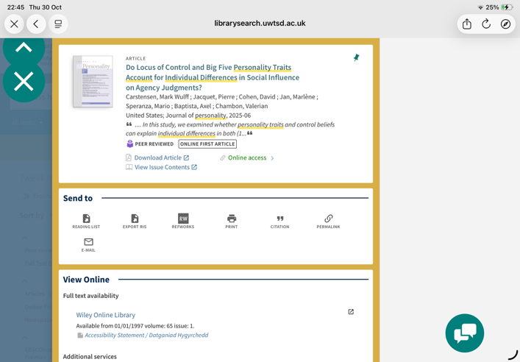
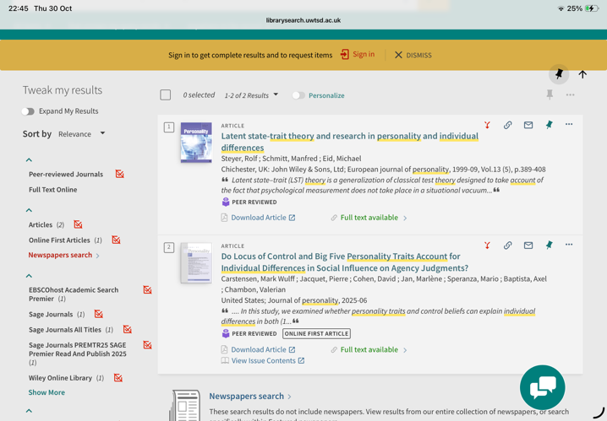
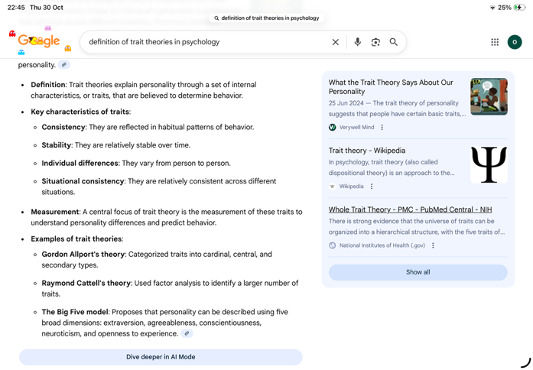
The screenshots provided, have been considered reliable, as the selected books and research I have chosen is both written by qualified psychologists. The sources stay credible ands up to date as they were published in 2025. Although, one of the books provided was published in 1999, despite this, psychologists published the book, so this evidence stays reliable. These pieces of research are found with relevance to my work, as it discusses my chosen topics and the key aims outlined in the essay plan.

