This Photo by Unknown Author is licensed under CC BY-NC
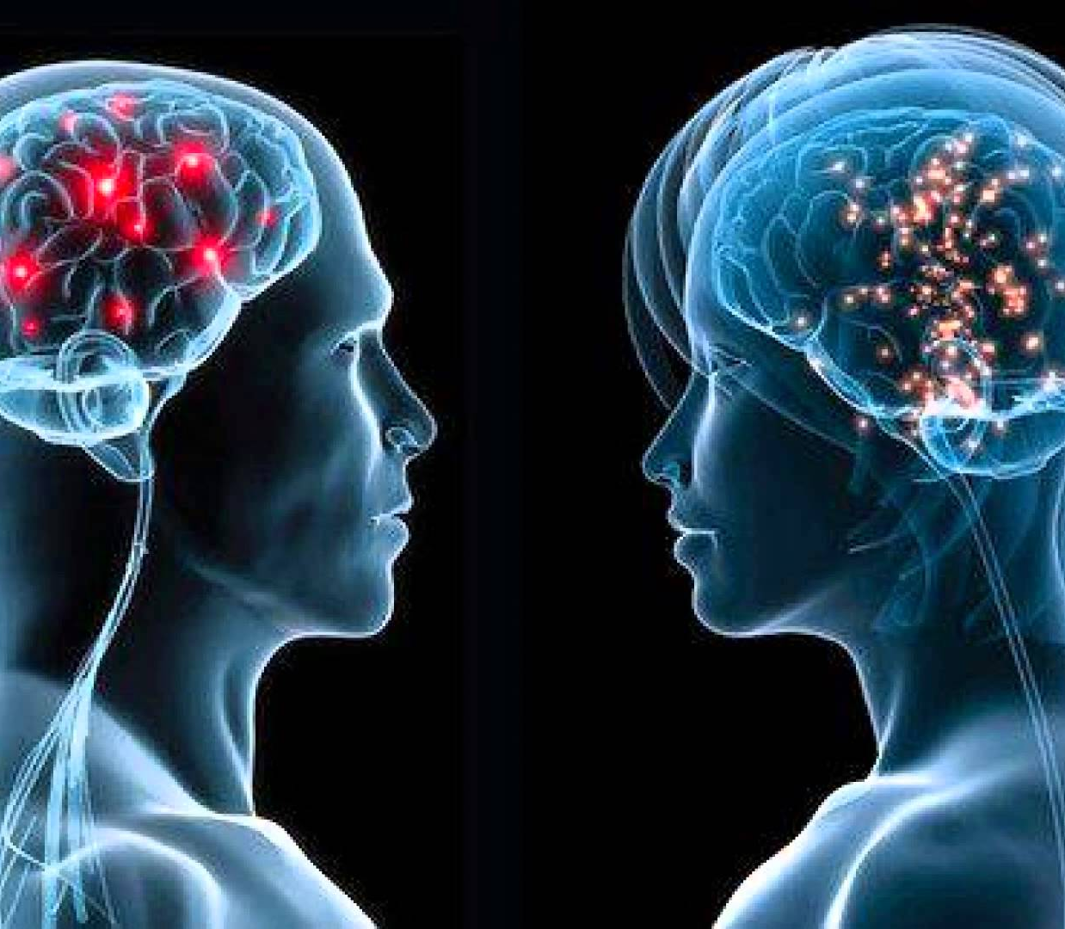
Psychology for Health and Social Care (BMHP4003_LON)
LECTURER NAME: MS ADESEWA AJAYI
Student name: Alexandra Nicut | Student ID: 1919639 | Subject: Death stage-Academic Essay

Psychology for Health and Social Care in death stage related to elderly people.

Table of contents

Introduction………………………………………………………………….2
What is psychology?............................................................................2
The human development by Dr Thomas Armstrong……………………2
Lifespan explained………………………………………………………………….3
Erikson’s theory of psychosocial development………………………………….3
Fields of psychology in relation to old dying stage.……………….……………4
Challenges in health seeking behaviours………………………………………..4
The stages of behaviour change in relation to death stage explained……….…..5
Carl Jung’s theory of personality types……………………………………….6
Explaining the death process shortly…………………………………………6
Research based discussion.………………………………….…………6 and 7
Conclusion……………………………………………………….………………8
References………………………………………………………………9 and 10
Appendix………………………………………………………………11

Introduction
This essay is aiming to demonstrate the relation between the psychology and human development up to the dying stage. I will include lifespan examples, and challenges that a person must go through as part of life.
I will exemplify how people who become a victim of the ongoing life and mental health diseases of all sorts, are facing the psychological process by themselves supported by family or government if there are no relatives involved.
Families and society play the most important role in supporting the elderly people. Therefore, a discussion about the emotional impact on their mental health will explain theories, field examples and how is this affecting them from a psychological perspective.
According to Dr Armstrong, there are 12 stages of human development, but I am only going to talk about the very last one, which is death or dying stage. Please note that these fields are selected out of a wide range of psychology fields and based on the subject, all the other fields of psychology, such as sports psychology, forensic psychology and cross-cultural psychology will not be discussed in this essay. However, all these psychology sectors may have been part of an individual’s past, daily routine, or career.
In conclusion, I will demonstrate the connection between the theories of Dr Armstrong, Erikson, and Jung’s psychology applies to old-aged people and above, including the death stage.
What is psychology?
Psychology “it’s the science of why we think and behave the way we do, alone and in our relationships, and its findings are relevant to every aspect of our lives” (Jarrett, 2011, p. 3).
People like Wilhelm Wundt (1879), considered the “Father of Modern Psychology” and its inventor, Francis Galton (1822-1911), “Father of Mental Tests” and Hermann Ebbinghaus (1885), the first to do memory experiments, are only some of the famous people that contributed to improve and discover more about psychology.

The human development by Dr Thomas Armstrong
According to the American Institute for Learning and Human Development, the executive director, Thomas Armstrong teaches 12 stages of life as follows (Please see appendix A):
1. Pre-Birth
2. Birth
3. Infancy
4. Early Childhood
5. Middle Childhood
6. Late Childhood
7. Adolescence
8. Early Adulthood
9. Midlife
10. Aged between 50-80 years old, called “Benevolence” and represents the mature adulthood.
11. Aged 80 years plus are considered the “wisdom” and represent the late adulthood.
12 Death and dying as part of life, represents our end-of-life stage which is teaching us the importance of living the life and value each moment (Lifeopedia.com, 2021).
However, I am going to refer only to the very last stage of life and demonstrate how this stage relates to the psychological lifespan theories through a discussion.
Lifespan explained.
Erikson Erik (1902-1994) has had a contribution to the lifespan development. Erikson came with a theory in which 8 different stages are developed and that people need to go through. Erikson won the National Book Award and the Pulitzer Prize for his most popular books, “Childhood and Society”, in 1950, and “Gandhi’s Truth”, in 1969 (Notes, 2021).

Erikson’s theory of psychosocial development looks as follows:
AGE  0-1  2-3  3-5  6-11  12-20  Mid-20s  25-60  60+ | STAGE  Infancy  Early childhood  Pre-school  School Age  Adolescence  Young adults  Adulthood  Old age | CRISIS  Trust vs Mistrust  Shame and doubt vs autonomy  Initiative vs guilt  Inferiority vs industry  Role confusion vs identity  Intimacy vs isolation  Stagnation vs generativity  Ego integrity vs despair

Fields of psychology in relation to old dying stage.
Developmental psychology studies why and how people change from birth to old age. This field started by studying children and infants, however, was advanced later and included elderly population, adults, and adolescents. Professionals, as part of their career, are investigating how ecological and genetic factors (nature and nurture), are impacting the human being advancement as the time goes by (UNIVERSITY, 2021).
Social psychology is the scientific study of people’s behaviour in their cultural and social surroundings (Argyle, 2021). Another explanation may be that this field studies how behaviour and attitude is affected while interacting with others, how people relate one to another and how are they influenced.
Clinical psychology is the study dealing with a variety of mental health issues and physical problems such as depression, anxiety, relationship issues and learning difficulties (NHS, 2021).
Health psychology is an area of specialty that concentrates on how psychology, behaviour, biology, and social aspects affect illness and health (Cherry, 2021).
Behavioural genetics is a study that relates to genetics and environmental factors which impact on behaviour (Bibliographies, 2017). Genetics refers to all human traits that are inherited and impact on a person’s behaviour.
Cognitive psychology “…is defined as the branch of psychology devoted to studying mental processes” (Thomas, 2021). Some examples of cognitive psychology are mental imagery, thinking, attention, reasoning, memory, making decisions or thinking of my own thinking, also known as meta-cognition.
Challenges in health seeking behaviours
Depending on an individual mental strength and the psychological development, a person may use health seeking behaviours to help them cope with the death stage.
Health seeking behaviours may include the family of the person in a dying stage. In most situations, family can support the mental health, bring up positive thoughts by sharing beautiful memories, can support financially and can assist with personal care such as feeding and encouraging the dying person in a way that can divert them from focusing on the end-of-life stage.
Having no family remaining to support individuals in their death stage is the most difficult part of this stage and means that the government and local authorities need to step in and fund the persons needs. A person needs in their death stage may vary from providing food, medication administration, day to day living supplies of creams, pads, equipment such as catheters or breathing machines, to housing or accommodation such as a care home, or domiciliary personnel, which is usually arranged by an authorised social care worker assigned by their local council.
The stages of behaviour change in relation to death stage explained as follows:
Precontemplation-Contemplation-Preparation-Action-Maintenance.
The precontemplation stage in old age means that the person is unaware of what is happening with themselves such as those living with advanced dementia or severe brain damage. In these cases, is very difficult to communicate with the individual and very unlikely that they would remember a simple thing such as not being able to remember what they have eaten or tell you what the time is while showing them a watch.
Contemplation is when the elderly person is aware of the death stage and their behaviour. During a lifetime, you may have encountered people that need to go through an acceptance process before understanding that they are approaching the end of the journey while other people just desire to go as soon as possible. Here comes the question whether is worth fighting back or not.
Preparation may be obvious and intentional in elderly stage because it is expressed through actions. In death stage, when a person is ready to end the chapter of their life, they may stop eating, drinking, walking, and decline to act against the process.
Action does not take place anymore, and the practice of desired behaviour becomes a routine. A person on their death stage may become less responsive, active, talkative, compliant, or less prepared to die.
Maintenance is more about sustaining the behaviour change, compliance and acceptance whether is willingly while aware or unwillingly if not aware due to a mental health condition.
According to Carl Jung’s theory of personality types (1875-1961), determines the differences between people in whatever way they prefer to use their minds. The original typology of Jung is divided into 2 personality attitudes, such as introversion and extroversion, and 4 functions such as sensation, thinking, intuition and feeling (PSYCHOLOGIA, 2021).
Carl Jung’s theory of personality types:
1.Focus of energy 2. Taking in information
-introversion. -sensing.
-extroversion. -intuition.
3.Coming to conclusions 4. Approach to life
-thinking. - perception.
-feeling. - judgement.
Explaining the death process shortly.
Losing a family member regardless of their age, gender, colour, marital status, beliefs, or culture is the most painful event in life. We all die at some stage in life and there is no way someone can change this. However, we can prepare in advance from a psychological point of view and be able to stay strong for the ones remaining.
When the countdown begins, you may find that your beloved family member may experience hallucinations in which they talk to people that died or are not present at the time.
As the leaving time gets closer, they may sleep more than they used to in the past and if awake they will have troubles co-operating, reacting, or replying to you as their senses may be collapsing.
In the very fewer hours of life left, their body will begin to shut down. The pulmonary and the circulatory system will start to fail gradually. They may not be able to see you, however, their hearing may not be affected just yet which means they might be able to hear you but not able to reply.
Some symptoms that can be experienced during this time may include cold hands, teary or glassy eyes that may be halfway opened, weak pulse, hallucinations, sleeping and unable to be awaken, breathing being interrupt or simply stop completely (HOSPICE, 2017).

Research based discussion.
In United Kingdom 2018, more over six hundred and sixteen thousand deaths, from which the most were between the years of 2000 to 2018 (Clark, 2020).
The human cognition, emotions, and behaviour specific to the death stage varies from one individual to another and all the other stages or age groups may be involved. For one reason or another, at any point in life someone can go through the death stage without getting to pass a certain age.
Dementia and Alzheimer’s disease are leading the cause of deaths in the United Kingdom, registering a total of 12,7% in 2018 (Statistics, 2020).
According to Child Bereavement UK: Office for National Statistics; National Records of Scotland; Northern Ireland Statistics and Research Agency, in United Kingdom, 5821 people committed suicide, around 9 babies every day, or 3200 were stillborn babies, 6,608 children and babies under five years old, 869 children aged between 5 and 16 years old died, and 7653 people, children, babies, under the age of 18 years old died in 2017 (UK, 2018).
Moving forward, the death stage in relation to Erikson, Armstrong, and Jung’s theory, demonstrates that some people can only reach to a certain stage while others go throughout all 12 stages, just as a normal life course should be.
Erikson states that “In adults the impairment of basic trust is expressed in basic mistrust” (Erikson, 1959-1980), explaining further that people may enter a psychotic state of regression that is causing elders to decline food, become unmindful to companionship and refuse comfort.
The anti-social behaviour is common in death stage which makes the process much more difficult for family and friends that suffer alongside. However, the preparation and maintenance are sustained by healthcare professionals through their experience, training and knowledge that is taking part into the dying process by being supportive, caring, and comprehensive towards the individual’s stage.
Conclusion
Death stage is one of the hardest to go through and sometimes is painful as well. It is not painful just for the subject but also for both, family, and friends. Death may intervene at any life stage due to the suicide rates, accidents, unknown heart diseases or complications that may occur during the life, cancer, high rates of obesity or diabetes type 2. My life experience as a community carer has thought me that even someone is not related to me, they are there for a reason and I am there to support them through their end-of-life stage.
The psychological impact on those in a dying stage is heart-breaking for the family and friends. The behaviour changes and challenges must be confronted in one way or another and we all come to an end where support and compassion is needed.
Developmental psychology, social psychology, clinical psychology, and psychology in general, has a beneficial impact on everyone’s life if there is enough willpower to change things on to a correct direction before the death stage.

References
Argyle, M., 2021. Britannica. [Online]
Available at: https://www.britannica.com/science/social-psychology/20th-century-approaches
[Accessed 1 4 2021].
Bibliographies, O., 2017. Oxford Bibliographies. [Online]
Available at: https://www.oxfordbibliographies.com/view/document/obo-9780199828340/obo-9780199828340-0010.xml?rskey=wpjLDS&result=1&q=behaviour+genetics#firstMatch
[Accessed 4 4 2021].
Cherry, K., 2021. Studying Health Psychology and Illness. [Online]
Available at: https://www.verywellmind.com/what-is-health-psychology-2794907
[Accessed 10 4 2021].
Clark, D., 2020. Statista Logo. [Online]
Available at: https://www.statista.com/topics/6656/death-in-the-uk/
[Accessed 10 4 2021].
Erikson, E. H., 1959-1980. Identity and The Life Cycle. First Edition ed. London: Penguin Books Canada Ltd.
HOSPICE, O. C., 2017. Omni Care HOSPICE. [Online]
Available at: https://omnicarehospice.com/end-of-life-timeline-signs-symptoms-dying/
[Accessed 15 4 2021].
Jarrett, D. C., 2011. The Rough Guide to PSYCHOLOGY an introduction of human behaviour and the mind. In: J. Staines, ed. The Rough Guide to PSYCHOLOGY an introduction of human behaviour and the mind. London: Rough Guides Ltd, p. 370.
Lifeopedia.com, 2021. Lifeopedia.com. [Online]
Available at: http://www.lifeopedia.com/different-needs-for-the-different-stages-of-our-lives/#:~:text=These%20four%20basic%20stages%20can%20be%20broken%20up,teaches%20the%2012%20stages%20of%20life%3A%20Pre-Birth.%20Birth.
[Accessed 2 4 2021].
NHS, 2021. NHS. [Online]
Available at: https://www.healthcareers.nhs.uk/explore-roles/psychological-therapies/roles/clinical-psychologist
[Accessed 17 3 2021].
Notes, S., 2021. Sparknotes. [Online]
Available at: https://www.sparknotes.com/psychology/psych101/majorfigures/characters/
[Accessed 15 3 2021].
PSYCHOLOGIA, 2021. Jung Personality Types: The Model of Typology. [Online]
Available at: https://psychologia.co/jung-personality-types/
[Accessed 21 3 2021].
Statistics, O. f. N., 2020. Office for National Statistics. [Online]
Available at: https://www.ons.gov.uk/peoplepopulationandcommunity/healthandsocialcare/causesofdeath/articles/leadingcausesofdeathuk/2001to2018
[Accessed 5 4 2021].
Thomas, J., 2021. better help. [Online]
Available at: https://www.betterhelp.com/advice/psychologists/what-is-cognitive-psychology-examples-definition-and-benefits/
[Accessed 11 4 2021].
UK, C. B., 2018. Child Breavement UK. [Online]
Available at: https://www.childbereavementuk.org/death-bereavement-statistics
[Accessed 29 3 2021].
UNIVERSITY, M., 2021. MARYVILLE UNIVERSITY. [Online]
Available at: https://online.maryville.edu/online-bachelors-degrees/psychology/types-of-psychology/#developmental
[Accessed 30 3 2021].

Appendix A
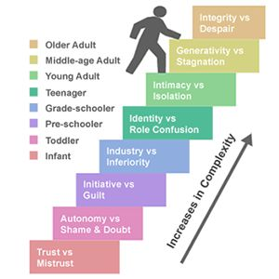
This Photo by Unknown Author is licensed under CC BY-NC

