

Student Name :- Patel Manthan Sureshbhai
Student Id :- 2241308
Programme :- MBA- Master Of Business Administration
Module :- Digital Marketing
Module Code :- LCMB7010
Lecturer Name :- Amitave Banik
Submission Date :- 18/12/2023

DIGITAL MARKETING STRATEGY OF ZARA

Table of Contents

Task 1 4
Part 1: Introduction 4
Company Background 4
Marketing Strategy 4
Overview of Zara’s Digital Marketing Strategy 4
Alignment with Overall Business Objectives 5
Internal and External Flows 6
Internal Communication and Workflow in Digital Marketing 6
Workflow in Digital Marketing 6
External Digital Communication Channels 6
Digital Asset 7
Zara’s Digital Asset Portfolio 7
Utilization and Performance of Digital Assets 8
Marketing Information Systems 8
Zara’s Marketing Information Systems Infrastructure 8
Data Management and Utilization for Marketing 9
Customer Relationship Management 9
CRM Strategies at Zara 9
Integration with Digital Marketing Efforts 10
Segmentations, Targeting, and Positioning 10
Market Segmentation Approaches by Zara 10
Targeting Strategies and Campaigns 10
Positioning of Zara in the Digital Space 11
Positioning Map and Link with Marketing Mix 11
Visualizing Zara’s Market Positioning 11
Correlation with Marketing Mix Elements 12
Competitive Advantage 12
Zara’s Digital Competitive Advantages 12
Marketing Mix 13

Application of the 7Ps in Zara’s Digital Marketing 13
Sweet Spot of Marketing 13
Identifying Zara’s Marketing Sweet Spot 13
Online Marketing Model 14
Frameworks Used by Zara for Digital Marketing 14
SOSTAC Model 14
Applying SOSTAC to Zara’s Digital Marketing Plan 14
Recommendations and Examples of Artificial Intelligence 15
Part 2: Machine Learning and its Influence on Digital Marketing 15
Ways Machine Learning Influences Digital Marketing 15
Critical Analysis of the applications of Machine Learning in digital marketing to maximize ROI and ROS 16
Ways ML will help Zara in building digital marketing strategy 19
Conclusion 20
References 21

Task 1

Part 1: Introduction
A new era is dawning in retail as online advertising takes center stage in drawing in customers and boosting revenue. Stores can't rely only on traditional retail methods and they also need to make use of digital channels to reach consumers where they spend more and more time: online. Retailers can reach their customers more efficiently and effectively with digital marketing thanks to its analytics and precise targeting capabilities. Retailers may reach more people and increase sales by using search engine optimization (SEO), social media marketing (SMM), and email marketing (Kingsnorth, S., 2022). In addition, digital marketing allows for direct interaction with customers, which is crucial for establishing trust and loyalty in the business.

Company Background
One of the most prominent names in quick fashion is Zara, which is owned by the Spanish retail behemoth Inditex. Zara, founded in 1975 by Amancio Ortega and Rosalía Mera, set themselves apart by transforming the apparel industry with lightning-fast design iteration, going from concept to shop shelves in just a few short weeks. Famous for its lightning-fast trend-following, Zara runs its unique business model via a vast web of physical locations and an effective integration of design, manufacturing, distribution, and sales (Sitaro, 2020). Zara is dedicated to adapting its operations to match the new needs of fashion while also being environmentally conscious, thanks to its sustainability efforts.

Marketing Strategy

Overview of Zara’s Digital Marketing Strategy
Zara's digital marketing approach is to reach a worldwide audience in a fast and stylish way, reflecting the brand's nimble and trend-driven fashion philosophy. A dedication to providing a smooth and responsive client experience via the use of cutting-edge digital advances is essential to this approach. With an e-commerce site that is as stylish as its retail shops, Zara has done an excellent job of establishing a strong online presence. The brand makes use of high-resolution images and interesting material to display its collections, and it makes sure the interface is easy to use and works well on mobile devices to appeal to the growing number of people who own smartphones (Kalsi, 2022). In terms of Zara's online presence, social media is crucial as sites like Instagram and Facebook serve as digital catwalks for the brand's newest collections.
One other pillar of Zara's approach is data-driven marketing. Using advanced data analytics, the organization learns about customers' tastes and buying patterns, which helps with inventory management and targeted advertising. Personalization in email marketing and retargeting advertisements encourages interaction and purchases from existing customers. Finally, to create one-of-a-kind online experiences that combine the real and virtual worlds, Zara has used augmented reality and other immersive technologies (Kalsi, 2022). Despite its size, the company's digital marketing approach is well-coordinated and in keeping with its reputation as a cutting-edge, customer-focused store.

Alignment with Overall Business Objectives
Zara's long-term goals include maintaining its position as the world's preeminent fast-fashion retailer, and its digital marketing strategy is an integral part of that plan. Quickly informing customers about new collections and trends is at the heart of Zara's digital strategy, which aims to be responsive to the market. Maintaining its reputation for swiftly getting items from the runway to the shop is a business aim, and this fits right in with that of its strategy. In keeping with its mission to make its products accessible to people all over the world, Zara is increasing its digital presence. Zara achieves its goal of international expansion and visibility by optimizing its online store for multiple countries and languages. This allows consumers globally to browse its current trends. Also, an attractive, easy-to-navigate e-commerce site is a reflection of Zara's commitment to providing a positive client experience (Popović-Šević et al., 2021). The goal of improving brand loyalty and consumer satisfaction by increasing online and in-store repeat visits is supported by this dedication to digital excellence. One of Zara's business goals is efficiency and its digital marketing approach makes use of data analytics to optimize resource allocation across the board, from supply chain management to targeted marketing. Efficiency and effectiveness in operations are bolstered by this initiative and the importance of sustainability to Zara's business model is growing.

Internal and External Flows

Internal Communication and Workflow in Digital Marketing
For digital marketing tactics to be successful, internal communication is crucial. Core to its purpose is making sure that every member of the team is on the same page with the company's mission, values, and overall message. When it comes to digital marketing, where it is necessary to have a clear and cohesive message across all channels, this alignment is crucial. The ability to effectively communicate inside an organization allows for the free flow of information, which in turn improves campaign innovation and cohesion (BOUFIM and BARKA, 2021). Meetings, tools for team collaboration, and intranets are common ways that people try to improve communication. Furthermore, having well-defined and accessible lines of communication facilitates the rapid resolution of any market concerns or changes, enabling quick answers and strategy revisions.
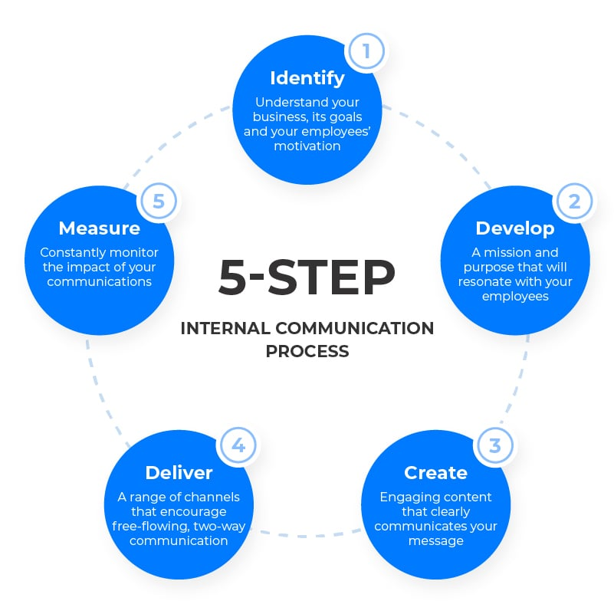
Figure 1: Internal Communication Flow
Source: (BOUFIM and BARKA, 2021)

Workflow in Digital Marketing
The methodical process of designing, executing, monitoring, and evaluating marketing campaigns is known as workflow in digital marketing. Allocating resources efficiently, keeping tabs on progress, and gauging outcomes are all made easier with a well-structured process. Common steps include gathering information, developing content, choosing a distribution channel, launching the campaign, and evaluating its success. Timely and high-quality completion of each phase is guaranteed by efficient workflow management (BOUFIM and BARKA, 2021). This is of utmost importance in the realm of digital marketing, where several initiatives may be launched across various platforms all at once. To simplify processes, delegate responsibilities, establish due dates, and monitor current projects, professionals often use sophisticated project management tools and software.

External Digital Communication Channels
When it comes to marketing, branding, engaging customers, and outreach, these channels are vital. The most important way to reach a wide variety of people nowadays is via social media. It facilitates the sharing of material, the interaction of consumers, and the development of brand recognition for enterprises. There are a variety of platforms that handle text, photos, and videos, and each one targets a distinct audience. Websites and blogs serve as official digital storefronts where businesses provide comprehensive information about their products, services, and company values. These channels are pivotal for establishing credibility and offering in-depth content like articles, case studies, and product descriptions. For targeted, one-on-one interactions, email marketing is still a must. Newsletters, promotional offers, and direct client involvement are all ways in which businesses utilize email. One of the best ways to retain customers and convert them is via email, because of its direct and personalized nature (Chang et al., 2019). To get more eyes on a website, a company need to use search engine optimization (SEO) and pay-per-click (PPC) ads. Both pay-per-click (PPC) advertising and search engine optimization (SEO) work to improve a website's visibility in search engine results. To increase engagement via visual storytelling, video platforms such as YouTube provide a place for sharing video content.

Digital Asset

Zara’s Digital Asset Portfolio
An extensive digital asset portfolio is a key factor in Zara's position as a fast-fashion industry leader. Zara is a flagship brand of the Inditex group. At its core, this portfolio is Zara's e-commerce platform, which showcases the trendy and contemporary style of the company. To attract and keep today's tech-savvy customers, the website prioritizes their best interests by providing an ideal user experience with simple navigation and a frictionless purchasing procedure (Haws, 2022). Customers may buy effortlessly on any device, thanks to its optimization for many platforms.
Social media: Zara is very visible on social media sites like as Instagram, Facebook, and Twitter. The most recent styles, collections, and brand campaigns are expertly shown on these platforms. Zara builds a following of style-conscious individuals and learns a lot about what its customers want via these channels (Haws, 2022).
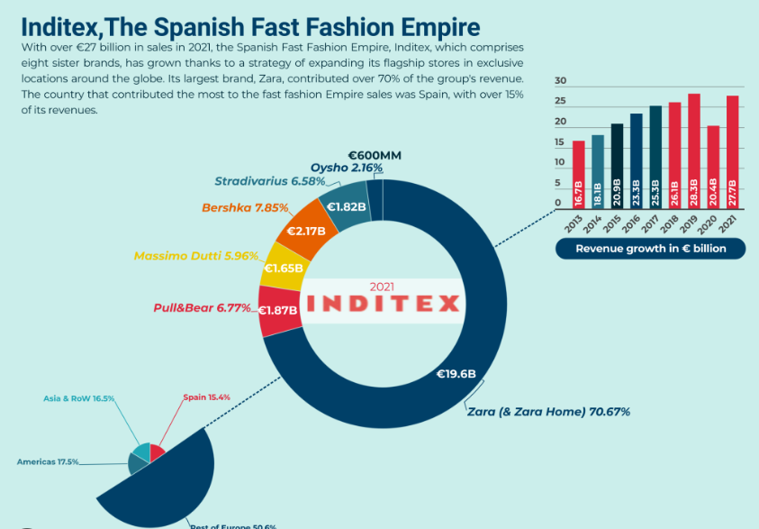
Figure 2: Zara’s Digital Empire
Source: (fourweekmba.com, 2023)
Competitive technology: One component of Zara's digital strategy is the use of competitive technology like AR and AI. Online and in-store shoppers both benefit from these technological advancements (Haws, 2022). As an example, the Zara app has augmented reality capabilities that let users see how garments would appear in different environments, making online buying more engaging.
Inventory management system: The advanced inventory management system is another essential part of Zara's digital portfolio. Aligning with Zara's fast-fashion approach, which needs rapid turnover of designs and trends, this system provides effective stock management across shops and online platforms by using real-time data analytics (Shin et al., 2023).
Digital supply chain: In addition, Zara has put resources into creating a supply chain that is digital-first. This method allows for a lightning-fast reaction to emerging styles, guaranteeing that consumers can find the most popular pieces in shops and on the internet in record time.

Utilization and Performance of Digital Assets
To accomplish objectives like increasing brand awareness, fostering customer relationships, and optimizing internal processes, organizations are increasingly turning to digital assets. Web pages, social media, app stores, digital media, and other similar things fall under this category. To have a powerful online presence, efficient marketing, and engaging with customers, it is essential to use these assets effectively. Digital asset performance evaluations include looking at KPIs including website visits, social media engagement, conversion rates, and ROI (Shin et al., 2023). With this information, companies can gauge the success of their digital initiatives, pinpoint problem areas, and settle on the best course of action. To stay ahead of the competition and succeed in the long run in today's digital world, Zara need to know how to use digital assets well and how to monitor their effectiveness.

Marketing Information Systems

Zara’s Marketing Information Systems Infrastructure
A strong Marketing Information Systems (MIS) infrastructure is crucial to the success of Zara, a worldwide leader in the fast-fashion business. Marketing and commercial choices may be better informed by this system's data collection, analysis, and use capabilities. Various sources of information, including sales data, customer feedback, internet browsing behaviors, and market trends, are gathered by Zara's sophisticated data analytics platform, which is at the heart of the company's MIS architecture (Popović-Šević et al., 2021). To analyze this data, the organization uses sophisticated algorithms and AI. This allows them to spot new trends in fashion, customer tastes, and business prospects with the help of this real-time data analysis, Zara can swiftly change its product lineup and advertising activities to meet the needs of its customers right now.
An effective supply chain management system is also a part of Zara's MIS as it works hand in hand with the company's marketing initiatives. By streamlining the design, manufacturing, and distribution processes, this approach allows businesses to swiftly respond to market trends by making new fashions accessible in shops and online Zara also uses its MIS infrastructure for its digital marketing. To reach its target demographic, the firm runs targeted internet ads, sends out email campaigns, and maintains an active social media presence (Popović-Šević et al., 2021). Personalized and successful marketing messages are made possible by this digital strategy, which is backed by data-driven insights. When it comes to marketing and quick, data-driven decisions, Zara's MIS infrastructure is the backbone of the company's strategy. This allows the brand to keep its fast-fashion leadership position.

Data Management and Utilization for Marketing
Strategic data collection and analysis from a variety of sources, including sales statistics, consumer feedback, and web browsing activities, allows Zara to succeed in data management. Using state-of-the-art algorithms and AI technologies, this data is evaluated with great care. This data is vital for Zara's decision-making process since it helps the company understand consumer tastes and market tendencies. The marketing tactics of Zara are greatly impacted by this data-driven approach and to stay in sync with what customers want and what's trending, the company uses real-time data to customize everything from ads to merchandise and even store layouts (Šević et al., 2021). In addition to improving Zara's product offers, this data-driven approach improves the company's marketing strategies, which in turn leads to better consumer engagement and increased conversion rates. To stay ahead of the competition in the fast-paced fashion sector, Zara effortlessly integrates data management with marketing.

Customer Relationship Management

CRM Strategies at Zara
As a leader in the fast fashion business, Zara attributes much of its success to its Customer Relationship Management (CRM) initiatives. The company's primary goal in developing its online and offline storefronts is to provide consumers with an enjoyable and unique purchasing experience. By analyzing client data, Zara can better cater its products and marketing messages to each individual's tastes and buying habits. The efficient omnichannel strategy is one of Zara's standout customer relationship management tactics. A seamless and hassle-free consumer experience is guaranteed by the brand's integration of its online and physical channels (Viardot and Nylund, 2017). Zara offers a consistent shopping experience across all channels, including the internet, mobile app, and retail shops, with the added convenience of easy exchanges and returns. Targeted email marketing and social media campaigns are another way Zara interacts with its consumers. These efforts provide customers with individualized suggestions and information about new collections. Customer feedback is valued by the brand, and it is used to enhance goods and services (Viardot and Nylund, 2017). Client relationship management (CRM) tactics used by Zara increase client loyalty and repeat business by putting the customer first and using data to address consumer requirements.

Integration with Digital Marketing Efforts
When it comes to digital marketing, Zara knows how to bring everything together to make an impression. The brand's harmony across its online and offline channels its website, social media, and physical stores is a prime example of this integration in action. Skillfully showcasing its newest collections on social media, Zara generates excitement that boosts online and in-store visitation. An improved shopping experience for customers is ensured by the brand's website and mobile app's seamless integration with its inventory system. This integration provides real-time updates on product availability (Viardot and Nylund, 2017). From customized internet ads to email campaigns, Zara uses data gathered from all sorts of digital touchpoints to make marketing more personal.

Segmentations, Targeting, and Positioning

Market Segmentation Approaches by Zara
Zara successfully serves its varied client base as Zara uses advanced market segmentation techniques. Age, gender, and economic level are the primary demographic variables used by the company to divide its target market. Zara can cater its collections to the many interests and preferences of its target demographics by using segmentation to create and sell items to certain groups, such as younger, more fashion-forward customers, working professionals, and luxury-seekers. Zara also employs psychographic segmentation, which focuses on consumer opinions and lifestyle choices (Aftab et al., 2018). By taking this tack, the company can zero in on the kind of customers that are interested in and supportive of current fashion trends. Customers who are always on the lookout for new trends will be completely satisfied with Zara's lightning-fast design turnaround.

Targeting Strategies and Campaigns
Zara uses targeted techniques in its marketing efforts, aiming mostly at young to middle-aged individuals who are fashion-forward and price-conscious. The brand's marketing targets this group by highlighting its affordability, trendiness, and ability to respond rapidly to changes in consumer taste. Through the use of visually engaging content and influencer partnerships, Zara deftly utilizes social media and digital advertising to engage with its audience (Aftab et al., 2018). A unified brand message is achieved via in-store experiences that are customized to mirror current fashion trends. Because of its fast product turnover and these focused efforts, Zara can keep its core client base interested and engaged.

Positioning of Zara in the Digital Space
Zara is known online for being a pioneer in fast fashion that skillfully combines affordable, modern design. With the help of its modern online shop and active social media accounts, the company showcases its fast-fashion, runway-inspired designs. Zara is dedicated to providing customers with the newest fashion trends at affordable prices, and their digital approach highlights that devotion. Zara attracts trend-conscious, convenience-loving customers by regularly updating its internet content with new, stylish products and captivating imagery (Lee, 2023). The internet world will forever remember Zara as a cutting-edge, innovative label thanks to this strategy.

Positioning Map and Link with Marketing Mix

Visualizing Zara’s Market Positioning
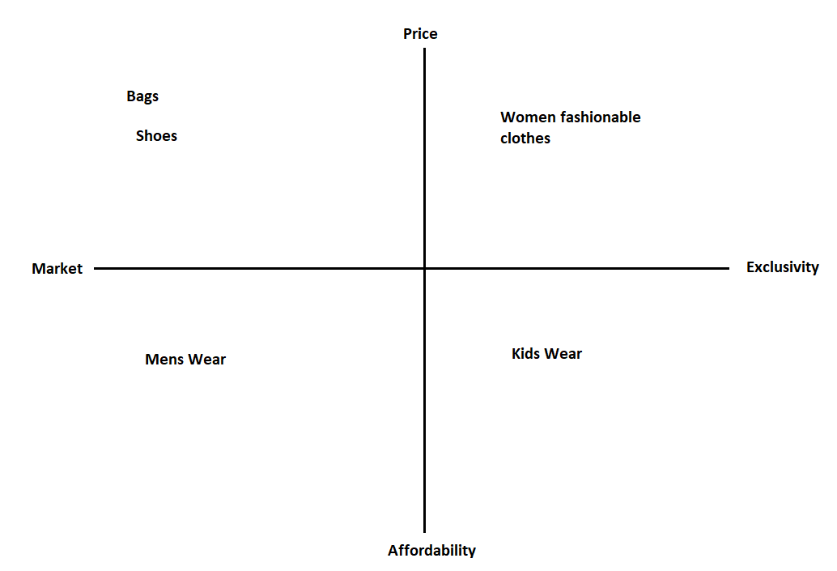
Figure 3: Positioning Map of Zara
The Zara positioning map shows where the brand's many product lines are strategically placed about pricing and market exclusivity. Women's trendy apparel is marketed as a premium section within Zara's offers, with a focus on exclusivity and higher prices. The more reasonably priced kids' clothes, which nonetheless lean towards exclusivity, hint at Zara's goal of offering fashionable but accessible children's wear. The men's section, on the other hand, is marketed as a more accessible, value-oriented alternative due to its lower price point and less exclusivity. Accessories like shoes and bags are likewise in the inexpensive quadrant, but they lean more towards exclusivity, suggesting that while they are accessible, they could have distinctive designs that aren't readily available. As this map shows, Zara aims to appeal to a wide variety of customers with its varied product offerings.

Correlation with Marketing Mix Elements
The Zara positioning map shows how the brand targets distinct market categories (Place) by differentiating its items (Products) across different price points (Price). This refers to the marketing mix aspects. As a result of its exclusivity and high price tag, women's trendy clothing is likely to use high-end design and marketing strategies to entice style-conscious buyers. The kids' clothing line offers great quality at affordable prices, indicating an advertising approach that focuses on value. A more aggressive price strategy and more distribution channels (Place) may explain the affordable men's clothing emphasis. Shoes and handbags, marketed as exclusive but reasonably priced, reveal a combination of one-of-a-kind products, calculated pricing, and clever positioning to appeal to a niche market.

Competitive Advantage

Zara’s Digital Competitive Advantages
Zara is ahead of the competition because of its nimble business strategy and cutting-edge tech usage. Zara has a huge advantage in product creation and inventory management. This nimbleness guarantees that Zara's products are continuously innovative and in tune with what customers want right now. Secondly, Zara makes it easy and enjoyable for people to purchase by combining their online and physical experiences. Interactive displays and augmented reality capabilities supplement its already advanced e-commerce infrastructure and smartphone app in-store (Tőkés, 2022). Zara's digital marketing approach boosts brand awareness and engagement via targeted online advertising and a strong social media presence.

Marketing Mix

Application of the 7Ps in Zara’s Digital Marketing
Product: Zara offers a wide range of trendy, high-quality fashion items that quickly mirror runway trends. Their digital channels frequently update with new arrivals, showcasing the depth and variety of their collections.
Price: The brand adopts a value-based pricing strategy, offering fashionable items at affordable prices. This approach is communicated through its digital platforms, appealing to budget-conscious, style-savvy consumers (Ruan et al., 2022).
Place: Zara's e-commerce website and mobile app are key digital platforms, ensuring a global reach. They provide a seamless, user-friendly shopping experience, complementing their physical stores.
Promotion: Zara employs digital marketing strategies like social media advertising, email marketing, and influencer collaborations to promote its products and engage with customers.
People: In the digital space, Zara focuses on customer service, offering support through various online channels, enhancing the customer experience, and building brand loyalty.
Process: The brand's efficient online ordering and delivery process, easy navigation, and hassle-free returns policy streamline the customer's purchasing journey (Agrawal and Mandhanya, 2021).
Physical Evidence: In the digital realm, Zara's website design, mobile app interface, and the overall aesthetic of its digital content serve as physical evidence of the brand's commitment to quality and style.

Sweet Spot of Marketing

Identifying Zara’s Marketing Sweet Spot
The capacity to quickly and affordably provide a wide market with the newest fashion trends is Zara's marketing sweet spot. The company's sharp supply chain and data analytics allow it to spot new trends with lightning speed and react accordingly. As a result of its nimble business model, Zara can meet the needs of trend-conscious customers who want to look good all the time without having to wait for the usual fashion cycles to kick in various seasons (Xia, 2023). Also, Zara's marketing strategy is both simple and effective. Zara has found its marketing sweet spot with a blend of affordable prices, reactivity to trends, and successful internet interaction.
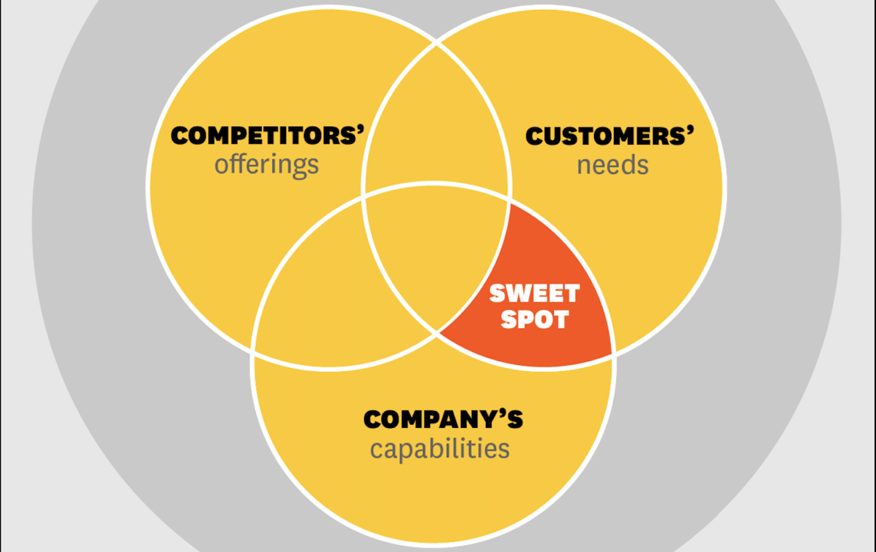
Figure 4: Sweet Spot
Source: (Tun, 2019)

Online Marketing Model

Frameworks Used by Zara for Digital Marketing
In its digital marketing strategy, Zara uses many important frameworks to stay ahead of the competition in the fast-fashion business. When a company uses analytics and big data to learn about its customers' habits and interests, it's practicing data-driven marketing. Zara can adapt its advertising and product offers to the ever-changing demands of its customers. Omnichannel marketing is another important framework. Whether a consumer shops on Zara's e-commerce site, mobile app, or in-store, they will have a similar brand experience because of the company's seamless integration of its online and offline channels (Viardot and Nylund, 2017). Zara also makes use of content marketing, which it employs in its digital campaigns via the use of high-quality images and narratives. Finally, CRM plays a vital role in Zara's online advertising. The company uses customer relationship management software to create meaningful connections with its consumers, which in turn increases client loyalty and spending.

SOSTAC Model

Applying SOSTAC to Zara’s Digital Marketing Plan
Situation Analysis: Zara assesses its market position as a leading fast-fashion brand with a strong digital presence. It examines market trends, customer behaviours, and digital performance metrics (Irwanto et al., 2021).
Objectives: Zara sets clear digital marketing goals, such as increasing online sales, enhancing brand engagement on social media, and improving customer loyalty through personalized experiences.
Strategy: The brand's strategy focuses on leveraging real-time data analytics for trend forecasting, maintaining a robust omnichannel presence, and engaging customers through high-quality, fashionable content.
Tactics: Zara employs tactics like targeted social media campaigns, influencer partnerships, email marketing, and an optimized e-commerce experience. It also integrates AR and AI technologies for an enhanced customer experience.
Action: The company implements these tactics through a coordinated effort across its digital platforms, ensuring consistent messaging and a seamless customer journey.
Control: Zara continuously monitors and evaluates the performance of its digital marketing activities using KPIs like website traffic, conversion rates, and social media engagement metrics. This allows for adjustments and refinements to align with evolving market conditions and objectives.

Recommendations and Examples of Artificial Intelligence
There are substantial chances for Zara to improve productivity and the consumer experience by incorporating AI into its processes. Using AI for inventory management is one suggestion. Zara can minimize overproduction and maximize the availability of popular goods by using AI algorithms to forecast trends and consumer preferences, allowing them to optimize stock levels. Chatbots powered by artificial intelligence may enhance Zara's customer care and lead to happier shoppers. Artificial intelligence (AI) can analyze consumer data to improve engagement and conversion rates by creating personalized marketing campaigns and product suggestions. AI may be integrated into the supply chain to simplify production and distribution procedures, leading to speedier and more efficient operations. This is especially important for Zara's fast-fashion strategy.

Part 2: Machine Learning and its Influence on Digital Marketing

Ways Machine Learning Influences Digital Marketing
Personalization: ML algorithms analyse vast amounts of data from user interactions, social media, and browsing behaviours to understand individual preferences. This enables marketers to tailor content, product recommendations, and advertisements to specific user profiles, enhancing the customer experience and increasing engagement (Saura, 2021).
Predictive Analytics: By predicting future trends and customer behaviours based on historical data, ML helps marketers anticipate market shifts and customer needs. This predictive power is particularly useful for inventory management, product development, and creating targeted marketing campaigns (Miklosik and Evans, 2020).
Customer Segmentation: ML algorithms can segment customers more accurately and dynamically than traditional methods. They can identify subtle patterns and group customers by behaviours, interests, and purchasing history, allowing for more effective and focused marketing strategies (Saura, 2021).
Optimized Ad Targeting: ML improves the efficiency of advertising campaigns by analysing which ads perform best on which platforms and at what times. This ensures better ROI by optimizing ad spend and improving conversion rates (Saura, 2021).
Enhanced User Experience: Chatbots and virtual assistants powered by ML provide real-time, personalized customer service, improving user engagement. They can handle inquiries, provide recommendations, and even assist in the shopping process.
Content Optimization: ML tools can analyse the performance of different content types, helping marketers understand what resonates best with their audience. This leads to the creation of more effective content strategies (Saura, 2021).
Churn Prediction: ML can identify warning signs that a customer may leave or decrease engagement. This allows brands to proactively address issues, improving customer retention (Miklosik and Evans, 2020).

Critical Analysis of the applications of Machine Learning in digital marketing to maximize ROI and ROS
Machine Learning (ML) applications in digital marketing offer significant potential to maximize Return on Investment (ROI) and Return on Sales (ROS) by optimizing marketing efforts, enhancing customer engagement, and improving decision-making. However, critical analysis reveals both opportunities and challenges in harnessing ML for these objectives.
Opportunities:
Personalization: Artificial intelligence (AI) allows for hyper-personalization via the analysis of user data to provide personalized content and suggestions. Both consumer involvement and sales are boosted by AI (Toni et al., 2023). To increase subscriber retention and return on investment (ROI), Netflix, for one, uses ML to provide content recommendations based on users' watching behaviour.
Predictive Analytics: Marketers may now make data-driven choices because of ML algorithms' ability to predict trends and consumer behaviour. This boosts return on investment (ROI) and decreases spending on inefficient marketing initiatives. Increased sales and profits are the results of predictive analytics that Amazon uses to fine-tune product suggestions and inventory management.
Ad Campaign Optimization: By fine-tuning targeting and bidding tactics, ML improves the efficacy of advertising campaigns. Ads on Google are served to the most appropriate audiences in real-time thanks to ML-powered real-time bid adjustments, which in turn increase click-through rates and return on investment.
Customer Segmentation: Marketers may design highly targeted ads with the help of ML's consumer behaviour and demographic segmentation capabilities. Increased engagement and sales are the results of this customer segmentation using AI (Toni et al., 2023). To increase subscriptions and user engagement, Spotify, for instance, uses ML to group people into playlists.
Chatbots and Virtual Assistants: Improving user experience and engagement, chatbots driven by ML provide rapid customer service. This round-the-clock availability boosts customer happiness and has the potential to improve ROS by lowering churn and boosting repeat purchases.
Challenges:
Data Quality and Privacy: Accuracy in ML is dependent on high-quality data. Clean, relevant data that complies with privacy standards like GDPR is essential for marketers. As a result of inaccurate forecasts and lower ROI, poor data quality is a major concern.
Complex Implementation: Expertise and resources are necessary for ML solution implementation. Adopting and maintaining ML systems may be challenging for smaller organizations, which might restrict their capacity to maximize return on investment.
Overfitting: Predictions made by ML models could be off-base if they overfit the data. If marketers want to keep ROI from taking a hit, they need to fine-tune their models thoroughly to prevent this problem.
Algorithm Bias: Marketing efforts using ML algorithms run the risk of being biased, which might hurt the brand's image and return on investment (Mintz et al., 2021). For example, insensitive material or the exclusion of certain populations might be the outcome of biased targeting.
Continuous Adaptation: To keep up with the ever-changing market dynamics and customer behaviour, ML models must be constantly monitored and adjusted. The return on investment (ROI) can drop over time if they don't continuously adapt to situations.
Cost: Although ML has long-term advantages, it might be expensive to apply ML solutions at first. The return on investment (ROI) of such initiatives should be carefully considered by smaller firms.
Best Practices:
To maximize ROI and ROS with ML in digital marketing, businesses should consider these best practices:
Invest in Data Quality: Verify that all information is accurate, complete, and by privacy standards. To get reliable ML predictions, Zara need high-quality data.
Expertise and Training: Put money into marketing team training or recruit ML specialists. For ML deployment to be effective, knowledgeable staff are essential.
Continuous Monitoring and Adaptation: To keep up with the ever-changing market and customer preferences, it is important to regularly evaluate and adjust ML models.
Ethical Considerations: Preserve a favourable reputation for the company and safeguard return on investment by addressing ethical problems and algorithm bias. To avoid biased targeting or content, put measures in place (Mintz et al., 2021).
Cost-Benefit Analysis: Consider the expenses and possible return on investment (ROI) of ML solutions. Make sure the advantages match up with their company's objectives.
ML applications in digital marketing have the potential to significantly enhance ROI and ROS through personalization, predictive analytics, and campaign optimization.

Ways ML will help Zara in building digital marketing strategy
Customer Segmentation: ML algorithms can analyse customer data to segment Zara's diverse customer base accurately. By identifying common behaviours, preferences, and demographics, Zara can create tailored marketing campaigns for different customer segments.
Personalized Recommendations: ML can power recommendation engines, suggesting products to customers based on their browsing and purchase history. Zara can use ML to offer customers personalized outfit suggestions or product bundles, increasing cross-selling and upselling opportunities.
Predictive Analytics: ML can forecast future fashion trends based on historical data and real-time market signals. Zara can use this predictive capability to proactively design and stock products that align with upcoming trends, reducing excess inventory and enhancing ROS.
Optimized Ad Campaigns: Zara can employ ML algorithms to optimize its digital advertising efforts. This includes real-time bid adjustments, ad placement decisions, and ad content optimization.
A/B Testing: ML can automate A/B testing processes, rapidly identifying which marketing strategies and content variations perform the best. Zara can use this information to refine its digital marketing approach, ensuring that it consistently delivers the most effective messages to its audience.
Chabot’s and Virtual Assistants: Implementing AI-powered chatbots and virtual assistants powered by ML can provide customers with instant support, answer inquiries, and assist in the shopping process, improving user experience and engagement.

Conclusion
Zara's digital marketing tactics, it clear that the fast-fashion company has maintained its dominance in the market by using innovation and technology. Zara stands apart because of its capacity to respond quickly to shifts in the market, predict what its customers want, and provide a frictionless shopping experience. To maintain its position as a digital marketing industry leader, Zara has made strategic use of AI, data analytics, and machine learning. Zara's digital marketing campaign is a great illustration of how data, technology, and a focus on customers can work together to succeed in today's retail industry. Despite all the changes and advancements in the fashion business, Zara's digital marketing is still top-notch.

References
Aftab, M.A., Yuanjian, Q., Kabir, N. and Barua, Z., 2018. Super responsive supply chain: The case of Spanish fast fashion retailer Inditex-Zara. International Journal of Business and Management, 13(5), pp.212-227.
Agrawal, B. and Mandhanya, Y.O.G.I.T.A., 2021. Promotional strategies for Indian pharmaceutical companies in the era of digital marketing. Global Management Review, 15(2), pp.69-76.
BOUFIM, M. and BARKA, H., 2021. Digital marketing: Five stages maturity model for digital marketing strategy implementation. IJBTSR International Journal of Business and Technology Studies and Research, 3(3), pp.15-pages.
Chang, X.H., Huang, R. and Park, J.H., 2019. Robust guaranteed cost control under digital communication channels. IEEE Transactions on Industrial Informatics, 16(1), pp.319-327.
fourweekmba.com, 2023. A Quick Glance At Zara Business Model. [Online]
Available at: https://fourweekmba.com/zara-business-model-2/
Haws, M., 2022. The e-commerce explosion: Rising to the challenge with digital asset management. Journal of Digital Media Management, 10(3), pp.236-241.
Irwanto, J., Murniati, W. and Fauziyah, A., 2021. Optimization of Digital Marketing Strategy with Implementation of SOSTAC Method. IJEBD (International Journal of Entrepreneurship and Business Development), 4(6), pp.886-892.
Kalsi, A.R., 2022. Investigating the impacts of digital marketing on consumer buying behavior in the fast fashion industry of Ireland–a case study of ZARA (Doctoral dissertation, Dublin, National College of Ireland).
Kingsnorth, S., 2022. Digital marketing strategy: an integrated approach to online marketing. Kogan Page Publishers.
Lee, T.H., 2023. ZARA, FAST FASHION, AND THE NEW GLOBAL PARADIGM FOR MARKETING COMMUNICATIONbyTing Hsuan (Vivian) Lee (Doctoral dissertation, Purdue University Graduate School).
Miklosik, A. and Evans, N., 2020. Impact of big data and machine learning on digital transformation in marketing: A literature review. Ieee Access, 8, pp.101284-101292.
Mintz, O., Gilbride, T.J., Lenk, P. and Currim, I.S., 2021. The right metrics for marketing-mix decisions. International Journal of Research in Marketing, 38(1), pp.32-49.
Popović-Šević, N., Jeremić, A., Slijepčević, M. and Ilić, M., 2021. Marketing focused on the online brand community: The example of Zara. Marketing, 52(1), pp.32-42.
Popović-Šević, N., Jeremić, A., Slijepčević, M. and Ilić, M., 2021. Marketing focused on the online brand community: The example of Zara. Marketing, 52(1), pp.32-42.
Ruan, T., Sang, D. and Zeng, Q., 2022. Research on ZARA’s Business Environment and Marketing Strategies in China. In 2022 2nd International Conference on Enterprise Management and Economic Development (ICEMED 2022) (pp. 659-672). Atlantis Press.
Saura, J.R., 2021. Using data sciences in digital marketing: Framework, methods, and performance metrics. Journal of Innovation & Knowledge, 6(2), pp.92-102.
Šević, N.P., Jeremić, A., Slijepčević, M. and Ilić, M., 2021. Marketing Focused on The Online Brand Community–The Example of Zara. Marketing (0354-3471), 52(1).
Shin, J.Y., Suk, J. and Chung, J.E., 2023. Consumer Responses to Fashion in the Metaverse: A Text-Mining Analysis on Online News Comments. In Future of Information and Communication Conference (pp. 12-24). Cham: Springer Nature Switzerland.
Sitaro, T.D., 2020. Fast Fashion and Sustainability-The Case of Inditex-Zara.
Tőkés, G.E., 2022. The Digital Brand Identity of Fast-Fashion Brand Zara. A Case Study. Acta Universitatis Sapientiae, Social Analysis, (12), pp.131-154.
Toni, N., Goh, T.S., Nyoto, N. and Hong, R., 2023. Role of Digital Marketing and Digital Transformation in the SME’s Financial Performance. Jurnal Manajemen Industri dan Logistik, 7(2).
Tun, A. P., 2019. How to find your Strategic Sweet Spot?. [Online]
Available at: https://sg.linkedin.com/in/aung-pye-tun?trk=article-ssr-frontend-pulse_publisher-author-card
Viardot, E. and Nylund, P.A., 2017. Conquering the digital customer: how Zara is confronting the digital innovation revolution. In Socio-Economic Perspectives on Consumer Engagement and Buying Behavior (pp. 334-354). IGI Global.
Xia, Y., 2023. The 4Ps of Marketing and Applications in Various Brands. Journal of Education, Humanities and Social Sciences, 16, pp.165-170.

