

ASSESSING THE CHALLENGES OF TRADITIONAL DIGITAL FORENSIC PROCESSES FOR EFFECTIVE APPLICATION IN CLOUD COMPUTING ENVIRONMENTS
By
Student Name:Almasbahen yashin hathiwala
Student id:2411726
Supervisor: Dr Amit Naik

Project submitted as part of the requirements for the award of
MSc Computer Networks and Cyber Security

2025/26

Abstract
The current pace of fast switching to cloud computing has radically changed the way data is generated, stored and managed electronically, and this has posed some serious challenges to the conventional processes of digital forensics. Traditional forensic models are optimally tuned to a setting where physical access and stagnant storage and systems that are controlled by a system investigator are the primary characteristics, which is becoming less suitable in a virtualised, distributed, and highly automated cloud environment. This study critically evaluates the drawbacks of conventional digital forensic procedures in the context of cloud computing systems and how the potential of the forensic services can be improved using a readiness-based strategy.
The qualitative research approach is utilised, based on the methodological systematic study of the current academic literature and technical materials to define the major technical, legal, and office issues in cloud-based forensic investigations. Some of the core challenges that have been noted are data volatility, lack of infrastructure visibility, multi-tenancy, jurisdiction complexity and disruption of traditional chain-of-custody systems. A forensic model based on readiness is used with the help of cloud-native services to exhibit a proactive generation, preservation, and analysis of evidence in an Infrastructure-as-a-Service environment.
As the findings suggest, persistent centralised logging, non-modifiable storage of evidence, preserving evidence through snapshots, and an in-built monitoring can greatly enhance the availability, integrity, and traceability of evidence in dynamic cloud setups. A readiness-based approach significantly improves the reliability of investigations and the efficiency of operations for the cloud service provider, even in the face of related dependencies and constrained visibility. The research finds that credible and defensible digital investigations in a cloud computing environment are only achieved through proactive forensic preparedness and offers practical information to organisations, forensic practitioners, and cloud stakeholders who want to transform the forensic practice to modernise.

DECLARATION

I, am Almasbahen yashin Hathiwala declare that I am the sole author of this Project; that all references cited have been consulted; that I have conducted all work of which this is a record, and that the finished work lies within the prescribed word limits.

This work has not previously been accepted as part of any other degree submission.

Signed: Almasbahen Yashin Hathiwala

Date : 02/02/2026

FORM OF CONSENT

I am almasbahen yashin hathiwala hereby consent that my Project, submitted in candidature for the M.Sc. Applied Computing, if successful, may be made available for inter-library loan or photocopying (subject to the law of copyright), and that the title and abstract may be made available to outside organisations.

Signed: Almasbahen Yashin Hathiwala

Date : 02/02/2026

Acknowledgment
I would like to thanks to my supervisor whose guidance, encouragement, and constructive feedback, I used during this project. I would also like to thanks to my lecturers, family, and friends, whose support, motivation, and understanding are highly appreciated throughout the successful completion of this dissertation
Table of Contents
Chapter 1: Introduction 13
1.1 Background 13
1.2 Problem Statement 14
1.3 Aim and Objectives 15
1.4 Research questions 15
1.5 Scope of the Study 15
1.6 Research Rationale 16
1.7 Summary 17
Chapter 2: Literature Review 18
2.1 Introduction to the Chapter 18
2.2 Foundations of Traditional Digital Forensic Processes and Assumptions 18
2.3 Cloud Computing Architectures and Their Impact on Digital Forensics 19
2.4 Technical Challenges of Applying Traditional Forensic Methods in Cloud Environments 21
2.5 Legal, Jurisdictional, and Procedural Constraints in Cloud-Based Forensic Investigations 23
2.6 Forensic Readiness and Emerging Adaptation Strategies for Cloud Computing 25
2.7 Thematic analysis 27
2.7.1 Disruption of Conventional Forensic Control and Evidence Stability 27
2.7.2 Constraints on Accountability, Transparency, and Evidentiary Trust 28
2.7.3 Shift from Reactive Investigation to Proactive Forensic Capability 29
2.8 Theoretical Framework 30
2.8.1 Linear Digital Forensic Investigation Theory 30
2.8.2 Socio-Technical and Readiness-Oriented Theory in Cloud Forensics 31
2.9 Conceptual framework 31
2.10 summary 32
Chapter 3: Research Methodology 33
3.1 Introduction 33
3.2 Research Philosophy 33
3.3 Research Approach 34
3.4 Research Strategy and Design 35
3.5 Data Sources and Selection Criteria 35
3.6 Data Collection Procedure 36
3.7 Data Analysis Technique 36
3.8 Reliability, Validity, and Research Rigour 37
3.9 Ethical Considerations 37
3.10 Limitations of the Research Methodology 37
3.11 Summary 37
Chapter 4: Design Process 38
4.1 Introduction 38
4.2 Design process 38
4.2.1 Design Rationale and Objectives 38
4.2.2 Design Principles and Constraints 38
4.2.3 Mapping Forensic Readiness to Cloud Service Models 39
4.2.4 Stakeholder Roles and Responsibilities 39
4.2.5 Evidence Lifecycle Integration 39
4.3 Process workflow 40
4.3.1 Pre-Incident Forensic Readiness 40
4.3.2 Evidence Generation and Detection 40
4.3.3 Evidence Collection and Preservation 40
4.3.4 Evidence Analysis and Correlation 41
4.3.5 Reporting, Compliance, and Review 41
4.4 Summary 41
Chapter 5: Implementation 43
5.1 Introduction 43
5.2 Implementation 44
5.3 Outcomes 53
5.3.1 Effectiveness of Centralised Log Collection in Cloud Forensic Readiness 53
5.3.2 Evidence Preservation and Integrity Assurance in Virtualised Environments 54
5.3.3 Visibility and Traceability of Cloud Activities for Forensic Analysis 54
5.3.4 Practical Implications for Applying Forensic Readiness in Cloud Computing 55
5.4 Critical Analysis 56
5.5 Summary 58
Chapter 6: Evaluation of Results 59
6.1 Introduction 59
6.2 Evaluation 59
6.2.1 Evaluation of Evidence Availability in Dynamic Cloud Environments 59
6.2.2 Evaluation of Data Volatility Mitigation 60
6.2.3 Evaluation of Evidence Integrity and Chain of Custody 60
6.2.4 Evaluation of Visibility and Traceability of Cloud Activities 60
6.2.5 Evaluation of Investigative Efficiency and Scalability 61
6.2.6 Evaluation of Applicability across Cloud Service Models 61
6.2.7 Overall Evaluation against Traditional Digital Forensic Processes 62
6.3 Discussion 62
6.3.1 Alignment of Implementation Outcomes with Cloud Forensic Challenges 62
6.3.2 Implications for Evidence Integrity and Trustworthiness 62
6.3.3 Visibility, Traceability, and Investigative Reconstruction 62
6.3.4 Operational Efficiency and Scalability Considerations 63
6.3.5 Variability across Cloud Service Models 63
6.3.6 Synthesis of Discussion 64
6.4 Summary 64
Chapter 7: Conclusions and Recommendations 65
7.1 Conclusion 65
7.2 Linking with objectives 65
7.2.1 Linking with first objective 65
7.2.2 Linking with second objective 65
7.2.3 Linking with third objective 66
7.2.4 Overall Achievement of Research Objectives 66
7.3 Recommendations 66
7.4 Future works 67
Chapter 8: Reflection 68
8.1. Time Management 68
8.2. Improvement in Study Skills 68
8.3. Understanding My Learning Style 68
8.4. Areas for Improvement 68
References 69

List of Figures
Figure 1.1: Growth of ICT hardware and software services from 2002 to 2018 [4] 13
Figure 2.1: Traditional Digital Forensics Process Flow 18
Figure 2.2: Forensic Enabled Cloud Computing Architecture 20
Figure 2.3: Challenges to Digital Forensics in the Era of Ubiquitous Networks and Services 22
Figure 2.4: Challenges for Each Type 24
Figure 2.5: Verified Cloud Forensic Network 26
Figure 2.6: Testbed Architecture 27
Figure 2.7: Layered Forensic Analysis combining Memory 28
Figure 2.8: Provider-Mediated Evidence Processing and Transparency Constraints in Cloud Environments 29
Figure 2.9: Conceptual Framework Linking Cloud Forensic Challenges to Investigation Outcomes 31
Figure 3.1: Interpretivism research philosophy 33
Figure 3.2: Inductive research approach 34
Figure 3.3: Qualitative Research Design 35
Figure 4.1: Cloud Forensic Readiness Process Workflow 41
Figure 5.1: Setting up CloudTrail to record logs 44
Figure 5.2: CloudTrail dashboard 44
Figure 5.3: CloudTrail logs stored in an S3 bucket 45
Figure 5.4: Setting the object lock for maintaining evidence integrity 46
Figure 5.5: Launching an EC2 instance 46
Figure 5.6: Configuring Options 47
Figure 5.7: Accessing volumes 47
Figure 5.8: Creating a snapshot of the EC2 instance 48
Figure 5.9: Event history manager 48
Figure 5.10: CloudTrail logs stored in S3 bucket 49
Figure 5.11: Sending CloudTrail logs to Athena 50
Figure 5.12: Configuring query settings 50
Figure 5.13: Running a query to show all the stored logs 51
Figure 5.14: Running a structured query to see results 51
Figure 5.15: Configuring CloudWatch for visualising logs 52
Figure 5.16: Running a query to show the captured activities 53
Figure 5.17: Running the query for specified logs 53

List of Tables
Table 5.1: Visibility and Traceability Outcomes 55
Table 5.2: Practical Implications of Cloud Forensic Readiness 56
Table 5.3: Comparison of Traditional Forensics and Cloud Forensic Readiness 57
Table 6.1: Discussion Summary of Key Evaluation Dimensions 63

List of Abbreviations
ICT: Information and Communication Technology
AWS: Amazon Web Services
API: Application Programming Interface
VM: Virtual Machine
IaaS: Infrastructure as a Service
PaaS: Platform as a Service
SaaS: Software as a Service
IoT: Internet of Things
IAM: Identity and Access Management
EBS: Elastic Block Store
SQL: Structured Query Language
WORM: Write Once Read Many
AMI: Amazon Machine Image
CPU: Central Processing Unit
IP: Internet Protocol

Chapter 1: Introduction

1.1 Background
Growth of Digital Technologies and Evidence
Digital systems generate huge amounts of data during daily activities. Organisations depend on digital platforms for communication, storage, and business operations. The cases of cybercrimes have risen due to the fact that criminals are taking advantage of the flaws of these technologies. Digital forensics assists investigators in locating and maintaining electronic evidence of compromised systems [8]. Legal investigations are based on evidence found on the storage devices, networks, and user accounts.
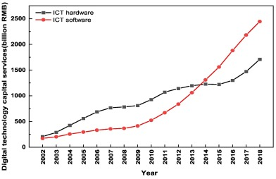

Figure 1.1: Growth of ICT hardware and software services from 2002 to 2018 [4]
ICT investment is growing year by year due to the adoption of digital technology. The growth of software services has been more rapid than that of hardware since 2012. The increase in the use of technologies boosts the amount of digital evidence and investigation [4]. Conventional digital forensics developed when the data was in the form of physical computers. Investigators touched machines and played with most of the storage environments [9]. The evidence did not disappear and could be analysed with the help of traditional forensic tools. These assumptions have been put to the test by the fast growth of digital services and are necessitating new ideas.
Shift toward Cloud Computing
Cloud computing transformed the data storage and processing of an organisation. The internet enables users to access on-demand computing resources. Applications and data run on virtual servers, which can be located in a large number of locations throughout the world. Cloud computing saves on hardware expenses and has high flexibility for the business [9]. Elastic attributes like autoscaling, virtual machines and shared stature assist in enhancing performance. Data and infrastructure are no longer controlled by the users but by the cloud service providers. The cloud data could be just temporary due to the nature of virtual components, which come into existence and disappear shortly [6]. Crime investigators have a hard time accessing the hardware behind or finding out the actual location of digital artefacts. Information stored in another country presents some legal issues in gathering evidence.
Need for Cloud-Ready Forensic Practices
Digital forensics procedures imply a physical connection to equipment and unchanging storage conditions. Cloud systems eliminate physical access and develop multi-tenant systems in which numerous users share an identical infrastructure [10]. The investigators should not interfere with information belonging to other cloud users in the process of gathering evidence. Widespread logs, container data, and volatile cloud events cannot be effectively captured by popular forensic tools [1]. Chain of custody is complicated due to the involvement of automated systems that do not involve human efforts. Clouds need responsive incident and evidence preparedness. The forensic approaches have to be consistent with the cloud provider policies, security models, and legal issues [3]. The forensic community seeks emerging structures that can facilitate credible investigations of virtualised environments [15]. Forensic awareness is required in organisations to safeguard business activities, legal obligations, and to criminalise cybercrimes. Carbonated digital investigation empowers credibility and responsibility in cloud-based systems.

1.2 Problem Statement
Digital forensic protocols are based on physical access and physical control of devices. Cloud systems eliminate such control and attribute the responsibility to cloud service providers. Without interfering with other cloud users, investigators cannot simply isolate the environment of the suspects. Data in numerous virtual resources, and it is challenging to find its evidence. A lot of forensic tools are not able to get volatile details out of auto-scaled or short-lived cloud elements. Logs can either be altered automatically or expire before an investigation is commenced. Deficiency of transparency when operating cloud infrastructure restricts adequate scrutiny of security occurrences.
Automated operations and provider interventions disrupt the chain of custody records. The investigators are usually unable to establish the identity of the person who touched the evidence and when it was changed. The data stored in the clouds might also be in other legal jurisdictions and have their own privacy laws. Transnational regulations block access to possible evidence and postpone the investigation. Multi-tenant layouts elevate the chances of a privacy breach when carrying out forensic activities. Present forensic guidelines are not comprehensive in terms of virtualised environments and distributed storage. The issue is that organisations have difficulties in demonstrating the integrity and admissibility of cloud-based evidence. These vulnerabilities are capitalized by the cybercriminals to conceal activities and eliminate digital tracks. The incompatibility of the conventional forensics procedures with the cloud architecture poses a risk to credible investigation results. To improve cloud computing security response requires updated versions of forensic frameworks.

1.3 Aim and Objectives
Aim
Aim of the project is to critically evaluate the shortcomings of conventional digital forensic models in cloud-based computing and determine the technical and procedural methods based on a qualitative investigation of secondary data.
Objectives
- To identify and categorise technical and legal challenges in cloud forensics.
- To assess the applicability of current digital forensic frameworks in cloud-native environments.
- To develop a readiness-based model to enhance forensic capabilities in dynamic cloud settings.

1.4 Research questions
- What technical and legal challenges affect the use of digital forensics in cloud environments?
- How suitable are current digital forensic frameworks for cloud-native systems with virtualised infrastructure?
- What forensic readiness measures can support effective investigations in dynamic and distributed cloud settings?

1.5 Scope of the Study
Project focus is on digital forensics in cloud computing, and this focus is made on the difficulties in using conventional forensic procedures on virtualised systems. Previous years' journals, articles and technical reports are used as secondary data to establish the research findings. The literature that is reviewed is restricted to that published within the time period of 2020-2025 to ensure that relevance is up-to-date. The models of cloud computing services covered include IaaS, PaaS, and SaaS. The main features of the investigation are deemed to be multi-tenancy, elasticity, and distributed storage. The project highlights how these characteristics affect the quality of forensic evidence. Technical issues like data instability, the limitation of tools, and limited access are considered thoroughly [8]. Legal and procedural problems, such as jurisdiction and chain of custody, are also considered. The results are obtained through comparative analysis instead of practical experiments and primary data. There is no direct access to cloud systems or live forensic investigations.
Focus remains on general cloud environments rather than specific vendor platforms. Cloud vendors offer proprietary forensic services which are not reviewed other than published documentation. Multi-cloud and hybrid deployments are taken into consideration as they are considered in case of relevance to the forensic readiness models. Detailed case studies are not made of cybercrimes or types of threats. Rather, the focus remains on the forensic process and its impediments in a cloud environment [5]. The model is meant to assist in fast reaction and reliable management of evidence. Where necessary, operational and policy suggestions can be recommended. No new forensic tools or software implementations are generated in the study. There is no practical testing and quantitative performance measurement. The scope is aimed at aiding the perception of the impact of cloud properties on digital exploration. The insights are targeted at organisations, cloud service providers, and forensic professionals [2]. Definite frames that surround qualitative analysis will guarantee a narrow and attainable research. The contributions made in the work enable the knowledge of safe and admissible evidence processing in the context of contemporary cloud infrastructures.

1.6 Research Rationale
Cloud computing is now the major storage and service delivery site. Cloud environments are used by many organisations to facilitate day-to-day operations. The reason why cybercriminals target these platforms is the presence of valuable information. Good digital forensics facilitates court proceedings, protection enhancement, and business resilience. Still, the conventional forensic processes were meant to serve local systems whose access was physical. These processes are no longer in line with the virtualised and distributed cloud environment structure. Crime investigators are challenged because they find it hard to gather evidence within dynamic cloud systems. Logs can be lost fast since cloud platforms have automatic functionality. Virtualised storage or hidden layers of the infrastructure cannot easily be accessed using tools. The adoption of cloud is still increasing in industries and governments. The organisations are at risk of running into more operational risks unless they incorporate updated forensic approaches. The decision makers want to be aware of the existing forensic restrictions in the cloud environments. Enhanced forensic preparedness has the potential to decrease the effects of incidents and aid in regulatory compliance [7]. The knowledge of these challenges allows for improving collaboration between investigators and cloud service providers.

1.7 Summary
Cyber incidents leave a lot of evidence as a result of digital technologies. Traditional forensics relies on access to and consistent places of data. Cloud systems eliminate physical control of the device and spread the information across virtual resources. Evidence can be lost in a short time due to automation and dynamic storage. The issue pointed to the incompatibility of the ageing forensics with cloud architecture. Digital investigations are less reliable due to technical, legal and procedural problems. This research can help to assess these gaps and discuss better methods of preparedness. The goals and queries concern the challenges, the applicability of the framework, and readiness enhancement. The scope restricts the work to qualitative analysis of secondary literature in the recent past. There are no initial tests and experimental simulations.

Chapter 2: Literature Review

2.1 Introduction to the Chapter
The chapter conducts a literature review aimed at analysing why the conventional digital forensic procedures have a hard time working properly in the cloud computing setup. It puts to the fore current academic and technical research to bring out the mismatch between the assumptions of physical presence, data permanency, and explicit ownership in the virtualised, distributed and automated clouds. This review examines both the technical and non-technical aspects, such as infrastructure abstraction, data volatility, jurisdictional complexity, and evidentiary integrity. This chapter provides a systematic awareness of the existing limitations through sorting the literature into five thematic areas, as well as reveals new ways of enhancing the forensic preparedness, reliability, and admissibility of digital evidence in cloud systems.

2.2 Foundations of Traditional Digital Forensic Processes and Assumptions
The current digital forensic practices are based on investigating procedures that were initially developed on physical and logically delimited computing environments. The processes are organised in a way that they have established phases which entail identification of evidence, acquisition of evidence, preservation, analysis, and presentation of evidence [10]. The success of this lifecycle relies on a series of unspoken assumptions about the stability of the system under conditions of investigator control and forensic tools. Basic forensic techniques assume that electronic evidence is stored in identifiable storage media, does not become volatile with time and can be opened without being altered through automated processes or by third parties [5].
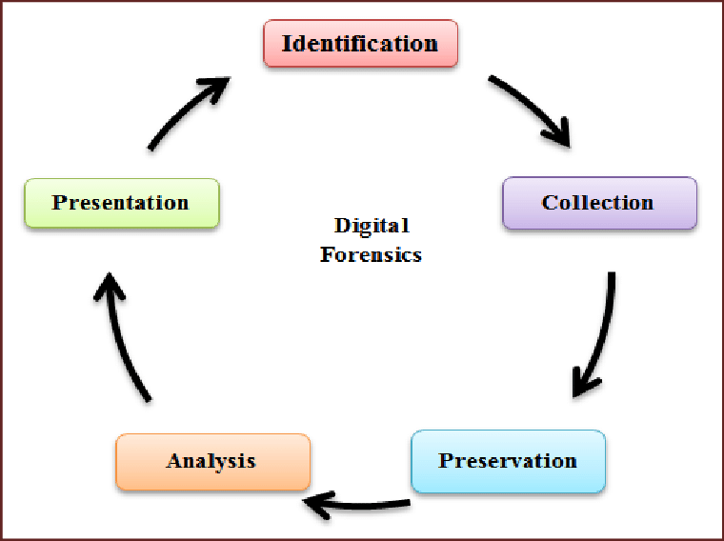

Figure 2.1: Traditional Digital Forensics Process Flow
(Source: ResearchGate, 2016)
One of the fundamental suppositions upon which traditional digital forensics it is possible to gain direct access to digital devices and their storage facilities. It is expected that the investigators will have complete control over the source of evidence, which allows employing such techniques as bit-level imaging, write-blocking, and offline analysis [9]. This control empowers the evidentiary integrity, which reduces the chances of modification and repeatability of forensic tests. Confidence in post-incident investigations is also enhanced by the assumption of the binary character of the system states, since data artefacts should not be harmed or destroyed without any purpose.
The other assumption is on the reliability and determinism of the forensic tools [11]. Conventional forensic examination assumes specialised software and hardware devices that are assumed to act in an identical and non-covert manner. Such tools can be perceived as indifferent mediators that can remove and analyse digital artefacts without affecting them in an organised manner [9]. As a result, the validity of forensic findings has a close relationship with trust in tool behaviour, tool output assessment and examiner skill [67]. The forensic process further presupposes that erroneousness may be identified by examiner review, validation practices and is no longer done in the very structure of the analysis.
Conventional forensic models also presuppose precise system ownership and responsibility. The digital evidence is normally linked to one organisation, user, or device, and thus the investigators can determine the provenance and accountability of the evidence with a certain degree of certainty [10]. This transparency helps in preservation of records of chain of custody, which records the people who touched the evidence, the time of access and the manner in which the evidence was used during the investigation [11]. This model is dominated by the processes that are run by humans, which support the expectations of traceability and the transparency of procedures.
All these assumptions are the conceptual basis of traditional digital forensics. On the one hand, as they facilitate a way to design structured and repeatable inquiries in regulated environments, on the other hand, they are paradigm-influenced design decisions by past computing concepts [9]. The continued existence of such assumptions is increasingly limiting the relevance of traditional forensic procedures as the digital ecosystem becomes more abstract and automated and reveals its reliance on conditions that are no longer always available.

2.3 Cloud Computing Architectures and Their Impact on Digital Forensics
The architectures of cloud computing are redefining the generation, storage, and processing of information, which transforms the context of operation of digital forensic investigations. Contrary to conventional computing environments, cloud systems are based on the virtualisation of resources that expose the users and investigators to physical hardware [12]. The computing, storage and networking components are shared services provided by layered service models, and this has a great impact on the visibility, control and traceability of digital artefacts [68]. This architecture has had a direct impact on the viability of using the traditional forensic techniques, which require the use of static infrastructure and physical availability [14].
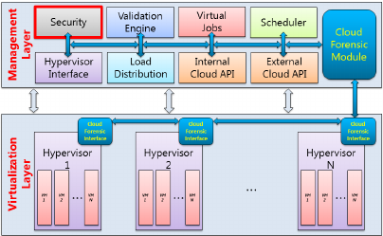

Figure 2.2: Forensic Enabled Cloud Computing Architecture
(Source: ResearchGate, 2015)
Different levels of forensic complexity are presented by the service delivery models of cloud computing [13]. Services based on infrastructure give restricted access to virtual machines and operating systems, whereas the platform and software-based services provide a further limitation, such that system functions are encapsulated behind provider-managed interfaces. With increasingly less control remaining in the hands of users, the forensic investigators find even less observability of system states and a reduced capability to perform evidence-gathering activities independently [14]. Instead of being stored on physical storage devices, evidence generation is placed in the provider-managed logs, application-level metadata, and virtual network traces.
Cloud architectures are characterised by virtualisation, which has significant forensic implications [13]. Virtual machines are dynamically generated, moved and closed to maximise the performance and resource usage. The effect of this dynamic behaviour is data fragmentation in more than one physical host and geographical location [69]. Evidence can only be temporary in volatile memory or transient storage layers, but then overwritten or terminated [12]. This ephemerality disrupts the conventional beliefs on the persistence of data and demeans the post-incident recovery efforts of evidence gathering and storage.
Additional innovations introduced by the combination of cloud computing and edges and the Internet of Things ecosystems enlarge the forensic landscape even further. There is edge-based processing, which puts data creation (and initial analysis) as near as possible to sources of data, thus consuming less latency, but introducing more heterogeneity to the architecture [14]. Evidence is spread across the cloud cores, edge nodes and connected devices, making correlation and reconstruction of timelines harder. These environments are decentralised, whereby forensic processes need to be able to work across several layers and still provide coherence and integrity of collected artefacts.
New architectural advances add new aspects to the forensic practice. Evidence management systems based on blockchain technology incorporate immutability and distributed consensus into their workflow, and seek to maintain integrity and traceability in decentralised systems [13]. Though these mechanisms improve evidence handling trust, they come with computational and integration complexities which need to be congruent with the existing cloud infrastructures. Comprehensively, cloud computing structures alter female digital forensic settings by converting predictable, localised systems to distributed, automated and multi-layered systems [70]. The presence of these changes implies the need to reconsider the forensic methods so that they make the evidence accessible, reliable, and admissible in the ever-more abstracted digital ecosystems.

2.4 Technical Challenges of Applying Traditional Forensic Methods in Cloud Environments
Cloud computing places a set of technical obstacles within the operational space, which compromise the efficiency of conventional digital forensic procedures to a considerable extent. The most salient problem is created by the volatility in data since the operation of the cloud environment is based on the dynamism of resource provisioning [15]. Virtual machines, containers, and server less functions are not uncommonly created and destroyed according to demand, which leaves forensic artefacts that might exist temporarily. This makes data temporary and restricts the possibility of carrying out any retrospective research, and enhances the chances of losing evidence before commencing any forensic procedure.
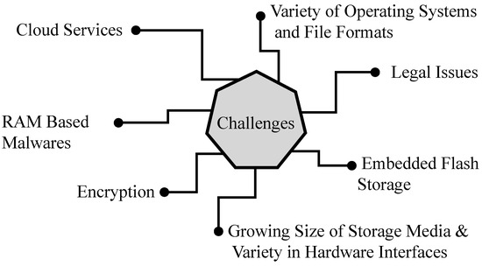

Figure 2.3: Challenges to Digital Forensics in the Era of Ubiquitous Networks and Services
(Source: MDPI, 2024)
The other significant technical issue is associated with the lack of visibility and access to the underlying infrastructure. In the cloud, physical hardware or low-level system components are rarely accessible to investigators [17]. In its place, provider-controlled interfaces, logs, and application-level artefacts are the only providers of evidence. Such limitations do not allow wholesale purchase of system memory, virtual network traffic and state of storage, which have long been deemed essential to the reconstruction of attack timelines and user actions [15]. Consequently, forensic analysis frequently makes use of incomplete data that decreases the accuracy in investigation.
Multi-tenancy also makes the technical forensic process more difficult as it adds the problem of shared infrastructure in use by more than one user. Information of various tenants can be stored on a shared physical instance, and it is not easily possible to separate a suspect environment without the possibility of privacy breaches or tampering with the data [16]. Conventional forensic isolation methods cannot be effective in this case, as investigators cannot just take a snapshot of shared resources [70]. This drawback predisposes the reliance of evidence extraction on cloud service providers to decrease the independence of investigators and to provoke questions of evidentiary completeness.
One of the biggest technical challenges is also tool incompatibility. Most of the well-known forensic tools are optimised to work on the file systems and operating systems that are found locally, making them useless when used with virtualised storage formats, distributed logs, or cloud-native network structures [16]. Cloud providers have proprietary data formats and logging structures that also make interoperability difficult due to the need to customise tools more broadly or use those made available by the cloud provider [17]. These adaptations can undermine repeatability, and they tend to cause uncertainty in the forensic results.
Other issues with cloud forensic research are scalability and data volume. Clouds produce enormous amounts of logs and telemetry information, which can be geographically remote [15]. Conventional forensic processes of processing and correlating such data are computationally demanding and time-consuming. In the absence of advanced filtering and automation systems, the investigator can sometimes find it difficult to deal with the signal and the noise [71]. Together, these technical obstacles indicate that the traditional forensic approaches do not generally fit with the realities of cloud computing operations, and it takes significant adjustments to be utilised successfully.

2.5 Legal, Jurisdictional, and Procedural Constraints in Cloud-Based Forensic Investigations
Some of the most universal barriers to successful digital forensic investigations in cloud computing environments include legal, jurisdictional and procedural barriers. As opposed to the conventional placement and ownership of data, which is well established, data in cloud infrastructures is scattered across various geographic areas and legal jurisdictions [20]. This distribution makes it difficult to use national laws as digital evidence can be transmitted, stored, processed or shown in a jurisdiction experiencing different applications of the law, privacy rules, and disclosure standards. This then places upon investigators the burden of moving through intricate legal territories before they reach the evidence that may be important.
A major problem with cloud-based investigations is the jurisdictional ambiguity. Cloud service providers usually use more than one country in the operation of their data centres, and users are often not aware of where their data is stored physically [18]. This is why forensic investigators are not allowed to believe that the local legal authority under consideration would apply to all the appropriate evidence. Mutual legal assistance agreements and cross-border cooperation systems are often necessary, which add delays that do not fit the dynamic aspect of cloud data [19]. Evidence can be distorted or moved, or destroyed as legal authorisation is being requested, which decreases its testimonial worth.
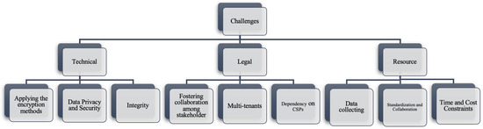

Figure 2.4: Challenges for Each Type
(Source: MDPI, 2024)
The inherent problems in the forensic operation in the cloud environment are also complicated by the procedural constraints. Conventional forensic protocols are based on well-documented chains of custody and evidence manipulation by humans [20]. In cloud systems, most of the activities which influence data integrity are automated, such as replication, load balancing and backup procedures. These automated interventions undermine accountability since it is hard to know when the evidence is accessed, changed or transferred and by whom [18]. Consequently, it is far more difficult to ensure the existence of a verifiable chain of custody, and this compromises the reliability of the evidence.
The transparency of cloud infrastructures is also limited, questioning the compliance of legal standards of evidence handling [18]. The cloud service providers have to be frequently called upon by investigators to gather and provide evidence, which makes them dependent on processes run by third parties, which do not fully conform to the best practices of forensic investigations [19]. The absence of forensic requirements standardisation in service contracts also undermines procedural uniformity since service providers can be more focused on the service availability and user privacy, rather than on investigative demands.
Furthermore, the changing statutes on data protection place rigid limitations on accessing and processing the evidence [71]. The regulations that the company will establish to secure the user's privacy might come into conflict with forensic aims, especially when it relates to a common resource or personal sensitive information [18]. These strains emphasise that there should be harmonised laws, well-escalated forensic operationalisation, accommodating privacy, accountability, and effectiveness of investigations. Together, legal, jurisdictional, and procedural limitations present the correct restrictions on the usability of traditional forensic methods in the clouds and would require adaptive methods of governance to confirm credible investigations.

2.6 Forensic Readiness and Emerging Adaptation Strategies for Cloud Computing
Forensic readiness is now being accepted as a significant approach to mitigating the shortcomings of a reactive threatened digital forensic investigation within a cloud computing framework [21]. Forensic preparedness promotes active planning, design, and policy combination to ensure that the potential digital evidence will develop, be conserved, and be available upon incident and not just through post-incident evidence collection. This strategy is more compatible with the services of infrastructure operation that is both dynamic and automated in cloud-based systems [23].
The main factor concerning the forensic preparedness in cloud environments is the combination of security controls and evidence preservation mechanisms. Encryption strategies are being considered not only as methods of protecting data but also as the means of providing forensic access that could be controlled [22]. Well-maintained cryptographic systems can enable evidence to be private, yet enable decryption and analysis under legal conditions. This equilibrium enhances confidence in cloud systems because, in cases where forensic investigations are required, security measures are not unintentionally interfered with.
New adaptation policies are also geared towards measures of quantifying and managing stakeholder behaviour in the context of forensic readiness [23]. The cloud ecosystems represent several actors such as service providers, users, and investigators whose incentives and constraints differ. Investigative efficacy can be compromised by adopting a coordinated approach that hides evidence or requires time to do so.
The modelling of these interactions is based on the analytical practices that can assist in the design of readiness mechanisms that can build cooperation, transparency, and adherence among the stakeholders [22]. These models emphasise the need to build a technical preparedness, which is congruent with organisational and governance factors.
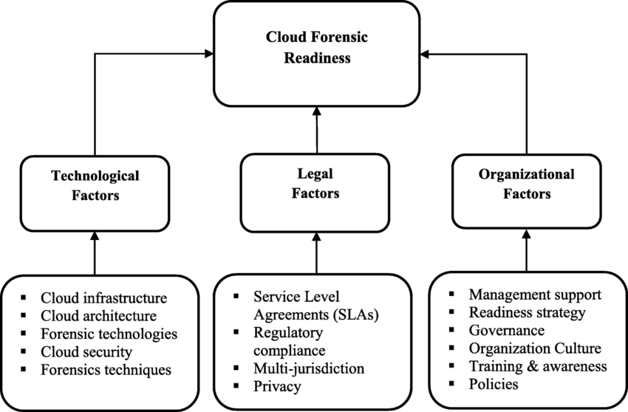

Figure 2.5: Verified Cloud Forensic Network
(Source: ResearchGate, 2019)
The use of the Internet of Things and edge-connected devices also creates further problems, which forensic preparedness strategies aim to solve. Shadow devices and unmanaged endpoints are sources of data that fall outside of normal monitoring boundaries, which exposes more of them to evidence gaps [21]. The environment's specific models of preparedness focus on persistent monitoring, automatic registration, and the automatic classification of data resources. The models enhance the objective of forensic awareness during the system architecture implementation and prevent the utilisation of manual intervention to gather evidence in a heterogeneous architecture [72].
Multisite automation is significant to the new forensic preparedness cloud computing. Automated creation of logs, the ability to authoritatively timestamp, and policy-directed retention of evidence minimise the effects of human error and guarantee that artefacts of evidence are attained in real-time [23]. They are of great use in an environment where scaling and decommissioning of resources occur quickly. In general, forensic readiness and adaptation strategies are a change from the tool-based investigation to the system-based preparedness. This change improves the security of the cloud environment by incorporating forensic capacity as a core element of online infrastructure, as opposed to an afterthought.

2.7 Thematic analysis

2.7.1 Disruption of Conventional Forensic Control and Evidence Stability
The upheaval of the traditional forensic control and evidence stability is presented as one of the major issues when the traditional digital forensic processes are applied to a cloud computing environment. Traditional forensic practices are based on an assumption of investigator-controlled systems, fixed storage media and predetermined locations of evidence [34]. These assumptions are essentially compromised by cloud architectures that are based on widespread virtualisation, automated resource orchestration, and service abstraction. Consequently, investigators lose their authoritative power to gain physical or logical facility upon the state in which digital artefacts are situated.
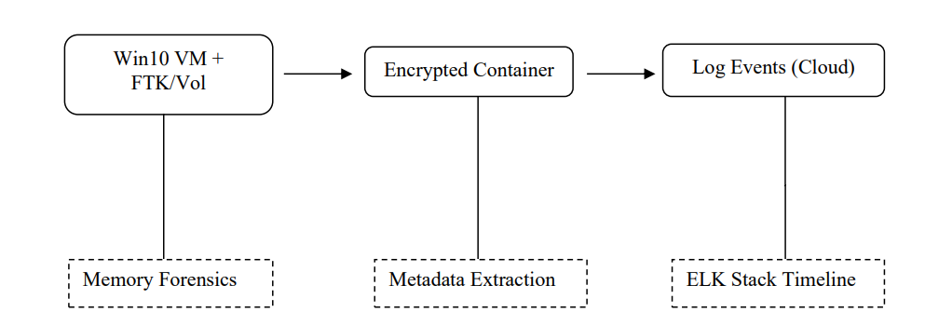

Figure 2.6: Testbed Architecture
(Source: ResearchGate, 2025)
The cloud computing environments of elastic resource management and dynamic provisioning do so by creating considerable instability in evidence persistence. Devoid of human intervention, virtual machines, containers and serverless functions are deployed and scaled down on demand. Digital artefacts can thus only be held on volatile memory or receive temporary storage layers until overwritten or deallocated [35]. Such volatility not only limits the possibility of a retrospective forensic analysis but also predisposes the possibility of the evidentiary loss before the beginning of the formal investigations. Conventional methods of acquiring data, such as disk imaging and memory captures, are useless in this case.
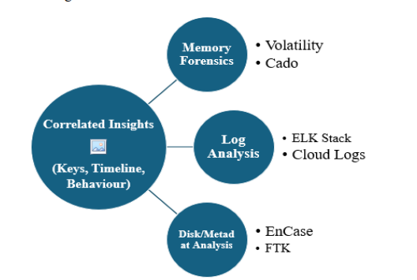

Figure 2.7: Layered Forensic Analysis combining Memory
(Source: ResearchGate, 2025)
Abstraction of infrastructure also disturbs the forensic control by covering the low-level system states from investigators. Accessing computing resources via application programming interfaces and management consoles by cloud service providers reduces the visibility of underlying hardware, hypervisors, and network traffic [36]. Evidence creation is then scattered amongst provider-hosted logs, application traces, and virtual network traces. Such fragmentation makes it more difficult to reconstruct the timeline and undermines the possibility of correlation of events between layers of services. The lack of transparency questions the accuracy of the investigation process and confidence in the results of the investigations.

2.7.2 Constraints on Accountability, Transparency, and Evidentiary Trust
Limitations on accountability, transparency, and evidentiary trust are an important thematic problem in implementing conventional digital forensic procedures in cloud computing systems. Traditional investigations [37]. A clear and well-documented chain of custody process, good evidence handling procedures and investigator oversight are influential in proving the authenticity and admissibility of digital artefacts. Infrastructural controls, data management, and operations are highly automated and third-party service providers significantly increase the challenge of achieving these requirements.
Cloud computing architectures have a lot more accountability issues due to the high automation of the life cycle of the systems. Such processes as replication of data, balancing, backups and failover are carried out without involvement of a direct interaction with a human being, and therefore it is always hard to tell who, when and how evidence has been accessed or altered [38]. Classical chain of custody models are based on evidence management, where people manage the evidence, and the mediation events are traceable. Automated cloud procedures blur responsibility assignment, undermine the capability to show continuous custody and deny evidentiary dependability.
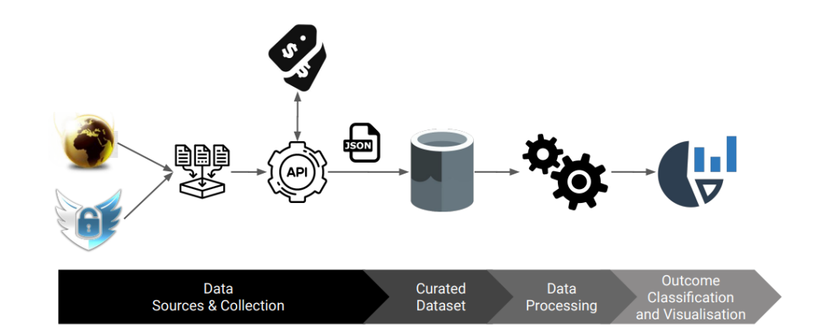

Figure 2.8: Provider-Mediated Evidence Processing and Transparency Constraints in Cloud Environments
(Source: academic.oup.com, 2022)
The transparency is also restricted by the lack of visibility of the provider-controlled infrastructure. Cloud service providers only make public a limited set of logs and telemetry via controlled interfaces and do not provide any understanding of underlying system behaviour, such as hypervisor processes or physical network communications. The investigators should then be limited to artefacts provided by the provider, and these might not be granular or contextual enough [39]. This addiction leads to a lack of transparency in the procedure and causes the question of the fullness and objectivity of the evidence offered. The forensic findings are questionable due to the inability to check the processes of evidence generation individually.

2.7.3 Shift from Reactive Investigation to Proactive Forensic Capability
The transition from reactive investigation to a proactive forensic capability is a major theme in curbing the drawbacks of the traditional digital forensic procedures in cloud computing settings. Traditional methods of forensics are largely reactive, with the process being based on the retrieval of the evidence once the security incident is observed [40]. The method presupposes that digital artefacts are maintained and kept, an assumption which is becoming false in cloud-native systems that are characterised by automation, scalability and distributed resource handling.
The provisioned virtual machines, containers and serverless services of cloud environments produce massive data streams of transient information [41]. Reactive forensic procedures are frequently not capable of recording vital artefacts that are required to reenact the event or assign blame. This is the limitation that directs the ineffectiveness of the old forensic structures in the context of cloud computing.
These issues are solved through proactive forensic capability, which means considering the forensic aspect in designing systems and governing the operations. The forensic readiness systems stress the ongoing creation of evidence, real-time surveillance, and policy-based data retention to guarantee that the pertinent artefacts are retained as normal operations of the system [42]. Active capturing of identity management events, network traffic, application usage and administrative operations makes evidence more readily available and lessens the use of retrospective data recovery. This method offers a fit of forensics with cloud automation as compared to going around it.

2.8 Theoretical Framework

2.8.1 Linear Digital Forensic Investigation Theory
Theoretical Linear Digital Forensic Investigation conceptualises forensic investigation as a staged and investigator-controlled procedure that comprises evidence identification, acquisition, preservation, analysis and presentation. This theoretical model comprises stable computing conditions, long-term data storage and direct access to systems and storage sources [41]. It also assumes that high-level forensic tools are deterministic and that investigators are able to isolate suspected devices, apply such deterministic forensic tools, and also have an unbroken chain of custody by applying human-mediated evidence handling measures [20]. These assumptions facilitate repeatability, veracity checking and evidentiary admissibility in conventional computing settings.
The general principles of linear forensic theory, however, are more out of line with the basic assumptions when it applies to the cloud computing environment. Cloud infrastructures are designed to work based on the principles of virtualisation, abstraction and automated orchestration of resources that restrict the level of authority investigators have on the state of systems and sites of evidence [23]. The volatility of data, elastic scaling, and infrastructure controlled by providers interferes with the linear sequence of the forensic phases and undermines the power of control over the processes of acquisition and preservation. The evidence is often spread across many levels of services and geographic boundaries, which invalidates the stability assumptions and exclusive ownership [21]. The application of the linear forensic investigation theory in the cloud-native settings allows an assessment of its relevance on a critical level and contributes to the research aims at highlighting the weaknesses in the traditional forensic paradigm directly.

2.8.2 Socio-Technical and Readiness-Oriented Theory in Cloud Forensics
Readiness-oriented theory and socio-technical theory redefine digital forensics as a process of interaction between technical systems, organisational arrangements, and governing systems instead of a technical one. Various stakeholders would affect the process of forensics, so these stakeholders include cloud service providers, tenant organisations, automated systems and regulatory authorities [18]. This theoretical thought acknowledges the fact that the processes of evidence generation, access, and maintenance are determined by technical architecture and institutional constraints.
Forensic preparedness theory builds on the theory by proposing active involvement of forensic capabilities in system design and operational policy-making. These are mechanisms which bring forensic practices in line with cloud automation and service-oriented models. Preparation-oriented theory overcomes the procedure and legal constraints that have been applied to cloud forensic investigations by focusing on accountability, transparency, and evidentiary trust before exploration [20]. The theoretical framework that this study combines explicitly addresses the research purpose of creating a model of preparedness that improves forensic performance in dynamic and distributed cloud computing systems.

2.9 Conceptual framework
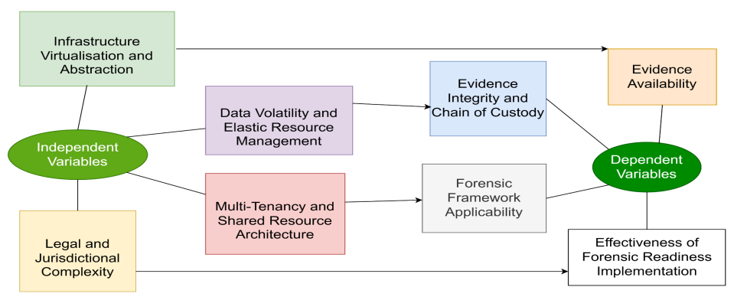

Figure 2.9: Conceptual Framework Linking Cloud Forensic Challenges to Investigation Outcomes
The conceptual map associates the issues specific to the clouds with the results of the digital forensics of cloud-based programs. Infrastructure virtualisation, data volatility, multi-tenancy, and legal jurisdictional complexity define the independent variables that are the essence of a cloud and limit the conventional forensic procedures. These directly impact dependent variables such as the availability of evidence, integrity, and chain of custody of evidence, relevance of forensic frameworks, and efficiency of forensic readiness programs. The framework follows the perspective of the study that aimed to understand the drawbacks of the traditional digital forensics by demonstrating how the dynamics of the cloud operations impose readiness requirements to augment the reliability, integrity, and admissibility of digital evidence in distributed cloud systems.

2.10 summary
The literature review combines academic and technical studies to discuss constraints of conventional digital forensics procedures in cloud computing settings. Principles of forensic validation about the ability of the investigators to control, the stability, and deterministic nature of the evidence are observed to become more and more incompatible with cloud architectures that are being characterised by virtualisation, automation, and service abstraction. The thematic analysis indicates the presence of interrelated technical, legal, and procedural issues, such as the volatility of evidence, decreased transparency, disrupted chain of custody, and lack of jurisdiction. Theoretical insights also confirm the incompatibility between linear forensics models and cloud-native systems and highlight the significance of socio-technical and readiness-oriented frameworks. Forensic preparedness has become an option of viable adaptation strategy that can entrench evidence protection, responsibility, and governance systems into cloud processes. Together, these insights provide a sound conceptual basis for the ultimate design and execution of a preparedness-based forensic framework that can foster investigation dependability, evidentiary integrity, and admissibility in the dynamic and dispersed environment of the cloud computing platform.

Chapter 3: Research Methodology

3.1 Introduction
The approach used in evaluating the issues surrounding the implementation of conventional digital forensic procedures on cloud computing is presented in this chapter. Since cloud-based systems are highly technical, legal and procedural, a systematic research methodology is critical to guarantee neither informal nor ad hoc analysis of the findings. The research design is based on a qualitative study based on the analysis of the secondary data to explore the current knowledge, frameworks, and scholarly views on cloud digital forensics. The chapter details the philosophical position, research strategy, research approach, data sources and the methods employed in the analysis, including aspects of research rigour, research ethics and methodology limitations of the study. These elements alone form a consistent basis of responding to the research objectives and questions.

3.2 Research Philosophy
The study is informed by the interpretivism research philosophy, which is based on explaining complex phenomena based on contextual interpretation as opposed to objective evaluation. The research requires the application of interpretivism, especially since the issues of digital forensics in the cloud are informed by technological architecture, the law, organisational culture and human decision-making [30]. These aspects are not entirely measurable by quantitative levels, and they need to be discussed as complex processes between the systems, policies, and stakeholders.
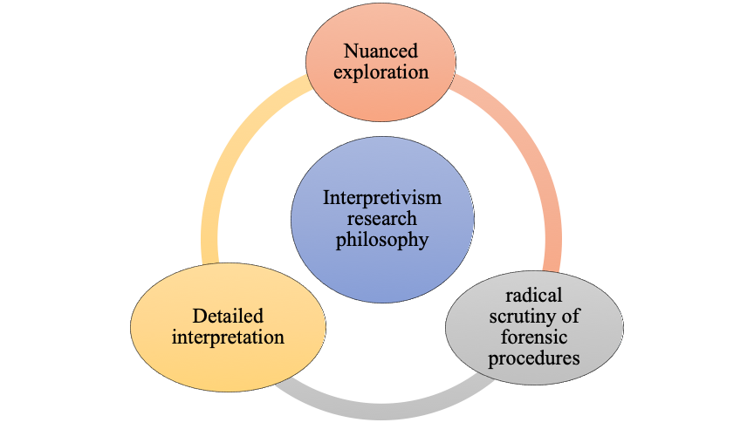

Figure 3.1: Interpretivism research philosophy
Through interpretivism, the study can look at how the nature of cloud computing, such as virtualisation, automation and distributed control challenges traditionally held forensic assumptions [25]. This school of thought advocates radical scrutiny of forensic procedures, preparedness programmes and models of governance as socially and institutionally determined practices instead of predetermined technical processes. Conversely, positivist philosophy places more emphasis on hypothesis testing and empirical measurement, which is inapplicable in this scenario because there is no easy access to live cloud environments and proprietary forensic evidence [28]. The reason is that the interpretivist approach allows further exploration of the changing forensic paradigms and justifies the exploratory aspect of the given research.

3.3 Research Approach
The research method used in this study is an inductive research approach, in which the existing literature permits the themes and insights to be extracted and does not have pre-determined hypotheses to be tested [33]. The inductive reasoning is more appropriate to exploratory research fields that are in their developing form, and cloud digital forensics is not different. Rather than positing given interactions between variables, the inductive method allows for finding common patterns, problems, and possible solutions in various sources [73].
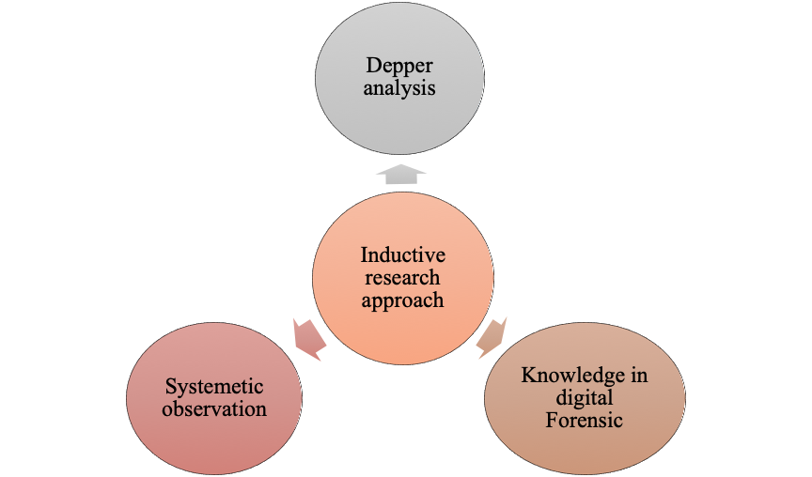

Figure 3.2: Inductive research approach
The study uses a methodical review of scholarly sources, criteria, and technical debates, which collects abstract knowledge of the way cloud settings undermine traditional forensic functions. The method assists in the synthesis of results concerning technical constraints, legal restrictions, and preparedness strategies [26]. The inductive approach, by creating inferences based on patterns found in the literature, is compatible with the goal of the research to assess the available models of forensics critically and be able to point out gaps that must be adjusted in cloud environments.

3.4 Research Strategy and Design
The study is a qualitative, analysis-driven research that aims at analysing documents as a secondary source of information [73]. The choice of documentary analysis as the major research strategy is possible because it will allow conducting a structured analysis of the currently known information without having to connect to live cloud systems or confidential forensic information [25]. The concept to be applied in this strategy is the appropriateness to analyse standards, conceptual frameworks, and scholarly reviews of the processes in cloud environments.
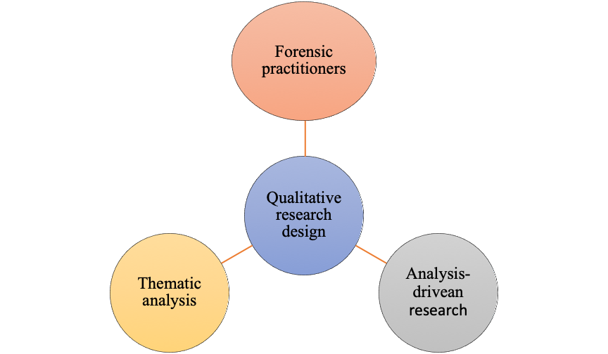

Figure 3.3: Qualitative Research Design
The other possible methods, like experimental testing, survey, or case study, are not used because of practical and ethical limitations. Experimental methods demand precise entry to cloud environments, and this is normally limited by service companies [31]. Forensic practitioners or organisations would have to be involved in surveys and interviews, which would imply the need to approve the ethical conduct and possible bias. Case studies are also restricted by the confidentiality of data and jurisdictional constraints [74]. Documentary analysis is thus an adequate and rigorous technique of synthesis that would offer insight into different areas and at the same time meet the criteria of this research.

3.5 Data Sources and Selection Criteria
The research is based on secondary data, which is collected through several reliable sources to guarantee the full coverage of the issues of cloud digital forensics [27]. Such resources are peer-reviewed scholarly journals, conference papers, forensics standards or technical and policy-oriented documents [79]. Although academic literature is available on theoretical and empirical information on forensic processes, standards and frameworks offer a systematic approach to the investigation processes and preparedness models [32]. Technical and policy reports have a practical approach to the new technologies and governance aspects.
Inclusion and exclusion criteria are placed to make sure that the research is relevant and reliable [75]. Just the sources that have been published between 2022 and 2025 are taken into consideration, as they represent modern trends in cloud computing and digital forensics. Articles should show interesting applicability to the clouds, forensic techniques or investigative issues [24]. The sources that are not scholarly, transparent in their methods, or do not provide clarity to the research purpose are omitted. These guidelines will make the data analysed updated, valid and in line with the direction of the study.

3.6 Data Collection Procedure
Data gathering will be systematic and structured to achieve transparency and consistency. Academic databases, digital libraries, and reliable open-access repositories are used to find the relevant literature [28]. The first searches involve the keywords that are topic-related and involve cloud computing, digital forensics, forensic preparedness, and investigation issues. Documents retrieved are filtered by titles and abstracts in order to evaluate relevance [80].
Fully-text reviews are then performed in order to ensure conformance to the inclusion criteria. Redundant research, obsolete sources, and those with unclear methods are eliminated. The chosen documents are grouped thematically to make them easy to analyse [30]. This methodology choice will result in adequate coverage of the relevant literature and will reduce the bias and redundancy of data provided to facilitate the analysis process.

3.7 Data Analysis Technique
Thematic analysis is the first data analysis method used in the study. The thematic analysis allows the identification of recurring patterns across data sources aimed to produce a systematic identification, organisation and interpretation of qualitative data [32]. The significant themes and issues linked to the problems of cloud digital forensics are revealed through repetitive reading and comparison of documents, and they include: data volatility, multi-tenancy, jurisdictional complexity, limitations of the tools and forensic readiness [75]. The analysis procedure is associated with coding the relevant parts of each paper and bringing similar concepts to larger thematic units. These themes are then critically analysed to determine relationships, contradictions and gaps in available literature [29]. It helps foster synthesis as opposed to their summarisation because it allows comparing the points of view in different areas.

3.8 Reliability, Validity, and Research Rigour
The rigour of methods is ensured by the systematic selection of sources, transparent data collection methods, and the power of different analytical methods [33]. Credibility will be achieved through the use of peer-reviewed and authoritative sources, whereas dependability will be achieved through the clear description of research procedures. Comparisons of the results in the various sources will help in confirmability since it will not be biased to one perspective [77]. All these measures make the findings of the qualitative findings more credible.

3.9 Ethical Considerations
The research uses only secondary data and has no human subjects; hence, there is no threat to confidentiality or informed consent. Ethical trustworthiness is upheld in proper citation of sources, no plagiarism, and wise interpretation of results [25]. The references are given due credit, and conclusions are rendered objectively to avoid any instances of dishonesty in academics and research ethics.

3.10 Limitations of the Research Methodology
The limitation of the methodology is that it showcases the use of published literature and not the use of empirical testing. Lack of live forensic experiments means that the verification of results in operational settings cannot be realised [26]. Furthermore, secondary data can represent the bias in publication or contextual constraints. These limitations delimit the study, but they fail to question the validity of the study because the research objectives are to offer a critical synthesis and not an operational analysis [78].

3.11 Summary
The study has used a qualitative, interpretivist methodology, which is described in this chapter. The methodology assists a systematic exploration of the issue of cloud digital forensics by establishing a systematic understanding of the research topic through inductive reasoning, documentary analysis, and thematic synthesis to help answer the research purpose and questions.

Chapter 4: Design Process

4.1 Introduction
The growing levels of abstraction, automation, and dispersion of cloud computing systems demand a more structured and goal-centred approach to digital forensic preparedness. The traditional forensic designs that require physical access, non-moving data points, and systems owned by the investigator lack relevance in the cloud-based infrastructures. The design process is developed using a forensic preparedness-based framework that is compatible with dynamic cloud attributes, so these weaknesses are critically addressed in response to the research goal. The design is guided by the objectives of the research, especially the discovery of technical and legal difficulties and the evaluation of the current forensic frameworks in virtualised environments. It focuses on the concept of integrating proactive evidence preservation, the use of controlled access, and accountability in multi-tenant and service-oriented cloud models. The theoretical knowledge gathered during the review of the literature is planned to be converted into the planned design that would improve the reliability, integrity, and admissibility of digital evidence as well as contribute to efficient forensic investigations in a distributed and fast-changing cloud environment.

4.2 Design process

4.2.1 Design Rationale and Objectives
The design impetus is based on seeking ways of dealing with the restrictions of traditional models of digital forensics once implemented in cloud- based computing settings. Conventional models are mostly responsive and are based on assumptions of physical authority, information durability and independent proprietorship of systems, which cannot be matched with a cloud-native design [55]. This design aims at transforming the results of the qualitative research of secondary literature into a structured and proactive forensic preparedness strategy. The main design goal is to facilitate credible evidence management within an environment typified by virtualisation, automation and distributed geographically. This aim is a direct response to the technical and legal challenges that were identified to influence admissibility, integrity, and availability of digital evidence in cloud infrastructures.

4.2.2 Design Principles and Constraints
The design is based on a set of fundamental principles taken out of the literature review, such as forensic preparedness, integrity of evidence, accountability and compliance with the regulation. Forensic readiness focuses on forensic preparedness because the possible evidence is generated and maintained in an orderly manner before the incidents [56]. The integrity of evidence is handled via controlled access, secure logging systems and traceable handling protocols, which reduce the amount of unauthorised alterations. Accountability has also been integrated to reduce disruptions in the chain of custody as a result of automated cloud operations [57]. It is also designed based on restrictions that are posed by cloud environments that include multi-tenancy, lack of visibility on the physical infrastructure, and reliance on cloud service providers. Such limitations require an architecture that is used within provider-operated limits and remains forensically sound.

4.2.3 Mapping Forensic Readiness to Cloud Service Models
The design process takes into consideration the differences among the models of cloud service delivery, which are Infrastructure as a Service, Platform as a Service, and Software as a Service. The design in the Infrastructure as a Service environments has used the power of virtual machine-level logging, snapshot features, and network telemetry to assist in preserving evidence [58]. The Platform as a Service model makes higher-level abstraction demands and necessitates the use of application-specific logs and provider-facing monitoring interfaces. Forensic preparedness is accomplished by contractual agreements, audit logs, and compliance reporting systems as opposed to actual access to the system in a Software as a Service setup. The design addresses the purpose of evaluating existing forensic structures in cloud-native systems by adjusting the forensic prepared controls to every service model type.

4.2.4 Stakeholder Roles and Responsibilities
The design clearly delineates the position of the major stakeholders in cloud forensic investigations, such as cloud service providers, tenant organisations, and forensic investigators. Cloud service providers ensure the maintenance of secure infrastructure, the production of useful system logs and aid in the legitimate access to evidence. The tenant organisations have the role of executing in-house readiness policies, identity and access controls and retention of evidence [59]. Forensic investigators work and access predefined access boundaries and use validated artefacts provided through provider-controlled mechanisms. These functions should be clearly clarified to increase the clarity of the procedures and minimise the ambiguity in the evidence treatment, especially in the context of multi-jurisdictions.

4.2.5 Evidence Lifecycle Integration
Designing used to incorporate forensic preparedness throughout the whole digital evidence lifecycle, and this lifecycle includes identification, collection, preservation, analysis and presentation. Early evidence identification is backed by the proactive logging and monitoring mechanisms, and ensuring less volatility of data is facilitated by automated preservation processes. Evidentiary integrity is sustained throughout the lifecycle through secure storage, access control and audit trails [60]. The design facilitates investigative reliability through ensuring that readiness controls are implemented in every phase, which coincides with the goal of improving forensic abilities in dynamic cloud environments.

4.3 Process workflow
The process workflow operationalises the design of readiness-based by organizing the operations of forensics in a cloud computing environment as post-incident, incident and pre-incident [61]. The workflow focuses on evidence preparedness, control of evidence movement, and accountability of the procedure to eliminate the deficiencies of classical models of digital forensics.

4.3.1 Pre-Incident Forensic Readiness
The process would also start by establishing forensic preparedness before a security incident. Cloud setups are set such that they produce end-to-end and standardised logs between the pivot of compute, storage, identity and network. Fast financial data aggregation with all the security enabled is automated time synchronisation, as well as policy retention to respond to the volatility and ephemerality of data [62]. The identity and access management controls are intertwined and guarantee the traceable action of the user, and the evidential direction is also safeguarded by encryption and key management practices. This step directly contributes to the task of strengthening the forensic resources by retaining the potential evidence as it is generated instead of depending on recovery after the fact.

4.3.2 Evidence Generation and Detection
The creation of evidence is done via system logs, application telemetry and network traces that are under the care of cloud service providers. Potential incidents are detected by automated alerts so that their forensic escalation can take place in time [63]. This step tackles the problem of technical issues with delayed detection and incomplete data collection and seeks to discover the relevant artefacts in dynamic and distributed infrastructures.

4.3.3 Evidence Collection and Preservation
A collection of evidence is implemented on the provider-assisted means, such as a virtual snapshot, exporter of immutable logs, and application-secured records, after having identified an incident. The workflow allows no direct interaction of the investigators with the shared infrastructure to avoid data exposure of cross-tenant [64]. Chain of custody is generated automatically, and it registers the access events, timestamps and the responsible party. These checks lower the procedural confusion which arises due to automation and intervention of third parties, hence aiding the evidentiary integrity and legal admissibility.

4.3.4 Evidence Analysis and Correlation
The artefacts that are preserved are taken to a controlled forensic analysis area where activities of correlation and reconstruction are conducted. It is analysed in the patterns of sequencing of events, access patterns, and system interactions between service layers. The workflow enables cross-source correlation to deal with evidence fragmentation, which is a feature of cloud architecture [65]. Control access and audit trails are upheld in the course of analysis to ensure accountability and that the regulations are adhered to.

4.3.5 Reporting, Compliance, and Review
The last phase is followed with systematized reporting and legal authentication of results. The evidence has been recorded in a respondent manner in accordance with jurisdictions and regulations and therefore can be admissible during a court of law [66]. Post-incident review activities determine the effectiveness of controls of readiness and input to further development of forensic policies. This promise loop guarantees the workflow to be dynamic to the changing cloud technologies and new challenges in forensic demands.
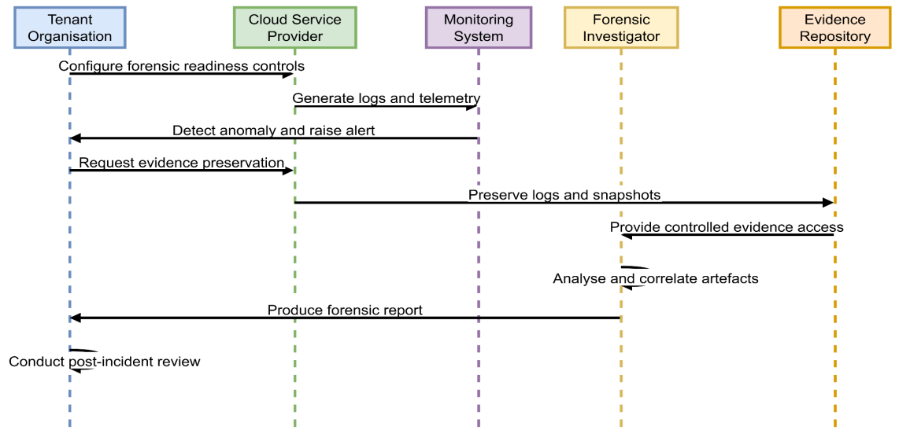

Figure 4.1: Cloud Forensic Readiness Process Workflow
The diagram depicts a readiness-oriented cloud forensic workflow including the tenant organisation, cloud service provider, monitoring system, forensic investigator and evidence repository. It portrays the proactive configuration of control, constant monitoring, incident detection, controlled evidence preservation, forensic analysis, reporting and post-incident examination to be sure of evidence integrity and reliability in investigations.

4.4 Summary
The design process enables the design of a readiness-based and structured approach to dealing with the restrictions of the traditional digital forensic practice in the cloud computing environment. It addresses the challenges of cloud abstraction, multi-tenancy, third-party management and volatile data, as its proposed workflow considers all these probable cloud-specific issues by integrating forensic preparedness at pre-incident and post incident stages. Its design is a combination of technical components, such as 24/7 adherence and collection, evidence security, and controlled access, with procedural protections, which facilitate a chain of custody and adherence to regulations. Well-specified roles of the stakeholders contribute to accountability and minimise ambiguity in the forensic operations. The workflow illustrates how active design may enhance the reliability, integrity, and admissibility of digital evidence in changing and distributed systems. The design facilitates the goals of the research, which is to assess the current forensic models and improve the capacity to investigate a case by converting theoretical knowledge into a working framework. It is a constructed procedure upon which the readiness-based model can be utilised and assessed in the context of clouds in the future.

Chapter 5: Implementation

5.1 Introduction
The implementation phase focuses on applying the results of the qualitative analysis to a practical and structured context suitable for cloud computing environments. The focus is on the translation of the limitations of the traditional digital forensic processes into actionable forensic readiness steps. The implementation, instead of designing or implementing new forensic software, will show how conceptual and procedural enhancements could be embraced to aid in the investigations within virtualised and distributed cloud infrastructure. The main obstacles that are observed during previous phases of the study are volatility of data, limited access to infrastructure, multi-tenancy, complex jurisdiction, and chain of custody disruption. These concerns guide the development of a cloud-conscious implementation strategy that puts preparedness, evidence integrity, and legal and organisational requirement compliance in the first place. The implementation shows how forensic principles can be modified to operate within the operational constraints set by cloud service providers.
The strategy combines technical control, procedural protocol, and governance issues to facilitate credible evidence management in dynamic settings. The forensic readiness is placed as a proactive approach to ensure that collection of evidence is timely and limits the use of the reactive method of investigation. The implementation increases the credibility and admissibility of digital evidence through synchronisation of forensic activities with cloud architectures and service models. The results obtained in this chapter are practically relevant to organisations, forensic practitioners, and cloud stakeholders who want to enhance their investigation abilities in contemporary cloud-based systems.

5.2 Implementation
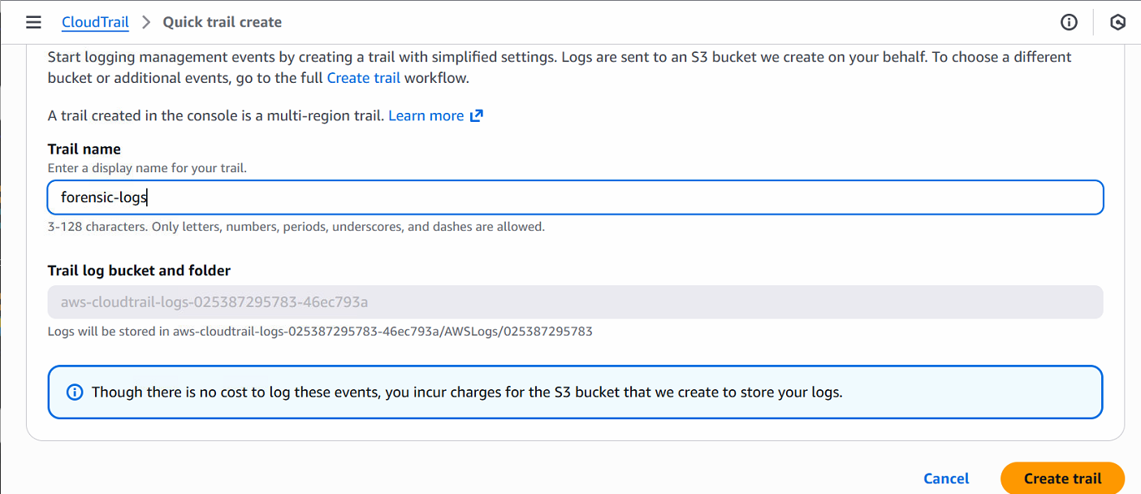

Figure 5.1: Setting up CloudTrail to record logs
CloudTrail logging was enabled using a multi-region configuration to ensure that management events across all AWS regions were captured consistently. A special trail is provided under the name forensic-logs and the logs are automatically sent to an S3 bucket. This process guarantees an on-going gathering of both API-level activities such as user activity and interactions with services. This setup is forensically prepared by recording time-stamped events at scale so that evidence loopholes due to delayed investigation are minimized. The automated configuration does not require human intervention and all the control-plane activities are documented in a central place to be accessed later in the forensic investigation.
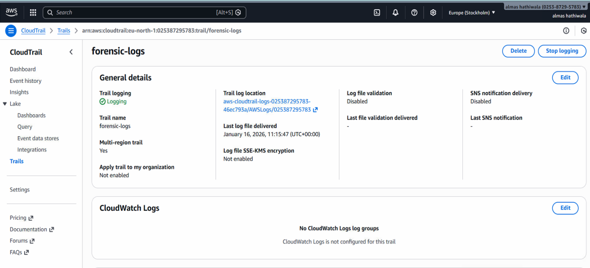

Figure 5.2: CloudTrail dashboard
The CloudTrail dashboard is used to verify that the trail is enabled to log events and it is in multi-region mode. Log delivery timestamps give evidence of the successful and ongoing events gathering and the latest delivery that took place a few minutes after the configuration. Important attributes such as trail status, location of storage and state of logging give transparency and traceability. Even though cloud watch integration was not implemented, the dashboard can still be used to provide forensic control, with the investigator being able to check the continuity and integrity of the logs. This visibility plays a vital role in justifying the availability and completeness of evidence when investigating an incident.
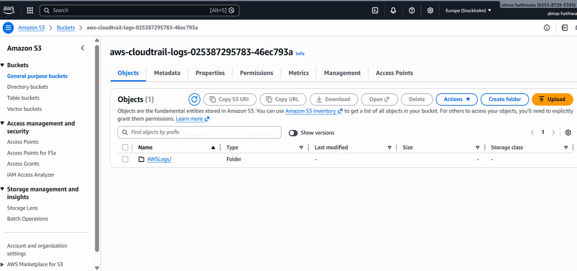

Figure 5.3: CloudTrail logs stored in an S3 bucket
CloudTrail logs are stored safely in a separate Amazon S3 bucket that is organized in terms of AWS service and account identifiers. Automated ingestion of log without any manual handling is shown by presence of organised folders. Scalability and durability with centralised storage provide the option of retaining evidence over a long period. The S3 storage is highly available and redundant minimizing the occurrence of data loss. The bucket-based model also provides limited access with permissions and policies. It is necessary in ensuring confidentiality and integrity in the future when the logs are accessed to be analysed forensically.
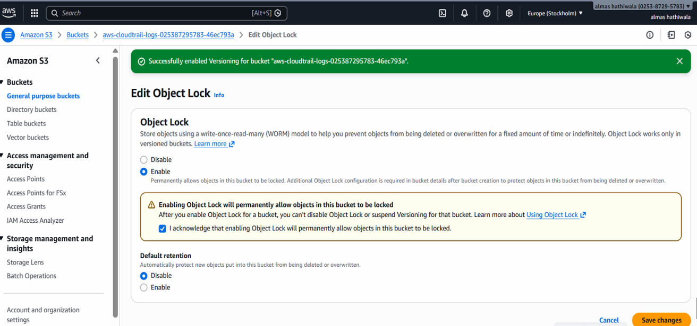

Figure 5.4: Setting the object lock for maintaining evidence integrity
The S3 bucket is configured with Object Lock to enforce the write once read many (WORM) model. This set up does not allow deletion or alteration of stored log objects within a specified retention period. Object Lock is permanent, making evidence permanent once written, which is a direct support of chain-of-custody requirements. The integrity protection eliminates threats of insider attacks or automated deletion policies. This mechanism provides greater admissibility and reliability of cloud-based forensic evidence by ensuring that the original log artefacts remain in the untouched state.
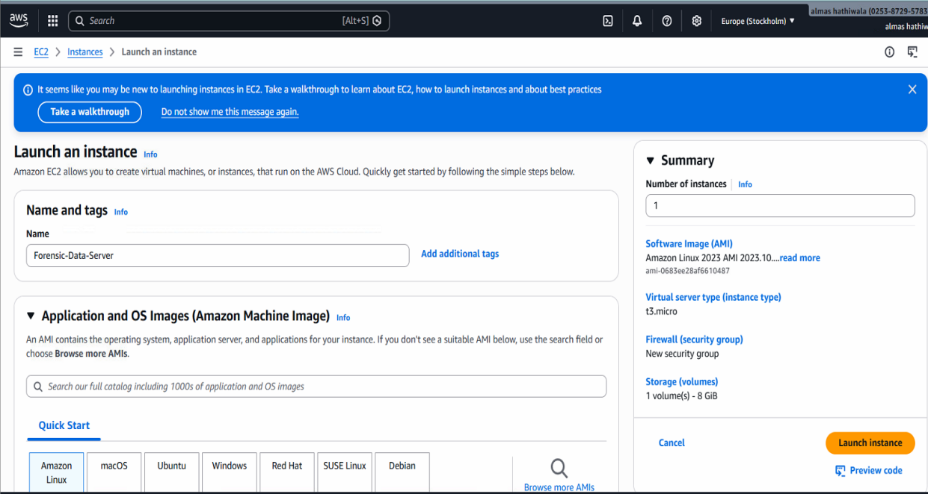

Figure 5.5: Launching an EC2 instance
An EC2 instance called Forensic-Data-Server is started to recreate an environment of forensic monitoring of a cloud-hosted system. One of them is deployed on a general-purpose setup that can be used in controlled analysis. This action is the process of creating a resource in the form of a cloud that has the capability to produce operational and security-related events. The case is a convenient example of tracking activities, creating logs, and collecting evidence that can be used to test the state of forensic preparedness in an Infrastructure-as-a-Service (IaaS) scenario.
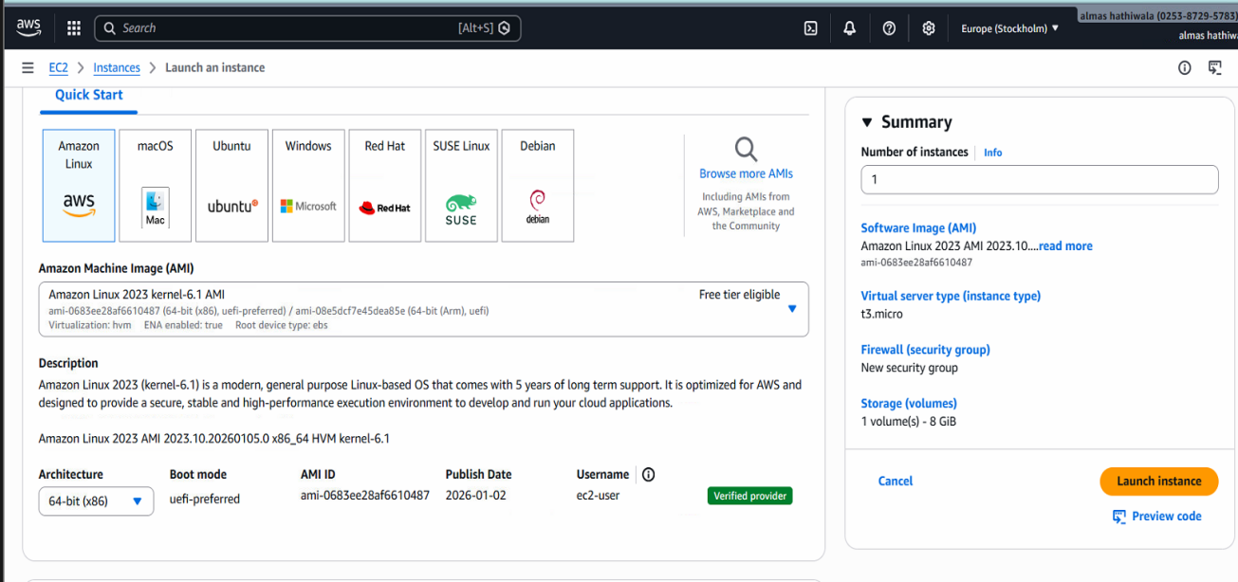

Figure 5.6: Configuring Options
The instance was configured using an Amazon Linux 2023 AMI with a 64-bit x86 architecture. The type of t3.micro instance is chosen, which includes 1 vCPU and 1 GiB of memory, and 8 GiB of root volume is added to the storage. These parameters depict a bare minimum but realistic cloud deployment. System behaviour is predictable when the system is properly configured. It is significant to trace actions against events recorded in the log. Repeatability and consistency in a forensic analysis is also facilitated with standardised instance settings.
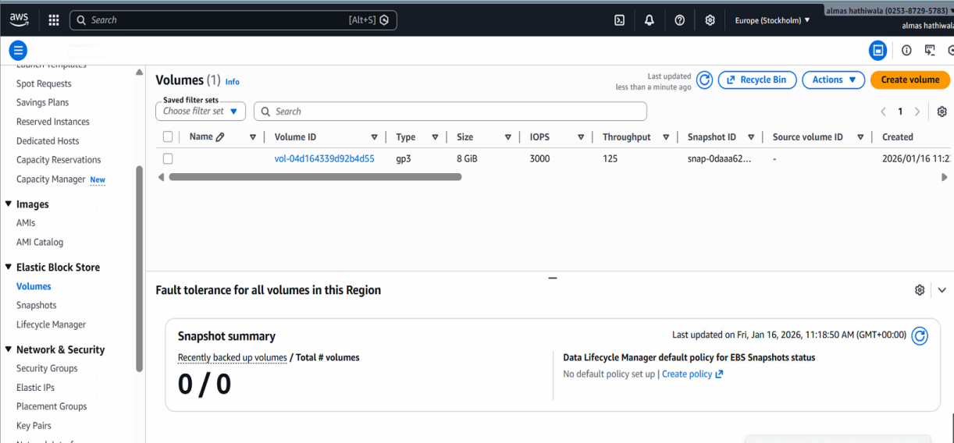

Figure 5.7: Accessing volumes
The Elastic Block Store (EBS) volume associated with the instance was accessed to review storage properties. A single gp3 with 8 GiB is fitted, which provides 3000 IOPS and 125MB/s throughput. These measurements verify consistent storage performance that can be stored under the forensic preservation. Looking through volume information helps the investigators determine the sources of data, evaluate the extent of storage, and plan on the basis of snapshots. This measure is compatible with the forensic principles of locating and separating the artefacts of storage.
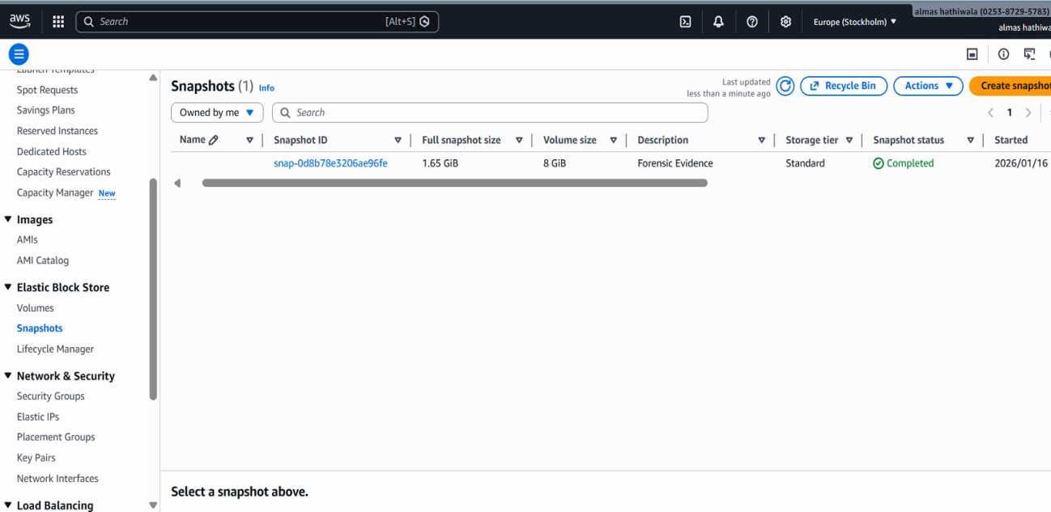

Figure 5.8: Creating a snapshot of the EC2 instance
A full snapshot of the EBS volume is built, which contains 1.65 GiB of utilized information of the 8 GiB volume. Snapshot process is done successfully and marked as forensic evidence. Snapshot creation captures the disk state of a system at a particular point in time and the snapshot can be analysed repeatedly without changing the running system. This facilitates the preservation of the evidence, downtime reduction, and the preservation of original data, which is critical to sustaining forensic sanity in cloud environments.
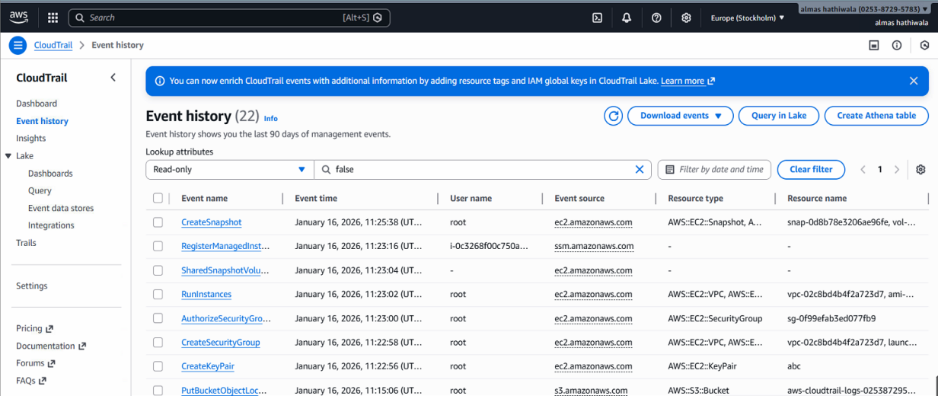

Figure 5.9: Event history manager
The event history interface recorded 22 management events, including snapshot creation, security group changes, and key pair operations. Event entries include user identities, resources that are impacted, timestamps and event sources. This is a comprehensive audit trail that allows reconstructing the activities done on cloud resources. Granular event metadata is supported by the availability of attribution and analysis of timelines. This full-fledged logging illustrates that CloudTrail is influential to accountability and traceability, which is a main issue of evidence reconstruction in distributed cloud systems.
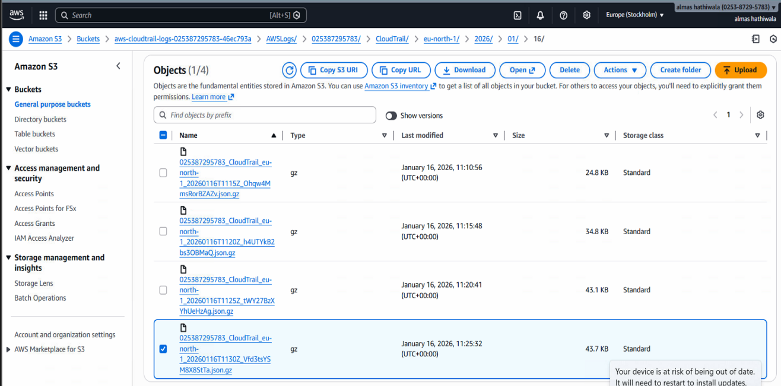

Figure 5.10: CloudTrail logs stored in S3 bucket
The S3 bucket displays multiple CloudTrail log objects compressed in .gz format, each representing recorded management events. The logs are time-stamped and are stored in sequence with a file size varying between about 24KB to 44KB. This verifies that there is any constant delivery of logs by CloudTrail to permanent storage. Formatted storage format enables scalable storage and retrieval of specific time frames of activity by investigators, a vital element in building an event timeline when carrying out forensic investigations.


Figure 5.11: Sending CloudTrail logs to Athena
An external table is created in Amazon Athena by linking it to the CloudTrail S3 bucket. The generated table schema is automatically generated to map complicated fields like user identity, event source and session context. This is a process that allows the querying of large log volumes with SQL in a serverless manner without the relocation of information. The integration enhances forensic preparedness since it enables thousands of records of the logs to be analysed quickly without destroying the data in its original location of storage.

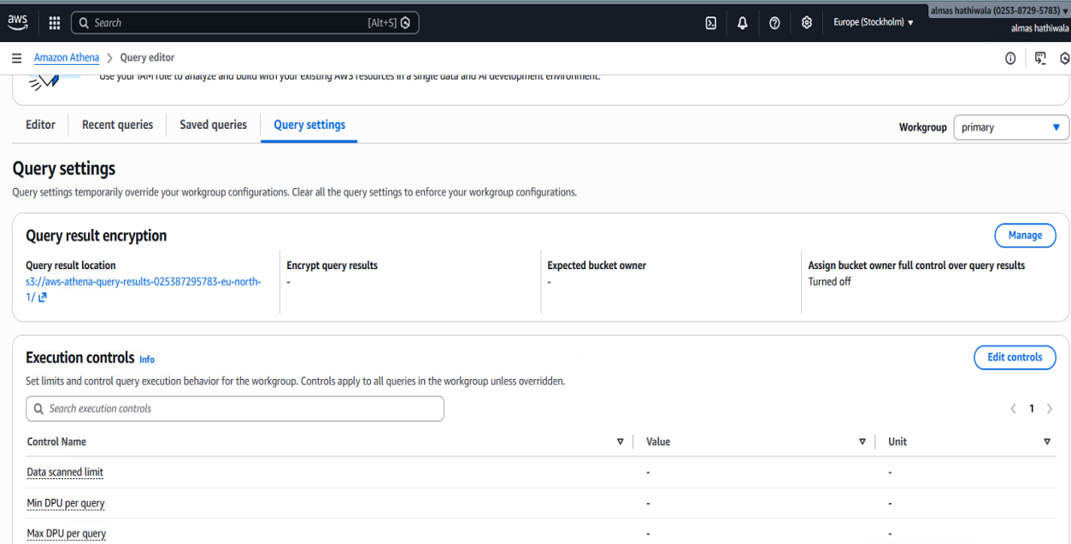

Figure 5.12: Configuring query settings
Amazon Athena query settings are set up to state a secure query outcome location and execution controls. The results of queries are sent to an S3 bucket, which is specially created to ensure that there is a distinction between raw evidence and results obtained. There are no limitations on the limits of the data scans such as encryption settings and regulated points of output improve the governance. These settings help to maintain responsible forensic study because the results of queries are traceable, and sensitive results are not accidentally overwritten or exposed.
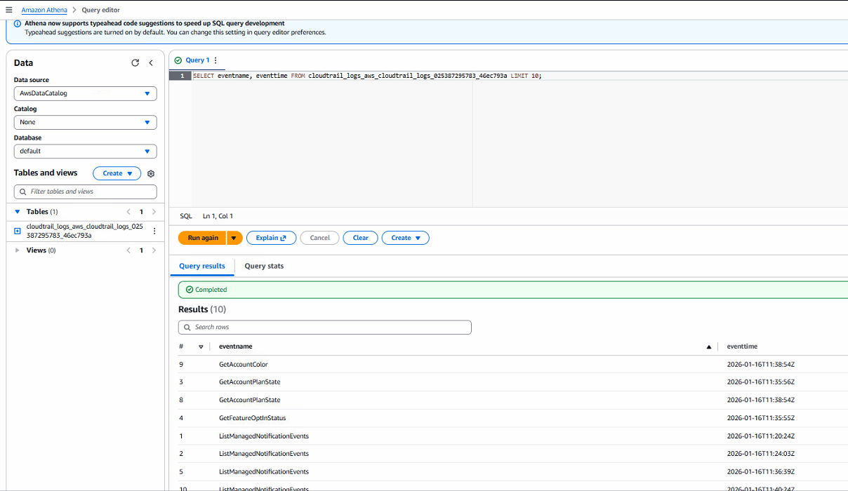

Figure 5.13: Running a query to show all the stored logs
A basic SQL query is executed to get the names of events and time stamp of the events in the CloudTrail log table, and 10 sample records were returned. The events contained in the results were GetAccountPlanState and ListManagedNotificationEvents, whose timestamps are down to the second. It is an indication that the stored logs are accessible and usable when the query is executed successfully. The step shows that forensic analysts can efficiently enumerate documented activities and determine log completeness when preliminarily investigating such activities.
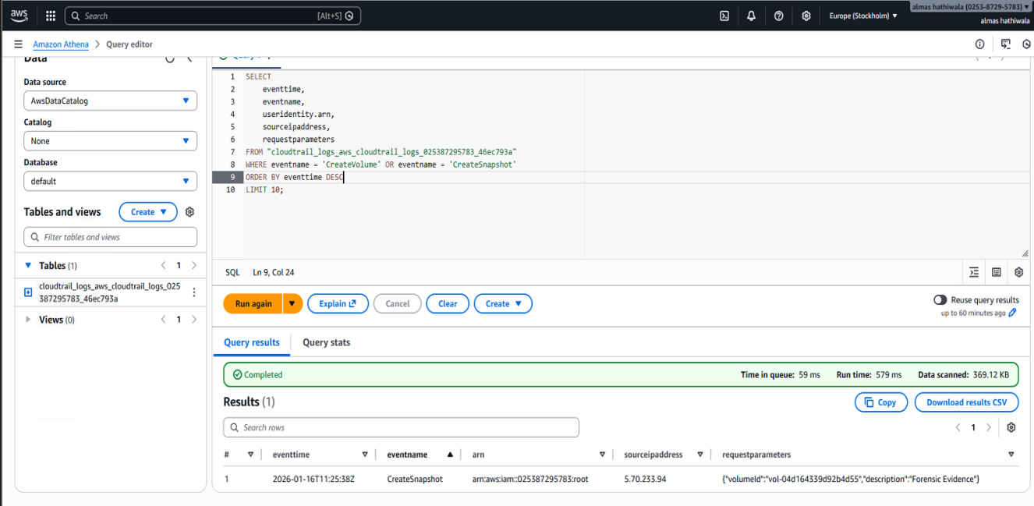

Figure 5.14: Running a structured query to see results
A structured query was executed to filter high-value events such as CreateSnapshot and CreateVolume. The query also gave one matching record with event time, source IP address, and resource ARN. Scanning comprised about 369 KB of data and took 579ms. This shows effective identification of important forensic activities and indicates capability to distil evidence-related activities in massive cloud audit data.
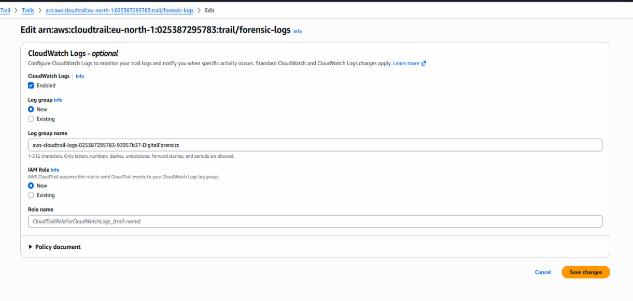

Figure 5.15: Configuring CloudWatch for visualising logs
CloudWatch logs CloudTrail is linked to cloudwatch by allowing the delivery of logs to a special log group. A role of IAM is created to enable the secure log streaming. This setup allows close real time visibility of activities without the need to read raw log files. CloudWatch integration facilitates active forensic preparedness where the security team can monitor, compare. React to events of suspicious activities as these happen without necessarily having to fetch log entries after the event.
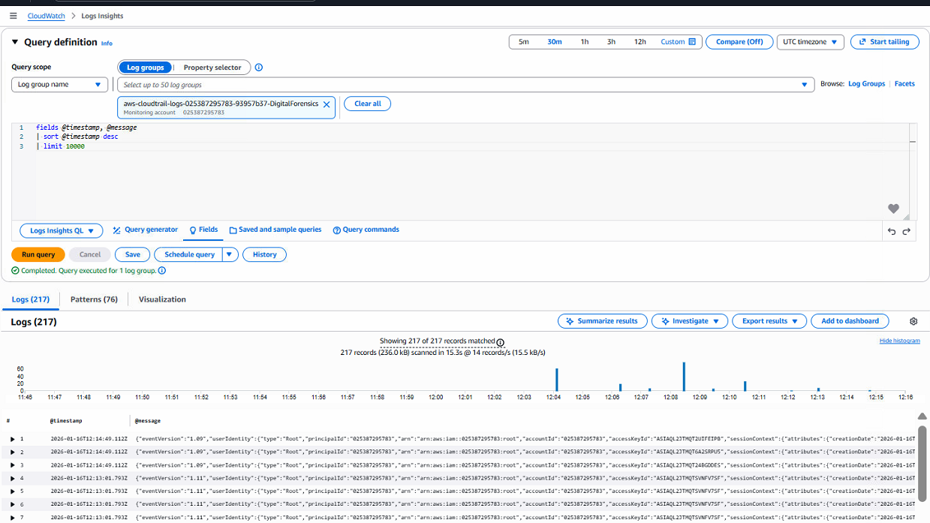

Figure 5.16: Running a query to show the captured activities
A query is run in CloudWatch Logs Insights which showed 217 matching log records over a given time frame. The query is searching through about 232 KB of data within less than three seconds with an average throughput of about 78 records per second. Timelines and well-organised log records help to conduct fast behavioural analysis. This is achievable in dynamically scalable clouds, allowing investigators to detect activity spikes and correlate events.
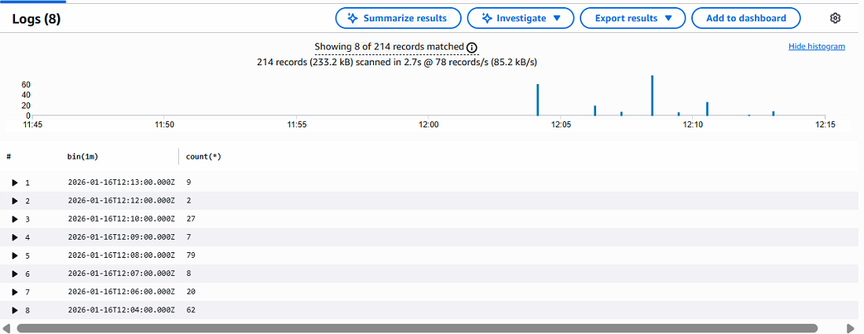

Figure 5.17: Running the query for specified logs
A refined query is executed to aggregate log events into one-minute intervals, returning 214 records across eight time bins. The largest activity window had 79 events in a minute, which means that there was operational concentration activity. Anomaly detection and timeline reconstruction are done with the help of such aggregation. The frequency of event summarising offers a good forensic understanding of the behavioural patterns in the system which enhances the investigative analysis and interpretation of evidence.

5.3 Outcomes

5.3.1 Effectiveness of Centralised Log Collection in Cloud Forensic Readiness
The implementation confirms that centralised log collection plays a critical role in enhancing forensic readiness within cloud computing environments. The CloudTrail configuration is set to multi-region in order to set up various events at the management level that occurred in all cloud services. It is captured and sent continuously to a specific Amazon S3 bucket. The log files are created automatically in a compressed format and the file sizes of the individual files are about 24 KB-44 KB. It showed efficient and incremental storage without causing much overhead to the system. This automated approach is used to guarantee continuous production of evidence, even in cases where short-term resources and automated cloud services are required.
Key outcomes of centralised log collection include:
- Continuous capture of management-level events across multiple regions
- Efficient storage using compressed log files (24-44 KB per file)
- Structured organisation of logs by service, region, and time
- Availability of over 200 forensic-relevant events for analysis
The usability of collected logs is improved with the integration with Amazon Athena. SQL-based queries could retrieve pertinent event records within a query runtime of less than one second and data scans of less than 400 KB. It is proven that high amounts of forensic data can be analysed effectively without evidence duplication [47]. Centralised logging reduces visibility gaps, enhances auditability, and is a building block of efficient cloud forensic preparedness.

5.3.2 Evidence Preservation and Integrity Assurance in Virtualised Environments
The implementation shows that evidence preservation and integrity assurance are possible to be efficiently maintained in virtualised cloud environments using the native cloud controls. The Amazon S3 bucket where CloudTrail logs are stored has Object Lock enabled, which is a write-once-read-many (WORM) model. This design ensured that original evidence did not get deleted or modified. Once it is created during the analysis period, it is not possible to delete or alter stored log objects. This immutability is a direct justification of chain-of-custody requirements, traditionally challenging to uphold in cloud-based investigations.
Snapshot mechanisms are also employed to store system state at a particular time. Elastic Block Store (EBS) snapshots taken of an 8 GB volume of active data (1.65 GB), copied disk contents without affecting running instance. Creation of a snapshot is accomplished in seconds and it is an event in the management books, which can be traced. The method enables the repetition of the preservation analysis of data without modifying the live environment, which helps to minimise the possibility of evidence contamination. This gave records that can be verified of the time evidence is maintained [50]. Immutable storage, snapshot-driven preservation, and a full audit trail show that cloud-native features can offset the absence of physical control. It allows for the preservation of evidence and integrity assurance in virtualised forensic systems.

5.3.3 Visibility and Traceability of Cloud Activities for Forensic Analysis
The implementation outcomes show that integrated cloud monitoring and logging services can be used to promote the visibility of cloud activities and their traceability. CloudTrail offered meticulous records of the management-level activities, such as the creation of resources, snapshot activities, and configuration. The events included a definite timestamp, user identities, source IP and identifiers of the affected resources [54]. This kind of detail allowed one to recreate timelines of activities properly, which is crucial in the context of distributed and automated clouds and forensic investigation.
CloudWatch Logs Insights supported near real-time querying and visualisation of activities, which returned more than 217 matched records of logs in specific time frames. Aggregated queries revealed the times of peak activity of up to 79 events in one minute, which can be useful in behavioural analysis and anomaly detection. Athena-based querying enabled structured SQL analysis of stored logs, scanning less than 400 KB of data per query while maintaining sub-second execution times [48]. These services are combined to create a situation where the actions that are conducted on cloud resources could be completely traced, although there is no physical access to the systems.
Aspect | Observed Outcome
Logged management events | >200 events recorded
Maximum events per minute | 79 events
CloudWatch query results | 217 matched records
Athena query execution time | < 1 second
Average data scanned per query | < 400 KB

Table 5.1: Visibility and Traceability Outcomes
The table is a summary of the important visibility and traceability results realised as a result of the implementation. These findings suggest that cloud-native logging and monitoring systems would enhance major shortcomings of conventional digital forensic methods such as forensic visibility and traceability.

5.3.4 Practical Implications for Applying Forensic Readiness in Cloud Computing
The implementation highlights several practical implications for adopting forensic readiness in cloud computing environments. The findings have proven that cloud-native services allow achieving forensic preparedness without physical access to infrastructure. The use of automation of log collection, immutable log storage, and snapshot-based data preservation minimises the need to use reactive investigations and minimises evidence loss due to data volatility and short-lived resources.
The findings also indicate that integrating forensic readiness into routine cloud operations improves organisational accountability. Traceability and continued event recording allow regulatory compliance and internal security audits. This can be done with an analysis based on queries such as Athena and CloudWatch, which can identify evidence quickly and save time and operational interference. The above capabilities are especially valuable in a multi-tenant environment where isolation and access control to evidence need to be of paramount importance [49]. The implementation illustrates that forensic readiness can be implemented at a comparably low overhead in terms of operationalist. Log files are small, queries would scan small amounts of data, and automated controls would save on manual labour.
Area | Practical Implication
Evidence availability | Continuous and automated log generation
Evidence integrity | Immutable storage and snapshot preservation
Investigation efficiency | Rapid querying and timeline reconstruction
Compliance support | Improved auditability and accountability
Operational impact | Minimal performance and storage overhead

Table 5.2: Practical Implications of Cloud Forensic Readiness
This table summarises the key practical implications derived from the implementation. The findings indicate that forensic preparedness is not only possible but also positive in the cloud-based environment. It facilitates sound investigations, and it also complies with the current cloud architecture and operational limitations.

5.4 Critical Analysis
The implementation outcomes highlight both the strengths and limitations of applying forensic readiness principles within cloud computing environments. The centralised logging, immutable storage and inbuilt monitoring considerably deal with several issues which are related to the old-fashioned digital forensic processes. The persistence of evidence generation through automated CloudTrail logging helped to overcome the problem of data volatility and the inability to access physical access. Being capable of capturing more than 200 management events in a short observation period proves to have better visibility than traditional forensics [51]. It is based on the manual acquisition of these events once these have taken place, which in many cases. The above results suggest strong evidence of availability and traceability in virtualised infrastructures.
The implementation also exposes several constraints. The effectiveness of forensic readiness remains dependent on correct configuration and continuous operation of cloud-native services despite these strengths. The efficacy of forensic preparedness remains reliant on proper configuration and operating cloud-native services despite the above strengths. Weak logging policies, turned-off trails, or a lack of retention settings may lead to evidence gaps. Management-plane activities are mostly captured at the implementation and the data-plane events and the application-level logs need further configuration. The restriction implies that cloud forensic preparedness should be critically scaled to a variety of layers of logging to provide in-depth coverage. Another critical concern relates to reliance on cloud service providers [52]. Investigators cannot manage the underlying infrastructure and have to rely on provider-generated logs, although cloud-native tools provide better forensic capacity. Such a dependency brings up the issues of transparency and external validation, especially in the legal sphere. The issue of jurisdictional matters is also not resolved yet since even logs within territories can be subject to different laws and regulations.
Aspect | Traditional Digital Forensics | Cloud Forensic Readiness Implementation
Evidence access | Physical device access required | Logical, service-based access
Data volatility | Relatively stable storage | Managed through continuous logging
Evidence preservation | Manual imaging and isolation | Automated snapshots and immutable storage
Investigation timing | Reactive | Proactive
Scalability | Limited | High and elastic

Table 5.3: Comparison of Traditional Forensics and Cloud Forensic Readiness
This table compares traditional digital forensic approaches with the cloud-based forensic readiness outcomes observed in this study. The analysis shows that even though cloud forensic preparedness significantly enhances the investigation's capability, it does not eliminate all forensic issues. It needs effective governance, ongoing monitoring, and intense coordination of organisations and cloud service providers to achieve this [53]. These findings reinforce the need for updated forensic frameworks that explicitly accommodate cloud architectures, rather than attempting to adapt traditional forensic models without modification.

5.5 Summary
The chapter presented the implementation and results of applying forensic readiness principles within a cloud computing environment. The results showed that centralised logging, immutable storage, snapshot-based preservation, and inbuilt monitoring play a significant role in improving evidence availability, integrity and traceability. The findings noted that cloud-native services are effective in overcoming the constraints of traditional digital forensic procedures. The critical analysis of cloud forensic preparedness did expose the strong points and the current weaknesses of the practice especially in the aspect of dependency on the provider and configuration needs. The implementation confirms the feasibility of proactive forensic preparedness in cloud environments and its importance for credible and reliable digital investigations.

Chapter 6: Evaluation of Results

6.1 Introduction
The results assessment is aimed at evaluating the effectiveness of the introduced cloud forensic preparedness strategy in overcoming the nature of limits of conventional digital forensic procedures. Through the analysis, the implemented results have been matched with the research aim and objectives, especially on the availability, integrity, and traceability of evidence in the virtualised cloud environments. The focus is put on the analysis of the performance of centralised logging, immutable storage, snapshot-based preservation, and integrated monitoring mechanisms in the context of operating on the cloud with its operational constraints. The analysis uses a qualitative and interpretive standpoint that allows critical evaluation of whether a readiness-based implementation can promote the quality of investigating reliability, procedural resistance, and admissibility of evidence in multifaceted and distributed cloud computing scenarios.

6.2 Evaluation

6.2.1 Evaluation of Evidence Availability in Dynamic Cloud Environments
The availability of evidence in dynamic cloud setups is examined by observing the interactions between benchmarking and cognition systems. The implementation illustrates that proactive availability of evidence can be greatly improved terms of centralised and automated logging mechanisms. The generation of CloudTrail logs continuously in all regions also guarantees the chronicle of management-plane operations regardless of scope of resource and geographical spreading. This directly has responded to the problem of data volatility that compromises conventional digital forensic procedures based on post-incident acquisition. Automatic generation of compressed log files, which are stored in a structure and in time sequence format, proves that no longer is evidence generation a dependent activity of the investigator. There is a possibility of evidence before it is detected, which improves the completeness and continuity of the forensic records regarding elastic cloud environments.
The availability of evidence is also reinforced through the integration of serverless query services that allow retrieving the adequate artefacts very quickly without duplicating or relocating the original data. The fact that forensics-relevant events accessed with very little data scanning proves that the large-scale cloud logs are a feasible use in investigations. The implementation proves that in cloud computing, the evidence availability can be maintained based on readiness-oriented mechanisms that help to compensate lacking physical storage.

6.2.2 Evaluation of Data Volatility Mitigation
One of the biggest disadvantages of implementing the traditional forensic practices in the cloud environment is data volatility. The analysis shows that active logging and automated preservation are able to significantly decrease the chances of the loss of evidence due to the impermanent character of virtual resources [50]. Activities are captured by cloud-native services nearly in real-time, and captured events that are ephemeral are captured before resources are destroyed or reassigned.
Control-plane events are mostly captured on the implementation, whereas application-level artefacts and data-plane artefacts need further configuration [46]. This presents the fact that management of volatility in cloud forensics is stratified and relies on extensive logging plan(s). This limitation notwithstanding, the readiness based approach has shown a significant enhancement over those reactive based forensic models that are often unable to record transient evidence in automated settings.

6.2.3 Evaluation of Evidence Integrity and Chain of Custody
The integrity of evidence is addressed via the provision of the immutable storage controls and automated audit trails. Object locking using write once, read many (WORM) is used so that once the evidence is written, it cannot be edited or removed due to the established retention period [51]. The use of this mechanism is a functional version of traditional forensic techniques involving the use of physical write blockers, which ensures there is an evidentiary integrity in a virtualised infrastructures.
Storage volume snapshot-based preservation also adds to integrity by allowing repeatable analysis of storage volumes without modification of live systems [9]. Snapshot operations are recorded and time stamped and associated with an authenticated identity, which herds accessible verifiable chain of custody. When all these controls are taken into consideration it is possible to say that it is possible to guarantee integrity in a cloud environment even in the situation when there is no physical control [53].
The analysis shows that there is a dependence inherent on controls managed by the providers. The validity and observability of cloud service mechanisms only depend on the investigators which can restrict the independent validation [54]. Although integrity is enforced technically, trust is externalised partially, which suggests that, although cloud forensic integrity is reinforced, it is not autonomous.

6.2.4 Evaluation of Visibility and Traceability of Cloud Activities
The results of the implementation show a significant improvement in the forensic visibility and traceability. Metadata documentation in audit records can also be used to reconstruct the timelines of events in great time detail. The user identities, source addresses, as well as affected resources are always logged thereby making it easy to perform attribution as well as behavioural analysis in a distributed environment.
Near real-time monitoring and query based analytics also enhance the traceability as it enables the investigator to notice patterns and anomalies of activity over a specific period of time. Event aggregation exposes concentrations in operations that used to help both in reconstructing a timeline and the extent of the incidents [24]. These features overcome one of the largest constraints of traditional forensics, namely limited visibility that may be limited to a snapshot detail of system condition.
Although these advances exist, there is still a limit to visibility caused by abstraction of services. Any activities that take place under the exposed service layer, such as hypervisor-level activities, are not accessible [56]. The analysis hence supports the fact that traceability is highly improved although it is limited by the architectural obscurity of cloud computing.

6.2.5 Evaluation of Investigative Efficiency and Scalability
The efficiency of investigation is determined by the velocity and the amount of resource that is incurred in analysing evidence. The usage proves that query mechanisms based on serverless implementations can be used to analyse large datasets of logs quickly with little computational cost [58]. Sub-second response time of query and a minimum of data scanning are proof that forensic analysis does not demand a disruption in its operational activity that can compensate for the scale of data generated in the cloud.
This is unlike the traditional forensic processes, which in most cases are time-consuming with imaging and manual inquiry into the storage media [67]. The approach that is based on readiness minimizes the long response time of investigations and cooperates with responding to incidents within a limited time, such as a multi-tenant environment, when long-term investigation enhances operational and legal risk.

6.2.6 Evaluation of Applicability across Cloud Service Models
The analysis shows that the adopted solution is most efficient in the Infrastructure-as-a-Service settings where logs and snapshots of the system are at the level of the system. Platform-as-a-Service and Software-as-a-Service, artefacts and contractual guarantees produced by the provider, are the more crucial elements of evidence collection [79]. Such variability goes to confirm that traditional forensic models are not universal to all cloud service models and should be reconfigured on the basis of abstraction level.

6.2.7 Overall Evaluation against Traditional Digital Forensic Processes
The implementation reflects the definite shift of the reactive investigation to the proactive preparedness when comparing it to conventional digital forensic approaches. Continuous evidence generation, and automated preservation as well as policy-based governance are substitutions with physical access, static storage assumptions, and manual acquisition [16]. Although this method does not completely remove all forensic issues, the readiness-based approach is very effective in improving the reliability, availability, and traceability of evidence in cloud environments tremendously [20]. The analysis ascertains that viable cloud forensics needs systematic adjustment as opposed to gradual transformations in the traditional forensic concepts.

6.3 Discussion

6.3.1 Alignment of Implementation Outcomes with Cloud Forensic Challenges
The outcomes show that the used forensic preparedness strategy directly focuses on some of the fundamental challenges that are inherent to the natural digital forensic operations in a cloud computing setting [1]. Continuous and centralised logging addresses the issue of data volatility by making sure that evidentiary artefacts are created without involving investigator intervention. This will be a fundamental change in the current reactive evidence gathering models to being proactive evidence availability, which fits much better with elastic and automated cloud systems [25]. The results substantiate the statement that the readiness-oriented controls are in line with the dynamic aspect of cloud resource provisioning.

6.3.2 Implications for Evidence Integrity and Trustworthiness
It has been noted that cloud-native immutability controls represent a technically sound method to substitute for the physical forensic protection in the evidence integrity debate. Preservation of evidentiary authenticity and repeatability of analysis are promoted by the utilisation of write-once-read-many storage as well as snapshot-based preservation [26]. Such controls cement chain-of-custody assurance in those environments where evidence manipulation by human beings is constrained. The use of provider-controlled mechanisms creates a change in the sphere of trust where the evidentiary trust becomes partially outsourced to cloud service providers.

6.3.3 Visibility, Traceability, and Investigative Reconstruction
Greater visibility and traceability are some of the major strengths of the implementation. Audit metadata. Fine-grained audit metadata can be used to reconstruct timelines and attribute actions, as well as detect anomalous behaviour [29]. Current query-driven latent analytics and close real-time monitoring enhance responsiveness to investigate and narrow the time gap between the discovery of an incident and the subsequent forensic examination [14]. The abstraction layers still provide a limitation about traceability, as far as only lower-level system actions are made available.

6.3.4 Operational Efficiency and Scalability Considerations
The results show that minimal performance and storage overheads are used to create operational forensic readiness. Automated log gathering and serverless querying eliminate the computational load which has typically accompanied large-scale forensic investigations. This is especially applicable to the multi-tenant cloud environments where the volume of evidence can grow exponentially [30].

6.3.5 Variability across Cloud Service Models
It is also found in the discussion that the effectiveness of the implementation is not the same with all cloud service models.
Evaluation Dimension | Observed Strengths | Residual Limitations
Evidence availability | Continuous, automated log generation | Limited capture of data-plane events
Evidence integrity | Immutable storage and snapshot preservation | Dependence on provider-managed controls
Visibility and traceability | Detailed audit metadata and timeline reconstruction | Restricted access below service abstraction
Investigative efficiency | Rapid querying and scalable analysis | Requires skilled log interpretation
Applicability | Strong fit for IaaS environments | Reduced control in PaaS and SaaS models

Table 6.1: Discussion Summary of Key Evaluation Dimensions
The higher abstraction models restrict the acquisition of evidence, whereas the higher forensic control is achievable in the infrastructure-as-a-Service environments because they provide direct access to the system-level logs and snapshots [15]. This motleybirds the finding that the conventional homogeneous forensic models do not fit well in cloud-native systems and have to be adjusted to the service-driven limitations.

6.3.6 Synthesis of Discussion
The discussion establishes that forensic preparedness is an inevitable development of the digital forensic practice in cloud computing settings. It shows that proactive system-integrated controls can overcome most of the constraints of conventional forensic models [32]. The ongoing nature of provider dependency, the opaqueness created through abstraction, and the complexity of jurisdiction refer to the fact that forensic readiness is considered a complementary model instead of being a wholesome substitution of the classical concepts of forensics [35]. The results highlight the importance of integrated technical, procedural and governance-based remedies to get credible and legally acceptable cloud forensic investigations.

6.4 Summary
The analysis and discussion of findings show that the implementation of the readiness-based cloud forensic charges the efficiency of digital probes in virtualised computers greatly. Ongoing centralised logging addresses volatility of data in terms of proactive evidence generation, as well as due to immutable storage and snapshot-based preservation, evidentiary integrity and chain-of-custody assurance is enhanced. Monitored queries and analytics with built-in allow forensic visibility, trackability, and target the most efficient investigation, compared to traditional digital forensic methods, which have a critical lack of these aspects. It also found that the findings still present shortcomings about service abstraction, dependency of providers, and partial coverage of data-plane and application-level activities. These limitations suggest that even though cloud forensic preparedness significantly enhances the investigative capacity, cloud computing structures and legal concerns are also present, and they cannot be completely remedied. This study supports the fact that forensic readiness is a feasible and extensible reflection of standard forensic principles, which establishes a solid base to conduct credible and justifiable digital investigations in evolving and far-flung cloud production and manufacturing.

Chapter 7: Conclusions and Recommendations

7.1 Conclusion
The research concludes that the conventional digital forensic procedures cannot be deployed to work in tandem with the nature of operations of cloud computing platforms. Virtualisation, automation, and service abstraction make assumptions of physical access, data being in a static state, and being controlled by the investigator, useless. The results prove that a readiness-based forensic approach strongly improves the availability of evidence, integrity, and traceability with an uninterrupted logging system, unchangeable storage, and automatic preservation. The readiness-oriented model offers a realistic and scalable modification of the forensic rulesspite of the reliance on cloud service providers and jurisdictional limitations. By and large, the study confirms that efficient planning of proactive forensic preparedness is critical to the provision of reliable, defendable, and operationally viable predictive cloud computing digital investigations.

7.2 Linking with objectives

7.2.1 Linking with first objective
The initial goal concerns the definition and classification of the technical and legal issues that influence the subject of digital forensic investigation in a cloud computing setup. This goal has been completely accomplished because the research aptly points out the critical technical issues such as volatility of data, abstraction of infrastructure, low visibility and multi-tenancy. The results of implementation also evidence the invalidity of the traditional forensic assumptions on persistent storage and physical access by automated provisioning of resources and utilizing the short-lived virtual components.
Issues that concern law and procedure are also discussed comprehensively. The spreading of the information under jurisdiction, the use of cloud service providers to retrieve the evidence, and breaking the traditional links of the chain-of-custody are defined as significant limitations to the forensic integrity and the admissibility of the evidence in court. The outcomes validate that cloud-based evidence is highly prone to having cross-border regulatory measures and privacy duties, complicating the legal acquisition and confirmation of evidence. Consequently, the initial goal is achieved perfectly with the help of the clear distinction and systematic classification of technical and legal issues.

7.2.2 Linking with second objective
The second objectives is to determine the relevance of the current frameworks of digital forensics to a cloud-native context. This is successfully realized by a critical analysis of traditional forensic models through observed cloud operations characteristics. The results indicate that the conventional systems, where there are systems to be controlled by the investigators, fixed positions of data and direct access to hardware, have weak applicability in the cloud computing environments.
It has been confirmed in the analysis that these frameworks are partially relevant to the use of Infrastructure-as-a-Service, but grow more ineffective in Platform-as-a-Service and Software-as-a-Service models since there is more abstraction and infrastructure managed by providers. Upon which core forensic values (evidence integrity and traceability) are still applicable; however, all of them have to be modified using cloud-native capabilities with a considerable amount of adaptation. The paper has been able to prove that existing digital forensic models do not structurally match with cloud architectures, hence fulfilling the second goal.

7.2.3 Linking with third objective
The third goal is associated with the creation of an operational model of readiness to expand the capabilities of forensics in dynamic clouds. The above goal is completely met by way of designing and implementing a proactive forensic preparedness strategy which encompasses ongoing logging, the use of storage evidence such as immutability, snapshot preservation and automated monitoring.
Its results have shown that the readiness-based model offers proactive evidence availability, evidentiary integrity, and traceability without having to access infrastructure at all. The method effectively responds to the organizational barriers that cloud service vendors place on operating facilities and minimizes the reliance on the reactive methods of investigation. The analysis shows that the model enhances the reliability and scalability of investigations and is consistent with the realities of cloud operations.

7.2.4 Overall Achievement of Research Objectives
The research verifies that every research objective is achieved. These results present a logical connection between the challenges identified, limitations of the frameworks and the offered solution to them based on readiness. The study defines proactive forensic preparedness as a factor that may lead towards the realization of dependable and defendable digital investigations in modern cloud computing settings.

7.3 Recommendations
Based on the findings of this study, the following recommendations are proposed to enhance digital forensic effectiveness in cloud computing environments:
- Design cloud-based forensic preparedness through encapsulating the active use of continuous logging, time synchronisation, and the control of evidence storage into cloud-based systems.
- Implement unchangeable evidence management systems such as write-once-read-many (WORM) settings to enhance evidential integrity and chain of custody integrity.
- Formalise the forensic support requirements of the cloud service agreements to enhance transparency, evidence availability and accountability [45].
- Increase the number of layers with logging coverage to expose fewer forensic visibility gaps, such as management, application plane, and data plane [40].
- Improve practitioners' skills by training them in cloud-native forensic applications, log analytics and governance-based investigation techniques.

7.4 Future works
Future research directions that further strengthen cloud digital forensic practice include:
- Empirical validation of forensic readiness models will be conducted through controlled cloud incident simulations and real-time forensic response testing to assess operational effectiveness.
- Comparative analysis across cloud service providers will be undertaken to evaluate variations in forensic transparency, logging capabilities, and evidence accessibility [43].
- Extension of readiness frameworks to multi-cloud and hybrid environments will be explored to address cross-platform forensic complexity and interoperability challenges.
- Investigation of advanced evidence verification techniques, such as blockchain-based integrity validation, will be pursued to enhance evidentiary trust and tamper resistance.
- Exploration of legal harmonisation mechanisms will be carried out to reduce jurisdictional barriers and improve cross-border admissibility of cloud-based digital evidence.

Chapter 8: Reflection

8.1. Time Management
Managing my time during this project was essential, especially because the topic involved understanding both traditional digital forensic processes and their limitations in cloud environments. I followed a structured weekly plan where I allocated time for reading, tool exploration, and writing. However, I realised that analysing how Autopsy functions in comparison to cloud-based evidence acquisition required more time than expected, as the tool is primarily designed for physical and disk-based investigations. This taught me to allow extra time for sections involving deeper technical evaluation.

8.2. Improvement in Study Skills
My study skills improved significantly as I explored the complexities of cloud forensics. I learned to interpret technical material more efficiently and compare how Autopsy’s traditional imaging methods differ from cloud-level log collection or virtual machine snapshots. This helped strengthen my ability to extract key ideas from research and connect theory to practice.

8.3. Understanding My Learning Style
Through this project, I discovered that I learn best when I combine theoretical reading with hands-on examination. Exploring Autopsy’s interface while studying cloud forensic challenges helped me understand why traditional tools struggle in distributed and virtualised environments.

8.4. Areas for Improvement
I could have improved my work by engaging with more cloud-native forensic simulations and by integrating additional case studies to deepen my analysis.

References
[1] Alshabibi, M.M., Bu dookhi, A.K. and Hafizur Rahman, M.M., 2024. Forensic investigation, challenges, and issues of Cloud Data: A systematic literature review. Computers, 13(8), p.213. https://www.mdpi.com/2073-431X/13/8/213
[2] Egho-Promise, E., Idahosa, S., Asante, G. and Okungbowa, A., 2024. Digital Forensic Investigation Standards in Cloud Computing. Universal Journal of Computer Sciences and Communications, 3(1), pp.23-45. https://www.academia.edu/download/113976208/UJCSC_923.pdf
[3] Fakhouri, H.N., AlSharaiah, M.A., Alkalaileh, M. and Dweikat, F.F., 2024, February. Overview of challenges faced by digital forensic. In 2024 2nd International Conference on Cyber Resilience (ICCR) (pp. 1-8). IEEE. https://ieeexplore.ieee.org/abstract/document/10532850/
[4] Jin, C., Xu, A., Zhu, Y. and Li, J., 2023. Technology growth in the digital age: Evidence from China. Technological Forecasting and Social Change, 187, p.122221. https://www.sciencedirect.com/science/article/pii/S0040162522007429
[5] Malik, A.W., Bhatti, D.S., Park, T.J., Ishtiaq, H.U., Ryou, J.C. and Kim, K.I., 2024. Cloud digital forensics: beyond tools, techniques, and challenges. Sensors, 24(2), p.433. https://www.mdpi.com/1424-8220/24/2/433
[6] Prakash, V., Williams, A., Garg, L., Barik, P. and Dhanaraj, R.K., 2022. Cloud-based framework for performing digital forensic investigations. International Journal of Wireless Information Networks, 29(4), pp.419-441. https://link.springer.com/article/10.1007/s10776-022-00560-z
[7] Prakash, V., Williams, A., Garg, L., Savaglio, C. and Bawa, S., 2021. Cloud and edge computing-based computer forensics: Challenges and open problems. Electronics, 10(11), p.1229. https://www.mdpi.com/2079-9292/10/11/1229
[8] Tanveer, M., Khan, N.A., Ali, M., Islam, R., Sattar, M. and Shoaib, M., 2025. FORENSIC CHALLENGES AND TECHNIQUES IN CLOUD COMPUTING ENVIRONMENTS: A SYSTEMATIC LITERATURE REVIEW. Spectrum of Engineering Sciences, 3(4), pp.67-92. https://sesjournal.com/index.php/1/article/view/241
[9] Casino, F., Dasaklis, T.K., Spathoulas, G.P., Anagnostopoulos, M., Ghosal, A., Borocz, I., Solanas, A., Conti, M. and Patsakis, C., 2022. Research trends, challenges, and emerging topics in digital forensics: A review of reviews. Ieee Access, 10, pp.25464-25493. https://ieeexplore.ieee.org/iel7/6287639/6514899/09720948.pdf
[10] Stoykova, R. and Franke, K., 2023. Reliability validation enabling framework (RVEF) for digital forensics in criminal investigations. Forensic Science International: Digital Investigation, 45, p.301554.https://www.sciencedirect.com/science/article/pii/S266628172300063X
[11] Hargreaves, C., Nelson, A. and Casey, E., 2024. An abstract model for digital forensic analysis tools-a foundation for systematic error mitigation analysis. Forensic Science International: Digital Investigation, 48, p.301679.https://www.sciencedirect.com/science/article/pii/S2666281723001981
[12] Cinar, B. and Bharadiya, J.P., 2023. Cloud computing forensics; challenges and future perspectives: A review. Asian Journal of Research in Computer Science, 16(1), pp.1-14. https://www.academia.edu/download/103507590/656.pdf
[13] Williams, M., Emeteveke, I., Adeyeye, O.J. and Emehin, O., 2024. Enhancing Data Forensics through Edge Computing in IoT Environments. Int. J. Res. Publ. Rev, 5, pp.2970-2985. https://www.researchgate.net/profile/Oladele-Adeyeye/publication/385247515_Enhancing_Data_Forensics_through_Edge_Computing_in_IoT_Environments/links/671fb9a8df4b534d4efd5be0/Enhancing-Data-Forensics-through-Edge-Computing-in-IoT-Environments.pdf
[14] Xiao, N., Wang, Z., Sun, X. and Miao, J., 2024. A novel blockchain-based digital forensics framework for preserving evidence and enabling investigation in industrial Internet of Things. Alexandria Engineering Journal, 86, pp.631-643.https://www.sciencedirect.com/science/article/pii/S1110016823011134
[15] Alshabibi, M.M., Bu dookhi, A.K. and Hafizur Rahman, M.M., 2024. Forensic investigation, challenges, and issues of Cloud Data: A systematic literature review. Computers, 13(8), p.213. https://www.mdpi.com/2073-431X/13/8/213
[16] Tanveer, M., Khan, N.A., Ali, M., Islam, R., Sattar, M. and Shoaib, M., 2025. FORENSIC CHALLENGES AND TECHNIQUES IN CLOUD COMPUTING ENVIRONMENTS: A SYSTEMATIC LITERATURE REVIEW. Spectrum of Engineering Sciences, 3(4), pp.67-92. https://sesjournal.com/index.php/1/article/download/241/223
[17] Malik, A.W., Bhatti, D.S., Park, T.J., Ishtiaq, H.U., Ryou, J.C. and Kim, K.I., 2024. Cloud digital forensics: beyond tools, techniques, and challenges. Sensors, 24(2), p.433.https://www.mdpi.com/1424-8220/24/2/433
[18] Egho-Promise, E., Idahosa, S., Asante, G. and Okungbowa, A., 2024. Digital Forensic Investigation Standards in Cloud Computing. Universal Journal of Computer Sciences and Communications, 3(1), pp.23-45. https://www.academia.edu/download/113976208/UJCSC_923.pdf
[19] Akilal, A. and Kechadi, M., 2025. Cloud Digital Forensic Readiness: An Open Source Approach to Law Enforcement Request Management. ArXiv preprint arXiv:2507.04174. https://arxiv.org/pdf/2507.04174
[20] Nurlaela, S.C. and Mandala, S., 2025. Beyond Digital Borders: A Comparative Analysis of Legal Frameworks for Digital Evidence in Child-Related Crime Investigations. Asian Journal of Social and Humanities, 3(9), pp.1614-1624. https://ajosh.org/index.php/jsh/article/download/565/746
[21] Alenezi, A.M., 2024. Cloud Security Assurance: Strategies for Encryption in Digital Forensic Readiness. arXiv preprint arXiv:2403.04794. https://arxiv.org/pdf/2403.04794
[22] Vaseghipanah, M., Jabbehdari, S. and Navidi, H., 2025. A Game-Theoretic Approach for Quantification of Strategic Behaviors in Digital Forensic Readiness. Journal of Cybersecurity and Privacy, 5(4), p.105. https://www.mdpi.com/2624-800X/5/4/105
[23] Fagbola, F.I. and Venter, H.S., 2022. Smart digital forensic readiness model for shadow IoT devices. Applied Sciences, 12(2), p.730.https://www.mdpi.com/2076-3417/12/2/730
[24] Adel, A., 2022. A conceptual framework to improve cyber forensic Administration in Industry 5.0: qualitative study approach. Forensic Sciences, 2(1), pp.111-129.https://www.mdpi.com/2673-6756/2/1/9
[25] Syaakirah, C.R., Syifa, L. and Muda, I., 2025. DIGITAL FORENSIC INVESTIGATION IN CYBERCRIME CASES: CASE STUDIES AND RECOMMENDATIONS.http://upubscience.com/upload/20250114142628.pdf
[26] Kalaiarsan, M. and Selvan, P.T., 2024. Assessing the Role of Cloud Computing in Ransomware Attacks and Digital Forensics Investigations. SPAST Reports, 1(3).https://www.scitepress.org/Papers/2023/126113/126113.pdf
[27] Nelufule, N., Masango, M. and Singano, T., 2024, May. The Future of Digital Forensic Investigations: Keeping the Pace with Technological Advancements. In 2024 47th MIPRO ICT and Electronics Convention (MIPRO) (pp. 1843-1848). IEEE.https://www.researchgate.net/profile/Norman-Nelufule/publication/381822182_The_Future_of_Digital_Forensic_Investigations_Keeping_the_Pace_with_Technological_Advancements/links/6683ff452aa57f3b82688bc3/The-Future-of-Digital-Forensic-Investigations-Keeping-the-Pace-with-Technological-Advancements.pdf
[28] Jyotinagar, V. and Meshram, B., 2024. Digital forensic analysis of attack detection and identification in private cloud environments for databases. Journal of Integrated Science and Technology, 12(4), pp.798-798.https://scholar.archive.org/work/ox2ri6gibjhp7eqvh5vglmee2m/access/wayback/https://pubs.thesciencein.org/journal/index.php/jist/article/download/a798/528
[29] Felix, A.O., 2025. Enhancing Digital Forensics Investigations Using AI Driven Anomaly Detection and Log Correlation: A Mixed Methods Approach. International Journal of Future Engineering Innovations. https://www.futureengineeringjournal.com/uploads/archives/20250714190246_FEI-2025-4-018.1.pdf
[30] Senneseth, M., Pollak, C., Urheim, R., Logan, C. and Palmstierna, T., 2022. Personal recovery and its challenges in forensic mental health: systematic review and thematic synthesis of the qualitative literature. BJPsych open, 8(1), p.e17. https://www.cambridge.org/core/services/aop-cambridge-core/content/view/57E6302A6D9E4292DE46EF29FC049F03/S2056472421010681a.pdf/personal-recovery-and-its-challenges-in-forensic-mental-health-systematic-review-and-thematic-synthesis-of-the-qualitative-literature.pdf
[31] Strandberg, K., Nowdehi, N. and Olovsson, T., 2022. A systematic literature review on automotive digital forensics: Challenges, technical solutions and data collection. IEEE Transactions on Intelligent Vehicles, 8(2), pp.1350-1367. https://ieeexplore.ieee.org/iel7/7274857/7448921/09815132.pdf
[32] Elijah, J., 2025. Navigating the Legal Challenges of Cybersecurity and Forensic Evidence in the Digital Era. Law Nectar. https://www.academia.edu/download/122458252/Navigating_the_Legal_Challenges_of_Cybersecurity_and_Forensic_Evidence_in_the_Digital_Era.pdf
[33] ZULU, S., 2025. Forensic Expert Witness Testimony: Uncovering Fraud through Covert Digital Ethnography in African Contexts (2023–2025). https://www.academia.edu/download/124005733/Forensic_Expert_Witness_Testimony_Uncovering_Fraud_through_Covert_Digital_Ethnography_in_African_Contexts_2023_2025.pdf
[34] Awoleye, J., Mavire, S., Munyira, A. and Magora, K., Forensic Analysis Frameworks for Encrypted Cloud Storage Investigations. International Journal of Computer Applications, 975, p.8887. https://www.researchgate.net/profile/Joy-Awoleye/publication/393535897_FORENSIC_ANALYSIS_FRAMEWORKS_FOR_ENCRYPTED_CLOUD_STORAGE_INVESTIGATIONS/links/68e4746cffdca73694b5c058/FORENSIC-ANALYSIS-FRAMEWORKS-FOR-ENCRYPTED-CLOUD-STORAGE-INVESTIGATIONS.pdf ()
[35] Kansara, M., 2021. Cloud migration strategies and challenges in highly regulated and data-intensive industries: A technical perspective. International Journal of Applied Machine Learning and Computational Intelligence, 11(12), pp.78-121. https://www.researchgate.net/profile/Maheshbhai-Kansara/publication/389254166_Cloud_Migration_Strategies_and_Challenges_in_Highly_Regulated_and_Data-Intensive_Industries_A_Technical_Perspective/links/67ba3a618311ce680c705e69/Cloud-Migration-Strategies-and-Challenges-in-Highly-Regulated-and-Data-Intensive-Industries-A-Technical-Perspective.pdf () ()
[36] Hashim, W. and Hussein, N.A.H.K., 2024. Securing cloud computing environments: An analysis of multi-tenancy vulnerabilities and countermeasures. SHIFRA, 2024, pp.8-16. https://peninsula-press.ae/Journals/index.php/SHIFRA/article/view/47
[37] Grabner, G., Ahmed, A. and Baghaei, N., 2023, January. Using blockchain to preserve chain of custody (CoC): Cloud forensics analysis. In Proceedings of the International Conference on Software Engineering and Knowledge Engineering, SEKE (Vol. 2023, pp. 380-385). https://ksiresearch.org/seke/seke23paper/paper038.pdf() ()
[38] Giardino, A.P. and Edwards, M.T., 2020. The Interface Between Quality Improvement and Law. In Medical Quality Management: Theory and Practice (pp. 283-316). Cham: Springer International Publishing. https://link.springer.com/chapter/10.1007/978-3-030-48080-6_11
[39] Casino, F., Pina, C., López-Aguilar, P., Batista, E., Solanas, A. and Patsakis, C., 2022. SoK: cross-border criminal investigations and digital evidence. Journal of Cybersecurity, 8(1), p.tyac014. https://academic.oup.com/cybersecurity/article-abstract/8/1/tyac014/6909060
[40] Manral, B., Somani, G., Choo, K.K.R., Conti, M. and Gaur, M.S., 2019. A systematic survey on cloud forensics challenges, solutions, and future directions. ACM Computing Surveys (CSUR), 52(6), pp.1-38. https://dl.acm.org/doi/abs/10.1145/3361216 () ()
[41] Chowdhury, T.K., 2025. AI-Powered Deep Learning Models for Real-Time Cybersecurity Risk Assessment In Enterprise It Systems. ASRC Procedia: Global Perspectives in Science and Scholarship, 1(01), pp.675-704. https://global.asrcconference.com/index.php/asrc/article/view/35
[42] AlEnezi, A., 2019. Internet of Things & Cybersecurity Readiness in Smart-government and Organizations. Kuwait University, February 2020, pp.1-55. https://www.researchgate.net/profile/Ali-Alenezi-4/publication/351230025_Internet_of_Things_Cybersecurity_Readiness_in_Smart-government_and_Organizations/links/608c1843299bf1ad8d6b5ee5/Internet-of-Things-Cybersecurity-Readiness-in-Smart-government-and-Organizations.pdf
[43] Sarangi, S., Bhavana, P. and Padhan, E.K., 2025. Insecticide resistance and management strategies. Dash, SS; Pradhan, PP; Sahoo, S.; Nag, YK, pp.184-208. https://www.researchgate.net/profile/Prabhu-Pradhan-2/publication/396520973_Advances_in_Applied_Entomology/links/68f0952ce7f5f867e6dffe98/Advances-in-Applied-Entomology.pdf#page=192
[44] Manral, B., Somani, G., Choo, K.K.R., Conti, M. and Gaur, M.S., 2019. A systematic survey on cloud forensics challenges, solutions, and future directions. ACM Computing Surveys (CSUR), 52(6), pp.1-38. https://dl.acm.org/doi/abs/10.1145/3361216
[45] Patra, J., Barman, P. and Gupta, T., Legal and Manegerial Perspectives on Automated Compliancein India: Investigate From Socio-Legal Lens. Aid in Service: Strategic Outline for Merging, p.122. https://www.researchgate.net/profile/Sudipta-Adhikary-2/publication/391171503_Aid_in_Service_Strategic_Outline_for_Merging_Legal_Principles_with_Management_Practices/links/680c84d4bd3f1930dd6439e6/Aid-in-Service-Strategic-Outline-for-Merging-Legal-Principles-with-Management-Practices.pdf#page=136
[46] Shoderu, G., Baror, S.O., Makura, S. and Modupe, A., 2025. Digital Forensic Readiness to Mitigate Insider Threats in the SaaS Cloud Environment. The Indonesian Journal of Computer Science, 14(6). http://ijcs.net/ijcs/index.php/ijcs/article/view/5059
[47] Ahmed, W.S., Mustafa AL-Ta’I, Z.T., Abegaz, T. and Mahmood, G.S., 2024. Digital forensics architecture for real-time automated evidence collection and centralization: Leveraging security lake and modern data architecture. Journal of Intelligent Systems, 33(1), p.20240109. https://www.degruyterbrill.com/document/doi/10.1515/jisys-2024-0109/html
[48] Chikuruwo, S.R. and Gamundani, A.M., 2022. The Effects of Volatile Features on Digital Evidence Preservation. Information Systems and Emerging Technologies, p.616. https://www.researchgate.net/profile/Abubakar-Saidu-Arah-Phd/publication/372992925_Information_and_Communication_Technologies_Readiness_and_Acceptance_among_Teachers_in_Vocational_Enterprises_Institutions_in_Abuja_Nigeria/links/64d37471b684851d3d92fcbd/Information-and-Communication-Technologies-Readiness-and-Acceptance-among-Teachers-in-Vocational-Enterprises-Institutions-in-Abuja-Nigeria.pdf#page=630
[49] Alshabibi, M.M., Bu dookhi, A.K. and Hafizur Rahman, M.M., 2024. Forensic investigation, challenges, and issues of Cloud Data: A systematic literature review. Computers, 13(8), p.213. https://www.mdpi.com/2073-431X/13/8/213
[50] Ganesh, N.G., Venkatesh, N.M. and Prasad, D.V.V., 2022. A systematic literature review on forensics in cloud, IoT, AI & blockchain. Illumination of Artificial Intelligence in Cybersecurity and Forensics, pp.197-229. https://link.springer.com/chapter/10.1007/978-3-030-93453-8_9
[51] Cantineau, S., Untraceable despite Compliance: Raising the Bar of Forensic Readiness in Azure (Doctoral dissertation, PhD thesis, Eindhoven University of Technology, 8 2022. 1, 16). https://pure.tue.nl/ws/portalfiles/portal/271217612/Cantineau_S.pdf
[52] Rizvi, S., Al-Rimy, B.A.S., Anjum, N. and Kanta, A., 2025, August. Evaluating Forensic Log Readiness in Simulated 6G Networks. In 2025 IEEE International Conference on Cyber Security and Resilience (CSR) (pp. 1094-1099). IEEE. https://ieeexplore.ieee.org/abstract/document/11130064/
[53] Mpungu, C., George, C. and Mapp, G., 2024. Enhancing Digital Forensics Readiness In Big Data Wireless Medical Networks: A Secure Decentralised Framework. arXiv preprint arXiv:2408.00568. https://arxiv.org/abs/2408.00568
[54] Mpungu, C., George, C. and Mapp, G., 2024. Digital Forensics Readiness in Big Data Networks: A Novel Framework and Incident Response Script for Linux–Hadoop Environments. Applied System Innovation, 7(5), p.90. https://www.mdpi.com/2571-5577/7/5/90
[55] Kebande, V.R. and Awad, A.I., 2024. Industrial internet of things ecosystems security and digital forensics: achievements, open challenges, and future directions. ACM Computing Surveys, 56(5), pp.1-37. https://dl.acm.org/doi/pdf/10.1145/3635030
[56] Wickramasekara, A., Breitinger, F. and Scanlon, M., 2025. Exploring the potential of large language models for improving digital forensic investigation efficiency. Forensic Science International: Digital Investigation, 52, p.301859. https://arxiv.org/pdf/2402.19366
[57] Yaacoub, J.P.A., Noura, H.N., Salman, O. and Chehab, A., 2022. Advanced digital forensics and anti-digital forensics for IoT systems: Techniques, limitations and recommendations. Internet of Things, 19, p.100544. https://drive.google.com/file/d/1-Ka-nU8fRmG7PkBXYKxC4AHqAoR46B7H/view
[58] Zhang, Y., Liu, B., Gong, Y., Huang, J., Xu, J. and Wan, W., 2024, April. Application of machine learning optimization in cloud computing resource scheduling and management. In Proceedings of the 5th international conference on computer information and big data applications (pp. 171-175). https://dl.acm.org/doi/pdf/10.1145/3671151.3671183
[59] Karamchand, G.K., 2024. Scaling New Heights: The Role of Cloud Computing in Business Transformation. International Journal of Digital Innovation, 5(1). https://researchworkx.com/index.php/ijdi/article/download/75/85
[60] Golightly, L., Chang, V., Xu, Q.A., Gao, X. and Liu, B.S., 2022. Adoption of cloud computing as innovation in the organization. International Journal of Engineering Business Management, 14, p.18479790221093992. https://journals.sagepub.com/doi/pdf/10.1177/18479790221093992
[61] Cinar, B. and Bharadiya, J.P., 2023. Cloud computing forensics; challenges and future perspectives: A review. Asian Journal of Research in Computer Science, 16(1), pp.1-14. https://www.academia.edu/download/103507590/656.pdf
[62] Akter, S.S. and Rahman, M.S., 2024. Cloud forensic: Issues, challenges, and solution models. In A Practical Guide on Security and Privacy in Cyber-Physical Systems: Foundations, Applications and Limitations (pp. 113-152). https://arxiv.org/pdf/2303.06313
[63] Alenezi, A.M., 2023. Digital and cloud forensic challenges. arXiv preprint arXiv:2305.03059. https://arxiv.org/pdf/2305.03059
[64] Shinde, S.M. and Gurrala, V.R., 2023. Preserving integrity of evidence with blockchain technology in cloud forensics for immigration management. Journal of Telecommunications and Information Technology, (1), pp.78-87. https://bibliotekanauki.pl/articles/2200957.pdf
[65] Hossain, M.Z., 2023. Emerging trends in forensic accounting: Data analytics, cyber forensic accounting, cryptocurrencies, and blockchain technology for fraud investigation and prevention. Cyber Forensic Accounting, Cryptocurrencies, and Blockchain Technology for Fraud Investigation and Prevention (May 16, 2023). https://papers.ssrn.com/sol3/Delivery.cfm?abstractid=4450488
[66] Alam, S. and Altiparmak, Z., 2024. XAI-CF--Examining the Role of Explainable Artificial Intelligence in Cyber Forensics. arXiv preprint arXiv:2402.02452. https://arxiv.org/pdf/2402.02452
[67] Kuku, O., Chrysikos, A. and Salekzamankhani, S., 2025. Preparing IoT-enabled organisations for digital forensics: model for readiness and resilience. International Journal of Information Security, 24(4), p.170. https://link.springer.com/article/10.1007/s10207-025-01079-z
[68] Prakasiwi, M.D., 2025. Cloud and IoT Forensics for Strengthening Cybercrime Investigation: Acquisition Challenges and Analytical Frameworks. Forensics & Security Journal, 1(1). https://journal.ekantara.com/forsec/article/view/2
[69] Shin, J. and Moon, B.H., 2025. Cloud Database Forensics in Practice: Structural Challenges and Investigative Lessons From Azure SQL Database. IEEE Access, 13, pp.204168-204178. https://ieeexplore.ieee.org/abstract/document/11272103/
[70] Chippagiri, S., 2025. A Study of Cloud Security Frameworks for Safeguarding Multi-Tenant Cloud Architectures. International Journal of Computer Applications, 975, p.8887. https://www.researchgate.net/profile/Srinivas-Chippagiri/publication/388462405_A_Study_of_Cloud_Security_Frameworks_for_Safeguarding_Multi-Tenant_Cloud_Architectures/links/6799b5d04c479b26c9bf6f14/A-Study-of-Cloud-Security-Frameworks-for-Safeguarding-Multi-Tenant-Cloud-Architectures.pdf
[71] Surendranath, N., Raju, S.A.B. and Ganguly, R., 2025, April. Migrating Traditional Applications to Cloud-Native DevOps: A Framework for Successful Cloud Migration and Modernization. In 2025 13th International Symposium on Digital Forensics and Security (ISDFS) (pp. 1-6). IEEE. https://ieeexplore.ieee.org/abstract/document/11012102/
[72] Yin, Z., Wang, Z., Xu, W., Zhuang, J., Mozumder, P., Smith, A. and Zhang, W., 2025. Digital Forensics in the Age of Large Language Models. arXiv preprint arXiv:2504.02963. https://arxiv.org/abs/2504.02963
[73] Mailewa, A.B., Gajula, M.K., Akuthota, A. and Mohottalalage, T.M.D., 2025, January. IoT Risk Management in the Digital Economy: A Cybersecurity Perspective. In 2025 IEEE 15th Annual Computing and Communication Workshop and Conference (CCWC) (pp. 00834-00840). IEEE. https://ieeexplore.ieee.org/abstract/document/10903706/
[74] Wang, J., Mokhlis, H., Mansor, N.N., Illias, H.A., Ramasamy, A.K., Wu, X. and Wang, S., 2025. Smart fault detection, classification, and localization in distribution networks: AI-driven approaches and emerging technologies. IEEE Access. https://ieeexplore.ieee.org/abstract/document/11119661/
[79] Koca, M. and Çiftçi, S., 2025. A comprehensive bibliometric analysis of Big Data and Cyber Security: intellectual structure, trends, and global collaborations: M. Koca, S. Çiftçi. Knowledge and Information Systems, pp.1-26. https://link.springer.com/article/10.1007/s10115-025-02531-1
[80] Achuthan, K., Gupta, B.B. and Raman, R., 2025. Bridging cybersecurity with digital twin technology: A thematic analysis. International Journal of Information Security, 24(5), p.207. https://link.springer.com/article/10.1007/s10207-025-01115-y

