The Impact of Virtual Learning Environment (VLE) – Moodle on students’ learning experience at the University of Wales Trinity Saint David London Campus.

Module Title: Digital Skills and Research Methods

Module Code: BMSW4003

Lecture’s Name: Amitave Banik

Name: Osman Sessay

ID :1906862

Contents
Introduction 3
Methods 3
Primary Data 4
Secondary Data 9
Conclusion 10
References 11
Appendices 12

Introduction

The Definition of Virtual Learning Environment is coming as supplement to the regular teaching methods and it means a web-based website or platform that can offer for lecturers and especially for students the chance to learn virtually. This type of learning is often used in high education institutions for example Universities of Colleges with use a wider learning management system like Moodle, Web CT or Blackboard. Moodle is the platform that is used by The University of Wales Trinity Saint David based in London for their lecturers and students. The difference between Virtual Learning Environment and a virtual classroom is that, the VLE has more useful tools for students, such as online library, quizzers, the possibility to upload the assessment directly to Moodle straight from the comfort of your home, digital communication, polls run and so on. VLE can also help the lecturers create, disseminate and store content, lessons, courses and facilitate a faster communication between them and the students through emails or online discussions.

Methods

In this report will be discussed the impact of Virtual Learning Environment on the students form University of Wales Trinity Saint David. To demonstrate the impact, in this report will be used primary data collected from the students with the help of a questionnaire designed to reveal the first impression of the students. The Primary Data are the data collected directly from the target group that is done the research about, is a new information collected especially for that purpose. There are many types of tools to collect Primary Data like surveys, which are a very good way to collect large amount of data from a given population or group, focus groups is based from a small group of people that fit the target demographic in a room to discuss what they dislike and like ,are confused about a certain topic or how to improve a idea or a concept. Social media monitoring can be also a great tool for Primary Data collection and can help to keep track on how much are people talking or using the Virtual Learning Environment, this can show all this data without any human interaction in the conversation. The next type of instrument to reveal the opinion of the students which is going to be used is secondary data collection from another survey made by researcher and published on the internet with the reason to help another people to use it for their essays or report. The Secondary Data is a public information that it is free, easy to obtain and ca be a strong foundation for any research project. The types of Secondary Data can be, Government statistics, which are publicly available and simply to access online can offer the helpful data when conducting a research but it is often need to sort the information in order to obtain the useful data, University Websites can be virtual goldmine of information because they usually public insights about annual reports or previous surveys done by the higher education institutions, market research reports can be full of useful information and can include quantitative data about some topic that is the research about.

Primary Data

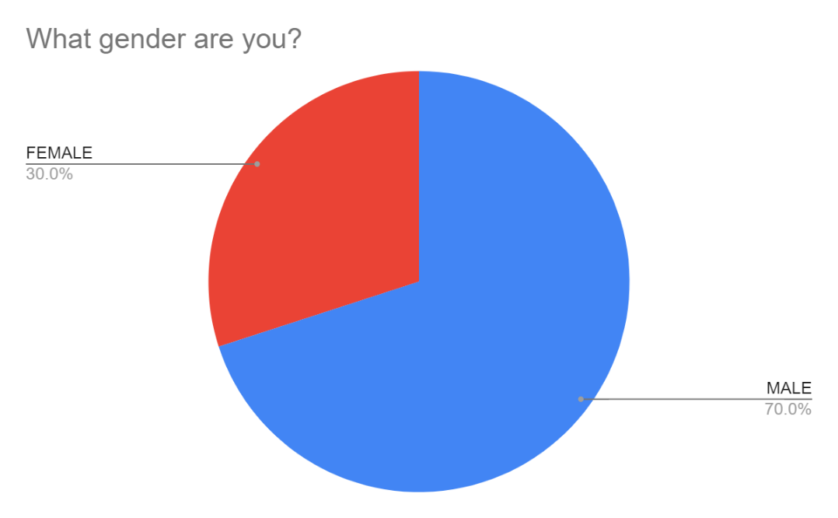
Based on the Question number 1 can say that after interrogating 10 students from the University of Wales Trinity Saint David the majority came as a males with 7 out of 10 and the females only with 3 out of 10 students, which means the majority of students in the class 10 of February enrolment are males.

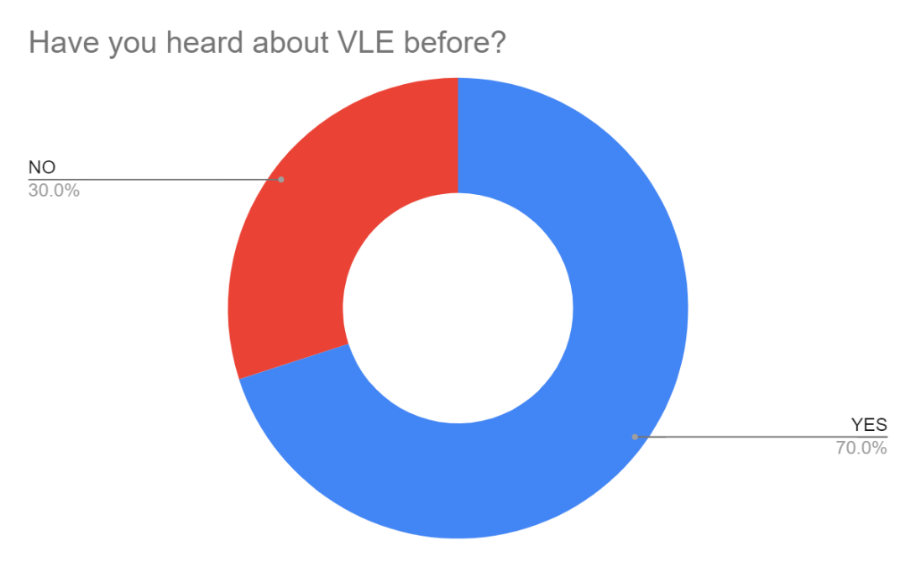
Question number two in asking about the students’ knowledge and if they heard about Virtual Learning Environment (VLE). With a positive response, 70% of the students heard about this expression before and only 30% of them had no clue about what VLE is meaning.

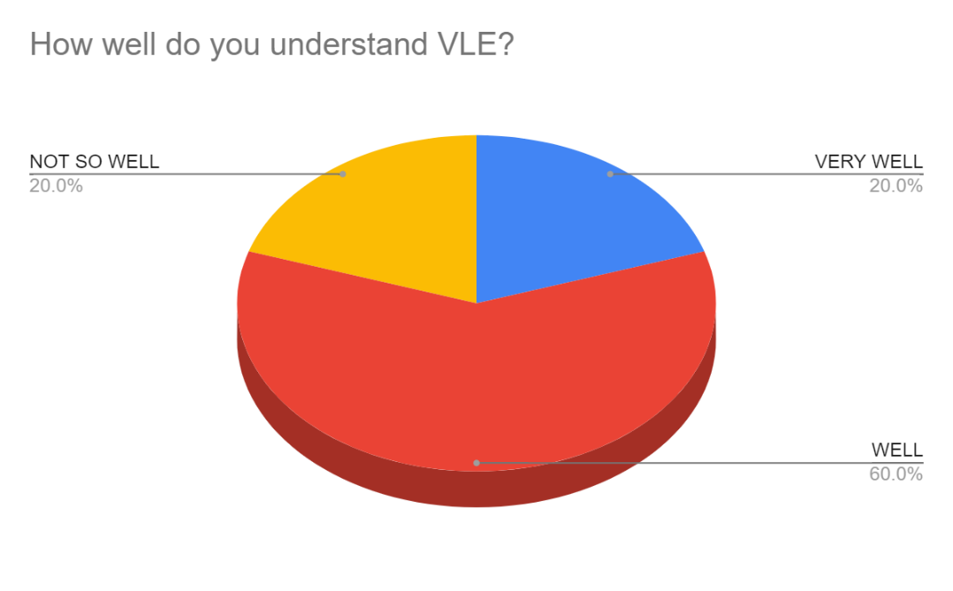
When asked how well the students understand the Virtual Learning the majority representing 60% responded with well option, which means that they understand something about what they are doing but there are still some insecurities and concerns about the Virtual environment and how they should approach it properly. The minorities are at the opposite ends, with 20% of the students that are understanding very well the concept and they can used it and learn from it without any hesitation. On the opposite part are the students that are having problems with using the portal Moodle and they do not understand why they need to use the platform and how the virtual environment is working.

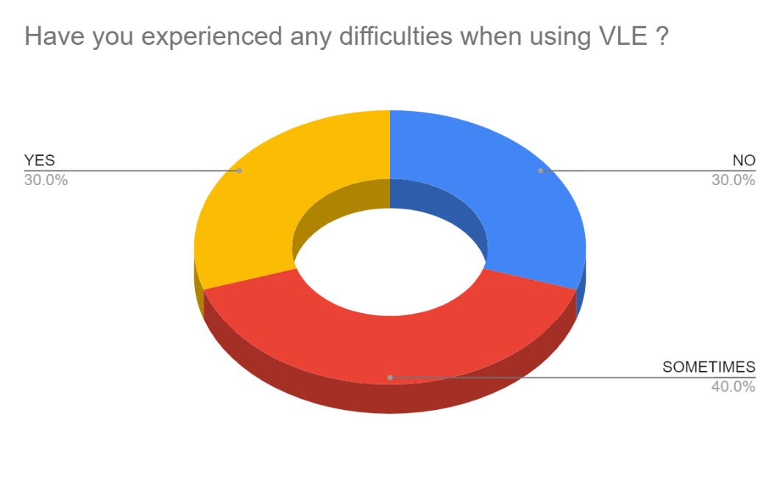
In the previous chart the majority responded that they understand well the term of VLE and that is why in this pie chart also the majority responded that sometimes can experience some difficulties when using the website Moodle ,but now just in a percentage of 40%. The rest in represented be 30% which definitely experienced difficulties during the virtual accommodation and the rest of 30% did not had any problems whatsoever.
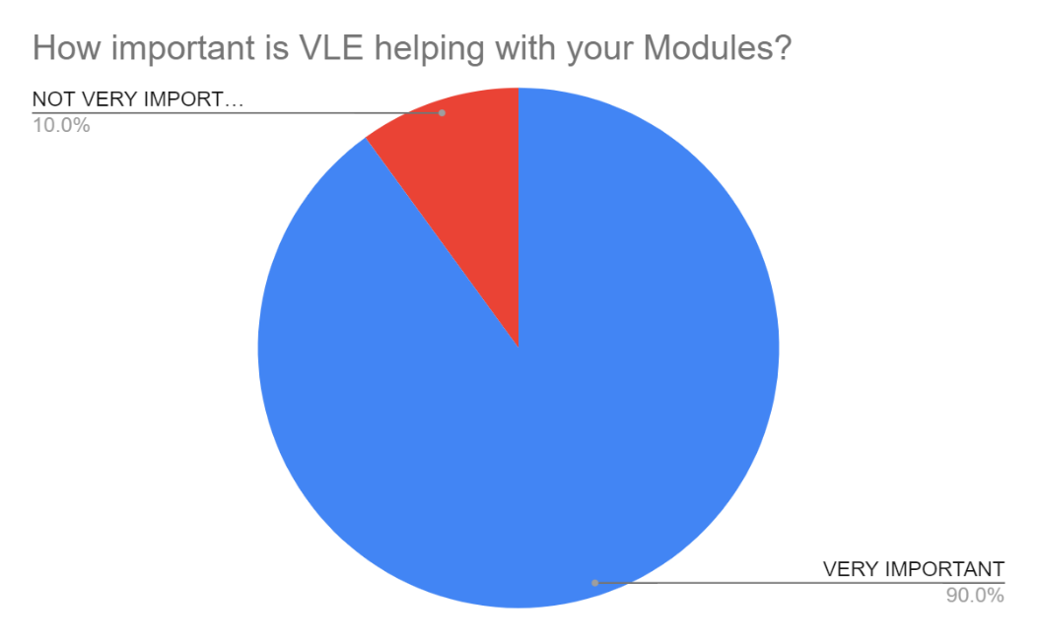
During this Covid-19 pandemic, 90% percentage of students responded that the Virtual Learning was very important because it helped the professors continue their teaching and the students to continue their studies, learn the modules and the information that was planned to teach and eventually pass the term, despite the campus is closed. And just a minority of 10% of the students responded with not very important.

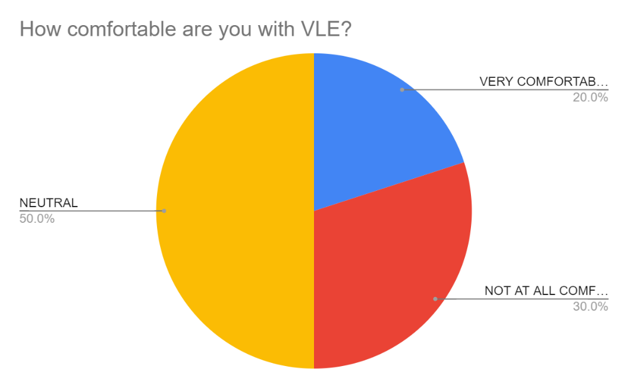
Half of the students responded that they are not so comfortable when using VLE, but they are also handling quite good, so that is why they chose the option neutral. The 20% represents the minority with can handle all of the online tasks and the virtual learning, so that is why they responded with very comfortable and the rest of 30% can not handle it at all, they have troubles when using it and they are not comfortable.

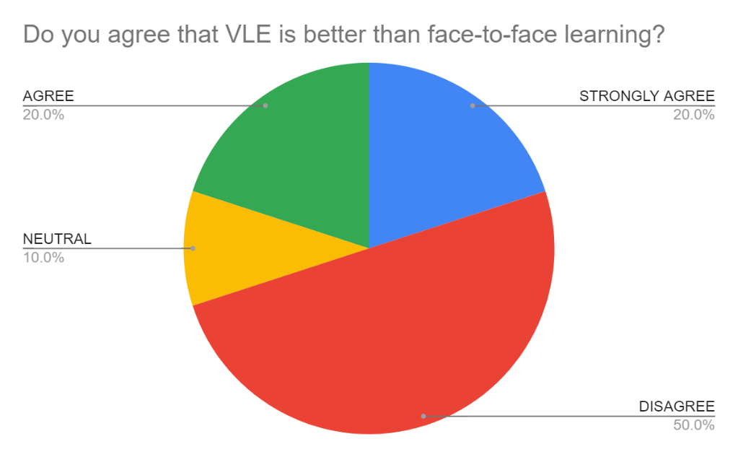
When the student has been asked about what preferences about learning face are to face or virtual learning and which one they prefer, the majority disagreed with the virtual learning environment. After all, human are social creatures and they need interaction especially when they need to learn something new from a person like a professor. The 20% of them strongly agreed with the virtual learning for personal reasons and because they are excel at it, another 20% of the students responded just with agree having a slightly doubt about VLE and the rest of 10% where neutral which means they can learn and interact in both of the environments.

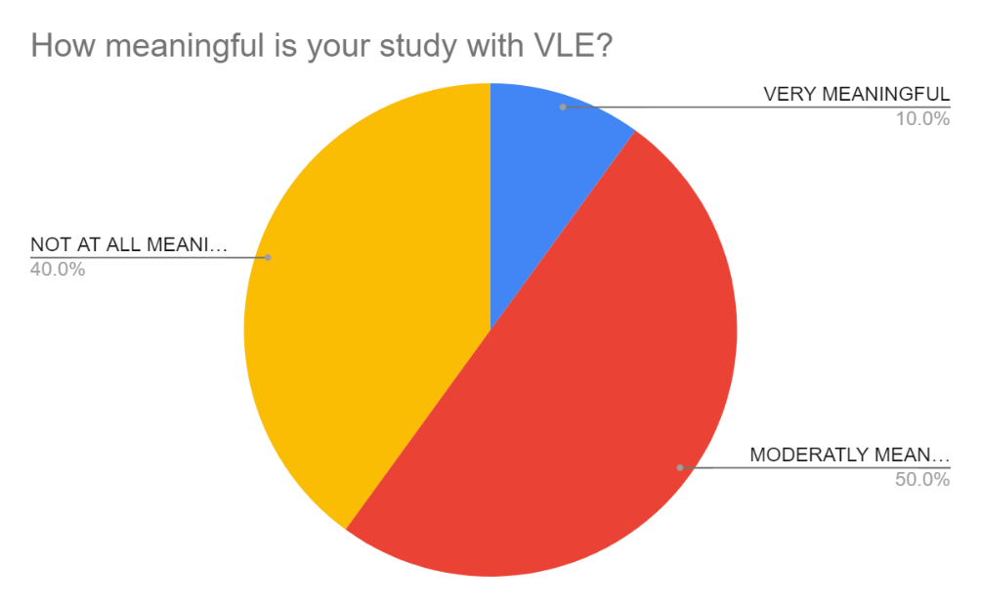

When using Virtual Learning Environment, 50% of the students reported that they have a moderately meaningful study compared with the old fashion method of study which indicates that they have an improvement but not a great one when using VLE. The second majority of 40% responded that for them the study with VLE is not meaningful at all which represents that they would like to return to the same old method of study, the face to face method. The rest of 10% manifested their choice choosing to respond their study with VLE is very meaningful and they are happy to continue.

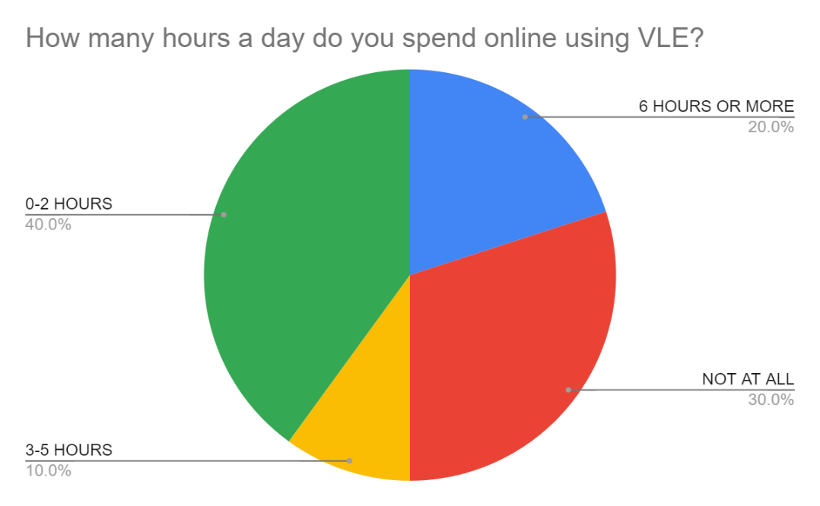

This question reveals that 40% of the students spend between 0-2 hours daily using their time to access Moodle and to be up to date with the changes, when 30% of the students responded that they do not spend time at all using Moodle. The 10% is represented be the people who are spending between 3-5 hours daily, improving their academic skills and learn from the portal and another 20% of the students spend more than 6 hours daily which is making them more comfortable with the platform and it features.

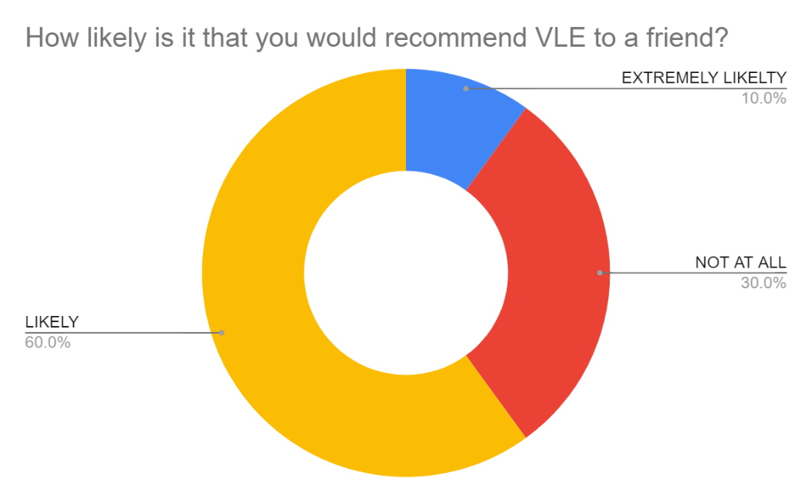
In the end when the students were asked if they would recommend the Virtual Learning to a friend most of them responded with likely which means that despite of their sometimes lack of understanding the majority of the students still would recommend it. The next 30% is represented by the students which would not recommend it at all to a friend probably because this part of them is used to the face to face approach and it is harder for them to accommodate and finally the remaining 20% responded that would definitely recommended to a friend.

Secondary Data

After doing a study on 6347 undergraduates in the academic year 2014-2015 the researchers have discovered that the Virtual Learning is diversified and can vary from zero to 1532 accesses, another thing that was founded is the number of courses a student passed and the positive moderate correlation between the numbers of students’ usage of the VLE, being a very low negative correlation. In addition, the higher the number of classes units students passed, the higher the number of accesses to the Virtual Learning Environment
According to (Werner, S. P. et all, 2000), after a survey for whether older non-traditional adults and computer-dependent technology-based instruction disadvantage woman on two groups, one graduated and one undergraduate of students, the researchers have found that the first group, the graduate students are more likely to access their information and course from home, at the same time the undergraduate students announced more enthusiasm about the use of Virtual Environment for learning. One of their opinion in the end was that the satisfaction of the students relies on the exposure and access, the tools used, the usefulness and the dependent upon utility. The use of Virtual Learning Environment needs a contemporary mindset of the students in social work education.

In a higher education study conducted by previous researchers, where the main group related on lecturers and students. One of the results of this survey was that the students who seems to be in class the type of introverts, the same students when they switched the environment to a Virtual Environment, they became more like extroverts and were involved in the online class discussion, being more active than a classroom-based course. Further on, when asked if VLE made a positive impact to studying and learning in an online environment, 79% if the students reported that they saw a positive change in their attitude when learning online and just 28% of the students said that they would rather go back to a traditional in class teaching methods. In addition, the online learning gave the opportunity to catch up with the courses and on missed materials, which helped the students who are working while studying and gave them a fair chance to learn and graduate.

Conclusion

In conclusion, the impact of Virtual Learning Environment on students is one that brings for the majority of the cases more positive impact than negative and for only a quarter of the students which are used to the traditional in class method in coming as a unhandy option or they do not know how to use the computers in general. In nowadays, more and more students prefer to switch their passive learning which is taught in class courses to an active learning which represents the new way of learning and the majority of the students reported to enjoy this type of learning because it give them the opportunity to communicate with the lecturers from their homes, to ask specific questions, to get an answer relatively fast and maybe the most important thing is gives flexibility, the students can log in at any time and learn what they need or research about any topic.

References
Alves, P. e. a., 2017. The Influence of Virtual Learning Environments in Students' Performance. [Online]
Available at: https://www.researchgate.net/publication/317307245_The_Influence_of_Virtual_Learning_Environments_in_Students'_Performance
[Accessed 27 August 2020].
Chou, S. and Liu, C., 2005. Learning effectiveness in a Web‐based virtual learning environment: a learner control perspective. [Online]
Available at: https://onlinelibrary.wiley.com/doi/full/10.1111/j.1365-2729.2005.00114.x?casa_token=wgREMhncEZEAAAAA%3AHxKVfR_eBJRNffr4jNj7pXtvnBjssYrMrD0m5NL63QIfz0icJ1jWekBFppalgKsp7KnREFT-qs48hfxU
[Accessed 25 August 2020].
Drlík, M. and Munk, M., 2016. Methodology of Predictive Modeling of Students’ Behavior in Virtual Learning Environment. [Online]
Available at: https://www.sciencedirect.com/topics/computer-science/virtual-learning-environments
[Accessed 25 August 2020].
Galyen, K., 2010. e-Learning, online learning, and distance learning environments: Are they the same?. [Online]
Available at: https://www.sciencedirect.com/science/article/pii/S1096751610000886?casa_token=5eEMP04uYQ4AAAAA:VuJgGNppTZqNIANEG5iodzBI1xf_fC5Jqc1yP1WOyTpv9-Z6V2GQyDc3LlFMyHnaFpyKzbPfKuno
[Accessed 25 August 2020].
Moore, J. e. a., 2010. e-Learning, online learning, and distance learning environments: Are they the same?. [Online]
Available at: https://www.sciencedirect.com/science/article/pii/S1096751610000886?casa_token=5eEMP04uYQ4AAAAA:VuJgGNppTZqNIANEG5iodzBI1xf_fC5Jqc1yP1WOyTpv9-Z6V2GQyDc3LlFMyHnaFpyKzbPfKuno
[Accessed 25 August 2020].
Werner, S. P. et all, 2000. Postcourse evaluations of WebCT classes by social work students. Research on Social work Practice. [Online]
Available at: https://www.researchgate.net/publication/258183313_Postcourse_Evaluations_of_WebCT_Web_Course_Tools_Classes_by_Social_Work_Students
[Accessed 28 August 2020].

Appendices

Question 1: What gender are you?
- MALE
- FEMALE

Question 2: Have you heard about VLE before?

- YES
- NO

Question 3: How well do you understand VLE?

- Very well
    - WELL
- Not too well

Question 4: Have you experienced any difficulties when using VLE ?
- Yes
- Sometimes
- No

Question 5: How important is VLE helping with your Modules?
- Very important
- Not very important

Question 6: How comfortable are you with VLE?
- Very comfortable
- Neutral
- Not at all comfortable

Question 7: Do you agree that VLE is better than face-to-face learning?
- Strongly agree
- Disagree
- Neutral
- Agree

Question 8: How meaningful is your study with VLE?
- Very meaningful
- Moderately meaningful
- Not at all meaningful

Question 9: How many hours a day do you spend online using VLE?
- Not at all
- 0 – 2 hours
- 3 – 5 hours
- 6 hours or more

Question 10: How likely is it that you would recommend VLE to a friend?

Not at All Likely Extremely likely
1 | 2 | 3 | 4 | 5 | 6 | 7 | 8 | 9 | 10

Student | Question 1 | Question 2 | Question 3 | Question 4 | Question 5 | Question 6 | Question 7 | Question 8 | Question 9 | Questions 10
1 | MALE | YES | VERY WELL | YES | VERY IMPORTANT | VERY COMFORTABLE | STRONGLY AGREE | VERY MEANINGFUL | 6 HOURS OR MORE | EXTREMELY LIKELTY
2 | MALE | NO | WELL | SOMETIMES | NOT VERY IMPORTANT | NOT AT ALL COMFORTABLE | DISAGREE | MODERATLY MEANINGFUL | 3-5 HOURS | NOT AT ALL
3 | MALE | YES | WELL | NO | VERY IMPORTANT | VERY COMFORTABLE | NEUTRAL | MODERATLY MEANINGFUL | 3-5 HOURS | LIKELY
4 | MALE | YES | WELL | SOMETIMES | VERY IMPORTANT | VERY COMFORTABLE | STRONGLY AGREE | MODERATLY MEANINGFUL | 6 HOURS OR MORE | LIKELY
5 | FEMALE | YES | WELL | NO | VERY IMPORTANT | NOT AT ALL COMFORTABLE | DISAGREE | NOT AT ALL MEANINGFUL | 0-2 HOURS | NOT AT ALL
6 | FEMALE | NO | WELL | SOMETIMES | NOT VERY IMPORTANT | NOT AT ALL COMFORTABLE | DISAGREE | NOT AT ALL MEANINGFUL | 0-2 HOURS | LIKELY
7 | MALE | YES | NOT SO WELL | YES | VERY IMPORTANT | VERY COMFORTABLE | AGREE | MODERATLY MEANINGFUL | 0-2 HOURS | LIKELY
8 | FEMALE | YES | VERY WELL | NO | VERY IMPORTANT | VERY COMFORTABLE | AGREE | MODERATLY MEANINGFUL | 0-2 HOURS | LIKELY
9 | MALE | NO | WELL | SOMETIMES | NOT VERY IMPORTANT | NOT AT ALL COMFORTABLE | DISAGREE | NOT AT ALL MEANINGFUL | 0-2 HOURS | NOT AT ALL
10 | MALE | YES | NOT SO WELL | YES | NOT VERY IMPORTANT | NOT AT ALL COMFORTABLE | DISAGREE | NOT AT ALL MEANINGFUL | 0-2 HOURS | LIKELY

