Games Design Document
Neo Drive

Contents

Overview 1

Gameplay 2

Target Platform / Minimum Hardware 3

Visual Style 4

Audio Style 5

Starting Out 6

Character Selection/Creation 6.1

Game Start and Intro 6.2

In-Game HUD /Menus 6.3

Multiplayer (If Applicable) 6.4

User Interface 7

Main Menu 7.1

Player Customization / Store 7.2

Game setup Screen 7.3

In-Game Options Menu 7.4

In-Game HUD 7.5

Game Over Screen/ Respawn 7.6

Level Selection 8

Level Types 8.1

Full Level List 8.2

Gameplay 9

Mechanics 9.1

Controls 9.2

Modes 9.3

Winning the Match 10

Score/Time 10.1

Challenges of importance 10.2

Missions and Achievements 10.3

Assets 11

Characters 11.1

Weapons 11.2

Equipment and Upgrades 11.3

Environmental 11.4

Audio 11.5

Backstory 11.6

Bonus Materials 11.7

CINEMATICS 11.8

Overview 1

Gameplay 2

2.1
Neo Drive is a single-player and multiplayer, high speed, high octane, adrenaline fuelled racing game taken place through a vast collection of Worlds. From a dark labyrinth metropolis where only the glow of neon fills the sky, to the rundown desolate overgrown lost city that time forgot, and then finally to the industrial train yard trailing into a steam fuelled factory within the darkness of the mountain. All these worlds are attempted by 12 racers, all worlds must be conquered, but only one can become the Neo Drive Champion.

2.2
Inside this dark underground world, thrill seekers come from around the world to participate in the well renowned Neo Drive Tournament, an annual race-to-the-death with a tantalizing prize pool. Each year the race claims multiple lives, however the winner gains instantaneous fame and riches. The offer of fame is too tempting for many thrill seekers to pass up.
Along with the race comes the underground gambling rings from around the World, hosted in shady, desolate, backstreet bars.
The voluntary drivers are thrown into a race taken place in a dying server. A server with one purpose, to purge all players from its system. The racers, armed with only their vehicle, guns and driving skill, race against both their other competitors, the system’s traps and the Collapse to make it through the ever-closing portal to make it to the next stage.
As the participants engage in the race, they are haunted by “The Collapse”, the server’s final attempt to purge them from the server, essentially consuming and destroying the world behind them. The Collapse’s tremendous destructive power emits immense energy, harvested and used by the racers to power boost, shields and guns to manipulate their fate. But don’t get too close, those too slow will begin to be consumed by the eternal void of the collapse, and sent to join the previous victims of Neo Drive.
Each stage takes the participants to a different world, introducing different challenges and obstacles. With only one escape, one means of survival, one goal, a single portal at the end of each track to the next world. However there is only enough energy to hold so many players. The drivers better be quick to take their spot inside that portal to the next stage, or they will find themselves at the mercy of the remorseless Collapse.
Join the race, but once you enter, there is no going back. Three stages to prove their skill to the world, three stages to earn the prize, all put onto one stage to become the Neo Drive Champion.
The game will be a fast paced portal jumping race. The player will need to multitask racing with resource management, by shooting and defending themselves from other enemy players. The games visuals will be made into a mechanic on each level, falling buildings, giant monsters, will all be apart of the high octane multi-plane experience of Neo_Drive.

Target Platform / Minimum Hardware 3

The decision for the games engine was agreed to be Unreal Engine 4 version 4.20. This is the newest build of Unreal Engine 4, where there have been many bug fixes. Another reason for choosing Unreal Engine 4 is the use of blueprints and nodes, this is the best way for our team to create a working demonstration of the game.
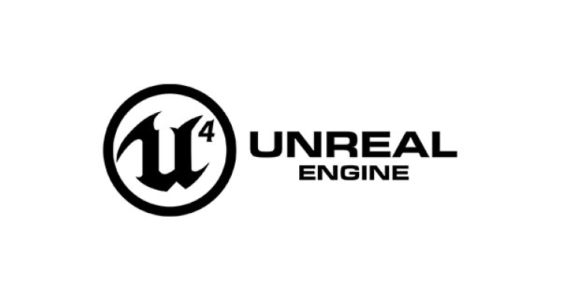
The agreed minimum specs of the game was to be confirmed, however the idea was to make it playable by the average gamer. The idea was not to have a huge game that would require the best pc.

The game is intended for PC, with the use of a controller (xbox 360/Xbox One), but not exclusively a keyboard can also be used.

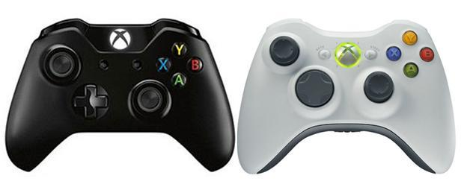

Visual Style 4

The Visual appearance of the game itself draws on the visual appearances and aesthetic elements from a range of existing environments and worlds in different media, such as the video game Pre-Alpha Power Drive 2000 and the film Blade Runner, to create our own unique take. The style itself will draw primarily upon a very stylised 80s retro appearance, with all the flash and neon that is so commonly associated with the time periods aesthetic, aiming toward a Cyberpunk environment spread across three different Levels, an industrial, Overgrown and Cityscape level, drawing the visual elements of the three toward a cohesive finish.
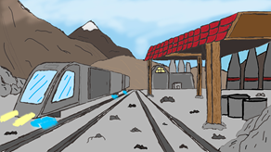
For the Industrial level, a mix of industrial and cyberpunk will be employed in the level, creating a dimly lit but striking environment. The track will have various underpasses, going under jutting out rock formations, under gantry ways and toward the end of the level, a large cave system will be present, giving the player a sense of claustrophobia that would be present in an industrial landscape, such as a mine or factory. Some utility elements that would be found in a typical industrial site, such as heavy loading machinery or transports for the workers will be present in the level, such as a train line to transport workers and materials, with the cranes being present to unload the materials.
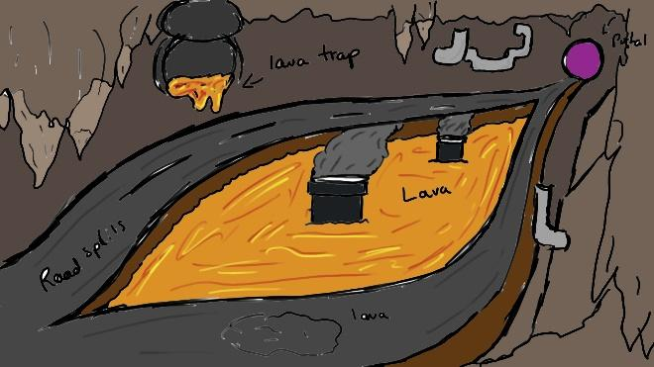
The Overgrown level will mainly be comprised, as the name suggests, of overgrown tracks and buildings, with an abundance of foliage and flora. Vines hanging from long abandoned towers, poorly kept sections of track in various states of disrepair, flickering neon advertising signs littering the buildings exteriors, in various states of poor maintenance and with litter and debris lining the roads of the track.
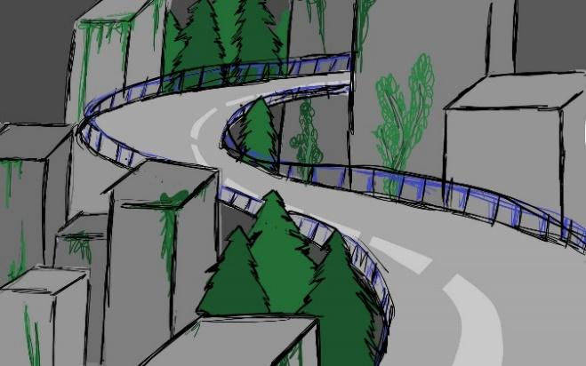
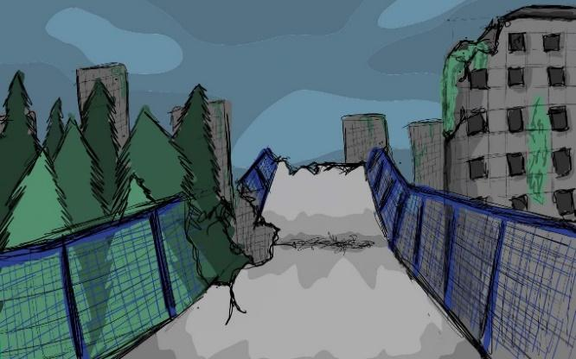

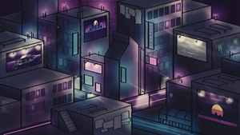
Neo-Tokyo will be the final level, with a vibrant city scape modelled off cities such as Tokyo and Hong Kong, drawing heavily upon their towering skylines and neon advertisements clustered in the environment of the city, with a packed cityscape creating a sense of claustrophobia for the player, then opening n to large open sections of track, with the player able to see the large figure of a mecha-lizard, similar to that of Godzilla but heavily stylised, appearing above the cityscape. The neon visuals can assist greatly in lighting the scene, as well as immersing the player in the level.
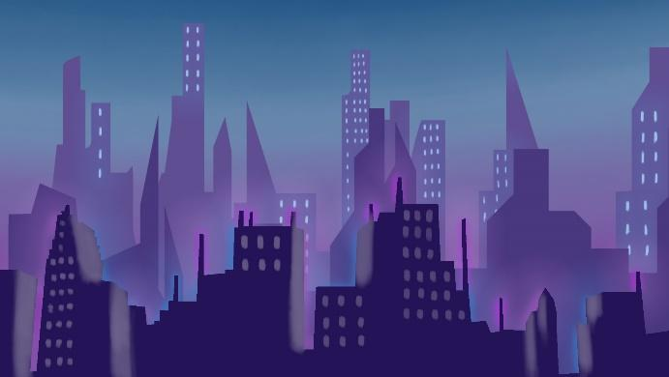

Audio Style 5

The audio style within the game will primarily draw on a selection of royalty free ‘New retro’ music tracks that will lend themselves to the Cyberpunk theme, using a soundscape to immerse the player in the race and the game itself, similar to media with a cyberpunk or heavily stylised 80s ambience in its soundtrack or audio effects, such as Power Drive 2000. Upbeat music tracks are the primary choice of music, with the ultimate goal being keeping the player both engaged in the race and ensuring their enjoyment of the game itself, as the player advances level by level.
We’ll be avoiding certain audio effects, such as tire screeches or a more traditional sounding revving and acceleration within the vehicles themselves, to highlight the more futuristic and science fiction elements within a cyberpunk environment, eschewing the traditional sounds of a modern automobile in favour of amore sci-fi inspired set of sounds and effects for the vehicle, perhaps a present day cars sounds spliced with that of a jets engine, to really set the vehicle's audio apart and make it unique to the vehicle.
Dialogue is not something we’ve planned to incorporate in to the game, as we primarily intend to focus the cars and the music of the levels, rather than recording dialogue for any of the racers that may appear in the game or its story. This may change as the game evolves and we adjust the project to include dialogue for the

Starting Out 6

Selection/Creation 6.1

When the game starts the player will have the option to click “play” or press “start” if they are using a controller, this will bring them to the Game mode selection menu where they will be able to choose either “single player” or “multiplayer”. If the player selects single player option it will take them to the “level select” menu and if they select the multiplayer option the menu will give the player the option to play “online multiplayer” or “local split screen” which will then take the player to the “level select” menu, at the moment we don’t have a multiplayer system but we are planning on adding it in the future.
In the level select menu there are three level choices that the player can chose “Neo-Tokyo”, “Industrial” and “Overgrown” after the player selects which level they would like to play they will be taken to the “Vehicle selection” menu where they can choose from three different types of vehicles. The first vehicle is the fast vehicle which is faster than the other vehicle but has less health than them. The second vehicle is the medium vehicle which has balanced speed and health, the third vehicle is the heavy vehicle which has a good amount of health but is not as quick as the other vehicles.
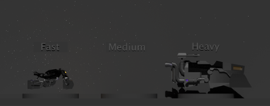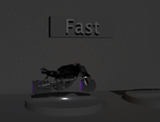

The vehicle select menu will have the three vehicles lined up with a button above them, all the menus will be in the style of Neo-Tokyo style and each of the buttons will have a glow around them to give the menu a Neo-Tokyo feel. All the menu`s will be created in a 3D space with assets from the levels in the background.
After selecting a vehicle, the player will be able to select a skin that they would like to use, at the moment we don’t have any other skins that the player can use but we will be implementing the option in the future.
After choosing a skin for their vehicle the player can click start which will load up the level with the vehicle that they have chosen, and they are ready to play the game.
In the future the player will be able to purchase skins and vehicle upgrades using coins that they have earnt by playing the game. We might be adding microtransactions in the future but it has not been confirmed at the moment.

Game Start and Intro 6.2

The player will have the option to choose from a single player, local multiplayer and Online multiplayer mode. All alternatively taking them to different screens with options to change the level and the game mode. This then leads to the vehicle selection screen where the player can choose what vehicle and skins they want to use. The player will start the game once the “start” button has been selected.
Depending on which options were selected will start the game differently. If its an online multiplayer, the player will sit in a loading screen waiting for other players to join the game. If it is local multiplayer or single player, the game will start automatically.
If the single player option was selected the player will have the option to “Play All” which will start the story narrative. The game will have tournaments, consisting of three levels per tournament. The individual levels for the game will be greyed out until unlocked by playing the story mode. This option will go through the cut scenes (See cinematics) and tell the overall story of the game, the player will then have the option to take the tutorial level (all of which is skippable if they prefer).
The tutorial room will be big open space with a single portal at the centre of the level. The player will then have to go through the tutorial,first teaching the controls and how to move. Then teaching basic mechanics, shooting, using speed boosts, respawning at checkpoints. It will then allow the player to go through the centre portal once they know what to do and are happy. This will then throw them into the first race.
The player is then placed in the level. They will have their health and overdrive bar on their vehicle. (Health = green, Overdrive = Blue). The players current position will be in the top right of the screen. The game will also have a countdown to start each race. For the first race they will always be in last position to start the race. When they win their next race they will be in the position that they won from the previous race.
Their objective is to not be in the last three positions of each race. This gets more tough the further the player gets in each tournament. The last race will have the player come first to win.

In-Game HUD & Menus 6.3

The in-game HUD will display the health and the Overdrive, (overdrive is the shield, boost and ammo for the vehicle/ player). The health and Overdrive will be displayed on the vehicle itself as a texture and will be dynamic with the gameplay, so as your health goes down so will the texture on the vehicle.

The main menu will be displayed as a 3D widget inside of a room. This will give effect of it being in a 3D space. This will give more depth to the menu. The menu will be able to be interacted with a controller and a mouse. This allows players on PC and console to control the game.

Multiplayer (If Applicable) 6.4

Once the player opens up the multiplayer option, they will have the option for local and online multiplayer. To start we will have a central server that will handle each match. The player will have the option to host their own game, with the ability to invite friends. The player will be given a list of active servers, ones that haven’t started and ones that are in progress. The player can only join a server that hasn't started and can also invite friends to ones that are not full. They will also have a search function to find a game that they want to play.
The servers will host different game modes and different tournaments. Allowing the player a variety of games to play. Depending on which game mode will determine what races they can play. We will have time trials, elimination tournaments and standard races. Winning a game will earn you credits that the player can exchange for skins and cosmetic items.
Hosts have the option to choose a game mode, the level they want to play and the parameters of each match. They also have the option to make a private match or public match. Hosts also have an option where the map and game mode can be chosen by the players, this lets the players decide on the game they want to play (Automating the gameplay for the host). They can also invite players and kick players.
I also want the players to have the ability to “vote” on a map. The idea is that the players all have the option to choose a map. The map is then highlighted with how many other players have also chosen that map. But in the end the final decision is entirely on the host. This is only meant to be an indicator on what the popular vote is for the host. However it is negated if the host allows for the players to choose the map and game mode option.

User Interface 7

Main Menu 7.1

The main menu will be in the style of Neo Tokyo, the menu buttons will be lit up in pink and blue. The background will be retro themed with some of the in-game assets on display. On the level select screen there will be previews of each level with an image of the level on the side. The vehicle selection screen will display a garage space. When you select the different vehicles, the vehicle on display will drop below the floor and swap to the chosen vehicle.
The options menu will have setting which can be changed, such as the resolution and sound.
Here are some screenshots on how the menu system will be laid out in the 3D space.
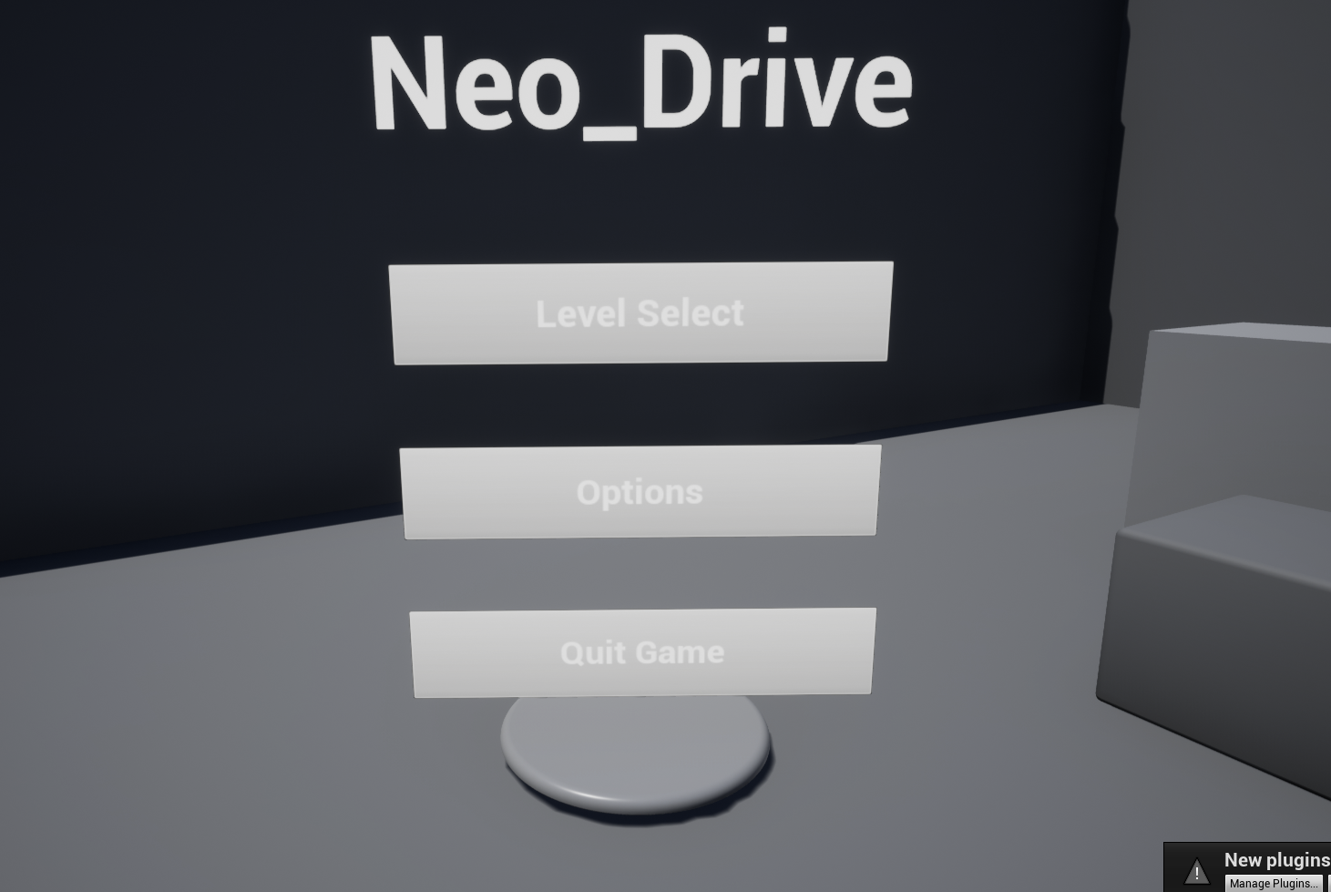
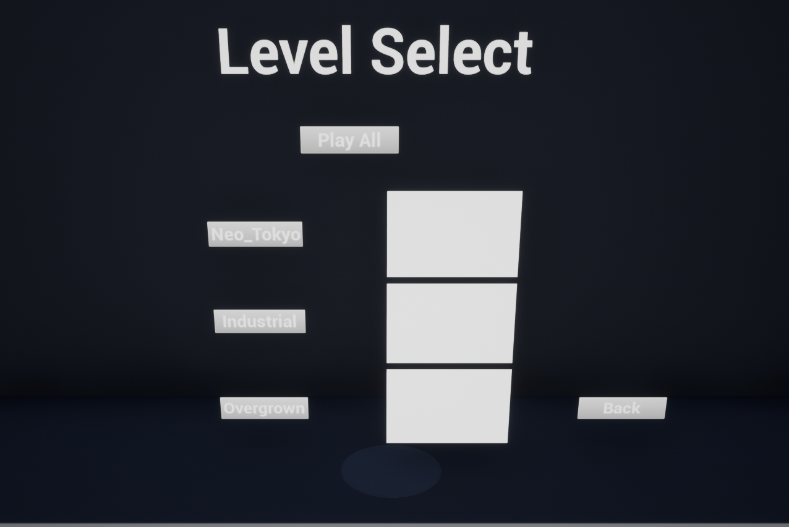
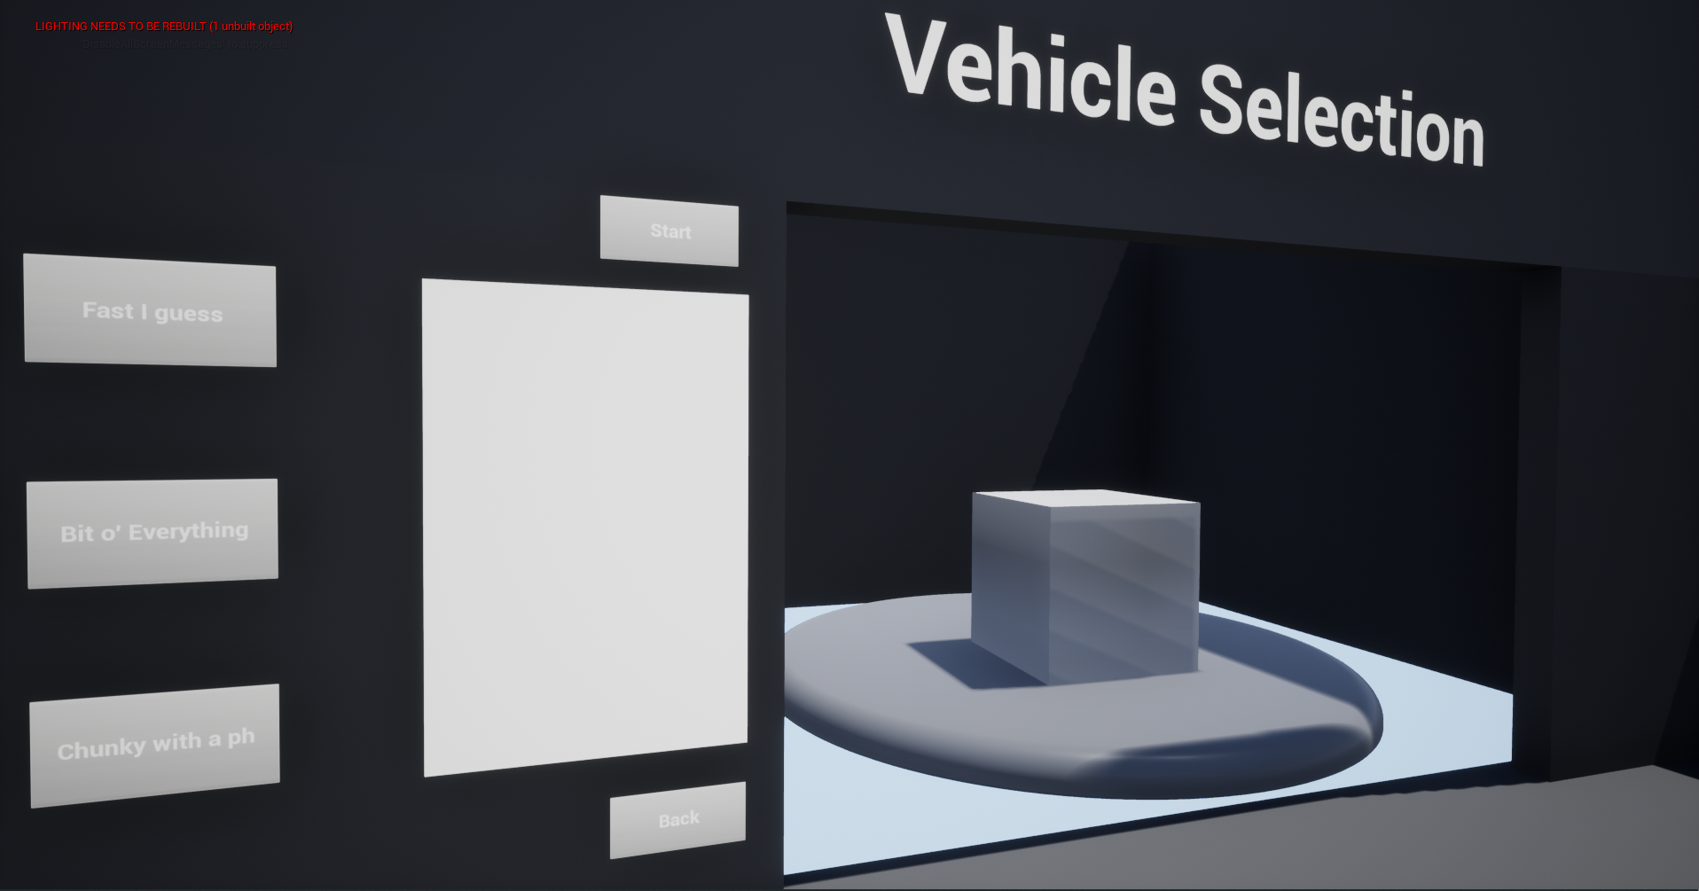
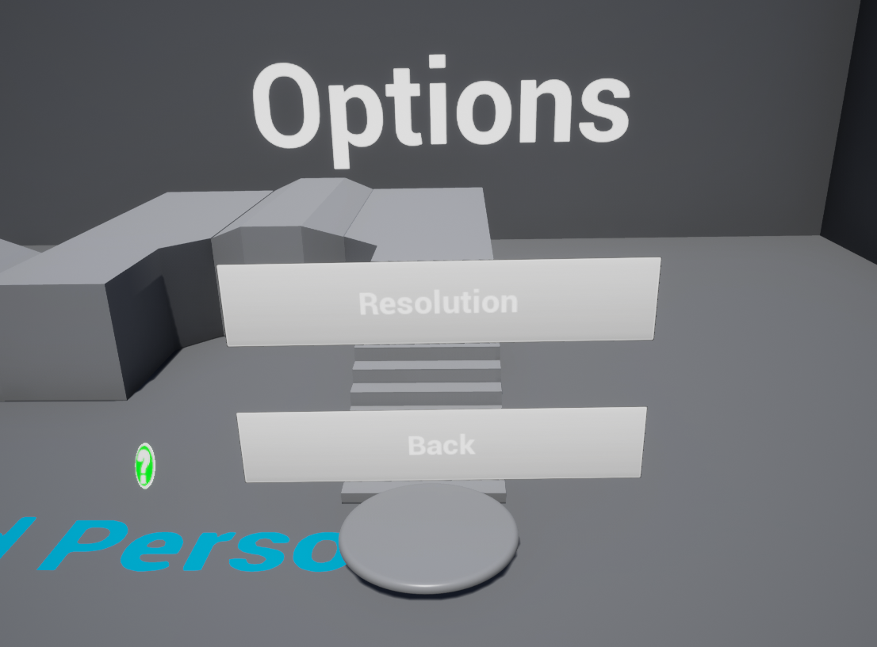

This is a flow diagram of how the menu system will work.
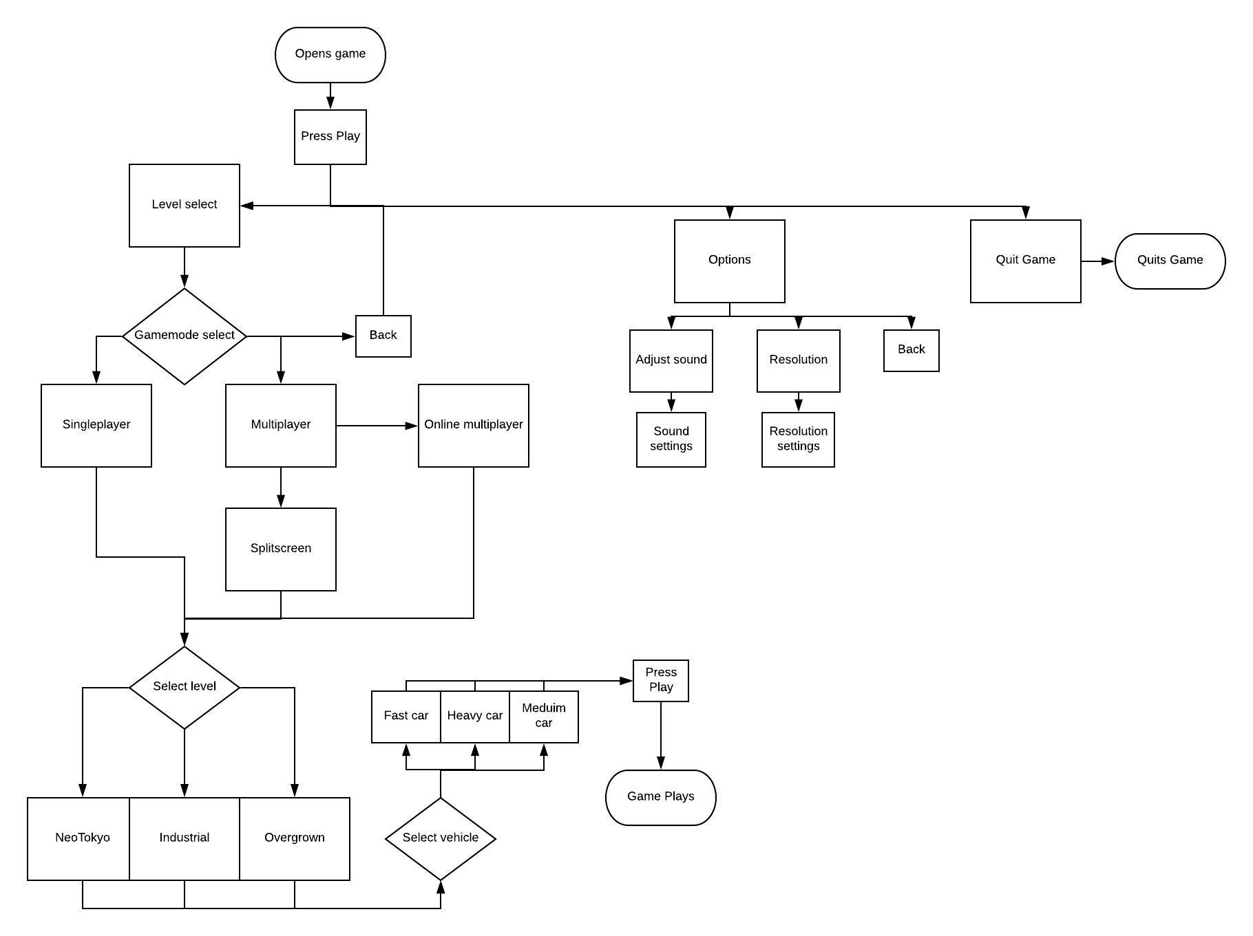

Player Customization / Store 7.1

This sections content was designed for future reference as early in development this was agreed not to be implemented at this time.

Here is the flowchart explaining the process from clicking on the store to buying and equipping skins.

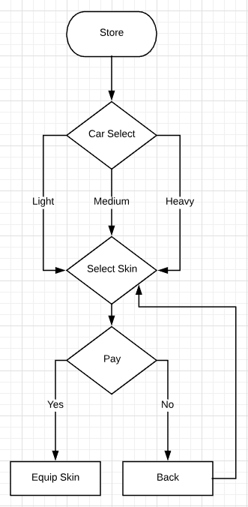

During game play, currency can be obtained through winning races. The higher the player ranks the better the reward; meaning the player can obtain more currency placing higher in the ranks. The actual amount of currency won is still to be confirmed, as it will require a lot of player testing to make sure that it is balanced.

The cost of skins is also to be confirmed for the same reason above. Also this process is a bit more complicated as it would take more balancing so that the player can have a nice amount of customisation as well as skins to work towards being more favourable.

There are only 3 vehicle designs, however the customisation of the vehicle is not lost. It has been decided that the vehicles could be customised through being able to obtain different skins. The player would be given a base few skins for the vehicle but there will also be the option of buying skins in the store using currency, as stated above. The currency is also discussed in briefly section Character Selection/Creation 4 and Missions/Achievements 7.

Here is the flowchart explaining the process of the skin selection when setting up the game; this is to be used in conjunction with the flowchart in the section Game Set-up Screen 7.3

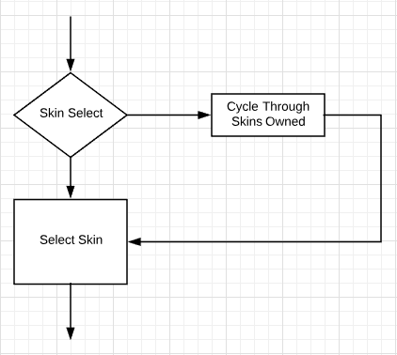

During this skin selection, the player will only be able to see the skins they already own; this is to avoid confusion and delaying game play.

Game Setup Screen 7.3

Below is a flowchart of the processes required for the player to go from “Start” to actual gameplay.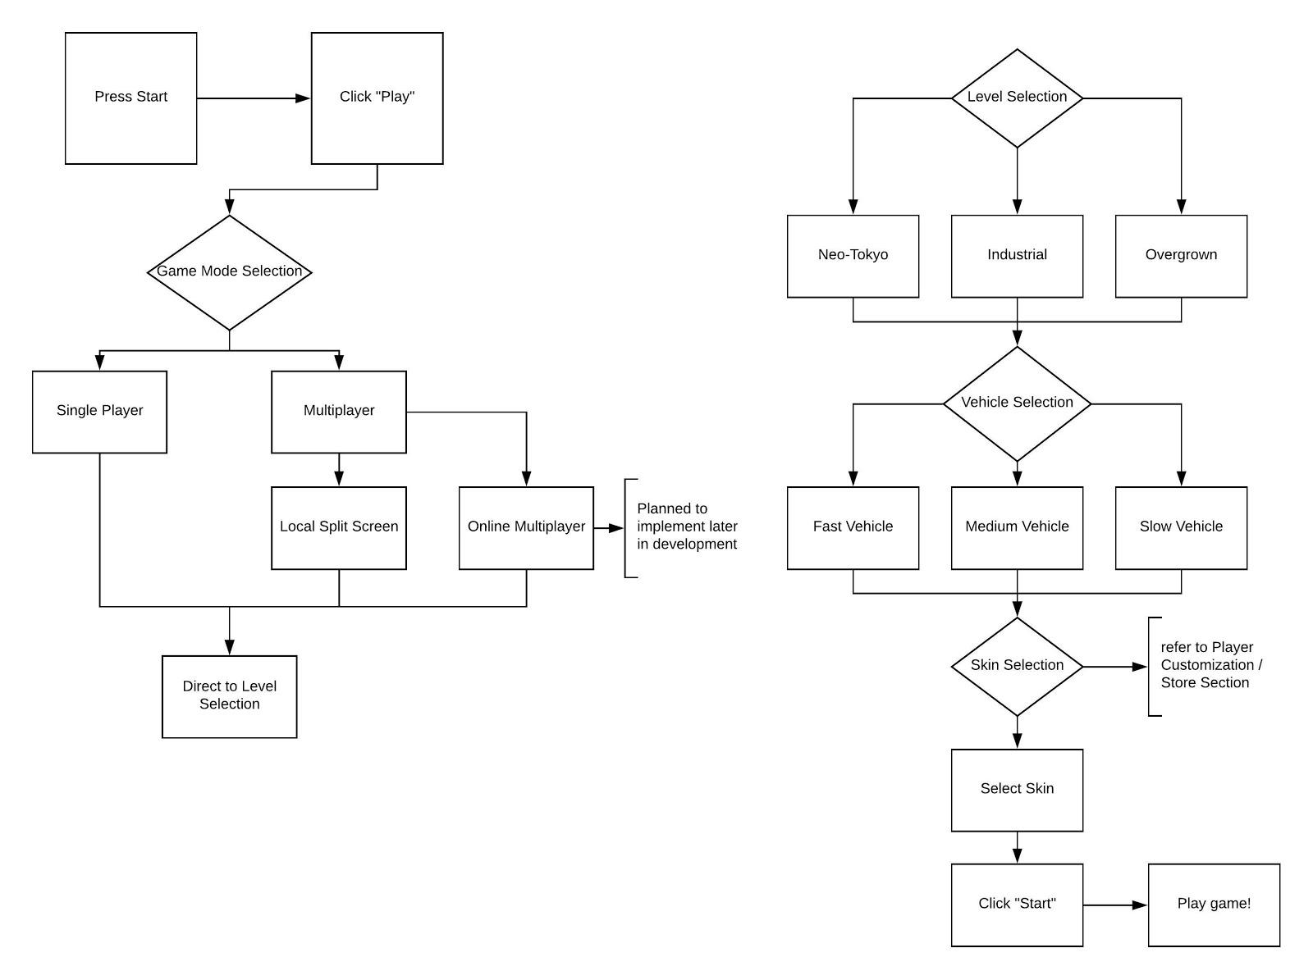

In-Game Options Menu 7.4

In the game Options Menu. There will be multiple choice which you will be able to change the setting for the game. These types of settings will appear when you press the pause button. This will then allows you to pause the game if you are in single player which will then bring up the settings. But we hope to add multiplayer in the future so when the pause menu is then pressed the game will NOT top as you will be up against other players.

In this menu you will have setting, Quit, Resume. When you click the resume button it will take you back to where you were in the game. If you click the Quit button then it will close the game down. When settings is clicked then it will bring up the settings for the game like resolution being the size of the window and also the quality of the game. it will also have settings like brightness and POV and these will allow the player to be able to customize there game to suit their computer that they are playing and then be able to jump back into the game where they left off.

In-Game HUD 7.5

The in game hud will consist of a health and overdrive meter. The meters themselves will be displayed on the vehicle in which the player is controlling. This will free up space in the viewport and make the player concentrate more on the gameplay and the surroundings.
The health and overdrive meter will be displayed on the vehicles as textures and will be dynamic, so that they will change when the vehicle takes damage or uses the overdrive.
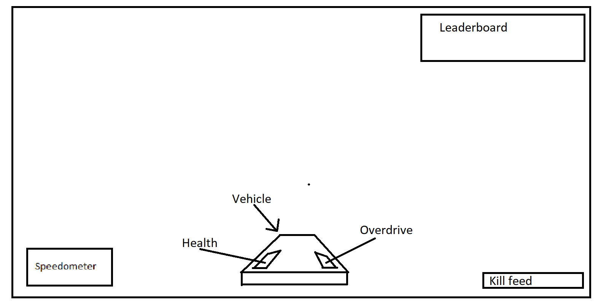
On the HUD there will be different things depending on the gamemode. If a normal race is being played then a leaderboard will be displayed in the top right. If a deathmatch is being played then it will also display a leaderboard but will also show other players health, in the deathmatch mode there will also be a killfeed in the bottom right of the screen. This will display who eliminated who and with what weapon/ vehicle. The bottom left of the screen will display a speedometer, this will display the speed of the vehicle.

Game Over Screen/ Respawn 7.6

In our game we will be having a game over screen which will appear when the player is destroyed or not able to get through the portal in time. This game Over Screen will show the position you came with the time, it will also show how many kill you got and the leaderboard so you can see how you did thought the game.
the game over screen will also have a button which will allow you to start over and be able to try and beat you last attempt without going back to the menu and then going back into the game. the game over screen will also have a home button. This will allow the player to be able to go to the homepage incase they want to buy anything with the credit they earn or wait. then they will be able to press play where they will go back into the game from the home page.
Respawns will happen if the game has ended via winning or losing. But will also happen with checkpoint as you are able to go back to the last checkpoint if you are having trouble carrying on with the level.

Level Selection 8

The levels will require an initial play through to unlock levels, this will be via the tournament or story mode. There will be a set sequence of races within a tournament, these will follow the story behind the game. However, once a single play through has occurred, there will be the ability to play individual levels as a standalone race. All levels are single player or multiplayer compatibility.

Level Type 8.1
There is currently only one level type implemented into each level “Time-trial”. This will be a point from A-B.
We do however plan on implementing two more level types into the game. Race and elimination.
Race - Simple A-B race against other players. AI and potentially one additional player.
Elimination - This will be a fight to the death as you race along the level. Only goal is to eliminate the enemy cars.

Full Level List 8.2

Each level is to be linked via portals at the end of each track. The player will have access to all the levels from the open of the game:

Current Levels

Neo-Tokyo
Style: Immersive wireframe neon glow metropolis.
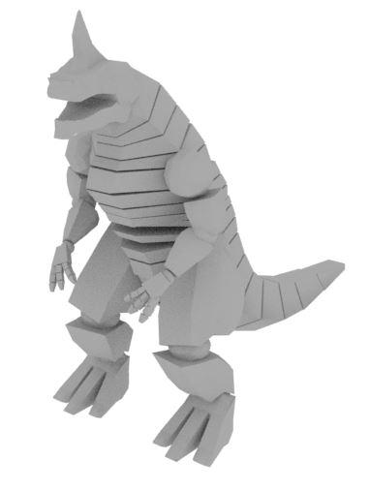
Obstacles: Mechzilla attacking
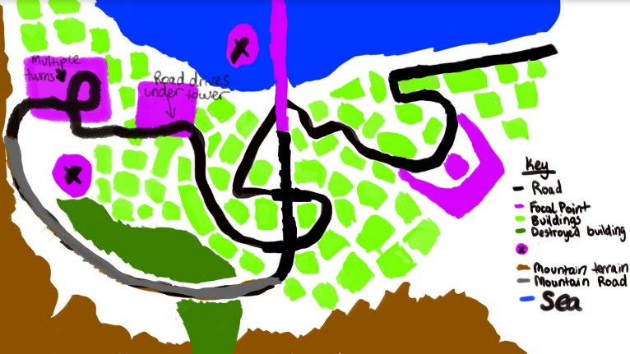
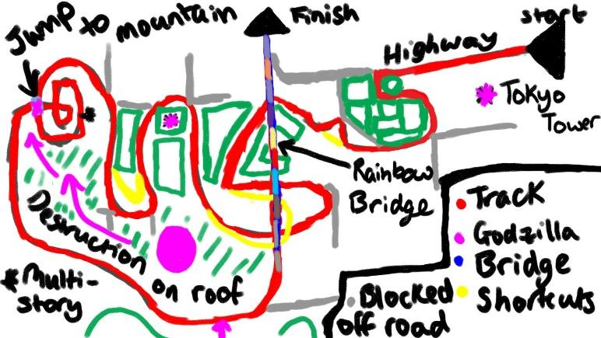
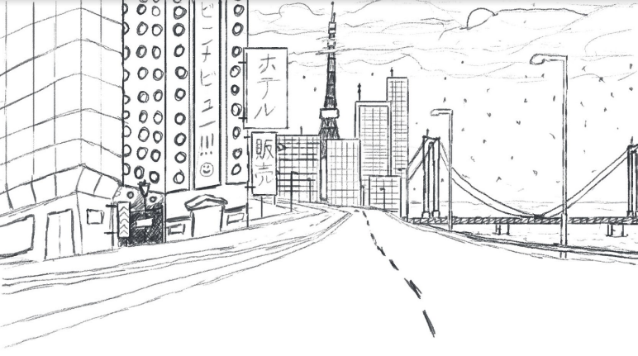
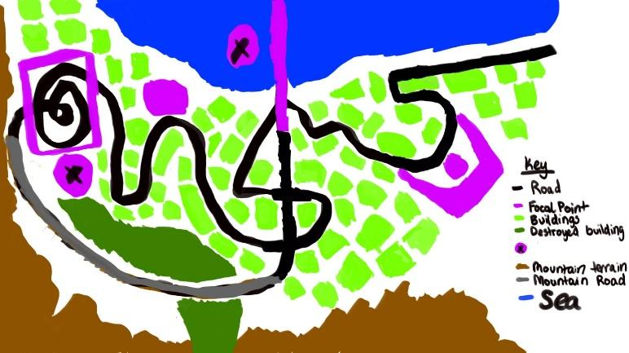

Industrial
Style: Realistic, steampunk, artificially lit, industrialised.
Obstacle: Laser turret, dynamic and static obstacles, traps
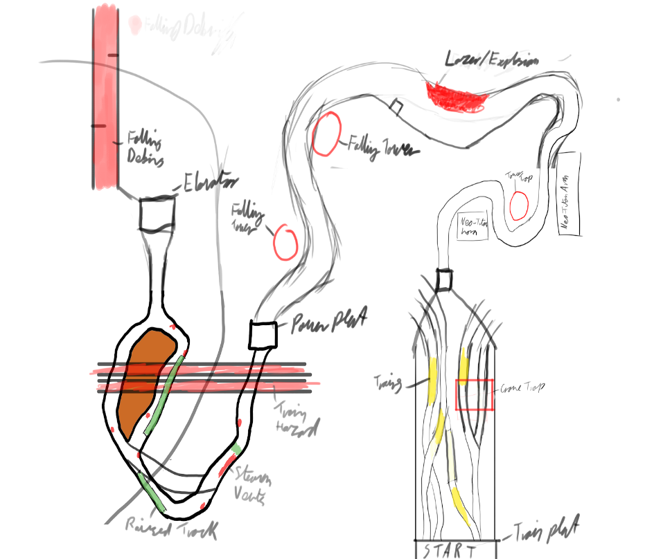
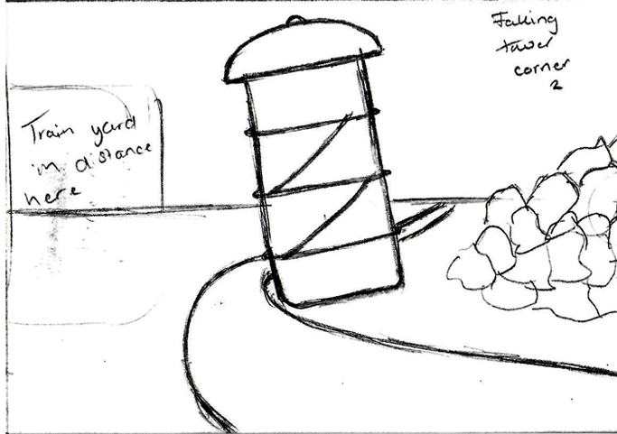

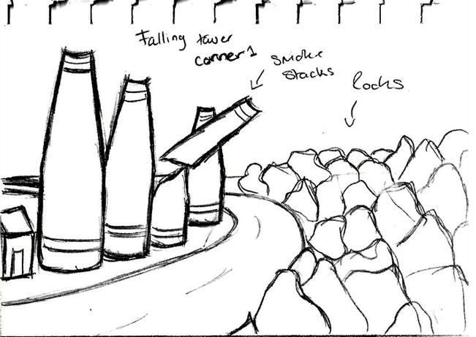
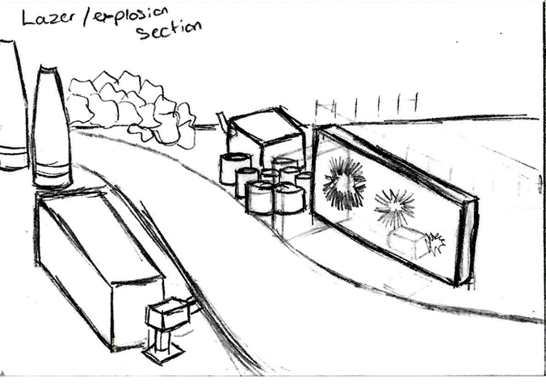
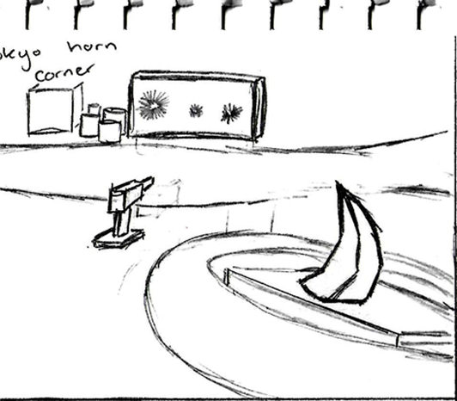

Overgrown
Style: Abandoned overgrown cyberpunk city. Naturally lit.
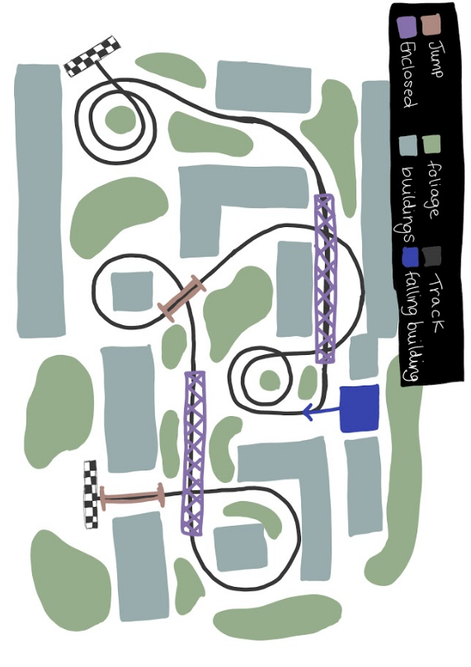
Obstacle: Collapsing buildings, debris on track, collapsing bridge.

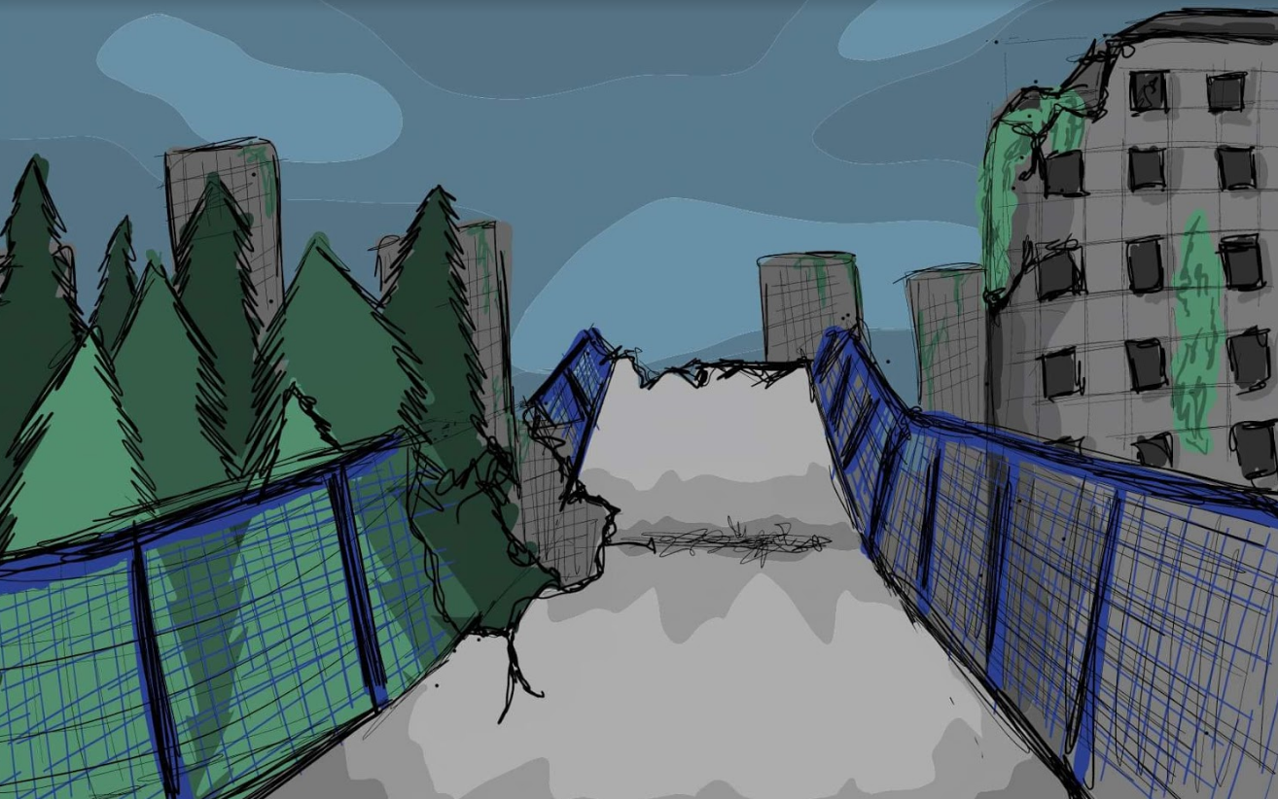
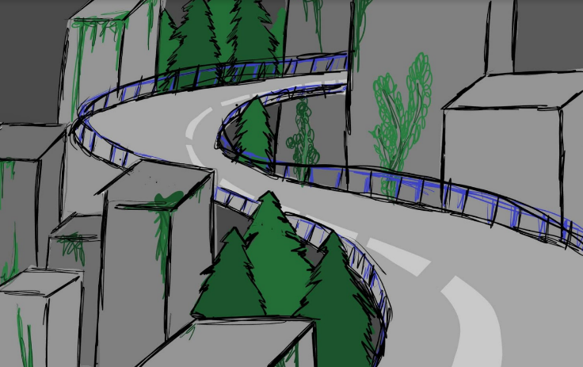
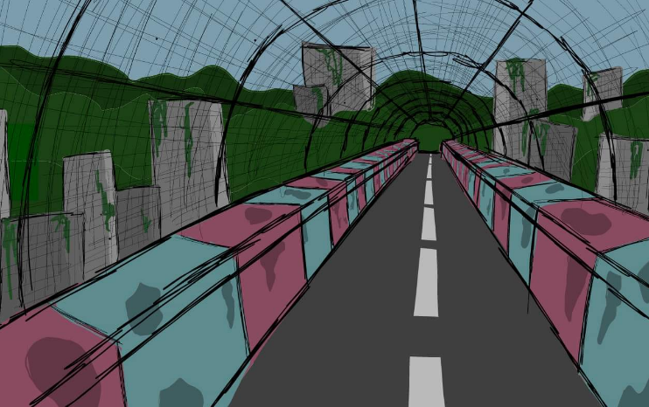

Gameplay 9

Mechanics 9.1

Movement;
The player’s vehicle will be a hover vehicle.
Health;
This is the players health. When this equals 0 then it will destroy the player and then respawn them at the last checkpoint that they went though.
Overdrive (Energy);
This is the resource that the player needs to manage, and will generate over time.
Speed Boost;
The player presses the boost button which will grant them temporary increase in speed.
Shooting;
The player presses the shoot button, allowing them to shoot enemies, decreasing their health. Giving the player a momentary advantage.
Shield;
The player presses the shield button, allowing them to give them a temporary shield against damage.
Pickups;
Guns (Temp)
A pick up on the track that allows the player a temporary boost in damage for their gun.

Controls 9.2
The game will be able to be controlled with either a keyboard and mouse or a controller. To navigate through the menu system you will be able to either select the buttons with the mouse or on a controller by using the D-Pad.
When controlling the vehicle again either a keyboard or a controller can be used. This is how all the inputs will be set out as. Below are some diagrams explaining the controls.
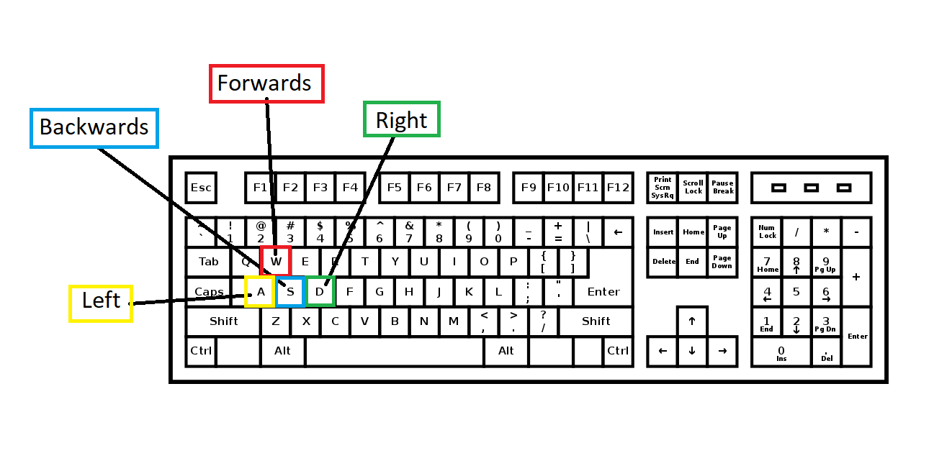
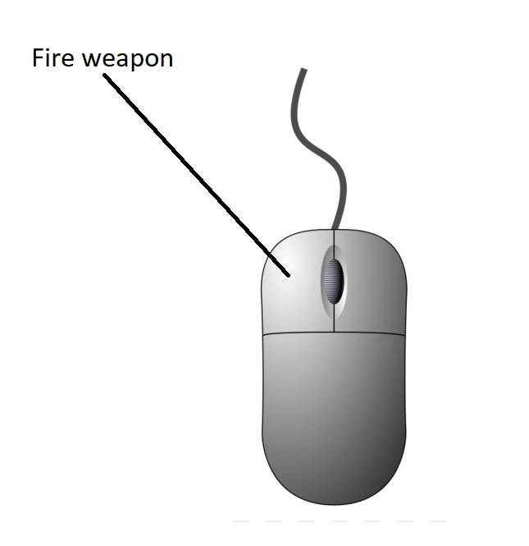
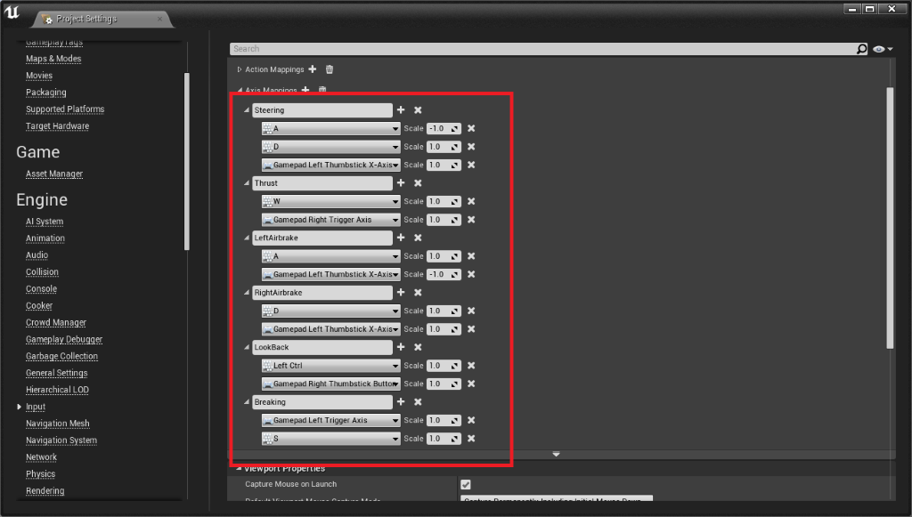
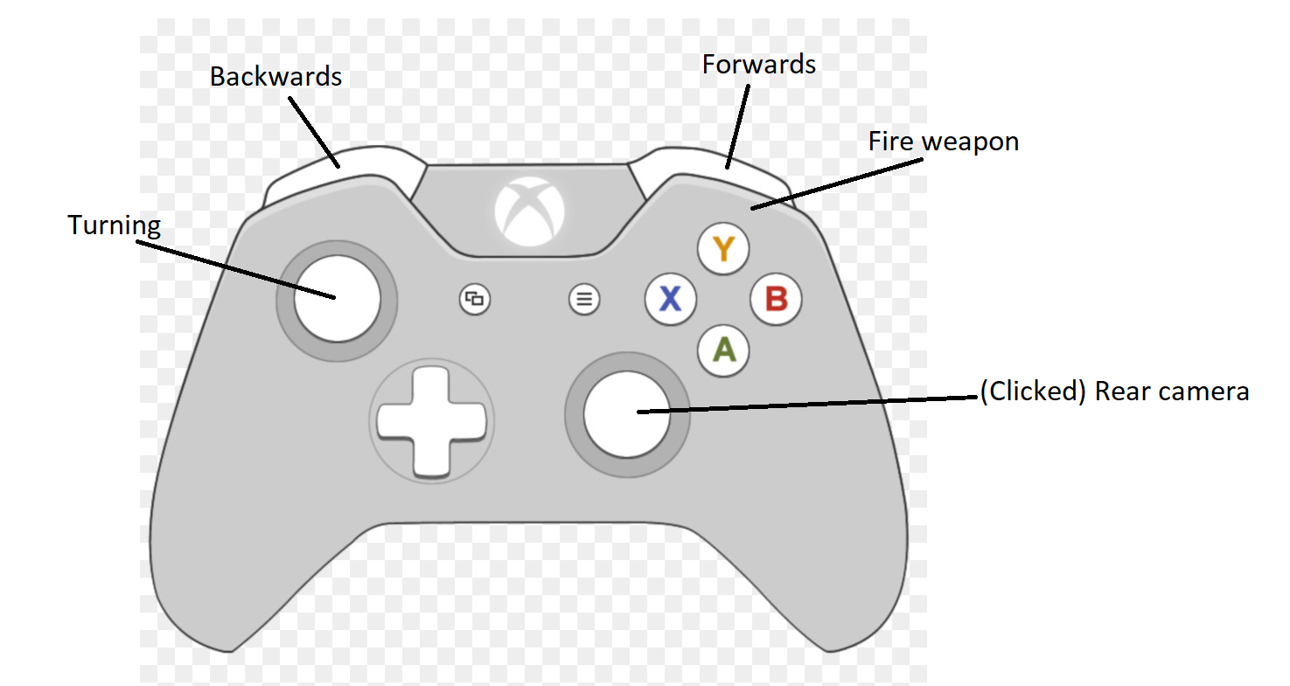

Modes 9.3

There are going to be a few game modes within Neo Drive itself, allowing the player to experience the game in many ways, they are Story Mode, Time Trial and Multiplayer. Having more than one game mode in the game is important as it gives the player a purpose to come back and play the game more.
Story Mode; the player will play through a sequence of levels that will correlate with a narrative based off the background story of the game, these levels would be Neo Tokyo themed, Industrial themed and Wasteland themed.
Time Trial; the player will race against a set time to reach the end of the level before the timer goes down to zero, the player can repeat this mode to try to achieve a better time. The player will be able to choose any track they would like to play, no matter what order they appeared in within story mode.
Multiplayer; the player will have the option to play against other players of the game, whether it is on the same device, i.e. PC, Console, the screen would become split into equal sizes for each player so that it is fair for all players. The player being able to play on a LAN network or on a global network such as the internet, the player will be playing on their own device, so they would have their entire screen for themselves.

Winning the Match 10

Score/Time

Race mode will be where the players will compete against one another in order to get in the top four, as there is three levels there will be twelve racers, as each level passes four players will be eliminated the player who comes in first place at the end of the last level will win the game.

The game will have a time trail mode where the player is timed, the fastest overall time is the winner of the match, this will be our main mode because there will be traps and timed events that will obstruct the player from progressing such as buildings falling and lasers to knock the player off course, so the quickest player who gets through the traps and events will be first.

In the future we may implement a score board and to get points the player will have to destroy other players this game mode will be called elimination, during the race using traps that can be triggered by going over pressure plates, and using the guns that will be mounted to the vehicles supplied.

The overgrown level is the longest level by fifteen seconds, next to Neo - Tokyo which has the second longest play time, and the industrial level has the shortest time, this may be changed in the future to make the play time longer for the overall game.

Time in minutes

Neo-Tokyo - 2.30

Industrial - 1.00

Overgrown - 2.45

10.1

Challenges of importance 10.2

The challenging aspect of neo drive is trying to beat the AI in a race the player can achieve this by finishing first .a soon to be added feature where the player and Ai can shoot at each other to make the victim crash and become static for a couple seconds this gives the aggressor a chance to gain the lead, there is also a time challenge the player can take part in which should be challenging. There are events that will happen to increase the difficulty for the player these are a monster, a falling building and falling towers. We also plan on adding multiplier if possible. The player can also challenge themselves by competing achievements in game.

Missions and Achievements 10.3
The player will get credits as a reward for finishing the game mode they have chosen these include a race mode, time challenge, and an elimination mode, the credits will allow the player to unlock new skins for cars and other cosmetic features however the credits in no way shape or form will give some players more advantage than others in a multiplayer race when added. This is referenced in Character Selection/Creation 6.1 and Player Customization/Store 7.2
The player can receive achievements by completing some challenges in game some examples of this are completing the race without crashing or eliminating the AI a certain amount of times in the elimination mode and completing the time challenge mode in a record breaking time. Players can also reward themselves by competing some challenges in game this will give them bragging rights over there friends who have Neo Drive as well.

Assets 11

Characters
The main classes of vehicle that will be used is a fast, medium, and heavy vehicle. The fast vehicle will have a speed advantage however the handling will suffer for the excess amount of speed, the mid class car will be the starter car for new players and is an all-round good car for handling, and speed however it isn’t as fast as the fast car. The heavy car will be slower than the other two classes however it is the heaviest and can ram the other two classes off the round it also has the best acceleration, too balance everything so it can keep up with the other classes. We also have a bike as a fast and nimble character however it is light and can be knocked off the road easily.
Mechazilla is the main asset in the Neo-Tokyo level, however it is a character because it has attack animations and moves around the map, and it can also interfere with the players by creating obstacles in the way of the payer to make for more dynamic gameplay which brings the level to life.
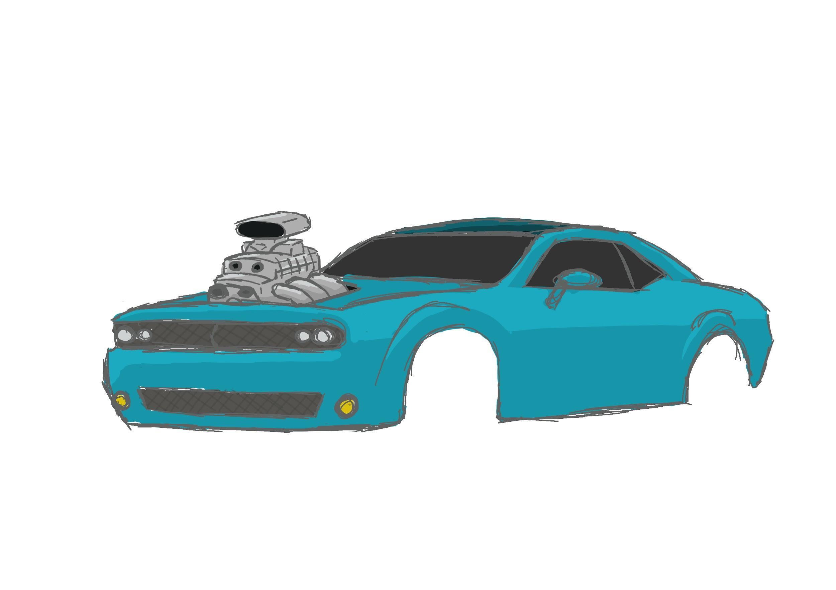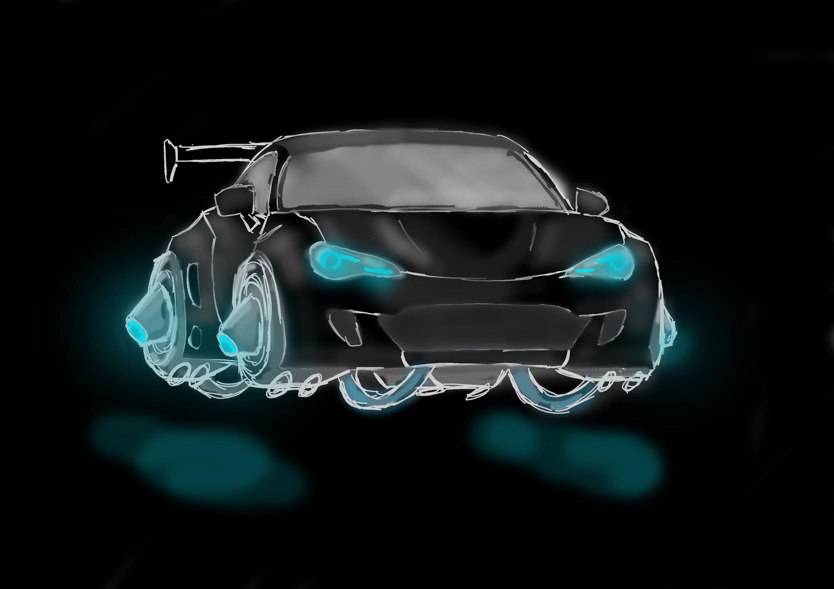

11.1

Weapons 11.2

This version of the game will will not have weapons since we wanted to focus on the main mechanics and they would distract from actually racing however we plan to introduce a weapons and health system in future iterations of the game.

The health of the player will be displayed on the vehicles and will be damaged either when they are shot by other players/Ai or when they come into hazards/traps

Each vehicle will have its own weapon that will do different amounts of damage depending on the class of vehicle with the heavy vehicle doing more damage than the medium or fast vehicles.

Equipment and Upgrades 11.3

Neo-Drive has no plans to have equipment or upgrades in this game or future variations of it however they may be implemented if it is decided that they will add to the experience.

Environmental 11.4
Within the environments in each level, there will be reused large and small assets throughout, they will be skinned differently to the level they will be placed in however, so that they fit the map they are placed within. The majority of the assets that are in the Neo Tokyo level will be outlined with neon lighting effect, all the global assets can be seen listed below:

Assets | Map Placement | Map Effect
Emissive Arrows | Along the walls of the race tracks for the player to know where they must turn on the race track | Will be lit up, visually showing the player where to turn on the track, using colours that would suit the level as well as the design
Signs | Scattered around areas near buildings and on them, whether they are destroyed or still intact | Some of these signs will be lit up with neon colours with English and Japanese text printed on them, the text may also glow as well
Street Lights | Street Lights will be near/close to the race track and other areas close to buildings | Street lights will be lit up with colours most suited for the area they will be placed in.
Wire Fencing | Wire fencing will be placed in areas where they would fit in the most, for example on borders marking a certain area of the map, wire fences around factories and buildings in the Industrial level and the wasteland level. | N/A
Buildings | Buildings will be scattered across the map, in areas where they seem to fit in the most | Some buildings will collapse, fall over making the map more dynamic, such as a smoke stack in the industrial level, and a damaged building in the wasteland level.
Bins | The bins will be scattered close to buildings and pathways along the race track. | Some bins will be placed close to the race track, so when the player drives through the bins, they’ll fall over, spilling paper and other contents
Construction Cones | The cones will be placed at sharp bends where the road would end, for example at the end of a street in Neo Tokyo as well as being placed in certain areas in the Industrial Level | N/A
Scaffolding | Will be placed around/close to damaged buildings in the wasteland area as well as Industrial buildings in the industrial level | N/A
Pipes | Pipes will be placed on large assets such as buildings or other large assets in the industrial level, they will appear to be placed randomly so that each building looks unique. The pipes are modular, allowing for there to be a system of piping throughout the level. | The pipes will have a smoke effect coming out of the end, however some of the pipes will be broken and burst, so steam will be coming out of these areas as well.
Vehicles | There are going to broken down vehicles scattered around the Wasteland level, however the player will also be driving a variety of vehicles. | Some of the broken down vehicles will have smoke and fire emitting from their engines  The drivable vehicles will have a fire/flame effect coming from the exhausts when they are accelerating.
Fuse Boxes | Located near/on buildings as well as the telephone poles and other assets that would require a fuse box | The fuse box will have an electric effect attached to it, however on the Neo Tokyo level, it will also be outlined with neon lights.
Telephone Poles | Telephone poles will be scattered across each map, placed near buildings and in the distance, placed in ways which it would not appear out of place | On some maps the telephone poles as well as their wiring will be lit up, mainly on the Neo Tokyo track

Audio 11.5

Audio
We plan on only using creative common music for our game. This includes sound effects and audio tracks. We will attribute all artists in the credits and also on the options page. Where we will have an “attribution” section. Here we will have all links to all artists of the original music and links to social media too. We have some audio that we have asked for permission for and not got a response. If they don’t get back to us when we release the game, we will have to choose something else.
Sound Effects:
Godzilla Roar / Royalty Free Sound Effect
https://www.youtube.com/watch?v=pi5WSsZqDaM
Glitch_Drums_005.wav by jalastram
https://freesound.org/people/jalastram/sounds/412340/
Retro_Game_Sounds_SFX_28.wav by jalastram
https://freesound.org/people/jalastram/sounds/318207/
Music
F.O.O.L - Highway
https://www.youtube.com/watch?v=_nppTcea5B0
Nemix - Catastrophe
https://www.youtube.com/watch?v=xagptShRJlI
Adam Vitovsky - Electric Punishment
https://www.youtube.com/watch?v=Ly4NxlQuv7I

Backstory 11.6

In the vast, underground bar network of Earth 2177, the prestigious annual Neo Drive 24 is about to begin.
The desolate corrupting Virtual Reality games are the playground for the greatest VR racers in the world, as they compete for the number one spot and the insane prize pool of Neo–Drive.
The deadly Neo-Drive death race, pits the world's top 12 players against each other as they willingly jump into the dying game, to gain renown from around the world. The game kills off the players that lose each race as each portal to the next race grows smaller. There can only be one victor, one winner and one survivor.

Bonus Materials 11.7

We intend to bring in various features in the later stages of development of the games. Some of these features include:
Online Multiplayer - This is an important feature we wish to bring in as soon as possible to allow the user to play online with their friends. However, we will aim to only have local multiplayer until the game is ready for online access.
New Skins - As the age of the game progresses, we will aim to bring in more customisation options for skins for each vehicle. Unlockable via store.
New Vehicles - As Well as the introduction of new skins we will also bring in brand new unlockable vehicles for the player to use and customise.
New levels - As the level types have been established, we will implement a wider variety of maps within these types. We aim to have 12+ playable maps available to the player. Also, the addition of tournament playlists will give a new dynamic to rep

CINEMATICS 11.8

The game starts with the cut scene showing the old, dark, underground bar. Filled with smoke from cigarettes and barely any light.
The cutscene will be made out as almost a slow moving image, similar to how holographics work. With three layers that move slightly.
The bar is filled with shady people, portrayed as silhouettes, the setting will give the player a sense of danger and mystery.
In the middle of the bar is a single television screen which everyone is surrounding anxiously.
Some people holding money in the air and other people taking bets.
This is meant to be presented as an underground gambling ring.
This then moves to the next cut scene where, it zooms into the television screen.
The games presenter is a lanky, steampunk, optimistic guy shouting down a microphone and presenting the annual Neo_Drive. The cutscene will be a commercial for the Neo-Drive, where the presenter quickly explains what the race is about.
The presenter then gives context to the game.
There are 12 players all fighting it out for the top spot where there is a prize pool of money.
The catch is that the game kills off the players that lose each race, through the collapse. The massive amount of energy used to clear out the game, which is deadly to anyone still inside the game.
The thrill seeking players are all willingly inside a dying VR game where the game is trying to kick out the players. The losing players will die as a result of the dying game. But the winner wins a huge prize pool of money.

