KNOWLEDGE AND INFORMATION
MANAGEMENT
SKILLS FOR THE WORKPLACE

PART ONE
BMSK 5006

BUDDHI PATHAK

Table of contents

1. Introduction…………………………………………………………………………… Page 3
- Exploring data and it’s uses………………………………………………………… Page 4
  - Differentiation between knowledge, data and information……………… Page 5
  - Tacit and explicit knowledge……………………………………………….. Page 7
  - Determining data, information and knowledge used in…………………..
decision making……………………………………………………………… Page 8
  - Converting data into information and knowledge for promoting………...
a product……………………………………………………………………… Page 10
- Conclusion.…….…………………………………………………………………….. Page 16
- Reference list………………………………………………………………………… Page 17

- Introduction

Today's economic and technological changes have an unquestionable impact on people, organisations and culture. Such changes require continuous adapting to new conditions and lifelong learning. The value of personal knowledge and information as well as the different abilities and competencies that improve the effectiveness of human activity is valued by people, organisations and the community (MacKenzie and Foster, 2017).

The writer will evaluate the definition and value of information management for the awareness and operation in an enterprise. This shall be done by understanding the core processes of information management needed for organisational success. The paper will answer 5 questions:
- Why the same set of data may be seen by some as relevant but irrelevant to others and whether the relevant data can be classed as ‘knowledge’.
- How does ‘knowledge’ differ from ‘data’ and ‘information’?
- In a card game, does a player use ‘tacit’ or ‘explicit’ knowledge?
- The writer will consider 5 decisions that were made and for each case determine the data, information, or knowledge that was used to make that decision.
- Finally, after inventing a new product, the demographic data will be collected from a sample population. The writer will determine how you would use the data to translate it into product information for promoting the product.

2. Exploring data and it’s uses

Why can the same set of data be seen by some as relevant information but irrelevant data to others and whether the relevant information can be classed as ‘knowledge’?

Firstly, data is described as a collection of symbols, text or numbers that has no meaning (CIE, 2005 p4). Here is a set of data; 23, 19, 47, 59, 72
This data can be deemed as relevant to a Doctor’s receptionist who has a list of their patients’ ages. Whereas, to an ordinary person, these numbers would be of no significance because they would be just a set of random numbers. Another example would be these alpha-numeric figures; PX 67 87 54 R, JN 54 23 91 F, RT 45 19 68 H.
These sets of data would be significant to a Housing Benefit Officer as they represent customers’ National Insurance numbers, whereas to another person, these would have no meaning, therefore being classed as irrelevant to them.

Secondly, can this relevant information be classed as knowledge? Although the data is relevant, it is said to only be classed as ‘knowledge’ once this data has been further interpreted, processed or put into further context; thus, being classed as information that is meaningful. Therefore, it would be deemed as knowledge in these cases; if the Doctor’s receptionist put all the ages of the patients into a graph or report to further display the age range of their patients at that particular surgery and the Housing Benefit Officer would put the National Insurance numbers into an excel spreadsheet against the claimant’s name and address for their database records, therefore turning both of these scenarios into a knowledgeable one. Baskarada and Koronios, 2013 (as cited in Chaffey and Wood, 2005, p.223) state knowledge blends data and facts, to which expert advice, expertise and experience are applied; creating a valuable tool for decision making.

2.1 Differentiation between knowledge, data and information

How does ‘knowledge’ differ from ‘data’ and ‘information’?
It is quite safe to state that there seems to be many different perceptions of what all of these words actually mean. Baskarada and Koronios (2013) express at how surprising it is that there seems to be a lack of consensus on the exact definitions whilst Liew (2007) suggests that a clear and complete picture of what they are and relations between them still appears to be vague. Nonetheless, the writer will attempt to differentiate them below, by introducing; Figure 1 which represents the Data, Information, Knowledge (DIK) model. According to Lee (2017), this pyramid is an attractively and simplistic model that offers a perspective of logical growth from one level to the next, suggesting that by collecting more data you will gain information on which you can build your knowledge. Tang, Yanine and Valenzuela (2016) sum up the DIK pyramid simply and intuitively stating that data is the know-what, information is the know-why and knowledge is the know-how.
WHEN DATA IS INTERPRETED

WHEN DATA IS PROCESSED IT BECOMES INTERPRETABLE AND GAINS SIGNIFICANCE

A COLLECTION OF SYMBOLS, NUMBERS AND TEXT THAT HAS NO MEANING
PRODUCED AS A RESULT OF UNDERSTANDING INFORMATION

USING THE INFORMATION TO GAIN KNOWLEDGE AND SOLVE PROBLEMS
Figure 1 - Data, Information, Knowledge (DIK) pyramid

Data is classed as a collection of numbers, text and symbols that have no meaning presented as they are:
- 61kg, 65kg, 71kg, 73kg
- 159.3cm, 165.4cm, 167.9cm, 171.2cm
- 34 years, 23 years, 29 years, 42 years
Data is uninterpreted objects, an example is the first lot of data above which may be the weight of a person, e.g. 61kg. The meaning of this alphanumeric figure cannot be understood without additional elements of data such as height and age. Sanchez (2003) describes data as always being incomplete representations, Berčič and George (2009) define data as being out of context and not conveying much information. Interestingly, Braganza (2004) contends that data elements are very important as mistakes and omissions would contribute to poor results. Overall, the general consensus seems to be the same; that data has no meaning, interpretation and is incomplete.
Information is the processing of data to make it meaningful. Weinberger (2010) refers to information as a refinement of mere data, whilst Prof. Elsa Barber (as cited in Zins, 2007) study defines information as a message used by the sender to reflect one or more ideas in the communications phase, intended to enhance the perception of the recipients.

Figure 2 - Transforming Data into Information

Figure 2 above shows the transformation process of data into information. If 61kg, 159.3cm and 34 years are the data that are put through the transformation process, the information received would be a person that weighs 61kg, their height is 159.3cm and their age is 34.

Knowledge is the ability to understand the connection between pieces of information and know what to do with it. It is information that has been collected and analysed to make it clearer to solve problems or aid in decision making (Lilley, Lightfoot, G and N, 2004). According to Von Krogh et al. (2000), knowledge allows humans to define, prepare, shape and learn how to solve a task or problem. By taking the above data that has been turned into information, we can now use these to gain further knowledge by saying that the oldest person is 42 years of age or the height of the shortest person is 159.3cm.
Many philosophers have long believed that knowledge is power, and that knowledge derives from the interpretation of information; information, in effect, is the assignment of meaning to data (CIE, 2005, p4).

2.2. Tacit and explicit knowledge.
The definition of knowledge in terms of knowledge management does not end here as it comes in two forms; tacit and explicit knowledge. These were introduced by Michael Polanyi in 1958 and 1966 whereby tacit knowledge is said to be things we cannot tell, they cannot be expressed, therefore making it very difficult to transfer or share (Hüttenegger, 2004). They are characterised by things such as visions, attitudes, beliefs, instincts and experience, thus much of the information may be unconsciously stored making it hard to create, explain or register. Polanyi defined explicit knowledge as being represented and expressed as words and numbers, shared in instructions, forms and data etc. Furthermore, he stated that these types of knowledge can be easily coded and transmitted formally and systematically to individuals.

In a card game, does a player use ‘tacit’ or ‘explicit’ knowledge?
The writer believes that both tacit and explicit knowledge are involved when a person is playing a card game. Firstly, in order for a player to understand the concept of a new card game that they have never played before, he/she must first learn how to play the game; this can be done by reading the game instructions/manual. This method of learning would be classed as explicit knowledge as Polanyi states that explicit knowledge appears in the form of words, numbers or shared in instructions. Understanding the game can also be carried out by watching a video that someone has uploaded; Polanyi classes visions under this category. The uploader is displaying their tacit knowledge by making a video and the card player would be gaining tacit knowledge by watching the video to learn how to play. Furthermore, the player may even watch and listen to another player to ascertain the rules and watch the process of playing. Both of these methods are known as tacit to tacit knowledge which is demonstrated in Figure 3 below. The whole education cycle includes development and transition of information from one source to another as confirmed by Nonaka and Takeuchi who introduced the SECI model in 1995. Once a player has learned how to play, any further game playing tends to be tacit knowledge as Polanyi states these come from instincts and experience that are unconsciously stored.

Tacit Explicit
Knowledge Knowledge
to

Teaching and training Speaking and writing
Sharing experiences Demonstrating skills
Learning through observation Use of theories and models
Tacit SOCIALISATION EXTERNALISATION
Knowledge Learning through imitation and practice Concept creation through collective reflection
Discussions Sharing information
Listening to others Reviews
from
Learning by doing Use of media including IT
Use of manuals and documents Identifying new pieces of information
Oral stories Actualise concepts into practice
Explicit INTERNALISATION CENTRALISATION
Knowledge Practicing new activities Web forums
Learning new formal notations Collaborative computing tools
Digesting new pieces of knowledge Transferring and diffusing knowledge

Figure 3 - Nonaka and Takeuchi’s 1995 SECI Model
2.3. Determining data, information and knowledge used in decision making.

Making a cup of tea
The data is a cup, mug, teaspoon, Tetley’s tea, Typhoo tea, Green tea, white sugar, brown sugar, sweeteners, milk powder, fresh milk, water, saucepan, kettle. The information is a cup of tea. The knowledge is knowing what to do with the information provided above and how to make a cup of tea. The writer has grasped tacit knowledge from her family members whilst they made tea when she was younger; she observed for many years and unconsciously stored these visions. With this knowledge, it has assisted her in being able to make her own tea. Although it is an easy process to carry out, there is a significant amount of information needed to make the tea look and taste good to one’s preference. There are many decisions to make whilst making a cup of tea and they come about instinctively. The writer chooses not to boil the water in a saucepan because there is a chance the water may not be hot enough, which would result in the tea not tasting nice. She proceeds to boil the water in a kettle as this guarantees water reaching boiling point. The next decision is what type of tea to select, she takes a Tetley tea bag and puts it into a mug adding one teaspoon of brown sugar. She notices the fresh milk’s use by date has expired, this information is now deemed useless. She applies her instinct and decides to use milk powder instead, adding one teaspoon into the mug, followed by pouring the boiled water in and lets the tea bag sit in the mug for a couple of minutes. After two minutes, she stirs the tea and takes the tea bag out, the tea is ready to drink, phew…………..!

The writer wants to pray Salah (Islamic prayer).
The data is Salah. The information is Dhuhr (Early afternoon Islamic prayer). The knowledge here is that the Dhuhr Salah consists of 12 Rak’ah (4 Rak’ah Sunnah, 4 Rak’ah Fard, 2 Rak’ah Sunnah and 2 Rak’ah Nafl). Rak’ah is the term used in Salah for a sequence of motions (BBC Bitesize, 2020). Fard means ‘obligatory’, Sunnah means ‘act by Prophet’ and Nafl means ‘optional’ (Ghazal, 2018). The knowledge the writer gained of how to prayer was ascertained through tacit knowledge from parents and older siblings by listening to them and watching them carry out their prayers. This was then transferred into explicit knowledge by note-taking and learning by doing. As there are 5 prayers that are performed by Muslims throughout the day, each have their set numbers of Rak’ah. Therefore, the knowledge involved to make the decision to pray, lies with finding out which Salah is involved to carry out the correct Rak’ah.

Lunchtime! Time to make a sandwich.
The data is brown bread, white bread, cheese, tuna, mayonnaise, margarine, butter knife. The information is a cheese and mayonnaise sandwich in white bread. The knowledge is making the sandwich from the information provided. Cooking and making food are usually gained from tacit knowledge and turns to explicit knowledge by reading recipes, blogs and watching videos etc. Deciding the bread type, how much mayonnaise to use, what type of cheese to eat comes down to an individual’s preference. This decision making comes from tacit knowledge, e.g. using your judgement on what ingredients to use and how much of it you wish to put into the sandwich; ultimately boiling down to an individual’s taste.

Whilst driving, the traffic light turned amber.
The data in this case is the “amber traffic light”. The information is “proceed to stop the vehicle”.
The knowledge involved in knowing why to stop at amber traffic lights has been gained through childhood education in the form of tacit knowledge by listening to teachers, parents, watching videos and looking at illustrations in books. Children are taught about road safety and the meaning of the traffic light colours; (red) means stop, (amber) means slow down/wait and (green) means go. These tacit knowledges are instilled into children at a young age and gradually moves to explicit knowledge when a child is able to read about it too. Eventually, they must develop the knowledge required to cope with life circumstances themselves and the tacit knowledge which they have learned from a younger age assists them to tackle road safety by putting it into practice. Interestingly, Gillham and Thompson (1996) question whether children are able to learn how to do so in a structured way through education or whether they simply pick the skills up for themselves. This study confirms Nonaka and Takeuchi SECI model which shows the transition from socialisation to internalisation; one has listened and been taught but has then followed it up through “learning by doing”. Now that the writer is an adult driver, she has gained the knowledge and experience and her instincts tell her what to do when a traffic light turns amber; it means proceed to stop the car at the traffic lights.

The writer is feeling tired and wants to sleep.
The data is feeling tired. The information is sleep. The knowledge is knowing how and where to sleep. As it is in the afternoon, the writer unconsciously makes the decision to have a nap on the living room sofa instead of going upstairs to sleep in her bed which is normally done at bedtime in the night. The sun is shining through the window, which is distracting the writer’s sleep, so she gets up to close the blinds to obstruct the daylight from coming in. All the decisions taken are tacit knowledge which includes the ability to adapt and experiment different situations. Similarly, Gourlay, 2004 (as cited in Josefson 1988: 26; Herbig et al 2001: 688, 690; Wagner et al 1999) says that tacit awareness makes it possible to adjust to new circumstances, particularly because it helps people to be quick in judgement without the need to deliberate.
2.4. Converting data into information and knowledge for promoting a product

The writer has just recently invented new products and has collected demographic data form a sample population. The writer will determine how the data collected from carrying out a survey will be used to convert the statistics into information and possibly knowledge for the promotion of the products.

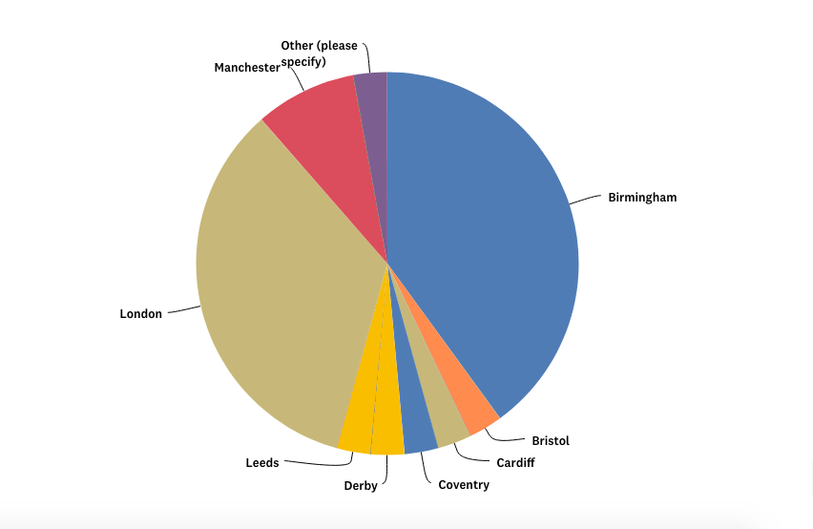
Majority of people live in Birmingham and London.

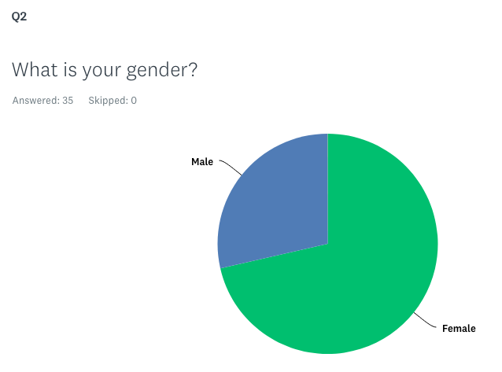

The target market will be more female.
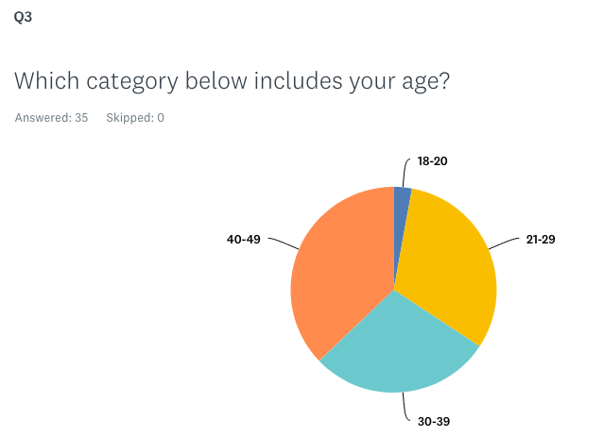

The target market will be for all ages.

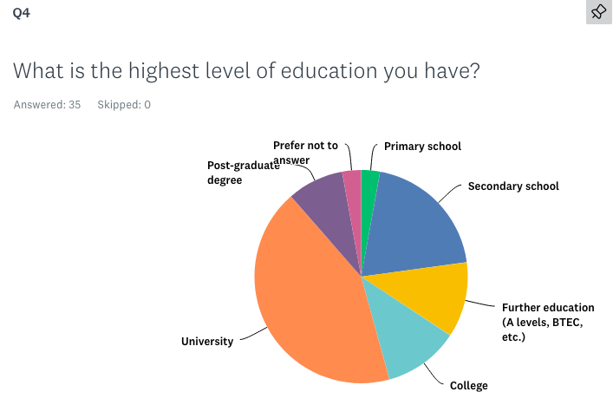

The highest level of education is University level.
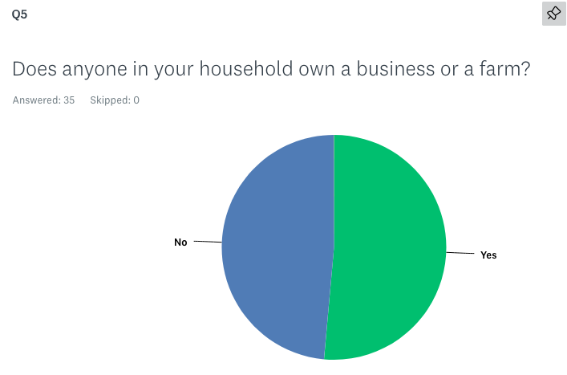

Majority people own a business.

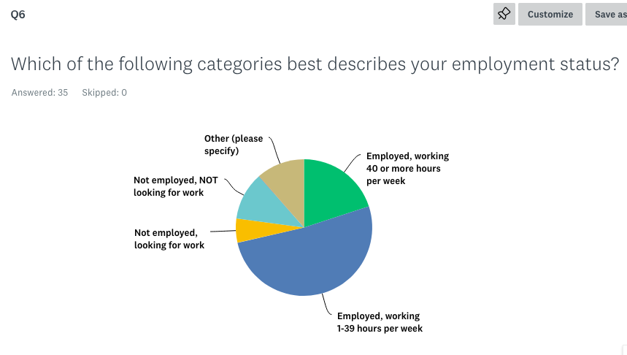
More than half of the people work full time.

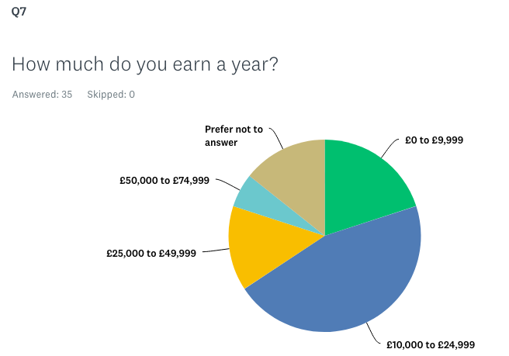
Nearly half of the people earn up to £25,000.

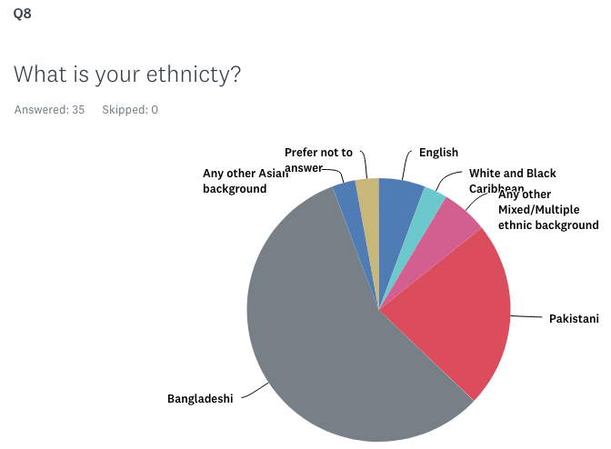
Majority people are of Bangladeshi origin.
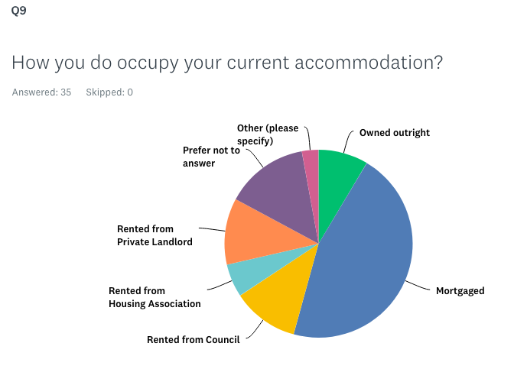
Majority are in a mortgaged property.

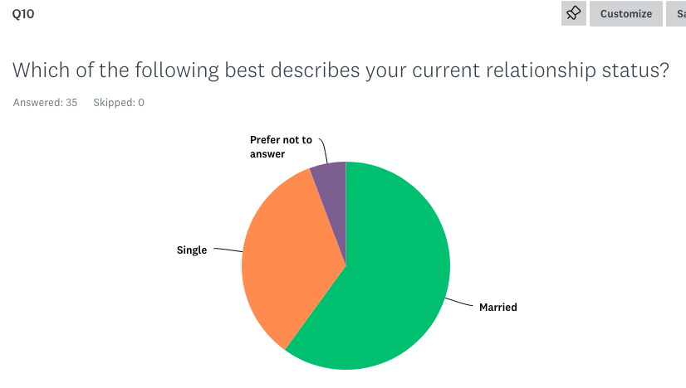
More than half of the people are married.
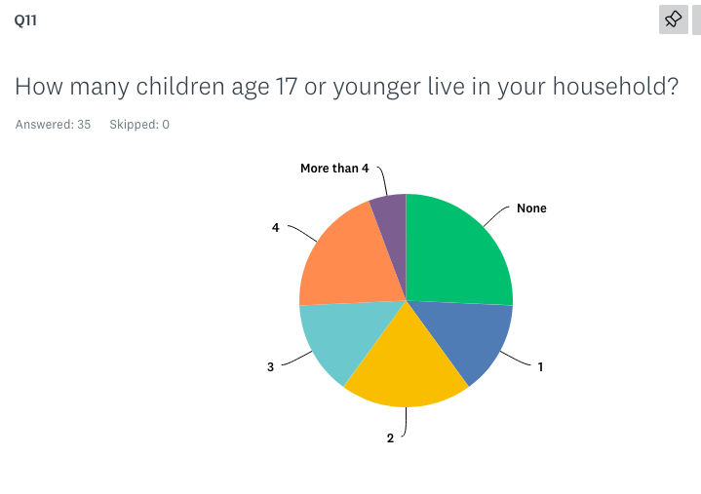

Majority have 1 or more children.

The writer received the 35 individual responses which is the data. It has been grouped together in the above pie charts turning them into quantitative data which has become information. This information has given the writer enough statistics to turn it into knowledge for promoting her products which are unique money gifting ideas. The writer’s products are personalised frames and money trees which will be advertised on social media platforms such as Facebook and Instagram. The target market will be to females of all ages in both Birmingham and London.

3. Conclusion

This paper has revealed the importance of data, information and knowledge in every aspect of our lives. These components are such assets nowadays that organisations are exploring ways in which they can gather data and information and turn it into knowledge. With this knowledge, organisations are in a better place to get their employees to share their experience through tacit and explicit knowledge. This inevitably will benefit the organisation with having more knowledgeable staff to carry out duties and even bring on innovation and wisdom.

4. Reference List

Baskarada and Koronios. (2013). Data, Information, Knowledge, Wisdom (DIKW): A Semiotic Theoretical and Empirical Exploration of the Hierarchy and its Quality Dimension. ‘Australasian Journal of Information Systems’. 18. 10.3127/ajis.v18i1.748. [online]. Available at:
https://www.researchgate.net/publication/279942958_Data_Information_Knowledge_Wisdom_DIKW_A_Semiotic_Theoretical_and_Empirical_Exploration_of_the_Hierarchy_and_its_Quality_Dimension
(Accessed 14 March 2020).

BBC Bitesize. (2020). Rakat - The Nature of God - GCSE Religious Studies Revision - WJEC - BBC Bitesize. [online] Available at:
https://www.bbc.co.uk/bitesize/guides/zcss7p3/revision/4
(Accessed 23 March 2020).

Berčič, B. and George, C. (2009). ‘Investigating the legal protection of data, information and knowledge under the EU data protection regime’, International Review of Law, Computers & Technology, 23(3), pp. 189–201. doi: 10.1080/13600860903262255. [online]. Available at:
https://web-a-ebscohost-com.ezproxy.uwtsd.ac.uk/ehost/detail/detail?vid=0&sid=53aae1ef-6f24-43ec-afba-73b82c05f9f3%40sdc-v-sessmgr01&bdata=JnNpdGU9ZWhvc3QtbGl2ZQ%3d%3d#AN=45141236&db=bth
(Accessed 14 March 2020).

Braganza, A. (2004). Rethinking the data–information–knowledge hierarchy: towards a case-based model. 2004. ‘International Journal of Information Management’, 24(4), pp. 347-356. [online]. Available at:
https://www-sciencedirect-com.ezproxy.uwtsd.ac.uk/science/article/pii/S0268401204000519
(Accessed 14 March 2020).

CIE. (2015). Cambridge International Examinations. ‘Topic 1.1 Data, Information and Knowledge’. p4. [online]. Available at:
https://www.cambridgeinternational.org/.../285017-data-information-and- knowledge.pdf
(Accessed 13 March 2020).

Ghazal, K. (2018). Physical benefits of (Salah) prayer - Strengthen the faith & fitness. Journal of Novel Physiotherapy and Rehabilitation, [online] pp.043-053. Available at: https://www.heighpubs.org/jnpr/jnpr-aid1020.php
(Accessed 22 March 2020).

Gillham, B. and Thompson, J. (1996). Child Safety: Problem and Prevention from Pre-School to Adolescence. A Handbook for Professionals. 1st ed. London: Routledge, p.6.

Gourlay, S. (2004). 'Tacit Knowledge': The Variety of Meanings in Empirical Research. SSRN Electronic Journal, [online] Available at: https://warwick.ac.uk/fac/soc/wbs/conf/olkc/archive/oklc5/papers/b-2_gourlay.pdf
(Accessed 22 March 2020).

Hüttenegger, G. (2004). Knowledge Management & Information Technology. München: GRIN-Verl., p.17.

Lee, E. (2012). 'Everything We Know Informs Everything We Do': A Vision for Historic Environment Sector Knowledge and Information Management. The Historic Environment: Policy & Practice, 3(1), pp. 28-41. [online]. Available at:
https://web-b-ebscohost-com.ezproxy.uwtsd.ac.uk/ehost/detail/detail?vid=1&sid=9ad6db34-ec8e-498c-8773-4e34eb0acf0d%40sessionmgr102&bdata=JnNpdGU9ZWhvc3QtbGl2ZQ%3d%3d#AN=78437886&db=asu
(Accessed 14 March 2020).

Liew, A. (2013) ‘DIKIW: Data, Information, Knowledge, Intelligence, Wisdom and their Interrelationships’, Business Management Dynamics, 2(10), pp. 49–62. [online]. Available at: https://search-ebscohost-com.ezproxy.uwtsd.ac.uk/login.aspx?direct=true&db=bth&AN=88271964&site=ehost-live (Accessed: 14 March 2020).

Lilley, S., Lightfoot, G., & N., P. (2004). Handling Knowledge Management ‘In Representing Organization’: Knowledge, Management and the Information Age: Oxford University Press. [online]. Available at:
https://www-oxfordscholarship-com.ezproxy.uwtsd.ac.uk/view/10.1093/acprof:oso/9780198775416.001.0001/acprof-9780198775416-chapter-
(Accessed 15 March 2020).

MacKenzie, M. and Foster, A. (2017) ‘Masculinity nostalgia: How war and occupation inspire a yearning for gender order’. Security Dialogue, 48(3), pp. 206–223. doi: 10.1177/0967010617696238. [online]. Available at:
https://journals-sagepub-com.ezproxy.uwtsd.ac.uk/doi/full/10.1177/0165551513501435#articleCitationDownloadContainer
(Accessed 9 March 2020).

Nonaka, Ikujiro, & Takeuchi, H. (1995). The Knowledge Creating Company. New York, New York, USA: Oxford University Press.

Polanyi, M. (1966). The Tacit Dimension. Garden City, New York: Doubleday

Sanchez, R. (2003). ‘Managing Knowledge into Competence: The Five Learning Cycles of the Competent Organization’. Knowledge Management and Organizational Competence. Oxford: Oxford University. [online]. Available at:
https://www-oxfordscholarship-com.ezproxy.uwtsd.ac.uk/view/10.1093/acprof:oso/9780199259281.001.0001/acprof-9780199259281-chapter-1iversity Press.
(Accessed 9 March 2020).
Tang, V., Yanine, F. and Valenzuela, L. (2016). Data, information, knowledge and intelligence. ‘International Journal of Innovation Science’, 8(3), pp. 199-216. [online]. Available at:
https://search-proquest-com.ezproxy.uwtsd.ac.uk/docview/2080863046?accountid=130472&rfr_id=info%3Axri%2Fsid%3Aprimo
(Accessed 14 March 2020).

Von Krogh G, Ichijo K, Nonaka I. (2000). Enabling knowledge creation: How to unlock the mystery of tacit knowledge and release the power of innovation. Oxford University Press, Oxford

Weinberger, D. (2010). The Problem with the Data-Information-Knowledge-Wisdom Hierarchy. ‘Harvard Business Review’. [online]. Available at:
https://hbr.org/2010/02/data-is-to-info-as-info-is-not
(Accessed 14 March 2020).

Zins, C. (2007) ‘Conceptual approaches for defining data, information, and knowledge’, Journal of the American Society for Information Science & Technology, 58(4), pp. 479-493. doi: 10.1002/asi.20508. [online]. Available at:
https://web-b-ebscohost-com.ezproxy.uwtsd.ac.uk/ehost/detail/detail?vid=0&sid=4535d402-aea7-404e-b3fc-fc2f107acf95%40sessionmgr103&bdata=JnNpdGU9ZWhvc3QtbGl2ZQ%3d%3d#AN=24169225&db=bth
(Accessed 14 March 2020).

KNOWLEDGE AND INFORMATION
MANAGEMENT
SKILLS FOR THE WORKPLACE

PART TWO
BMSK 5006

BUDDHI PATHAK

Table of contents

- Introduction…………………………………………………………………………... Page 3

Part 1 - Case study of American Airlines (AA) and IBM’s Semi-Automatic
Business Research Environment (SABRE)
- How SABRE incorporated cost leadership and product differentiation………...
to their organisation…………………………………………………………………. Page 4
2.1. How SABRE provided American Airlines with a competitive edge………. Page 6
2.2. Factors which caused the erosion of the organisation’s lead…………….. Page 7

Part 2 - Information Systems (IS)
- Definition of IS……………………………………………………………………….. Page 8
3.1. Categories of computer-based information systems………………………. Page 10
3.2. How computer-based IS can support managers…………………………… Page 11
4. Conclusion……………………………………………………………………………. Page 12
5. Reference List……………………………………………………………………….. Page 13

1. Introduction

Knowledge assets represent the foundation of the competence and skills of an organisation, which are considered central to its success, productivity and human development (Kamasak, Yucelen and Bulutlar 2009). In such fast moving times; it becomes imperative for organisations to look into how their corporate strategy will be guided by information that increases product and service efficiency and accelerates selling times to provide them with a competitive edge.

The study will contain two parts; the first will cover American Airlines (AA) and IBM’s joint adventure of developing the Semi-Automatic Business Research Environment (SABRE) software. The writer will be describing and analysing SABRE’s functionality, successes and downfalls by using Porter’s 5 Forces which was developed by Michael Porter in 1980. An argument will be put forward to claim AA are still the world leaders in the airline industry.

The second part will be based around discussing Information Systems (IS) and the importance of their vital position in promoting the operations of a corporation.

Part 1
2. How SABRE incorporated cost leadership and product differentiation to their organisation:

Cost leadership is when a business recognises and integrates all cost saving channels and strives to become a significant consumer of costs in the market which follows a policy of continuous cost control (Ifm.eng.cam.ac.uk. 2020). Following World War II, the airline industry saw a growth in air travel, but the airlines were struggling to handle the relationship between the inventory of airline companies and reservations of passengers. This led to many inaccuracies; flights being overbooked or under booked, customer service complaints and underused aircrafts.
Things needed to change, and it was only when a conversation sparked between the American Airline’s President and IBM’s Senior Sales Representative that ideas came about. The brainwave of inventing a data management device (SABRE) capable of establishing and handling airline reservations for seats and having that accessible to every employee at all locations electronically was born (Sabre.com, 2020, p3). AA serve thousands of customers every minute, be it passengers or agents by allowing reservations to be booked through their technology. SABRE improved the profitability of AA and equipped the business with a number of great advantages: AA were processing hand-written bookings, Scheier (2002) states “a round-trip reservation between New York and Buffalo required the efforts of 12 people, at least 15 procedural steps and up to three hours”. Therefore, building this pioneering system would inevitably cut costs by thousands if not millions, Travel Agents were able to look for the cheapest fares and book flights and accommodation for the passengers instead. Price reduction ensured that AA were able to cut excessive costs and supply its passengers with the same facilities as most carriers but at a cheaper price to provide a greater discount for the product provided. In order for AA to obtain cost leadership in the airline industry, they needed to obtain information on how many seats could be sold to maximise the yield on any given flight, which required complex computer calculations. Hence, introducing SABRE would play a key role as this system would be able to track passengers on any seat and any distance at any time. Thus, being able to offer discounted fares through SABRE’s advanced capabilities (Hill and Jones, 2008). The incorporation of Porter’s cost leadership was met as SABRE allowed AA and IBM to reduce their fare costs, retain their travellers and ultimately reduced the threat of substitute products on the market. AA seemed to be reaching ultimate heights after discovering that by just eliminating one olive from their passenger’s salad plate would reduce their expense by $40,000! (Vetter 2015).

Product differentiation is an enterprise strategy which refers to the production of a particular product targeted to different customer groups (Billig and Cook, 2017). Airlines tend to pursue a differentiated strategy offering a variety of facilities, some for cost-conscious consumers (for example, coach fares) and others for first-class passengers. A superior product differentiation was created by AA and IBM by offering Travel Agents to use their SABRE automated terminals to make bookings instead of consumers directly going via the Airlines. Hopper (1990) described SABRE as transforming marketing and distribution in the airline industry. SABRE was a much needed system that was unique and indeed met customer’s needs, Porter (1985, p9) describes product differentiation as, “A firm can distinguish itself better from its rivals by meeting the buyer's needs.

2.1. How SABRE provided American Airlines with a competitive edge:

Competitive advantage is namely; ‘cost leadership’ and ‘product differentiation’. Porter (1985) states that competitive advantage as: “the choice of competitive scope or the range of a firm's activities, can play a powerful role in determining competitive advantage”. SABRE provided AA with a competitive edge through their yield management system as they were able to offer a variety of discounted fares using projections based on past experience. It allowed to undercut or match the cheaper fares offered by competitors, simply by discounting some seats and keeping others more expensive. The flexibility in SABRE’s technology was unable to be matched by other airlines and AA managed to retain its leadership position for decades (Hill and Jones, 2008). AA managed to implement Porter’s ‘entry barriers’ by innovating a new product that was such a significant breakthrough for the airline industry. Porter (1985, p7) describes this as “a new product idea that reduces barriers to entry”. This is also known as first mover advantage whereby a firm has the ability to gain early entry into a new market (Sammut-Bonnici and Channon 2015). Porter’s capital requirements under entry barriers also shows AA had a competitive advantage over other airlines because several hundred million dollars are involved with designing, maintaining, updating, and upgrading these programmes (Gupta, 1992). Interestingly, the same author states because of very few airlines being able to compete with AA’s technology, they agreed to subscribe to this system by allowing SABRE to link to their own system and paying a fee. SABRE’s website affirms the technology development cost nearly $40 million resulting in a cutting-edge mainframe programme that managed 84,000 transactions a day (Sabre.com, 2020, p4). Furthermore, the writer believes that Porter’s ‘brand identity’ under entry barrier played a significant role to AA and IBM. Their recognisable brands may have had an impact in terms of consumer preference which would have resulted in an entry barrier for competitors.

2.2. Factors which caused the erosion of the organisation’s lead

The writer believes that AA no longer maintain a competitive advantage in the airline industry.

American Airlines tried to maintain their competitive edge by venturing out further by introducing SABRE into hotels, rail companies and rental car companies (Khosrowpour, 2003). SABRE became an immense competitive advantage for AA, so much so, that it compelled every other airline to develop their own booking network (Ibm.com, 2020). The irony of this statement by IBM suggests that they caused their own downfall. By introducing this unique and much needed technology, it almost inevitably compelled other airlines to follow their trait in order to keep up with competitiveness in the industry. And so, others surely followed, United Airlines’ Apollo system was their biggest rival who reduced SABRE’s market share to just 40% of computerised booking systems (Khosrowpour, 2003). This suggests that AA were experiencing their first decline in competitive edge.
The second problem appeared to have happened following The Airline Deregulation Act of 1978 which changed the aviation industry. This Act deregulated passenger’s fares and services unleashing much upheaval and adjustments deeming industries to become increasingly uncontrolled from a safe and controlled business environment (Peterson, 2018, p10). According to Ibm.com (2020) obstacles came about whereby passengers were not only searching for seats available, but for seats available at the cheapest price. Peterson (2018, p13) continues saying the deregulation opened up further possibilities for alternative market models for airlines, some of which were successful whilst others struggled. F. Warren McFarlan’s prominent HBR report on the strategic value of information technology in 1984 asked questions such as; “Could technology build barriers to competitive entry? Could it increase switching costs for customers? Max Hopper who became a director of SABRE in 1972, interestingly stated that upon reading this article, many companies would answer yes but he was of the opinion that the answer would be no. He went on to say that although denying the power of information technology is risky than ever, it is even riskier to believe that an information system alone will deliver a permanent market advantage because it is only the latest ones that are valid. The writer believes this statement to be true because there will always be newer and more advanced technologies to emerge. A third factor causing erosion in AA’s lead in the industry may have been caused by several competitors filing lawsuits against them; claiming that AA had an unfair advantage of their flights being listed first on the systems. The writer believes that these publicities will inevitably cause lack in trust in the AA and their credibility.

Figure 1 - Amadeus's Competitors, Revenue, Number of Employees, Funding and Acquisitions, Owler.com, 2020.

Although SABRE were once the airline warriors and the first mover in their invention, they have now sadly decreased in ranks due to many factors. The above chart shows they are still operating but unfortunately no longer hold their competitive edge. SABRE’s director quoted, “America’s Airline system has greatly deteriorated. Our airlines, once world leaders, are now laggards in every category, including fleet age, service quality, and international reputation.

3. Information Systems

Part 2
Definition of an Information System (IS)
Information Systems (IS) comprise of a wide range of Information Technologies (IT) for example software, computers, communication systems, databases, mobile devices, the internet and many more. When one talks about IS, it can get quite confusing as many people could interpret it as anything to do with IT. According to Boell and Cecez-Kecmanovic (2015), IS researchers have used the word "system" or "systems" to refer to anything which involves electronic IT. They go on to state that such usage of the terms makes both of the meanings indistinctive. In reality, they are two separate routes which attract different skills and disciplines (Ashford.edu, 2018). Therefore, if the meanings are not made distinguishable, people will be unaware of the meanings. If researchers are not sure what they mean when documenting about IS, contrasting study findings and building on the experience of each other contributing to the practises of quantitative analysis would prove difficult (Boell and Cecez-Kecmanovic, 2015).

Figure 2 - Information System

The aim of an information system is to translate raw information into usable knowledge and have the best resources for corporate decision such as forecasting, monitoring and planning (Al-Mamary, Shamsuddin and Aziati, 2014). IS covers the entire range of knowledge, in particular the technical dimension of the IT framework.

3.1. Categories of Computer Based Information Systems (CBIS)

- Hardware: these consist of computer equipment able to perform input, processing and output activities such as a processor, monitor, keyboard and a printer.
An example of this may be at a GP surgery. The GP is able to input your details on to the computer processor, once your details and medical records are bought up on the screen, they are able to order your medication and print off a prescription.
- Software: are computer programmes or system that helps hardware to process data.
Payroll processing, the software allows an employee to input the salary details and hours worked. The software is then able to calculate and deduct any amounts automatically and also send out reminders to employers when necessary forms need completing for tax purposes.
- Database: a usually large collection of data organised especially for rapid search and retrieval as by a computer (Merriam-webster.com, 2018).
A school will have a database of all the pupils with their name, address and contact details.
- People: It is the people who actually use the hardware and software to run a programme and maintain it to achieve an output.
These would include a data entry clerk, a computer programmer or a technical analyst.
- Telecommunications: These are communication signals that allow organisations to execute their processes and tasks via a computer network.
Co-workers are able to share graphs and reports via their intranets or the internet which connect them through networks.
- Procedures: these are the instructions, strategies, policies, methods and rules for using computer based information systems (Bhavin and Kishan 2016).
These could be manuals, company procedures, training etc.

3.2. How Computer Based IS can support managers

Figure 3 - Different types of decision making by Managers

Transaction Processing Systems (TPS) is an information system devised to handle the day-to-day business events at an operational level of an organisation. Operational Managers use TPS systems to generate data for example reports, recording how many workers where present and how many hours they worked on any given day.
Management Information Systems (MIS) is a computerised financial information database, which is structured and configured in such a way that information is collected e.g. daily operating reports can be generated at management levels of an organisation (Inc.com, 2018). Management at this level take the data (from TPS) level but there is a lot of data to compile as its usually from several departments at the operational level. These can be several types of reports e.g. budget reports, inventory control, personnel which are merged and put into final reports to be sent to the final level of management.
Executive Information Systems (EIS) take the compiled data from the lower two levels (TPS & MIS) and are seen to be a decision support framework that may be viewed as the knowledge base that senior management utilise. It allows expertise to be developed and shared with the organisation. This level tries to gain a competitive advantage to the organisation, aims to be a leader and looks at the long-term aspects of the organisation. This may be achieved through external events, inventing new products and keeping up a step ahead of their competitors.
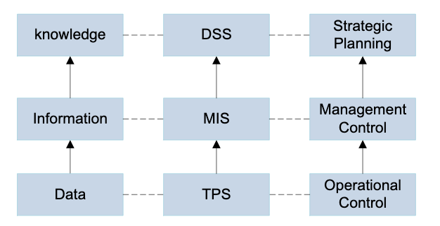
EIS
Figure 4 - TPS/MIS/EIS framework, Zhang, 2013.

- Conclusion

This paper covered American Airline and IBM’s joint venture of introducing SABRE; the ground-breaking first airline reservation technological system which made way for a new way to introduce reservations from all parts of the world via technology. Although they were and are still known today for the competitive advantage they held for SABRE, it did not take long for other competitors to overtake their ranking. Technology is somewhat growing like we all do with age and there is always going to be something bigger and better that comes along. The current leaders in the airline industry are on top now but the question is how long until something bigger comes along to take their place? Could holding a competitive advantage be a temporary thing? However it may be, the writer believes that organisations should continue to look for ways in being different and holding that competitive edge. They must persevere and bring about innovations that will assist them in ultimately being successful.

- Reference List

Al-Mamary, Y., Shamsuddin, A. and Aziati, N. (2014). The Role of Different Types of Information Systems in Business Organizations: A Review. International Journal of Research. pp1279-1286. [online]. Available at:

Ashford.edu. (2018). Information Technology Vs. Information Systems: Which Degree Is Right for Me? - Ashford University. [online] Available at:
https://www.ashford.edu/online-degrees/information-technology/information-technology-vs-information-systems-which-degree-is-right-for-me
(Accessed 1 April 2020).

BBC Bitesize. 2020. Information System and Purpose - Purpose, Functionality and Users - Higher Computing Science Revision - BBC Bitesize. [online] Available at: https://www.bbc.co.uk/bitesize/guides/z8xpsbk/revision/1
(Accessed 1 April 2020).

Bhavin, G. and Kishan, A. (2016). Share and Discover Knowledge on LinkedIn SlideShare. [online]. Available at: https://www.slideshare.net/kishnaalagiya/cbis-56786386
(Accessed 1 April 2020).

Billig, B. and Cook, G.N. (2017). Airline Operations and Management: A Management Textbook. Routledge. [online]. Available at: https://books.google.co.uk/books?id=6cgNDgAAQBAJ&pg=PT221&lpg=PT221&dq=product+differentiation+in+American+Airlines+SABRE+story&source=bl&ots=8BNWtUtOH5&sig=ACfU3U3f0nHqRp5d0OXm-mMHzFaIzjjqNA&hl=en&sa=X&ved=2ahUKEwjelpydy8DoAhVMe8AKHaidBmkQ6AEwDXoECAgQAQ#v=onepage&q=differentiation&f=falsee].
(Accessed 28 March 2020).

Boell, B. and Cecez-Kecmanovic, D.(2015). What is an Information System?. In: 48th Hawaiian International Conference on System Sciences (HICSS). [online] Available at: https://www.researchgate.net/publication/271588444_What_is_an_Information_System (Accessed 31 March 2020).

Gupta, R. (1992). Information Systems Technology as a Strategic Resource in Strategic Planning for a Small Business. Journal of Small Business & Entrepreneurship, 9(2), pp. 48-56. [online]. Available at:
https://books.google.co.uk/books?id=LcdR7YDBlvEC&pg=PA49&lpg=PA49&dq=porters+%22entry%22+barriers+SABRE&source=bl&ots=42JThydxOn&sig=ACfU3U0nIGK-AFaVNA7iifiYG2g4M5GO2w&hl=en&sa=X&ved=2ahUKEwiUycGkqsHoAhXHVsAKHd3GBT4Q6AEwAXoECAsQAQ#v=onepage&q=porters%20%22entry%22%20barriers%20SABRE&f=ffals
(Accessed 30 March 2020).

Hill, C. and Jones, G. (2008). Strategic Management: An Integrated Approach. 10th ed. Mason: South-Western, p.229. [online]. Available at:
https://books.google.co.uk/books?id=Xax9awcoiDsC&pg=SL3-PA229&lpg=SL3-PA229&dq=Cost+leadership+American+Airlines+SABRE&source=bl&ots=zuq8B8XVGx&sig=ACfU3U2jvEGbA6SrFHi_0JAZ9z8_jvOHoA&hl=en&sa=X&ved=2ahUKEwjMq6fn1L7oAhXfQkEAHeeGB4sQ6AEwDnoECAgQAQ#v=onepage&q=Cost%20leadership%20American%20Airlines%20SABRE&f=false
(Accessed 28 March 2020).

Hopper, M. D. (1990). ‘Rattling SABRE - New Ways to Compete on Information’, Harvard Business Review, 68(3), pp. 118-125. Available at:
https://search-ebscohost-com.ezproxy.uwtsd.ac.uk/login.aspx?direct=true&db=bth&AN=9006181438&site=ehost-live
(Accessed 29 March 2020).

Ibm.com. (2020). IBM100 - Sabre. [online] Available at: https://www.ibm.com/ibm/history/ibm100/us/en/icons/sabre/
(Accessed 31 March 2020).

Ifm.eng.cam.ac.uk. (2020). Porter's Generic Competitive Strategies (Ways of Competing). [online] Available at:
https://www.ifm.eng.cam.ac.uk/research/dstools/porters-generic-competitive-strategies/
(Accessed 28 March 2020).

Inc.com. (2018). Management Information Systems (MIS). [online] Available at: https://www.inc.com/encyclopedia/management-information-systems-mis.html.
(Accessed 1 April 2020).
Kamasak, R., Yucelen, M. and Bulutlar, F. (2009). Knowledge assets and their influence on the development of organizational strategies. In: 7th International Knowledge. [online]. Yalova: Economy and Management Congress, pp.1977-1984. Available at: https://www.researchgate.net/publication/294260169_KNOWLEDGE_ASSET_MANAGEMENT_KNOWLEDGE_ASSETS_AND_THEIR_INFLUENCE_ON_THE_DEVELOPMENT_OF_ORGANIZATIONAL_STRATEGIES
(Accessed 26 March 2020).

Khosrowpour, M. (2003). Information Technology and Organizations: Trends, Issues, Challenges and Solutions. 1st ed. Harrisburg, PA: Idea Group Inc. p.616. [online]. Available at:
https://books.google.co.uk/books?id=RGXEoPkZVacC&pg=PA616&lpg=PA616&dq=what+happened+to+American+Airlines+SABRE+after+1980&source=bl&ots=gyxCoFUyu6&sig=ACfU3U0q_8wp3sQWPtUMTdTHM9sSDQVeRA&hl=en&sa=X&ved=2ahUKEwjXlLKN2sfoAhWKecAKHVnSBrIQ6AEwD3oECA0QNw#v=onepage&q=what%20happened%20to%20American%20Airlines%20SABRE%20after%201980&f=false
(Accessed 31 March 2020).

Merriam-webster.com. (2018). Definition of DATABASE. [online]. Available at: https://www.merriam-webster.com/dictionary/database.
(Accessed 1 April 2020).
‌
Owler. (2020). Amadeus's Competitors, Revenue, Number of Employees, Funding and Acquisitions. [online] Available at:
https://www.owler.com/company/amadeus
(Accessed 31 March 2020).

Peterson, R. (2018). Impacts of Airline Deregulation. TRS News 315, p.10. [online]. Available at:
http://onlinepubs.trb.org/onlinepubs/trnews/trnews315airlinedereg.pdf
(Accessed 31 March 2020).

Porter, M. (1985). Competitive Advantage: Creating and Sustaining Superior Performance. New York: Free Press, p3. [online]. Available at:
https://www.albany.edu/~gs149266/Porter%20(1985)%20-%20chapter%201.pdf
(Accessed 29 March 2020).

Porter, M. (2008). Competitive Strategy: Techniques for Analysing Industries and Competitors. Simon and Schuster. [online]. Available at:
https://books.google.co.uk/books?hl=en&lr=&id=Hn1kNE0OcGsC&oi=fnd&pg=PT5&dq=related:9LjhfKxuxet9QM:scholar.google.com/&ots=KKETohgdIP&sig=3wM_X7v9Vo3bZDJ0WxYffTYy6pw&redir_esc=y#v=onepage&q=competitive%20advantage&f=false
(Accessed 29 March 2020).

Sabre.com. (2020). The Sabre Story - A Chance Meeting on An Airline Flight That Turned Into The Technology Leader For The Travel Industry. [online] Available at: https://www.sabre.com/files/Sabre-History.pdf
[Accessed 30 March 2020].

Sammut-Bonnici, T. and Channon, D. (2015). Wiley Encyclopaedia of Management. In: First Mover Advantage. [online] John Wiley & Sons Ltd. Available at: https://www.researchgate.net/profile/Tanya_Sammut-Bonnici/publication/313967223_First_Mover_Advantage/links/5a6072a045851517c7ad5ccc/FiFir-Mover-Advantage.pdf0).

Scheier, R. L. (2002) ‘Technology TAKES FLIGHT’, Computerworld, 36(40), p. 34. Available at: https://search-ebscohost-com.ezproxy.uwtsd.ac.uk/login.aspx?direct=true&db=bth&AN=7530060&site=ehost-live (Accessed 29 March 2020).

Vetter, M. (2015). The $40,000 Olive: How Entrepreneurs Can Spend Time Saving Money. [online] Forbes. Available at:
https://www.forbes.com/sites/moiravetter/2015/06/04/the-40000-olive-how-entrepreneurs-can-spend-time-saving-money/
(Accessed 29 March 2020).

Warren McFarlane, F. (1984). Information Technology Changes the Way You Compete. [online] Harvard Business Review. Available at:
https://hbr.org/1984/05/information-technology-changes-the-way-you-compete
(Accessed 31 March 2020).

Zhang, X, J. (2013). ‘The Evolution of Management Information Systems: A Literature Review’, Journal of Integrated Design & Process Science, 17(2), pp. 59–88. doi: 10.3233/jid-2013-0009. [online]. Available at:
https://web-b-ebscohost-com.ezproxy.uwtsd.ac.uk/ehost/pdfviewer/pdfviewer?vid=1&sid=7efcf7f4-eb15-42e4-9061-c76dd101a3ed%40pdc-v-sessmgr06
(Accessed 1 April 2020).

