
Master of Business Administration
Word Count:2808
Student Name- Harshkumar Manojkumar Patel
Student ID- 2503790
Lecturer Name- Dr. Jia Miao
Dissertation Proposal
LCMB7035

Topic: Evaluating the Role of Clubcard Personalisation in Improving Customer Loyalty in the UK Supermarket Industry
Table of Contents
1. Title 3
2. Introduction / Background / Research Problem 3
3. Research aim, objectives, questions 4
4. Preliminary literature search 5
4.1 Introduction 5
4.2 Customer Loyalty in the UK Supermarket Industry 6
4.3 Personalisation in Retail Loyalty Programmes 7
4.4 Role of Clubcard Personalisation in Customer Loyalty 8
4.5 Theoretical Framework 9
4.6 Research Gap 10
5. Research methodology 10
5.1 Research Design 10
5.2 Data Collection and Analysis 12
5.3 Ethical Consideration 13
5.4 Limitation 13
6. Risks 13
7. Timeline 14
Reference List 15

1. Title
Evaluating the Role of Clubcard Personalisation in Improving Customer Loyalty in the UK Supermarket Industry

2. Introduction / Background / Research Problem
The UK supermarket market is a highly competitive retail business that can be defined by a high level of competition between well-established retailers, including Tesco, Sainsbury and others. Despite Tesco still maintaining the largest market share in the UK grocery market, the market positions of discount retailers have been reinforced through their lower prices and value-based propositions, which have created pressure on the industry as a whole (Meng, 2024). As a result, supermarkets are increasingly becoming differentiated with customer relationship strategies as opposed to price competition. The report by Watty (2025) shows that the market share of major grocery retailers in the UK is comparatively high, which depicts the competitiveness in the industry.
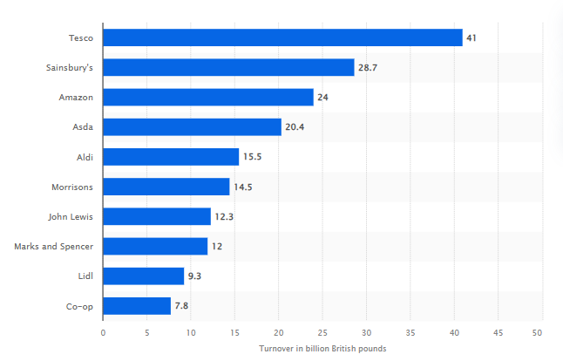
Figure 1: Market share of leading UK retailers
(Source: Watty, 2025)
Loyalty programmes have thus turned out to be a significant strategic asset in enhancing customer retention and eliciting repeat purchases. According to Patel and Swamy (2023), the use of loyalty schemes by consumers in the UK is widespread, Tesco Clubcard and Sainsbury's Nectar being the most well-known and most commonly used schemes. The popularity of loyalty programmes in the UK demonstrates the increasing importance of loyalty-based marketing.
Problem Statement
This development of loyalty programmes has moved away from the old system of point-based rewards to a more personalised marketing where customer buying information is used to provide customers with discounts, product recommendations and offers. This change will allow retailers to improve customer interaction through more relevant shopping experiences. Yet, existing studies have given both positive and negative results on whether personalised loyalty programs result in sustainable customer loyalty or are simply a way to stimulate short-term buying behaviour. Additionally, the literature mainly examines loyalty programmes or personalisation in isolation, and there is limited data on how Clubcard personalisation can lead to customer loyalty in the UK supermarket industry as a whole.
Thus, this study fills this gap by determining the effectiveness of Clubcard personalisation in enhancing customer loyalty in the UK supermarket industry with a specific focus on Tesco and Sainsbury. In order to provide a in-depth understanding of the ways personalisation strategies impact customer loyalty across the UK supermarket sector. These findings are anticipated to add to the knowledge of personalised loyalty strategies, besides offering a practical input to the retailers who are keen on enhancing long-lasting customer relationships in the ever-changing competitive market.

3. Research aim, objectives, questions
Aim
The research aims to assess the role of Clubcard personalisation in improving
customer loyalty in the UK Supermarket Industry, with a focus on the comparison between Tesco Clubcard and Sainsbury's Nectar.
Objectives
- To analyse the role of personalised loyalty programmes in enhancing customer loyalty within the UK supermarket industry.
- To compare the personalised features of Tesco Clubcard and Sainsbury's Nectar and evaluate their contribution to customer loyalty.
- To examine the connection between Customer loyalty and Clubcard personalisation in the UK supermarket industry.
- To propose measures to enhance customer loyalty within the UK supermarket sector with regards to Clubcard personalisation.
Questions
- How can personalised loyalty programmes improve customer loyalty in the UK supermarket industry?
- How do the personalised features of Tesco Clubcard and Sainsbury's Nectar contribute to customer loyalty?
- What is the connection between customer loyalty and Clubcard personalisation in the UK supermarket industry?
- How can we enhance the personalisation of Clubcard to enhance customer loyalty within the UK supermarket sector?

4. Preliminary literature search

4.1 Introduction
This literature review critically analyses the available literature on customer loyalty, personalised loyalty programmes and Clubcard in the UK supermarket industry. It assesses the main theories and empirical evidence, finds inconsistencies and research gaps, and determines the rationale behind exploring the role of Clubcard personalisation in enhancing customer loyalty.

4.2 Customer Loyalty in the UK Supermarket Industry
Customer loyalty is commonly accepted to be a strategic asset within the supermarket business as it leads to repeat purchases and positive word-of-mouth, as well as long-term profitability. Competition in the UK grocery market is very high, and retailers are gaining more and more dependence on loyalty programmes to retain customer loyalty instead of competing by price alone. In 2022/2023, Tesco made annual sales of about £41 billion, with the Big Four of UK supermarkets (Tesco, Sainsbury's, Asda and Morrisons) controlling over 60% of the grocery retail market in the country (Comarch, 2024). This shows the increasing role of loyalty programs in determining consumer shopping behaviour.
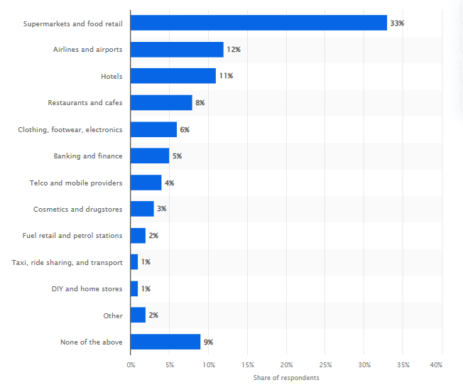
Figure 2: Global loyalty programs participation
(Source: Comarch, 2024)
Earlier research has shown divergent opinions on customer loyalty drivers. As opined by Coyle and Gamberi (2024), loyalty involves cognitive, affective, and behavioural steps, and thus the long-term relationship does not just stop at a repetitive purchase. On the same note, a study conducted by Paavola et al. (2024) established that customer loyalty is greatly enhanced by service quality, trust and store experience. Nonetheless, Wolniak et al. (2024) contradicted that traditional loyalty cards are mostly used to stimulate transactional buying behaviour as opposed to emotional commitment. Similarly, research on grocery loyalty schemes has shown that customers tend to enrol in schemes due to the price discount, as well as reward, and other factors like privacy issues, shopping pleasure, and perceived worth still play a role in influencing the participation (Theeb et al., 2023). Therefore, the current body of literature proposes that though loyalty programmes are effective in retaining customers, they should bring value other than the monetary reward, which implies the necessity to explore whether customer loyalty is stronger and more durable when based on personalised loyalty strategies.

4.3 Personalisation in Retail Loyalty Programmes
The retail loyalty programmes have matured beyond the normal reward programs to personalised marketing using data to offer customised discounts, personalised product recommendations and promotional offers based on the buying behaviour of the customers. Researchers claim that personalisation has been proven to increase cognitive and emotional customer experiences, which results in increased customer loyalty. On the same note, Febriyanti and Tuti (2023) recognise personalisation as one of the customer relationship management techniques that enhance customer involvement and value perception. Nevertheless, the success of personalised loyalty programmes is controversial. This study by Singh et al. (2023) discovered that personalised price promotions tend to be more effective in boosting purchases than non-personalised promotions, but again, the effectiveness of promotions differs depending on the way of targeting and the characteristics of the consumer. Moreover, YouGov (2024) found that loyalty programmes affect behavioural loyalty more than attitudinal loyalty, implying that repeat purchases do not always reflect a true commitment. These conflicting results suggest that although personalisation can enhance customer loyalty, its success depends on its application and perceptions of customers, which warrants further research in the context of supermarket loyalty programmes, especially Clubcard.
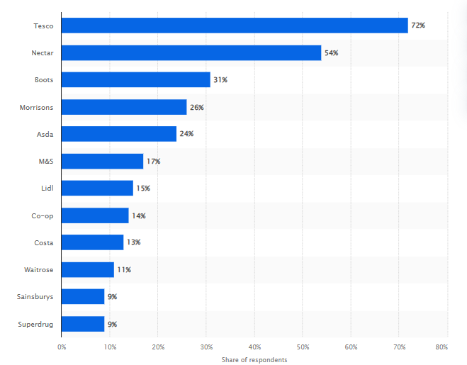
Figure 3: Best-known supermarket loyalty programs in the UK
(Source: YouGov, 2024)

4.4 Role of Clubcard Personalisation in Customer Loyalty
As stated by Xu and Hu (2022), Clubcard is commonly considered to be one of the most successful data-driven loyalty programmes, in which the purchase history of customers is used to provide them with personalised discounts, vouchers and product recommendations. In addition to Tesco Clubcard, other schemes, including Sainsbury Nectar utilise customer purchase information to offer personalised discounts and promotional messages. Nevertheless, Tesco Clubcard and Sainsbury's Nectar are generally considered to be the standard of retail personalisation as it has been using customer analytics since the time to provide customers with the relevant offers and improve the shopping experience. Relying on this, Clubcard generates customer value by building long-term relationships via personalised communication, as opposed to only rewarding transactions. However, Rane et al. (2023) believe that loyalty cannot be explained by individualised rewards only, as price competitiveness, convenience and service quality remain factors that can impact the choice of supermarkets. Thus, assessing personalisation of Clubcard in the context of the greater UK supermarket sector offers a suitable framework of understanding how personalised loyalty programmes help to build customer loyalty whilst tackling a larger industry issue.

4.5 Theoretical Framework
This research will use Relationship Marketing Theory and the Social Exchange Theory to describe the role of customer loyalty in the context of customer personalisation with Clubcard.
Relationship Marketing Theory
According to Relationship Marketing Theory, organisations build long-term customer relationships based on trust, commitment and continuous value creation as opposed to single transactions. In the retail industry, individualised rewards, customised offers and relevance reinforce customer interaction and stimulate repeat buying as they help to nurture relationships. However, Pfajfar et al. (2022) believe that relationship marketing may not be sufficient to explain customer loyalty since there are external forces like price competition and convenience that also play a role in the purchasing decision.
Social Exchange Theory
Social Exchange Theory adds to this point of view by proposing that customers will sustain relationships when they perceive the benefits of a relationship to be greater than the costs (Ahmad et al., 2023). Personalised discounts, exclusive rewards and shopping convenience are advantages of the supermarket loyalty programmes, and privacy and data sharing are the possible costs. This means that customers will feel more attached when the value obtained surpasses these fears. These theories will assist in the overall understanding of the role played by Clubcard personalisation towards customer loyalty in the UK supermarket industry.

4.6 Research Gap
The literature available suggests that customer retention and engagement in the retail environment are positively affected by the existence of loyalty programmes and personalised marketing. Nonetheless, the earlier researchers tend to analyse the loyalty programmes or personalisation as distinct entities, and there is little interwoven of the role of Clubcard personalisation as a factor in customer loyalty within the UK supermarket sector. Moreover, current studies are highly oriented on purchase behaviour, customer satisfaction or customer loyalty programme adoption, but offer few details on the efficacy of personalised loyalty features in promoting long-term customer loyalty. As a result, the current literature still has a gap that can be fulfilled via empirical studies that can assess the impact of Clubcard personalisation on customer loyalty in the competitive UK supermarket market.

5. Research methodology

5.1 Research Design
This paper uses the Research Onion by Saunders et al. to offer a systematic approach to the design of the research methodology.
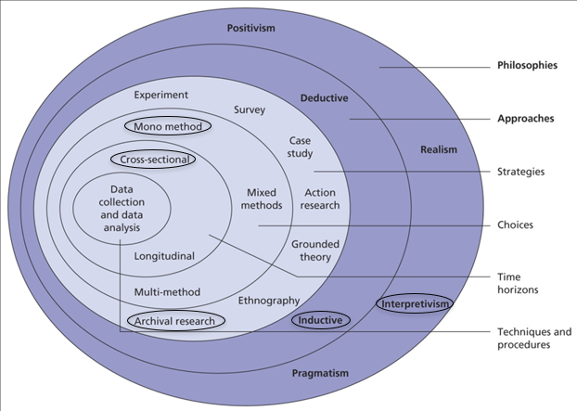
Figure 4: Research Onion
(Source: Saunders et al., 2023)
The interpretivist philosophy that can be used in the research is justified since the study aims to interpret and critically analyse the available evidence on the role of personalisation of the Clubcard in enhancing customer loyalty in the UK supermarket industry. Instead of testing numerical relationships, interpretivism allows one to gain a more in-depth insight into the opinions and discoveries that were made in earlier studies (Firdaus et al., 2021).
An inductive research approach will be utilised, which means the patterns and themes will be outlined based on the literature reviewed rather than by means of testing the predefined hypotheses. This method can be used to synthesise the existing knowledge and extract common themes with regards to personalised loyalty programmes and customer loyalty. The research uses the strategy of an archival strategy because it systematically examines the available documentary evidence in the form of peer-reviewed literature, industry reports, and organisational publications to answer the research objectives (Saunders et al., 2023).
The research is based on a mono-method qualitative research option that will obtain Data through secondary research sources only, where the researcher will draw secondary data only from published sources of information such as academic books, peer-reviewed journal articles, industry reports, Statista datasets, government publications and company reports. These secondary sources offer detailed and reliable evidence on loyalty programmes, personalisation strategies, and customer loyalty in the UK supermarket industry.
The study is cross-sectional because it examines the current literature and evidence of the industry at the time the study was done and does not look at how this has changed over time. As a result, the Research Onion by Saunders et al. offers a logical methodological framework that corresponds to the objective of the study when the authors are going to assess the Clubcard personalisation on the basis of the available academic and industry evidence.

5.2 Data Collection and Analysis
This research uses a Systematic Literature Review (SLR), which is a transparent and rigorous method of collecting secondary qualitative data. To reduce selection bias and maximise research reliability, the SLR adheres to a systematic approach of identifying, screening, selecting and reviewing relevant literature (Mishra and Alok, 2022). Using a secondary qualitative approach through a SLR is appropriate as it enables a comprehensive and unbiased synthesis of existing evidence related to Tesco Clubcard, Sainsbury's Nectar and customer loyalty. It strongly addresses the research objectives by comparing existing data and identifying themes, trends and knowledge gaps regardless of time and resource extensiveness of primary data collection.

Data Source
Peer-reviewed journal articles, which are indexed in databases like Scopus, Wiley Online Library, ScienceDirect and Google Scholar, will be used to gather data in addition to industry reports, Statista publications, government reports and company documents related to the UK supermarket industry with a focus on Tesco Clubcard and Sainsbury's Nectar.
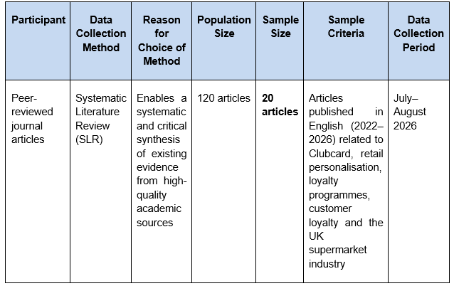
The inclusion criteria will include English-language publications published in 2022-2026 that discuss loyalty programmes, personalisation, customer loyalty and Clubcard in the context of Tesco Clubcard and Sainsbury's Nectar. Irrelevant, non-peer-reviewed and duplicated studies will be eliminated to ensure the quality and credibility of the evidence.
The six-phase thematic analysis of Braun and Clarke (2006) will be used to analyse the collected data. First, the chosen literature will be carefully revised to ensure data familiarisation and then systematic coding of the findings will be carried out. The similar codes will then be clustered into larger themes that will be analysed, edited and made precise to give uniformity (Braun and Clarke, 2022). Comparative themes between Tesco Clubcard and Sainsbury's Nectar will be identified during thematic analysis. Lastly, the themes identified will be analysed in connection with the research aim and objectives and will allow conducting a thorough analysis of how Clubcard personalisation can enhance customer loyalty in the UK supermarket industry.

5.3 Ethical Consideration
As this research is solely secondary research, it has no human subjects and no personal data would be collected; thus, the ethical risks are minimal. Credible and publicly available sources, such as peer-reviewed journal articles, industry reports, government publications and company documents, will be used to uphold ethical standards (Drolet et al., 2023). Every reference will be duly credited and cited with the necessary Harvard reference style in order to prevent plagiarism and protect intellectual property rights. Moreover, the researcher will make sure that an objectively and critically interpreted literature is not misrepresented or falsified, ensuring the academic integrity, transparency and the overall credibility of the research.

5.4 Limitation
The research is limited to secondary qualitative data, which might not give a comprehensive picture of consumer perceptions or behaviours that are present. The results are limited to the accessibility and quality of available literature and industry reports, which could restrict the chance to gain first-hand data and determine causal connections between the personalisation of Clubcard and customer loyalty.

6. Risks
The research can be threatened by such factors as the lack of access to high-quality academic databases and the recent literature on the topic of Clubcard personalisation. Publication bias is also a possibility, with any existing study having a tendency to report only positive results. The study will involve various credible databases, an inclusion and exclusion criterion, and a critical analysis of evidence offered by various academic and industry sources to reduce these risks.

7. Timeline
The project will be a 63-day project, between 13 July and 6 October 2026. The first phase is concerned with the research planning, such as the definition of the topic and the proposal preparation, the development of the methodology and ethical approval. This is then followed by a systematic literature review, which entails database search, study screening, quality appraisal and data collection. The results will then be synthesised and the dissertation written, revised and edited according to the feedback of the supervisor. The last step involves formatting, proofreading and handing the completed dissertation within the due date.
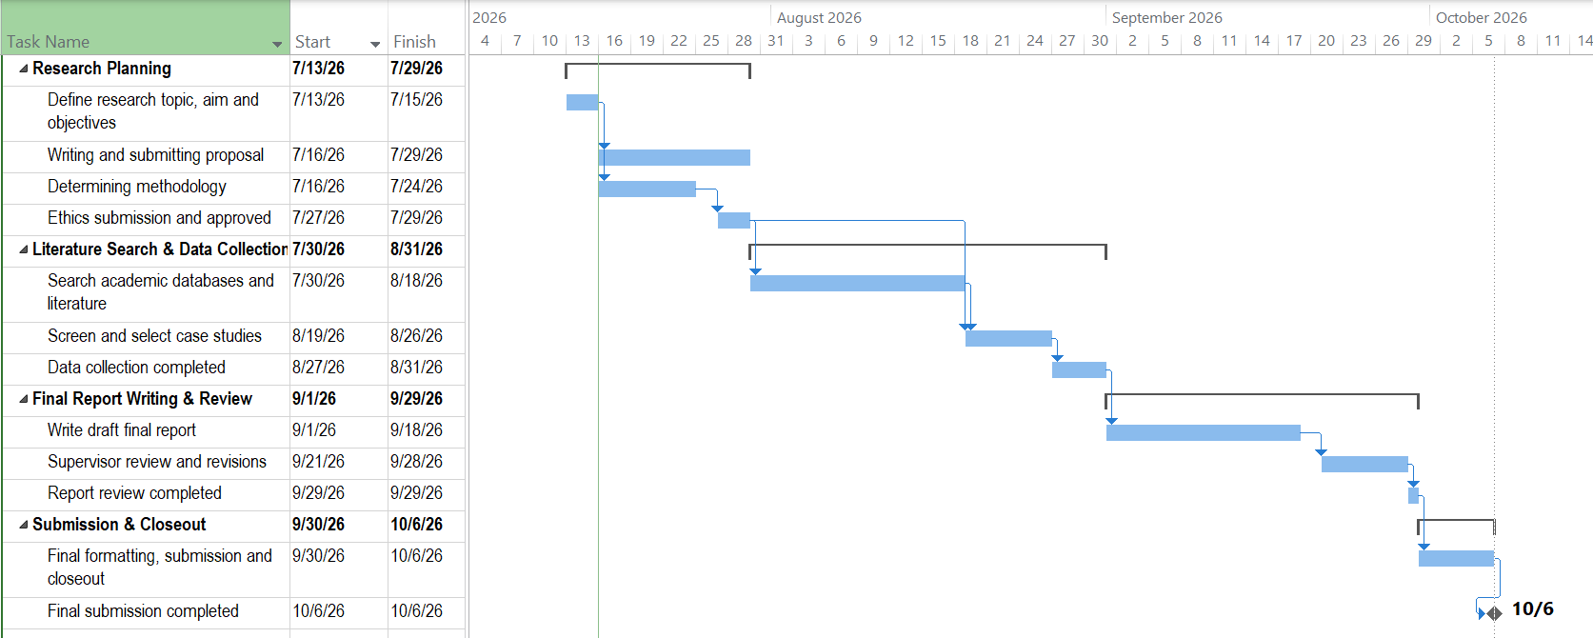
Figure 5: Research Timeline

(Source: Self-developed)
Reference List
Ahmad, R., Nawaz, M.R., Ishaq, M.I., Khan, M.M. and Ashraf, H.A., (2023). Social exchange theory: Systematic review and future directions. Frontiers in psychology, 13, p.1015921. https://www.frontiersin.org/journals/psychology/articles/10.3389/fpsyg.2022.1015921/full
Braun, V. and Clarke, V., (2022). Conceptual and design thinking for thematic analysis. Qualitative psychology, 9(1), p.3. https://psycnet.apa.org/journals/qua/9/1/3/
Comarch, (2024). Global loyalty program participation by category | Statista. [online] Statista. Available at: https://www.statista.com/statistics/1537011/loyalty-programs-participation-categories-worldwide/ [Accessed 16 July 2026].
Coyle, D. and Gamberi, L., (2024). A real options approach to data valuation. Business Economics, 59(4), pp.227-234. https://link.springer.com/article/10.1057/s11369-024-00374-2
Drolet, M.J., Rose-Derouin, E., Leblanc, J.C., Ruest, M. and Williams-Jones, B., (2023). Ethical issues in research: Perceptions of researchers, research ethics board members and research ethics experts. Journal of Academic Ethics, 21(2), pp.269-292. https://link.springer.com/article/10.1007/s10805-022-09455-3
Febriyanti, I. and Tuti, M., (2023). Assuring customer value, customer experience, and trust to improve customer loyalty. Jurnal Dinamika Manajemen Dan Bisnis, 6(2), pp.37-51. https://journal.unj.ac.id/unj/index.php/jdmb/article/view/34726
Firdaus, F., Zulfadilla, Z. and Caniago, F., (2021). Research methodology: Types in the new perspective. Manazhim, 3(1), pp.1-16. https://ejournal.stitpn.ac.id/index.php/manazhim/article/view/903
Meng, S., (2024). Operation management of grocery retailer in the uk: a case of tesco. Pacific International Journal, 7(2), pp.136-142. http://rclss.com/index.php/pij/article/view/586
Mishra, S.B. and Alok, S., (2022). Handbook of research methodology. Educreation publishing. http://74.208.36.141:8080/jspui/bitstream/123456789/1319/1/BookResearchMethodology.pdf
Paavola, L., Julkunen, S. and Gabrielsson, M., (2024). Role of Customer Loyalty in the Application of Customer Data within Supply Chains. https://scholarspace.manoa.hawaii.edu/items/06d2c959-9e1a-47da-bf05-4b2b51637b9f
Patel, K.S. and Swamy, D., (2023). Customer Role in Relationship Marketing in Acquisition and Retention of Customers: TESCO. Modern Research in Consumer Behaviour and Marketing Research, p.87. https://www.scripown.com/docs/EBOOK_20230412_040943.pdf#page=91
Pfajfar, G., Shoham, A., Małecka, A. and Zalaznik, M., (2022). Value of corporate social responsibility for multiple stakeholders and social impact–Relationship marketing perspective. Journal of business research, 143, pp.46-61. https://www.sciencedirect.com/science/article/pii/S0148296322000613
Rane, N., Choudhary, S. and Rane, J., (2023). Hyper-personalization for enhancing customer loyalty and satisfaction in Customer Relationship Management (CRM) systems. Available at SSRN 4641044. https://papers.ssrn.com/sol3/papers.cfm?abstract_id=4641044
Saunders, M.N., Lewis, P. and Thornhill, A., (2023). Research Methods for Business Students. https://research.birmingham.ac.uk/en/publications/research-methods-for-business-students-3
Singh, V., Sharma, M.P., Jayapriya, K., Kumar, B.K., Chander, M.A.R.N. and Kumar, B.R., (2023). Service quality, customer satisfaction and customer loyalty: A comprehensive literature review. Journal of Survey in Fisheries Sciences, 10(4S), pp.3457-3464. https://www.researchgate.net/profile/Vikas-Singh-49/publication/371809524_Service_Quality_Customer_Satisfaction_And_Customer_Loyalty_A_Comprehensive_Literature_Review/links/64965cd18de7ed28ba5231c4/Service-Quality-Customer-Satisfaction-And-Customer-Loyalty-A-Comprehensive-Literature-Review.pdf
Theeb, K.A., Mansour, A.M.D., Khaled, A.S., Syed, A.A. and Saeed, A.M., (2023). The impact of information technology on retail industry: an empirical study. International Journal of Procurement Management, 16(4), pp.549-568. https://www.inderscienceonline.com/doi/abs/10.1504/IJPM.2023.129553
Watty, F. (2025). Leading 10 retailers in the UK 2025| Statista. [online] Statista. Available at: https://www.statista.com/statistics/462863/leading-ten-retailers-by-sales-uk/?srsltid=afmboopdnml58h9am9mvcfmpnn-3_joyjd1sde7rvdce3wvd0yevvksp [Accessed 16 July 2026].
Wolniak, R., Stecuła, K. and Aydın, B., (2024). Digital transformation of grocery in-store shopping-scanners, artificial intelligence, augmented reality and beyond: A review. Foods, 13(18), p.2948. https://www.mdpi.com/2304-8158/13/18/2948
Xu, X. and Hu, Z., (2022). Effect of introducing virtual community and community group buying on customer’s perceived value and loyalty behavior: A convenience store-based perspective. Frontiers in Psychology, 13, p.989463. https://www.frontiersin.org/journals/psychology/articles/10.3389/fpsyg.2022.989463/full
YouGov, (2024). Best-known supermarket loyalty programs in the UK 2024. [online] Statista. Available at: https://www.statista.com/statistics/1399724/supermarket-loyalty-programs-uk/?srsltid=afmboor6pnweuizirmatnsnecdk-ooacmqqhfmxmr2fff-taqkf7wspc [Accessed 16 July 2026].

