UNIVERSITY OF WALES TRINITY SAINT DAVID
LONDON CAMPUS
Assignment 2
Learning in the Digital Era
Video Link: https://youtu.be/0KlOpUrUzrY
Module Name: Learning in the Digital Era
Module Code: ACCA 4025

Student Name: Liliana Stryzhakovska
Student ID: 2518099
Group: 1

Lecturer’s Name: Koushik Modak

Table of Contents
Introduction …………………………………………………………………………………………3
Main Body …………………………………………………………………………………………..3
Conclusions ………………………………………………………………………………………...9
References …………………………………………………………………………………………10

Introduction
This report provides an overview of my self-evaluation, outlining my current strengths, areas for improvement, and overall progress. It also presents a detailed professional development plan designed to support my growth and enhance my skills moving forward. In addition, the report includes a summary of the assigned topic, highlighting the key points, insights, and relevance to my personal and professional development. Together, these sections aim to demonstrate reflective practice and a commitment to continuous learning.

Main Body
This report covers three key tasks: a self-evaluation that explores my strengths, weaknesses, and traits gained from reflection; a personal development plan that outlines my SMART goals for improvement; and an analysis of experiences through reflective practice to understand how they support my growth. Together, these tasks demonstrate my commitment to developing both personally and professionally as a lifelong learner.
Video Link: https://youtu.be/0KlOpUrUzrY
Slide 1 COVER PAGE
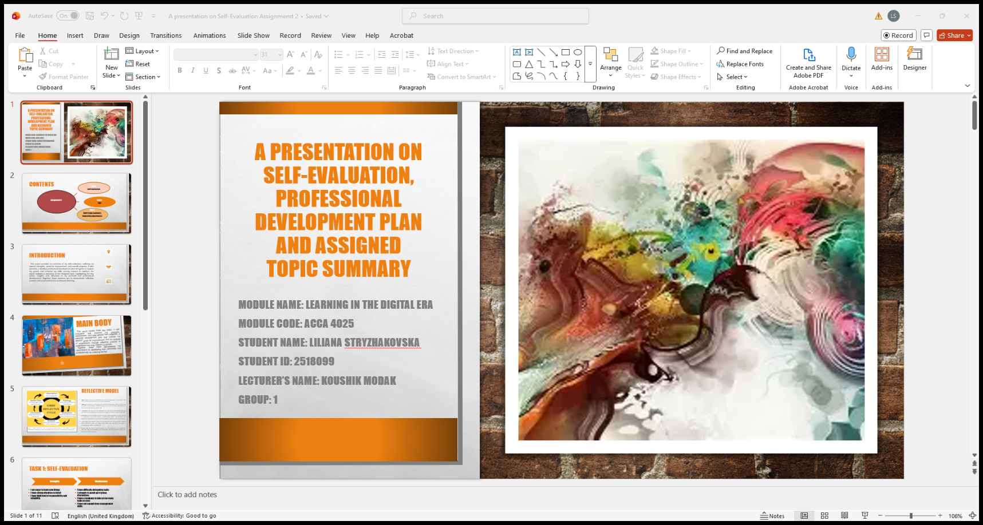
This cover page presents my work for the module ‘Learning in the Digital Era,’ including a Self-Evaluation, Professional Development Plan, and Assigned Topic Summary.

Slide 2 CONTENTS
This presentation covers three main tasks: first, a self-evaluation where I reflect on my learning; second, my professional development plan outlining steps for skill growth; and third, a summary of the Unit 4 topic where I share key learnings and personal experiences.
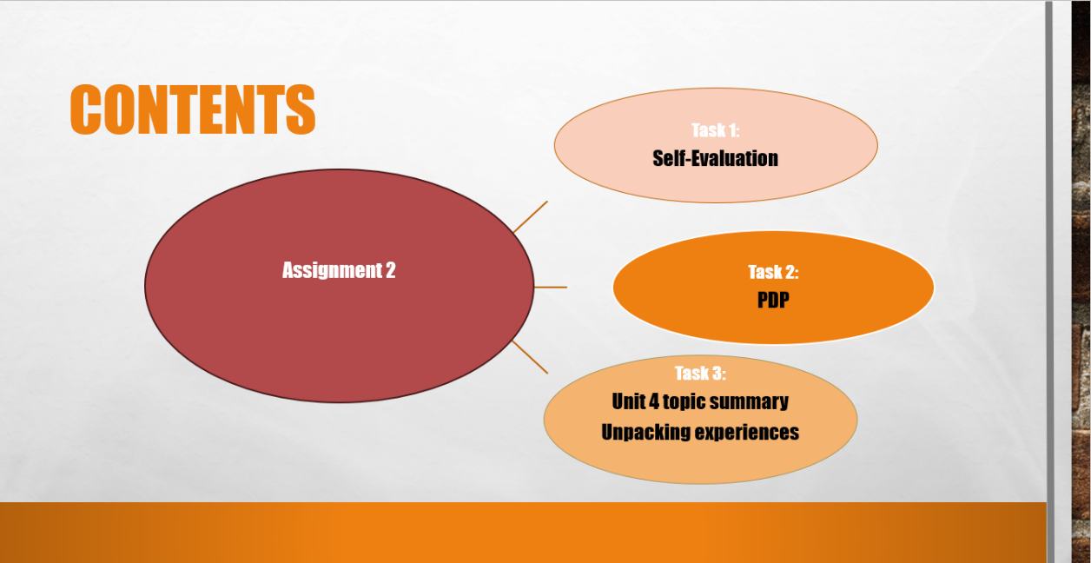

Slide 3 INTRODUCTION
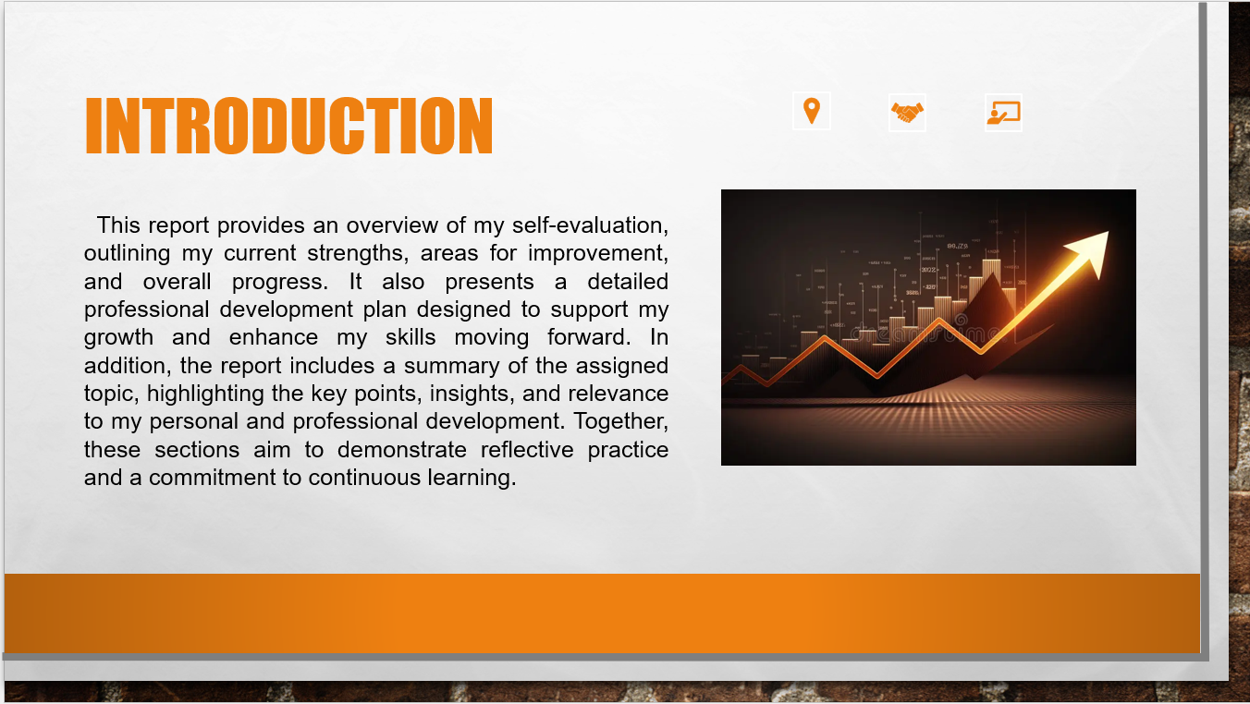
This report summarizes my self-evaluation, professional development plan, and key insights from the assigned topic, demonstrating reflective practice and my commitment to ongoing personal and professional growth.
Slide 4 MAIN BODY
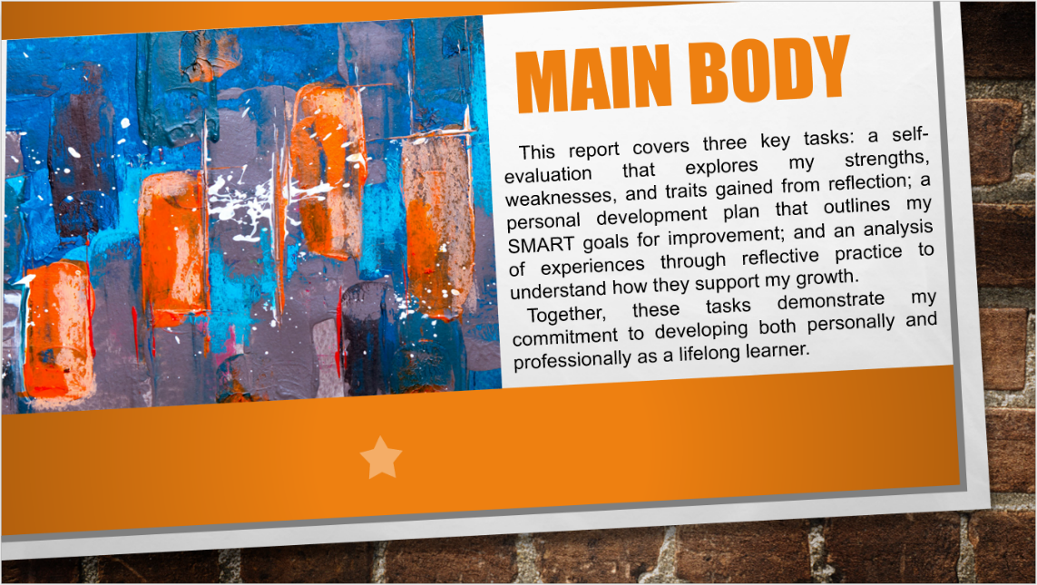
This report includes a self-evaluation of my strengths, weaknesses, and personal traits; a Personal Development Plan with SMART goals; and a reflective analysis of key experiences. Together, these tasks show my commitment to continuous personal and professional growth as a lifelong learner.
Slide 5 GIBB’s REFLECTIVE MODEL
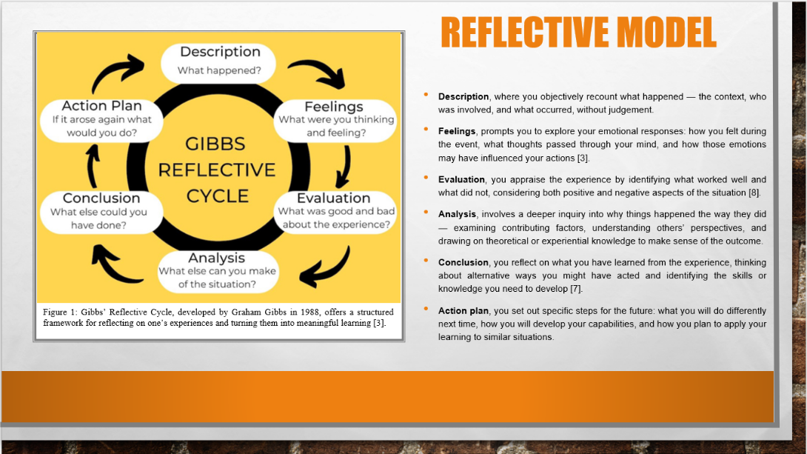
Gibb’s Model is a structured framework for reflective writing that helps you think deeply about an experience and learn from it. It consists of six stages. The Description stage involves clearly explaining what happened, who was involved, and the context, without adding opinions or judgement. In the Feelings stage, you explore your emotions and thoughts during the situation and consider how they may have influenced your behaviour. The Evaluation stage allows you to assess what went well and what did not, looking at both the positive and negative aspects of the experience.
Next, the Analysis stage helps you examine why the situation unfolded as it did, considering different perspectives and linking to relevant theories or previous experiences. In the Conclusion, you reflect on what you have learned and think about how you could handle similar situations differently in the future. Finally, the Action Plan outlines the specific steps you will take to improve your skills and apply your learning moving forward.
In my Assignment, I can apply Gibb’s Model by using each stage to reflect on a real-life experience related to my personal development. This will help me organise my reflection clearly, understand my behaviour more deeply, and identify practical steps for improvement.

Slide 6 TASK 1: SELF EVALUATION
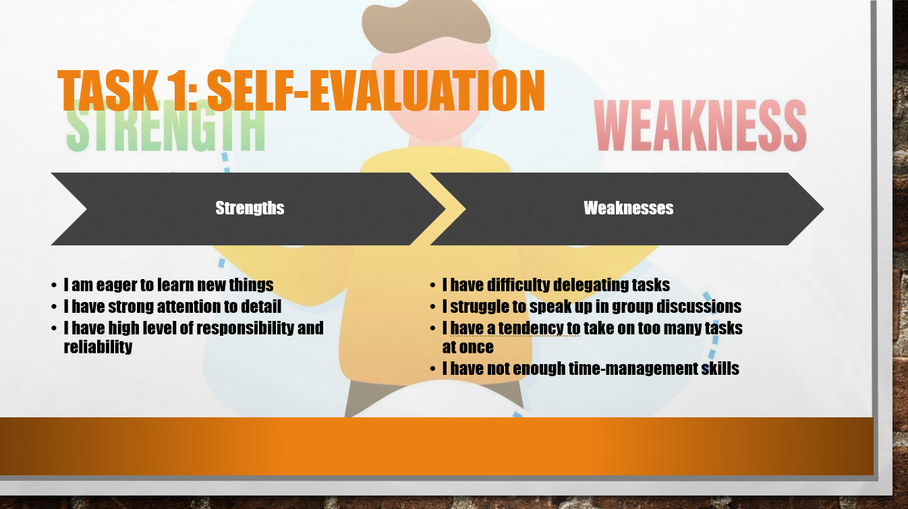
Based on my SWOT analysis, I have identified several strengths that support my personal and professional development. I am eager to learn new things, which helps me adapt quickly and stay open to improvement. I also have strong attention to detail, allowing me to complete tasks accurately and efficiently. In addition, my high level of responsibility and reliability ensures that I remain committed to meeting deadlines and fulfilling my goals.
However, I have also recognised a few weaknesses that I need to work on. I sometimes find it difficult to delegate tasks, which can lead to unnecessary stress. I also struggle to speak up during group discussions, which affects my participation and confidence. Another challenge is my tendency to take on too many tasks at once, making it harder to stay organised. Finally, I need to improve my time-management skills to work more efficiently. Understanding these weaknesses helps me plan how to overcome them and continue developing professionally.

Slide 7 TRAITS GAINED FROM THE SELF EVALUATION
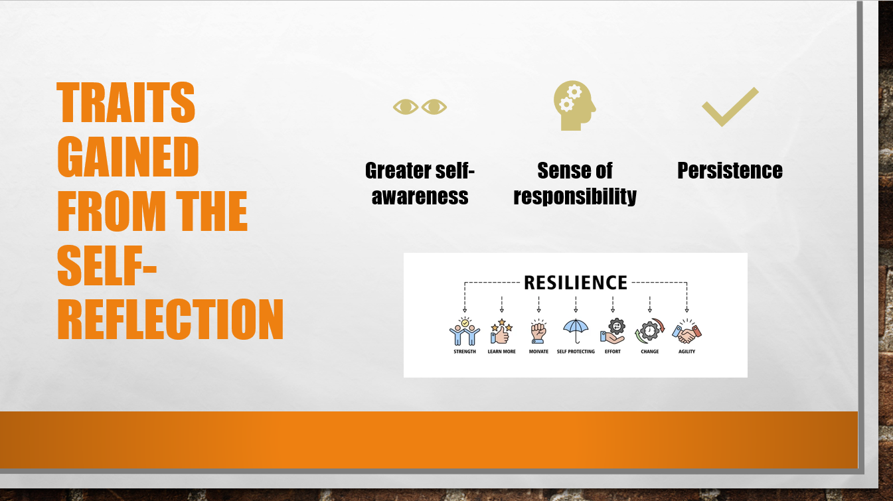
Through self-reflection, the writer has identified key traits that influence how they learn and work. They have developed greater self-awareness, allowing them to understand their strengths and weaknesses more clearly. They also recognise their persistence, which helps them stay motivated during difficult tasks, and their sense of responsibility, which supports them in taking ownership of their goals. These traits will continue to support their growth in both personal and professional areas.

Slide 8 PROFESSIONAL DEVELOPMENT PLAN
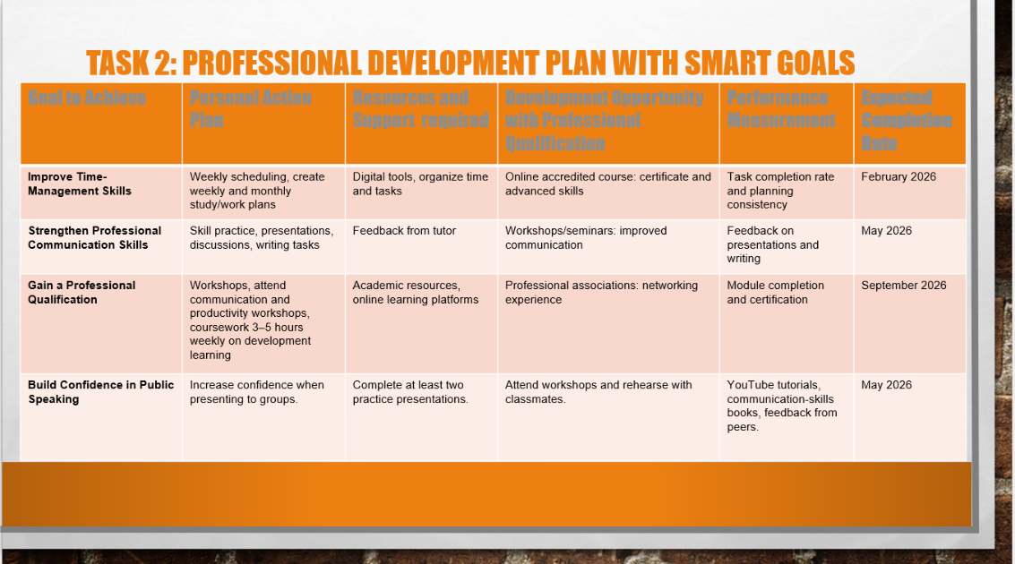
This table outlines a Professional Development Plan using SMART goals. It lists four key goals—improving time-management, strengthening communication skills, gaining a professional qualification, and building confidence in public speaking. For each goal, the plan describes the actions the learner will take, the resources they need, and the opportunities available to support their development, such as workshops, online courses, and feedback from others. It also includes measurements of success, such as completing tasks on time or receiving positive feedback, along with target completion dates to help track progress. Overall, the table provides a structured roadmap to guide both academic and professional growth.

Slide 9 UNIT 4 TOPIC SUMMARY
Change bullet points
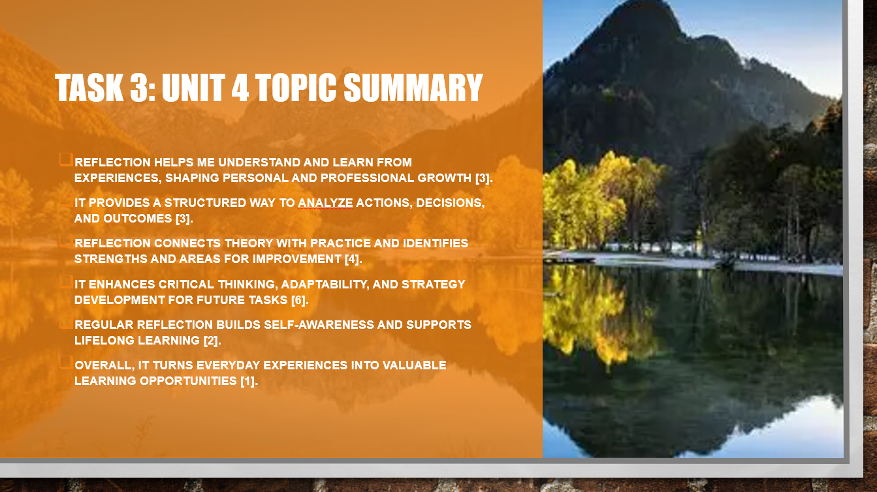
In this task, I explored how reflection supports ongoing personal and professional learning. By unpacking my experiences, I can analyse what happened, why it happened, and what I can learn from it. This practice not only strengthens self-awareness and critical thinking but also helps me connect theory to practice and continuously develop my skills.
Slide 10 CONCLUSION
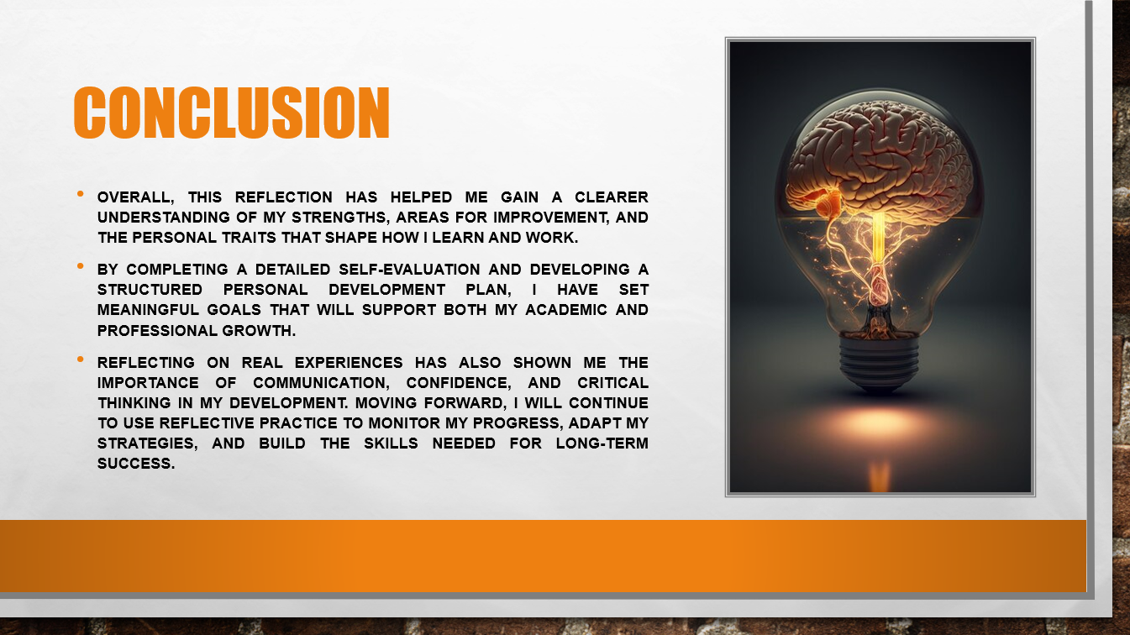
The reflection explains that the writer has learned more about their strengths, weaknesses, and personal qualities through self-evaluation. By creating a Personal Development Plan, they have set clear goals to help them grow academically and professionally. Their real experiences showed them the importance of communication, confidence, and critical thinking. They plan to keep reflecting regularly so they can track their progress, adjust their approach, and continue developing the skills they need for long-term success.
Slide 11 REFERENCES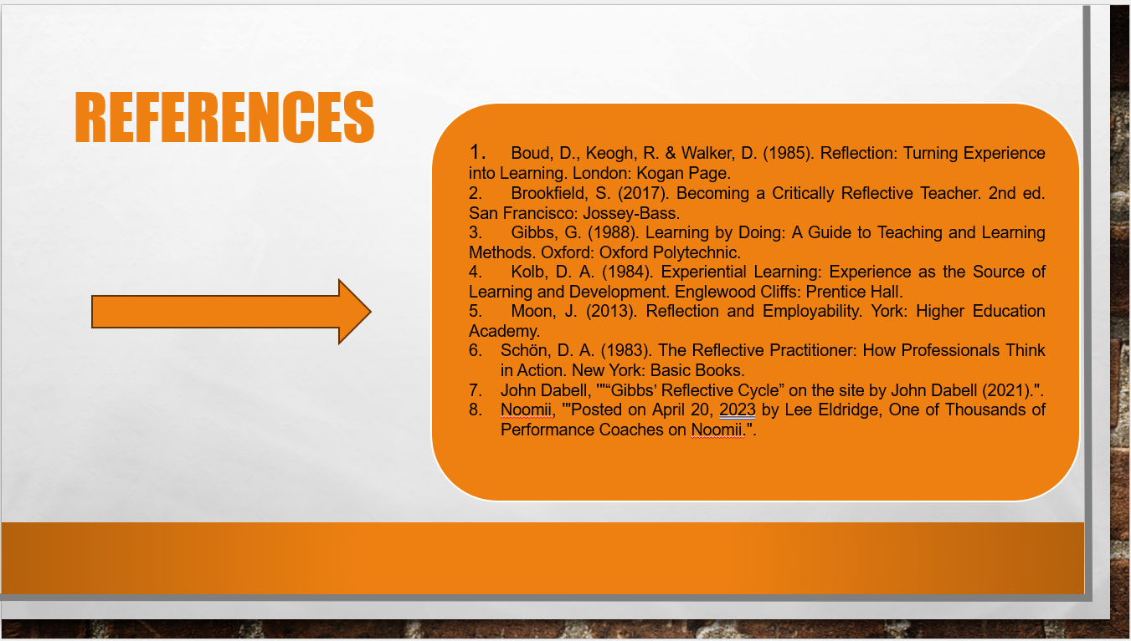
This slide shows the key references I used for my report. These sources helped me understand reflective practice and personal development, including models such as Gibbs’ Reflective Cycle and experiential learning. They supported my reflection and helped me structure my Personal Development Plan.
Overall, this reflective report has enabled me to gain a deeper understanding of my personal strengths, areas for improvement, and the key traits that influence how I learn and work. Through completing a detailed self-evaluation and creating a structured Personal Development Plan, I have established clear and achievable goals that will support my academic progress and future professional development. Reflecting on real-life experiences has highlighted the importance of effective communication, confidence, and critical thinking in enhancing my performance. Moving forward, I will continue to apply reflective practice to monitor my progress, adapt my learning strategies, and develop the skills necessary for long-term personal and professional success.

