

TOPIC: SUSTAINABLE MANUFACTURING AND CIRCULAR ECONOMY: REDUCING INDUSTRIAL WASTE IN MECHANICAL ENGINEERING PRODUCTION

STUDENT NAME : AMINUR ISLAM TONMOY
STUDENT ID : 2522779

TASK DESCRIPTION

Use of Generative AI in Assessment
(Lecturer to indicate Yes or Not against each element)

RESEARCH | For this assessment, you can use Generative AI to support you in research and data analysis. | Yes ☐  No ☒
STRUCTURE | For this assessment, you can use Generative AI to support you in structuring your submission, including creating a draft argument structure, identifying parts  and headings, etc. | Yes ☒  No ☐
PROOFREADING | For this assessment, you can use Generative AI to check your own text/creation for grammatical and syntactical mistakes, including getting suggestions to  rephrase your work. | Yes ☒  No ☐
WRITING | For this assessment, you can use Generative AI to create text for submission. | Yes ☐  No ☒
CREATIVE | For this assessment, you can use Generative AI to create creative materials, such as images. | Yes ☐  No ☒
PROGRAMING | For this assessment, you can use Generative AI to create and check code. | Yes ☐  No ☒
NONE | For this assessment, you are not allowed to use any type of Generative AI support. This includes research support, structure support, writing/proofreading  support and creative support. | √

Table of Contents
Assessment Component 2: Research Proposal 4
2.1 Introduction 4
2.1.1 Background 4
2.1.2 Rationale 4
2.1.3 Aims and Objectives 4
2.1.4 Questions 5
2.2 Literature Review 5
2.2.1 Role and significance of sustainable manufacturing and circular economy practices for mechanical engineering production 5
2.2.2 Benefits of integrating sustainable manufacturing and circular economy for mechanical engineering to reduce industrial waste 6
2.2.3 Factors impacting the integration of sustainable manufacturing and circular economy practices in mechanical engineering projects 6
2.2.4 Challenges faced by mechanical engineering projects in maintaining sustainable manufacturing and reducing industrial waste in production 7
2.2.5 Ways to reduce industrial waste from mechanical engineering production by following sustainable manufacturing and circular economy practices 7
2.2.6 Theoretical Underpinnings 7
2.2.7 Conceptual framework 9
2.2.8 Literature gaps and contribution of the proposed research to the literature 10
2.3 Methods 11
2.3.1 Research Philosophy 11
2.3.2 Research Design 11
2.3.3 Research Approach 11
2.3.4 Data Collection strategy 11
2.3.5 Sampling Technique 12
2.3.6 Data Analysis 12
2.3.7 Inclusion-exclusion criteria 12
2.3.8 Ethical consideration 13
2.3.9 Research Timeline 13
2.4 Results 13
2.5 Evaluation 14
References 15

Assessment Component 2: Research Proposal

2.1 Introduction

2.1.1 Background
The adoption of sustainable manufacturing tactics and circular economy concepts has been valuable in the UK in relevance to lowering the margin of waste generated through mechanical engineering production. Accordingly, reports highlight that over 400 local authorities are continuously managing around 30 different schemes of waste collection across the UK in 2025 (Statista, 2025). This statistical data acts as evidence that shows the growth of waste reduction approaches in the UK to eventually reduce the level of industrial waste. Henceforth, this research serves the purpose of evaluating the effectiveness of sustainable manufacturing and the circular economy approach in minimising industrial waste from mechanical engineering production.

2.1.2 Rationale
The rapid increase in the margin of waste generation across the UK is the critical problem that will be evaluated and significantly addressed in this research. In essence, investigations reveal that around 41.1 million tons of industrial waste is generated all over the UK in a single year (Businesswaste, 2026). As a consequence, this research will put stress on addressing this specific environmental issue through the integration of sustainable manufacturing and circular economy in mechanical engineering production practices. Therefore, the key deliverables of this research are expected to be valuable in lowering industrial waste by enhancing the sustainability of mechanical engineering production procedures in an effective manner.

2.1.3 Aims and Objectives
Aim
The aim of this research will be based on the idea of evaluating the integration and role of sustainable manufacturing and circular economy in reducing the margin of industrial waste generated from mechanical engineering production practices.
Objectives
The core objectives that this research will address are:
- To assess the adoption of sustainable manufacturing approaches and the circular economy concept in order to lower the margin of industrial waste in mechanical engineering production
- To evaluate the impact of sustainable manufacturing practices and the circular economy on reducing the level of industrial waste produced from mechanical engineering production
- To examine the critical challenges and obstacles that are associated with the adoption and implementation of sustainable manufacturing and circular economy approaches in mechanical engineering production practices
- To provide effectively recommended actionable tactics to overcome the challenges of implementing sustainable manufacturing and the circular economy in mechanical engineering production procedures

2.1.4 Questions
The questions that will be significantly answered in this research are as follows:
- What is the adoption status of sustainable manufacturing approaches and the circular economy concept across mechanical engineering production processes to successfully reduce the generation of industrial waste?
- How does the implementation of the circular economy process and sustainable manufacturing impact the lowering of industrial waste generation across mechanical engineering production procedures effectively?
- What are the significant challenges and barriers that hinder the adoption of sustainable manufacturing and the circular economy strategy in mechanical engineering production processes?
- How can the challenges associated with the application of sustainable manufacturing and the circular economy in mechanical engineering production procedures be mitigated in terms of lowering the margin of industrial waste successfully?

2.2 Literature Review

2.2.1 Role and significance of sustainable manufacturing and circular economy practices for mechanical engineering production
The role of sustainable manufacturing has been found to be significant for mechanical engineering to reduce environmental impact by lowering industrial waste and carbon emission while increasing operational efficiency for better competitiveness (Lopes et al. 2023). Shifting towards sustainable manufacturing practices has become crucial for mechanical engineering production for environmental protection, waste minimisation, regulatory compliance and economic advantage. Conversely, “Cleaner production (CP) paradigm” is identified as a global benchmark for resource circularity by following circular economy practices for minimising waste production and lowering GHG emission from the manufacturing sector (Kurniawan et al. 2022). Shifting towards a sustainable and closed-loop system from the take-make-waste model by following circular economy practices can be advantageous for mechanical engineering projects to increase resource efficiency, decrease industrial waste and reduce carbon emission. Considering the rapid depletion of earth's natural resources for raw materials, adhering to a circular economy for sustainable manufacturing and circular production has become significant for mechanical engineering projects to address raw materials unavailability.

2.2.2 Benefits of integrating sustainable manufacturing and circular economy for mechanical engineering to reduce industrial waste
Integration of sustainable manufacturing identified as beneficial for manufacturers for maximising resource efficiency, increasing mass customisation and lowering waste amount with the help of technologies such as AI and 3D printing (Narkhede et al. 2023). Contrarily, inclusion of circular economy practices in engineering production can be helpful for promoting product longevity, emphasising remanufacturing as well as refurbishing, minimising environmental pollution and boosting economic competitiveness (Russell and Nasr, 2023). Referring to this, following sustainable manufacturing and circular economy principles can be beneficial for mechanical engineering projects to embrace material circularity, decrease raw material dependency and reduce carbon footprint and pollution.

2.2.3 Factors impacting the integration of sustainable manufacturing and circular economy practices in mechanical engineering projects
Technological advancement, legal and regulatory pressure, eco-design, waste management, customer demand, top management commitment, economic benefits and cost savings identified as crucial factors influencing sustainable manufacturing integration in engineering projects (Kuo et al. 2022). Contrarily, consumer perception, material selection, resource efficiency need, technological infrastructure, supply chain and logistics and brand reputation influence the incorporation of circular economy practices in engineering projects (Karlovsek et al 2024). Further, supply chain management, organisational culture, employee skill set, design for circularity and policy frameworks can also cause significant impact on the adoption of sustainable manufacturing and circular economy in mechanical engineering to reduce industrial waste.

2.2.4 Challenges faced by mechanical engineering projects in maintaining sustainable manufacturing and reducing industrial waste in production
Technological limitations, regulatory barriers and economic constraints identified as crucial challenges encountered by industrial engineering projects during circular economy adoption to maintain sustainable manufacturing (Nwamekwe and Chikwendu, 2025). On the contrary, poor infrastructure for transitioning towards circularity, limited capabilities of local manufacturing, supply chain challenges and lack of recycling networks can cause challenging concerns to adopt sustainable manufacturing (Dumée, 2022). Additionally, lack of funding for green technology, high energy consumption, material complexities and technological constraints also raise challenges for mechanical engineers to adopt sustainable manufacturing and circular economy in production practices for limiting waste generation.

2.2.5 Ways to reduce industrial waste from mechanical engineering production by following sustainable manufacturing and circular economy practices
Integration of lean manufacturing principles for waste minimisation, emphasising on-site material recycling, prioritising industrial symbiosis and incorporating waste tracking system can be advantageous for engineering projects to reduce industrial waste through sustainable manufacturing. Inclusion of lean manufacturing principles such as JIT (just-in-time) can significantly contribute to industrial waste minimisation by optimising resource allocation, increasing sustainability by limiting carbon footprint and enhancing product quality. Conversely, implementing “Life Cycle Analysis” (LCA) as an advanced tool, optimising material flow along with process simulation can be beneficial for industrial engineering to integrate sustainable manufacturing and circular economy principles (Nwamekwe and Chikwendu, 2025). Besides this, inclusion of emerging technologies such as AI and IoT can accelerate the integration of circular economy principles in mechanical engineering production for driving sustainable manufacturing, strengthening resource management and lowering industrial waste.

2.2.6 Theoretical Underpinnings
ReSOLVE framework for transitioning to circular economy
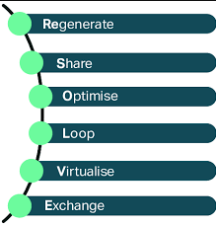
Figure 1: ReSOLVE framework
(Source: Inspired by Sell et al. 2023)
ReSOLVE framework is a strategic tool that empowers businesses in generating circular strategies along with growth initiatives by assessing technology gaps and planning for “information technology investment” for supporting transition towards circular economy (Sell et al. 2023). Being a structured and actionable approach, integration of the ReSOLVE framework can be favourable for mechanical engineers to reduce industrial waste production by closing material loops and minimising scraps, extending product lifespan and improving resource efficiency. “Circular economy paradigm” is growingly recognised as a crucial framework for “sustainable industrial engineering” to emphasise resource efficiency via recycling, reuse and remanufacturing that contrast with the “traditional linear model of production” (Nwamekwe and Chikwendu, 2025). Integration of the circular economy principles can be helpful for mechanical engineers for optimising manufacturing processes and addressing global challenges related to unsustainable production and resource depletion, useful for mechanical engineering projects to reduce industrial waste.
5Rs framework for waste minimisation to promote sustainability
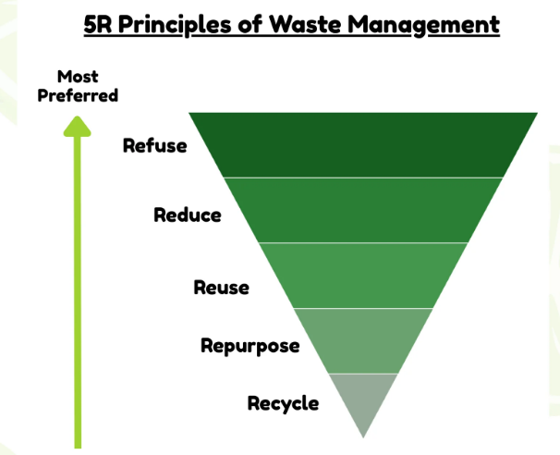
Figure 2: 5Rs framework for waste management
(Source: Inspired by Meshram, 2024)
The 5Rs framework is identified as a hierarchical waste management strategy, encompassing refuse, reduce, reuse, repurpose and recycle for minimising waste, preserving resources and promoting sustainable manufacturing (Meshram, 2024). Integration of the 5Rs framework as a structured approach can be favourable for mechanical engineering production to incorporate sustainable manufacturing with resource conservation for lowering industrial waste and maintaining sustainable business practices.

2.2.7 Conceptual framework
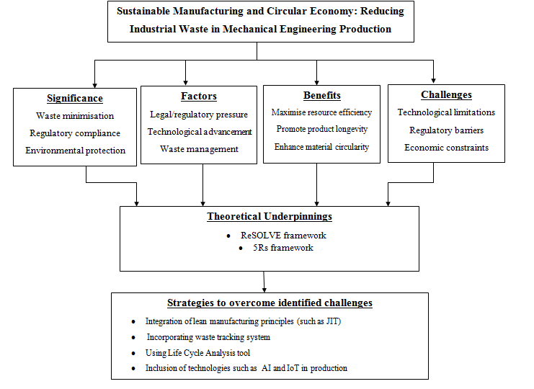
Figure 3: Conceptual framework
(Source: Self-developed)
The above figure demonstrates the conceptual framework of the proposed research, highlighting connection between theoretical framework such as 5Rs framework and ReSOLVE framework to address identified challenges.

2.2.8 Literature gaps and contribution of the proposed research to the literature
Existing literary sources contain adequate information about the benefits, significance and necessity of sustainable manufacturing and circular economy principles for organisations to reduce industrial waste. For example, Narkhede et al. (2023) mentioned that inclusion of sustainable manufacturing is beneficial for manufacturers to maximise resource efficiency, increase mass customisation and reduce industrial waste. However, existing literature provided a limited amount of information about the significance and necessity of sustainable manufacturing along with circular economy production for mechanical engineering projects to limit industrial waste generation. In this context, the proposed study will contribute to critically analyse the significance of sustainable manufacturing and circular economy for mechanical engineering production by assessing challenges and recommending potential strategies to decrease industrial waste.

2.3 Methods

2.3.1 Research Philosophy
Acquiring deep and contextual understanding, uncovering hidden meanings, data collection flexibility and addressing research complexity identified as benefits of using interpretivism philosophy (Paudel, 2024). However, rigid application, inflexibility, contextual blindness and neglecting subjective reliability identified as main limitations of applying positivism philosophy in academic research (William, 2024). Interpretivism philosophy will be followed in the proposed research for acquiring subjective meanings and contextual understanding about the role of sustainable manufacturing and circular economy to limit industrial waste generation of mechanical engineering production.

2.3.2 Research Design
Cost-effectiveness, time-efficiency, flexible approach, fast method and versatility in application are identified as key benefits of applying descriptive research design (Mogaka, 2025). However, lack of generalisability, inconclusive results, resource, time-intensive nature and unstructured nature become limitations of exploratory research design (Mujeeb et al. 2025). Implication of descriptive research design will be appropriate for the proposed study to analyse the current adoption rate of sustainable manufacturing and circular economy practices in mechanical engineering production for lowering industrial waste generation.

2.3.3 Research Approach
High flexibility, suitability to explore existing literature, capturing context-specific insights and pattern recognition are identified as positive aspects of applying inductive approach in secondary research (Abbasnejad et al. 2026). Conversely, limited flexibility, oversimplification and high sample requirements identified as main limitations of applying deductive research approach (Robinson and Bailey-Rodriguez, 2026). Implying an inductive research approach will be favourable for successful accomplishment of the current research to explore emerging trends and patterns related to sustainable manufacturing and circular economy principles for minimising waste generation.

2.3.4 Data Collection strategy
Saving time, cost and effort, reusability, high efficiency and obtaining contextual understanding are considered as primary benefits of secondary qualitative research (Cheong et al. 2023). Conversely, high time and cost requirements, respondent bias potential, access issues and limited scope are considered as disadvantages of using primary research (Good fellow, 2023). Deploying secondary qualitative data collection in the proposed research will be advantageous for exploring existing and potential challenges faced by mechanical engineering projects while adopting sustainable manufacturing and circular economy practices by analysing existing sources.

2.3.5 Sampling Technique
Using the non-probability convenience sampling technique enables researchers to access required data and information from existing, readily available and easily accessible sources for ensuring cost-efficiency (Räsänen et al. 2024). Potential for inaccuracy, non-responsive bias, resource-intensive nature and high complexity identified as negative aspects related to probability sampling (Howarth et al. 2024). Employing non-probability convenience sampling will be beneficial for conducting the current research by selecting relevant, authentic and available existing data sources for meeting research objectives. A total of 16 qualitative secondary based sources will be considered for data collection purposes including journals, government publications, news articles, business magazines and authentic websites.

2.3.6 Data Analysis
Implying thematic analysis provides a cost-effective and time-saving method for extracting deep and nuanced insights from existing datasets (Martin et al. 2026). Inversely, inclusion of statistical analysis can lead to susceptibility to misinterpretation or data manipulation due to lack of understanding about statistical methods, affecting research validity and credibility (Adeniran et al. 2024). Doing thematic analysis will be appropriate for the proposed research to evaluate drivers, significance and barriers for mechanical engineering production while transitioning to sustainable manufacturing and circular economy practices for minimising industrial waste.

2.3.7 Inclusion-exclusion criteria
Criteria | Inclusion | Exclusion
Relevance | Sources containing information about sustainable manufacturing and circular economy principles | Sources containing relevant information
Language | Sources published in English language only | Sources containing information in any other language except English
Recency | Sources published within last 5 years (2022-2026) | Sources published before last five years (before 2022)
Table 1: Inclusion-exclusion criteria for the proposed research
(Source: Self-evaluated)

2.3.8 Ethical consideration
The proposed study will follow research integrity, comply with university guidelines to conduct ethical research and maintain proper in-text citations with reference list to avoid plagiarism concerns.

2.3.9 Research Timeline
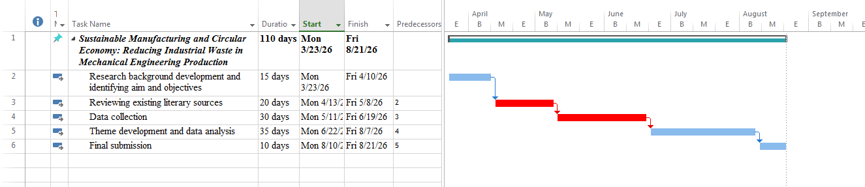
Figure 4: Research Timeline
(Source: Self-developed)

2.4 Results
Data about the current adoption rate of sustainable manufacturing and circulation economy implementation will be collected by considering industrial reports, corporate reports and CSR reports to evaluate the role of sustainable manufacturing for reducing industrial waste. For example, referring to recent sustainability trends, 70% of UK-based SMEs decreased waste generation by deploying sustainable business practices such as going paperless and increasing recycling initiatives (Phelan, 2025). Additionally, data related to barriers and challenges to adopt circular economy practices and sustainable manufacturing will be collected from journals, news articles and business magazines to identify existing limitations. Besides this, data from regulatory documents, journal articles, industry standards, government policies and environmental regulations will also be obtained for exploring strategic recommendations for mechanical engineering organisations for successful addition of a circular economy and sustainable manufacturing.

2.5 Evaluation
Referring to potential impact, the proposed research will drive sustainable manufacturing and circular economy principle adoption in mechanical engineering production for waste minimisation, resource efficiency, economic benefits and environmental sustainability. Implication of sustainable manufacturing and circular economy principles can aid manufacturing businesses to strengthen energy management, increase resource efficiency, encourage waste reduction and reduce emission rate (Narkhede et al. 2023). Therefore, outcomes of the proposed research will drive operational and economic benefits of mechanical engineering projects by transitioning to a circular economy, extending product lifespan and reducing negative environmental impact. However, solely depending on secondary research by collecting information from existing sources and exclusion of primary research due to financial constraints and time limitations identified as weaknesses of the proposed research. Despite this, emphasising data triangulation by comparing findings with multiple sources and using data from recent publications will be useful for the proposed research to overcome identified weaknesses and limitations.

References
Abbasnejad, B., Soltani, S., Taghizadeh, F. and Zare, A., (2026). ‘Developing a multilevel framework for AI integration in technical and engineering higher education: insights from bibliometric analysis and ethnographic research’. Interactive Technology and Smart Education, 23(1), pp.49-79. Available at: https://www.emerald.com/itse/article/23/1/49/1251419 (Accessed: 5 March 2026).
Adeniran, A.O., ASIFAT, J.T., FAMILUSI, O.B. and FOLORUNSO, S.S., (2024). ‘Critical analysis of research methods and misperceptions of statistical analysis’. International journal of innovation in management, economics and social sciences, 4(3), pp.29-50. Available at: https://www.researchgate.net/profile/Adetayo-Adeniran/publication/387130053_Critical_Analysis_of_Research_Methods_and_Misperceptions_of_Statistical_Analysis/links/67617fa6af28fb680fbfc8b1/Critical-Analysis-of-Research-Methods-and-Misperceptions-of-Statistical-Analysis.pdf (Accessed: 1 March 2026).
Available at: https://www.emerald.com/ecam/article/31/11/4645/1230354 (Accessed: 3 March 2026).
Businesswaste (2026) Waste Facts. Available at: https://www.businesswaste.co.uk/waste-facts/ (Accessed: 9 March 2026).
Cheong, H.I., Lyons, A., Houghton, R. and Majumdar, A., (2023). ‘Secondary qualitative research methodology using online data within the context of social sciences’. International Journal of Qualitative Methods, 22, p.16094069231180160. Available at: https://journals.sagepub.com/doi/abs/10.1177/16094069231180160 (Accessed: 2 March 2026).
Dumée, L.F., (2022). ‘Circular materials and circular design—review on challenges towards sustainable manufacturing and recycling’. Circular economy and sustainability, 2(1), pp.9-23. Available at: https://link.springer.com/article/10.1007/s43615-021-00085-2 (Accessed: 4 March 2026).
Goodfellow, L.T., (2023). ‘An overview of survey research’. Respiratory Care, 68(9), pp.1309-1313. Available at: https://journals.sagepub.com/doi/abs/10.4187/respcare.11041 (Accessed: 5 March 2026).
Howarth, A., Cooke, S.J., Nguyen, V.M. and Hunt, L.M., (2024). Non-probabilistic surveys and sampling in the human dimensions of fisheries. Reviews in Fish Biology and Fisheries, 34(2), pp.597-622. Available at: https://link.springer.com/article/10.1007/s11160-023-09831-1 (Accessed: 3 March 2026).
Karlovsek, J., Meath, C., Miles-Mwangangi, L., MacDonald, C. and Brockmann, A., (2024). ‘Implementing circular economy principles in infrastructure procurement to support circular supply chains’. Engineering, Construction and Architectural Management, 31(11), pp.4645-4658.
Kuo, Y.C., Wu, Y.M. and Liu, Y.X., (2022). ‘Identifying key factors for sustainable manufacturing and development’. Review of Integrative Business and Economics Research, 11(1), pp.30-50. Available at: https://sibresearch.org/uploads/3/4/0/9/34097180/riber_11-1_02_m20-905_30-50.pdf (Accessed: 3 March 2026).
Kurniawan, T.A., Othman, M.H.D., Hwang, G.H. and Gikas, P., (2022). ‘Unlocking digital technologies for waste recycling in Industry 4.0 era: A transformation towards a digitalization-based circular economy in Indonesia’. Journal of Cleaner Production, 357, p.131911. Available at: https://www.sciencedirect.com/science/article/pii/S0959652622015219 (Accessed: 4 March 2026).
Lopes, J.C., Oliveira, D.D.J., Ávila, B.N., Rodrigues, M.D.S., Souza, G.G.D., Talon, A.G., Ribeiro, F.S.F., Rodrigues, A.R., Sanchez, L.E.D.A. and Bianchi, E.C., (2023). ‘Reducing carbon footprint in grinding: exploring green manufacturing to mitigate CO2 emission from cutting fluids’. The International Journal of Advanced Manufacturing Technology, 129(11), pp.5691-5708. Available at: https://link.springer.com/article/10.1007/s00170-023-12676-4 (Accessed: 5 March 2026).
Martin, S., Beecham, E., Kursumovic, E., Armstrong, R.A., Cook, T.M., Déom, N., Kane, A.D., Moniz, S., Soar, J., Vindrola-Padros, C. and Collaborators, (2026). ‘Comparing human vs. machine-assisted analysis to develop a new approach for Big Qualitative Data Analysis’. PLOS Digital Health, 5(2), p.e0000576. Available at: https://journals.plos.org/digitalhealth/article?id=10.1371/journal.pdig.0000576 (Accessed: 5 March 2026).
Meshram, K.K., (2024). ‘The circular economy, 5R framework, and green organic practices: pillars of sustainable development and zero-waste living’. Discover Environment, 2(1), p.147. Available at: https://link.springer.com/article/10.1007/s44274-024-00177-4 (Accessed: 5 March 2026).
Mogaka, C.O., (2025). ‘The effect of SCOR metrics on supply chain performance among SMEs in Mombasa County, Kenya: A focus on cycle time, cost, and flexibility’. Journal of Sustainable Development of Transport and Logistics, 10(1), pp.125-151. Available at: https://cyberleninka.ru/article/n/the-effect-of-scor-metrics-on-supply-chain-performance-among-smes-in-mombasa-county-kenya-a-focus-on-cycle-time-cost-and (Accessed: 4 March 2026).
Mujeeb, N., Ali, A. and Anam, S., (2025). ‘Exploring Qualitative, Quantitative, and Mixed Methods: A Comprehensive Review in Educational Research’. UMT Education Review, 8(1), pp.24-60.Available at: https://journals.umt.edu.pk/index.php/uer/article/view/7072 (Accessed: 3 March 2026).
Narkhede, G., Pasi, B., Rajhans, N. and Kulkarni, A., (2023). ‘Industry 5.0 and the future of sustainable manufacturing: A systematic literature review’. Business Strategy & Development, 6(4), pp.704-723.Available at: https://onlinelibrary.wiley.com/doi/abs/10.1002/bsd2.272 (Accessed: 5 March 2026).
Nwamekwe, C.O. and Chikwendu, O.C., (2025). ‘Circular economy strategies in industrial engineering: From theory to practice’. International Journal of Multidisciplinary Research and Growth Evaluation, 6(01), pp.1773-1782. Available at: https://hal.science/hal-04943409/ (Accessed: 5 March 2026).
Paudel, P., (2024). ‘Examining paradigmatic shifts: Unveiling the philosophical foundations shaping social research methodologies’. Journal of the University of Ruhuna, 12(1). Available at: https://account.jur.sljol.info/index.php/sljo-j-jur/article/view/8033 (Accessed: 1 March 2026).
Phelan, J., (2025) Sustainability in business: latest trends and statistics. Available at: https://www.money.co.uk/business/business-statistics/business-sustainability-report (Accessed: 2 March 2026).
Räsänen, P., Oksanen, A., Lehdonvirta, V. and Blank, G., (2024). ‘Social media, web, and panel surveys: Using non-probability samples to study population characteristics’. In Advanced Research Methods for Applied Psychology (pp. 140-152). Routledge. Available at: https://www.taylorfrancis.com/chapters/edit/10.4324/9781003362715-13/social-media-web-panel-surveys-pekka-r%C3%A4s%C3%A4nen-atte-oksanen-vili-lehdonvirta-grant-blank (Accessed: 4 March 2026).
Robinson, O.C. and Bailey-Rodriguez, D., (2026). ‘Deductive qualitative research: an integrative approach to designing studies’. Qualitative Research in Psychology, pp.1-16. Available at: https://www.tandfonline.com/doi/abs/10.1080/14780887.2025.2604773 (Accessed: 4 March 2026).
Russell, J.D. and Nasr, N.Z., (2023). ‘Value-retained vs. impacts avoided: the differentiated contributions of remanufacturing, refurbishment, repair, and reuse within a circular economy’. Journal of Remanufacturing, 13(1), pp.25-51. Available at: https://link.springer.com/article/10.1007/s13243-022-00119-4 (Accessed: 4 March 2026).
Sell, L.G., Tedesco, M., Simioni, F.J., Sehnem, S., Soares, J.F. and Junior, L.M.C., (2023). ‘Circular economy practices using the ReSOLVE framework: An assessment by sector and scale in the Brazilian planted tree industry’. Journal of Cleaner Production, 433, p.139780. Available at: https://www.sciencedirect.com/science/article/pii/S0959652623039380 (Accessed: 2 March 2026).
Statista, (2025) Recycling in the UK - statistics & facts. Available at: https://www.statista.com/topics/12216/recycling-in-the-uk/?srsltid=AfmBOopVbyPgDKYUkGlgfACEy0S5RROKijoqyPrmB3SrNZjXdR60LDY1#topicOverview (Accessed: 9 March 2026).
William, F.K.A., (2024). ‘Delving into the principles and application of positivism in research: A guide for scholars’. International Journal of Research Publications, 146(1), pp.7-13. Available at: https://www.researchgate.net/profile/Arthur-William-Fodouop-Kouam/publication/379448183_Delving_into_the_Principles_and_Application_of_Positivism_in_Research_A_Guide_for_Scholars/links/660a6b0ff5a5de0a9ff30b09/Delving-into-the-Principles-and-Application-of-Positivism-in-Research-A-Guide-for-Scholars.pdf (Accessed: 5 March 2026).

