

Student name: Ionut Claudiu Ungureanu
Student Id: 2323114
Module: Managing Projects in Organisations
Assignment Title: Reflective blogs
Lecturer: Giulia Chifari
Deadline: 19th June by 23:59
Table of Contents
Blog 1: Project Introduction + team role 3
Blog 2: Project Initiation, Scope, Aims, and Objectives 4
Blog 3: Stakeholder analysis and communication 6
Blog 4: Planning Tools, WBS, and Gantt Chart 8
Blog 5: Risk + self-evaluation/ development 10
References 12

List of Figures

Figure 1: Belbin’s Team Roles 4
Figure 2: Iron Triangle 6
Figure 3: WBS 8
List of Tables

Table 1: Stakeholder Matrix 7
Table 2: Gantt Chart 8

Blog 1: Project Introduction + team role
Project Overview
Our project was a charity event at the university on June 15th, promoting traditional Romanian cakes and collecting donations for Eyst Swansea. The University and the charity acted as our key stakeholders. Our five members team included Andreea Porumbel, Mariana, Silvia, Andreea Lilea and myself.

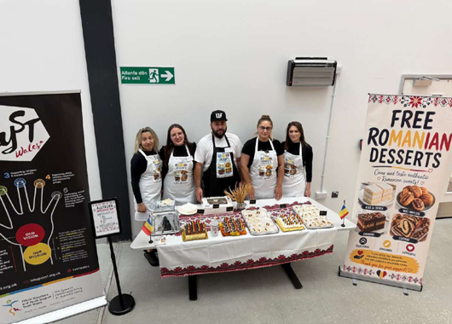

Personal Contribution
As the project coordinator, my role was to manage the overall direction, divide tasks, and monitor our schedule. Through this leadership experience, I developed essential skills such as time management, team motivation, and problem solving under pressure. I delegated university and association approvals to Andreea Lilea, Andreea Porumbel ordered traditional Romanian cakes from Top Cakes Ana Homemade, labelled with content and allergens and personalised aprons, decoration to Mariana and flyers distribution to Silvia, ensuring everyone met their targets.
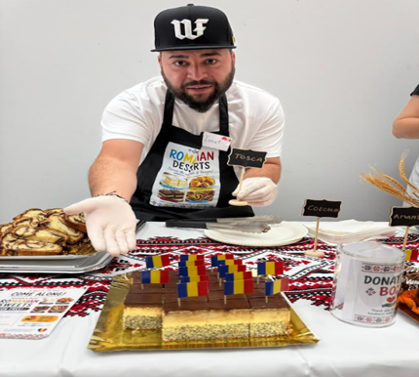

Belbin Team Roles
According to the Belbin Team Inventory framework developed at Henley Management College, my behaviour reflects the Coordinator role (Indeed, 2026). This role is essential for clarifying team objectives and delegating duties effectively to the right people (Holubiev et al., 2022)
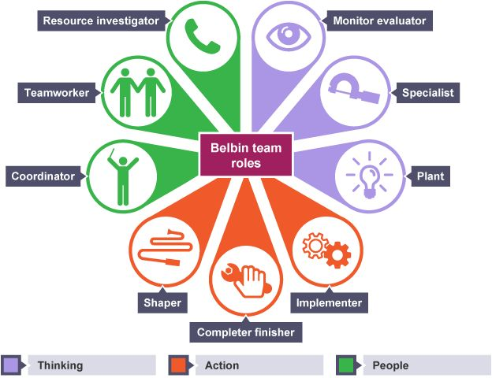

Figure 1: Belbin’s Team Roles
(Source: Belbin and Brown, 2022)

Critical Assessment
Belbin’s model is effective for identifying team strengths (Belbin and Brown, 2022). However, a major limitation as a coordinator was the risk of over-relying on others. When task delayed, I had to work beyond my managerial role to prevent project failure.

Blog 2: Project Initiation, Scope, Aims, and Objectives
Aim and Objectives
The main aim of this project was promoting traditional Romanian cake and organise a charity event on June 15th at the University. Our main objectives were organising the event successfully, raising cultural awareness, and attract campus visitors during their breaks.
Project Initiation and Scope
In the initiation phase, my job as coordinator was securing permissions. I supervised the completion of the risk assessment and disclaimer form required by the university before we could start. The scope involved marketing the event, displaying flags, and offering five specific traditional cakes at 10:30am.
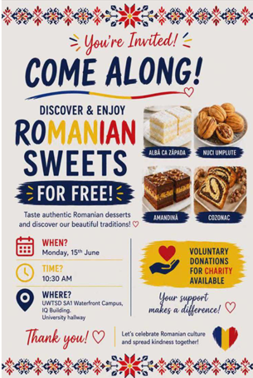

Iron Triangle
The Iron Triangle shows how project scope, cost, and time affect quality (Heagney, 2016). For our project, we had to manage direct costs like buying the cakes and indirect costs like travel.
As coordinator, I checked every step to make sure our event would be successful. The hardest part was balancing quality and time. We wanted high-quality Romanian cakes, so we used a professional baker. However, this was risky because if the delivery was late, we would miss the university break and fail the project.

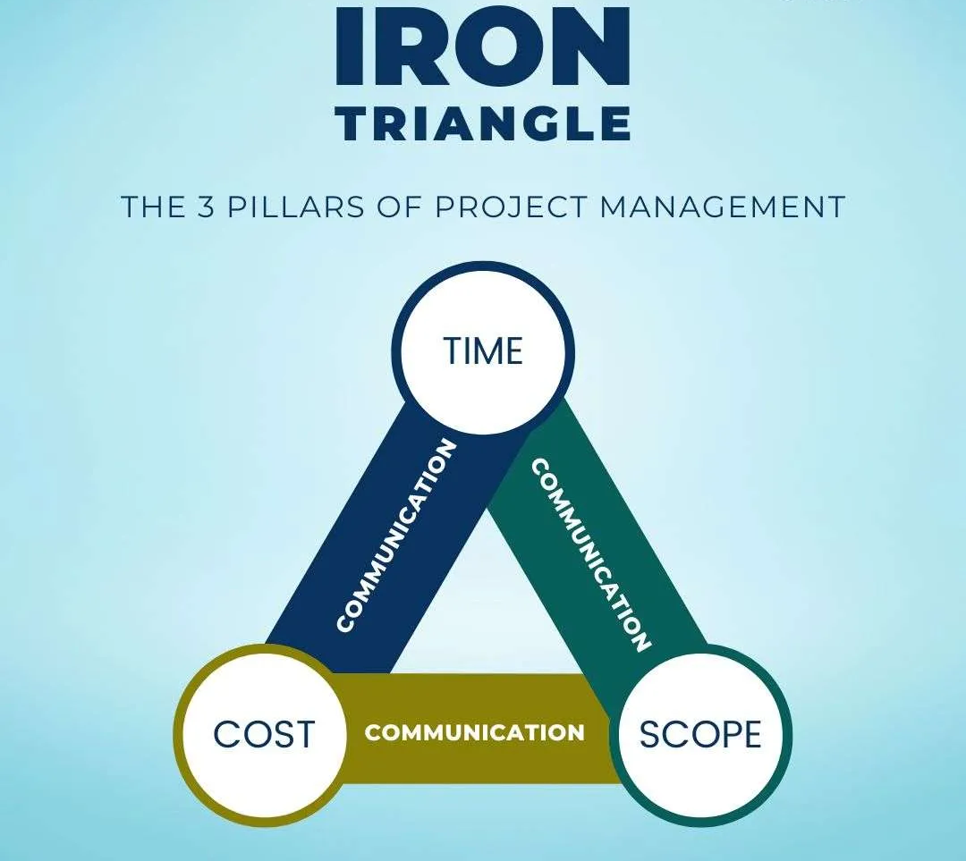

Figure 2: Iron Triangle
(Source: Duggan, 2026)

Blog 3: Stakeholder analysis and communication
Stakeholders
The major stakeholders are:
University
Eyst Swansea charity
Customers
Project team members
Stakeholder Matrix
To prioritise our communication, we mapped our stakeholders using Mendelow’s Power/Interest Matrix (Mendelow, 1991).

Stakeholder | Power | Interest | Communication Strategy
University | High Power | High Interest | Formal Emails
Eyst Swansea charity | High Power | Low Interest | Official Updates
Customers | Low Power | High Interest | Posters and flyers
Team Members | Moderate Power | High Interest | WhatsApp and Meetings

Table 1: Stakeholder Matrix
(Source: Self-Created)

Communication Plan
Our communication plan directly followed the matrix. For high-power stakeholders like the University and Eyst charity, we used formal emails and official updates for approvals. To reach customers, we placed promotional posters around campus. For our internal team, we used a WhatsApp group for quick daily updates and weekly face to face meetings to track tasks.
Assessment
Using this matrix helped us focus communication on the right people. However, as coordinator, balancing these styles was a challenge. Formal emails worked great for university staff but were too slow for team tasks. Meanwhile, relying on WhatsApp for the team sometimes caused minor misunderstandings because text messages are easily misinterpreted, so I had to make personals calls to clarify duties.

Blog 4: Planning Tools, WBS, and Gantt Chart
Work Breakdown Structure
To organise our charity event well, I created a WBS chart to split the project into clear stages, as shown in Figure 3. This tool helped me a lot as a leader to divide the tasks fairly. I gave specific roles to the girls. So, everyone knew exactly what to do and we did not get confused.
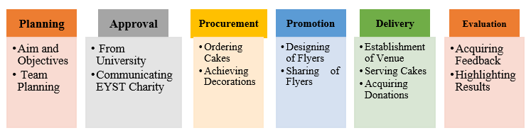

Figure 3: WBS
(Source: Self-Created)

Gantt Chart
To manage our time, I made a 4-week plan using a Gantt Chart table. In week 1, we focused on project planning and getting university approval. In week 2, we worked on the assessment of risks. Week 3 was dedicated to ordering our traditional Romanian cakes and aprons, plus designing and distributing flyers. Finally, in week 4, we focused entirely on the preparation and execution of the charity event.

Activities | W1 | W2 | W3 | W4
Planning of project
Getting approval from University
Assessment of risks
Ordering of cakes and aprons
Designing banners and flyers
Distribution of flyers
Preparation of event
Event of Charity
Table 2: Gantt Chart
(Source: Self-Created)
Benefits
Using the WBS and Gantt Chart brought great benefits because they kept our team organised and on schedule. It gave us transparency, and as coordinator, I could easily see if anyone needed help with their tasks.

Problems
Everything went well, but our main problem was that one team member replied very late to my messages about the project updates. To solve this, I spoke with them directly and established a quicker way to communicate, which kept our planning on schedule.
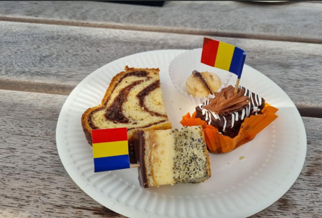

Blog 5: Risk + self-evaluation/ development

Strengths
My main strength during the Romanian Desserts project was handling the logistics. I managed to coordinate the team effectively, ensuring that the absolutely everything was ordered and received perfectly on time for our event.
Risks
An important risk in this event has been consideration of food allergies. To avoid any issues, we included clear information on our allergens as labels (Chang et al., 2023). Furthermore, we made sure to ask customers about their allergies before serving them any cakes.
Weakness
My main weaknesses was being too shy at the start of the event. I was very good at organising everything behind the scenes, but when people came to our stand, I felt nervous to speak and promote our Romanian culture right away.
Reflection
This project really helped me improve my planning, communication, and teamwork skills. Getting positive feedback from customers showed me that our hard work paid off, and it made me feel much more confident about coordinating similar events in the future.

Self-Enhancement Plan
Goal | Actions | Time
Improving communication skills | I will engage in team operations and proper presentation of information to develop my communication skills | 3 months
Developing project management skills | I will complete a virtual course on project management to enhance my project management skills | 6 months
Regulation of Stress | I will apply planning tools and time management methods for stress management | 1 year

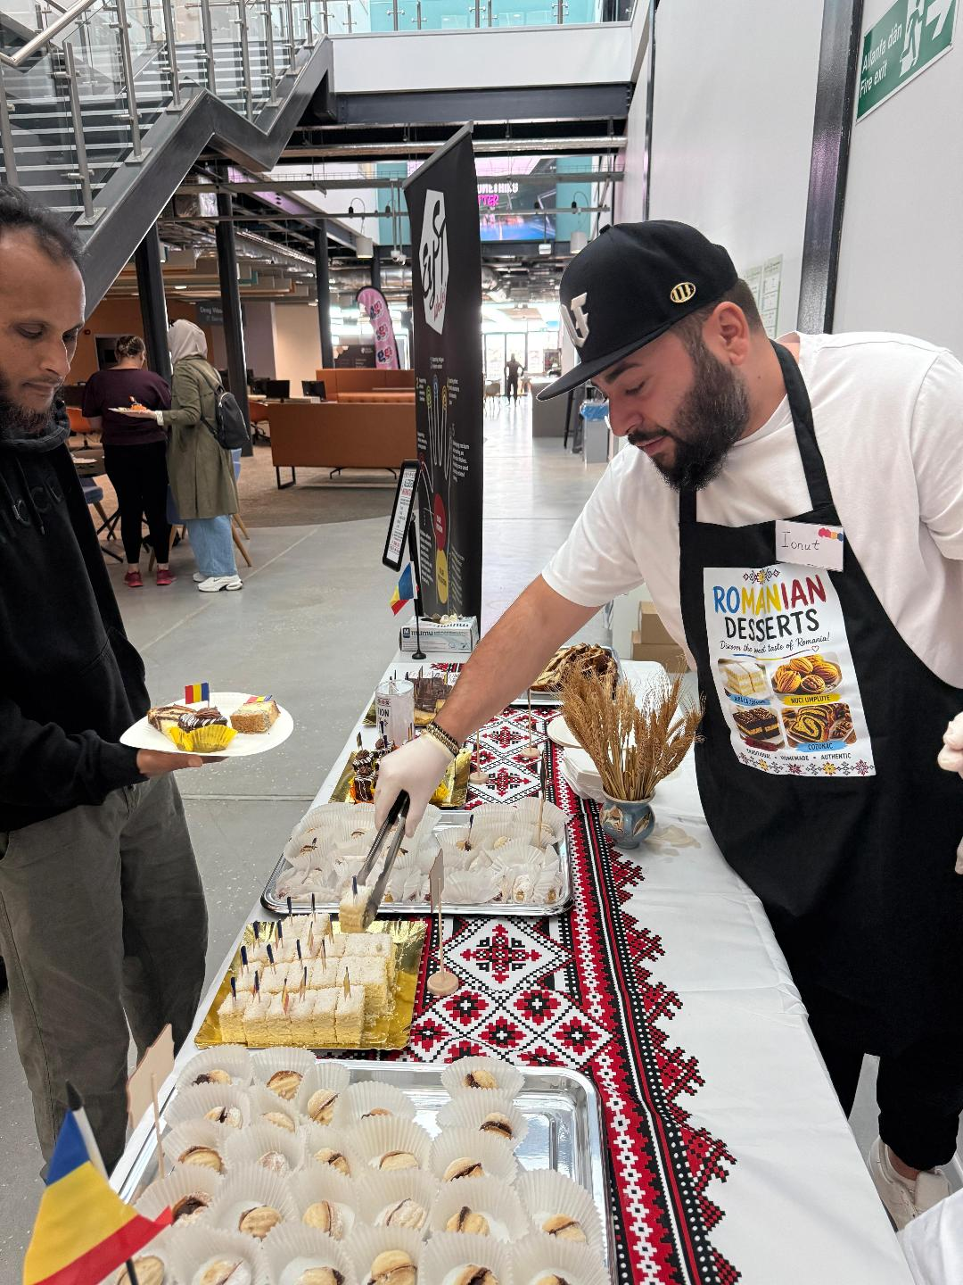
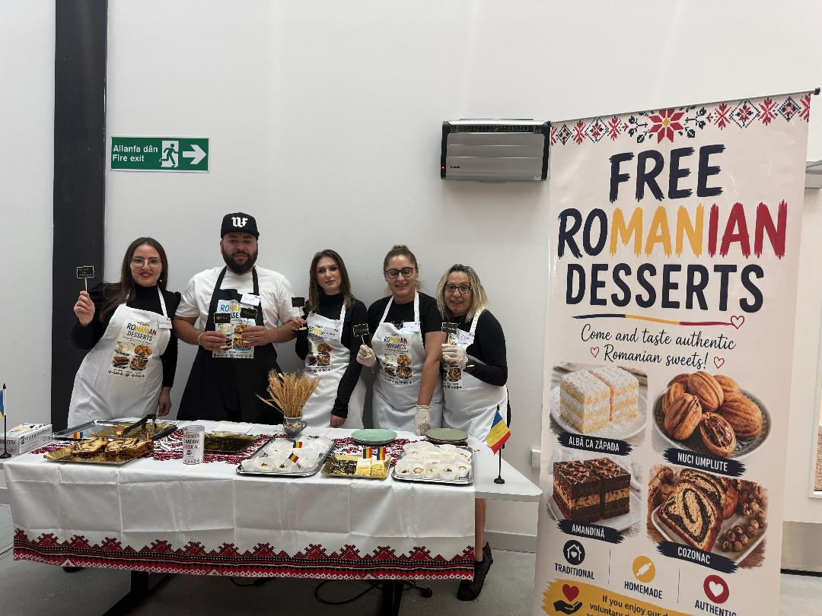

References
Atkinson, R. (1999). Project management: cost, time and quality, two best guesses and a development, its time to accept other success criteria. International Journal of Project Management, 17(6), pp.337-342.
Belbin, R.M. and Brown, R. (2022). Team Roles in Practice: Developing High-Performing Teams. London: Routledge.
Chang, Y., Wang, L. and Smith, J. (2023). Food Safety and Allergen Management in Community Events. London: Academic Press.
Duggan, J. (2026). The Iron Triangle: How to Balance Construction Constraints | Concord. The Concord Group. Available at: https://concord-cc.com/blog/the-iron-triangle/ (Accessed: 18 June 2026).
Freeman, R.E. (2010). Strategic Management: A Stakeholder Approach. Cambridge: Cambridge University Press.
Gibbs, G. (1988). Learning by Doing: A Guide to Teaching and Learning Methods. Further Education Unit. Oxford: Oxford Polytechnic.
Indeed (2026). The 9 Belbin Team Roles (With Definitions and Examples). Available at: https://www.indeed.com/career-advice/career-development/belbin-team-roles (Accessed: 17 June 2026).
Miller, D. (2026). Advantages and Disadvantages of Gantt Chart (+4 Best Tools). ProProfs Project Blog. Available at: https://www.proprofsproject.com/blog/advantages-disadvantages-gantt-charts/ (Accessed: 17 June 2026).
Simon, B. (2017). How to Use Teamwork Roles to Build Winning Teams. Smartsheet. Available at: https://www.smartsheet.com/how-to-use-teamwork-roles-to-boost-performance (Accessed: 17 June 2026).
Sukmono, C. (2023). Enhancing Project Management Efficiency in PERTAMINA through Work Breakdown Structure (WBS) and Cost Breakdown Structure (CBS) Integration. Structure (CBS), 1(2). Available at: https://pmworldlibrary.net/wp-content/uploads/2023/09/pmwj133-Sep2023-Sukmono-enhancing-project-management-efficiency-at-Pertamina-through-wbs-cbs-integration.pdf (Accessed: 17 June 2026).
Tampio, K.P., Haapasalo, H. and Ali, F. (2022). Stakeholder analysis and landscape in a hospital project—elements and implications for value creation. International Journal of Managing Projects in Business, 15(8), pp.48-76. Available at: https://www.emerald.com/ijmpb/article-pdf/15/8/48/930151/ijmpb-07-2021-0179.pdf (Accessed: 17 June 2026).

