Module: Introduction to Leadership and Management
Module Code: LCBB4015
Component 1: Practical: Group Presentation
Title: Managerial Roles in Unilever

Student Name: Razvan-Sorin Grigore
Mihaela-Mirela Grigore

Student ID:2328067
2328068

Table of Contents
Slide 1: Cover page 3
Slide 2: Table of Contents 4
Slide 3: Introduction 5
Slide 4: Overview of Unilever 6
Slide 5: Mintzberg’s 10 managerial roles framework 7
Slide 6: Interpersonal Roles – Figurehead 8
Slide 7: Interpersonal Roles – Leader 9
Slide 8: Interpersonal Roles – Liaison 10
Slide 9: Informational Roles – Monitor 11
Slide 10: Informational Roles – Disseminator 12
Slide 11: Informational Roles – Spokesperson 13
Slide 12: Decisional Roles – Entrepreneur 14
Slide 13: Decisional Roles – Disturbance Handler 15
Slide 14: Decisional Roles – Resource Allocator 16
Slide 15: Decisional Roles – Negotiator 17
Slide 16: Additional Managerial Roles in Today’s Environment 18
Slide 17: Additional Managerial Roles in Today’s Environment 19
Slide 18: Future of Managerial Roles 19
Slide 19: Conclusion 21
Slide 20: Reference List 22
Slide 21: Thank You 25

Slide 1: Cover page
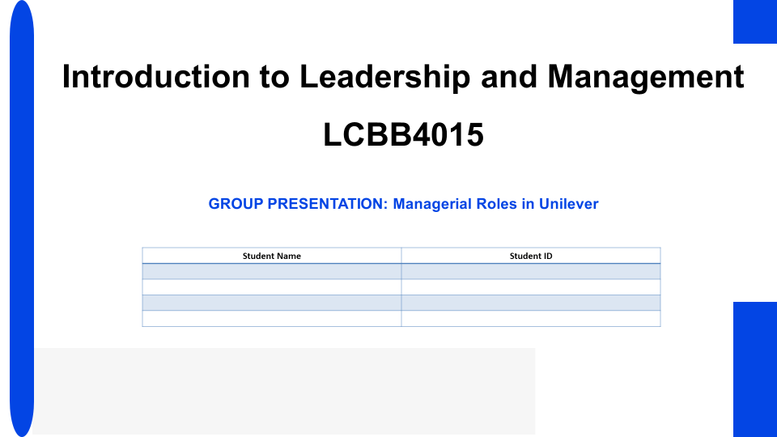

Slide 2: Table of Contents
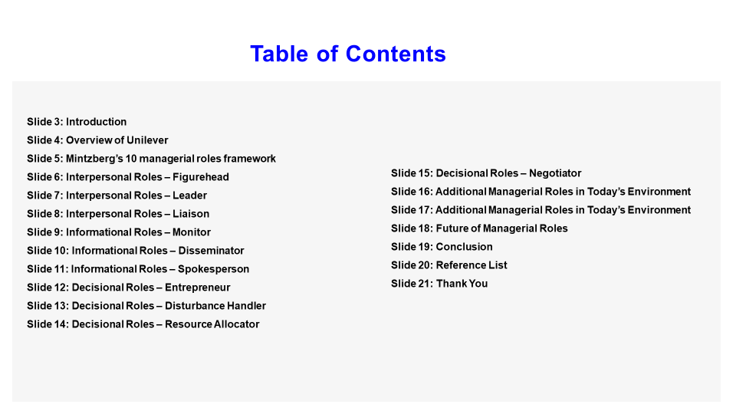

Slide 3: Introduction
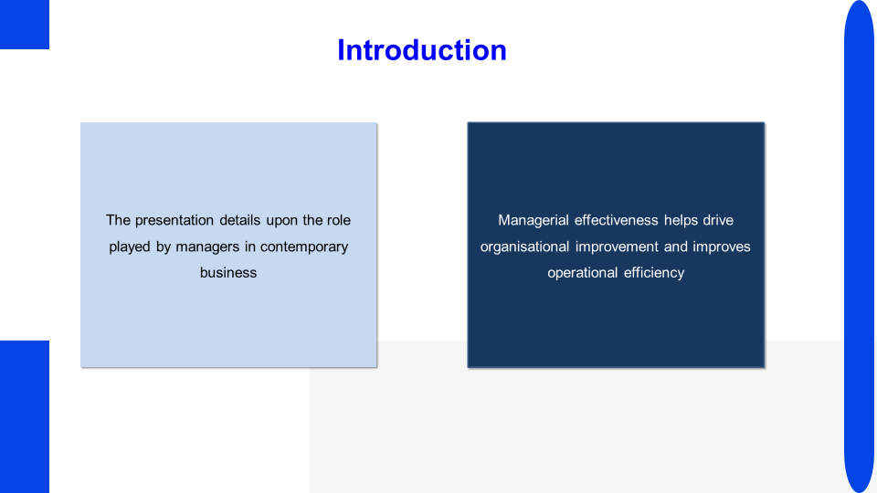
Speaker Notes
The presentation focuses on determining the role of contemporary business managers and their role in enabling improvement in operations. The ten managerial role model of Mintzberg is utilised to evaluate relevance of managerial behavioural implications. The UK based MNC Unilever is chosen due to the presence of multiple managers in various levels helping assess the dynamic management of managerial roles in organisations. The presentation also identifies additional managerial roles relevant in today’s environment and ones that can be utilised to foster employee growth respectively.

Slide 4: Overview of Unilever
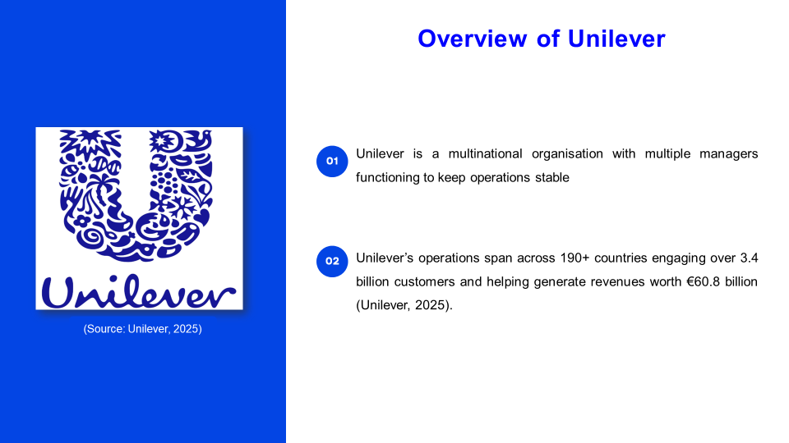
Speaker Notes
Unilever is a prominent MNC and is chosen as its multiple managerial roles are perfect for evaluation via Mintzberg’s model. Unilever operates in the FMCG sector and sports a vast range of product SKUs and categories to maximise revenue sales. The firm is vastly successful in its market as evident from the €60.8 billion revenue as of 2024 and 58% market acceptance in emerging markets. Thus, the firm’s managers help maximise operational efficiency, increase service viability and also facilitate seamless labour management.

Slide 5: Mintzberg’s 10 managerial roles framework
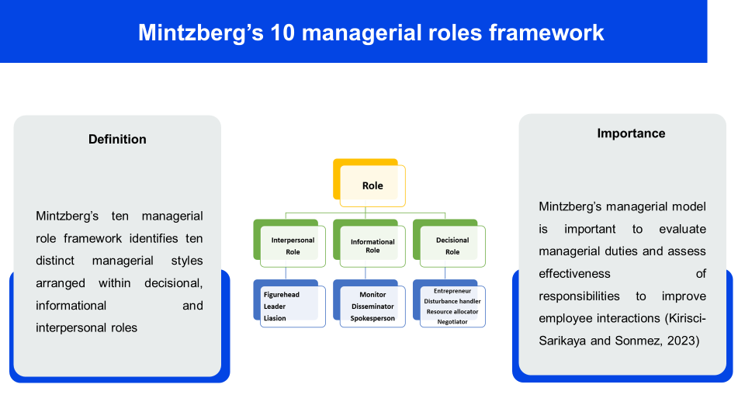
Speaker Notes
The ten roles of Mintzberg's managerial framework highlights the behavioural styles categories for managerial positions to act as a checklist. The model is relevant for managers to assess personal operational style and identify the facets of behaviour to adopt for maximising worker efficiency. The ten behavioural styles of the framework are utilised to assess potential behavioural traits within managers of Unilever and evaluate methods to improve performance.

Slide 6: Interpersonal Roles – Figurehead
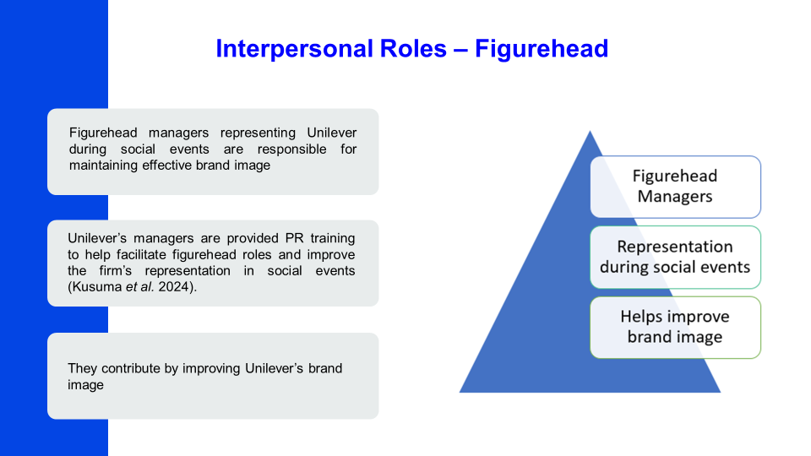
Speaker Notes
Figurehead managerial role involves completing duties such as public events and appearances and is only set forth for highest-level managers. The managers of Unilever can develop the role of Figurehead by being offered behavioural analysis during PR training to maximise public engagement during events. The Figurehead role contributes to Unilever’s firm performance by setting forth a beneficiary and esteemed brand image in the eyes of the public to maximise market share.

Slide 7: Interpersonal Roles – Leader
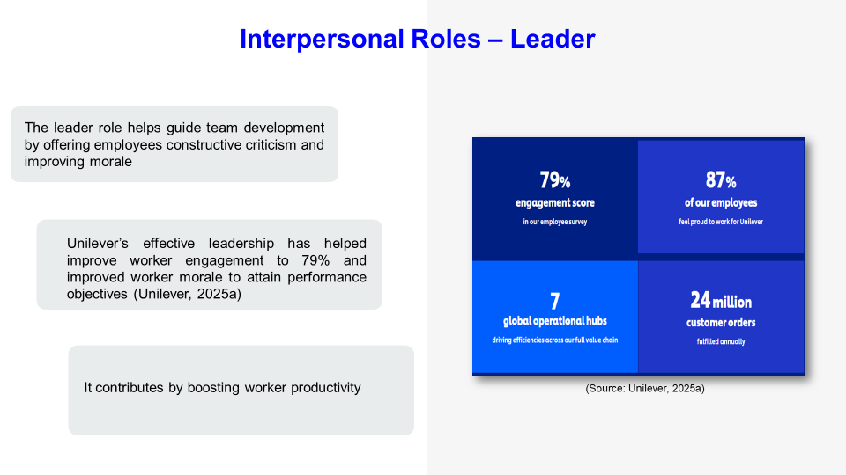
Speaker Notes
The role of leader interpersonal managerial role is to improve worker morale and offer supportive resources to improve individual productivity levels. The managers in Unilever have effectively developed leadership skills via receiving worker training and utilised well-being initiatives to improve worker engagement levels. The leadership behaviour can be improved within Unilever’s managers by improving work benefits provided and increasing the rate of appraisal of workers to further improve engagement. The interpersonal managerial role contributes to organisational performance of Unilever by increasing worker morale and improving alignment between personal goals and organisational objectives of workers.

Slide 8: Interpersonal Roles – Liaison
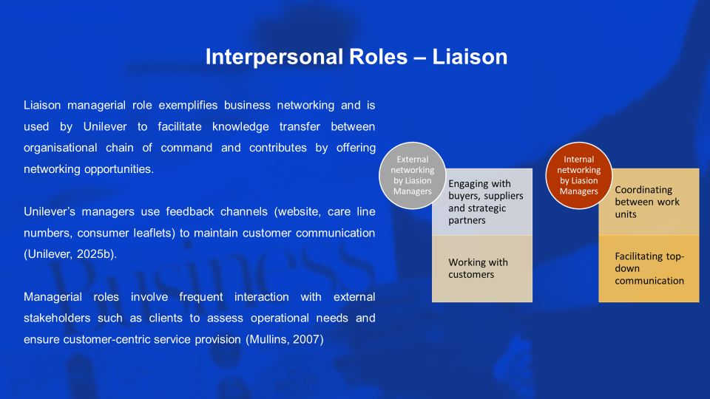
Speaker Notes
The role of Liaison managers is to effectively manage a consistent business network consisting of external and internal stakeholders. Unilever’s managers exemplify this behaviour by using feedback channels to connect with customers and suppliers respectively. The managers of Unilever can further develop the role by opting to implement a centralised communication platform. The Liaison role helps improve organisational communication and allows firms such as Unilever to maintain a stable stakeholder network.

Slide 9: Informational Roles – Monitor
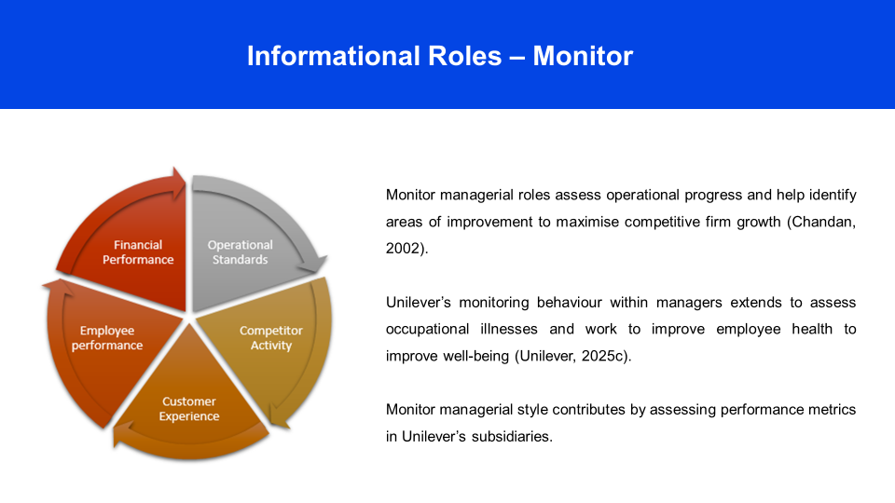
Speaker Notes
The monitor role is useful for firms to ensure that intel is gathered from operations to assess the target attainment of quarters and to identify areas of improving efficiency. Unilever’s process of monitoring by managers can be improved by communicating operational targets and offering attractive incentives to maximise worker engagement. The monitor role contributes to organisational success within large-scale firms such as Unilever by assessing performance attainment in all subsidiaries and matching it to expectations of upper management.

Slide 10: Informational Roles – Disseminator
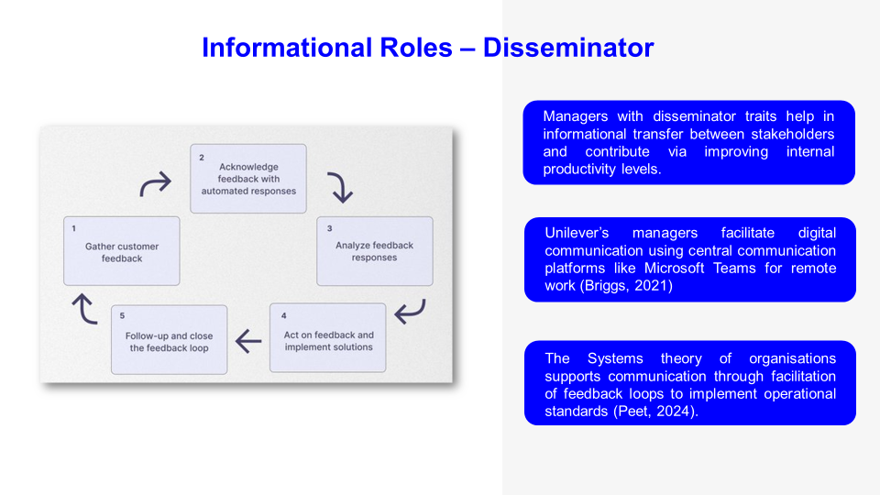
Speaker Notes
The Disseminator managerial style is reciprocated by HR managers of Unilever by facilitating use of digital communication via Microsoft teams to maximise operational efficiency. The disseminator style helps improve Unilever’s financial success by allowing for heightened productivity even in remote work teams. The Systems theory supports the style and denotes that regular communication via feedback channels is vital to maintain operational compliance with upper management.

Slide 11: Informational Roles – Spokesperson
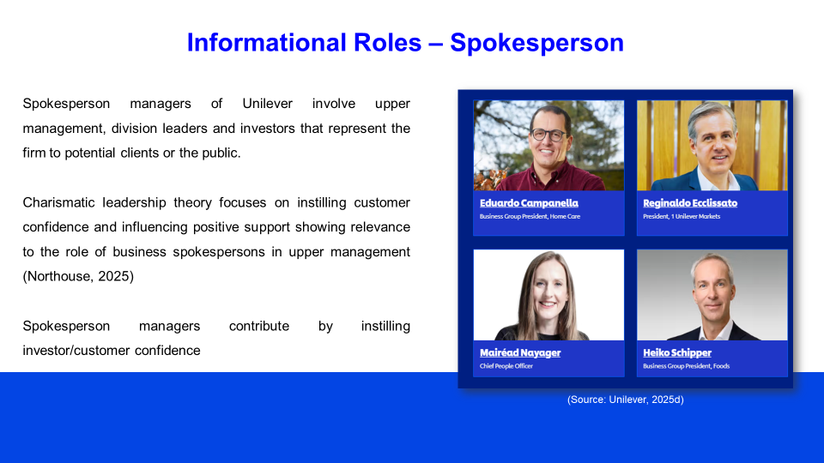
Speaker Notes
The spokesperson managerial roles in Unilever comprise of group presidents and chief people officers who are responsible for frequent PR communications to maintain brand awareness. The managerial role contributes to Unilever’s organisational success by helping create a reputed brand image and improving general public brand reception, improving chances of revenue attainment. The charismatic leadership theory best represents the spokesperson style as it involves developing public-pleasing personalities that are able to instill confidence within investors or customers to maximise brand adoption.

Slide 12: Decisional Roles – Entrepreneur
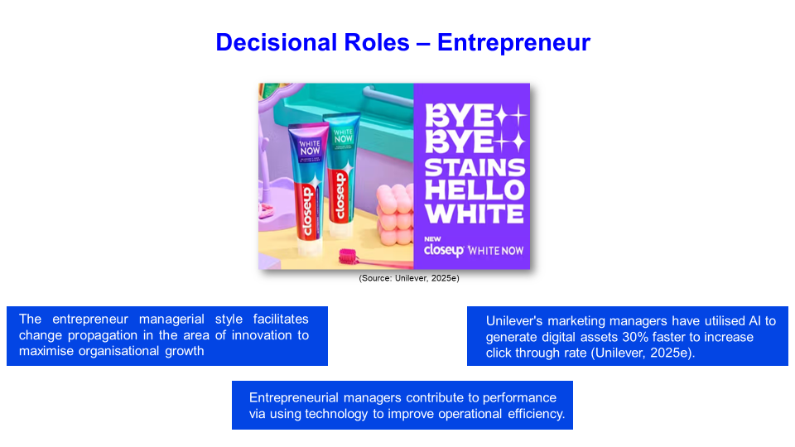

Speaker Notes
The entrepreneurial managerial style in Unilever has observed managers developing skill in AI usage to maximise asset generation efficiency. The use of AI developed assets has helped Unilever to support the change of automated asset management and boosted marketing click through rate by 22.5%. The use of AI and other technologies helps contribute to firm performance by increasing work efficiency and maximising marketing returns.

Slide 13: Decisional Roles – Disturbance Handler
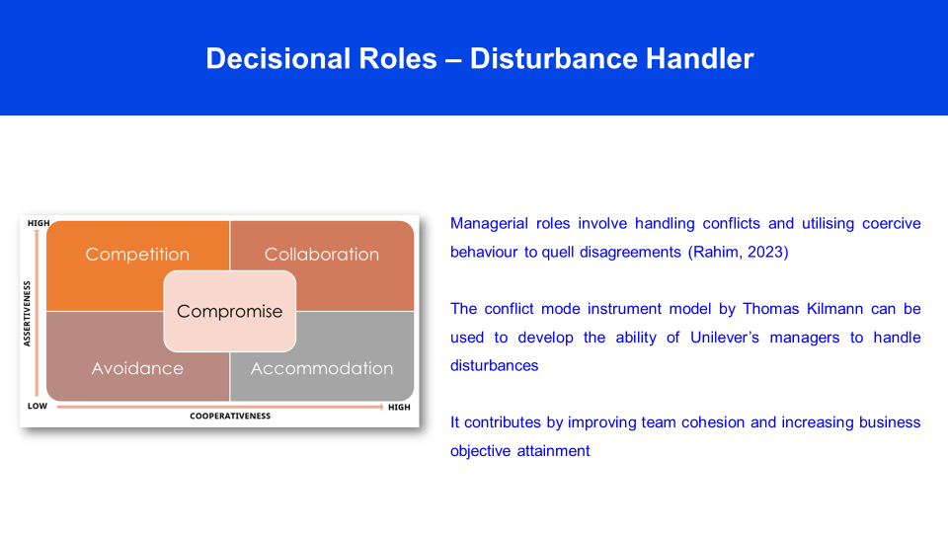
Speaker Notes
The disturbance handler managerial role involves the process of resolving conflicts and maintaining a harmonious work environment to improve service appeal. The conflict mode instrument model dictates that assertive and cooperative traits are essential for managers to maintain a balance between demands of all parties during conflicts. The managerial role can contribute to improve team cohesion levels in Unilever and maximise individual productivity of workers in attainment of business objectives respectively.

Slide 14: Decisional Roles – Resource Allocator
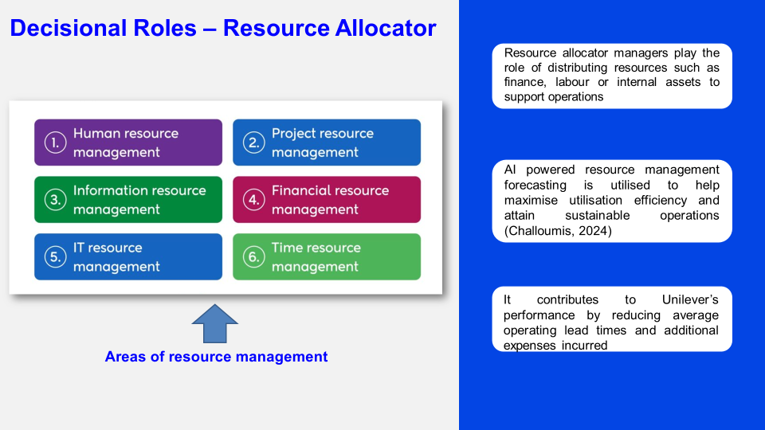
Speaker Notes
Resource allocator managers in respect to Unilever typically constitute project managers or operations heads that offer each department a fixed budget, manpower or resources. The AI powered resource management is recommended to help managers of Unilever develop this role and offer proactive resources. The style contributes to firm performance as it reduces lead times and helps maintain a pre-set budget.

Slide 15: Decisional Roles – Negotiator
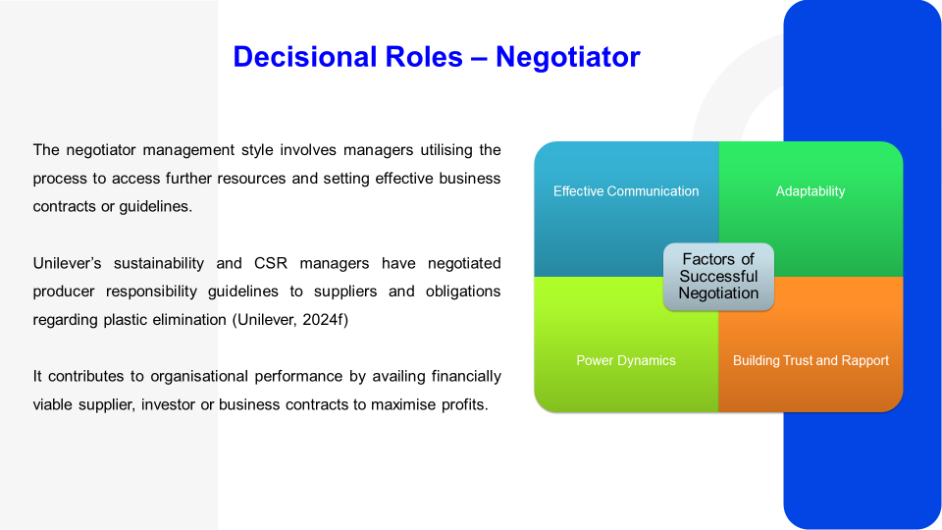
Speaker Notes
The role of negotiator managers in Unilever was identified to utilise the skill and increase the firm’s access to capital or operational resources. The example shows that Unilever’s managers effectively use negotiation to regularly update supplier contracts to maximise accountability regarding responsible sourcing to support the sustainable brand image of Unilever.

Slide 16: Additional Managerial Roles in Today’s Environment
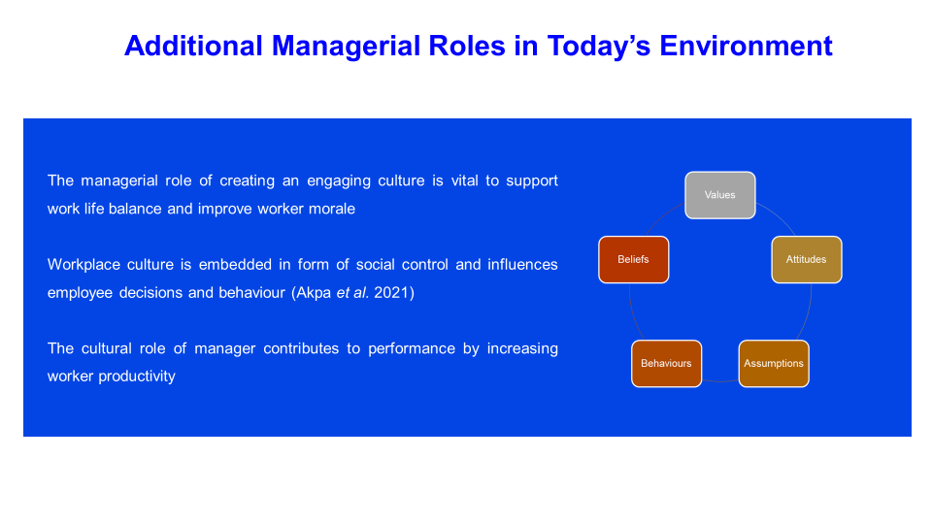
Speaker Notes
The managerial role of culturally engaging managers are relevant in the modern environment as a positive culture drives worker productivity. A positive cultural integration in firms such as Unilever have helped to set a precedent for sustainable brand image and is crucial to improve worker productivity.

Slide 17: Additional Managerial Roles in Today’s Environment
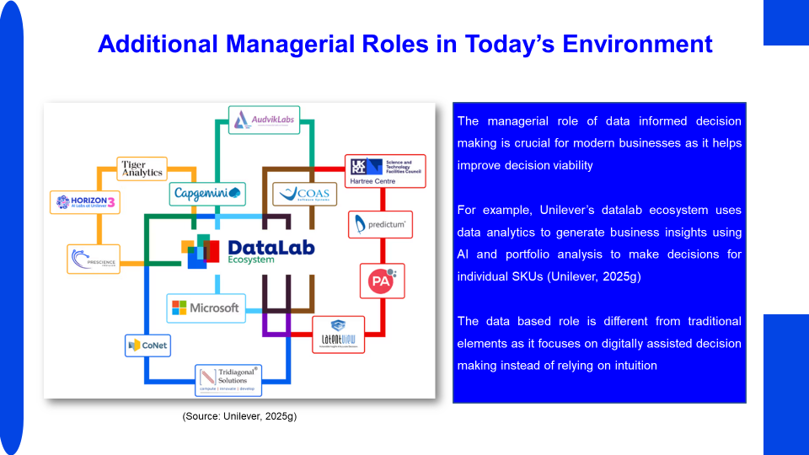
Speaker Notes
The managerial role of using data analytics helps utilise business insights to support decisions and maximise revenue generated. The example of Unilever shows that the managerial style eliminates the reliance on personal intuition and utilises forecasting to support business decisions respectively.

Slide 18: Future of Managerial Roles
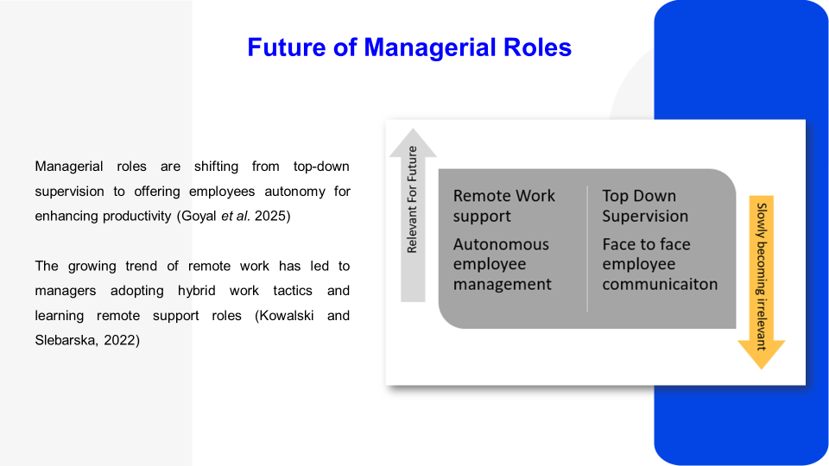
Speaker Notes
The future of managerial roles is leaning towards offering workers autonomy in order to support internal creativity and improve time management in operations. Similarly, the trend of remote work has led to managers becoming prepared to handle hybrid work and offering support to remote teams effectively using decentralised communication platforms.

Slide 19: Conclusion
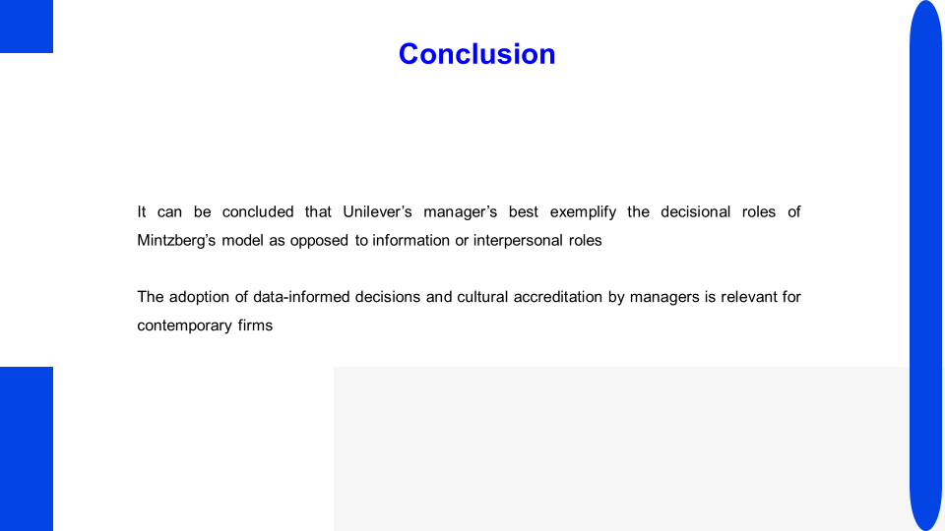
Speaker Notes
The managerial roles of Mintzberg’s model effectively denote the multifaceted nature of behaviours that support firms such as Unilever to maximise stakeholder engagement. The future of managerial roles show that Unilever can increase worker autonomy provision and maximise support for remote work teams by creating new digital platforms.

Slide 20: Reference List
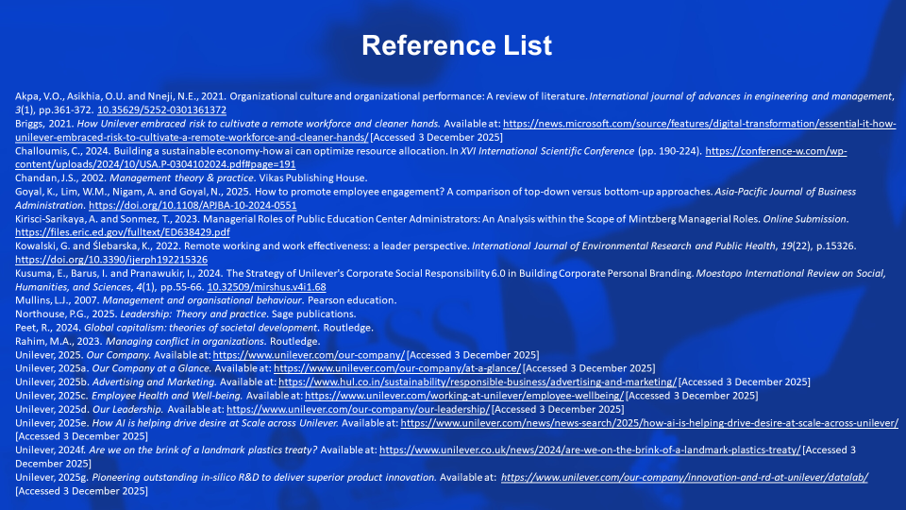
Akpa, V.O., Asikhia, O.U. and Nneji, N.E., 2021. Organizational culture and organizational performance: A review of literature. International journal of advances in engineering and management, 3(1), pp.361-372. 10.35629/5252-0301361372
Briggs, 2021. How Unilever embraced risk to cultivate a remote workforce and cleaner hands. Available at: https://news.microsoft.com/source/features/digital-transformation/essential-it-how-unilever-embraced-risk-to-cultivate-a-remote-workforce-and-cleaner-hands/ [Accessed 3 December 2025]
Challoumis, C., 2024. Building a sustainable economy-how ai can optimize resource allocation. In XVI International Scientific Conference (pp. 190-224). https://conference-w.com/wp-content/uploads/2024/10/USA.P-0304102024.pdf#page=191
Chandan, J.S., 2002. Management theory & practice. Vikas Publishing House.
Goyal, K., Lim, W.M., Nigam, A. and Goyal, N., 2025. How to promote employee engagement? A comparison of top-down versus bottom-up approaches. Asia-Pacific Journal of Business Administration. https://doi.org/10.1108/APJBA-10-2024-0551
Kirisci-Sarikaya, A. and Sonmez, T., 2023. Managerial Roles of Public Education Center Administrators: An Analysis within the Scope of Mintzberg Managerial Roles. Online Submission. https://files.eric.ed.gov/fulltext/ED638429.pdf
Kowalski, G. and Ślebarska, K., 2022. Remote working and work effectiveness: a leader perspective. International Journal of Environmental Research and Public Health, 19(22), p.15326. https://doi.org/10.3390/ijerph192215326
Kusuma, E., Barus, I. and Pranawukir, I., 2024. The Strategy of Unilever's Corporate Social Responsibility 6.0 in Building Corporate Personal Branding. Moestopo International Review on Social, Humanities, and Sciences, 4(1), pp.55-66. 10.32509/mirshus.v4i1.68
Mullins, L.J., 2007. Management and organisational behaviour. Pearson education.
Northouse, P.G., 2025. Leadership: Theory and practice. Sage publications.
Peet, R., 2024. Global capitalism: theories of societal development. Routledge.
Rahim, M.A., 2023. Managing conflict in organizations. Routledge.
Unilever, 2024f. Are we on the brink of a landmark plastics treaty? Available at: https://www.unilever.co.uk/news/2024/are-we-on-the-brink-of-a-landmark-plastics-treaty/ [Accessed 3 December 2025]
Unilever, 2025. Our Company. Available at: https://www.unilever.com/our-company/ [Accessed 3 December 2025]
Unilever, 2025a. Our Company at a Glance. Available at: https://www.unilever.com/our-company/at-a-glance/ [Accessed 3 December 2025]
Unilever, 2025b. Advertising and Marketing. Available at: https://www.hul.co.in/sustainability/responsible-business/advertising-and-marketing/ [Accessed 3 December 2025]
Unilever, 2025c. Employee Health and Well-being. Available at: https://www.unilever.com/working-at-unilever/employee-wellbeing/ [Accessed 3 December 2025]
Unilever, 2025d. Our Leadership. Available at: https://www.unilever.com/our-company/our-leadership/ [Accessed 3 December 2025]
Unilever, 2025e. How AI is helping drive desire at Scale across Unilever. Available at: https://www.unilever.com/news/news-search/2025/how-ai-is-helping-drive-desire-at-scale-across-unilever/ [Accessed 3 December 2025]
Unilever, 2025g Pioneering outstanding in-silico R&D to deliver superior product innovation. Available at: https://www.unilever.com/our-company/innovation-and-rd-at-unilever/datalab/ [Accessed 3 December 2025]

Slide 21: Thank You


