Foreign Languages and Cultural Awareness
BMIH5003

Diversity Hotel & Spa expansion in Italy
Report
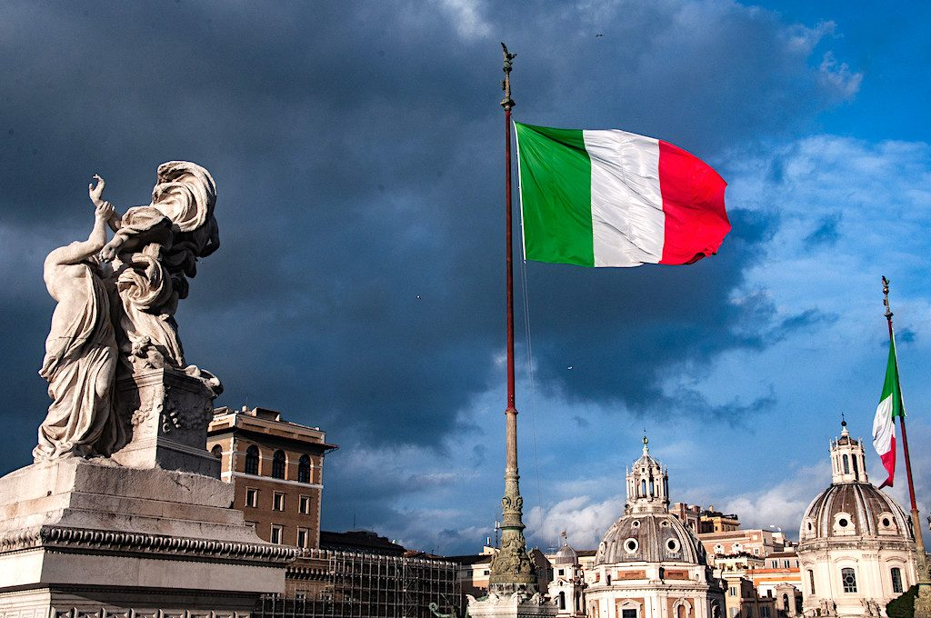

Module leader: Heidi Prosser
Student name: Georgiana Ramona Cucu
Student id: 2213957
Word count: 1080

Executive summary
In order to bring Diversity Hotel & Spa into compliance with Italian hospitality standards, an accurate understanding of the cultural dynamics of the region is necessary. Italian culture affects what is expected of service sectors because of its emphasis on formal business conduct, family, and community. This paper addresses the value of intercultural competency in delivering exceptional customer service by giving the general manager vital insights into Italian business practises and society standards. It draws attention to the necessity of management techniques that take into account the regional cultural differences in Italy and suggests methods that encourage tailored but organised visitor experiences.

Contents:

Executive summary 2
Introduction 4
Italy’s cultural atmosphere 4
Italy’s Hofstede analysis 4
Italy’s insights from the Globe Project 6
Cultural intelligence and sensitivity 6
Conclusion 7
Recommendations 7
References 9

Diversity Hotel & Spa expansion in Italy

Introduction
The report has as objective to inform the general manager of Diversity Hotel & Spa about the Italian culture. This is because the Diversity Hotel &Spa have recently expanded its operations into Italy. The reputation of Italy for its rich cultural legacy, which includes art, food, and manners, is critical to providing exceptional guest service. In addition, the report will analyse how Italian cultural norms affect hospitality. The general manager must be familiar with this in order to make sure that the brand's standards are in line with Italian norms.

Italy’s cultural atmosphere
Italy's cultural setting is richer because of its history, and this history continues to shape how people live and do business there. In modern Italy, there is an intense focus on family and community, which is an important part of both everyday life and work relationships. A study that looked at how culture affects business indicated that Italian companies put a lot of value on social capital and relationship networks, which facilitate business and are necessary for managing the local market (Capaldo, 2007). Additionally, in Italy, interpersonal connections and networks are critical. This is characteristic of the Mediterranean culture, where trust and long-term relationships are common in business (Ritala et al., 2015). In the hospitality business, where personalised service and building relationships with guests can lead to higher customer happiness and loyalty, this trait is vital. Italian culture also places considerable importance on charismatic and paternalistic leadership styles in the areas of management and leadership. These styles are consistent with the country's focus on respecting authority figures and maintaining familial relationships. Effective leaders have to find a balance between meeting professional obligations and showing genuine care for the welfare of their subordinates (Maheshkar and Sharma, 2018).

Italy’s Hofstede analysis
When applying Hofstede's five dimensions to Italy, it can be seen that the country maintains a good balance between collectivism and individualism. The northern area of Italy, which values decentralisation, and equality, has a lower power distance score than the southern region, which has greater power distance attributes, reflecting differing management expectations in hospitality. Italy has a moderate level of individualism (53), although there is still a geographical split, with the north being more individualistic than the south. This may indicate that hospitality professionals in northern Italy place a higher priority on individualism and success than their southern Italian equivalents, who place a higher importance on family and community (Hofstede Insights, 2023). On the other hand, the high level of masculinity in Italy (70) can be explained by the nation's focus on hard work and achievement. As a result, those who work in the hospitality business tend to demonstrate their successes by providing very high standards of service and infrastructure. The Italian hospitality industry is highly structured and formal, with defined expectations and standards, possibly reflecting the country's high uncertainty avoidance score (75). Contrarily, the United Kingdom has a smaller power distance (35) than Italy does, suggesting that its citizens would like to reduce inequality. As a result, British hospitality may become more inclusive as a result. (Hofstede Insights, 2023). The United Kingdom has a higher level of individualism (76), suggesting a culture that promotes personal freedom and pride in one's own accomplishments; this may translate into a style of leadership that encourages autonomy and initiative on the job.

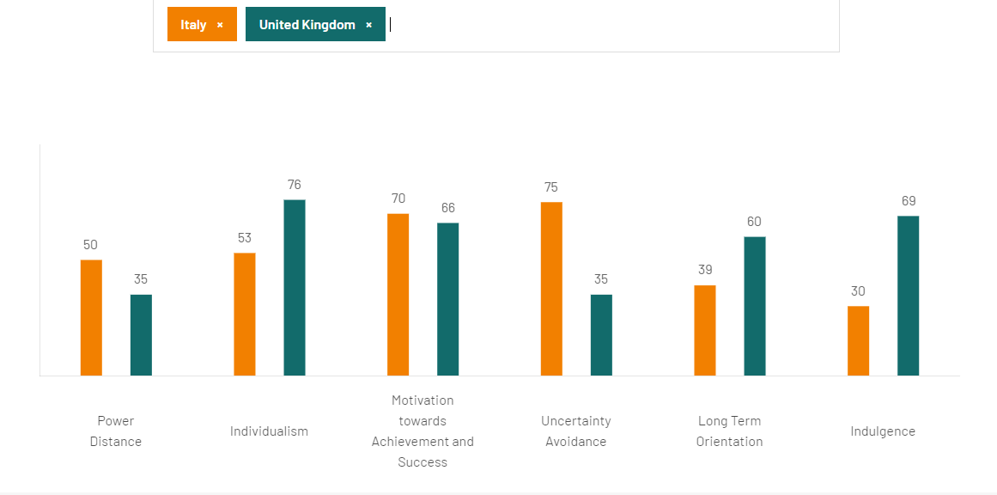
Fig 1. Hofstede Insights (2023). Italy comparison with United Kingdom.

Italy’s insights from the Globe project
Analysis of Italy by the Globe Project (2023) indicates a high performance focus indicative of a culture that promotes improvement in performance and excellence. Additionally, Italians are recognised for their assertiveness and directness in interpersonal interactions, there is a clear focus on the future, with a social tendency to save and invest for the future. The society rewards justice and selflessness, demonstrating a humanitarian mindset. Measures of institutional and in-group collectivism show the tendency of Italian institutional practises to promote group activities and resource sharing. Although it must be done so within a culture that acknowledges power disparities and status distinctions, gender equality is promoted. Moderate uncertainty avoidance finds a balance between adherence to established standards and a certain level of adaptability. Italian leadership is known for its charismatic approach, high-achieving, values-aligned performance, and team-oriented leadership that promotes cooperation towards shared objectives (Globe Project, 2023). Involving team members in decision-making processes, managers tend to display participatory behaviour, which is indicative of a culture that values both individual contribution and harmony within the group.
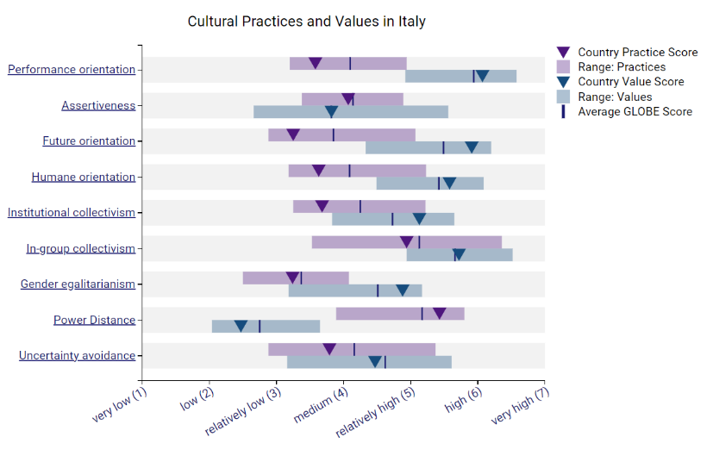 | 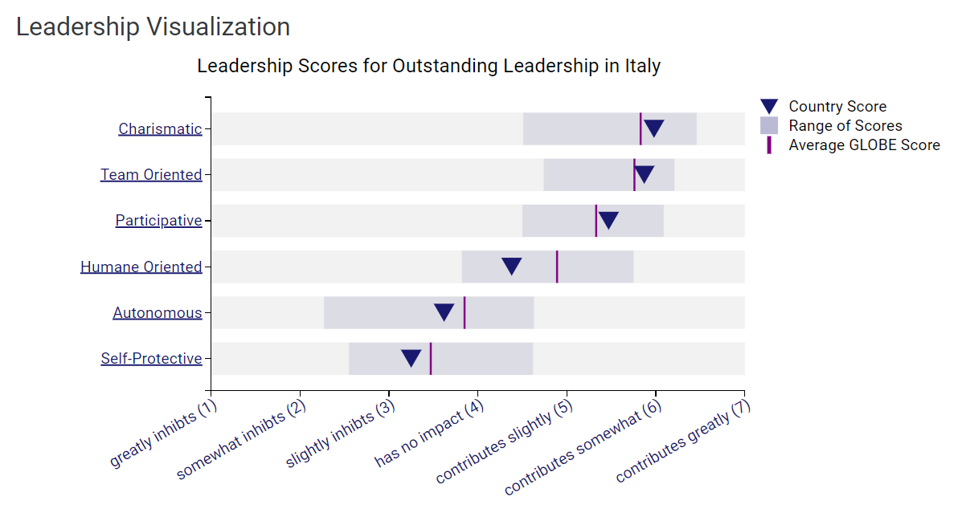
Fig 2. Global Project (2023). Italy’s Culture and Leadership

Cultural intelligence and sensitivity
The capacity to function and interact well in a range of cultural situations is what Italians refer to as cultural intelligence. The varied socioeconomic environment of Italy, which has been influenced by significant demographic shifts and an expanding labour force of foreign nationals, makes this skill especially relevant (Thomas, 2018). The four essential components of cultural intelligence are motivational, behavioural, metacognitive, and cognitive. The metacognitive component entails comprehending cultural assumptions and engaging in considerate thought. Cognitive ability and familiarity with cultural norms and practises are related. The motivational component concerns the desire to comprehend and perform in a multicultural environment (Eisenberg et al., 2013). Lastly, the capacity to modify one's behaviour correctly in various cross-cultural situations is referred to as behavioural intelligence. The initiative to validate a Cultural Intelligence Scale, which aims to evaluate and develop cultural abilities, demonstrates Italy's dedication to cultivating such intelligence. This project demonstrates how Italy views cultural sensitivity and adaptation, seeing them as essential in a globalising professional environment (Gozzoli and Gozzoli, 2018).

Conclusion
To conclude, the general manager must possess a keen understanding of Italian culture given Diversity Hotel & Spa's entry into the country. In order to make sure the brand is in accordance with local expectations and norms, the research outlines how important it is to comprehend and respect Italy's varied cultural etiquette and business behaviour. It is imperative to conform to Italian hospitality conventions and leadership styles in order to ensure smooth operations and a genuine visitor experience that is consistent with Italy's renowned cultural legacy.

Recommendations
- Accept regional cultural variations within Italy and modify management and customer service approaches accordingly.
- Encourage employees to develop interpersonal skills in line with Italy's emphasis on trust and social capital (Hampden-Turner and Trompenaars, 2020).
- Motivate employees in the hotel industry to provide exceptional service, mirroring Italy's emphasis on accomplishment.
- Advance gender parity and managerial participation, honouring power structures and fostering collaboration (Burke, 2014).

References

- Burke, P. (2014). The Italian Renaissance: Culture and Society in Italy - Third Edition. [online] Google Books. Princeton University Press. Available at: https://www.google.co.uk/books/edition/The_Italian_Renaissance/5uo9DwAAQBAJ?hl=en&gbpv=1&dq=Italy+culture&pg=PA1&printsec=frontcover [Accessed 2 Nov. 2023].

- Capaldo, A. (2007). Network structure and innovation: The leveraging of a dual network as a distinctive relational capability. Strategic Management Journal, 28(6), pp.585–608. doi:https://doi.org/10.1002/smj.621.

- Eisenberg, J., Lee, H.-J., Brück, F., Brenner, B., Claes, M.-T., Mironski, J. and Bell, R. (2013). Can Business Schools Make Students Culturally Competent? Effects of Cross-Cultural Management Courses on Cultural Intelligence. Academy of Management Learning & Education, 12(4), pp.603–621. doi:https://doi.org/10.5465/amle.2012.0022.

- Globe Project (2023). Results - Italy GLOBE Project. [online] Available at: https://globeproject.com/results/countries/ITA?menu=list#country.

- Gozzoli, C. & Gazzaroli, D. (2018) 'The Cultural Intelligence Scale (CQS): A Contribution to the Italian Validation', Frontiers in Psychology, 9, [Online]. Available at: https://doi.org/10.3389/fpsyg.2018.01183

- Hampden-Turner, C. and Trompenaars, F. (2020) Riding the Waves of Culture. 4 th Ed. London: John Murray Press.

- Hofstede Insights (2023). Country comparison tool. [online] Available at: https://www.hofstede-insights.com/country-comparison-tool?countries=italy%2Cunited+kingdom.

- Maheshkar, C. and Sharma, V. (2018) Handbook of Research on Cross-Cultural Business Education. Hershey: IGI Global.

- Ritala, P., Olander, H., Michailova, S. and Husted, K. (2015). Knowledge sharing, knowledge leaking and relative innovation performance: An empirical study. Technovation, 35, pp.22–31. doi:https://doi.org/10.1016/j.technovation.2014.07.011.

- Thomas, D.C. (2008). Cultural Intelligence: People Skills for Global Business. [online] Google Books. ReadHowYouWant.com. Available at: https://www.google.co.uk/books/edition/Cultural_Intelligence/ag6Ciiz9fpUC?hl=en&gbpv=1&dq=cultural+intelligence+italy+business&pg=PR1&printsec=frontcover [Accessed 30 Oct. 2023].
‌

‌

