Michael Thomas – 2312281
History & Theory 1
ACAA4003

Robie House - Frank Lloyd Wright

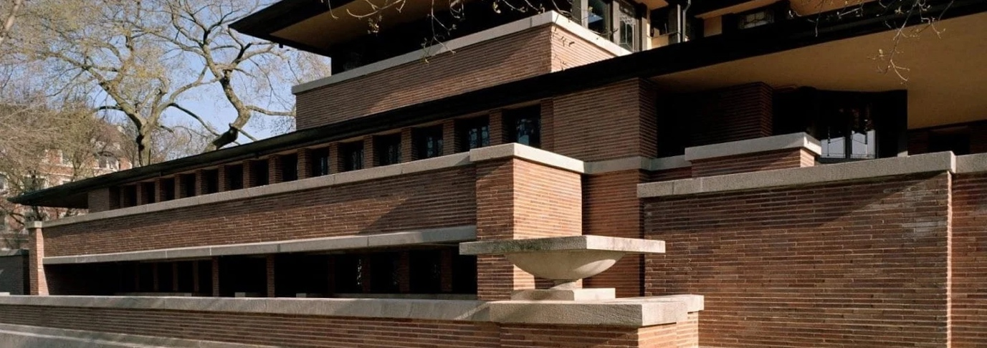
1
Figure 1. South front of Robie House, Chicago, Illinois (Frank Lloyd Wright Foundation, n.d.)

Background

The site which would become known as The Robie House, was purchased by Frederick C. Robie in April 1908, at a cost of $13,500 (Hoffman, 1984). Situated on the junction of Woodlawn Avenue and East 58th Street and just a short distance from The University of Chicago, the site covers approximately 180ft X 60ft (Hoffman, 1984). Robie, an executive car manufacturer, had bought the land with the intention of building a home for his young family. In his mind he wanted a house that differed with the designs of its time, what he would call a “conglomeration of architecture” (Hoffman, 1984). He intended on having rooms without interruption, with a vast amount of light penetrating the inside, offering views of the surrounding streets while also creating privacy and security for himself and his family (Hoffman, 1984).

To achieve these goals Robie would employ architect Frank Lloyd Wright in 1908. Wright had come to prominence in the late 19th century working for Adler & Sullivan before eventually opening his own studio from his home in Oak Park, Chicago (Pfeiffer, 2002). Before the meeting of the two men, Wright had established a new distinctive style which he would become renown for, the Prairie House. The Robie House, which would be completed in 1910 (Hoffman, 1984) would eventually be regarded as the highpoint of this unique style.

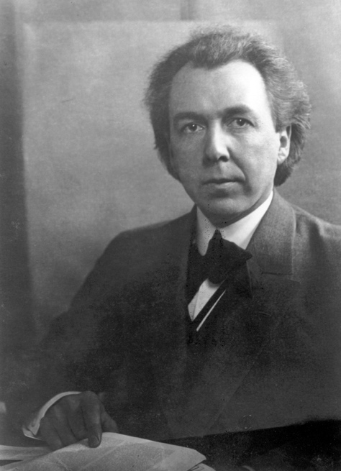
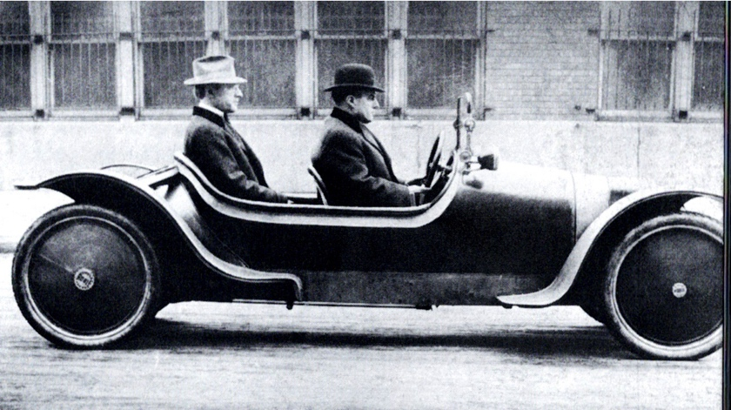
3
2

Figure 2. Fred C. Robie in the back of his experimental car, circa 1906 (Hoffman, 1984)

Figure 3. Frank Lloyd Wright (Frank Lloyd Wright Trust, n.d.)

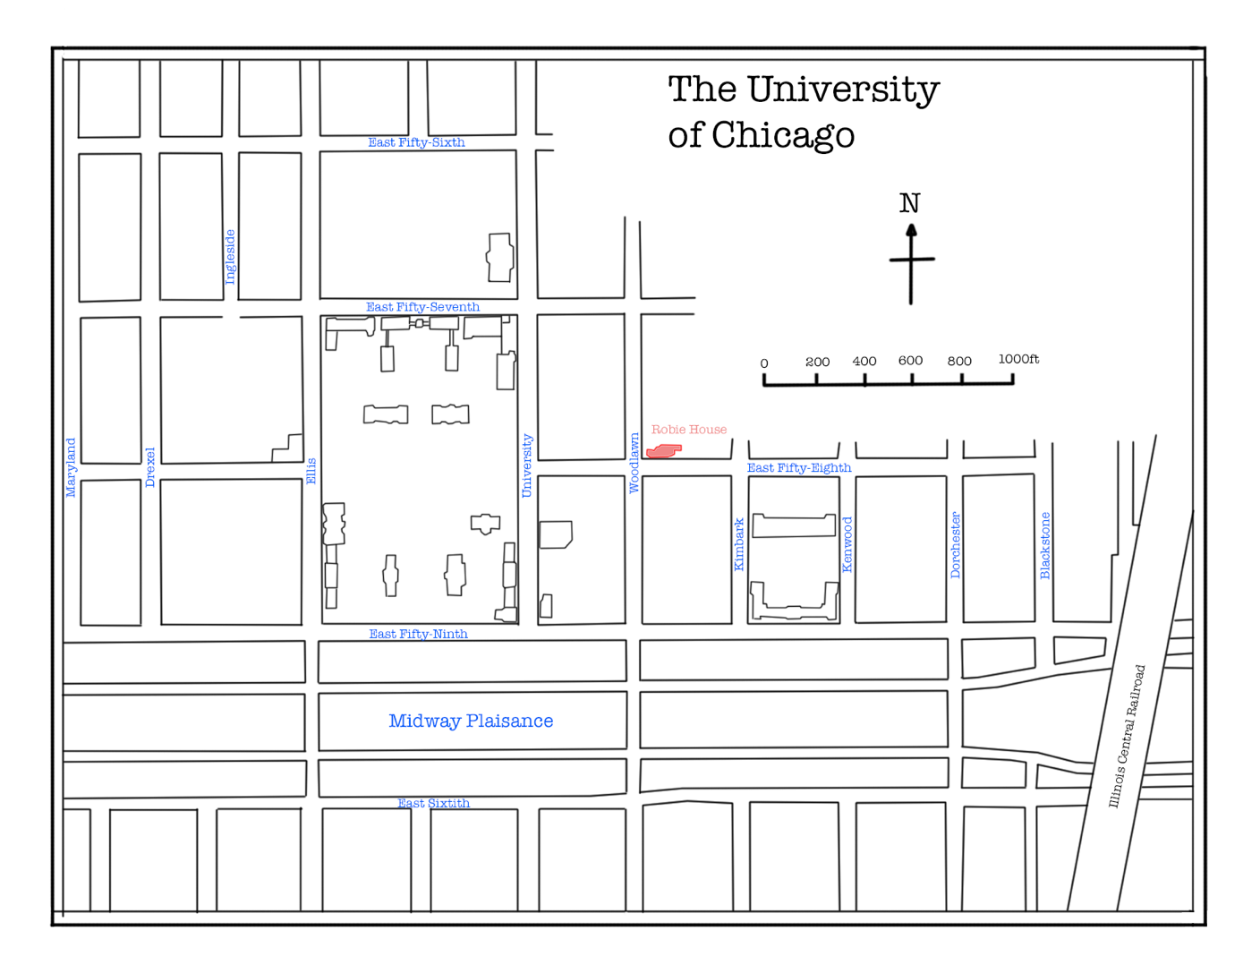
4
Figure 4. Site plan (1909-10) showing the Robie House (in red) in relation to the major buildings of The University of Chicago. Original image from (Hoffman, 1984) restored and illustrated by The Author.

Buildings Layout

The entrance can be found on the west side, coming off Woodlawn Avenue. It is hidden behind the main wing, at the end of a long walkway. Through the entrance hall the main staircase lies, set within the brickwork of the central fireplace. The First (Ground) Floor (Figure 4) and Second (Main) Floor (Figure 5) are made up of two sections which overlap each other in a brick bond effect. The northern section is mainly made up of rooms utilised for the servicing of the house. Whereas the southern section, is the family quarters.
A Billiards room and Playroom sit either side of the fireplace on the First Floor, with the service section made up of the heating and laundry rooms as well as the triple doored garage space.

The hallway at the top of the main staircase on the Second Floor leads to the large open space where the living room and dining room meet, separated only by the chimney. The south face of the house is made up of 14 French doors (7 in the living room, 1 facing the side of the chimney, 2 over the staircase and 4 in the dining room) which lead out onto the balcony overlooking East 58th Street. The service section has the kitchen, a bathroom, a dining room for the servants and two bedrooms for the servants. It also includes a guest room, which overlooks Woodlawn Avenue.

The Third (Top) Floor (Figure 6) rises through the centre of the house, tying the two sections together. All 3 of the main rooms here are bedrooms, a master, children’s and guest’s bed, all of which have an individual balcony.
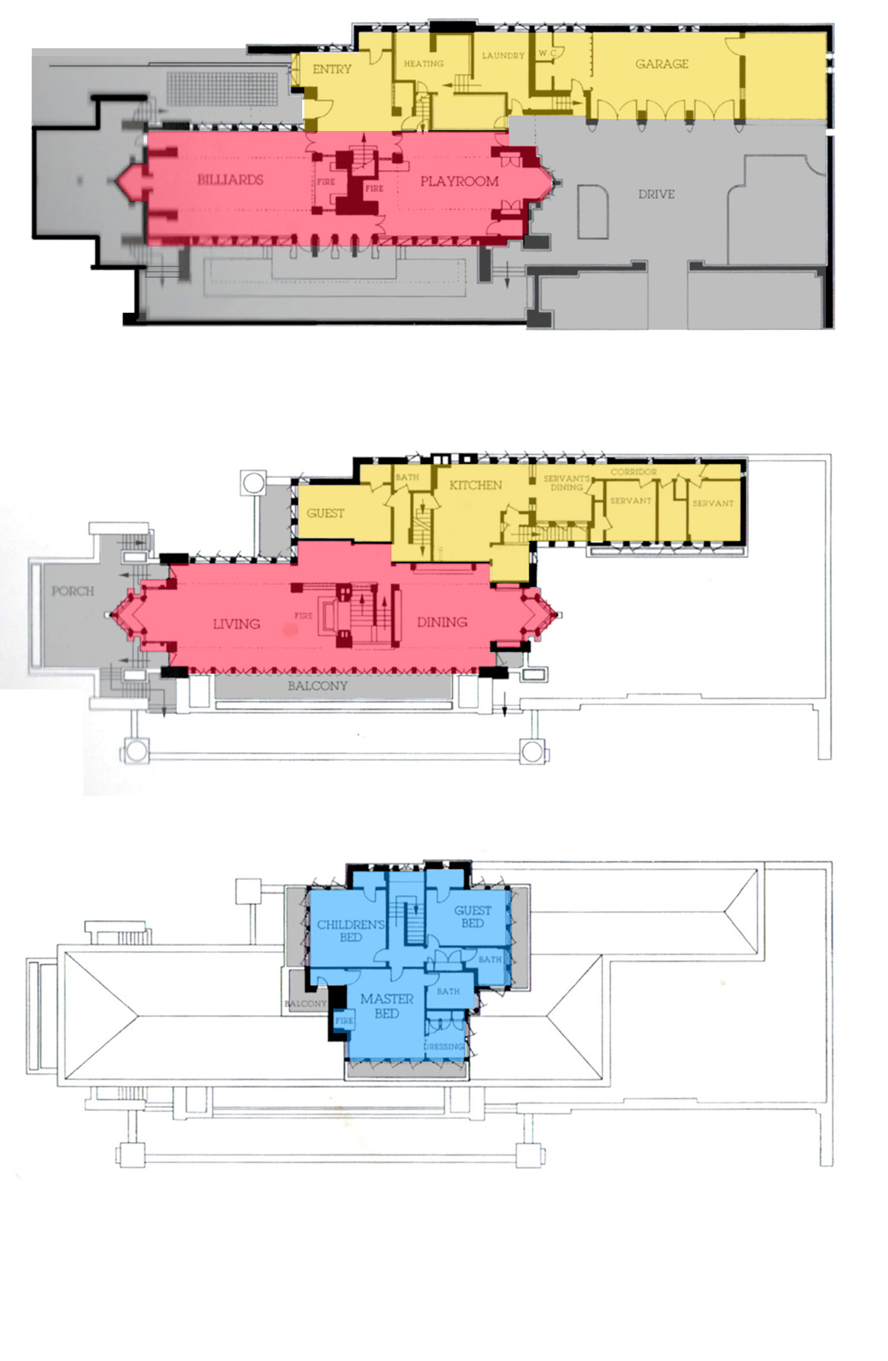Materials & Light
Figures 5, 6 & 7 originals are from (Upton, 1998) with highlighting done by The Author.
The outside ground space for each floor, such as the paths, drive, porch and balconies are highlighted in grey.
The yellow highlighted areas consist of rooms mainly used for the servicing of the house. The main family quarters are highlighted in red.

Figure 7. The Third (Top) Floor ground space highlighted in blue
Figure 6. Second (Main) Floor
Figure 5. First (Ground) Floor.

Wright’s idea for the Prairie style was to create an emphasis on horizontal over vertical, this was in response to the sprawling American planes. In the Robie House he would use slender Roman bricks (made up of a mixture of brown, orange, red and violet colouring) (Hoffman, 1984), recessing the mortar beds while leaving the perpends flush, this was done to suppress the vertical breaks. Limestone copings and sills stretch around the many layers of the house, again highlighting the horizontal planes. The shallow hipped roof has large overhanging eaves, with a copper cornice, that shade the areas below. This was constructed out of reinforced concrete and beams of steel (the largest being 12inch channel beams measuring up to 60ft in length) (Hoffman, 1984). By using such materials Wright was able to design the open plan that Robie desired. Rather than having a house in the traditional style that were, as Wright would say, “cut up into box-like compartments” (Hoffman, 1984). He could now offer rooms that were more spacious and merge into others without the need for solid partitions.
The transition from the outside to within the house is connected by the numerous leaded glass doors and windows. The patterned glass is made up of geometric shapes, that include a variety of different colours that blend into each room.
Electrical lighting in the living and dining rooms is passed through globe shaped glass fittings, hanging from oak trimmings. Radiators are also integrated behind oak latticework.
Every bit of design, whether external or internal, is meticulously thought through. Wright’s attention to detail is done with the intention of the house, its surroundings and the furnishings within, must unite to form a uniformed whole (Evers, 2006).

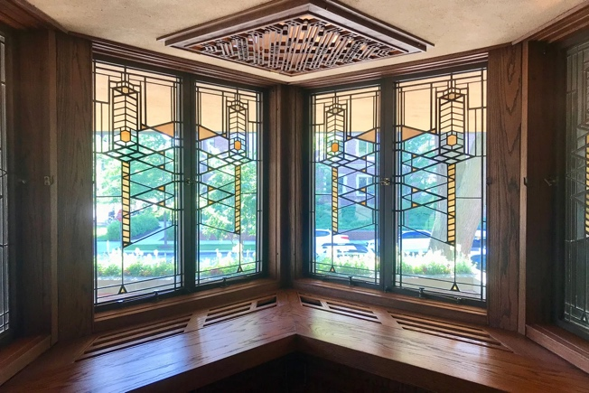
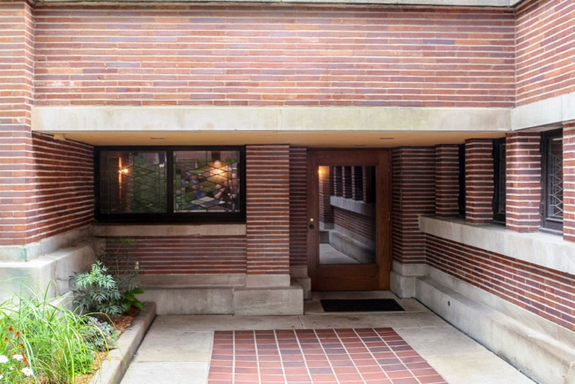
9
8

Figure 8. Entrance to house (Mitch Darby Architect, 2013)
Figure 9. The west prow, overlooking Woodlawn Avenue (Beard, 2023)

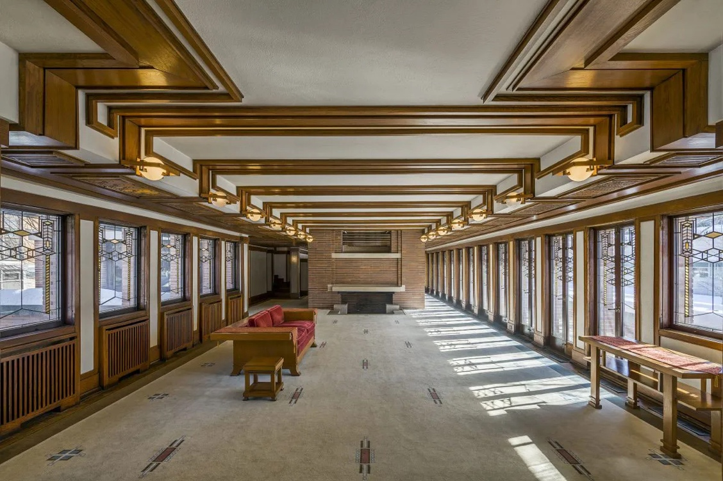
10
Figure 10. View from within the living room (Caulfield, 2023)

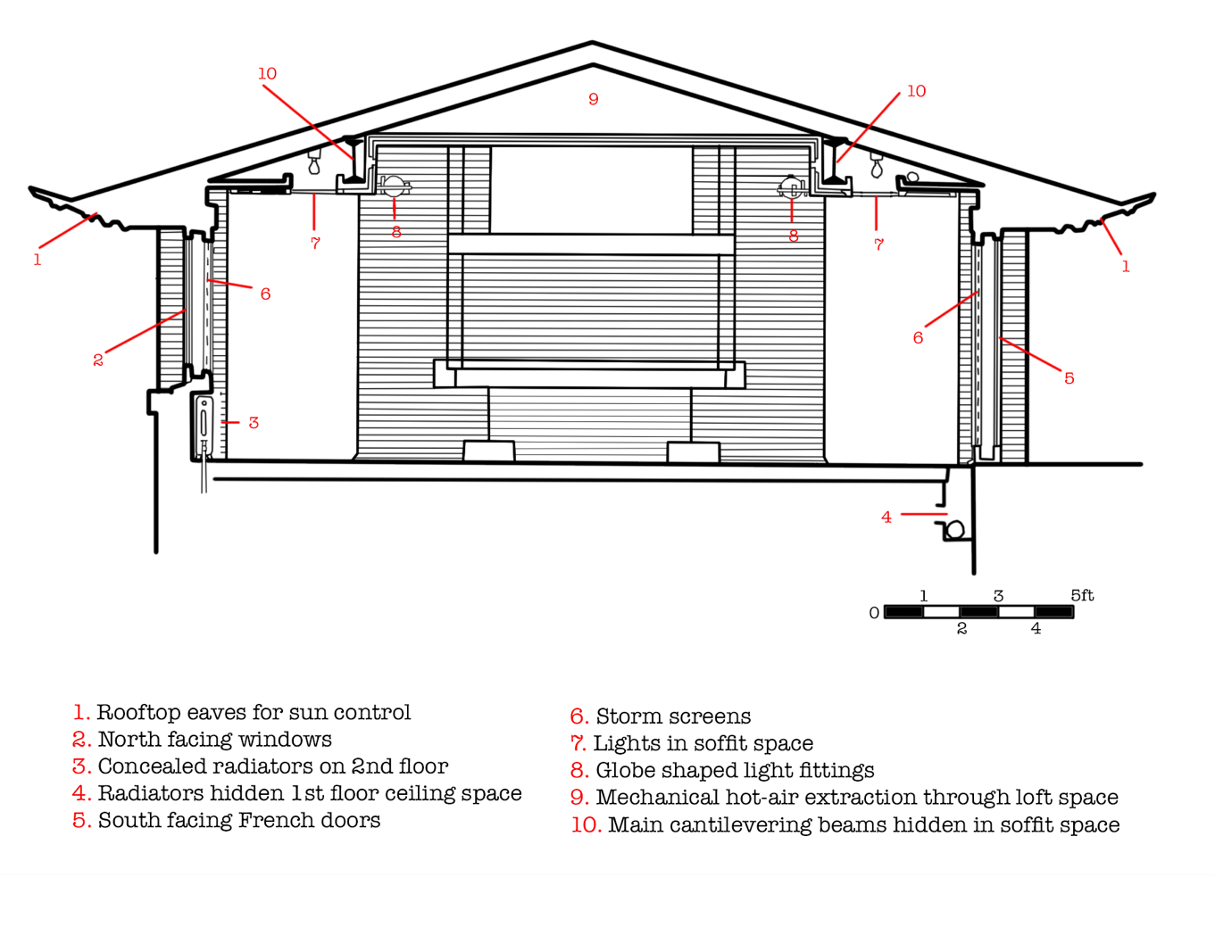
11

Figure 11. Section diagram of the first floor, detailing lighting, heating and cooling. Original diagram from (Hoffman, 1984), image and illustration since restored by The Author.

Conclusion

When completed in 1910, it achieved the main goals set out by the two most fundamental men involved in the project. Robie was thrilled with the end result, “I think it’s the most ideal place in the world” (Hoffman, 1984), he would later say. Wright had managed to fulfil Robie’s brief while also rewarding his own character. His beliefs of organic architecture and a building should be ‘of’ a hill not ‘on’ a hill (Weston, 2011) were carried out magnificently in The Robie House.
Today the house is regarded as one of the most important buildings in America, in 1991 it was named as one of the 10 most significant structures of the 20th Century by the American Institute of Architects (Gibson, 2017). With its open plan living space and extensive use of glass windows and doors, along with the striking cantilevers, Wright had designed something that would influence many buildings for years to come.

Bibliography
Beard, P., 2023. Arch Eyes. [Online]
Available at: https://archeyes.com/the-robie-house-a-masterpiece-of-frank-lloyd-wright-architecture/#jp-carousel-29128
Caulfield, J., 2023. Arch Eyes. [Online]
Available at: https://archeyes.com/the-robie-house-a-masterpiece-of-frank-lloyd-wright-architecture/
Chicago Architecture Centre, n.d. Frank Lloyd Wright. [Online]
Available at: https://www.architecture.org/online-resources/architecture-encyclopedia/frank-lloyd-wright
Evers, B., 2006. Architectural Theory. In: From the Renaissance to the Present. s.l.:Taschen, p. 494.
Frank Lloyd Wright Foundation, n.d. franklloydwright.org. [Online]
Available at: franklloydwright.org/site/robie-house
Frank Lloyd Wright Trust, n.d. Teaching By Design. [Online]
Available at: https://www.teachingbydesign.org/about/frank-lloyd-wright/
Gibson, E., 2017. Dezeen. [Online]
Available at: https://www.dezeen.com/2017/06/05/robie-house-frank-lloyd-wright-150-anniversary-prairie-style-20th-century-architecture-usa/
Hoffman, D., 1984. Frank Lloyd Wright's Robie House. In: The Illustrated Story of an American Masterpiece. New York: Dover Publications Inc., p. 27.
Hoffman, D., 1984. Frank Lloyd Wright's Robie House. In: The Illustrated Story of an American Masterpiece. New York: Dover Publications Inc., p. 8.
Hoffman, D., 1984. Frank Lloyd Wright's Robie House. In: The Illustrated Story of an American Masterpiece. New York: Dover Publications Inc., p. 3.
Hoffman, D., 1984. Frank Lloyd Wright's Robie House. In: The Illustrated Story of an American Masterpiece. New York: Dover Publications Inc., p. 42.
Hoffman, D., 1984. Frank Lloyd Wright's Robie House. In: The Illustrated Story of an American Masterpiece. New York: Dover Publications Inc., p. 31.
Hoffman, D., 1984. Frank Lloyd Wright's Robie House. In: The Illustrated Story of an American Masterpiece. New York: Dover Publications Inc., p. 10.
Hoffman, D., 1984. Frank Lloyd Wright's Robie House. In: The Illustrated Story of an American Masterpiec. New York: Dover Publications Inc., p. 21.
Hoffman, D., 1984. Frank Lloyd Wright's Robie House. In: The Illustrated Story of an American Masterpiece. New York: Dover Publications Inc., p. 27.
Hoffman, D., 1984. Frank Lloyd Wright's Robie House. In: An Illustrated Story of an American Masterpiece. New York: Dover Publications Inc., p. 8.
Hoffman, D., 1984. Frank Lloyd Wright's Robie House. In: An Illustrated Story of an American Masterpiece. New York: Dover Publications Inc., p. 94.
Hoffman, D., 1984. Frank Lloyd Wright's Robie House. In: The Illustrated Story of an American Masterpiece. New York: Dover Publications Inc., p. 32.
Hoffman, D., 1984. Frank Lloyd Wright's Robie House. In: The Illustrated Story of an American Masterpiece. New York: Dover Publications Inc., p. 6.
Hoffman, D., 1984. Frank Lloyd Wright's Robie House . In: The Illustrated Story of an American Masterpiece. New York: Dover Publications Inc., p. 6.
Mitch Darby Architect, 2013. Mitch Darby Architect. [Online]
Available at: https://mitchdarbyarchitect.com/blog/2013/6/4/a-visit-to-the-robie-house
Pfeiffer, B. B., 2002. Frank LLoyd Wright. In: s.l.:Taschen, p. 10.
Upton, D., 1998. Architecture in the United States. In: New York: Oxford University Press, p. 49.
Weston, R., 2011. 100 Ideas That Changed Architecture. In: London: Laurence King Publishing.

FIGURES
- Frank Lloyd Wright Foundation, n.d. franklloydwright.org. [Online]
Available at: franklloydwright.org/site/robie-house
- Hoffman, D., 1984. Frank Lloyd Wright's Robie House. In: The Illustrated Story of an American Masterpiece. New York: Dover Publications Inc., p. 3.
- Frank Lloyd Wright Trust, n.d. Teaching By Design. [Online]
Available at: https://www.teachingbydesign.org/about/frank-lloyd-wright/
- Hoffman, D., 1984. Frank Lloyd Wright's Robie House. In: The Illustrated Story of an American Masterpiece. New York: Dover Publications Inc., p. 6.
Image restored and illustrated by The Author, 2025
5, 6 & 7. Upton, D., 1998. Architecture in the United States. In: New York: Oxford University Press, p. 49. Images highlighted by The Author, 2025
8. Mitch Darby Architect, 2013. Mitch Darby Architect. [Online]
Available at: https://mitchdarbyarchitect.com/blog/2013/6/4/a-visit-to-the-robie-house
9. Beard, P., 2023. Arch Eyes. [Online]
Available at: https://archeyes.com/the-robie-house-a-masterpiece-of-frank-lloyd-wright-architecture/#jp-carousel-29128
10. Caulfield, J., 2023. Arch Eyes. [Online]
Available at: https://archeyes.com/the-robie-house-a-masterpiece-of-frank-lloyd-wright-architecture/
11. Hoffman, D., 1984. Frank Lloyd Wright's Robie House. In: The Illustrated Story of an American Masterpiece. New York: Dover Publications Inc., p. 32. Image restored and illustrated by The Author, 2025

