
ACE PRACTICAL PORTFILIO

STUDENT NUMBER: CHANTELLE BRAVEBOY

STUDENT NUMBER: 2027957

MODULE TITLE: ACADEMIC & EMPLOYABILITY SKILLS

MODULE CODE: BMSW4001

LECTUER NAME: JOY BOTU
Table of Contents

Introduction / Key Aspects 1
Time Management / Organising Studies 2
Reflection - Driscoll's What Model 3
Public Speaking & Giving Presentations 4
Online Learning Experience 5
Referencing 6
Conclusion 7
References 8

INTRODUCTION.

During the first term we explored a variety of topics. Equally there are some topics I have been introduced such as referencing, reflection, cover letter writing, to on the other hand there are some I’ve crossed paths with before such as time management / organising studies, academic writing, summarising, CV writing, public speaking and giving presentations & online learning experience. Out of those ten topics I’ve chosen 5 to discuss on my learning within this module, applying my method of reflection to each & reflect on how useful they have been to me. My chosen topics are… Time management / organising studies, Reflection (Driscoll’s what model), Public speaking and presentation giving, Online learning experience & Referencing.

KEY ASPECTS
- Reflect on your learning in this module. Using a recognised one model of reflection.
- Discuss 3-4 topics covered during the term
- Reflect on how useful they have been to you.
- What you already knew & any learning you undertook outside of the classroom.
- Explain the chosen model of reflection.
- Apply to each topic.

TIME MANAGEMENT & ORGANISING STUDIES.

Time management can be defined as the effectiveness, productivity, planning and exercising of the ability to consciously control time spent on activities or tasks. Organising studies is commonly known as the structure, processes & practices which in return will shape social relations, creating institutions that heavily influence people.
Last two month has been a life changing month due to these two milestones in my life. The first milestone is started in June 2021. I am officially a university student; this is currently doing her first year. Reviews? ... it is going well; every lesson is something different. The second milestone is having a job, I work 4 days a week, in a fast-paced restaurant. Both these milestones are new experiences which require time management and to organise my studies. Before coming to university, time management for me was horrific, ask my family they will admit it was a huge issue. I was always late, no matter what technique I tired. However, having a job requires me to be punctual as I am on currently on 6 months probation, no failures especially lateness. So far it is going better than I though, the first two shifts I was late. Then I started to reflect, which lead to planning such things as… the best form of transport, when I need to leave, what time I need to be up. By doing this I have effectively created a schedule / routine. The negative aspects of this experience not being able to wake up when I want to wake up, less sleep & less free time. The positive aspect of this experience is it has been about a month since I have properly started focusing on my timing and the results of this are amazing, I am getting to know myself better, creating a routine, technique & method that suits perfectly. Other than my first the two shifts I was late for, I can happily admit I have not been late since. Without completing this module my time management wouldn’t have changed. The information that I would take with me if I was experience something like this again would be always leave one hour & twenty minutes before my shift. This calculates to at least up to 7 minutes extra, before my I will arrive at work. For example, if I start at 12pm, I will leave the house at 10:40am. My form of transport is bus & the journey is an hour. If the bus comes at 10:52am, I will arrive at work at 11:52am exactly. The only negative side to is there is only 1 effective route to work, all other forms of transport is either more transfers or longer travel time. Action I would take when going to work are, trying to leave by 10:30, 10:40 latest, checking the bus time from the minute I leave the house, walking two bus stops ahead of going to normal bus stop. Preventing me from not missing the bus.

PUBLIC SPEAKING & GIVING PRESENTATIONS.
Public speaking consists of making, saying, or giving effective oral communication to the public, wither this be an audience, giving presentation or meetings. The speech is usual a layout of information, this can either entertain, persuade, or influence the former listeners. To give a direct presentation. You must be able to speak publicly. This is due to presentations customarily demonstrating, introducing, lecturing, building up goodwill or even presenting a new idea, it is important that this is done with confidence as they may be trying to persuade or entertain the listeners. Back in February 2019, I completed a course called “Prince Trust” and during the course, I had eye opening experiences, gained life changing and transferable skills one of them being a leader for a project. The team & I had the pleasured task of creating a drama, concert & fashion show alongside 3 amazing sponsors that go by the name of Mulacake Clothing, Space Streatham Space Project & of course Prince Trust. Being a leader has taught me to have patients but also be understanding of other opinion, it also brings a since of confidence as I had to stand in front of the class to dictate roles, give a sense of structure and format. This experience combined created an amazing project that ended in fun, happiness & confidence.

Each sponsor had played a role that led to a successful event. Let’s start with Prince Trust who are a company that helps transform lives into supportable communities worldwide particularly focusing on supporting the young people mostly between 11 to 30 years of age into education and employment. This charity is funded by The Prince of Wales, His Royal Highness, Prince Charles since 1976. They have helped bring out my inner confidence. Secondly, Mulacake Clothing. Mulacake Clothing was established since 2010 but officially launched in 2013. Dexter Simms, the founder of Mulacake specialises in producing fun, hip fashionable street wear for the young people and at a modest price. Mulacake also sell cakes in addition to running summer holiday activities for children. They have helped bring out my leader skills. Lastly, Streatham Space Project started back in 2018 and established a team of arts professional’s which provide the space for live events such as theatre, music, and comedy. They have help with my public speaking. These are their logo’s, and it goes as follows…

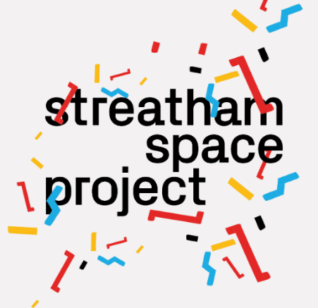


The negative aspects of this experience were being pushed out of my comfort zone. For example, I can be very timid, when in new environment, eventually I will warm up, but it usually takes a while. However, the positive aspects of this experience were being able to discover new skills, that would later help me with this course. Skills such as analysing, socialising, planning, negotiating skills, valuing diversity & difference, ability to learn / adapt, ability to work in a team, organisational skills, ability to work under pressure & to meet deadlines, using the initiative, being self-motivated, problem solving and communicating alongside interpersonal skills. The information that I would take with me if I was experience something like this again would be, don’t be afraid to come out your comfort zone, widen your horizon & have an open mind

ONLINE LEARNING EXPERIENCE
After finishing college, I wasn’t ready mentally ready to go to university plus I didn’t have enough UCAS points to get into university. This is where my journey of online learning began. As a result of this I ended up applying for two A levels with a company called “Open Study” with this I was able to get a three-year online course in sociology & psychology. Sociology is known to be the study of human social relationships & institution. Psychology is known as the scientific study of the mind & its behaviours this includes human development, sports, health, clinical, social behaviours & cognitive processes. The negative aspects of this online learning experience were not being able to have physically contact my tutor, as had a big strain on me due to not having the proper access, not being able to ask proper question about assignments. The only other negative aspect about online learning would be there is no audio description for people who have a learning disability, for example who are autistic or dyslexic. The positive aspects of this online learning experience would be gaining not one but two sets of UCAS points, alongside having three years to complete the course which I think is a generous amount of time for independent studies. The actions that I would take with me if I was experience something like this again would be organising my studies, creating a timetable that works perfectly for me.

REFLECTION – DRISCOLL’S WHAT MODEL

The term reflection is often followed by the analysed intention to learn from concurrent & former experiences. This is a form of thinking anticipatedly at successfully bettering their understanding creating a path to new possibilities of learning.
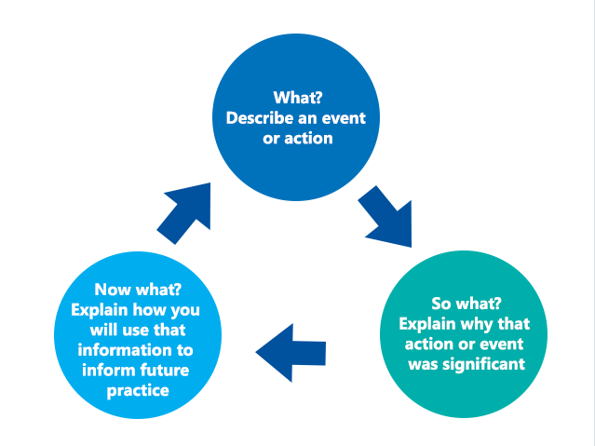
John Driscoll model of reflection was first developed in 1994, then again in 2004 and then adapted for the last time in 2007. This framework for reflection is one of the simplest models used so far. However, thanks to the study of Boston back 1970 who inspired Driscoll to use the three-stem question structure used in his framework, which go as follows…..

Above is physical example of Driscoll What Model.

Here are three easy and useful steps to use Driscoll What Reflection Model. Using the questions to answer each step.
Step One; What? – What happened? What did you experience in this situation or incident? What exactly did you do? Step Two; So What? – What are the negative aspects of this experience? What are the positive aspects of this experience? How did you feel at that specific moment? What was your reaction? Step Three; Now What? – What information would you take with you if the same situation was to occur next time? Could you have prevented any negative outcomes? And how could you have done so?

There are currently one negative aspects of this experience, and this includes online lessons, reflection personally would have been better within a classroom or in group so that everybody is able to share their reflections. The positive aspects of this experience would have to be learning about reflection in detail as I struggle to reflect. This module has helped me feel comfortable and find a framework of reflecting that works best for me. The information that I would take with me if I was experience something like this again would be don’t always look for the easier option. If something is not clear or understandable, don’t be afraid to ask.

REFRENCING

The term referencing is used when one uses another person work wither this be the writer or researcher. Referencing is used as acknowledgement for using author’s work. When becoming a university student, it is one hundred percent certain that you will come across assignments, no matter what university you go to, every assignment needs to have a referencing page. By referencing it provides evidence, it is crucial to having a successful research, it also helps the reader to find the original source, it is also helps improves academically, adds authenticity to the arguments, shows amazing reading and writing skills in addition to bettering your mark.

Being a student a university, includes knowing how to properly reference. This is something I had to gasp within the first term as assignment were to be completed by the ending of the month with the correct format and styling of referencing. There are many forms of referencing but the one that I use is commonly known by “Harvard referencing”. Incorrect format and layout of our referencing could lead to plagiarism, which is something every student does not want. The negative aspect of this experience is that referencing is very long, but it must be done, if not it could cause harm to my assignment moreover my marks. The positive aspects of this experience having to do referencing teaches everyone to not just copy and paste their work but to read and summarising. The information that I would take with me if I was to experience something like this again would be to try different sources for a range of opinions, arguments and information for example books, videos, podcasts.

Conclusion

My first term at the University of Wales, Trinity Saint David’s has been a buddle of new experiences and life changing teaching that I will forever take with me, no matter where I go in life. UWTSD helped with my ability to now have effective time management & organisational studies. Before this module I used to struggle with being motivated and procrastination. The result of my self-motivation has increased dramatically whilst my level of procrastination has decreased. Both, side by side enable a positive outcome mentally, physically. There have been more positive outcomes than bad during this module. If anything, this module has helped me discover who I am and who I want to be.

REFERENCES
All Answers Ltd (2018). Driscoll Model of Reflection. Available at: https://nursinganswers.net/reflective-guides/driscoll-model-of-reflection.php. (Accessed 22.08.2021)

Collins Dictionary (2021). Presentation. Available at: https://www.collinsdictionary.com/dictionary/english/presentation (Accessed 25.08.2021)

Dr. Saul McLeod (2019). What is Psychology? Available at: https://www.simplypsychology.org/whatispsychology.html (Accessed 23.08.2021)

Effective Learning Service (N.D.) Reflection. https://www.qmu.ac.uk/media/5533/reflection-2014.pdf. PAGE 3. (Accessed 25.08.2021)

Essay Writing Service UK (N.D.) Driscoll Model of Reflection. Available at: https://essaywritingserviceuk.co.uk/advice-and-guidance/driscoll-model-of-reflection. (Accessed 21.08.2021)

Harvard (N.D.). Referencing. Available at: https://www.qub.ac.uk/cite2write/harvard.pdf PAGE 1. (Accessed 26.08.2021)

Prince Trust (2021). The Princes Trust Group. Available at: https://www.princes-trust.org.uk/about-the-trust/princes-trust-group (Accessed 26.08.2021)

Toolshero (N.D.) John Driscoll Model of Reflection. Available at: https://www.toolshero.com/personal-development/john-driscoll-model-of-reflection/ (Accessed 22.08.2021)

UNSW Sydney (2019). Why is Referencing Important? Available at: https://student.unsw.edu.au/why-referencing-important. (Accessed 26.08.2021)

University of North Carolina (2021). What is Sociology? Available at: https://sociology.unc.edu/undergraduate-program/sociology-major/what-is-sociology/ (Accessed 23.08.2021)

Webster. M (2021). Public Speaking. Available at: https://www.merriam-webster.com/dictionary/public%20speaking. (Accessed 23.08.2021)

Wikipedia (2021). Time Management. Available at: https://en.wikipedia.org/wiki/Time_management. (Accessed 19.08.2021)

Wikipedia (2021). Organizational Stakeholder Studies. Available at: https://en.wikipedia.org/wiki/Organizational_Stakeholder_Studies#:~:text=Organizational%20studies%20is%20%22the%20examination,institutions%20that%20ultimately%20influence%20people%22. (Accessed 19.08.2021)

Wikipedia (2021). Public Speaking. Available at: https://simple.wikipedia.org/wiki/Public_speaking. (Accessed 23.08.2021)

Wikipedia (2021). Prince Trust. Available at: https://en.wikipedia.org/wiki/The_Prince's_Trust. (Accessed 24.08.2021)

