Slides for the video.

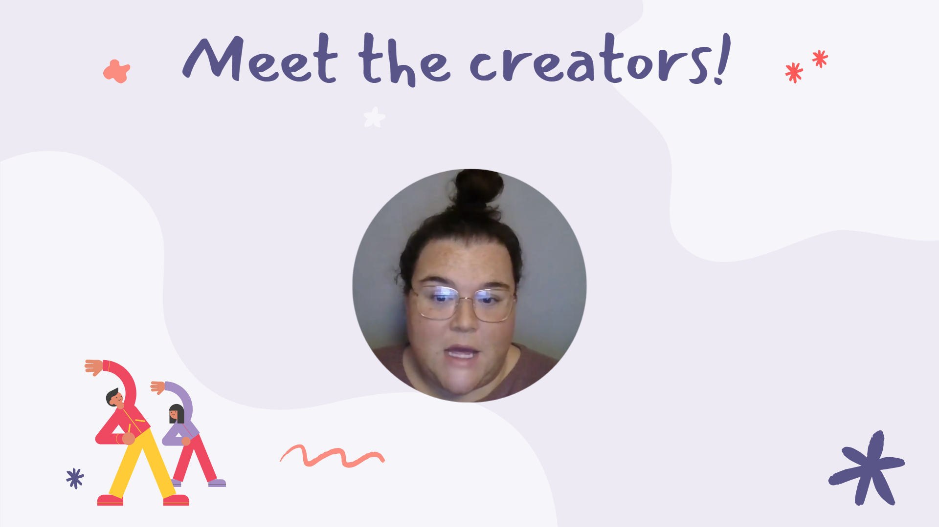

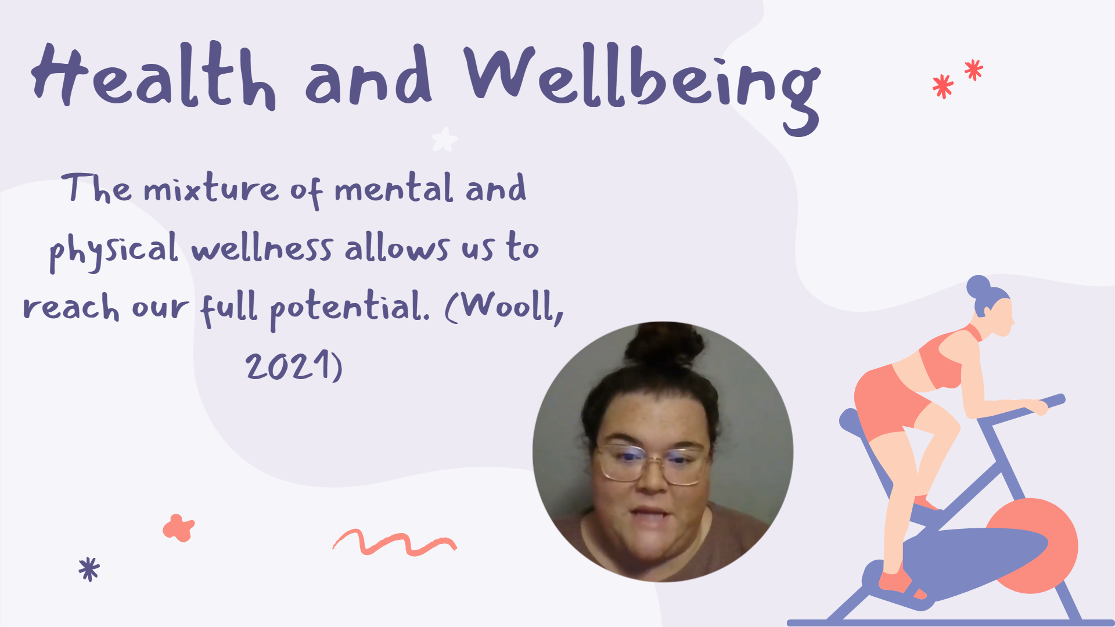

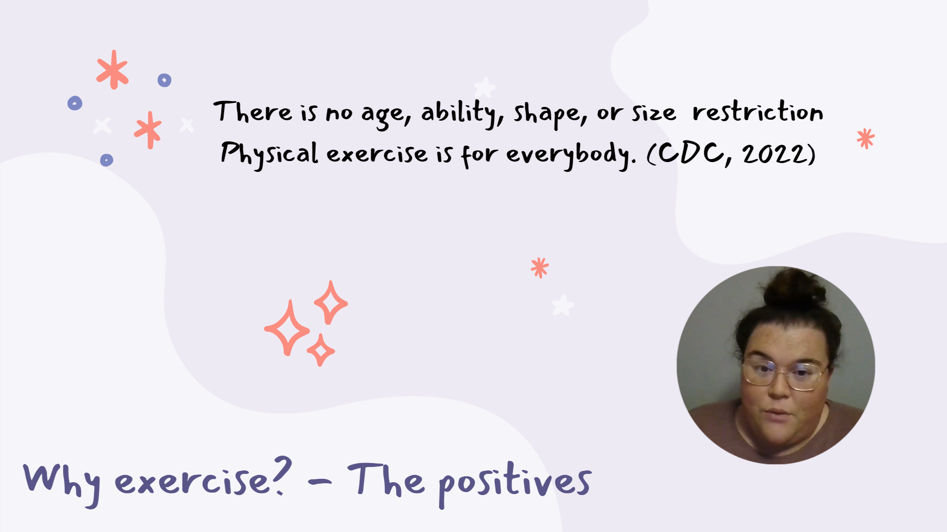

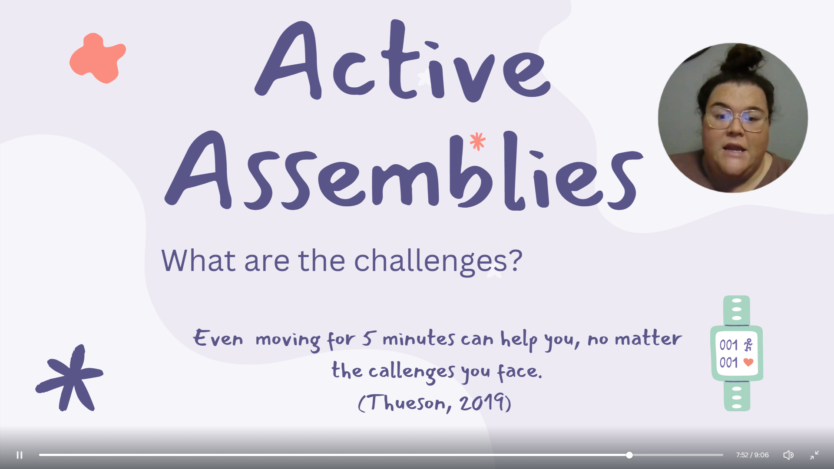

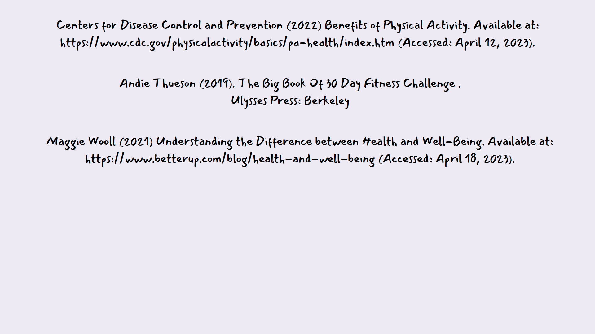

Reflection Summary:

For the video assessment we were given, it was the first time we had to work in a group, there were 3 of us grouped together and we all decided on a topic that we wanted to do and then discussed who was saying what and deciding who would take the lead in organising the slides etc which I will go into more detail about later on. I felt nervous to begin with as I hadn’t done group work before and was worried that my planning wouldn’t be as good or good enough for the rest of my group but as soon as we got into it and started throwing ideas about it seemed we were all on the same sort of wave length.
I felt so comfortable within my group as they were both so helpful and were willing to meet up when everybody was free or if we couldn’t meet up then they were happy to have chats about our video. I think we all gelled really well and got on brilliantly. It’s important for groups to get along and have a laugh together whilst also being professional. We decided that one of us would take the lead and do most of the video slides then we could all add our own little bits to it, we would all do the research and then one of us would jot the main ideas down.
I found that writing things down and discussing them together worked really well as we were throwing different ideas in the mix and then we were able to come up with one big topic which we chose to do. We chose health and wellbeing. Talking about that for me was a good choice as there’s so much stigma around health at the moment, both physical and mental so it was good to cover a topic with so much taboo surrounding it. We were hoping it will make children enjoy getting active which helps their brain massively.
I found meeting up and talking quite a challenge as we all lead different and busy lives its sometimes quite hard to catch everybody at the same time. I also found videoing myself quite difficult and challenging as I don’t like to do public speaking very often and also trying to remember what I needed to say was quite tricky as I had notes on queue cards but had to make sure my slide was no longer than around 30 seconds each.
We also could have managed our time a lot better and tried to meet up more often and try to prioritise certain areas we were going to cover. Stephen Covey had a theory called the matrix which is when you divide all your tasks into priority order (Mueller, 2020). I personally felt I didn’t do this and that’s why I possibly struggled a bit on the group video as everybody else knew what they were talking about but I think I put more effort into my blogs as I feel more strongly and passionate towards that topic so I then prioritised that whereas I should have set out specific time slots for the both of them. That is something I can use going forward and put that into place in my next assignment.

There’s a few things I would do differently next time given the chance, even though I felt it all flowed , we all worked together and respected each other’s ideas and thoughts, I would like to try a little harder to all meet up more within the group to discuss things rather than trying to catch each other when we had chance because sometimes that did get confusing. Also I would prioritise my own time better to make sure I can get enough research in.

According to Psychologist Bruce Tuckman, forming, storming, norming, and performing describes a path that can lead to a higher performance. These stages are supposedly due to start when the team first gets together and keep going until you get to the desired end. (Mind Tools Content Team, 2023). I like this theory and it’s something we used as it breaks down different categories to help you work together better. I found storming quite useful as it gave us all a chance to get to know each other and to help brain storm ideas. We discussed roles straight away so that nobody felt overwhelmed. We began to recognise each other’s strengths and weaknesses and used them to our ability. Because of this, we felt comfortable with each other in giving each other constructive feedback or any advice.

Another theorist who discusses group work is Frey, Fisher and Everlove (2009) They’ve said group work can often go wrong if people are put together as they all have different opinions and might not want to all do the same project which can then cause conflict that’s why in a lot of schools now teachers will decide the groups as they know the children well enough to know who works good together. In our class we all chose a topic that we wanted to do and then grouped ourselves off to those who chose the same topic.

I really enjoyed the group video and enjoyed working as part of a team, it made me feel a lot more confident that if I have to do group work again it won’t be as daunting and frightening. It was good to see everybody else’s ideas and get to share them, I picked up a lot of useful tips and hints for certain things whilst working in a group which I can now use when I work independently.

As reported by The University Of Edinburgh (2019) The whole purpose of reflection is so you can help improve your own practice and decisions. Being more able and effective in what we are doing is so important as it makes our work better and more professional. I enjoy reflecting on my work so I know next time what I can do different, if I have gone wrong anywhere or what worked well for me.

References:

Mind Tools Content Team (2023). MindTools. Available at: https://www.mindtools.com/abyj5fi/forming-storming-norming-and-performing (Accessed: April 29, 2023).

Nancy Frey, Douglas Fisher, Sandi Everlove (2009). Productive Group Work.
ASCD, Alexandria.

The University Of Edinburgh (2019). Reflecting for self-awareness. Available at: https://www.ed.ac.uk/reflection/reflectors-toolkit/self-awareness (Accessed: April 3, 2023).

