As a group we set out to create an 3D animated scene which was to be roughly one-minute long. After I organised a group meeting at the start of the semester the gather all the idea’s we could come up with for a good storyline we finally all agreed on one that we thought we give a strong approach to the target audience. Alongside this meeting we also discussed who would be taking up each role and to even them out as equally as possible. Each person took the role’s in which we were stronger in.
The story idea that my group had is to have Two older brothers fighting in an arena with loads of people around watching them. Which after an intense fight sequence, that was in their imagination together they created this fantasy words between them using only stuff within their living room but while you do not see their living room and only the arena you soon see this when it then flips to a living room scene where in reality you see Two younger brothers between the ages of 6-11, the oldest holding the tv remote in which they had been fighting over the television, the older brother has won the fight.
Within this project I had the role of modelling the arena scene along with the texturing. For this I learnt a new software called substance painter to get the best quality textures. I also created some props for the arena scene to make sure it was well equipped to give a more detailed environment and understanding of what would happen in the scene. After using just very basic shapes in Maya to create the arena, again I also learn a new technique on how to get the arena into a circle. To create the arena, I used a tool called spline bend, this technique allowed me to replicate a segment of the arena and have itself instance around a spline guide. With this technique I was able to save a large amount of time due to this tool, and therefore I was able to help many of my colleagues when they were struggling.
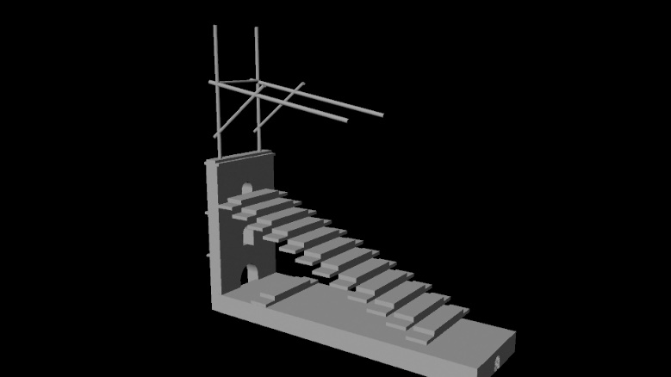
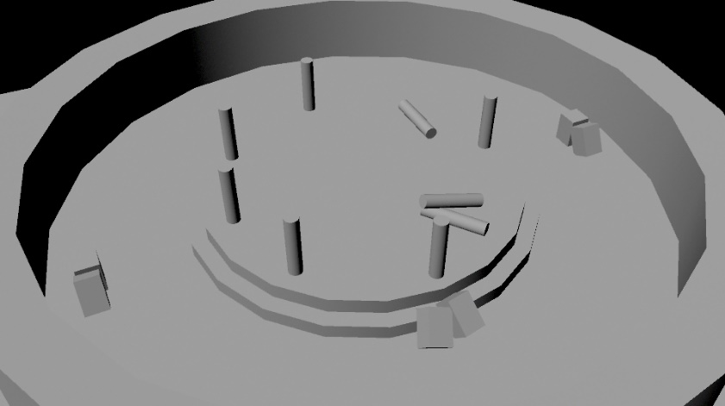
I took charge in creating a block out scene for the arena to create a basic plan of where the props would be placed and the organisation in which we could correspond certain parts of the arena scene with the living room scene to get a good resemblance and mix of both when swapping the scene.

Furthering my development toward the final piece I offered my time to texture the living room as I had finished my arena model and texturing before the set time we set for it to be completed. I had also completed some props which I designed, modelled and textured. I added theses to the scene to forward the process for the animator to be able to use them.

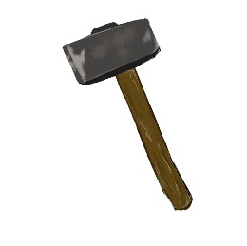
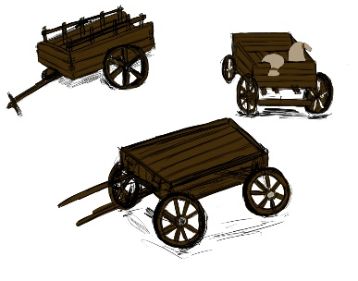
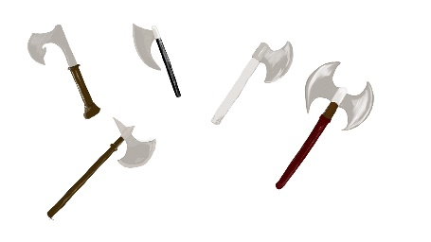

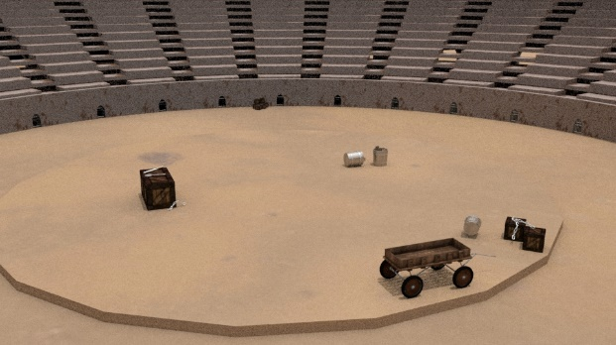
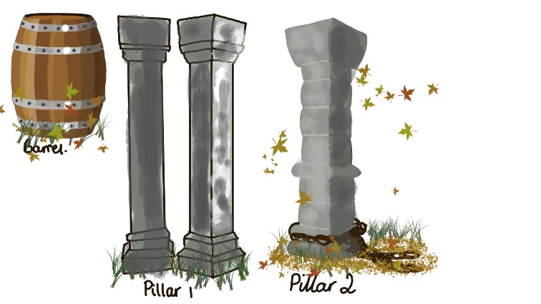

Originally, we wanted to fill the arena more than this example above, therefore we spoke about adding pillars around the arena, but after further discussion we felt it was not appropriate for the time in civilisation, so as a group we decided to add a few more props scattered around on the floor.

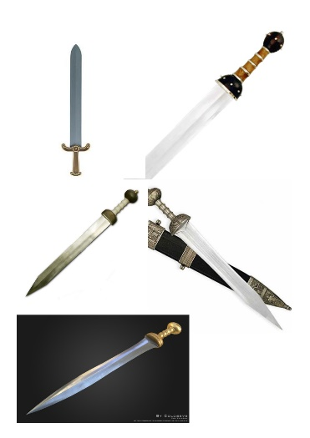
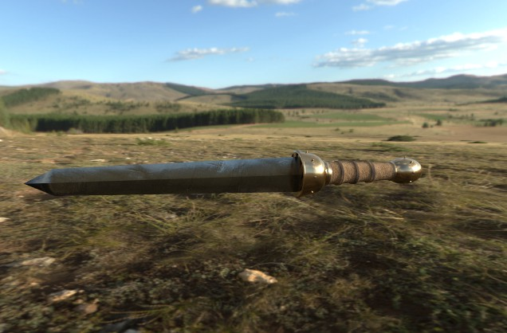

After researching the Gladius, I felt that I was able to create my own version of the sword whilst staying true to its historical characteristics. The above image is the sword I created and textured, I’m happy with the outcome of this sword it is very close to my reference images. I felt personally more could have been done on this weapon by adding more find detail or trying assorted colour variations until I found one that I strongly liked.

For my personally learning and development I am happy with the outcome I have achieved, I gradually learnt new software alongside creating this project. During the early stages of development while the concept for the weapons were being drawn up I felt there should have been more concepts and different colour variations to help get the chosen final colours. My favourite part of this whole project was the modelling and texturing, I thoroughly enjoyed this part of the project so intent to make this my main focus going forward in this course.
Overall the group worked very closely together and have gained effective communication skills to achieve a final 3D animation. When having a group discussion, I would take time to write down any updates or feedback to give to anyone who was absent. During the project I feel we could have had a lot more group meetings and present more updated work through the progression reel to gain positive feedback to improve each stage of development.
If I were to do this project again I wish we had more group meeting as I felt with the number of group meetings we had that we did not get the progression we really wanted out of our time. I would go back and redo the textures to the arena because now I have learnt more about what substance painter has to offer and improved the quality towards the end of the project. After getting to grips with substance painter and familiarizing myself with the interface, I noticed I had been inputting a setting incorrectly which had a knock-on effect as I did not display in Maya correctly. The result of this is I had to re-export the textures so they would display correctly.
Within the group due to unforeseen circumstances the sounds were delivered late therefore we were unable to attach them to the animatic to get the timing of the sounds to correspond with the scene’s, this lead to delays in production which help up others.

