

THE ROLE OF ARTIFICIAL INTELLIGENCE IN TRANSFORMING DIGITAL MARKETING PRACTICES IN THE UK RETAIL INDUSTRY

Submitted by:
Sanya Suneja
Student ID: 2234449
Programme: BA Business Management
Module: Dissertation (LCBB6000)
University of Wales Trinity Saint David, London
Institute of Inner-city Learning (IICL)

Submitted to:
Dr. Laila Maazouz
DBA,MBA, BA(HONS) Business Management Lecturer | Supervisor
University of Wales Trinity Saint David, London
Institute of Inner-city Learning (IICL)

Declaration

This declaration affirms that the dissertation entitled “The Role of Artificial Intelligence in transforming Digital Marketing practices in the UK Retail Industry” is my own original creation and has been written in compliance with the academic standards required by University. It is not previously submitted either wholly or partially for any other degree award.
The study utilized a quantitative approach whereby data from the structured survey was collected and analysed. All sources of information relied on during the study have been adequately cited. I solemnly declare that this dissertation does not in any way violate the principle of plagiarism and is completely mine.
Ethical aspects were followed in all phases of research, which included obtaining informed consent, maintaining confidentiality and protecting the data. Help received in the course of this research has been duly recognized.
I take complete responsibility for the contents of this thesis.

Sanya Suneja
University of Wales Trinity Saint David, London
1st May 2026

Abstract
In this paper, we explore the concept of artificial intelligence in the UK retail industry, with focus on digital marketing strategies. We assess the level of use of AI and its effect on customer interaction and marketing strategies, as well as challenges of implementing it. Quantitative methods have been used for gathering data, in which a structured questionnaire was created and sent via Google Forms. In all, 70 questionnaires were sent, with 51 being completed.
It can be seen from the findings that AI is highly prevalent in digital marketing strategies in the UK retail sector. More precisely, AI has a huge effect on improving customer experience in terms of fast customer service and personalized interactions, as well as better marketing strategies. Besides, the use of AI makes it easier to manage inventory, cuts down expenses and promotes data-driven decisions.
Nevertheless, there are other issues, such as high costs of implementation, lack of technical expertise, as well as ethical issues, including privacy and data bias. In addition, the analysis demonstrates that people have contradictory opinions concerning the impact of AI on employment because it could either result in job losses or transformations. Although most people believe that it is positively affecting their lives, there are still some worries connected with lack of interactions and biases.
Thus, in conclusion, it can be stated that AI is an innovative and valuable tool which may be successfully used in retail digital marketing provided that the company is prepared for it. It adds to existing literature on the topic by conducting an analysis of the industry in the UK based on empirical data. Further research is required to investigate the issue using qualitative methods.
Keywords: Artificial Intelligence, Digital Marketing, Retail Industry, Customer Engagement, Personalisation, Data Analytics, Marketing Performance, Automation, Consumer Behaviour, UK Retail Sector

Acknowledgement
In this context, I must express my sincere gratitude to Dr. Laila Maazouz who gave me excellent guidance and support throughout the process of doing this research. Professional as well as moral support was essential on his part, which enabled me to carry out this research.
In addition to that, I am grateful to University of Wales Trinity Saint David for rendering its assistance to conduct this research. I wish to thank all the participants who completed this survey, as their valuable responses were used in conducting this research.
Moreover, I am greatly thankful to my peers and co-workers for their useful suggestions during this research process, which helped me develop an insight into the research topic.
Lastly, I am highly indebted to my family members and friends for encouraging me all along and giving me motivation and inspiration to move forward on this research path.

Sanya Suneja
1st May 2026

Contents
Declaration 2
Abstract 3
Acknowledgement 4
Chapter 1: Introduction 7
1.1 Background of the Study 7
1.2 Problem Statement 8
1.3 Research Aim 8
1.4 Research Objectives 8
1.5 Research Questions 8
1.6 Significance of the Study 8
1.7 Rationale of the Study 9
1.8 Dissertation Structure 9
Chapter 2: Literature Review 9
2.1 Introduction 9
2.2 Theoretical Frameworks and Models 10
2.3 Definition and Concept of AI in Digital Marketing 12
2.4 Characteristics of AI in Digital Marketing 12
2.5 Importance of AI in Retail Digital Marketing 13
2.6 Advantages of AI in Digital Marketing 13
2.7 Disadvantages of AI in Digital Marketing 13
2.8 Research Gap and Summary 14
Chapter 3: Research Methodology 15
3.1 Introduction 15
3.2 Research Philosophy 16
3.3 Research Approach 17
3.4 Research Strategy 17
3.5 Methodological Choice 20
3.6 Data Collection Method 21
3.7 Sampling Strategy 21
3.8 Data Analysis Procedure 21
3.9 Reliability and Validity 22
3.10 Ethical Considerations 22
3.11 Summary 22
Chapter 4: Data Analysis and Discussion 24
4.1 Introduction 24
4.2 Section B: Primary Data Analysis (51 Responses) 24
4.3 Summary 37
Chapter 5: Conclusion and Recommendations 38
5.1 Introduction 38
5.2 Findings of each objective 38
5.3 Theoretical contribution: 38
5.4 Practical contribution: 38
5.5 Limitations 39
5.6 Recommendations 39
5.7 Summary 39
References 40

Table of Figures
Figure 1: Technology Acceptance Model (TAM) 6
Figure 2: Diffusion of Innovation Theory (DIT) 7
Figure 3: Research Onion Model 12
Figure 4: Methodological framework 15
Figure 5: Gender Distribution of Respondents 22
Figure 6: Occupation Distribution of Respondents 22
Figure 7: Respondents with Experience in the Retail Sector 23
Figure 8: Familiarity with AI Technologies in the Workplace 24
Figure 9: Areas Where AI is Used in Retail Workplaces 24
Figure 10: Frequency of Interaction with AI Systems in Job Roles 24
Figure 11: Job Position of Respondents in Retail Organisations 25
Figure 12: Years of Work Experience in Retail 25
Figure 13: AI Improves Customer Experience in Retail 26
Figure 14: AI Helps in Faster and More Efficient Service 26
Figure 15: AI Provides Better Product Recommendations 27
Figure 16: AI Helps Retailers Manage Inventory Effectively 27
Figure 17: AI Reduces Operational Costs for Businesses 28
Figure 18: AI Enhances Decision-Making Using Data Analytics 28
Figure 19: AI Leads to Job Losses in the Retail Sector 29
Figure 20: Biggest Advantage of AI in Retail (Open-Ended Responses) 29
Figure 21: Should Retailers Increase the Use of AI in the Future? 29
Figure 22: AI Systems Can Make Biased or Incorrect Decisions 30
Figure 23: AI is More Beneficial than Harmful in Retail 30
Figure 24: AI Reduces Human Interaction in Shopping Experiences 31

Chapter 1: Introduction
  - Background of the Study
Artificial intelligence (AI) is now a major source of digital transformation in industries, especially in the retail sector where competition and customer demands are changing at a very high rate (Singla & Shalender, 2025). The AI is commonly employed in the UK retail sector (such as personalised recommendations, customer segmentation, chatbots, and automated advertising). These applications enable the retailers to provide better customer experience, to achieve better marketing efficiency and to effectively respond to dynamic consumer behaviour (Lakshmi, 2025).
  - Problem Statement
Regardless of the increased significance of AI, its application in retail digital marketing is uneven. The implementation of AI technologies poses a great challenge to many organisations, such as high costs of implementation, absence of technical skills, and organisational resistance to change. Also, data privacy, algorithmic bias, and ethical consumer information usage concerns present another obstacle to adoption (Simetgo et al., 2025). This leaves a knowledge gap about the role of AI in marketing performance and customer interaction in the real-life context.
  - Research Aim
This research paper will explore the way artificial intelligence is changing the digital marketing in the UK retail industry.

1.4 Research Objectives
- To determine the degree of AI application in digital marketing in the UK retail sector.
- To explore how the use of AI-based tools can transform customer engagement, personalisation and marketing performance.
- To determine the most significant advantages and challenges, which are connected with the introduction of AI in the retail digital marketing.

1.5 Research Questions
- What is the prevalence of AI in online marketing in the retail industry?
- How do AI-based technologies affect customer relationships and marketing performance?
- What are the challenges facing the retailers in their implementation of AI in digital marketing strategies?

1.6 Significance of the Study
This study is important from both academic and practical perspectives. It contributes to the existing body of knowledge by providing empirical information on the relevance of AI to digital marketing within the UK retail setting in the academic field. It also addresses the literature gaps, in particular, the lack of quantitative data concerning the adoption and effectiveness of AI (Simetgo & Giovanis, 2025). The results can assist organisations make wise decisions about AI implementation taking into account ethical and operational issues.

1.7 Rationale of the Study
This research is justified by the fact that AI technologies are developing quite fast and gaining more and more power over consumer behaviour and marketing activities. The study of the UK retail industry offers context-specific and relevant information that is useful in academic research and application in the industry.

1.8 Dissertation Structure
This dissertation is divided into five chapters.
Chapter 1 presents the research subject matter, background, aim, objectives, and research questions.
Chapter 2 is a critical review of the literature of the subject and outlines some of the gaps in research.
Chapter 3 provides the research methodology, data collection and analysis methodology.
In Chapter 4, the research findings are presented and discussed
Chapter 5 provides a conclusion of the study with the main findings, limitations, and recommendations on how to conduct further research.

Chapter 2: Literature Review

2.1 Introduction
The application of artificial intelligence (AI) has drastically impacted the digital marketing aspect, specifically in the retailer sector where customer-centric and data-based approaches are critical. This chapter is a critical literature review of the literature on AI in digital marketing, its definitions, nature, significance, theoretical frameworks, benefits, drawbacks, and challenges.

2.2 Theoretical Frameworks and Models
There are a number of theoretical models that can be used to explain adoption and influence of AI in online marketing. The Technology Acceptance Model (TAM) is a popular model that is applied to comprehend user adoption of the new technologies depending on the usefulness and ease of use perceptions (Chowdhury & Marwah, 2026). When it comes to AI, marketers would be willing to use AI tools more when they perceive that the technology enhances performance and is simple to deploy.
This theoretical approach is very relevant to the present research as it clearly facilitates the research objective that involves identifying ways through which AI is revolutionizing digital marketing practices in the retail industry of the UK. Through the application of the Technology Acceptance Model (TAM), it will be possible to understand the levels at which marketers are adopting AI technology depending on how useful they think the technology is.
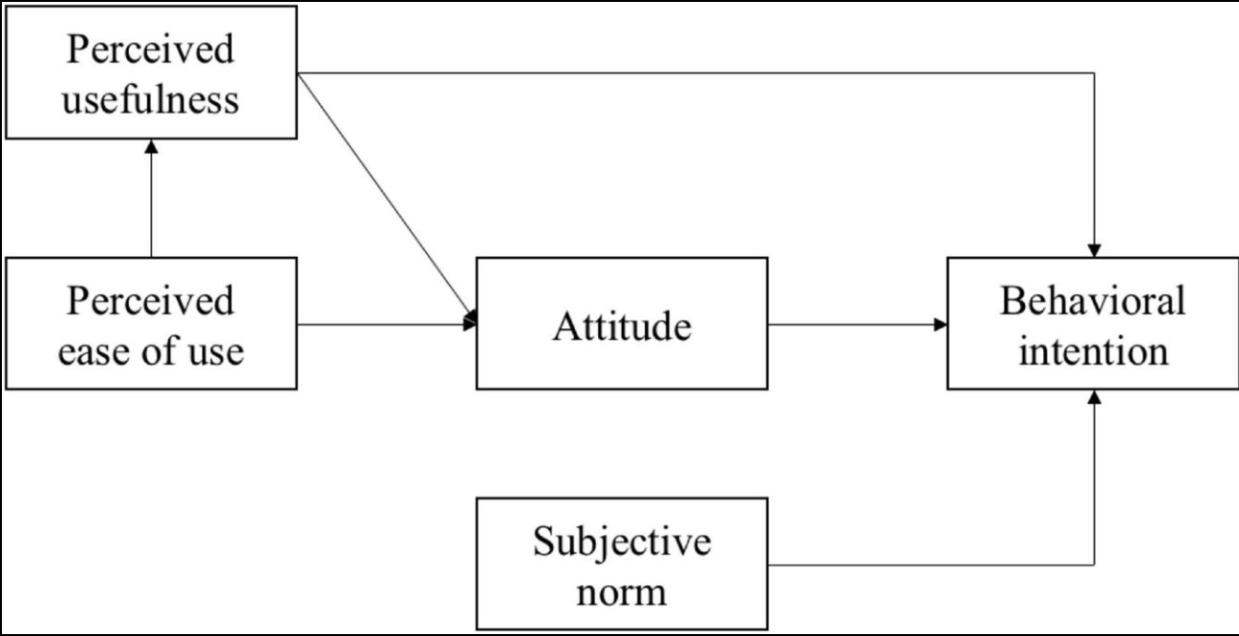
Figure 1: Technology Acceptance Model (TAM)
According to the Technology Acceptance Model (TAM), the acceptance of technology by users depends on the perception of two main attributes: usefulness and ease of use. The usefulness attribute represents an individual’s opinion regarding how the technology can improve his or her performance. The attribute of ease of use represents the degree of difficulty associated with the operation of the technology. These attributes determine the attitude of users towards adopting technology as well as behavioural intentions to do so.
The Diffusion of Innovation Theory also describes the spread of AI technologies in organisations and industries. The theory identifies relative advantage, compatibility, and complexity as the important determinants of adoption. These factors affect the adoption of AI in retail, especially the perceived advantages and difficulties of adoption. This theory is pertinent to the objective of this research since it explains how artificial intelligence (AI) adoption is diffused in the UK retail industry and the reasons behind its quicker adoption by certain organizations.
Also, there is Customer Engagement Theory that explains how AI is used to improve the contact between organisations and consumers (Alhumaid, 2025). Chatbots and recommendation systems and other forms of AI offer real-time and personalised customer interaction, which enhances customer engagement and satisfaction. This theory is important for the objectives of this research because it explains how AI is used to improve customer engagement in the process of digital marketing. This theory will assist in analysing how AI contributes to marketing success through its ability to personalize marketing activities in the UK retail industry.
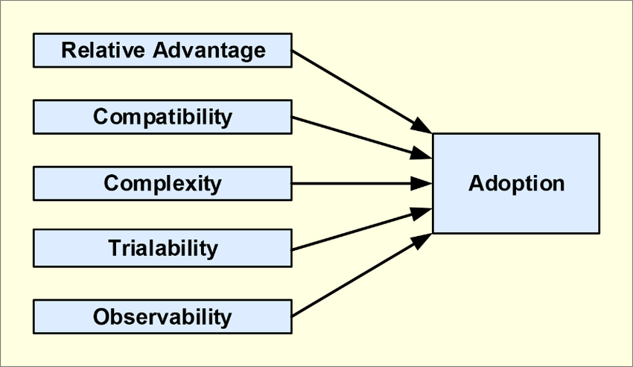
Figure 2: Diffusion of Innovation Theory (DIT)
Diffusion of Innovation Theory sheds light on how innovations or technologies diffuse among organizations or industries. Relative advantage, compatibility, complexity, trialability, and observability are some of the important elements considered in this theory to facilitate diffusion processes. Furthermore, adopters are classified into innovators, early adopters, early majority, late majority, and laggards under this theory. With respect to the current research work, the Diffusion of Innovation theory would be used for understanding the diffusion process of artificial intelligence technologies in the retail industry in the UK.
These models have strengths, but there are weaknesses to them. Equally, Diffusion of Innovation Theory might fail to recognize the ethical and regulatory challenges related to the use of AI. Thus, to have a comprehensive perspective on AI in digital marketing, a mix of the theoretical approaches is required.

2.3 Definition and Concept of AI in Digital Marketing
Artificial intelligence is the ability of machines to act like humans in terms of learning, reasoning, and decision making. The digital marketing technologies that fall under AI (machine learning, predictive analytics, and natural language processing) enable organisations to process information about consumers and streamline their marketing processes (Shalender & Singh, 2025).
Nevertheless, the definition of the AI concept in marketing is commonly widely interpreted, which results in differences in application between studies. Some researchers concentrate on the automation and data analytics (Kennedy & Bryson, 2025)whereas others dwell upon the technologies of customer contact including chatbots (Odoom & Agyepong, 2025). This conceptual ambiguity restricts the generalisation of findings and the necessity of a more unified definition of AI in digital marketing (Basu & Kumar, 2025)

2.4 Characteristics of AI in Digital Marketing
The main features of AI-driven marketing are automation, personalisation, scalability, and real-time responsiveness. The capability to process large datasets in a short period is one of the most important features, since organisations can anticipate consumer behaviour and optimise marketing strategies. AI is used to enhance decision-making by delivering precise and real-time data, which are used to optimize marketing (Kumar & Gupta, 2025).
Another important feature is personalisation, in which AI allows marketers to personalise content based on their behaviour and preferences of the individual consumer (Yas & Aldabbagh, 2025). Also, AI will facilitate automation of marketing activities, including email campaigns, chatbots, and programmatic advertising, which can make operations less costly and more efficient.
In spite of these, the literature also presents limitations. Excessive dependence on AI can decrease human innovation and marketing strategy. Moreover, AI systems require data quality and incorrect or biased data will result in unproductive results. This implies that although AI can be very useful, it is necessary to combine it with human knowledge to get the best outcomes (Haldar & Alam, 2025).

2.5 Importance of AI in Retail Digital Marketing
The use of AI in retail digital marketing has become more relevant because it helps to improve customer experience and increase marketing performance. Retailers apply AI to provide personalised recommendations, optimization of prices, and customer service with chatbots and virtual assistants (Dek & N Ibrahim, 2025).
But there is no even distribution of the significance of AI in all organisations. This results in a digital divide in the sector and indicates that the opportunities of AI depend on organisational capacities and resources (Mittal & Rani, 2026)

2.6 Advantages of AI in Digital Marketing
AI has a number of benefits in digital marketing, especially in terms of efficiency, accuracy, and personalisation. Among the most significant advantages, one can refer to better customer targeting, as AI helps marketers divide audiences and provide them with specific content. The Role of Digital Marketing Approaches on Customer Purchasing Behaviour in the UK shows that personalised marketing has a strong impact on consumer purchasing behaviours, as well as improving engagement.
AI is also effective in making decisions as it offers predictive analytics and insights that are based on data (Rahman & Rahayu, 2025). Nevertheless, other researchers state that the advantages of AI can be exaggerated. The efficacy of AI relies on the quality of data, technological equipment, and organisational preparedness. The lack of these factors can result in AI failing to produce the desired results, and it is crucial to consider the role of contextual factors in defining the success of AI (Askri and Shah, 2026).

2.7 Disadvantages of AI in Digital Marketing
Although it has its benefits, AI implementation in digital marketing has a number of challenges. The issue of data privacy is one of the biggest issues since AI systems depend heavily on consumer data. Personal information may be used wrongly and this may increase the risk of both legal and reputational problems (Menghani & N Pathak, 2025).
The cost of implementation is another hurdle that can be a hurdle to small and medium sized enterprises. The need to hire skilled professionals to develop and maintain AI systems is also a challenge on its own to organisations with limited resources.
Also, AI systems may cause unfair or inaccurate results due to algorithmic bias and a lack of transparency. These aspects demonstrate the necessity to have responsible AI practices and proper policy systems to achieve ethical and sustainable use (Kallivokas, 2025).
Another critical view that has surfaced in the literature recently is the necessity to balance technology development and ethical responsibility and human-focused marketing. Another related issue is that there is an ever-increasing fear about the sustainability of AI-based marketing approaches in the long term, because of the constant technological updates and data management demands that make operations more complicated (Barry & Kohtamäki, 2025). Consequently, the future studies must not only be about the outcome of performances but also analyse ethical governance, consumer trust, and the strategic alignment of AI to organisational values.

2.8 Research Gap and Summary
As the literature has shown, AI is changing digital marketing by making it more personalised, enhancing decision-making, and increasing efficiency of operations. Such theories as TAM and Diffusion of Innovation give an idea about the adoption of AI technologies, and the empirical research shows its advantages and disadvantages.
Nevertheless, there are still a number of gaps in the literature. Empirical studies on the UK retail sector are scarce and most of the studies are conceptual or qualitative in nature. Moreover, the quantitative data that would investigate the connection between AI adoption and the effectiveness of marketing are not available.
Thus, the proposed study will fill these gaps by offering empirical evidence on the adoption of AI, its influence on the digital marketing practice, and the issue faced by retailers in the UK. This is the reason why the current research is necessary and in line with the research objectives stated in Chapter 1.

Chapter 3: Research Methodology

3.1 Introduction
This chapter provides a description of the methodological framework that will be applied to examine the role of artificial intelligence (AI) in reshaping digital marketing practices in the UK retail sector. It describes the research philosophy, methodology, plan, data collection method, sampling technique, data analysis processes, and ethical considerations. This chapter is aimed at justification of the selected methods and showing how they correspond to the goals of the research.
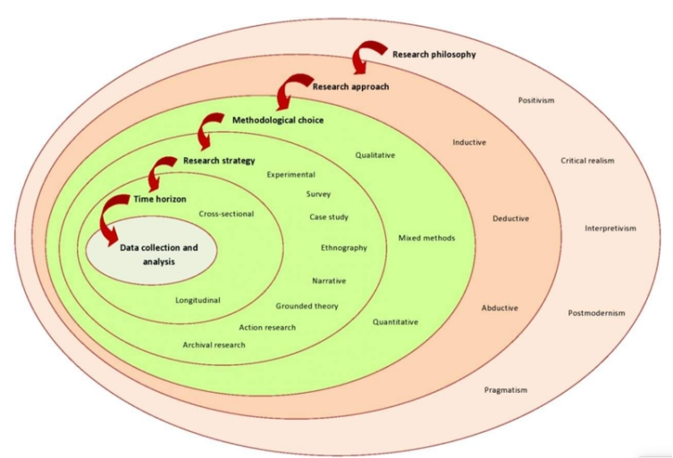
Figure 3: Research Onion Model
Research Onion Model by Saunders allows researchers to design their methodology in a structured manner through the use of a number of layers where each one reflects a particular kind of decisions that need to be made. From outside, these include research philosophy, research approach, methodological choice, research strategy, time horizon, and data gathering methods at the centre. In this paper, the Research Onion model has been utilized to justify the decision made about research philosophy (positivism), research approach (deductive), research methodology (quantitative), and research strategy (survey). Time horizon of the research is cross-sectional.

3.2 Research Philosophy
Research philosophy is the beliefs regarding the way of how knowledge is constructed and comprehended. The research philosophy of this study is positivist research philosophy, which presupposes that reality is objective and can be measured with the help of observable and measurable data. The research on business and management heavily relies on positivism because it allows researchers to test the relation of variables using empirical data.
The positivism approach is suitable in the current study since the proposed research will quantify the levels of AI adoption and the effects it has on the effectiveness of digital marketing through numerical data (Singh & Taterh, 2025). Customers engagement, personalisation, and perceived challenges are all variables that can be measured and assessed statistically.
Positivism is however limited because it emphasizes objective measurement and can ignore the subjective experiences and contextual issues. Nevertheless, it is applicable to this study because of its focus on reliability, objectivity, and generalisability.
Moreover, the implementation of positivism would be useful for conducting surveys using structured research tools like questionnaires. The advantage of this method is that it helps obtain standardized data that can be used to conduct statistical analysis and establish links between variables. Thus, the positivist approach is useful for investigating the influence of AI implementation on the performance of digital marketing in the retail industry.
Also, the implementation of positivism is useful for enhancing the credibility of the research since it allows minimizing researcher bias through numerical data obtained from respondents. It is crucial in technological adoption research because it is necessary to objectively measure efficiency, engagement, and performance (Nyagadza & Bashar, 2025). Consequently, the implementation of positivism in this study is useful for making the research systematic and data-driven.

3.3 Research Approach
The research design is deductive research design since the study formulates research questions on the basis of current theories and aims to test them with empirical evidence. The deductive method is systematic as general ideas are analysed using concrete observations.
To use a deductive approach is reasonable since the previous literature has already discovered the main themes regarding the adoption of AI, its marketing efficiency, and difficulties in its implementation (Chu & Mundel, 2025). This research is based on these conclusions because the quantitative data is gathered in order to confirm or refute the existing assumptions.
The deductive approach promotes the clarity and direction of the research; nevertheless, it can restrict the discovery of new insights. In spite of this weakness, it suits this research given that it fits in the positivism philosophy and quantitative design.

3.4 Research Strategy
The research design utilized in the study is a survey research design, which is usually applied in quantitative research to gather information about a large group of respondents. Surveys enable the researcher to acquire standardised data in an efficient manner and they are therefore appropriate in analysing patterns and relationships.
A questionnaire was created with the help of Google Forms to gather the answers of people who work in the sphere of retail and marketing (Le, 2025). The questionnaire will contain structured questions that will help to understand the level of AI adoption, its effect on marketing performance, and challenges.
The survey approach is beneficial since it allows collecting similar data and statistical analysis. Nevertheless, it can also cause such shortcomings as response bias and insufficient insights.
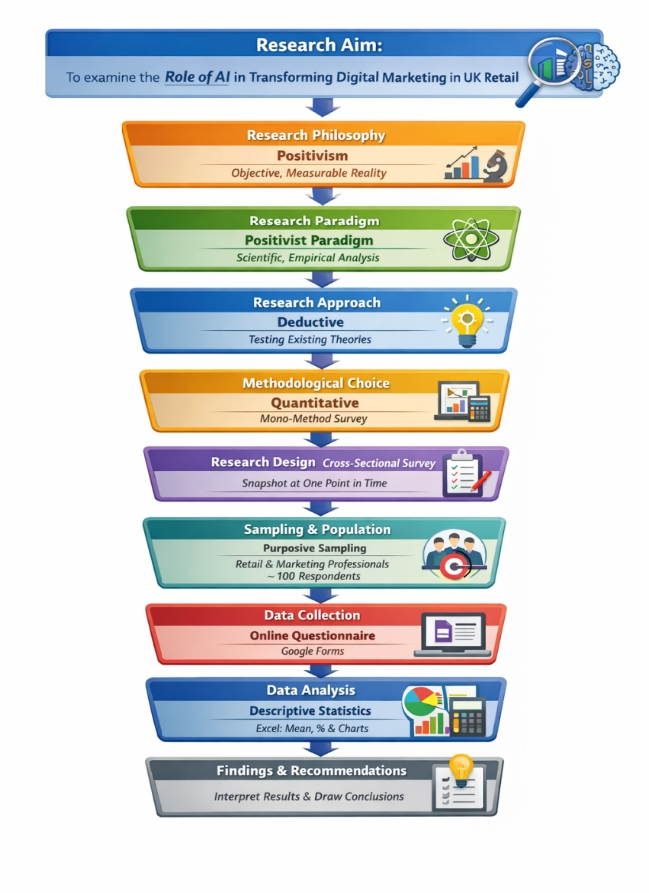
Figure 4: Methodological framework
Flowchart methodology shown in figure underscores the organized and well-planned process used to conduct this study aimed at evaluating the impact of artificial intelligence on changes in digital marketing in the UK retail industry. The first step is the identification of the research objective which forms the basis for the direction of the research process. Following the chosen paradigm, a deductive approach is selected, which means that certain theories are examined based on the collected data. Then, the quantitative methodological approach is chosen, and this is further operationalized through a survey and cross-sectional research design allowing for standardized data collection at a particular point in time. Moreover, the flowchart shows the sampling and data collection stages, according to which a convenient sample is selected through the application of purposeful sampling, while data is obtained with an online questionnaire. Finally, the analysis of the obtained data is presented together with the findings and conclusions derived from the results.

3.5 Methodological Choice
This research design is a mono-method quantitative research design, which aims at gathering numerical data and analysing it through the use of statistical methods. The quantitative research is appropriate in this study because it enables an objective measurement of variables and patterns.
Data analysis is simplified and there is uniformity in the use of one method. The survey contains closed-ended questions and Likert-scale statements, which will allow the respondent to indicate the degree to which they agree or feel that AI is going to influence digital marketing.
Despite the fact that quantitative research gives a clear and measurable outcome, it might fail to give a vivid understanding of what the participants actually go through (Nguyen & Chebbi, 2025). In spite of this weakness, the approach is suitable in accomplishing the research objectives.
Another advantage of the chosen approach is that Likert scales allow measuring perceptions and attitudes consistently, thereby facilitating the process of interpreting the obtained results (Aktar, 2025). For instance, it will be easy to interpret and compare the answers that the participants give regarding customer engagement, personalization, and challenges in adopting AI technologies.
Additionally, the possibility of minimizing any forms of bias exists due to the use of neutral items in the questionnaire. Moreover, the anonymity of the responses can make sure that they are unbiased as well.
All in all, the methodological aspects of this paper are designed systematically, ensuring a thorough and credible analysis.

3.6 Data Collection Method
In this research, the major technique of data collection is an online questionnaire. The questionnaire will be divided into a few parts, such as demographic, AI adoption level, its effect on marketing performance, and difficulties encountered during implementation.
Online questionnaires are also popular in research as they are cost effective, easily accessible and easily distributed. They enable the researcher to access a wider audience and gather information effectively (Basu & Kumar, 2025). Google Forms can also be used to record and export data automatically to be analysed.
Online survey can however be vulnerable to issues like low response rate and inability to control respondents. The questionnaire will be straightforward, clear and easy to fill in to ensure that these issues are minimised.

3.7 Sampling Strategy
The research employs a purposive sampling strategy, which is in which the participants are chosen according to the relevance they hold to the research subject. The target group consists of people employed in the sphere of retail, digital marketing, or other areas, having the familiarity with AI technologies.
The purposive sampling will be suitable in this research as it will make the respondents to have the right experience which will augment the quality and reliability of the data. The research is planned to gather the answers of around 100 respondents, and it is the number enough to detect the trends and patterns.
Yet, purposive sampling is a non-probability technique, and it implies that the results would not be generalisable to the whole population (Singla & Shalender, 2025). Irrespective of this limitation, it fits this research because of practical constraints and requirement of targeted participants.

3.8 Data Analysis Procedure
The questionnaire data will be analysed through quantitative statistical methods. The data will be summarised in descriptive statistics that include frequencies, percentages, means, and standard deviations that will be used to identify trends.
Data analysis will be performed in Microsoft Excel since it offers the means of organising the data, making calculations, and visualisation of data in the form of charts and graphs. These visualisations aid in the effective presentation of the findings.
Descriptive statistics are useful, but they might not come up with all the details of complex relationships between variables. Better statistical methods may give more insightful analysis, yet the selected methods are adequate in reaching the research objectives.
Another critical issue to be addressed in this study is the rationale behind the selected sample size and analysis tools. About 100 respondents are taken to be sufficient to determine the significant patterns and trends in quantitative research and especially in the study that involves perceptions and behavioural understanding.
Regarding data analysis, it would be appropriate to use Microsoft Excel since it is available, effective and it can perform the required statistical processes required in this study. Excel enables sorting a big amount of data, descriptive statistics, and graphic display in the form of bar charts and pie charts that simplify the results (Lakshmi, 2025).

3.9 Reliability and Validity
Reliability is the consistency of the research instrument and validity is its accuracy in measuring what it is supposed to measure. Reliability in this study is made possible by the use of structured and standardised items on the questionnaire. To detect any problem and enhance the questionnaire design, pilot test will be undertaken.
The validity will be improved through paralleling the questionnaire with the research goals and the literature review. The clarity and conciseness of the questions minimize the chances of misinterpretation and enhances the accuracy of the responses.
Although these precautions are taken, there are other sources of possible limitations like the bias in responses and misrepresentation of self-reporting (Simetgo et al., 2025). The study however undertakes the right measures to reduce these risks.

3.10 Ethical Considerations
The issue of ethics is critical in the responsibility of carrying out the research. The purpose of the study and rights of the participants will be explained to them. The consent will be informed, and it will be voluntary. No personal identifying information will be collected and this will ensure confidentiality and anonymity. These ethical considerations will guarantee that the rights and privacy of the participants are upheld during the research process.

3.11 Summary
This chapter has identified the research methodology employed in the study including the positivist philosophy, deductive approach and survey strategy. The data were collected through a quantitative approach based on the use of an online questionnaire with the help of which the data regarding the relevant participants were gathered. Sampling, data analysis, reliability, validity and ethical considerations were also discussed in the chapter. In general, the methodology offers a systematic and suitable way of dealing with the research goals and producing valid results.

Chapter 4: Data Analysis and Discussion

4.1 Introduction
The chapter outlines the results and discussion of the findings that are relevant to the application of artificial intelligence (AI) to revolutionize digital marketing in the retail industry. The evaluation shows the results of the primary data analysis based on the survey conducted using Google Forms, which provides the data related to real-life applications of AI in the retail industry.
The combination of secondary and primary data will provide a full assessment of the influence of AI on customer engagement, operation efficiency, marketing performance, and organisational decision making.

4.2 Section B: Primary Data Analysis (51 Responses)
4.2.1 Demographic and Professional Profile
A total of 70 questionnaires were distributed, out of which 51 valid responses were received, resulting in a response rate of approximately 72.9%, which is considered acceptable for quantitative research and supports the reliability of the findings. The survey comprised of 51 respondents, which offered a more credible dataset to be analysed. The gender arrangement was quite equal, and it was guaranteed to have different points of view. Most of the respondents worked in jobs that were related to the retail profession such as customer service, sales and management jobs.
A high percentage of the respondents were already in the retail industry and the majority stated that they were familiar with AI technologies in the workplace. This means that information is informed by people with the relevant knowledge and experience to increase the validity of the findings.
Question 1: what is your Gender?
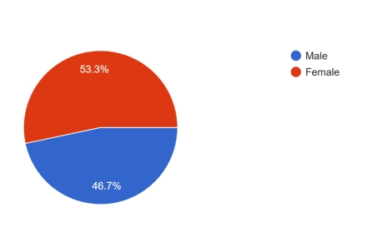
Figure 5: Gender Distribution of Respondents
The figure shows that 53.3% of the respondents were female and 46.7% were male. The fact that the gender distribution is almost equal increases the validity of the data set as it is less skewed by demographic factors. Even such minor domination of one group can, however, affect responses based on perception in a subtle way.
Question 2: What is your Occupation?

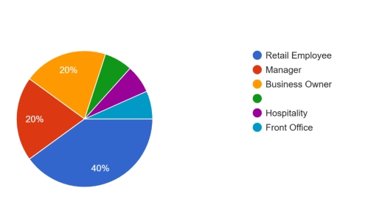
Figure 6: Occupation Distribution of Respondents
The largest proportion of participants consists of retail employees (40%), followed by managers (20%) and business owners (20%). Smaller proportions include individuals from hospitality (approximately 7%), front office roles (approximately 7%), and other related sectors. The preponderance of retail employees guarantees real-world insights, and management representation provides the strategic view. The lack of diversity in technical positions can limit the knowledge about the complexity of AI implementation.
4.2.2 AI Adoption and Workplace Usage
From the findings obtained, it can be seen that the application of artificial intelligence is widespread in the retail industry. Most of the participants stated that their organizations have applied AI technology, mainly in their customer services and marketing.
Chatbots, personal recommendation systems, and automated service platforms constitute the AI technologies widely used. The application of AI technologies is mainly to boost customer interaction and improve their service efficiency.
However, the proportion of those who were uncertain about the application of AI is very small, suggesting a gap in knowledge and communication within their organizations.
Have you ever worked in the retail sector?
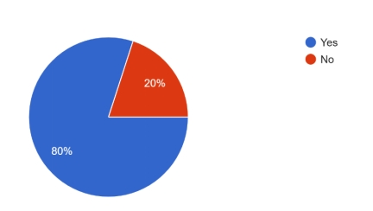
Figure 7: Respondents with Experience in the Retail Sector
The findings indicate that a significant majority of respondents, 80%, have prior experience working in the retail sector, while only 20% reported no such experience. Retail experience of the respondents is high and contributes to informed opinions to strengthen validity of findings. Nevertheless, there can be fewer external views that can decrease cross-industry comparison.
4.2.3 Interaction with AI Systems
The rate of engagement with AI systems is different among respondents. A large percentage of them have frequent interactions, which means that AI is a part of everyday activities. Nonetheless, other respondents noted that there was little or no interactions, implying that there is a disproportionate use of AI in various job positions.
This emphasizes the need to train and make it more accessible, with employees having to be trained in the skills required to utilize AI tools.
Are you familiar with the use of AI technologies in your workplace?

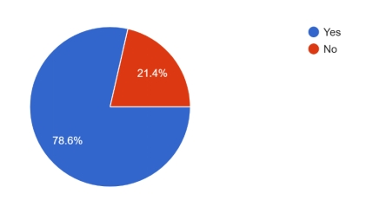
Figure 8: Familiarity with AI Technologies in the Workplace
The results indicate that a substantial majority of respondents, 78.6%, reported being familiar with the use of artificial intelligence technologies in their workplace, while 21.4% indicated a lack of familiarity. High familiarity implies that the answers are founded on actual exposure as opposed to guesses. However, the appearance of non-familiar respondents illustrates lack of awareness and training in organisations.
Where have you observed AI being used in your retail workplace?
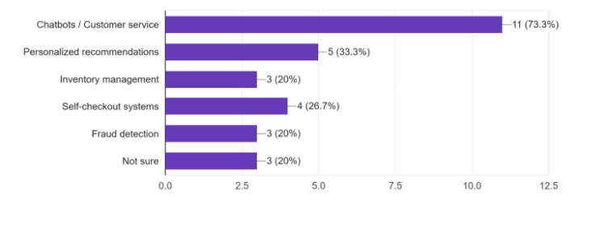
Figure 9: Areas Where AI is Used in Retail Workplaces
The most prominent application identified by respondents is chatbots and customer service, reported by 73.3% of participants. This highlights the strong emphasis on enhancing customer interaction and providing real-time assistance through AI-driven tools. Other notable areas include personalised recommendations (33.3%), which support targeted marketing strategies, and self-checkout systems (26.7%), reflecting the role of AI in refining operational efficiency and customer convenience. Additionally, inventory management (20%) and fraud detection (20%) demonstrate that AI is also utilised in backend operations to optimise processes and ensure security.
AI is mostly applied in customer-facing areas, which means that it is concerned with interaction and service optimization. Under usage in the backend functions implies that AI is not utilised to the full potential.
How often do you interact with AI systems as part of your job role?
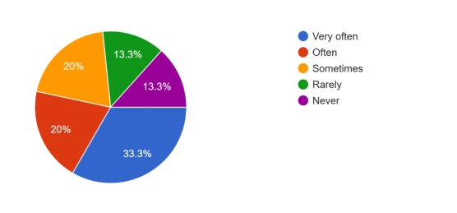
Figure 10: Frequency of Interaction with AI Systems in Job Roles
A significant proportion, 33.3%, reported that they interact with AI systems very often, while 20% indicated that they interact often. Additionally, 20% of respondents reported interacting with AI sometimes, suggesting moderate engagement with AI technologies in their daily work activities. On the other hand, 13.3% of respondents stated that they rarely interact with AI systems, and another 13.3% reported never interacting with such technologies. The daily integration of AI is confirmed by the frequent interaction. Unequal engagement, however, reflects a lack of fairness in the access to, or role relevance, or training between employees.
4.2.4 Impact on Customer Experience
The vast majority of the respondents said that AI enhances customer experience. This is majorly because of the fact that AI can offer personalised recommendations, quicker responsiveness, and improved services.
These results are highly consistent with the literature, which states personalisation as one of the advantages of AI. Nevertheless, some respondents (a minority) disagreed, which suggests that the usefulness of AI can be related to the quality of implementation.
Your job position in the retail organization?
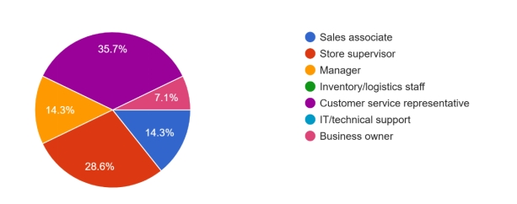
Figure 11: Job Position of Respondents in Retail Organisations
The largest group consists of customer service representatives (35.7%), followed by store supervisors (28.6%). Other roles include sales associates (14.3%) and managers (14.3%), while a smaller proportion is represented by business owners (7.1%). The presence of customer-facing roles is highly represented to provide information about the influence of AI on customer experience. Absence of technical positions inhibits realization of system design and implementation issues.
Years of work experience in retail?
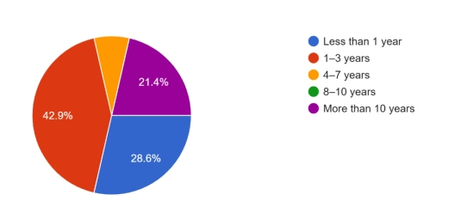
Figure 12: Years of Work Experience in Retail
The largest proportion of participants, 42.9%, reported having 1–3 years of experience, followed by 28.6% with less than 1 year of experience. Additionally, 21.4% of respondents have more than 10 years of experience, while a small percentage (approximately 7.1%) reported 4–7 years of experience. Notably, there were no respondents within the 8–10 years’ experience category. An interplay of young and old professionals offers adaptive and strategic views. Nonetheless, a lack of mid-level experience can undermine the understanding of the transitional workforce dynamics.
AI improves customer experience in retail.

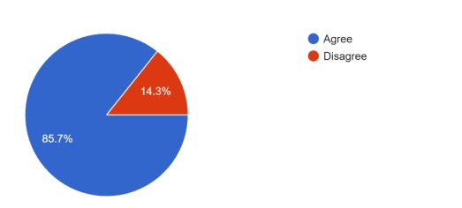
Figure 13: AI Improves Customer Experience in Retail
The larger number (85.7%) agreed that AI helps enhance customer experiences by means of personalization and speed. The findings coincide with those reported by (Alhumaid, 2025), whereby AI is said to increase customer engagement and satisfaction.
4.2.5 Service Efficiency and Marketing Performance
The results indicate that AI can greatly enhance the efficiency of the services and the majority of the respondents claim that AI will allow providing services more quickly and efficiently. This is especially applicable in retail where speed and responsiveness will determine customer satisfaction.
Likewise, AI is seen to positively impact marketing performance, in terms of targeting and campaign effectiveness. These results affirm that AI can help in enhancing operational effectiveness and strategic marketing results.
AI helps in faster and more efficient service.
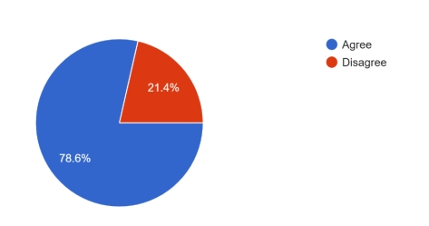
Figure 14: AI Helps in Faster and More Efficient Service
A majority (78.6%) of survey participants found efficiency improvement in their service through the use of AI. This is consistent with (Haldar & Alam, 2025), who emphasize that AI is effective in automating operations and enhancing speed.
AI provides better product recommendations.
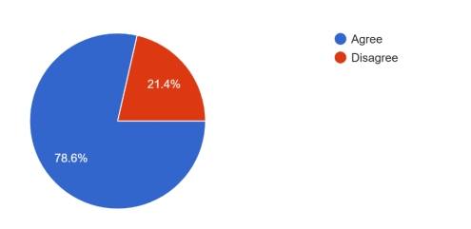
Figure 15: AI Provides Better Product Recommendations
Findings (78.6%) indicate AI boosts product recommendations. This finding aligns with that of (Yas & Aldabbagh, 2025) where they state AI personalises products based on consumer data analysis for targeted marketing purposes.
4.2.6 Operational Benefits
Another effect of AI is on operational efficiency. Most of the respondents reported that AI improves inventory management and reduces costs in operations.
This shows the larger application of AI in digital marketing that is crucial for business performance. However, some respondents stated that AI depends on its proper implementation.
AI helps retailers manage inventory effectively.

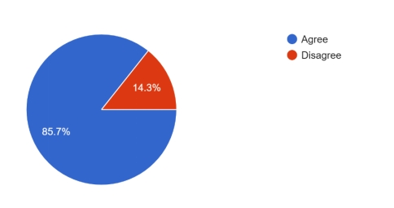
Figure 16: AI Helps Retailers Manage Inventory Effectively
There was agreement from the majority (85.7%) that AI assists in improving inventory management. This finding is consistent with the conclusions by (Singh & Taterh, 2025) who claim that AI increases forecasting accuracy and operational efficiencies.
AI reduces operational costs for businesses.
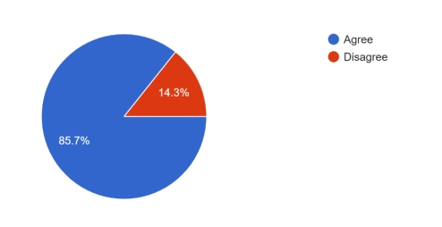
Figure 17: AI Reduces Operational Costs for Businesses
The majority (85.7%) agree that AI results in cost savings. This is consistent with (Askri & Shah, 2026) who suggest that AI results in cost savings via automation and optimization of resources.
4.2.7 Decision-Making and Data Analytics
Most of the respondents agreed that AI plays an important role in decision-making through data analytics. In the presence of AI, organizations have the ability to analyze huge data and draw insights from it that help them take decisions.
Nevertheless, a significant percentage of the participants indicated their worries regarding the credibility of AI-based decisions, revealing the relevance of quality data and accuracy of the system.
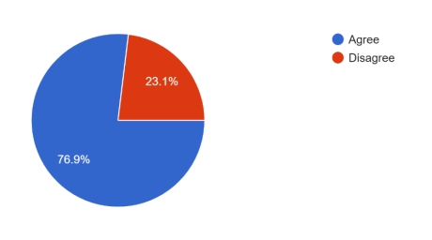
Figure 18: AI Enhances Decision-Making Using Data Analytics
Conclusion from results (76.9%) shows that AI enhances decision-making processes. The findings affirm (Basu & Kumar, 2025) assertions on how AI allows strategic decision-making through analysis of data.
AI leads to job losses in the retail sector
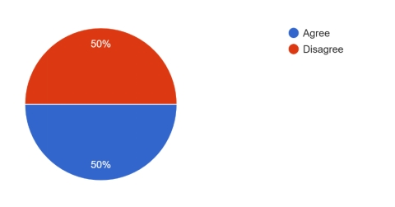
Figure 19: AI Leads to Job Losses in the Retail Sector
The even split indicates doubt regarding the effect on employment. This is in line with (Barry & Kohtamäki, 2025) who argue that AI does not lead to job cuts but merely job transformation.
What is the biggest advantage of AI in retail?
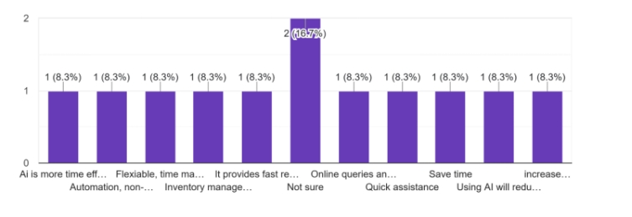
Figure 20: Biggest Advantage of AI in Retail (Open-Ended Responses)
The results indicate a diverse range of opinions, with no single dominant theme, although “Not sure” (16.7%) was the most frequently selected response. The remaining responses were evenly distributed across multiple advantages, each representing approximately 8.3% of the total responses. Various reactions demonstrate the multi-faceted advantages of AI in operations and marketing. Uncertainty is high which implies that there is no organisational communication on the value of AI.
Should retailers increase the use of AI in the future?
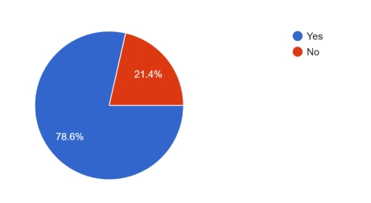
Figure 21: Should Retailers Increase the Use of AI in the Future?
A significant majority of respondents, 78.6%, believe that retailers should increase the use of AI in the future, while only 21.4% disagreed. The high level of support suggests faith in the strategic significance of AI in the long-term. Nonetheless, some respondents seem to be resisting, which may be a sign of cost, ethical, and workforce implications.
4.2.8 Ethical Concerns and Risks
The results illustrate that there are serious issues to be concerned about in terms of ethical issues. Most of the interviewees consider the possibility of biased or erroneous decisions made by AI systems, pointing to the dangers of data-driven technologies.
Also, the views on job losses are split, some of the respondents think that AI poses a threat to the jobs, others think that it opens up opportunities. This is an indication of the debate that has been going on in the literature.
AI systems can make biased or incorrect decisions.
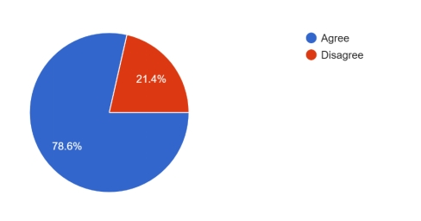
Figure 22: AI Systems Can Make Biased or Incorrect Decisions
Most respondents (78.6%) expressed concerns related to AI bias issues. This finding matches (Kallivokas, 2025) assertions about dangers of biased algorithms.
Do you think AI is more beneficial than harmful in retail?
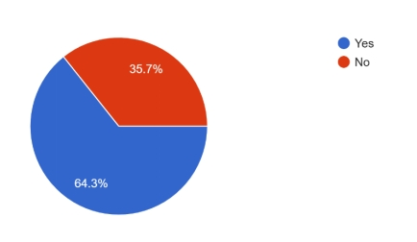
Figure 23: AI is More Beneficial than Harmful in Retail
The findings indicate that a majority of respondents, 64.3%, believe that artificial intelligence is more beneficial than harmful in the retail sector, while 35.7% expressed the opposite view. The perception of the majority testifies to the greater good rather than evil of AI. Nevertheless, there are serious issues in minority concerns that point to unaddressed ethical and operational issues.
4.2.9 Human Interaction in Retail
A significant number of respondents feel that AI is decreasing the level of interaction between humans and shopping activities. While AI contributes to efficiency, at the same time it may decrease human interaction that plays an important role in building up good customer relations.
This shows that there must be a balance between AI and human interaction.
AI reduces human interaction in shopping experiences.
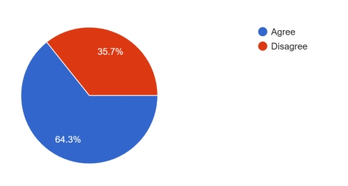
Figure 24: AI Reduces Human Interaction in Shopping Experiences
A majority of the participants (64.3%) opine that AI diminishes human engagement. This is consistent with the findings of (Barry & Kohtamäki, 2025) that automation can affect human relations in a service environment.
4.2.10 Overall Perception of AI
Most of the respondents feel that AI has more positive than negative effects in retail. This is a positive sign overall, but there are still some concerns regarding ethical concerns and implementation issues.
4.2.11 Open-Ended Insights
The open-ended questions uncover that AI is viewed as something with numerous benefits such as time-efficiency, automation, and quality of service. Nevertheless, there were also respondents who did not know the main advantages of it, which implies that it should be better educated and trained.

4.3 Summary
In this chapter, secondary and primary data were examined to determine the significance of AI in retail digital marketing. The results prove that AI enhances customer experience, operational efficiency and decision-making process significantly, which also leads to cost reduction and better performance.
Nevertheless, ethical issues, job displacement, and decreased human interaction are some of the difficulties that can emerge, and thus responsible implementation is required. On the whole, the findings prove that AI is a disruptive technology in retail and helps achieve the research goals and set a solid basis of the final conclusions.

Chapter 5: Conclusion and Recommendations

5.1 Introduction
In this chapter, we can find the conclusions reached by the study conducted to determine the influence of artificial intelligence on changes in digital marketing in the retail industry. Here, we have the outcomes obtained as a result of the analysis of the literature and collected from 51 respondents as well as an assessment of the accomplishment of the research objectives.

5.2 Findings of each objective
- Objective 1: Extent of AI Adoption in Retail Digital Marketing
The deployment of AI in digital marketing by retailers appears to be common practice and is mostly used in customer services, recommendation engines, and analytics. In contrast, AI deployment varies significantly across different organizations based on their sizes, as bigger organizations show higher AI deployments because of their greater capacity. Thus, organizational readiness becomes an essential factor in AI deployment.
- Objective 2: Impact of AI on Customer Experience and Marketing Performance
It has been confirmed that AI has an important role to play in the positive impacts that customers experience during interactions with retailers. In other words, AI helps create better user experience through personalization, timely service provision, and customer interactions. Furthermore, AI enhances decision-making based on data and analytical tools although the results depend on the quality of data and systems.
- Objective 3: Challenges in Implementing AI in Retail Digital Marketing
The main challenges in implementing AI have been discovered. They include issues such as cost, technical skills required for implementation, and data ethics. Other challenges include perceptions about job displacements due to AI implementation.

5.3 Theoretical contribution:
The current research is in alignment with the theory of diffusion of innovation by proving the unequal adoption of artificial intelligence among different organizations, while it adds to the customer engagement theory by emphasizing the significance of personalization.

5.4 Practical contribution:
This research offers valuable practical lessons to organizations on how AI could be applied to strengthen the customer experience, boost efficiency, and assist with decision making. This research has shown that training and ethical considerations are important during the process of implementation.

5.5 Limitations
The research was hindered by the fact that the sample consisted of 51 respondents only and the methodology used was purely quantitative. Purposeful sampling used in this research may have introduced bias.

5.6 Recommendations
Training should be considered an investment, AI integration should be gradual, and ethics such as transparency and privacy must be taken into consideration by organisations. Balance should also be achieved between human interaction and AI usage.

5.7 Summary
AI in retail digital marketing can be described as a revolutionary innovation that will help in improving performance and effectiveness in this industry. However, some concerns must be solved first.

References
Aktar, M. N. (2025). Artificial intelligence, big data, and their impact on improving marketing effectiveness and customer experience in the retail sector in the Kingdom of Saudi. Researchgate.Net. https://www.researchgate.net/profile/Ibrahim-Alotaibi/publication/388028349_Artificial_Intelligence_Big_Data_and_Their_Impact_on_Improving_Marketing_Effectiveness_and_Customer_Experience_in_the_Retail_Sector_in_the_Kingdom_of_Saudi_Arabia/links/6787bb74f8b7bf1abcbc5fcb/Artificial-Intelligence-Big-Data-and-Their-Impact-on-Improving-Marketing-Effectiveness-and-Customer-Experience-in-the-Retail-Sector-in-the-Kingdom-of-Saudi-Arabia.pdf
Alhumaid, M. (2025). Artificial intelligence, big data, and their impact on improving marketing effectiveness and customer experience in the retail sector in the Kingdom of Saudi. Researchgate.Net. https://www.researchgate.net/profile/Ibrahim-Alotaibi/publication/388028349_Artificial_Intelligence_Big_Data_and_Their_Impact_on_Improving_Marketing_Effectiveness_and_Customer_Experience_in_the_Retail_Sector_in_the_Kingdom_of_Saudi_Arabia/links/6787bb74f8b7bf1abcbc5fcb/Artificial-Intelligence-Big-Data-and-Their-Impact-on-Improving-Marketing-Effectiveness-and-Customer-Experience-in-the-Retail-Sector-in-the-Kingdom-of-Saudi-Arabia.pdf
Askri, S., & Shah, A. (2026). The Role of Digital Marketing Approaches on Customer Purchasing Behaviour in the UK. Springer, 178, 107–119. https://doi.org/10.1007/978-3-031-97613-1_10
Barry, N., & Kohtamäki, M. (2025). The Role of Artificial Intelligence in the Future of Work: Insights from the Marketing Field. https://osuva.uwasa.fi/items/541b29da-8a1e-4e64-9b4e-17500fc04b73
Basu, R., & Kumar, S. (2025). The interplay of artificial intelligence, machine learning, and data analytics in digital marketing and promotions: a review and research agenda: R. Basu et al. Springer, 13(2), 267–287. https://doi.org/10.1057/S41270-024-00355-6
Chowdhury, A. R., & Marwah, K. (2026). The Role of Digital Marketing Approaches on Customer Purchasing Behaviour in the UK. Springer, 178, 107–119. https://doi.org/10.1007/978-3-031-97613-1_10
Chu, S. C., & Mundel, J. (2025). Artificial intelligence, virtual and augmented reality, social media, online reviews, and influencers: a review of how service businesses use promotional devices and. Taylor & Francis, 44(5), 798–828. https://doi.org/10.1080/02650487.2024.2325835
Dek, H., & N Ibrahim. (2025). Artificial Intelligence in Digital Marketing: Impacts on Consumer Decision-Making and Privacy Concerns. Resdojournals.Com, 8(3), 1–16. https://doi.org/10.5281/zenodo.17315079
Haldar, U., & Alam, G. (2025). AI-driven business analytics for economic growth leveraging machine learning and MIS for data-driven decision-making in the US economy. Ceeol.Com, 12(1). https://doi.org/10.1080/23311975.2024.2448608
Kallivokas, D. (2025). Exploring king khalid university faculty members’ perspectives on consumer behavior and the evolution of marketing strategies in the age of artificial intelligence. Researchgate.Net. https://www.researchgate.net/profile/Ali-Alhaj-3/publication/389273104_EXPLORING_KING_KHALID_UNIVERSITY_FACULTY_MEMBERS’_PERSPECTIVES_ON_CONSUMER_BEHAVIOR_AND_THE_EVOLUTION_OF_MARKETING_STRATEGIES_IN_THE_AGE_OF_ARTIFICIAL_INTELLIGENCE_Perspectives_on_Consumer_Behavior_an/links/67bc7338207c0c20fa9579c4/EXPLORING-KING-KHALID-UNIVERSITY-FACULTY-MEMBERS-PERSPECTIVES-ON-CONSUMER-BEHAVIOR-AND-THE-EVOLUTION-OF-MARKETING-STRATEGIES-IN-THE-AGE-OF-ARTIFICIAL-INTELLIGENCE-Perspectives-on-Consumer-Behavior-and.pdf
Kennedy, R., & Bryson, S. (2025). Fake profiles, mean comments, and toxic communities: College students’ perspectives on cyberbullying across social media platforms. Springer. https://doi.org/10.1007/s42380-025-00295-4
Kumar, R., & Gupta, G. (2025). Pioneering zero-waste technologies utilization and its framework on sustainable management: international, national and state level. Springer, 7(3), 224. https://doi.org/10.1007/s42452-025-06693-z
Lakshmi, S. (2025). Exploring king khalid university faculty members’ perspectives on consumer behavior and the evolution of marketing strategies in the age of artificial intelligence. Researchgate.Net. https://www.researchgate.net/profile/Ali-Alhaj-3/publication/389273104_EXPLORING_KING_KHALID_UNIVERSITY_FACULTY_MEMBERS’_PERSPECTIVES_ON_CONSUMER_BEHAVIOR_AND_THE_EVOLUTION_OF_MARKETING_STRATEGIES_IN_THE_AGE_OF_ARTIFICIAL_INTELLIGENCE_Perspectives_on_Consumer_Behavior_an/links/67bc7338207c0c20fa9579c4/EXPLORING-KING-KHALID-UNIVERSITY-FACULTY-MEMBERS-PERSPECTIVES-ON-CONSUMER-BEHAVIOR-AND-THE-EVOLUTION-OF-MARKETING-STRATEGIES-IN-THE-AGE-OF-ARTIFICIAL-INTELLIGENCE-Perspectives-on-Consumer-Behavior-and.pdf
Le, H. T. P. M. (2025). How digital marketing affiliates the digital stores: a deep dive into Shopify, Amazon, Walmart, and Other E-Commerce giants. Al-Kindipublishers.Org, 1(1), 1–9. https://al-kindipublishers.org/index.php/jcsts/article/view/9086
Menghani, K., & N Pathak. (2025). Application of Data Science and Artificial Intelligence in Retail Sector. Taylorfrancis.Com, 291–312. https://doi.org/10.1201/9781003558279-13/APPLICATION-DATA-SCIENCE-ARTIFICIAL-INTELLIGENCE-RETAIL-SECTOR-KIRAN-MENGHANI-NITISH-PATHAK
Mittal, A., & Rani, K. (2026). Artificial Intelligence and IoT in retail marketing: innovations in smart stores and personalized shopping. Researchgate.Net, 1519 LNNS(6), 23–31. https://doi.org/10.1007/978-981-96-8901-9_3
Nguyen, P. V., & Chebbi, H. (2025). Digital marketing tools and digital transformation capability as a factor in enhancing business performance in China and Kazakhstan. Nature.Com, 1–36. https://doi.org/10.1108/IMR-04-2025-0176/1310577
Nyagadza, B., & Bashar, A. (2025). Artificial Intelligence (AI), Machine Learning (ML) and Big Data Analytics’ Impact on Frugal Digital Marketing Firms. https://www.emerald.com/books/edited-volume/17353/chapter/94318977
Odoom, D., & Agyepong, L. (2025). Unveiling the social media landscape: exploring factors influencing usage patterns among tertiary education students in Ghana. Springer, 30(3), 3861–3883. https://doi.org/10.1007/s10639-024-12944-0
Rahman, S., & Rahayu, A. (2025). The Influence of Digital Marketing Strategies on Consumer Purchase Decisions. Researchgate.Net. https://www.researchgate.net/profile/Pallavi-Tyagi-5/publication/389737196_The_Influence_of_Digital_Marketing_Strategies_on_Consumer_Purchase_Decisions/links/683e7a858a76251f22eb19c0/The-Influence-of-Digital-Marketing-Strategies-on-Consumer-Purchase-Decisions.pdf
Shalender, K., & Singh, N. (2025). Navigating Data Science: Unleashing the Creative Potential of Artificial Intelligence. In Navigating Data Science. Emerald Publishing Limited. https://doi.org/10.1108/978-1-83608-298-920251009/FULL/HTML
Simetgo, K., & Giovanis, A. (2025). The Role of ChatGPT and Artificial Intelligence in Customer Management Strategy Transformation: A Systematic. https://www.researchgate.net/profile/Keivan-Simetgo-Simko/publication/389148202_The_role_of_ChatGPT_and_artificial_intelligence_in_customer_management_strategy_transformation_A_systematic_literature_review/links/6839d9bfd1054b0207f86fa1/The-role-of-ChatGPT-and-artificial-intelligence-in-customer-management-strategy-transformation-A-systematic-literature-review.pdf
Simetgo, K., Giovanis, A., & Kallivokas, D. (2025). The Role of ChatGPT and Artificial Intelligence in Customer Management Strategy Transformation: A Systematic. https://www.researchgate.net/profile/Keivan-Simetgo-Simko/publication/389148202_The_role_of_ChatGPT_and_artificial_intelligence_in_customer_management_strategy_transformation_A_systematic_literature_review/links/6839d9bfd1054b0207f86fa1/The-role-of-ChatGPT-and-artificial-intelligence-in-customer-management-strategy-transformation-A-systematic-literature-review.pdf
Singh, A., & Taterh, S. (2025). Digital Transformation in SME Retail Operations: An Empirical Study of AI-Driven Inventory Management Systems in Regulated Markets. Papers.Ssrn.Com, 12(1). https://doi.org/10.1080/23311975.2025.2469765
Singla, B., & Shalender, K. (2025). Navigating Data Science: Unleashing the Creative Potential of Artificial Intelligence. In Navigating Data Science. Emerald Publishing Limited. https://doi.org/10.1108/978-1-83608-298-920251009/FULL/HTML
Yas, H., & Aldabbagh, Z. (2025). Is artificial intelligence a game-changer in steering e-business into the future? uncovering latent topics with probabilistic generative models. Mdpi.Com, 12(2), 105–121. https://doi.org/10.1504/IJBPIM.2025.146532

