

Module name: Changemakers: Building your Personal Brand for Sustainable Employment
Module code: BMHP5015

Lecturer name: Caroline Salami
Student Name: Ashura San-Sellus
Student Id: 2412818
Date: 31 July 2026

Introduction | “Changemakers: Building your Personal Brand for Sustainable Employment” module is based on the career-development concept or specific employability workshop. The module provided some core concepts based on personal branding, boundaryless careers and skills, networking techniques, emotional intelligence, and others. Mainly, four units are included in this module: “Brand You” (Unit 1), “It’s a small world” (Unit 2), “Opportunity Knocks” (Unit 3), “The Pursuit of Happiness” (Unit 4). Unit 1 focuses on identifying personal strengths, core values, and career goals within the health and social care, where learners can map out the professional practices. Unit 2 teaches the way networking can construct a professional persona by showing clinical competencies and professional achievements. Further, Unit 3 guides in effective networking strategies by engaging with professionals in the healthcare sector, while Unit 4 focuses on building a personalised continuing professional development plan, which affects my learning and professional development journey.
Reflection on Unit 1: Brand You | Reflection on learned topics  Two weeks have been utilised for understanding the context of Unit 1, where each week covered different topics. In the first week, the lectures are focused on two topics, which are “Ambition is Critical” and “What drives you.” The second week involved two topics, following “Boundaryless careers” and “Boundaryless skills.”  Description of learning  In the first week, I have learned that building skills and competencies are necessary for career resilience and professional development for the future work. Besides, I learned about the way ambition can help in increasing motivation and setting individual goals, along with the importance of autonomy in the process. In this case, self-determination plays a vital role in choosing the right actions to reach the goals or achieve those (Shogren et al., 2024). Besides, I can use Pink's theory of Autonomy, Mastery, and Purpose, which guides people in achieving success, driven by ambition. I have the ambition to develop a career in the healthcare industry, which can be guided by this theory. In the second week, I understood that a boundaryless career in healthcare refers to moving across traditional boundaries, such as organisations, specialities, and clinical-to-corporate roles.  During the lecture, I came to know about the gig economy that shapes the boundaryless skills, such as emotional intelligence and self-awareness. I have developed the understanding that emotional intelligence is the ability to understand, use, and manage one's own and others’ emotions. In this industry, I can use my emotional intelligence to make effective decisions through understanding patient’s conditions and emotions. At the same time, I have developed the self-awareness skills, which are the ability to see oneself clearly, and objectively through reflection and introspection.  Linking reflection to relevant academic literature and models  Pink’s theory of Autonomy, Mastery, and Purpose is the theory of intrinsic motivation, which reflects on the fact that modern professionals are driven by three psychological needs. The needs are autonomy (control over work), mastery (the desire to continually enhance), and purpose conducting work that connects to a larger and meaningful cause) (West, 2026). This theory has helped me to understand that my ambition for developing a career in the healthcare sector can drive my motivation and create a desire to set goals for the upcoming periods. In this case, I will need self-determination for driving my career and skills development plans. On the other hand, I can state that The Johari Window has assisted me to learn about self-awareness in a better way. This window helps to understand self-awareness across four quadrants, including open, blind, hidden, and unknown (Challoumis, 2026). It determined my core open and transparent skills, including the hidden skills as well.  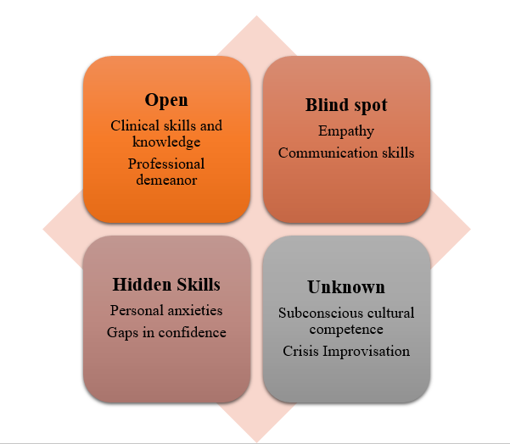  Figure 1: Application of Johari Window to learn self-awareness  Screenshots based on online activities  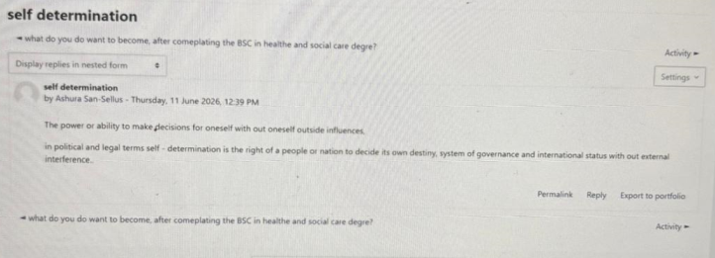  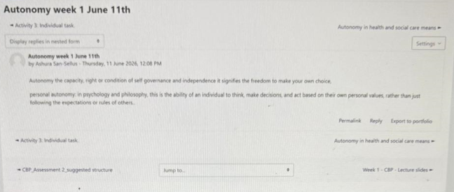

Reflection on Unit 2: It’s a Small World | Reflection on learned topics  Week 3 and 4 covered some topics of Unit 2 to learn about “It’s a Small World.” In the third week, two topics have been discussed, which are “It is a small world” and “Variety is the spice of life.” Networking, global connections, diversity, and the cultural competencies were the focuses this week to help the students in the health and social care sector. In the fourth week, I attended the lecture classes of “Network society” and “Making connections” for professional development.  Description of learning  The third and fourth week assisted me to learn about networking and its importance, along with the significance of diversity in networking. I have learned that networking is essential for building relationships. This can be formed by talking to people at a conference, being active on LinkedIn, or engaging in conversations about the subject on social media platforms. Networking helps in developing positive links and potential collaboration for a diverse and robust professional community (Gibson et al., 2014). Besides, evaluation increases the value judgments for personal and professional development and opens opportunities for improving skills and competencies through making connections. In this case, I can utilise goal-based evaluations using SMART or FAST goals for improving my connection in this industry and strengthening my skills and competencies. However, I will be aware of sticking in the comfort zone, which can negatively affect my creativity and innovation skills. At the same time, I understood that it could limit my judgement, while I can engage in a diverse workplace to open up my thinking and make decisions for my professional career. Hence, I understood the meaning of hierarchy and bureaucracy in the healthcare industry, as networking is dependent on these facts. The case study of COVID-19 vaccines has helped in understanding the networks of influence, along with social prescribing.  Linking reflection to relevant academic literature and models  According to the learnings in these weeks, I have understood that networking is important for professional development in the healthcare industry. Wani (2024) stated that networking is a critical component of professional development in medical education that involves the establishment and maintenance of relationships. Hofstede's Cultural Dimensions can be implicated for understanding the way networking helps the professionals to navigate diverse medical teams and patient populations (Zidkova et al., 2025). I understood that people form high power distance index expect strict adherence to titles that encourage decision-making. However, people from low power distance prefer team-based communication where junior staff can feel comfortable questioning. Besides, collectivism emphasises group consensus, while individualism focuses on personal autonomy, patient-centred rights, and direct feedback. I have also found that people from high uncertainty avoidance index (UAI), prefer clear protocols, formalised guidelines, and resistance to unexpected changes. Oppositely, low UAI prefers more adaptability to fluid, comfortable managing risks, and unstructured situations, which increases my cultural awareness.
Reflection on Unit 3: Opportunity Knocks | Reflection on learned topics  Unit 3 is based on two individual weeks (5 and 6), which are focused on different topics that helped me to build my personal brand for sustainable employment. The fifth week considers two topics, including “Creating your own luck” and “Identifying career opportunities.” Hence, the sixth week lectures are based on “Open doors” and “Me.com,” which are essential for creating an online presence to spot opportunities, drive goals setting and personal development planning.  Description of learning with link to literature  Gibbs’ reflective cycle  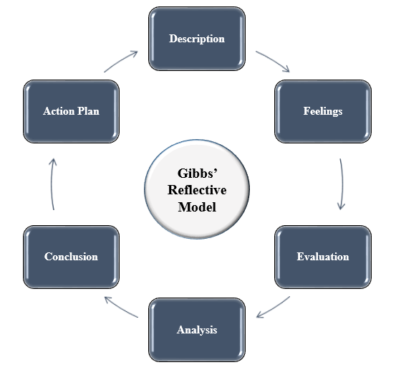  Figure 2: Gibbs’ reflective cycle  Description  I came to know about serendipity mindset, starch goal, traditional and modern recruitment, and work value. I also found that skill, market, and interest are connected to each other to develop one’s abilities and competencies in the healthcare sector. Therefore, I addressed the process of opening doors for job opportunities, along with creating online presence, such as writing a blog.  Feelings  These lecture classes have encouraged me to create a LinkedIn profile to attract employers in the healthcare industry. It helped me to build my confidence as a healthcare professional, eases the way to pursue a career with developed skills. On the other hand, it has triggered my anxiety about not having all the skills of a healthcare professional. At the same time, I am assured that following the steps and techniques can help in building my personal brand for professional development.  Evaluation  I have understood from the lessons that there are many options to develop a career in this field. Urdaneta-Ponte, Oleagordia-Ruiz, and Mendez-Zorrilla (2022) stated that the updating of the resume and increasing networking with the professionals through LinkedIn and social media channels is necessary. The job boards and company websites will provide me with access to jobs and opportunities to improve my skills through practical activities. However, a thing was unclear to me, which is the process of developing the LinkedIn profile effectively, so that it can attract employers. The application of Five Cs in the learning process has helped me to understand it.  Analysis  The lecture classes have clarified about the recruitment processes, including traditional and modern. I have understood that I have good communication skills and the storing knowledge of clinical techniques, which I can add in my resume to strengthen my personal brand. However, I have a lack of emotional intelligence skills, which lowers my confidence as a medical professional.  Conclusion  According to my experiences and learning, I found that I have good communication and clinical skills, which will ease the process of getting a job. Besides, I have to work on my emotional intelligence skills.  Action plan  Screenshots based on online activities  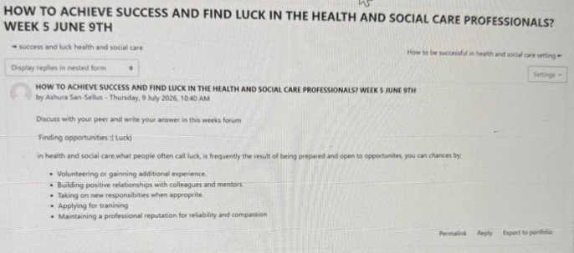  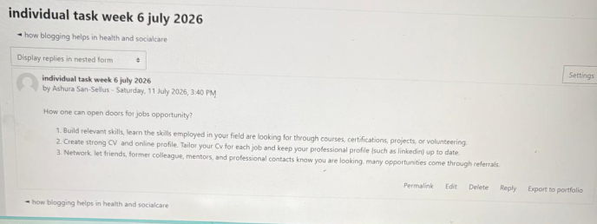  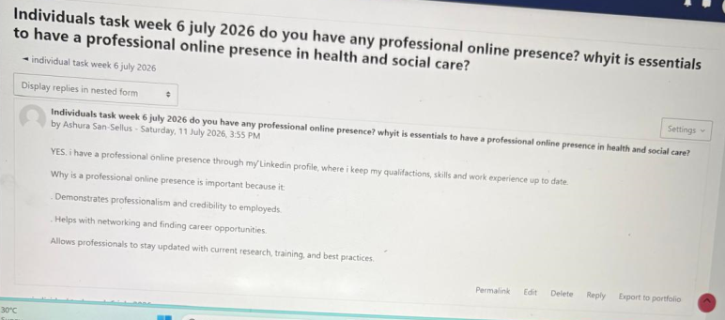  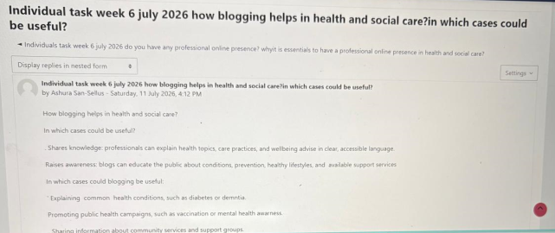  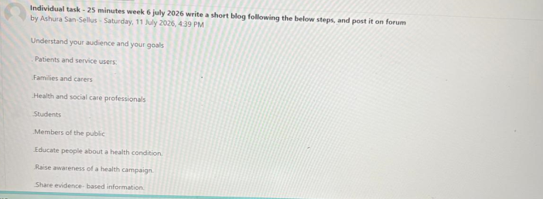  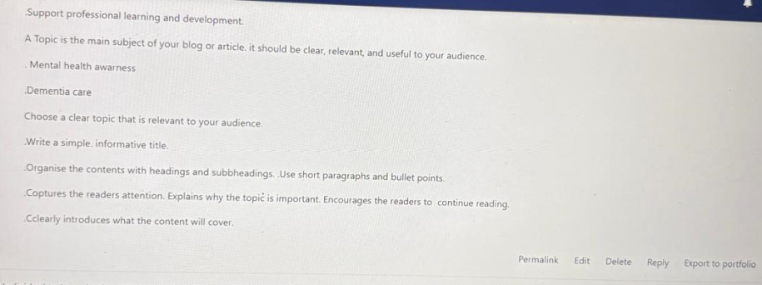
  Objective | Specific | Measurable | Attainable | Relevant | Time-bound
  To improve my emotional intelligence skills within the next 5 months | I want to improve my emotional intelligence. | I will measure these skills using standardised self-report assessments and behavioural 360-degree feedback. | I will utilise the teach-back method, along with engaging in post-shift reflection. | This is important for gaining more opportunities in the job market. | 5 months
Reflection on Unit 4: The Pursuit of Happiness | Reflection on learned topics  The seventh week discussed two topics, including “Future me” and “Passion and perseverance.” This week helped me to understand the reasons behind studying, limiting beliefs, and grit, which indicate personal wellbeing, resilience, and work-life balance. Therefore, the last week covers other two topics, including “Plan, prepare, perform” and “Career role models.” This week assisted me to understand the impact of changes due to technology in the sector and the future of employment in this industry.  Description of learning  I have understood that self-doubt, envy, defensiveness, excuses, and stagnation can be my limiting beliefs, while I can overcome them through reflecting and responding precisely for my personal development. Besides, I need to improve my grit to deal with failure in the professional field. In this case, self-esteem and self-regulation are necessary for confident decision-making and clear patient communication, along with the management of stress and emotional exhaustion in fast-paced environments (Skiba, 2024). I can prevent burnout in high-stress jobs or practices. Hence, I need to develop my digital skills to cope up with the changing trends and workplace needs in the health and social care industry. AI plays a vital role for corporate jobs, such as clinical prompt engineering, data literacy, and ethical governance (World Health Organization, 2024). These capabilities can diversify my career options in the fast-paced industry.  Linking reflection to relevant academic literature and models  PERMA model of wellbeing  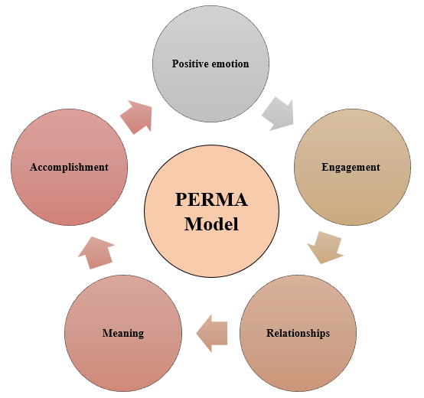  Figure 3: PERMA model  The PERMA model can be utilised to discuss the importance of wellbeing for a healthcare professional by reflecting on Positive emotion, Engagement, Relationships, Meaning, and Accomplishment (Al-Hendawi et al., 2024).  Positive emotion  I found that I could achieve positive emotion in this field through experiencing joy, gratitude, and hope, which act as the psychological buffer against daily stressors. In this case, I can keep a gratitude journal that can savour one positive interaction with a patient or peer.  Engagement  I can use AI and technological competencies for minimising low-value administrative tasks where possible through seeking out clinical cases. I can also take part in hands-on medical work, where I can entirely utilize my expertise.  Relationships  I can try to lean on my colleagues for emotional support through participating in formal and informal debriefs. Hence, I can also express my gratitude to the health teams and connect with peers through professional networks,  Meaning  I would like to reflect on the impact of my provided care and mentor younger medical students. The engagement in advocacy and research work can drive my healthcare field forwards.  Accomplishment  In this case, I can break down overwhelming professional and personal challenges into small and actionable milestones. Furthermore, I can pursue continuing medical education in areas of interest, along with mastering new clinical or technological skills.  Screenshots based on online activities  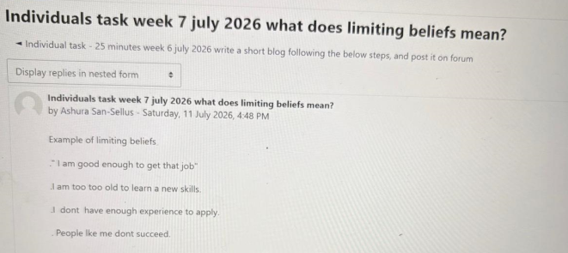  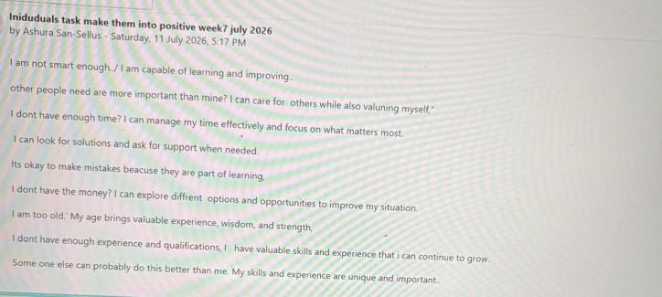  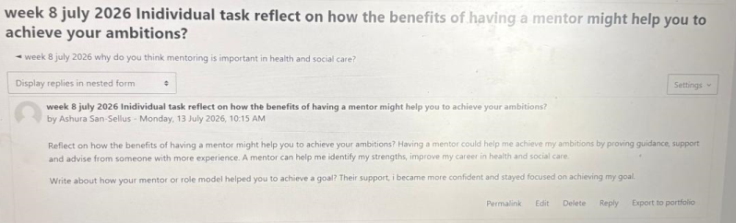  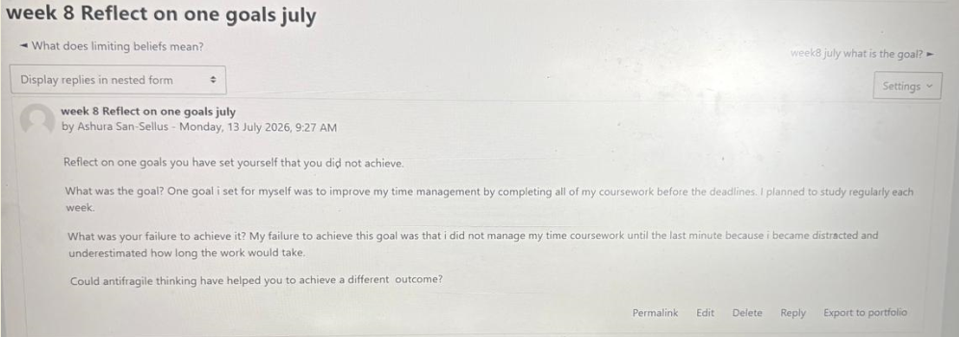  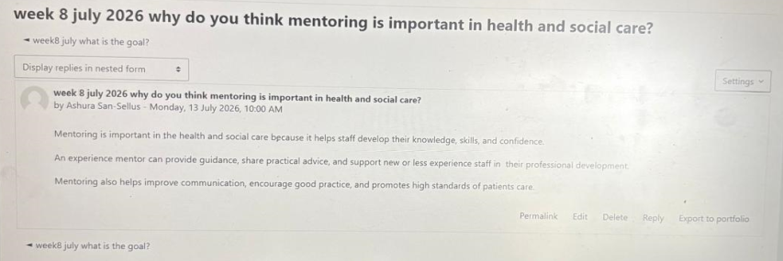
Conclusion | According to the study, I can conclude that all of the units are helpful for the healthcare learners to learn about resilience, adaptability, and continuous development for pursuing the future career. I have attended lecture classes to learn the role of ambition and motivation to set goals, along with self-determination to achieve them, which can help me in the career development and professional journey. I got to know about the essential and additional skills for a boundaryless career, which are emotional intelligence and self-awareness. I have engaged in the lecture classes of the fifth and sixth week, where I learned about perception and the way to achieve success and find luck in the health and social care profession.
References | Al-Hendawi, M., Alodat, A., Al-Zoubi, S. and Bulut, S., (2024). A PERMA model approach to well-being: a psychometric properties study. BMC psychology, 12(1), p.414. https://link.springer.com/content/pdf/10.1186/s40359-024-01909-0.pdf  Challoumis, C., (2026). Feedback and Johari Window: An Academic Analysis of Self-Disclosure, Perceived Feedback, and Personal Growth. https://www.researchgate.net/profile/Constantinos-Challoumis-Konstantinos-Challoumes/publication/405009860_Feedback_and_Johari_Window_An_Academic_Analysis_of_Self-Disclosure_Perceived_Feedback_and_Personal_Growth/links/6a0c36dfffeb2910364bc469/Feedback-and-Johari-Window-An-Academic-Analysis-of-Self-Disclosure-Perceived-Feedback-and-Personal-Growth.pdf  Gibson, C., H. Hardy III, J. and Ronald Buckley, M. (2014). Understanding the role of networking in organizations. Career Development International, 19(2), pp.146-161. https://www.emerald.com/cdi/article/19/2/146/26621  Shogren, K.A., Burke, K.M., Linnenkamp, B. and Wehmeyer, M.L., (2024). Self-determination. In Handbook of Research-Based Practices for Educating Students with Intellectual Disability (pp. 268-290). Routledge. https://www.academia.edu/download/112197345/978-3-319-59066-0.pdf#page=58  Skiba, R., (2024). Developing and using emotional intelligence at work. After Midnight Publishing.  Urdaneta-Ponte, M.C., Oleagordia-Ruiz, I. and Mendez-Zorrilla, A., (2022). Using linkedin endorsements to reinforce an ontology and machine learning-based recommender system to improve professional skills. Electronics, 11(8), p.1190. https://www.mdpi.com/2079-9292/11/8/1190  Wani, P., (2024). Connecting for success: the role of networking in medical education. Cureus, 16(11). https://www.cureus.com/articles/296315-connecting-for-success-the-role-of-networking-in-medical-education.pdf  West, E.K. ed., (2026). Reigniting Enthusiasm, Creativity, and Purpose Within Modern Educators. IGI Global.  World Health Organization, (2024). Ethics and governance of artificial intelligence for health: large multi-modal models. WHO guidance. World Health Organization.  Zidkova, R., Furstova, J., Malinakova, K., van Dijk, J.P., Tavel, P. and Gulis, G., (2025). National cultural characteristics as defined by Hofstede’s dimensions and their associations with population health. BMC public health, 25(1), p.1879. https://link.springer.com/content/pdf/10.1186/s12889-025-22915-w.pdf

