DSR Assessment 2
Individual Report on impact of Virtual Learning Environment (VLE)

Mark Zankov
2030454

Lecturer: Amitave Banik
Module code BMSW4003
Executive summary
The purpose of this study is to identify the advantages and disadvantages of the virtual learning environment of the University of Wales Trinity Saint David during this covid situation. This report helps to identify the increasing digital literacy through different courses. It is also helpful for students and teachers to learn more new techniques and increase technical skills during this lockdown period from any corner of this country. Lastly, it is compared here that online study material and techniques are not sufficient for all students in virtual mode whereas some of them prefer classroom programs.
Table of Contents

1. Introduction 4
2. Primary data collection 5
3. Primary data analysis (Survey analysis) 10
4. Secondary data collection 18
5. Secondary data analysis 19
6. Recommendation 21
7. Conclusion 22
References 23
Journals and Books 23
Website 23

1. Introduction
Virtual learning has become one of the most popular learning modules nowadays. The University of Wales Trinity Saint David, London has also started virtual learning programs for their students of different departments during this pandemic situation. They have started different new terms and conditions for their online lectures, classroom services, test programs and many more (Pubmed, 2019). This report includes a mixed survey report on the impact of the virtual learning environment in the University of Wales Trinity Saint David, London Campus. Lastly, it compares the primary and secondary data findings effectively.

2. Primary data collection
Primary data in this context of the impact of the virtual learning environment of the University of Wales has been conducted with 20 participants who are directly connected with this institution.
Question. 1 |  | Do you think Virtual learning environments are enough for proper education and the University of Wales offers low-cost virtual learning environments in the UK more than other universities?
Response | Response Tone | Yes | No | Maybe
Response | Response | 8 | 10 | 2
Response | Response Percentage  (%) | 40 | 50 | 10
Table 1: Response of Question 1

Question. 2 |  | Do you think the virtual learning environment is better than the classroom learning environment?
Response | Response Tone | Yes | No | Maybe
Response | Response | 4 | 14 | 2
Response | Response Percentage  (%) | 20 | 70 | 10
Table 2: Response of Question 2

Question. 3 |  | Do you prefer online study materials more than offline books and classes along with the facilities of college libraries?
Response | Response Tone | Yes | No | Maybe
Response | Response | 6 | 14 | 0
Response | Response Percentage  (%) | 30 | 70 | 0
Table 3: Response of Question 3

Question. 4 |  | Is the communication style of virtual learning appropriate for this university in order to motivate students?
Response | Response Tone | Yes | No | Maybe
Response | Response | 6 | 4 | 10
Response | Response Percentage  (%) | 30 | 20 | 50
Table 4: Response of Question 4

Question. 5 |  | Is the virtual mode of learning affordable and accessible for all?
Response | Response Tone | Yes | No | Maybe
Response | Response | 8 | 6 | 6
Response | Response Percentage  (%) | 40 | 30 | 30
Table 5: Response of Question 5

Question. 6 |  | Do you think the virtual learning season is more flexible than classroom programs?
Response | Response Tone | Yes | No | Maybe
Response | Response | 10 | 8 | 2
Response | Response Percentage  (%) | 50 | 40 | 10
Table 6: Response of Question 6

Question. 7 |  | Does the virtual learning technique help in improving technical skills and in expanding world view among students and teachers?
Response | Response Tone | Yes | No | Maybe
Response | Response | 10 | 8 | 2
Response | Response Percentage  (%) | 50 | 40 | 10
Table 7: Response of Question 7

Question. 8 |  | Is a virtual learning environment helpful in relationship building and in increasing inclusivity among shy students?
Response | Response Tone | Yes | No | Maybe
Response | Response | 12 | 4 | 4
Response | Response Percentage  (%) | 60 | 20 | 20
Table 8: Response of Question 8

Question. 9 |  | Does covid 19 give a strong impact on accessing technologies and techniques in virtual learning?
Response | Response Tone | Yes | No | Maybe
Response | Response | 14 | 2 | 4
Response | Response Percentage  (%) | 70 | 10 | 20
Table 9: Response of Question 9

Question. 10 |  | Does virtual learning help in improving digital literacy during this covid situation?
Response | Response Tone | Yes | No | Maybe
Response | Response | 16 | 2 | 2
Response | Response Percentage  (%) | 80 | 10 | 10
Table 10: Response of Question 10

3. Primary data analysis (Survey analysis)
The Virtual learning environment of University of Wales Trinity Saint David is a well-known feature for all aged students in the UK. This survey report on the impact of the virtual learning environment during the covid situation consists of 10 questionnaires from 20 students at this university. They have shared their own experiences in this context during this period effectively.

Question no. 1
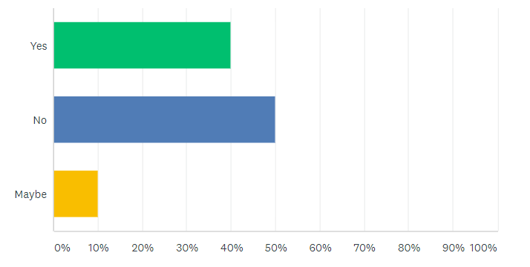
Figure 1: Graphical Representation of Question 1
Analysis
According to this online survey, 40% of the participants think that virtual learning is enough for proper education and the University of Wales Trinity Saint David offers people low-cost virtual education services in the UK. Alternatively, 50% of the audience does not agree with this comment and 10% of the participants have refused to give an answer.

Question no. 2
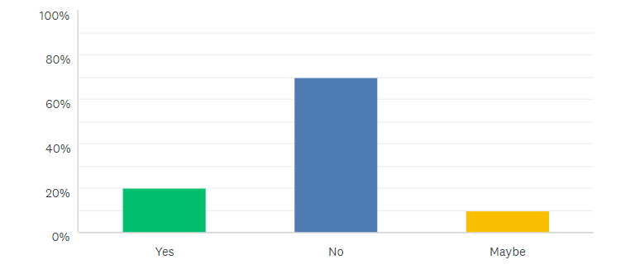
Figure 2: Graphical Representation of Question 2
Analysis
According to this question, 70% of the participants do not think virtual learning programs are more useful than classroom programs but 20% of people find it more useful than offline mode of education.

Question no. 3
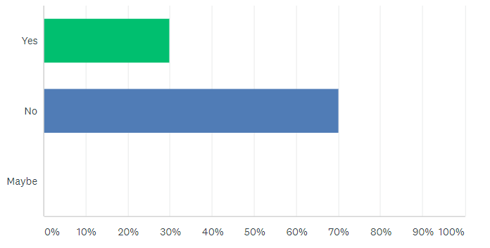
Figure 3: Graphical Representation of Question 3

Analysis
According to this online survey, 70% of the participants prefer online study materials but 30% of the students like to study books and to facilitate college libraries.

Question no. 4
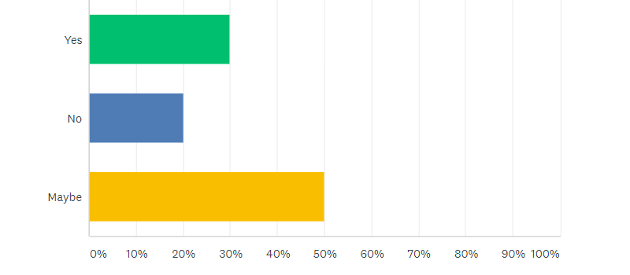
Figure 4: Graphical Representation of Question 4
Analysis
As in this survey, 30% of the participants are satisfied with the communication styles of this virtual learning and they think it is motivational for students. Alternatively, 20% out of the total have refused to believe in proper communication style from virtual learning and 50% of the audience has refused to give any comment.

Question no. 5
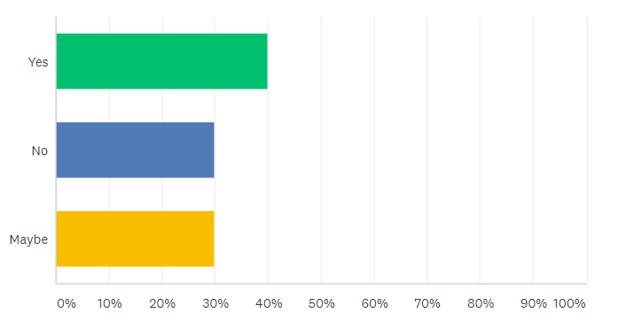
Figure 5: Graphical Representation of Question 5
Analysis
According to the 5th question of this survey, 40% of the participants have said that virtual learning is easily affordable and accessible in this pandemic situation but the remaining 30% people either have refused to answer or neglected to believe this opinion.

Question no. 6
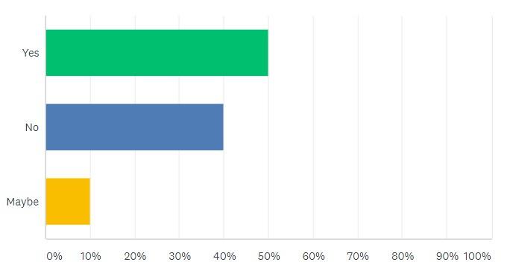
Figure 6: Graphical Representation of Question 6
Analysis
According to question no 6, 50% of the students think that online learning is more flexible than classroom programs whereas 40% out of the total have refused to believe in the flexibility of a virtual learning environment. Additionally, 10% of the audiences have refused to answer in this context.

Question no. 7
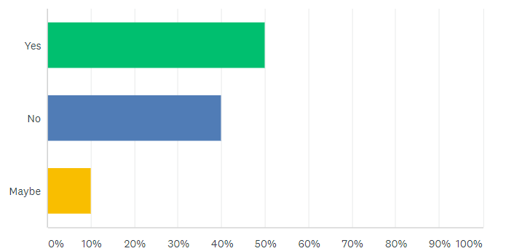
Figure 7: Graphical Representation of Question 7
Analysis
50% of the participants of this survey have admired that virtual learning helps them to improve their technical skills but 40% of the remaining have also faced different types of technical difficulties in the mode of virtual learning during this covid situation.

Question no. 8
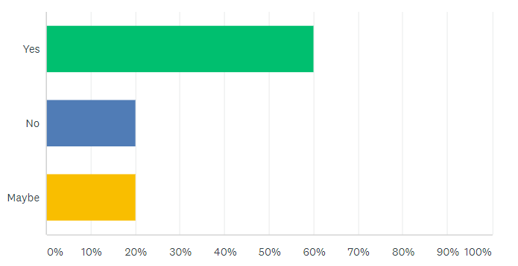
Figure 8: Graphical Representation of Question 8

Analysis
According to the 8th question of this online survey, 60% of the participants of University of Wales have admired that a virtual learning environment is more helpful in building relationships with classmates and teachers than offline classes. They have also said that they have overcome all their shyness through this mode of education but 20% of the students also have refused this comment.

Question no. 9
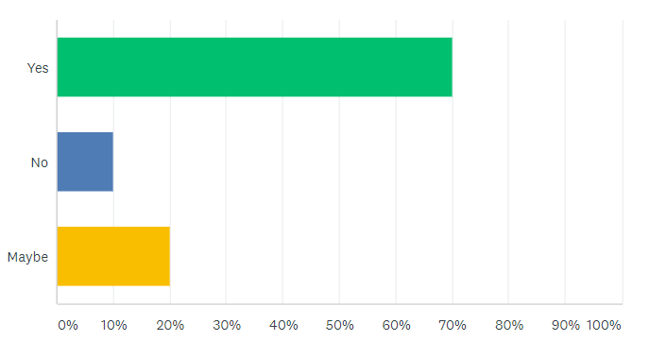
Figure 9: Graphical Representation of Question 9
Analysis
This graphical identification of question no 9 represents that 70% of the participants of this survey think covid 19 has an important impact on virtual learning. It has severally increased the percentages of using virtual mode of learning and students have adopted new technologies and techniques in this context effectively. Alternatively, 10% of people said that they have faced more difficulties in admiring new techniques in this situation.

Question no. 10
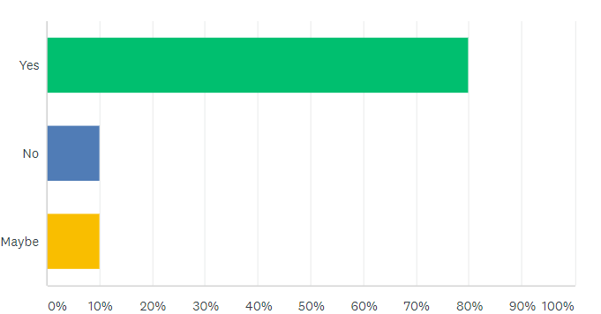
Figure 10: Graphical Representation of Question 10
Analysis
According to this graphical analysis, the maximum number of audiences, like 80% out of the total participants, have admired that virtual learning is very much useful in improving digital literacy during this covid situation.

4. Secondary data collection
According to Abdeldayem et.al., (2020, p. 1), Virtual learning environments are an older phenomenon in the field of education. Lots of universities, schools, colleges, and other institutions along with business organizations are already using the virtual learning process before the covid situation. University of Wales Trinity Saint David mainly offers their students offline learning programs, but they have started their new virtual learning programs from 2019 due to the covid situation. According to Reddy and Rajpur, (2020, p. 19), this is totally a computer-aided learning approach which reveals various new challenges, opportunities to the teachers and students as well as the administrative department of this organization. According to Gomez, (2020, p. 3), it is revealed from the organization that the virtual learning environment of the University of Wales is much more flexible and affordable for students than other institutions in the UK. Similarly, this campus allows people all their learning online and there is no need to attend any test, class, registration or all other purposes in offline mode (Funtech, 2021). According to Kee, (2021, p. 3), this education environment admires that they make available very high-quality education through online mode during this exhausted situation all over the world.
The virtual learning environment of the University of Wales Trinity Saint David claims that it is a friendly environment for teachers to manage administrative work, plan lessons, check students’ activity and performance and all (Insightstobehavior, 2020). Their virtual environment is also termed as an easier way of analyzing the learning efficiency to the current activity. According to Bhagat and Kim, (2020, p. 1), London Campus also approaches their students and teachers to make different experiments with various new approaches and contextual formats. Alternatively, an important disadvantage of this virtual learning environment is weak motivational power and poor self-discipline among students. Similarly, it consists of a lot of communication tools to communicate with teachers and classmates also but there are such communication gaps rather than face to face communication (Insightstobehavior, 2020). The virtual learning environment of this university has also claimed that they offer two or more classes of different programs at a time with this mode at any place of this country during this pandemic situation. According to their opinion, it is the easier way for people to learn more concepts without getting outside their home. They also said that 15% of people in the UK are unable to adjust with this virtual environment though this university has spent lots of time trying to adjust with them (Ucas, 2019). Thus, the virtual learning environment has become an important part of life during this pandemic situation.

5. Secondary data analysis
This report represents a brief study on the impact of the virtual learning environment of University of Wales with the help of an online survey and different secondary data finding from the official website of this organization. This organization has said that they offer students low-cost virtual learning modules and two or more degrees at a time during this lockdown period. Both the students and teachers at this university have also admired this comment of the university (Scand, 2020). Additionally, they said that it is very useful for all students because it gives the opportunity of learning from home during this pandemic situation even from the remote areas. Additionally, the virtually learning opportunity is much more associating and useful for students as the teachers organize their study curriculum with proper planning before any case study. According to Vladova, (2021, p. 225), the virtual learning method of this university provides opportunities for their students to attend or watch their online classes at any time without missing any season of learning but most of the students wrongly use this concept due to their poor self-obedience.
According to Kurbakova et al., (2020, p. 17), students have also said that the online materials of the university are not sufficient for any course. Online learning environment is also not sufficient to improve the communication gap among students and teachers who refuse the authority of this university. It is said by the administrative department of the University of Wales that they give lots of online study material, but many students prefer offline classes as well as books. Alternatively, both students and teachers have admired that the virtual learning environment is creating a big communication gap. Virtual environment does not give any laboratory experiments to their students, but the university always tries to facilitate their students with more curricular activities (UWTSD, 2021). Additionally, this mode of learning tries to discipline people with lots of motivational power during the lockdown period, but the lazy people do not facilitate this opportunity. Similarly, maximum students have admired that this university is truthful on their comment of easily affordable and accessible virtual learning (Ingresqr, 2020). They are also in the same opinion with this university about the flexibility of online learning during this pandemic situation. They all admire that virtual learning is the only way of learning safely during this difficult situation in the UK as well as all over the world. The virtual learning environment helps to improve the technical skills of both students and teachers, and they have admired that they have taught various new techniques through online classes in this period (Wales, 2019). Most importantly, it is primarily and secondarily proved that virtual learning methods have improved the percentage of digital literacy during this covid situation which is much appreciated for any country.

6. Recommendation
Recommendation 1: New plan for live communication
Many students are very undisciplined during online classes, and they are continuously attending their classes at specific times only for their laziness. Thus, the university needs to plan for new live communication techniques during their virtual classes which will prevent the huge number of non-attending students in this environment.

Recommendation 2: More awareness among parents and university authority about students’ performance
Most of the students are not conscious or aware of learning new skills through virtual mode as they easily copy with other gadgets during any online tests. Alternatively, the university authority does not conduct any meeting about student's performance during this covid situation which also causes an under growth in education. Thus, it is recommended for the parents and university authority to be more aware of students’ performance to maintain the educational quality.

Recommendation 3: Restriction on missing classes and delayed answers of different activities
The virtual learning programs of this university are flexible and some of the students are misusing this facility. Thus, it is highly recommended for the university to keep restrictions on missing two or more classes and delay in giving answers of different activities.

7. Conclusion
This report concludes the pros and cons of the virtual learning environment of the University of Wales during this covid situation. It consists of an online survey along with questionnaires on experiences of 20 selected students of this campus during this lockdown period and some secondary data findings from different journals, blogs and many more. Additionally, it is observed that most of the students, teachers, parents and the university authority are faithful with the virtual learning environment, and they think it is enough for skill development in this spontaneous situation.

References

Journals and Books
Abdeldayem, M.M., Aldulaimi, S.H. and Aldulaimi, M.L.A., 2020. Virtual learning and students’ connectedness in the time of coronavirus. International Journal of Advanced Science and Technology, 29(5), pp.12634-12645.
Bhagat, S. and Kim, D.J., 2020. Higher education amidst COVID-19: challenges and silver lining. Information Systems Management, 37(4), pp.366-371.
Gomez, I.N.B., 2020. Reflections on the role of occupational therapy programs on the mental health of stakeholders’ transition to e-learning during the COVID-19 pandemic. World Federation of Occupational Therapists Bulletin.
Kee, C.E., 2021. The impact of COVID-19: Graduate students’ emotional and psychological experiences. Journal of Human Behavior in the Social Environment, 31(1-4), pp.476-488.
Kurbakova, S., Volkova, Z. and Kurbakov, A., 2020, July. Virtual Learning and Educational Environment: New Opportunities and Challenges under the COVID-19 Pandemic. In 2020 The 4th International Conference on Education and Multimedia Technology (pp. 167-171).
Reddy, M.S. and Rajpur, A., 2020. ROLE OF VIRTUAL LEARNING ENVIRONMENTS IN MODERN EDUCATION SYSTEM. DEVELOPING THE NEXT GENERATION LEARNERS IN THIS DIGITAL ERA (Vol. II), p.19.
Vladova, G., 2021, May. Yes, We Can (?)-A Critical Review of the COVID-19 Semester. In Technology and Innovation in Learning, Teaching and Education: Second International Conference, TECH-EDU 2020, Vila Real, Portugal, December 2–4, 2020, Proceedings (Vol. 1384, p. 225). Springer Nature.

Website
Funtech, 2021. “8 Benefits of Virtual Learning Environments (Importance of Virtual Classrooms)”. Available at:
https://funtech.co.uk/latest/benefits-virtual-learning-environments-classrooms [Accessed on 30.07.2021]
Ingresqr, 2020. “How Virtual Learning Can Affect Academic Performance In 2020”. Available at: https://www.ingresqr.com/virtual-learning-affect-academic-performance/ [Accessed on 30.07.2021]
Insightstobehavior, 2020. “Common Obstacles Students Face in a Virtual Classroom and How to Manage Them”. Available at: https://insightstobehavior.com/blog/common-obstacles-students-face-virtual-classroom-manage/ [Accessed on 30.07.2021]
Pubmed, 2019. “Impact of Virtual Learning Environment on Students' Satisfaction, Engagement, Recall, and Retention”. Available at: https://pubmed.ncbi.nlm.nih.gov/31229502/#:~:text=Results%3A%20Virtual%20learning%20seemed%20to,this%20was%20not%20statistically%20significant [Accessed on 30.07.2021]
Scand, 2020. “The Use of Virtual Learning Environment In Education”. Available at: https://scand.com/company/blog/the-use-of-virtual-learning-environment-in-education/ [Accessed on 30.07.2021]
Ucas, 2019. “HOW YOUR SURROUNDINGS AFFECT THE WAY YOU STUDY”. Available at: https://www.ucas.com/connect/blogs/how-your-surroundings-affect-way-you-study [Accessed on 30.07.2021]
UWTSD, 2021. “UWTSD has a long history of offering programs through distance learning”. Available at: https://www.uwtsd.ac.uk/online/ [Accessed on 30.07.2021]
Wales, 2019. “Google Classroom' - A new virtual learning environment”. Available at: https://www.wales.ac.uk/en/NewsandEvents/News/Quality-News/Google-Classroom.aspx [Accessed on 30.07.2021]

