Effective Teamwork and Communication AS1
MODULE CODE BMSW4002
Student Name: Iosif Tcaciu
Student id no : 2022775
Module leader :Lloyd Beharry
Lecturers Ejiro Esohwode

Table of Contents
Section 1: Introduction: 3
Section 2: Models of Communication 3
2.1 Points of Shannon-Weaver Model of communication 3
2.2 Schramm model of communication 4
2.3 Berlo’s model of communication 5
Section 3: Communication Skills 6
Skills and Methods of Communication 6
3.1 Verbal Communication 6
3.2 Non-verbal Communication 7
3.3 Listening 7
Tools and approaches for supporting the skills of communication 8
Suggestions for making communication effective in business environment relating to case study on my workplace 8
Section 4: Conclusion: 9
References: 10

Section 1: Introduction:
Communication indicates the transaction of a message from one person to another by using an understanding message and facing the noises around the receiver and sender (Plathottam, 2021). Communication is very important in this world because smooth functioning in any company cannot be thought without proper communication. Emotional barriers, usage of jargon, noise, lack of attention, differences in perception and hearing problems are the prime barriers that may lead to poor communication. Poor Communication may lag a company behind in gaining success. This report is going to include a discussion on several issues related to communication and effective team working and those issues are models and skills of communication, usage of different tools to support communication skills and case study of my workplace to show poor communication and to suggest some solutions for reducing the bad effect of poor communication.

Section 2: Models of Communication
Communication models are the simplified representation of how people interact with each other and what creates problems in that journey and thus they direct the people to communicate effectively (Smetschka and Gaube, 2020). Several models of communication are used by the professionals and out of those Shannon-Weaver model, Schramm model and Berlo’s model are mostly used ones.

2.1 Points of Shannon-Weaver Model of communication

Figure: Shannon-Weaver Model of Communication
Source: (Miazga and Królikowska, 2020)
Shannon-Weaver model is a linear model where two parties are sender and receiver. The message developed by the sender is encoded to send through a communication channel like messenger, Telephone or any other channel. The receiver may get the real message by decoding the encoded message. Noise within this journey may create problems to send the message properly. In my workplace at Unilever, my assistant called me in a day. He informed me that anyone wants to meet with me. I told him, “Send him later”. Due to loud sounds, he just listened to “Send”. So, he sent the man although I was busy. Here the loud sound is the noise, send him later is the message, the telephone has encoded and decoded the message and channel is cable. However, the Shannon-weaver model does not say how misunderstanding due to noise can be avoided and this can be counted as one of the limitations of this model. In Shannon-Weaver model, physical noises such as mechanical and engineering noise is believed to create problem in communication (Jordan, 2021). But there might also have some other noises such as channel overload due to capacity problems, small group discussions in meetings and standing of any person in front of anyone which may not be counted in the Shannon-weaver model.

2.2 Schramm model of communication
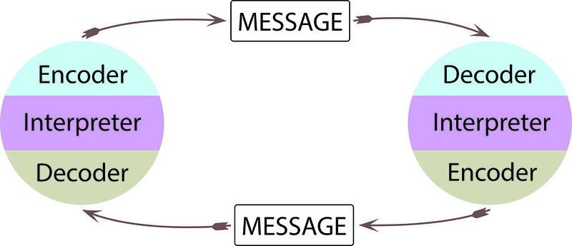
Figure: Schramm Model of Communication
Source: (Mitra et al, 2020)
Schramm model is a little bit different from the Shannon-Weaver model, although the parts and factors of the two models are almost the same. The Shannon-weaver model is a straight-line model whereas the Schramm model of communication is circular (Nayak and Rath, 2019).
In the circular model of Schramm, the sender becomes receiver with time. Both sender and receiver might have encoding, decoding systems and interpretation systems. It is natural that in a conversation both people may interact with each other. When a person may send a message to another person, the person on the opposite side may reply. In case of the replying, there might also have a message which has to be encoded to send through the channel.
There might also have a system of interference like the noise system in the Shannon-weaver model of communication (Umeozor, 2020). In the case of my assistant’s call to me, the loud sound faced by him can be counted as inference. As I was busy with my activities, my assistant should ask me again if he could not understand me rather sending the person to me. Sending the person to me, he has interrupted my activities and the person might also be disappointed just because of his poor communication skills. So, people should be careful to communicate well and they should follow some norms as I mentioned.

2.3 Berlo’s model of communication
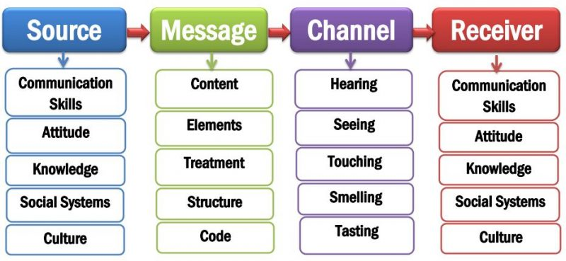
Figure: Berlo’s model of communication
Source: (Kuznar and Yager, 2020)
Berlo model may have some similarities and differences with other models (Irvine et al, 2021). For example, Berlo’s model is a straight-line model like the Shannon-weaver model. This model has source and receiver in two parts of the communication which is available in other models as well. Here, the source indicates the starter of communication or sender as well. The factors that influence the communication of both sources and receivers are communication skills, attitude, knowledge, culture and social system. So, it can be said that Berlo’s model is the one where cultural norms, values and beliefs are counted as one of the important issues of communication. Depending on the culture of a person, his or her communication can be different from others (Bambaeeroo and Shokrpour, 2017).
In my workplace, Unilever UK, there are people from some Asian and African countries and their native languages are not English. In a day, a Senior Officer was delivering a speech and that officer was an English. As he had high fluency in his speech, the employees of Asian and African origin could not understand him well.

Section 3: Communication Skills

Skills and Methods of Communication
Communication skills are very important for every employee working in any business organisation (Hargie et al, 2017). Communication skills may depend on the verbal, non-verbal and listening skills or method of communication. The employees who have skills on all these threes, they can be considered as the best one and he will be able to contribute the high amount to the success of the company.

3.1 Verbal Communication
Verbal communication may not only depend on speaking fluency but also the choices of words and tones of voice (Jiang and Chun, 2021). Verbal communication is also considered as Speaking or oral communication and most of the communication is dependent on this method of communication. People can express their feelings, thoughts, needs and wants through verbal communication. Written communication is also included in verbal communication. In the case of formal communication, written communication is widely used. In the formal meeting, verbal communication is used. Effective communicators are those persons who can selectively use their words and whose tune is good. Advising others, giving credit for good works, leading people for doing work effectively, conducting any meeting, and conveying feedback. The advantages of verbal communication are that this saves time in communication, quick feedback may be gotten from others, and it provides a complete understanding of the factors of communication.

3.2 Non-verbal Communication
Non-verbal communication is the physical movement, gestures, signs, postures and body language (Tresnasari, 2020). Non-verbal communication may vary from region to region and it is seen that where a sign is good to people is bad to people in other areas. For example, in some Asian countries, people show thumbnails when they are angry with others and this sign seems to them that the person who is showing this sign to me is humiliating me. On the other hand, in the American or European countries, it is considered as good. The situation is getting changed day by day due to the globalisation worldwide. However, non-verbal communication is highly important for people to make the sense of verbal communication.
In my workplace, a subordinate was disappointed with me when I showed him a thumbnail for his good work. He was from India and that sign is considered bad in his country. To reduce this poor communication, it can be suggested to that subordinate to learn the culture where he is working.

3.3 Listening
There are two concepts related to listening skills of communication and those are active listening and empathetic listening. Active listening indicates being attentive during the speech of others with whom a person is communicating (Khanna, 2020). Active listening helps to understand the speech very well. On the other hand, emphatic listening indicates that kind of listening where the listeners not only listen to any person but also feel the positive of that person by emotionally placing themselves in the position of that person. This listening skill is effective for knowing the needs and wants of the subordinates and so on.
On a day in Unilever UK, a team leader was taking a session by delivering a speech but the teammates were not attentive to the speech. Here, it can be said that there was a lack of active listening. So, to keep the teammates engaged, the team leader can ask the teammates questions, make comments about any issues and these will make them active.

Tools and approaches for supporting the skills of communication
There might have some tools and approaches in the communication study which may help to enrich or support the communication skills mentioned above.
S.O.L.E.R: SOLER indicates Sit squarely, Open posture, Lean towards others, Eye contact and Relax which are some techniques that will allow a person to be a good communicator and an active listener as well (Ellis and Abbott, 2018). When a person will follow all the mentioned steps of SOLER, they will be good communicators.
Proxemics / Kinesics: Positions of head Gaze and Limbs and actions of a person during their communication is considered as Kinesics whereas Proxemics is considered as the perception and structure of interpersonal and environmental space. Proxemics is effective for enriching verbal communication whereas Kinesics may enrich non-verbal communication.
Personal awareness – K.E.Y.S: KEYS indicates the Knowledge to Empower Youth for Success which means that every person should gain knowledge and enrich their awareness to be a good communicator through sharpening their communication skills (Woodfin and Plaut, 2021).

Suggestions for making communication effective in business environment relating to case study on my workplace
In a Business organisation, there should have good interrelationships among the employees which will lead them to create effective communication (Stacho et al, 2019). Trust and loyalty with each other should be grown. Employees could be given training on communication for increasing their knowledge on communication. All the employees of the business organisation should be lead to increase their culture-related knowledge so that cultural differences could not be a barrier in communication. All these factors can make communication effective in any business organisation.
Effective communication is also required in my company as well. In Unilever, poor communication is seen many times. For example, Sometimes people from a non-English background may not understand English well. Sometimes, the leader or speaker speak so quickly that the attendees cannot understand the speakers. The speakers might not also keep any feedback sessions as well. This is poor communication indeed which should be improved. To improve this communication problem, both the higher and lower-level employees should be given proper training.

Section 4: Conclusion:
Communication is one of the important transferable skills which is expected to be known by all the employees of any organisation (Dawson and Thomson, 2018). A good communicator can disseminate the message more effectively than bad communicators. This report is all about communication where communication models, communication skills, application of communication skills in the business organisation, some examples of poor communication skills and suggestions to improve those poor communication has been described. All the description of this report has provided a deep understanding on communication. To enrich communication, students like me will be able to learn lots of things. Moreover, the suggestions could be applied by several organisations to make the communication effective for their companies.

References:
Bambaeeroo, F. and Shokrpour, N., 2017. The impact of the teachers’ non-verbal communication on success in teaching. Journal of advances in medical education & professionalism, 5(2), p.51.
Dawson, J. and Thomson, R., 2018. The future cybersecurity workforce: going beyond technical skills for successful cyber performance. Frontiers in Psychology, 9, p.744.
Ellis, P. and Abbott, J., 2018. Active listening, part one: how and where. Journal of Kidney Care, 3(2), pp.126-128.
Hargie, O., Dickson, D. and Tourish, D., 2017. Communication skills for effective management. Macmillan International Higher Education.
Irvine, A.R., van Berlo, D., Shekani, R. and Masereeuw, R., 2021. A systematic review of in vitro models of drug-induced kidney injury. Current Opinion in Toxicology.
Jiang, Y. and Chun, D., 2021. Web-based intonation training helps improve ESL and EFL Chinese students' oral speech. Computer Assisted Language Learning, pp.1-29.
Jordan, M.F., 2021. Noise. In Information (pp. 148-161). Columbia University Press.
Khanna, P., 2020. Techniques and Strategies to Develop Active Listening Skills: The Armour for Effective Communication across Business Organizations. The Achievers Journal: Journal of English Language, Literature and Culture, 6(3), pp.50-60.
Kuznar, L.A. and Yager, M., 2020. The Development of Communication Models, Quick Look. Joint Staff J39, Strategic Multi-layer Assessment Washington, DC United States.
Miazga, M. and Królikowska, J., 2020. Assessment of Security of Water Supply for Benissa Municipality, Spain Employing the Shannon-Weaver Model Shannon-Weaver. Rocznik Ochrona Środowiska, 22.
Mitra, A., Ahmed, N., Pramanik, P. and Nandi, S., 2020. Language Studies and Communication Models. International Journal of English Learning & Teaching Skills, 3(1), pp.1776-1794.
Nayak, A.S. and Rath, P.K., 2019. Non-verbal Feedback and Communication. Prowess Publishing.
Plathottam, G., 2021. Unit-1 Communication–Concepts, Types and Process. Indira Gandhi National Open University, New Delhi.
Smetschka, B. and Gaube, V., 2020. Co-creating formalized models: participatory modelling as method and process in transdisciplinary research and its impact potentials. Environmental Science & Policy, 103, pp.41-49.
Stacho, Z., Stachová, K., Papula, J., Papulová, Z. and Kohnová, L., 2019. Effective communication in organisations increases their competitiveness. Polish Journal of Management Studies, 19.
Tresnasari, N., 2020. Non-Verbal Communication In Anime “Diamond No Ace” Episodes 1 And 2 (Barthes Semiotics Approach). IZUMI, 9(2), pp.128-136.
Umeozor, S.N., 2020. Information Retrieval: A Communication Process in the 21st Century Library. International Journal of Knowledge Content Development & Technology, 10(2), pp.7-18.
Woodfin, L. and Plaut, S.N., 2021. Your Curriculum Companion:: The Essential Guide to Teaching the El Education K-5 Language Arts Curriculum. EL Education.

