HNC Process Operations Engineering

Process Engineering Practice



Jake Merry

Operation of processes

Table of contents

Contents
Table of contents 2
Introduction 2
Task 1 3
Task 2 6
Bibliography 10

Introduction

The assignment that follows will aim to demonstrate an ability to describe a type of process equipment’s and its operation. Also, the process and physical hazards that are present at an oil refinery. The assignment will also contain a detailed description on the main units that ensures the refinery runs and how they produced the specified end products.

Task 1

Compressors
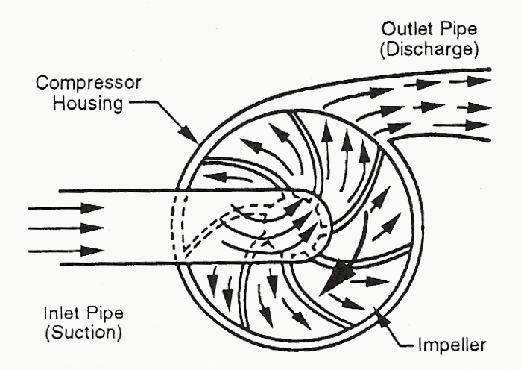
Compressors are widely utilised pieces of equipment at an oil refinery. Their main purpose is to compress and transfer air and gases from one location to another. There are two main types of compressors used at Pembroke refinery which are centrifugal compressors and positive displacement (rotary screw) compressors. The most common is a centrifugal compressor that works under the principle that is almost identical to how a centrifugal pump operates. The fluid enters the compressor housing and strikes the rotating impeller. The impeller contains multiple blades that rotate in unison with the impeller. As this fluid makes contact with the blades and drives the fluid into the centre of the impeller with a far greater kinetic energy due to this increase in energy the velocity of the fluid increases. This fluid is then accelerated into the diffuser channel by the impeller. These diffuser section causes the air or gas to reduce in velocity but cause an increase to the static pressure. This compressed fluid is then exerted through the discharge pipework to its desired location. (Waqar, Mechanical boost, 2021)

Figure 1- Working principle of a centrifugal compressor.

A rotary screw compressor works under the principle of two rotors attached to a group of helical lobes connected to a shaft. The male rotor is the first rotor, while the female rotor is the second rotor. The female rotor will always have numerically more valleys (flutes) than the male rotor lobes for better efficiency. As the male lobe rotates, the leading strip of the male approaches the female groove's shape and traps the air in the previously established pocket. As the volume is decreased, the air is transported through the female rotor groove and compressed. The trapped air is released from the discharge pipework when the male rotor lobe reaches the groove's end.
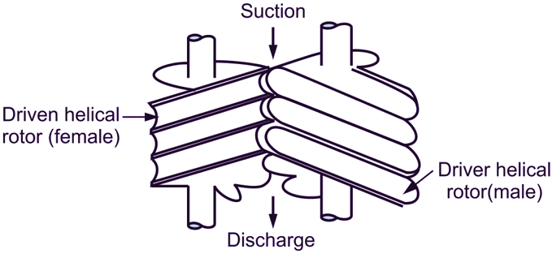

Figure 2- Rotary screw compressor working principle

The working principle of the compressors just explained would be called a single stage compressor. However, there are multiple multi-stage compressors used across the refinery which are much more efficient pieces of machinery. Multi-stage compressors increase the overall pressure one stage at a time by forcing the fluid through successively smaller casing to achieve the desired output pressure. Single stage compressors are limited by the by-product of compression which is heat. This is factored in for multi-stage compressors with the use of an intercooler at each stage. This intercooler reduces the temperature of the air by passing cooling water over the air between compression stages therefore less energy is required to achieve the output pressure. (compressor, 2022)
Compressors are susceptible to different failure modes due to their nature of their high-speed rotating operation. A common failure of a compressor is inadequate lubrication, irregular lubrication oil changes and low lubricating oil levels can cause compressors to fail. This is because of the friction between any moving components within the compressor. When the same lubricating oils are used continuously, the viscosity is dramatically altered as a result of continued exposure to cooling and heating cycles within the compressor. Another common failure of a compressor is bearing failure. Bearings are used in compressors to reduce friction between moving parts and bear and align the load of the rotating compressor shaft. Bearings have a lifespan of working operation which can be accounted for and replaced at the end of the lifespan. However, sudden bearing failure is a common and expensive mode of compressor failure. Bearing failure can most likely be put down to misalignment of the shaft or cross contamination in the bearing housing. Another failure mode of a compressor is overloading. This can happen if the compressor is loaded over its designed running capacity. Operating compressors above their optimal capacity can consume excess power and overwork machines, leading to overheating, premature machine wear and increased maintenance needs. (Copco, n.d.).The last mode of compressor failure is surging. When the inlet flow of the compressor is reduced and the compressor head developed is so low that it cannot overcome the pressure of the compressors discharge, compressor surge is a characteristic behaviour of the compressor that takes place. When a centrifugal compressor surge occurs, the compressor's outlet pressure and energy drop greatly, which causes the compressor's flow to reverse.
The compressor surging subsequently leads to high excess compressor vibration, which can lead to compressor component failure, the surge in a compressor is regarded as a very dangerous scenario. Cycles of compressor surge place a great deal of stress on the impeller, seals, and compressor bearings.

To overcome and prevent these said compressor failures there are HSE based control measures that are put in place across the refinery to avoid equipment downtime and the hazards surrounding sudden equipment failures. One of these control measures is regular planned maintenance of the compressor. This planned maintenance procedure could occur on an annual or bi-annual occurrence. The planned maintenance would involve visual inspection of key components, measurements of components and replacement of life spanned components such as air filters and lubrication oil. This procedure will help prevent potential future failures that can’t be foreseen with the compressor. Another HSE based control is regular operator checks, the operator will be responsible for conducting a four sensory inspection of the compressor at least 3 times per shift usually. The operator is looking for any unusual abnormalities with the equipment that could cause potential failures such as high temperatures, high vibrations and low lube oil levels. Finally, the last is process design before installation and operation of the compressor. The HSE based risk assessments and checks would ensure that the selected compressor is fit for purpose depending on the process service. If the wrong type and size of compressor was to be selected it could lead to process issues such as overloading and surging which can cause catastrophic compressor failures.

Task 2

Valero Pembroke refinery is a Crude oil refinery situated in Pembrokeshire, Wales. The refinery facility is capable of processing 220,000 barrels per day (bpd) of crude and 50,000 bpd other feedstocks. The refinery is made up of many process units that are responsible for producing gasoline, diesel fuel, kerosene, liquefied petroleum gas (LPG) and petrochemical feedstocks every day (Valero Pembroke, 2023). The refinery is split up into two main complexes which are Refining and Cracking & Olefins.
The refining complex is made up of a Crude Distillation Unit (CDU) which separates crude oil into its components by fractional distillation. The Vacuum Distillation Unit (VDU) which removes heavy and light gas oil fractions from crude atmospheric residue. A Viscosity Breaker Unit (VBU) which upgrades vacuum residue by thermal conversion into primarily middle distillate and stable heavy fuel oil. There is two diesel hydrotreaters (HTU1 and HTU2) which removes sulphur, nitrogen, metals and other impurities from diesel. The Unifiner unit removes sulphur, nitrogen, metals and other impurities from naphtha. The isomerisation unit uses hydrogen to increases the octane rating of light naphtha. Finally, the platformer unit increases octane rating of heavy naphtha. Also produces hydrogen for the site.
The Cracking & Olefins complex is made up of the Fluid Catalytic Cracking Unit (FCCU) which catalytically cracks large hydrocarbons into smaller chain (lighter) more valuable products. The Ultra Low Sulphur Gasoline unit (ULSG) which removes sulphur from Naphtha (produced by the FCCU) without significantly reducing the octane rating. The Alkylation unit which combines olefins with isobutane in the presence of HF acid to make alkylate. The Butamer unit which separates N-Butane (nC4, heavier) into Isobutane (iC4, lighter) in a fractionization column for use in the Alkylation unit.
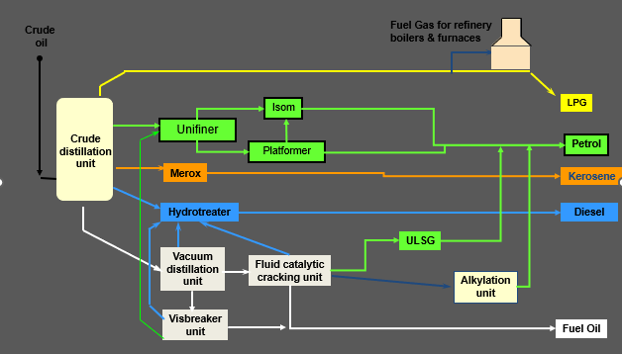

Figure 3- Overview of Pembroke Refinery process units
As can be seen in figure 3 above the refinery’s main processing unit is the Crude distillation unit. The next section of the report will explain the physical and chemical changes of Crude into its end products on the Crude distillation unit. The processing of crude oil to obtain final on specification product is a complex operation. However, the Crude distillation unit’s operating principle is a simple method of heating crude oil until each product is drawn off the distillation column at different temperatures. Firstly, the crude is stored in tankage and blended together to obtain the correct chemical properties required depending on the end yield required for sale. The crude charge pumps pump it through a series of heat exchangers to initially pre-heat the crude. Then water is injected into the crude before the desalters. Before crude oil is sent to the refining process, contaminants must be removed to assure its high quality, which is why desalting is essential. With this treatment, harmful substances like sulphur, water, salts, and even mechanical contaminants are reduced or completely removed, ensuring the pipework’s long-term functionality (Raj, 2023). The desalters use high voltage electrical grids to create an interface of crude mixture and brine solution, which is removed.

The crude then enters a pre-flash drum in which its purpose is to allow for higher heater inlet temperatures by removing lighter components from the crude prior to entering the hotter parts of the crude heater. Removal of the light components avoids crude vaporisation at the charge heater pass controllers. The flashed vapour from the pre-flash drum is sent to the CDU main column. The remaining crude is then pumped through the crude heater which heats the crude mix to around 340degs before it enters the bottom of the distillation column.
The crude distillation column is where the main distillation occurs across the refinery. Depending on their boiling points, the various hydrocarbon products within the crude are drawn off the column at side draws. Within the distillation column temperature management is crucial because a change in top temperature has an impact on how well the crude column functions as a whole. By returning some of the condensed naphtha as reflux, the temperature is controlled effectively within the column. However, the increase in reflux makes the overhead naphtha lighter by lowering its endpoint. Additionally, the high rate of naphtha reflux will lower Kerosene's Initial Boiling Point (IBP), which is the product that follows it on the bottom tray. The principle of reflux is that the colder reflux liquid that flows down the column comes into contact with the hot vapours rising through the trays up in the column. The lighter hydrocarbon fractions are vaporised during this contact, while the heavier hydrocarbon chains ones are condensed.
Also, stripping steam is introduced into the column at the bottom of the stripping section to remove any light hydrocarbons from the atmospheric crude residue. Stripping steam is injected into the bottom of the crude to reduce the oils particle pressure, increasing vapour velocity, and subsequently improving fractional distillation. The remaining crude residue at the bottom of the column that can be fractioned is then sent to the Vacuum distillation Unit to be further separated under vacuum pressure.
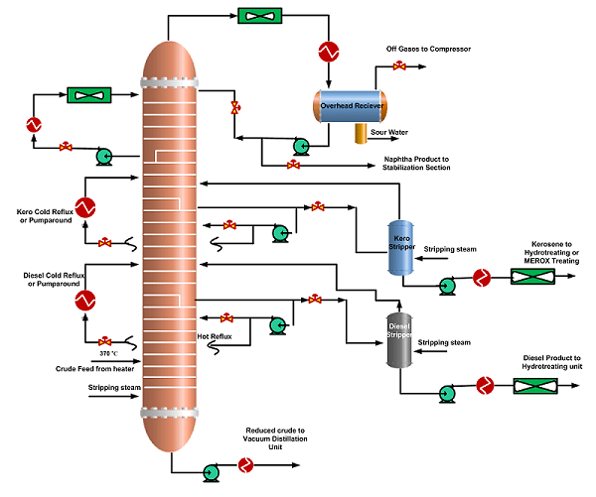

Figure 4- Complex crude distillation column

Bibliography

compressor, Q. (2022, March 11). Quincy compressor. Retrieved from Multi-Stage Compressors: https://www.quincycompressor.com/2-and-3-stage-air-compressors/#:~:text=Multi%2Dstage%20compressors%20feature%20two,the%20second%20or%20third%20stages.
Copco, A. (n.d.). How to fix compressor overload? Retrieved from Trim Down Your Costs by Increasing Compressor Count: https://www.atlascopco.com/en-uk/compressors/air-compressor-blog/challenger/backup/trim-down-costs-by-increasing-compressor-count
Raj, V. (2023). Crude Oil desalter. Retrieved from All about piping: https://www.allaboutpiping.com/what-is-desalter/
Valero Pembroke. (2023). Pembroke Refinery. Retrieved from https://www.valero.com/about/locations/pembroke-refinery
Waqar, E. (2021). Mechanical boost. Retrieved from What is a Centrifugal Compressor? : https://mechanicalboost.com/centrifugal-compressor-working-principle-and-construction/?utm_content=cmp-true

