E-PORTFOLIO
BMHP5015
Lecturer: Kennedy Obohwemu
afia basharat(2027071)
[Document subtitle]

Curriculum Vitae Afia Basharat
245 Church Road, Sheldon, Birmingham, B26 3YH

Mobile:07476064840

Email: 2027071@student.uwtsd.ac.uk
Profile Assistant in compassionate care with 6 years of experience I have always been a loyal and trustworthy person. I have excellent time management skills and a constant desire to learn new things. I am a nice, considerate, and warm-hearted person with a great sense of humour. I can work both individually and collaboratively in a hectic setting. When it comes to finding answers to problems, I am outgoing, diplomatic, and able to listen well.
A skilled, knowledgeable health assistant with a complete understanding of residential care law, including best practises and health and safety requirements. experienced in caring for children, adults, seniors, those with special needs, and/or people who are suffering from mental health issues. capable of doing all duties associated with the position, including taking care of oneself, providing medication, preparing meals, and keeping records. Being a team player, eager to participate in training sessions and team meetings, and possessing a car that can be used to drive, say, between different sites. possess in-depth knowledge of national care standards and how they relate to various care recipient categories.

Key Skills
- Excellent linguistic skills.
- A focus on the details.
- Community events.
- Administering medication. management of a care plan.
- Analyses and techniques for risk management.
- First aid and client safety.
- Compassionate customer service.
- Behavioural rerouting.
- Healthcare
- Elder Care
- Home Care
- Nursing
- Cardiopulmonary Resuscitation (CPR)
- Basic Life Support (BLS)
- Mental Health
- Full Driving License Holder
- I like being a member of a team and helping it succeed. I can connect with clients from a variety of backgrounds because I am discreet and diplomatic. As a care worker, I spend a lot of time one-on-one with my service users, which gives me the freedom to exercise my own initiative while seeing to it that their needs and overall comfort are satisfied. I have first aid training, am sane, and can operate within the rules of health and safety.

Care Assistant | Helping Hand Care Home Nov 2020 to May 2022
Home care providers in Birmingham.

- 1. Maintained the best standards feasible for the client's living and care surroundings, giving risk management, wellness, and cleanliness first attention.
- 2. Maintained an elevated level of customer satisfaction by consistently providing services that met their needs. Provided all-encompassing care by encouraging creative and leisure activities.
- Verified patient needs and medication schedules to ensure proper medication delivery.
- Organizing and cleaning the patients' "living quarters"
Care Worker | Radley Court Extra Care Scheme Sep 2018 to Oct 2020
Extra care scheme with on-site care staff and Careline alarm service.
- Created a weekly patient progress report that allowed for regular reviews and care plan modifications.
- Accompanied clients to appointments and other activities while transporting them safely.
- Assisting clients with bedtime rituals, such as dressing and washing up, to promote healthy sleeping patterns.
- Put the client's comfort and health first when administering medication.
- Upheld the dignity and respect of the client while providing personal care assistance, such as dressing, showering, and utilizing the restroom.

Care Assistant |St. Giles Care Home Jan 2016- Sep 2018
During my time with St. Giles Care Home, I held various regular roles including:
- Student support service; working with teenagers with physical and mental disabilities.
- Home Care Assistant: workedwith a client in her 40’s who had a learning difficulty. In this role I supported all aspects of independent living, including finances, meal preparation, self-care, and medication compliance.
- Live in-home care. supported an elderly lady who suffered with respiratory problems and who had suffered a stroke. Role included errands, meal preparation and meditation assistant.
Care Assistant| Field House Care Home Sep 2018-Oct 2022
Provided the client with care, support, and promoted independence while upholding a prominent level of care. Assisting with personal care, helping with tasks, noting occurrences in the care plan, and making sure clients were in a safe environment were few of the responsibilities.
Collaborated with individuals who had a range of needs, including learning challenges and impairments. This experience improved my interpersonal skills by showing me how critical it is to adapt my approach to the people I work with and attending to their individual care requirements.

Cover Letter
245 Church Road, Birmingham, B26 3YH 6 March 2022
Mob:07476064840
Email: 2027071@student.uwtsd.ac.uk
Emma Pickavance
Care More
Sutton, SM2 5AE, United Kingdom
96164692
Dear Miss Pickavance,
Your business recently published an advertisement for care assistant. Because my experience and skills exactly meet your needs, I am convinced that I would be a perfect fit for this role.
Without intending to come off as pompous, I believe that I have a background that sets me apart from the other applicants and makes me a strong candidate.
I'm very interested in learning more about the healthcare field as a whole and establishing a career in it.
Additionally, I believe that my education and professional experience have given me great knowledge and abilities that will enable me to assist service users in achieving the maximum quality of life possible.
My core competencies include, but are not limited to the following:
- Ensuring that each service user's independence and dignity are always preserved.
- All service users are urged to participate in and take an active role in any conversations about their daily living arrangements.
- Being able to establish a rapport with service users rapidly.
Currently, I wish to work for a respectable and interesting organisation like yours where my talents will have a lot of room to shine. To explore my strengths and value to your already successful organisation in greater depth, I would thus welcome the opportunity for an interview.
I appreciate your time and eagerly await your response
I believe that my strong communication abilities, education, and personal care experience make me a qualified candidate for this role because I am a driven and dedicated personality. My work experience has given me the expertise and self-assurance I need to properly assist people with their personal care needs. I also fit several important criteria listed in your job description.
I am a trustworthy and loyal person who delights in providing care to people from various backgrounds. I am willing to work hard and am up for any challenge.
Currently, I wish to work for a respectable and interesting organisation like yours where my talents will have a lot of room to shine. To explore my strengths and value to your already successful organisation in greater depth, I would thus welcome the opportunity for an interview.
I appreciate your time and eagerly await your response
I have attached my resume for your consideration
Afia Basharat

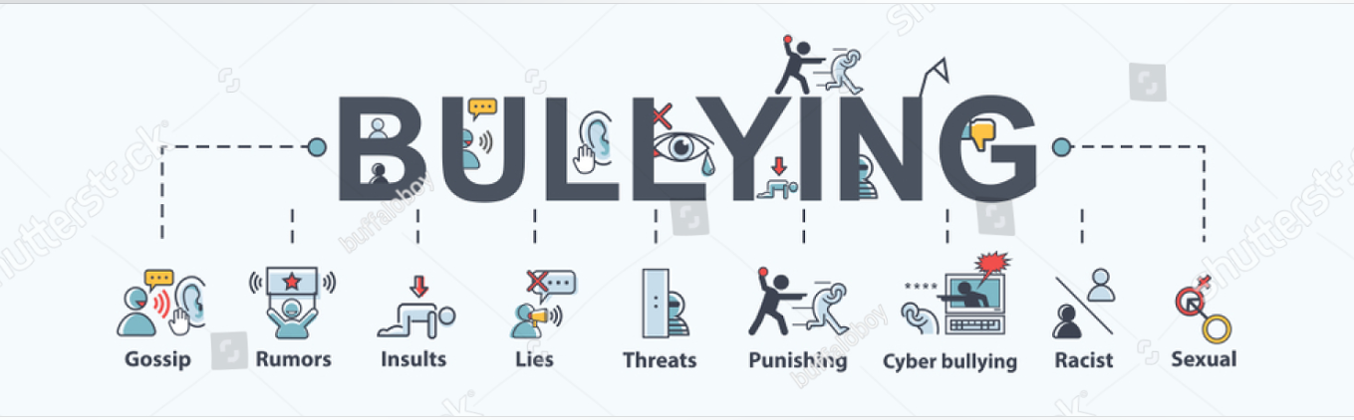
(Shutterstock images 2022).
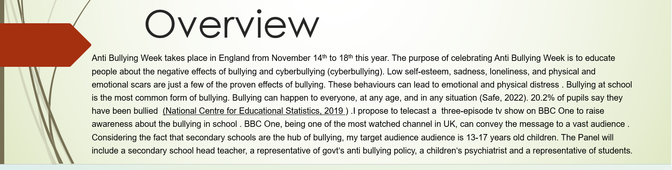

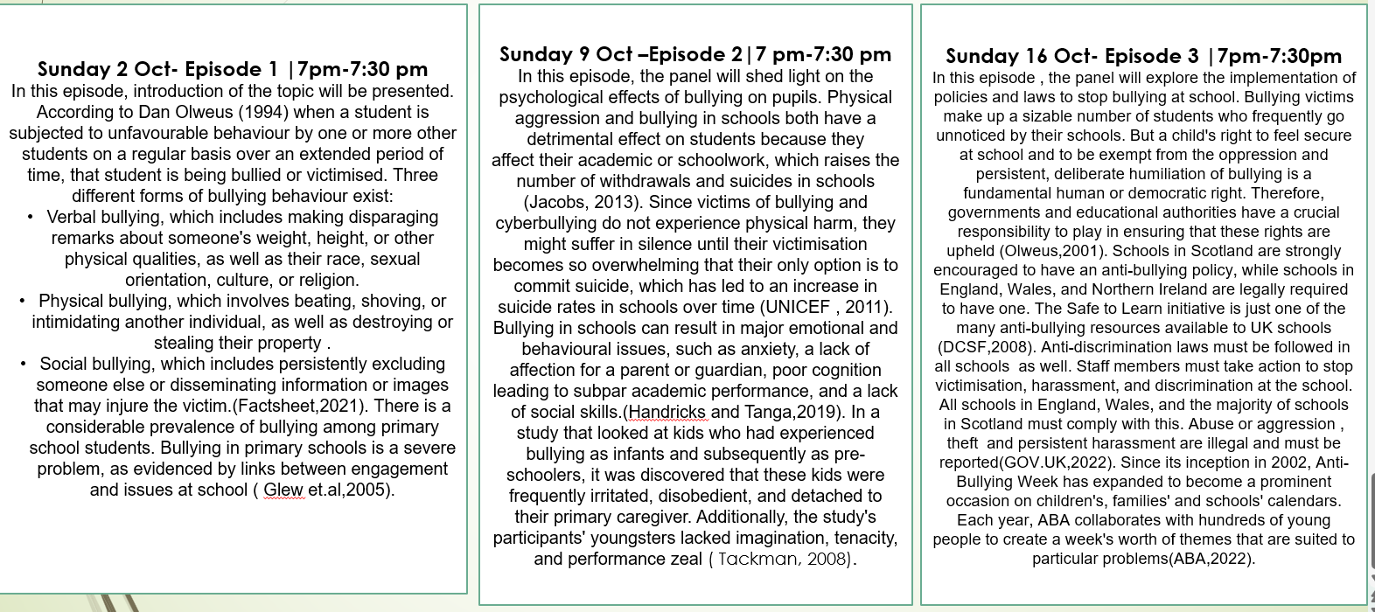

References
- Anti-Bullying Alliance (2022) United Against Bullying (UAB) programme.(online). Available at: https://anti-bullyingalliance.org.uk [Accessed: November 1, 2022].
- Bullying No Way. (2021) Fact sheets (online). Available at: https://bullyingnoway.gov.au/resources/fact-sheets [Accessed: November 1, 2022].
- Department for Children, S.and F. (2008) Department for Children, Schools and Families Departmental Report 2008, GOV.UK. (online). Available at: https://www.gov.uk/government/publications/department-for-children-schools-and-families-departmental-report-2008 (Accessed: November 1, 2022).
- Glew, G.M., Fan, M.Y., Katon, W., Rivara, F.P. and Kernic, M.A., (2005) ‘Bullying, psychosocial adjustment, and academic performance in elementary school’. Archives of pediatrics & adolescent medicine, 159(11), pp.1026-1031.
- GOV.UK. (2015) Bullying at school. (online). Available at: https://www.gov.uk/bullying-at-school [Accessed: November 1, 2022].
- Hendricks, E.A. and Tanga, P.T., (2019) ‘Effects of bullying on the psychological functioning of victims’. Southern African Journal of Social Work and Social Development, 31(1), pp.1-17.
- Jacobs, L., (2013) ‘Towards Understanding Different Faces of School Violence in Different" Worlds" of One Country’. Bulgarian Comparative Education Society.
- National Center for Educational Statistics. (2019). Student reports of bullying: Results from the 2017 School Crime Supplement to the National Victimization Survey. US Department of Education. (online). Available at: http://nces.ed.gov/pubsearch/pubsinfo.asp?pubid=2015056
- Olweus, D., (1994). ‘Bullying at school: basic facts and effects of a school-based intervention program’. Journal of child psychology and psychiatry, 35(7), pp.1171-1190.
- Olweus, D., (2001). ‘Bullying at school: Tackling the problem’. OECD observer, pp.24-24.
- Shutterstock images (2022) [image].Available at: Bullying Banner Web Icon Rumors Discredit Stock Vector (Royalty Free) 1284117682 | Shutterstock (Accessed,2 November,2022).
- Safe (2022). National Bullying Prevention Awareness Month - October 2022, Safeguarding Associates for Excellence Ltd. Available at: https://www.safe-ltd.com/national-bullying-awareness-month (Accessed: October 31, 2022).
- UNICEF. (2011) Children at War. [online ] . Available at: http://www.unicef.org/sowc96/childwar.htm .(Accessed : November 2, 2022).
- Tackman, V. M. (2008) ‘Educators’ Perceptions of School Violence’. PhD thesis, University of the Witwatersrand.

