

Programme: BA (Hons) Leadership and Management Skills for the Workplace
Module: Understanding and Engaging in the Customer Experience
Code: BMSW 5103
Assignment Title: Organisation’s quality systems and customer relationship management

Student Name: Leila Kanfoudi
Student ID: 1914911



Executive summary
Customer service is the core element of business firms which helps to build and maintain a good relationship with the customers. This report has discussed several theories and models basis on the competitive situation. Firstly, the elements of the marketing mix and considering factors to build an ideal marketing mix are illustrated. After that communication mix, Ansoff matrix, stakeholder mapping, and Porter’s five forces analysis are elaborated. Finally, the internal and external factors which influence the quality management and customer relationship management (CRM) of the business firms are illustrated.
Table of Contents
Executive summary 2
Introduction 4
Marketing mix 5
Ansoff Matrix 7
Communication mix 9
Stakeholders mapping 12
Porter’s five forces 15
Critically analyse internal and external factors that influence your organisation's quality systems and controls for customers 16
Internal and external factors that support your organisation's quality processes and customer relationship management (CRM) 17
Conclusion 18
Reference 19

Introduction
Customer service is the core function of the business organization. Because good customer service indicates maintaining a good relationship with the customers and trying to provide them with the best service experience and reduce the time of response to meet their needs. There are mainly three different stages of customer service before taking service or purchase, during purchase, and after purchase. Before taking service or completing a purchase the customers need sufficient information about the service or product. The second is during the service-taking or purchase decision. In this stage, the salesman and customer directly communicate to complete the process of purchase. And last is after-sale service. It indicates the providing the service after sales. There are several types of after-sales services like guarantee, warranty, and user process. Refers to customer service is the basic work for the business organization to make satisfied customers and to provide the best service experience. So, this report is going to discuss the customer service-related issues regarding the “Ynyshir” destination restaurant which is located in Wales, UK. This restaurant is transformed from the former country to the UK’s best destination restaurant in 2013 by Gareth Ward. There are several types of food menus with different tastes and it requires a few times to prepare. It also offers brilliant ingredient-led small plates, cooked over the fire, and it is the only Welsh restaurant in history to be renowned as an honour.

Marketing mix
The marketing mix is the combination of the 4Ps of marketing which covers all the activities of marketing regarding any product or service. Those factors are products, prices, places, and promotions. This theory or elements were first introduced by a Harvard professor which is known as the marketing developing strategy.
Among these elements of the marketing mix, every element works for a different type of utility creation like product meets market offerings, price determines or meets the balance between need and cost, place removes the location barriers from producer to consumers, and finally, promotion meets the information utility for the customers.
Product: A product is anything which is offered for sale to the customers. It is the main reason why customers decide to purchase from the seller. That’s why every company should focus on it and its development as well as superior value creation. Besides, the product may goods and services both (adamkasi, 2018). For example, a customer purchases toothpaste not for the outside or packaging but rather purchases for its core value which is paste. From the aspect of Ynyshir restaurant, it offers a wide range of food items which is delicious and contain heritage of the UK. It offers several categorical dishes like Lobster, Blue Fin Tuna Belly, Black Cod, Duck, and Dessert, and where all items have also different variants.
Price: Price is the number of money charged for getting any particular product or service. That means the price is the state of money which refers to the financial value of that product or service. During setting the price, a firm must have to consider several things like the perceived value of the product to the customers, competitor’s pricing, the demand for the product or service to the market, and the ability to meet the value of the customers (adamkasi, 2018). So, the price of Ynyshir is not so high but not so cheaper. Because the customers of this restaurant are financially enough capable and do not consider the price actually, rather than they need quality time and a comfortable environment.
Place: Place is very much vital for a successful business formation and operation. Because a customer will not prefer a such place which is not common and easy to access (adamkasi, 2018). That means the concept of the place indicates the way to reach the product to the most comfortable and suitable zone for the customer so that they can purchase the product and service from here easily. The restaurant place refers to the selection of a suitable location where the customers can easily reach for the desired service and feel comfortable. The place is so much fascinating and suitable for the Ynyshir restaurant where customers feel closer to nature and heritage.
Promotion: Promotion is another basic component of the marketing mix which makes the process of selling and informing too much easiest way to the prospect and actual customers. Mainly it removes the barrier of information and reaches closer to the customer which persuades the customers for purchasing the products or take the services. There are several tools of promotion by which an organization can solve this problem like advertising, personal selling, salesmanship, and publicity. As Ynyshir is one of the most famous and renowned destination restaurants in the UK and last year it achieved The Estrella Damm National Restaurant Awards 2022 that’s why it has a strong position on the market.
Way of developing an ideal marketing mix for “Ynyshir” restaurant:
To develop an ideal marketing mix for the restaurant some tasks have to complete professionally, these are-
Market segments
Before deciding on the marketing mix, market segmentation is very much essential. Because it helps to understand the core function and area of serving through product and service and actually for who’s the product or service are produced (adamkasi, 2018). From the aspect of the “Ynyshir” restaurant, the market segmentation will be like which type of food will be offered by the restaurant. There are several options for offering such as dining, carryout & delivery, and catering. But Ynyshir restaurant offers large categories of food items in its historical place.
Target customer
Another essential condition of a successful marketing mix. That means before setting an ideal marketing mix, the target customer must have to determine who will be the actual and potential customer of the product and service (de, 2022). This is very much essential for successful marketing mix formulation. There are several criteria for selecting the target market age, income, occupation, and standard of living. According to this restaurant, the target customers are middle-income people who feel better about taking a meal with their family in this wonderful destination restaurant.

Competition
Identifying the competitors is also very much important because the business filed is very much competitive and hard to survive without formatting proper plans and strategies. That’s why it often analyzes the competitor’s menu, pricing strategy, promotion, and online activities to get a competitive advantage by using unique plans and strategies.

Ansoff Matrix
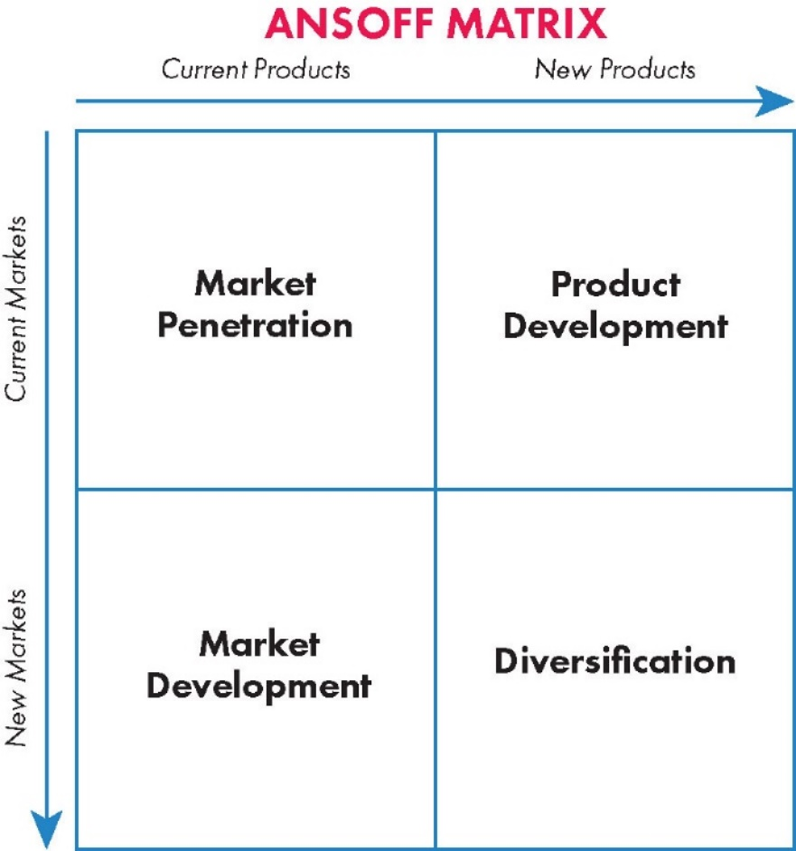
Figure 1: Ansoff Matrix
Source: (adamkasi, 2018)
Market penetration: Market penetration refers to the state of promoting the strategy which modifies the product or price scale in the present product and within the current market. From the perspective of Ynyshir restaurant, it offers a lot of delicious dishes for its customer and the customers are delighted to take service from here. Most of the time it offers some additional service along with the regular dishes so that the needs and wants of the customers may be fulfilled perfectly (de, 2022). The restaurant mainly offers a wide range of food items which is delicious and contain the heritage of the UK. It offers several categorical dishes like Lobster, Blue Fin Tuna Belly, Black Cod, Duck, and Dessert, and where all items have also different variants. On the other hand, this restaurant also offers some discounts for regular visitors so that they feel special and become loyal customers and come more frequently. In addition, this restaurant also makes a quick response to the customers’ needs and tries to reduce the time of response so that they do not feel bored or angry during taking service. It also takes many promotional activities within the current market to reach more customers and to make this it uses several media like newspapers, television ads, billboards, social medial promotion, and so on.
Market development: When the current product is launched into a new market then it’s called market development. That means the structure or category of the market is changed. In this process the product is current but the market is new. When any organization wants to extend their product or service to a new market with the current product then it is taken. From the aspect of Ynyshir restaurant, it develops the market by introducing a delivery service for online customers. As this is a stable location-based business that’s why to change the location is not possible but introducing its business in a new area is possible through introducing several pathways like launching new outlets in that area, taking online orders from the new area and delivering the product to the desired area. Now it serves three areas Eglwys Fach, Ceredigion, and Wales.
Product development: Product development means the introduction of a new product to the current market. When any business introduces a new product or service into its current business location then it’s called product development. Product development is very much essential for getting more customers’ attention (de, 2022). Because customers’ needs are ever-changing and they always want to get a new dimension of product and service if the firm cannot meet up the needs of customers then they will switch to a substitute product or the competitive product. So, to reduce the threats of competition it is also very much essential for the business firms to develop the product regularly based on the customers’ needs and observations. That’s why Ynyshir always tries to develop the product as per customers’ demand. Very recently this restaurant has launched a new type of dessert and new food and drinks. Besides, it also offers several types of new reservations for different types of customers’ needs.
Diversification: Diversification indicates when the product is new and the market is also new. Ynyshir uses horizontal diversification which introduces several types of new dishes and items for the prospective customers at the new location of this destination restaurant. In Ceredigion the natural diversity is more than in other areas of Ynyshir that’s why in this location the food items and destination reservations are also different and tourist based. The company has different types of strategic policies for product and market diversification.

Communication mix
Producing a random product and selling it to an uncertain market is not the actual form of a successful business. To become successful in the business ground there are a lot of tools and techniques which a business must have to follow. This communication mix helps to reach the business to the customers easily. There are different types of the communication process which are an organization follow to maintain this channel with the customers. Besides, there are also several types of elements of the communication mix, like-
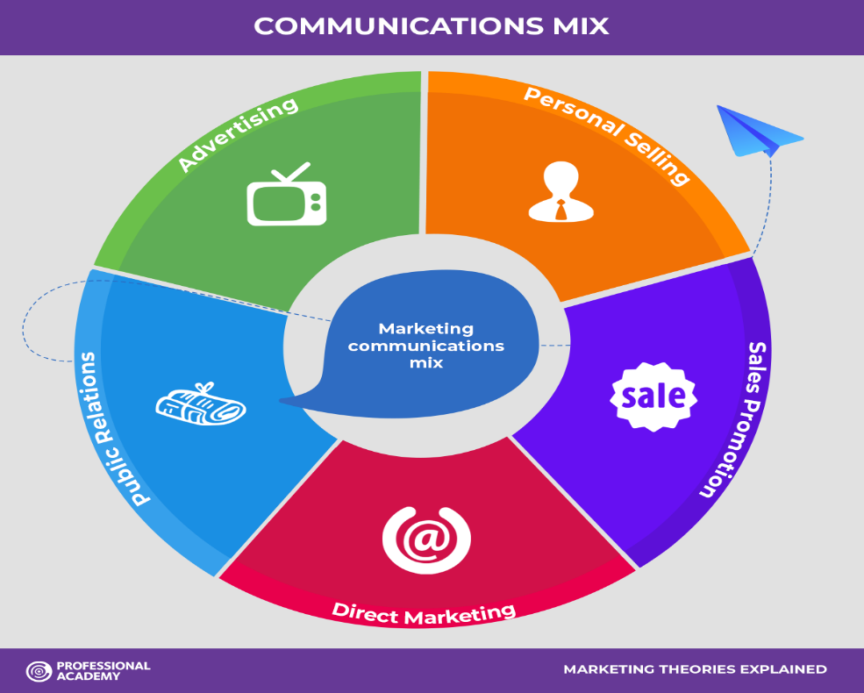
Figure 2: Communication mix
Source: (de, 2022)
Advertising: Advertising is a form of promotion which refers to an identified sponsor and paid media. That means the media of the advertising is identified and they work with a paid form. Advertising is a very much effective and oldest way to inform the customer and persuade the customer about purchasing products and services (de, 2022). There are different forms of advertising media like television advertising, radio advertising, and PPC advertising. In this type of advertising some core elements are used like headlines, slogans, and the motto of advertisements. On the other hand, this is a messy communication way to meet the informational utility where a lot of actual and potential customers are available here. Most recently, PPC advertising is come by the grass of modern technology advancement. This type of advertising is very much effective because here can be emotive, and creative, and an eye-catching urge can be created.
Direct marketing and digital marketing: Every buyer is not the same and the creation of urge will not be in the same pattern. That’s why sometimes marketers should have to communicate with them directly to persuade them properly for closing a successful buying process and to increase sales. Another is digital marketing. Digital marketing is the process of marketing where the marketer communicates with the actual and potential buyers through using modern technology and digital platform (Hridi Wajahat Noor, 2022). This type of communication is very much effective nowadays because most people now use digital media and when a marketer communicates with a buyer directly then they think again about their product and service and if possible then they will purchase that from them. There are several types of elements of direct marketing and digital marketing are- is email; email is a very much effective way to communicate with another shortly and formally. Most of the time business firms communicate with customers through this media. Another is social media. Social media is much more essential for the plan.
Public relations: Public relations is another part and-parcel element of the communication mix. It is the core part of the promotion where a message is transmitted to the people regarding the product and service in favour of the producer so that they can persuade them to the sale. As every product and service is prepared for the potential and actual customers that’s why public relations are much more essential for the organization for a successful communication mix.
Personal selling: Sometimes successfully persuading people for a successful sale is not so easy task then they directly meet with the people and communicate with them directly to complete the selling process by providing them with valid information and effectiveness regarding the product and service. Salesmen, representatives, and brand ambassadors are the people who do this critical task on behalf of the producer. This is not so easy task, and to get the desired result the salesman needs to obtain some extra skills, and experience regarding the company and product. On the other hand, they must have to contain good communication skills and aim to inform and encourage the people regarding the product and company.
Sales promotion: sales promotion is part and parcel part of the communication mix. It emphasizes the increase of selling through promoting more friendly sales to the actual and potential customers so that they feel the urge to buy a product or service (Hridi Wajahat Noor, 2022). Sales promotion is mainly the promoting sales which express the sales are in favour of the customers and it shows that sales are a profitable task for them indeed. It is a very short-term business policy which is developed by marketers to attract and persuade customers to increase sale volume. There are several ways to make this work. For example, in Ynyshir restaurant, often it takes some short-term sales promotional strategy, which is resulting the reason for huge sales in a certain timeframe. Often it shows a huge discount for promoting many festivals, and occasions. Big offer on booking! Get up to 25% off during the festival for summer reservations on Ynyshir. 15% off on seafood for the newly married couple.
Social media: Social media is one of the vital elements of the communication mix. Because nowadays social media is one of the strongest mediums for successful promotional activities. That’s why every business organization now model and develop the wing of promotion through this sector. Social media has changed the concept of promotional activities because it makes the channel of promotion easy and friendly (Hridi Wajahat Noor, 2022). That’s why it turns the direct marketing sector of the communication mix which helps to gain and retain new customers and gather them for getting valid feedback regarding the product and service.
Product packaging: Product packaging is an outstanding way of communicating with potential and actual customers. Because it creates a visual urge in the customers’ minds regarding a specific product and service. Packaging is not for only protecting the product from unexpected situations and product damage rather than it is very much essential for reaching the customers’ minds with a positive impression regarding the product (Hridi Wajahat Noor, 2022). It creates a visual scenario about the product and feels convinced to buy that. So, every business organization should use more attractive and convincing packaging.

Stakeholders mapping
Stakeholders are the core functioning parts of a business organization. That means who are the basic people regarding a business organization and business establishment. There is some backward and forward integration which are directly and indirectly help to develop and operate a business organization successfully. So, before doing any successful business formulation and operation the understanding of stakeholders and their mapping is very much essential for every business organization. Besides, stakeholder mapping refers to the process of identifying the key stakeholders which may be individuals or groups and understanding their relationship with each other to formulate and operate a successful business venture. So, there are some key stakeholders like-
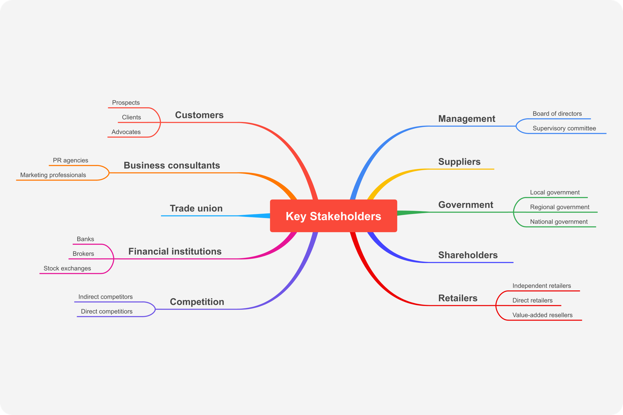
Figure 3: Stakeholder mapping
Source: (Hridi Wajahat Noor, 2022)
Customers: The customer is the core stakeholder for every business organization. Because this is the only stakeholder which helps to cash inflow for the business organization. Besides, customers help to gin the business aim for which every business is formed and operated. So, before taking any decision regarding the business firm the customers is the most important element to consider. That’s why Ynyshir restaurant always prioritizes the needs of the customers and their basic preferences for selecting food items (Hridi Wajahat Noor, 2022). For that reason, Ynyshir restaurant always takes feedback from the customers regarding the product and service.
Business consultants: Big firm is not run their business activities separately rather than it appoints consultants who help to take business decisions in several circumstances. They are much more expert in this field that’s why business organization hires them to consult them in several unexpected situations of the organization and which help to take more valid and effective decision.
Trade union: A trade union is also very much essential for an export-based business organization where business gets several opportunities regarding this organization. Although a trade union is an external stakeholder of an organization the impact of this trade union on the business is huge. So, this factor also be considered.
Financial institutions: Financial institution refers to such type of institution which helps businesses by providing financial assistance during crisis moments and also providing financial advice for the business organization (Hunt, 2016). There are some basic financial organizations like banks, brokers, and stock exchanges which help to provide financial aid to the organization. That’s why every business organization should build and maintain a good relationship with those financial institutions.
Competition: Competitors are also very much vital stakeholders for the business organization. Because these competitors are such types of business organizations which also provides the same product or service to the market. That’s why the business organization must have to select such policies and strategies which will help to get a competitive advantage for the business. If the business is not able to understand and assess the competitive condition then sustainable development is not possible (Hunt, 2016). So, this is also a very essential stakeholder for a successful business organization.
Management: Management is an unavoidable part of the business organization and internal stakeholder for the business. If the management is not enough capable to build and maintain a good relationship with the related situation and issues then the desired outcome of the business and profitability of the business is not possible. For example, if the authority does not form and build a stakeholder mapping for its business organization then the interrelationship among other departments cannot be defined properly.
Suppliers: Suppliers are such part of external stakeholders which help to maintain the continuity of production. Besides, the price and quality of the product vastly depend on the suppliers and supplied raw materials (Hunt, 2016). That’s why every company must have to consider the suppliers and build as well as maintain a good relationship with them so that the price of raw materials and quality of raw materials become satisfying. As it is the core part of the production pipeline that’s why if this factor does not work properly then the outcome of the entire process will not much satisfying.
Government: Government is the core rule maker for the business organization. From the tax imposed, to after-sales service procedure, and sometimes defines what will be the relationship with other stakeholders. There are many versatile situations which may arise for the government’s policymaking that may impact the business organization intensively. For example, during the COVID-19 pandemic, the government does not allow public gatherings and talked to maintain social distancing so that the pandemic could not spread to make a disaster. So, this is also a strong stakeholder of the business organization.
Shareholder: This is the core and fundamental stakeholder who are the main owner of the business organization. Shareholders refer to such persons who have invested assets in the business and are the actual owner of the business. So, their demand of them is very much essential to fulfil.

Porter’s five forces
Michel Porter has given a model which helps to elaborate the competitive situation and competitive advantage of a firm. So, from the aspect of Ynyshir restaurant, those factors are-
The threat of New Entrants: Every firm situates within a particular industry which refers to the condition of that firm and situational factors of that firm. Normally, a similar type of business organization stayed within a single industry to get competitive advantages and to operate its business (Mailchimp, 2019). But every business has some uncertainty for new entrance because if new entrances become able to enter into this industry then competition will be higher. But there are some barriers to the new entrance like fixed cost, economies of scale, operating cost, and cost advantage. But if any new restaurant wants to enter into this industry, then that will be produced more customised and has to establish a cost advantage.
Bargaining power of buyers: The bargaining power of buyers is very much essential for business operations. If the bargaining power of the buyer is huge then business power is low because the buyer may switch from one firm to another. According to the restaurant business, the bargaining power of buyers is moderate.
Bargaining power of supplier: The bargaining power of suppliers indicates how much strong a position is held by the suppliers. If the bargaining power of the supplier is huge then the price of the product will be higher. But from the aspect of Ynyshir restaurant, the bargaining power of suppliers is less.
Threats of substitute products: The threats of substitute products refer the having alternative products and services along with the core product. If the substitute products have stayed then if the price is high the customers will switch to other options to meet up their needs. As this is a restaurant business that’s why the threats of substitute products are huge.
Competitive rivalry: There is a lot of competition in the restaurant industry. Because they are similar types of services and products offered to the market (Mailchimp, 2019). As the competitive rivalry is high that’s why if the company wants to get a competitive advantage then it has to hold more market share which gives it a more sustainable advantage. Besides, Ynyshir is one of the award-winning restaurants and is a well-known destination restaurant in the UK. So, from this point of view, it gets some extra benefits from the competitive satiation.

Critically analyse internal and external factors that influence your organisation's quality systems and controls for customers
There are some internal and external factors which influence the organizational decision regarding quality systems and customer control. Internal factors are too closer to the company and external factors are a little far from the business organization.
Internal factors: There are some internal factors like company, management, employees, suppliers, and strategy. Those are the direct causes of quality management. For example, if the suppliers do not supply quality products then the final product will not be the best quality. Besides, if the employees are not so skilled then they will not be able to produce a quality product. So, those factors directly influence the quality of the product.
External factors: There are also some external factors which are liable for the quality of the product. Some of those external factors are political factors, government policy, natural factors, and so on (Mailchimp, 2019). For example, if the government policy is not support or creates any legal issues in the production process or distribution process then the quality of the product will be hampered. That’s why Ynyshir restaurant always tries to coordinate with those factors to get a fruitful outcome as a whole.

Internal and external factors that support your organisation's quality processes and customer relationship management (CRM)
Customer relationship management (CRM) refers to the combination of practices and strategic development which a company use to manage its customer-related issue. The core goal of customer relationship management is to reduce service response time and reduce customer retention as well as drive sales growth.
There are some core benefits and challenges of customer relationship management which define the position of the company compering with its competition. Service is the fundamental function for attracting new customers and retaining old customers. Some benefits of CRM are-
Reduce customer complaints: If customer relationship management works well then, the complaints of customers will be less. Because the customers are become more satisfied by taking service.
Increase sales: The sales rate also increases by this practice because satisfied customer purchase more frequently and recommend others to purchase.
Increase productivity: Productivity also increases when customer relationship management will work perfectly.
There are also some challenges in customer relationship management. Those are, it is hard to understand human behaviour and maintain a good relationship with them (Mano Behera, 2016). Because human behaviour is too much complex to understand and maintain. Besides, changing social response is also another challenge of CRM which means the social response is an ever-changing factor which is not so easy to detect and use.

Conclusion
After discussing all of those factors it can be said that the basic requirements of the report have been achieved. This report has demonstrated the core mechanism of customer service at Ynyshir restaurant. It has been discussed several theories and models which are helped to understand the competitive situation and survival state of business firms. So, finally, the learner will be able to understand the core change and impact of several competitive environments and survival factors.

Reference
adamkasi (2018). Porter’s five forces of Restaurant Industry - Porter Analysis. [online] Porter Analysis. Available at: https://www.porteranalysis.com/porters-five-forces-of-restaurant-industry/ [Accessed 12 Apr. 2023].
adamkhankasi (2020). Ansoff Matrix of McDonald’s - Ansoff Matrix. [online] Ansoff Matrix. Available at: https://ansoffs.com/ansoff-matrix-of-mcdonalds/ [Accessed 12 Apr. 2023].
de, W. (2022). Cocriação de valor na educação híbrida. [online] Sociedade Mineira de Cultura – Editora PUC Minas. Available at: https://www.torrossa.com/en/resources/an/4913713#page=170 [Accessed 14 Apr. 2023].
Debnath, R., Datta, B. and Mukhopadhyay, S. (2016). Customer Relationship Management Theory and Research in the New Millennium: Directions for Future Research. Journal of Relationship Marketing, 15(4), pp.299–325. doi:https://doi.org/10.1080/15332667.2016.1209053.
Economic Research-Ekonomska Istraživanja. (2021). Research model for measuring the impact of customer relationship management (CRM) on performance indicators. [online] Available at: https://www.tandfonline.com/doi/full/10.1080/1331677X.2020.1836992 [Accessed 14 Apr. 2023].
Hridi Wajahat Noor (2022). Customer Relationship Management: An analysis based on Restaurant Industry. [online] Academia.edu. Available at: https://www.academia.edu/14253918/Customer_Relationship_Management_An_analysis_based_on_Restaurant_Industry [Accessed 12 Apr. 2023].
Hunt, S.D. (2016). General Theories and the Fundamental Explananda of Marketing - Shelby D. Hunt, 1983. [online] Journal of Marketing. Available at: https://journals.sagepub.com/doi/abs/10.1177/002224298304700402?journalCode=jmxa [Accessed 14 Apr. 2023].
Hunt, S.D. and Menon, A. (1995). Metaphors and competitive advantage: Evaluating the use of metaphors in theories of competitive strategy. Journal of Business Research, [online] 33(2), pp.81–90. doi:https://doi.org/10.1016/0148-2963(94)00057-l.
International Journal of Hospitality & Tourism Administration. (2023). Mediated Effects of Customer Orientation on Customer Relationship Management Performance. [online] Available at: https://www.tandfonline.com/doi/abs/10.1080/15256480801909089 [Accessed 14 Apr. 2023].
James Martin Market. (2022). Gareth Ward Ynyshir Restaurant - James Martin Market. [online] Available at: https://shop.jamesmartinchef.co.uk/products/gareth-ward-ynyshir-restaurant/ [Accessed 12 Apr. 2023].
Journal of Hospitality Marketing & Management. (2021). Social customer relationship management: a customer perspective. [online] Available at: https://www.tandfonline.com/doi/abs/10.1080/19368623.2021.1884162 [Accessed 14 Apr. 2023].
Journal of Relationship Marketing. (2023). Trust, Satisfaction and Loyalty in Customer Relationship Management. [online] Available at: https://www.tandfonline.com/doi/abs/10.1300/J366v04n03_03 [Accessed 14 Apr. 2023].
Mailchimp. (2019). Marketing Mix and The 7 Ps of Marketing | Mailchimp. [online] Available at: https://mailchimp.com/marketing-glossary/marketing-mix-7ps/#:~:text=What%20are%20the%204%20P's,Price%2C%20Place%2C%20and%20Promotion. [Accessed 13 Apr. 2023].
Mano Behera (2016). A Guide To Restaurant Marketing Mix. [online] The Digital Restaurant. Available at: https://thedigitalrestaurant.com/restaurant-marketing-mix/ [Accessed 12 Apr. 2023].
Professionalacademy.com. (2023). Marketing Theories – The Communications Mix. [online] Available at: https://www.professionalacademy.com/blogs/marketing-theories-the-communications-mix/#:~:text=The%20communications%20mix%20involves%20all,elements%20of%20the%20communications%20mix. [Accessed 12 Apr. 2023].
qpm_tech_admin (2019). What are the External Factors that affects Quality Management? [online] Qualityze. Available at: https://www.qualityze.com/what-are-the-external-factors-that-affect-quality-management/#:~:text=The%20external%20factors%20like%20politics,can%20be%20controlled%20by%20you. [Accessed 13 Apr. 2023].
Rowlands, E. (2022). The absolutely incredible menu at the Welsh restaurant just named best in the UK. [online] WalesOnline. Available at: https://www.walesonline.co.uk/whats-on/food-drink-news/ynyshir-restaurant-menu-prices-how-24219050 [Accessed 13 Apr. 2023].

