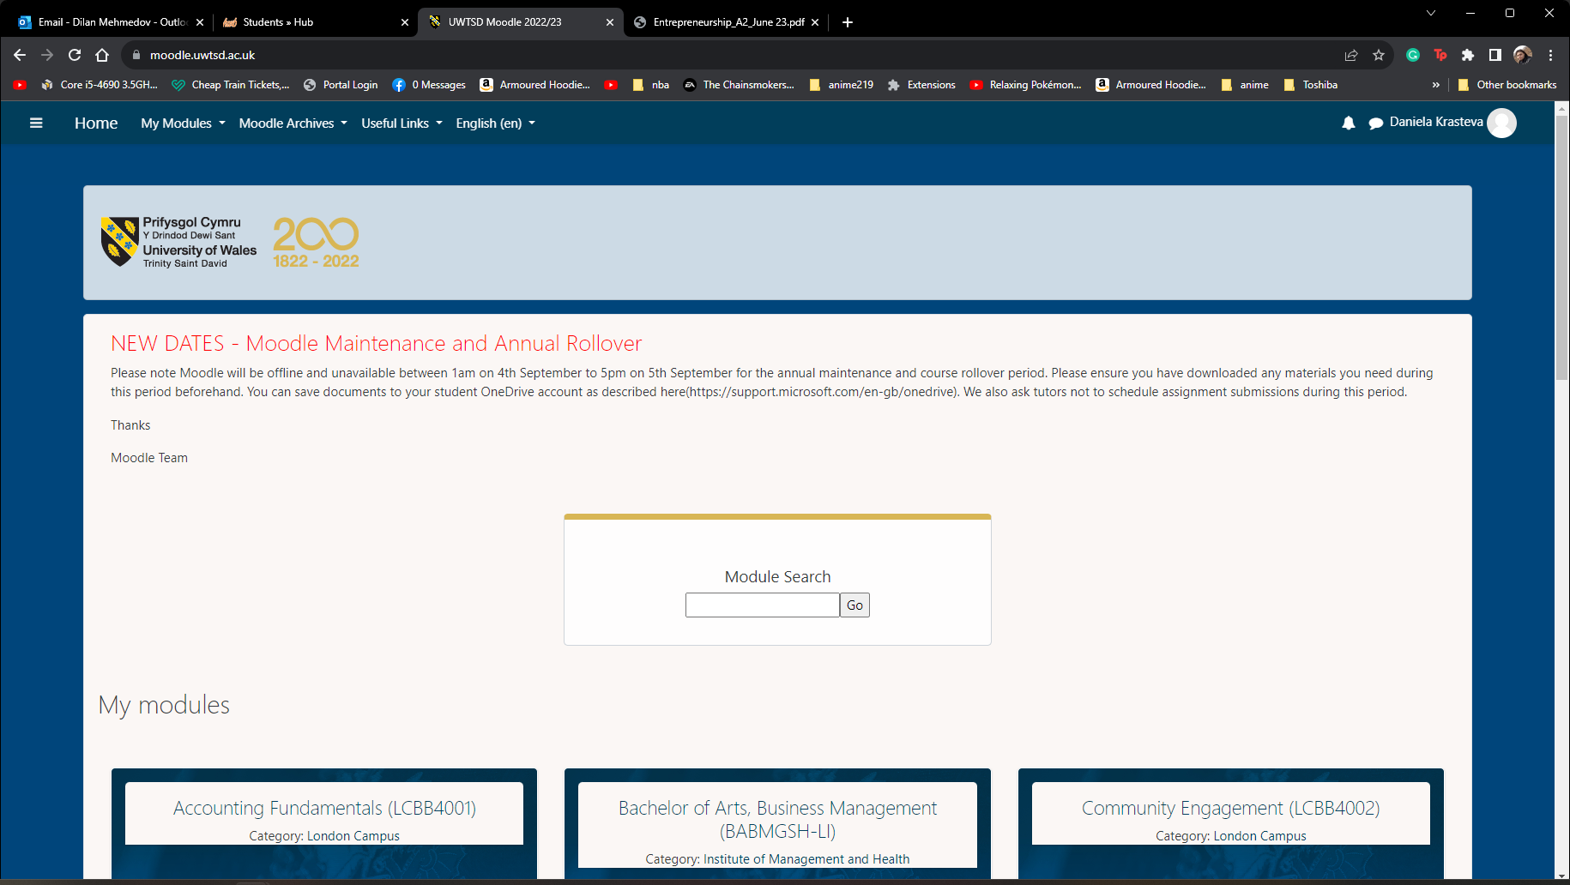
BA Business Management
Module: Entrepreneurship
Module code: LCBB5001
Lecturer: Dr Laila Mazouz
Assignment Title: Coursework:
Business Plan
Student number: 2124368
Student name: Daniela Ivanova Krasteva

Table of Contents
Introduction 3
Business Description 4
Industry Analysis 5
Operation and Management Team Plan 7
Marketing Plan 8
Financial Plan 9
Marketing Research 10
Conclusion 12
Reference List 13

Introduction
The report has demonstrated the new business plan with the new venture's distinctive nature. Moreover, the report has explained the mission statement, products or service description, and target audience for organizational growth. It has illustrated the ownership structure and legal considerations should be laid out. The report has discussed Porter's five force model to understand the dynamic environment of Graphic Tee. Moreover, the Company mainly focuses on legal structure with planned business and justifies the choice for organizational growth. Simply, Graphic Tee focuses on distinct options available and evaluates the difference among marketing t-shirt office businesses. The report has demonstrated the financial plan with distinct kinds of financing available to increase the sales margin. It highlighted the market research on the t-shirt designing industry.

Business Description
Entrepreneur mainly focuses on the development of new business ideas of graphic design on t-shirts as per customer requirements. In the fashion world, graphic design becomes the latest trend to grab the attention of teenagers (Manko, 2023). In this organization, the Manager of Graphic Tee mainly focuses on details types of business to target audiences like men, women, unisex, and children with unique designs as well as sizes. To deal with the changing environment, Graphic Tee focuses on the production of t-shirt manufacturing to fulfill customer needs effectively (Triyono et al., 2023).
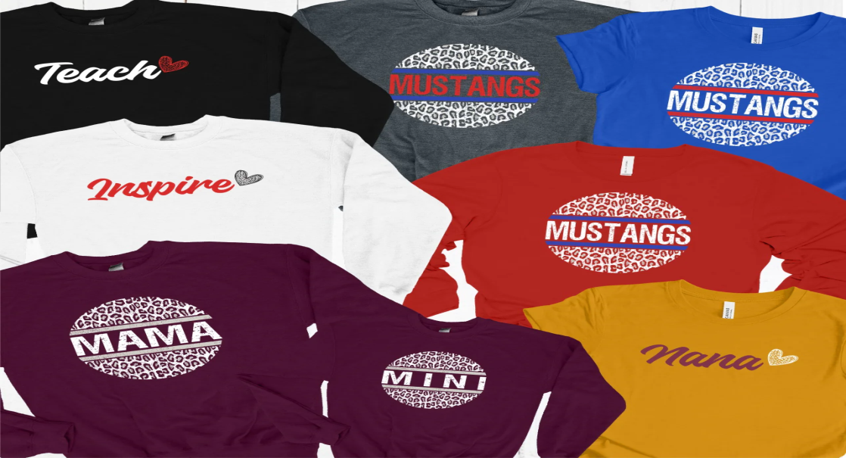
Source: (Manko, 2023)
Mission: Graphic Tee's main mission is a classic round neck, super soft t-shirt for better fits (Shin et al., 2023). The Company engages in the consumption of soft-quality materials to improve the customer experience. Graphic Tee mission-created t-shirts through the support of independent artists from around the globe.
Products and Service: Graphic Tee mainly focuses on printing options and designing new t-shirts to meet customer needs. The Company always focuses on comfortable t-shirts, and soft materials to fulfill the customer requirement (Laili, 2022). Graphic Tee focuses on materials quality and addition to any wardrobe. The Company offered categories and several levels of subcategories for graphic designing t-shirts to meet the demand of changing clients. Graphic Tee mainly focuses on the development of new ways to understand the printing requirement of customers. The Company focuses on creating new products or services to meet the need of the target client (Jagad, 2022).
Legal Consideration: The manager of Graphic Tee mainly focuses on developing copyright laws to manage their work. Moreover, the Company mainly focuses on exclusive rights and regulation to survive in the competitive marketplace (Tong and Su, 2022). Graphic Tee focuses on the tempting use of attractive images, short quotes, and graphics to design products for organizational growth. Moreover, the Company mainly focuses on avoiding any legal issues to create a unique design t-shirt.

Industry Analysis
In 2023, the T-shirt segment generated total revenue of US$2.29 billion in 2023. The Company has expected to grow the market annually by 3.12% (Wagner and Schweizer, 2023). The global custom t-shirt printing size is valued at USD 4314 million in 2022. Thus, Graphic Tee focuses on growing customized t-shirts as well as branding to major contribution toward market growth (Özbek, 2020).
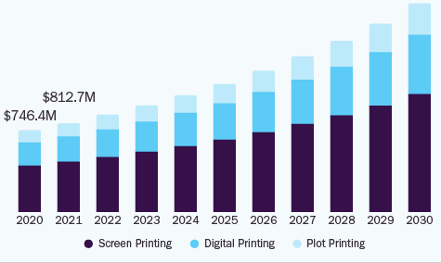
Source: (Shin et al., 2023)
The Company mainly focuses on the fashion industry and wearing customized clothing for organizational success (Manko, 2023). In changing situation, the Manager of Graphic Tee contributes toward the growth of the market and targets a large number of people for future success effectively.
Porter Five Forces Model
Graphic Tee mainly focuses on Porter's model framework to examine the competitive forces and others in the fashion industry.
- Buyer Power: In the fashion industry, Graphic Tee focuses on target clients to lower product costs. The customer may attain to select the purchase pattern while shifting toward another seller in the fashion industry (Laili, 2022). The Company mainly focuses on finding out the best way to attract new clients to generate income.
- Supplier Power: Graphic Tee maintains a strong connection with clothing and fashion supplier that impact most of the sources from providers who sell cheaply (Shin et al., 2023). Moreover, the Company selects to choose from one dealer to another, to make the inputs relatively low.
- Competitive Rivalry: In the clothing industry, the company fined challenges with another firm that provide the same item at the best cost to fulfill the changing demand of customer (Jagad, 2022). Moreover, Graphic Tee focuses on the value derived to maintain its brand image among customer mindset. In this industry, Graphic Tee faced tough competition with local and international ways to thrive in the market.
- Threat of New Entrant: The Company faced tough competition with new firms in the clothing industry (Triyono et al., 2023). Moreover, emerging companies used social media channels, and other platforms for marketing their products or service to increase brand awareness (Özbek, 2020).
- The threat of substitutes: In the fashion industry, it does not easy to get substitutes from the designing or customized clothing items. The Company may use social media channels, and other platforms to market its products or service to increase brand awareness (Tong and Su, 2022). Graphic Tee focuses on understanding the demand of clients for organizational success.

Operation and Management Team Plan
Legal Structure: A t-shirt designing business idea is the more profitable business model for organizational success. The Company focuses on modern-day print-on-demand service to fulfill customer needs (Wagner and Schweizer, 2023). Graphic Tee entrepreneur focuses on the t-shirt niche with effective market research for organizational development. The Company mainly focuses on sole traders with all activities like product design, materials used, and selected e-commerce platforms to fulfill customer needs. The Company mainly registers as a sole proprietorship with unique designs of t-shirts to meet the changing demand of customers (Laili, 2022). Moreover, Graphic Tee focuses on process the setting of new business ideas for organizational development. The Company focuses on copyright laws to print as the client desire.
Management Team
Graphic Tee mainly focuses on the development of new abilities to become successful in the marketplace (Manko, 2023). The Company focuses on building strong teams emphasizing skill and experience for organizational success. The manager of Graphic Tee focuses on tracking the advisory board with the support of answers and questions for future success (Ahmad et al., 2019).
- Human Resource department: HR Manager of Graphic Tee focus on the management of employees to fulfill customer needs (Shin et al., 2023). The Company mainly focuses on scanning the resume of candidates to fill the vacancy for organizational enlargement.
- Finance Department: Graphic Tee focuses on the finance department to manage the inflows and outflows of money to manage the organizational needs (Triyono et al., 2023). The Company always tries to identify the needs of money by the distinct department to manage the activities smoothly. Graphic Tee focus on supporting the finance team to delegate the amount to manage the organizational operations.
- Sales Department: Marketer of Graphic Tee mainly focuses on the development of a team who engages in the sales margin of the firm (Laili, 2022). The Company always focuses on social media channels to promote new products or services to grab the attention of clients. The sales team focuses on promotional channels to raise the profit and sales margin of Graphic Tee.
- Marketing Department: Graphic Tee focuses on marketing channels to promote or understand the current demand for t-shirts in the UK (Tong and Su, 2022). The Company always tries to update the data in the context of the current target audience for organizational success.

Marketing Plan
Graphic Tee mainly focuses on the development of a marketing mix plan with an online t-shirt channel for future development (Wagner and Schweizer, 2023). The Company focuses on building powerful marketing tactics and balancing marketing activities. The marketing mix is the best way to implement the online t-shirt firm with major four components for organizational development.
- Products: The manager of Graphic Tee mainly focuses on quality products or services to meet customer requirements. The Company always focuses on attributes of products, branding, and designing the merchandise for organizational success (Shin et al., 2023). Graphic Tee focuses on consumer behavior, and proper decision to improve the business fruitfully. The Company mainly focuses on packaging and labeling with clear instructions to support the client demand effectively.
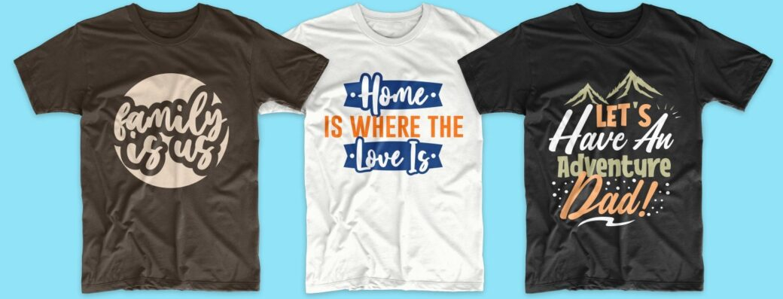
Source: (Triyono et al., 2023)
- Price: The Company mainly focuses on competitive and discounting pricing strategy to meet customer demand effectively. The manager of Graphic Tee focuses on strategy, expenditure, and marketing objectives to target the audience (Manko, 2023). The Company mainly focuses on reducing the cost of products or services for economic value and government policies effectively. Graphic Tee focuses on effective raw materials at the best cost so the client feels comfortable.
- Place: In this marketing, the Manager of Graphic Tee mainly focuses on essential decisions to place the manufactured item to the client (Laili, 2022). The Company focuses on online as well as offline channels to distribute the products or services to fulfill the changing demand of customers effectively. Graphic Tee focuses on social media channels to the client of distribution is very important.
- Promotion: It focuses on methods and decisions to promote the products or services for organizational development (Wagner and Schweizer, 2023). In changing situations, the Manager of Graphic Tee focuses on social media channels to promote the unique design of t-shirts to fulfill the customer demand effectively. With online channels, Graphic Tee focuses on advertisement, personal selling, and sales promotion to increase the total revenue of the firm (Ahmad et al., 2019).

Financial Plan
The manager of Graphic Tee focuses on estimating the profit and loss statement to understand the inflows and outflows of the money for organizational growth (Shin et al., 2023). The Company looking toward a business plan showing the start-up cost with distinct source and fund flow statement for better success in the t-shirt market. The Company mainly focuses on the development of six months cash budget estimate that reflects to attain financial sustainability. Graphic Tee focus on the development of new ways to know the income and expenses to survive in the fashion industry (Tong and Su, 2022). The Company has estimated the total expenditures to be £250,000 and checks £100,000 to deal with uncertainty.
Particular | Expenses (£)
Office Equipment | 5000
Office Premises | 10000
Salaries | 15000
Business Insurance | 2500
Taxes and permits | 3200
Legal Expenses | 1500

Marketing Research
The manager of Graphic Tee focuses on extensive marketing research on the particular industry and macro environment (Manko, 2023). The Company mainly focuses on environmental tools to analyze the forces that affect organizational effectiveness.
SWOT Analysis of Graphic Tee
Strengths | Weaknesses
- Graphic Tee focuses on innovative design  - Focus on brand awareness  - Product line (Triyono et al., 2023)  - Quality and rapid expansion  - Long experience | - Price changes in raw materials  - High operational cost (Tong and Su, 2022)  - Changing demand of customer
Opportunities | Threats
- Expansion of market share (Laili, 2022)  - Technological development  - Easy to manage the new marketplace  - Expand customer base (Jagad, 2022) | - High competitive market  - Global finance crisis (Shin et al., 2023)

PEST Analysis of Graphic Tee
Political Factor | Nowadays, Government mainly focuses on motivating the organization to purchase fabrics locally with no excess taxation (Tong and Su, 2022). The Company mainly focuses on political instability influencing the fashion trend. In addition, Graphic Tee focuses on a sustainable strategy to fulfill the demand of customers.
Economic Factor | Graphic Tee mainly focuses on new ways to find out fashionable without breaking the bank (Wagner and Schweizer, 2023). The Company focuses on low-income groups with high unemployment rates who need to survive in the marketplace. The Company seeing for expansion of rentable clothing with formal and casual for personal taste.
Social Factor | Graphic Tee focuses on iconic and designer t-shirts to fulfill the changing demand of customers (Shin et al., 2023). The Company mainly focuses on understanding the client's behavior to fulfill the demand effectively.
Technological Factor | Nowadays, the Manager of Graphic Tee focuses on online channels to deliver the products or services to meet the client's needs (Triyono et al., 2023). The Company uses artificial intelligence and machine learning to enhance organizational power. Graphic Tee used social media channels to earn a high margin of profits (Jagad, 2022).

Conclusion
In conclusion, the report has examined the new business idea of t-shirt designing at the best cost in the United Kingdom. The report has evaluated the mission, legal structure, and mission of Graphic Tee to meet the organizational demand. It has analyzed the operation and management team, and marketing plan of Graphic Tee to survive in the fashion industry. The report has examined the financial plan with an expenses statement that shows the expenses of the start-up business. Graphic Tee focuses on the development of marketing research to understand the start-up and supported strategy for organizational development.

Reference List
Manko, B.A., 2023. The evolution of fashion: How digital technology makes a basic graphic T-Shirt a marketing staple. Journal of Information Technology Teaching Cases, p.20438869231151971.
Shin, E., Kincade, D.H. and Han, J., 2023. Exploring online consumer reviews of customized apparel products. Journal of Fashion Marketing and Management: An International Journal.
Wagner, K. and Schweizer, M., 2023. Glasses in a Design-Savvy Environment with Fashionable Competence. In Multisensory in Stationary Retail: Principles and Practice of Customer-Centered Store Design (pp. 453-461). Wiesbaden: Springer Fachmedien Wiesbaden.
Laili, L., 2022. IMPORTANT THINGS IN CLOTHING BUSINESS ARE PRODUCT QUALITY AND Friendliness IN SELLING. BERTUMBUH: Jurnal Manajemen Kontemporer, 1(1), pp.181-190.
Tong, X. and Su, J., 2022. Exploring T-shirt slogans by content and thematic analysis. International Journal of Fashion Design, Technology and Education, 15(3), pp.277-286.
Jagad, R.G., 2022. TRENDY T-SHIRT PRODUCT DESIGN ON BENK BRAND USING QUALITY FUNCTION DEPLOYMENT METHOD.
Ahmad, S.A., Zainol, Z., Yunos, R., Abd Kadir, A., Ghazali, M.Z.H. and Murad, M.F., 2019. Application of augmented reality (AR) in T-shirt catalog. International Journal of Innovative Computing, 9(1).
Özbek, A.H.M.E.T., 2020. Online Customised T-shirt Design and Evaluation of Online Websites for customisation. Industria Textila, 71(4).
Triyono, T., Devara, H.R., Sari, S.R. and Silviana, A., 2023, July. Cultivating an entrepreneurial spirit in the youth association of Jurang Belimbing through the application of the t-shirt screen printing business. In AIP Conference Proceedings (Vol. 2722, No. 1). AIP Publishing.

