Samantha Westwood
Student number: 2436467
Lecturer: Daniel Harruna
Certificate of higher education for the workplace (Health and social care)
Module: Introduction to Public Health
Module Code: LCHS4008

Table of contents:
Introduction ................................................................................................................................3
Health Consequences of Pertussis and the Role of Vaccination..........................................4
How pertussis affects the community and the NHS...............................................................5
How Pertussis is controlled......................................................................................................6
Conclusion..................................................................................................................................7
Reference list..............................................................................................................................8

Pertussis (Whooping Cough): A Preventable Disease with Serious Outcomes.

Introduction.
Pertussis, also known as whooping cough, is a very contagious bacterial infection that causes strong coughing fits and affects the lungs and airways. It’s classed as a nationally notifiable disease, meaning doctors must report suspected cases to public health teams. Pertussis spreads easily through tiny droplets in the air when someone coughs or sneezes and through close contact with someone who’s already infected.
This highly infectious lung condition causes repeated bouts of heavy coughing, often mixed with other symptoms like tiredness or feeling unwell. Most people recover fully and the illness usually lasts a few weeks. Thanks to vaccines, pertussis is rare in young children in the UK, but immunity can fade over time putting older children and adults at risk (Dr. Wiggins C, 2023).
Cases of pertussis have been rising. In 2024, more than 10,000 new infections were reported across the UK. Worldwide, the number of cases has also gone up, reaching over 181 per million people.
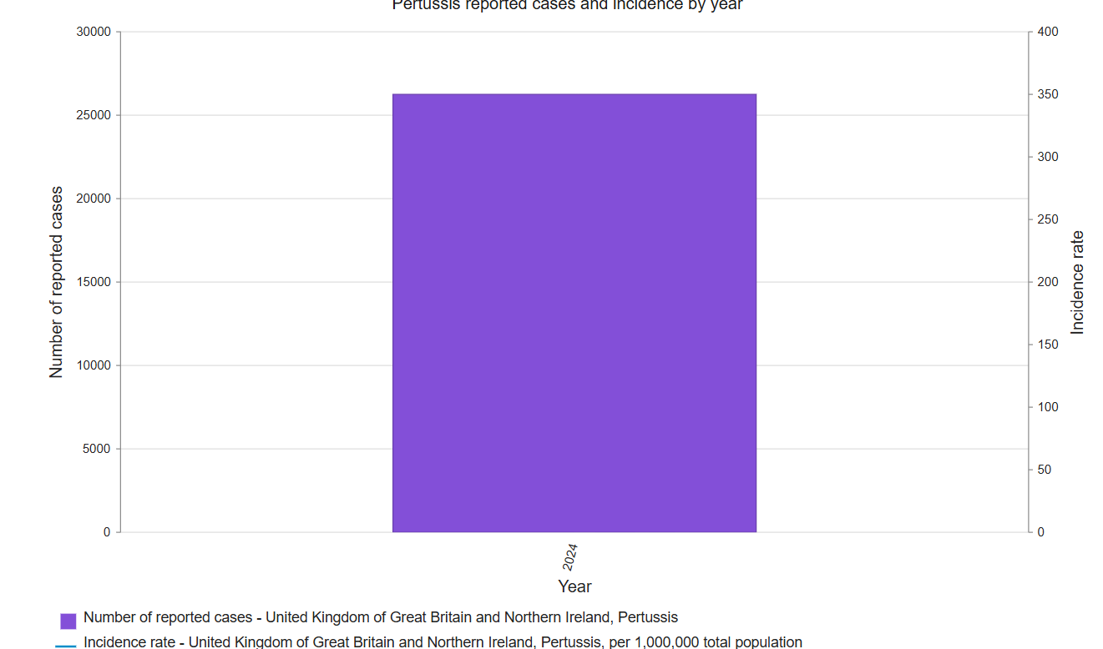

(Who, 2024).

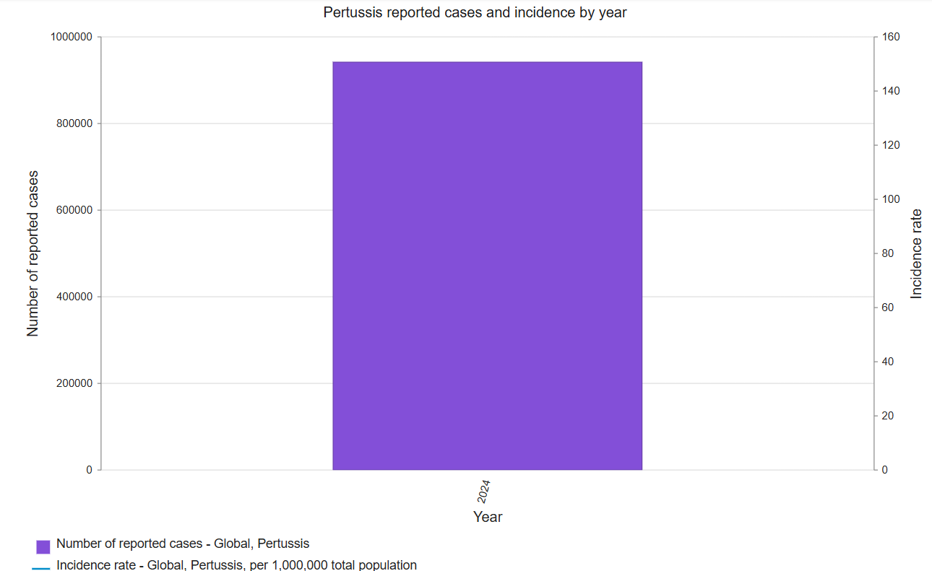

(Who, 2024).
Health Consequences of Pertussis and the Role of Vaccination.
It is a common misconception that only babies can catch pertussis, but that’s not true. People of any age or gender can catch it. That said, newborns are especially at risk because their immune systems aren’t fully developed yet. This is why it’s so important to vaccinate babies and make sure pregnant women get their immunisations, which helps protect their babies from birth.
Pertussis can lead to serious health problems. In some cases, it means a stay in hospital, intensive treatment, and sadly, it can even increase the risk of death. The Centers for Disease Control and Prevention (CDC) (2025) lists pertussis as one of the leading causes of death that could be prevented with vaccines especially in infants who haven’t had all their jabs yet.
While global death figures for 2024 are still being confirmed, earlier data gives us a clear picture. Back in 2014, around 160,700 children under five died from pertussis worldwide. The disease hits hardest in places where vaccination rates are low. In the UK, the Health Security Agency (2025) reported 11 infant deaths from pertussis between January and December 2024. Most of these babies were especially vulnerable because of their age and hadn’t completed their vaccination schedule.

How pertussis affects the community and the NHS.
Pertussis places considerable strain on both communities and NHS services, particularly during outbreaks or when vaccination coverage declines. This overview is informed by a health and social care perspective, highlighting the complex impact of the disease on public systems and individual wellbeing.
Impact on the NHS:
Rising hospital admissions are a key concern. Babies younger than six months are especially vulnerable and frequently require inpatient treatment due to serious complications such as pneumonia, convulsions, or breathing issues. Treatment for whooping cough varies depending on age and the duration of infection. Hospital care is typically necessary for severe cases, especially when infants under six months are affected (NHS, 2023).
Emergency services also face heightened pressure. Critical cases often result in emergency calls and visits to A&E, particularly when symptoms escalate into cyanosis or acute respiratory distress. Severe manifestations such as cerebral hypoxia or significant breathing difficulties in infants may demand urgent hospitalisation, placing additional strain on emergency response teams (NICE, 2023).
Public health resources are stretched during pertussis outbreaks. These events require swift and coordinated intervention, including contact tracing, preventative antibiotics and intensified monitoring. Such measures are essential to contain transmission but can significantly burden NHS infrastructure. Rapid public health action comprising antibiotic prophylaxis and enhanced surveillance is vital, yet resource-intensive (UK Health Security Agency, 2024).
To mitigate spread and protect vulnerable populations, the NHS delivers targeted immunisation efforts. These initiatives prioritise pregnant individuals and frontline healthcare staff, aiming to reduce transmission risk and safeguard infants during their most vulnerable months.
Impact on the community:
Pertussis is highly contagious, spreading easily via respiratory droplets. This makes environments such as schools, childcare settings and overcrowded homes particularly susceptible. Close contact such as living in the same household or spending prolonged time together facilitates transmission. In educational and childcare settings, this includes classmates or staff sharing indoor spaces for extended periods (UK Health Security Agency, 2024).
The disease also disrupts daily life. Persistent coughing episodes, which can last for several weeks, interfere with education, employment and social engagement. This disruption often leads to isolation and emotional distress, particularly for caregivers and affected children.
Health outcomes are not evenly distributed. Communities with limited access to vaccination due to digital exclusion, misinformation, or service gaps face higher infection rates and more severe consequences. The RCPCH policy report Vaccination in the UK: Access, Uptake and Equity (2025) outlines a multi-pronged strategy to address declining childhood vaccination rates and widening health inequalities across the UK (Royal College of Paediatrics and Child Health, 2025).
Pertussis is a notifiable condition, meaning suspected cases must be formally reported to local health protection authorities. This legal requirement facilitates early outbreak detection and coordinated response. Medical professionals are obligated to notify their local council’s designated officer or health protection team (HPT) immediately upon clinical suspicion without waiting for lab confirmation. Notifications must be submitted securely within three days and in urgent cases, verbal notification must occur within 24 hours (Dr. McKechnie D, 2024).
How Pertussis is controlled.
Managing pertussis properly means using a mix of prevention, early spotting of symptoms and strong public health action especially when it comes to protecting vulnerable groups like newborn babies.
Vaccination is still the best way to stop pertussis from spreading. The DTaP vaccine is routinely given to babies and young children to protect them from diphtheria, tetanus and pertussis. To keep immunity strong, older children, adults and pregnant people are advised to get a Tdap booster. For pregnant individuals, the ideal time is between 16 and 32 weeks, as this helps pass protective antibodies to the baby before birth. Since immunity can fade over time, these boosters are key to keeping long-term protection going.
To give babies the best start, the pertussis vaccine is ideally given before 32 weeks of pregnancy. But even if someone misses that window, getting vaccinated later can still help. Sadly, five babies died from pertussis in the first few months of 2024. Since the vaccine programme began, most deaths 21 out of 26 were in babies under three months old whose mothers hadn’t been vaccinated during pregnancy.
Vaccination rates have dropped in recent years across England. Among pregnant women, uptake fell from 72.3% in December 2019 to about 59.5% by December 2023. With pertussis cases on the rise, this drop is worrying especially since maternal vaccination is one of the most effective ways to protect newborns during their first few months (Temmink C, Dr. Ramsay M, CBE 2024).
To stop the infection from spreading, people with pertussis are advised to isolate during the contagious phase, which can last up to three weeks after coughing starts if left untreated. This long infectious period puts close contacts, especially babies and people with weakened immune systems at risk. Starting antibiotics early, ideally within two weeks of symptoms appearing, can help reduce how long someone is contagious and lower the chance of passing it on. Common treatments include macrolide antibiotics like azithromycin and clarithromycin. However, once the intense coughing fits begins, these medicines don’t do much to ease symptoms. That’s why public health teams focus on catching cases early and encouraging isolation to protect others.
Antibiotics like azithromycin or clarithromycin work best when taken within two weeks of symptoms starting. They help cut down the risk of spreading the infection and shorten how long someone stays contagious. But once the classic coughing fits kick in, antibiotics don’t do much to ease the cough itself. Isolation is still recommended during the infectious phase, which can last up to three weeks after coughing begins if no treatment is given (NICE, 2024).
Conclusion.
In summary, pertussis is still a serious public health issue because it spreads easily, can cause dangerous complications and hits vulnerable groups especially babies the hardest. Even though we have effective vaccines and antibiotics, the number of cases is going up, and fewer people are getting vaccinated. This puts extra pressure on both the NHS and local communities.
For the NHS, this means more babies needing hospital care, more emergency calls and the need for quick action during outbreaks. In everyday life, pertussis can cause long-lasting disruption, make health inequalities worse and highlight just how important it is to catch cases early and focus on vaccination especially for those most at risk.
To tackle the rise in cases, we need a joined-up approach that includes prevention, early treatment and strong public health monitoring. Raising awareness and boosting vaccine uptake especially among pregnant people is key to stopping the spread and protecting those who need it most. With the right steps, we can reduce the impact of this preventable illness and make sure everyone has fair access to care.

Reference list:
Centers for Disease Control and Prevention (2024) Pertussis in Other Countries. Available at: https://www.cdc.gov/pertussis/php/global/index.html (Accessed on: 22nd October 2025).
Dr. McKechnie D (2024). List of Notifiable Diseases in the UK. Available at: List of Notifiable Diseases in the UK (Accessed on: 22nd October 2025)
Dr. Wiggins C (2023). Whooping cough. Available at: Whooping Cough: Symptoms, Treatment, and Prevention (Accessed on: 21st October 2025).
NHS. (2023). Whooping cough (pertussis). Available at: Whooping cough - NHS (Accessed on: 22nd October 2025).
NICE (2024) Scenario: Management of whooping cough. How should I manage a person with whooping cough?. Available at:Scenario: Management of whooping cough | Management | Whooping cough | CKS | NICE (Accessed on: 23rd October 2025).
NICE. (2023). Whooping cough: What are the complications? Available at: Complications | Background information | Whooping cough | CKS | NICE (Accessed on: 22nd October 2025).
Royal College of Paediatrics and Child Health (RCPCH). (2025). Vaccination in the UK: Access, uptake and equity. Available at:Vaccination in the UK: Access, uptake and equity | RCPCH (Accessed on: 22nd October 2025).
Temmink C, Dr. Ramsay M, CBE (2024). Change to pertussis vaccination in pregnancy programme from 1 July 2024. Available at: NHSE-change-of-pertussis-vax-in-pregnancy-programme_May-2024.pdf (Accessed on: 23rd Oct. 2025).
UK Health Security Agency (UKHSA). (2024). Guidance on the management of cases of pertussis during high activity. pg5 1.1 para 7, Available at: UKHSA guidance on the management of cases of pertussis (Accessed on: 22nd October 2025).
UK Health Security Agency (UKHSA) (2025). Confirmed cases of pertussis in England by month, 2024. Available at: https://www.gov.uk/government/publications/pertussis-epidemiology-in-england-2024/confirmed-cases-of-pertussis-in-england-by-month (Accessed on: 22nd October 2025).
UK Health Security Agency (UKHSA). (2024). Pertussis: guidelines for public health management. Pg 8, 2.2.1, para 3, Available at: UKHSA guidance on the management of cases of pertussis (Accessed on: 22nd October 2025).
World Health Organisation (2024). Pertussis incidence UK and chart. Pertussis reported cases and incidence. Available at: Pertussis reported cases and incidence (Accessed on: 21st October 2025).
World Health Organisation (2024). Pertussis incidence Global and chart. Pertussis reported cases and incidence. Available at: Pertussis reported cases and incidence (Accessed on: 21st October 2025).

