Project Title,
How to improve the aesthetic acceptance of Chinese landscape paintings in museums.

Meixin Tian, 2423436

Research Questions
1. How are Chinese landscape paintings displayed and viewed in museums?
2. How does the aesthetic reception of Chinese landscape paintings differ across cultural contexts?
3. How are the artistic conceptions of Chinese landscape paintings displayed and interpreted?

Research Objectives
This study first analyses and compares the display methods and audience reception of Chinese landscape paintings in museums in China and the UK. It explores how the artistic conception of Chinese landscape painting is conveyed and presented within public museum spaces. By collecting audience feedback on their viewing motivations and aesthetic experiences, combined with an analysis of display methods, this study identifies the cultural meanings, limitations, and challenges in the cross-cultural presentation and reception of Chinese landscape painting. Further, it highlights the potential and value of multimedia-based display approaches. Finally, it integrates personal creative practice to explore the feasibility of using digital technologies to enhance the dissemination and understanding of Chinese landscape painting.

Abstract
This research focuses on the aesthetic reception of Chinese landscape painting within museum contexts, particularly examining the differences in exhibition practices and audience interpretation between Chinese and British cultural settings. Since the 19th century, when Chinese landscape painting first entered Western museums, its display has long been dominated by Western visual logic, neglecting the native aesthetic mechanisms and spiritual essence inherent to its art form. Today, the exhibition of Chinese landscape painting remains influenced by Western display practices, drifting away from traditional aesthetic experiences. To investigate this, the study adopts an interdisciplinary approach combining archive analysis, case studies, and audience research. The archive analysis provides historical and theoretical foundations, case studies reveal how exhibition methods affect the transmission of artistic conception, and audience research supplies empirical feedback on reception. Drawing on a phenomenological perspective, the research emphasizes the importance of subjective audience experience. Personal artistic practice introduces digital technology into landscape painting exhibitions, exploring immersive and interactive formats. This study enriches cross-cultural discussions within the museum and art dissemination fields and proposes innovative strategies for the contemporary expression of Chinese traditional art.

Introduction
1. Research Scope and Structure
This research focuses on the phenomenon of the aesthetic reception of Chinese landscape paintings in museums. It is divided into four parts. First, it traces the collection history of Chinese landscape paintings in British museums and examines how they have been displayed in both Chinese and Western museums, along with the underlying aesthetic logics. The literature review then summarises key studies on Chinese painting viewing practices in China and the West, identifying research questions. Following this, the methodology section describes the case study approach and analyses the researcher's connection to the study from an ontological perspective. Finally, the discussion explores how the findings inform both academic practice and personal artistic creation. This research defines Chinese landscape paintings
Like Yang (2023, 348) defines, Chinese artists refer to traditional landscape paintings as ‘mountain and water’ paintings. Mountains and water are conceived as partners rather than objects, with the two components representing the two immanent polarities of Tao. The Chinese landscape paintings in this research refer to the landscape painting drawing by the traditional Chinese ink materials and the Chinese philosophical mindset.
2. Historical Misunderstandings in British Collections
The collection of Chinese paintings, especially Chinese landscape paintings, by public institutions such as British folk and museums can be traced back to the Victorian period in the 19th century. Today, British public institutions such as the British Museum and the V&A Museum still retain a large number of precious collections of Chinese landscape paintings, but the extent of their research and display is far from truly reflecting their value. The British Museum holds 1,138 Chinese landscape paintings from the Ming and Qing Dynasties, but currently, less than 10 of them are on display (British Museum, 2025). On the other hand, according to the doctoral research of Huang (2010, p11), a scholar from the University of St Andrews, on the collection history of Chinese paintings in the UK, the lack of professional training in collection institutions and individuals, as well as the motivation to collect as postcard souvenirs, have led to the failure to truly understand and recognize the collection history of Chinese paintings in the UK.
Huang (2010) points out that since the 19th century, Chinese painting gradually entered museums in the UK, but it was not truly understood or fairly appreciated at first. In the early days, a large number of Chinese paintings entered Britain as "export paintings". Most of these works were created to cater to Western tastes, depicting customs, clothing, etc., and were regarded as ethnographic materials rather than artistic treasures. They lack the presentation of the inherent aesthetic traditions of Chinese painting, resulting in the British public's one-sided and superficial understanding of Chinese art. It was not until the early 20th century that Laurence Binyon's efforts promoted a deeper understanding of traditional Chinese painting in Britain. During his career at the British Museum, he actively purchased Chinese paintings, such as those from the Stein collection (1909) and the Wegener Collection (1910), and popularised knowledge of Eastern paintings through numerous publications and lectures. However, Bin Yang and his colleagues were also deeply influenced by Japanese art and Western aesthetics, which often led them to be biased in their judgments of Chinese painting. Overall, Huang (2010) 's research concludes that Chinese painting has long been viewed from the perspective of the "Eastern Other" in the UK. The ethnographic function in the 19th century, the Oriental fantasy in the early 20th century, and the "alternative modernity" in modern art exhibitions all demonstrate their externalities and one-sidedness in aesthetic evaluation and historical positioning. This reveals the historical background in which Chinese paintings were misunderstood in the Western context.
3. Contemporary Exhibition Challenges
In the contemporary exhibition context, the differences in the viewing of Chinese paintings between China and the West still exist. The viewing differences of Chinese painting from the perspectives of China and the West stem from the different understandings of visual and spiritual experiences by the two cultures. Cao and Yu (2005, p.91) pointed out that Chinese painting emphasises the viewing methods of "wandering the eyes", "careful appreciation" and "privacy", and its scattered perspective and spiritual composition pursue an immersive experience of the viewer's soul. In contrast, Western painting focuses on focal perspective and spatial restoration, emphasising the objectivity of vision and physical presentation. Therefore, its way of viewing is more inclined towards collectivisation and externalisation.
This difference has caused misinterpretation in the contemporary exhibition system. Tang (2012, p. 13) criticises the display method of simply hanging Chinese paintings in Western art galleries, which undermines their original privacy and spiritual viewing mechanism. Chen (2012, p. 8, p. 21) points out from the perspective of architectural design that the spatial logic of modern art galleries is incompatible with the "view" of Chinese painting, and the traditional artistic experience has been weakened. The "Westernisation" of this display method not only obscures the original aesthetic connotation of Chinese painting but also weakens its dissemination power and cultural value in the contemporary context.
Therefore, it is important to study the display and viewing of Chinese paintings. As Li Geye (2021, p. 105) points out, the interaction between the exhibition space and the works determines the way the audience accepts and the aesthetic effect. This research not only contributes to the contemporary expression of Chinese painting, but also responds to the development issues of the discipline of Chinese painting itself, reminding the audience to think about the contemporary significance and identity of Chinese painting, as well as what it means for different audience groups.
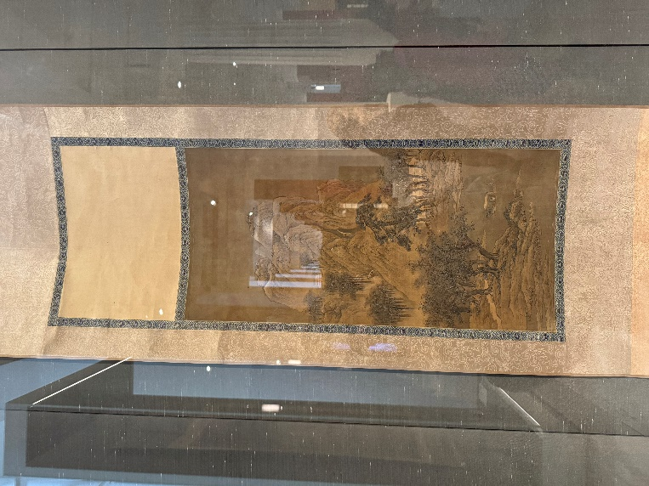
Figure 1: Chinese landscape paintings in the British Museum. Picture from the author,14,03 2025.

Literature Review
In this study, the literature is mainly divided into three categories: the collection history of Chinese landscape paintings in the UK, the display and viewing of Chinese landscape paintings in the UK, and the display and viewing of Chinese landscape paintings in China. I particularly paid attention to the research gap between Chinese and English literature. For this research, the above-mentioned literature is the channel through which I understand and approach the phenomenon of the display and cognition of Chinese paintings. They provide the research background and historical experience. However, as Hall (2001, p. 89) said, archives are not created out of thin air. Each archive has a pre-history, which originated from the context at that time. Therefore, in my research, I will critically compare how the research subject (Chinese landscape painting) is recognised in Chinese studies and Western studies, and what the differences are in their presentation methods, as well as what historical background and context these differences stem from.
1. Collection History of Chinese Landscape Paintings in the UK
In the first part about the collection history of Chinese landscape paintings in the UK, I mainly referred to Huang’s research. His doctoral dissertation focused on the formation period of the British Museum's collection of Chinese paintings from 1880 to 1920, which was the peak of collecting Chinese artworks. It involves extensive and complex relationships between China and the UK, public museums and private collectors, as well as the collection, display and interpretation of Chinese paintings. Huang (2010) 's research reveals the historical processes, such as the reasons, motivations and changes in collecting interests of Chinese paintings by British public institutions and private collectors, especially the mutual influence with the contemporary Japanese art trend. He pointed out that the collection and research of Chinese paintings in the UK have not been analysed in depth (Huang, 2010, p9). These contents provide a historical background for my research, enabling me to compare the role changes and cultural identities of Chinese paintings in the Western public sphere. Not only in the 19th century, but his research also extended to the attention and collection of modern Chinese paintings in British museums from the mid-20th century to the present. Taking the British Museum and the Ashmolean Museum as examples, he explored the vision and strategies of British museums in forming modern Chinese painting collections in the second half of the 20th century. It focuses on the history of the institutions, acquisition policies, and the collections of Chinese painting art in these two museums (Huang, 2020). Although his research did not directly discuss the relationship between the works and the exhibition space, it provided a new perspective for my research, offering references in terms of the sources of the collections and acquisition strategies. This also reflects the aesthetic changes in the West towards Chinese paintings.
2. Comparative Viewing Practices: China and the West
Next, I will analyse the differences in the viewing and understanding of Chinese paintings from the perspectives of China and the West based on the theories of scholars Wu Hong and Clunas on the viewing of Chinese paintings. Wu Hong and Clunas are respectively representative scholars in the fields of Chinese and English for the study of traditional Chinese art. Their theories both start from their own cultural and educational systems to understand Chinese art. Wu Hong (1996) accurately summarised the viewing mechanism of Chinese painting, especially landscape painting, including the changes in viewing perspectives and contemporary viewing contexts. This perspective embodies the aesthetic requirements of traditional Chinese painting. In contrast, Clunas (2017) focused on the relationship between Chinese painting and audiences of different identities. He analysed the differences in the perception of Chinese paintings between Chinese and Western audiences, as well as how the concept of Chinese paintings was formed and evolved during the viewing process. Therefore, the traditional perspective of Chinese painting adopted by Wu Hong and the perspective of Western art historians represented by Clunas can infer the reasons for the cognitive differences of Chinese painting in the local and cross-cultural contexts from the levels of aesthetics and art history.
3. Display and Interpretation in Contemporary Contexts
Finally, I will focus on the display research of Chinese paintings in the academic circles of both Chinese and English. As the birthplace of Chinese painting, the Chinese academic circle has rich experience in the research of Chinese painting. However, compared with the research on Chinese paintings themselves, the research on the display and viewing of Chinese paintings in the contemporary context started relatively late, but it has shown an upward trend in recent years. As Li (2021, p.104) pointed out, the display of Chinese paintings in the public domain is related to the development of Chinese museums since the 1990s. The research on the display and viewing of Chinese paintings in the Chinese academic circle began with Professor Li (1989) of Tsinghua University's reflection on the insufficient representativeness of Chinese paintings in contemporary exhibitions at the 7th National Art Exhibition. Taking this exhibition as an opportunity, he keenly perceived the development crisis of Chinese painting in the exhibition under the influence of Western modernism and other trends, as well as the problem of insufficient representation in the exhibition. He pointed out that as a cultural representative with a history of several thousand years, the discipline of Chinese painting itself and its development limitations in exhibitions also echoed the thoughts of the Chinese art circle on the transformation of Chinese painting at that time (Li, 1989, p. 4). Although the author did not directly analyse the specific display methods of Chinese painting, he directly pointed out the challenges that Chinese painting faces in contemporary public space exhibitions compared with other art media, inspiring the audience to think about the disciplinary significance of Chinese painting and the role it plays in contemporary public Spaces.
In the past two decades, this topic has been highly focused by scholars from multiple fields such as aesthetics, architectural design, and computer science. Cao and Yu (2005), scholars from the field of aesthetics, paid attention to the viewing differences between Chinese paintings and Western paintings relatively early. They summarised three typical ways of viewing Chinese paintings by combining ancient Chinese painting theories, including moving viewing, experiencing the details of the picture and the requirement for private viewing. During the same period, the interactive works designed by scholars Shen, Yang and Xiao (2009) from the field of computer science at Shanghai Jiao Tong University provided a precedent for the multimedia display of Chinese paintings and played a pioneering role. They combine Chinese landscape paintings with Musical Instruments. Viewers can interact with the Chinese landscape paintings on the screen and create content by manipulating the guqin. This way of combining music and paintings ingeniously integrates two representative Chinese cultures. It not only enhances the visiting experience of the audience, creating an immersive visiting experience that encompasses both vision and hearing, but also expands the cultural connotation and exhibition methods of Chinese paintings, strengthening their cultural appeal. In the past decade, the research on the display of Chinese paintings has expanded to fields such as architectural design and literature. For instance, Chen (2012), a scholar from the Department of Architecture of Tsinghua University, took the design project of Yongchuan Art Museum in Chongqing as a case to analyse the limitations of the exhibition of Chinese paintings in contemporary architectural Spaces. He first pointed out that Chinese painting, as a type of painting with a unique appreciation paradigm, has obvious differences from the modern art museum display system originated in the West (2012, p. 8). From the perspective of architecture, he summarised the entertainment-oriented and complex tendencies of exhibition Spaces such as contemporary art galleries, which also led to the conceptualisation and flattening of the exhibits there, and the stripping of their own aesthetic characteristics. Meanwhile, he also analysed the unique aesthetic characteristics of different forms of Chinese paintings and sorted out the ideal display space for Chinese paintings. In the project of Yongchuan Art Museum, he specially designed the external form, internal space and open space of the art museum building based on this aesthetic ideal of Chinese painting. The research project of Chen (2012) provides a relatively comprehensive case of the display space of Chinese paintings, expands the viewing perspective of Chinese paintings from the limited indoor space to the museum architectural space itself, puts forward more precise design requirements, and also provides a reference for the display form of Chinese paintings in contemporary public Spaces. Furthermore, Liu from Shanghai University (2020) noticed the differences in the philosophical logic of the viewing methods of Chinese paintings by Chinese and Western theorists, providing a theoretical reference for understanding the aesthetic acceptance of Chinese paintings by Chinese and Western audiences. These documents are based on the local display context of Chinese paintings and have a relatively accurate observation of their display status.
On the other hand, the research on the display of Chinese paintings in the English academic circle is insufficient. The research on the display and viewing of Chinese paintings in the English academic circle started relatively late. It has only received certain attention in the past five years, mainly focusing on digital display. The current research is still led by Chinese scholars and developed based on domestic research cases in China. Compared with the research of Chinese scholars, the research on the display of Chinese paintings in the Western academic circle is incomplete, insufficient, and even periodized. On the one hand, it is because the aesthetic characteristics of Chinese painting are quite different from those of Western painting. On the other hand, it is also because of the unreasonable and monotonous display that this ancient art medium has not been fully understood by Western audiences and scholars, which has led to its underestimation. It is worth studying how Western audiences perceive this Eastern art medium and whether this perception is different from that of the 19th century. It can reflect the status and cognitive changes of the Chinese cultural image in the West.
The research in English focuses on the exploration of virtual reality (VR) technology in the display, education and dissemination of traditional Chinese paintings. Ma et al. (2012) were the first to propose combining audio, 3D modelling and high-resolution images to achieve an immersive exhibition experience of long scrolls such as "Along the River During the Qingming Festival", laying a multimodal interaction foundation for subsequent research. Jin et al. (2020, 2022) further digitised and reconstructed Chinese paintings such as "Spring Dawn in the Han Palace" in a VR environment. Through empirical research, they demonstrated that immersive learning can significantly enhance learning motivation and cultural understanding, especially outperforming traditional touchscreen systems in terms of detailed memory and spatial cognition. Mu et al. (2024) emphasised the crucial role of episodic narrative in cultural accessibility and emotional resonance through the VR reconstruction of the murals in Cave 61 of Dunhuang. In terms of artistic expression, Cheng et al. (2023) focused on the three-dimensional translation of Chinese painting lines in VR, exploring the contemporary expression of traditional line drawing through the composition of spatial layers and 3D models. Li (2020) and Liu et al. (2024) approached from the perspectives of thematic creation and colour perception to discuss the possibility of combining VR painting with Serious games, emphasising that the unity of technical beauty and cultural spirit should be taken into account in artistic creation.
Overall, scholars unanimously agree that VR can effectively enhance the display and learning experience of Chinese paintings, but they also point out that there is still room for in-depth optimisation in aspects such as narrative structure, style restoration, and interactive design at present. Future research should further promote the development of personalisation, collaboration and multimodal interaction to achieve the true reconstruction and cultural inheritance of traditional art in the virtual space. Through the comparison of research in the Chinese and English academic circles, it can be seen that there are limitations in the display of Chinese paintings in different contexts, as well as the huge potential of digital technology in enhancing the viewing and aesthetic acceptance experience of Chinese paintings. My research will delve into this field and offer my own artistic creations to provide new references for the display of Chinese paintings.

Methodology
The Connection between the researcher and research
In this section, I will explain the relationship between my background and this research from the perspectives of ontology and autobiographical ethnography, as well as how this research question was discovered. As Mao et al (2024) summarised, the help of autobiographical ethnography to art studies lies in providing a creative or research method that combines subjective experience with critical analysis, which is particularly suitable for exploring identity, power relations and social issues in art practice. My artistic creations, personal diaries and previous research results on Chinese landscape paintings, etc., constitute the sources of literature for my autobiographical ethnography. Reference materials of such personal experiences will also be collected from the interviewees as a source of information reflecting the visiting experience of the audience.
First of all, my artistic creation experience is closely related to Chinese landscape painting. Since I started learning Chinese painting in Hangzhou in 2018, I have accumulated seven years of creative experience. When I was sketching in Zhejiang Province, which is the birthplace of the renowned Wu School of Painting, I was deeply attracted by the profound heritage of Chinese landscape painting. Through the study of Chinese painting theory, I have realised that Chinese landscape painting pursues spiritual freedom, bringing a sense of inner belonging and aesthetic experience at the spiritual level to both the audience and the author. As Cao and Yu summarised (2005, p. 91), the purpose of Chinese painting is by no means the art form itself, but rather to achieve the artist's exploration of the deep meaning and the pursuit of the infinite symbolic meaning in spirit through it. Therefore, Chinese landscape painting has become a way for me to express my spiritual pursuit, and this spiritually oriented medium is in line with traditional Chinese philosophical thought.
On the other hand, as an art teacher, I have deepened my understanding of Chinese landscape painting in my teaching and creative practice and gained new insights into its display methods. As Li and Bhattarai (2025, p. 91) pointed out in their research on autobiographical ethnographies and art education, art education encourages scholars to know themselves in different ways. During the teaching process in the museum, I found that the display context of Chinese paintings is vastly different from the traditional way of viewing. Chinese painting, as a genre of painting with extremely strong privacy and individuality, has always been displayed in private Spaces such as study rooms in China, requiring individuals to touch and manipulate the artworks. This also contradicts the public nature of modern art museums (Chen, 2012, p. 14). In most contemporary exhibition Spaces, Chinese paintings are not specially placed according to their materials and framing forms, which gives the audience, especially students who are not familiar with Chinese paintings, an illusion that this medium is equated with other Western paintings on display. Especially after coming to the UK, I found that this kind of exhibition practice deepened the stereotypical impression of Chinese art and hindered the audience's objective understanding and recognition of Chinese paintings in a cross-cultural context. Therefore, my experiences in artistic creation, teaching and museum visits have generated a sense of responsibility for promoting Chinese art, inspiring me to study how Chinese painting can be presented and understood more effectively in the contemporary cross-cultural context.
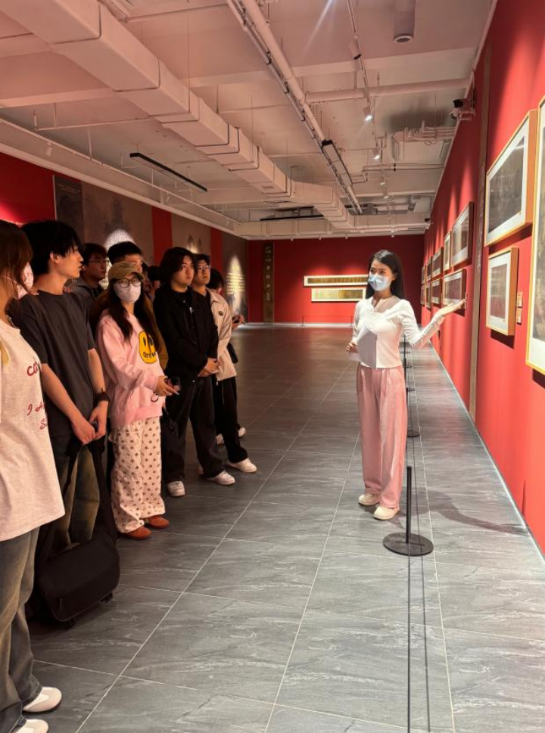
Figure 2: teaching Chinese landscape painting in the museum. Picture from Hebei Academy of Fine Arts, 14,04 2025.

The Method Design
My research will adopt interdisciplinary research methods. While addressing the issue of insufficient display and acceptance of Chinese landscape paintings, guided by the research conclusions, I will apply multimedia digital technology to my doctoral creation, opening up new paths and experiences for the digital display of Chinese landscape paintings. My research design refers to the phenomenological method to analyse the aesthetic acceptance phenomenon of Chinese landscape paintings in specific public Spaces from the perspectives of museums, the works themselves, and the audience.
First of all, I will adopt the archive analysis method to sort out the display and viewing situation of Chinese landscape paintings in museums. As Hall (2001, p. 92) said, archives are not inert historical collections; they are in an active and continuous conversational relationship when questioning the past. This highlights the research value of the exhibition records in the contemporary context, providing a critical perspective for reflecting on the past and the present. By analysing the exhibition records, exhibition reviews and related records of the British Museum, the National Museum of China and the Shanghai Museum, it helps me position the research cases and understand the display characteristics of Chinese landscape paintings in different public Spaces as a whole. Thus, I can compare and restore the exhibition practices of the past and the present and find out the differences in their display and aesthetic acceptance. This method is widely used in the fields of Chinese painting and museum research. For example, Huang (2010) adopted the method combining historical documents and cross-cultural research, and reconstructed the acceptance process of Chinese paintings in the UK from the 19th to the 20th century through museum archives, letters and exhibition records. Li (2020) sorted out the entry points of Chinese painting creation and VR painting technology, the development process of VR painting technology, as well as the possibility and necessity of its development through literature analysis.
After identifying representative exhibition cases through literature analysis, I will adopt the method of case analysis to explain how the artistic conception of Chinese landscape paintings is displayed and interpreted by museums from both the aspects of Chinese landscape paintings themselves and the curatorial practice of museums and evaluate the effectiveness of this practice in combination with the following audience interviews. In addition to the exhibition cases in the literature, I will also analyse the exhibition practices of Chinese landscape paintings in the contemporary British Museum and museums in China. Case studies are widely applied in museum research and are typically used to conduct critical evaluations of specific cultural phenomena. For instance, Huang (2010) transformed the aesthetic conception of Chinese landscape paintings into visual and cultural narratives through the interpretation of British museum exhibitions and curators. Cao and Yu (2005) combined traditional works such as "Along the River During the Qingming Festival" to analyse the conflicts between ancient viewing methods and modern exhibition models, thereby constructing three representative viewing paradigms of Chinese paintings. These case analyses highlight their value in revealing real problems and exploring solutions.
Finally, I will collect the visiting experiences of Chinese landscape paintings from the audience through questionnaires and interviews in the museum, and compare them with the above research results to verify the effectiveness of the display of these works. For instance, whether its explanation is clear, whether the meaning of the work is definite, and whether the display of the work is reasonable, etc.
I plan to interview twenty audiences and collect no less than fifty questionnaires in the museum and on the Internet. The interviewees are mainly divided into teachers and artists from universities in China and the UK, as well as the audience at the museum site. The reason for choosing to interview teachers and artists is that they have certain professional backgrounds and professional cognition of Chinese painting. Therefore, to a certain extent, they can represent the mainstream scholars' understanding of the phenomenon of aesthetic acceptance of Chinese painting. On the other hand, the rest ten research subjects will be randomly selected from the audience of the museum, and Chinese and non-Chinese audiences will be included as much as possible to expand the diversity of the sample. To protect the privacy and data security of the audience, this study will adopt an anonymous approach. The identity information and images of the audience will not be collected, and the audience will be required to sign an informed consent form. Anonymised questionnaires and interviews have played an important role as empirical methods for studying the display and viewing of Chinese paintings. For example, Chen (2012) adopted a questionnaire survey to collect the feedback of the audience of Yongchuan Art Museum on the atmosphere of the exhibition space, and further explored the relationship between the viewing behaviour of "viewing" in Chinese paintings and architectural space. In addition, the study by Liu et al. (2024) took the colours of Dunhuang cave murals as design cases, invited 30 participants to take part in a comparative experiment, and used interdisciplinary methods such as interviews to compare the performance of VR SG with VR display games. This study confirmed the potential of VR SG in enhancing the education, entertainment and dissemination of cultural heritage colours, and discussed the significance of VR SG in supporting digital cultural heritage experiences. This method is conducive to revealing the audience perception in the context of Chinese painting display, providing data support and a theoretical basis for spatial design and exhibition planning.
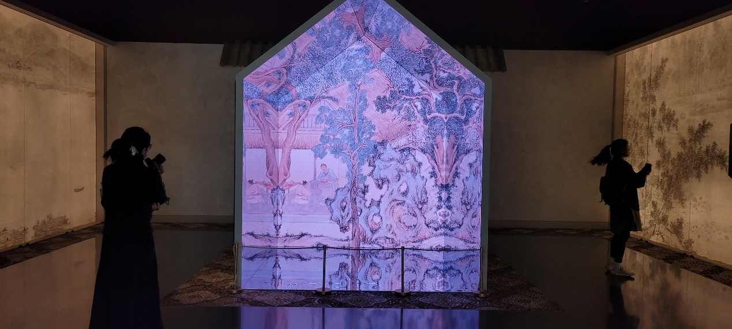
Figure 3: Chinese landscape paintings exhibition in the Shanghai Museum. Picture from the author, 07,04 2025.

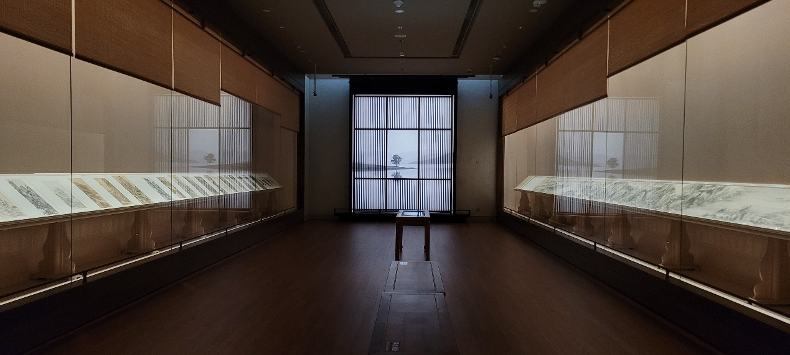
Figure 4: Chinese landscape paintings exhibition in the Shanghai Museum. Picture from the author, 07,04 2025.

Discussion and Analysis
This study adopts interdisciplinary methods such as archive analysis, case studies and audience interviews to construct an interdisciplinary and cross-cultural research framework to answer research questions such as how Chinese landscape paintings are displayed in museums, how the artistic conception is conveyed, and the differences in aesthetic acceptance under different cultural backgrounds. This combination of methods has good explanatory power and practical feasibility.
This study referred to the research approach of phenomenology. The focus of phenomenology is "how experience is perceived", and my research precisely attempts to capture how Chinese landscape paintings are "viewed" and "understood" in different display contexts, which is a systematic analysis of the aesthetic experience itself. From the perspective of phenomenology, what we focus on is not only the physical level of the display, but also the subjective perception and meaning construction formed between the audience and the artworks. Gupta and Zieske (2024, p. 3) advocate integrating art into phenomenological research, arguing that art can intuitively express the essence of life experience, echoing Husserl's concept of "returning to things themselves". Art is both a tool and a core approach for phenomenological exploration, promoting interdisciplinary innovation. Similarly, the research by Neubauer, Witkop and Varpio (2019) also confirmed this. This method emphasises "returning to the experience itself". In this study, the audience and I will understand the aesthetic conception brought by landscape paintings from the perspective of art viewers. This empirical retrospection enables me to have a deeper understanding that the "display" of landscape paintings is not only a process of visual presentation, but also a complex cultural experience and cognitive activity.
Archive analysis, as the first step of the research, helped me clarify the historical trajectory and exhibition structure of Chinese landscape paintings in museums in both China and the UK. Just as Hall (2001, p. 91) emphasised, the archives of public Spaces are the result of conscious collection, screening and display, revealing the hidden value standards and tastes of the managers behind them. By comparing historical documents and exhibition records, I will assess whether Chinese landscape paintings have long been regarded as a symbol of the "Eastern Other" in Britain, and whether their display methods are limited by Western visual logic and museum systems, lacking the reproduction of their intrinsic aesthetic value. I will figure out does this ideology directly affects the audience's acceptance and understanding of the "artistic conception" of landscape paintings.
Combining the analysis of images and exhibition cases, I will further explore how the "viewing system" of landscape paintings has been weakened in contemporary museums. The "dual viewing mechanism" theory proposed by Wu Hong (1996) emphasises that Chinese painting is essentially centred on "introspectiveness", highlighting the viewing paths of "wandering eyes" and "entering the country". At present, most Western museums adopt linear, collective and focused viewing paths, which leads to the inability to achieve the spiritual experience pursued by Chinese landscape paintings. Clunas (2017) analysed the differences in cognitive mechanisms between Chinese and Western audiences from the perspective of the construction of social viewers. By combining these two theories, I can evaluate more systematically how the display space affects the audience's understanding of landscape paintings and thereby influences their cultural dissemination effect.
Based on the data from audience questionnaires and interviews, I will compare the different experiences of Chinese and British audiences when viewing landscape paintings. Whether the experience of Chinese audiences towards the collection is consistent with the traditional aesthetic experience, and what differences there are in the preferences and attitudes of audiences from different cultural backgrounds towards it, etc., will be the core entry points of my research. I will invite adult audiences over 18 years old to participate in the interviews and questionnaires. This is because the museum visiting experience of adults has been widely ignored (Ellis and King, 2011, p. 571). In addition, children have different levels of visual and cognitive maturity, and thus cannot obtain accurate feedback as adults do, which also increases the complexity of ethical procedures. As Aldridge (2015, p. 37) pointed out, not all research methods apply to children at different developmental stages, and the cognitive level of children largely depends on the background of their parents. Therefore, my interviewees will focus on adult groups from different cultural backgrounds.
In terms of the theoretical framework, this study integrates art history, museology, phenomenology and cross-cultural communication theories. The perspectives of Wu Hong and Kruger have helped me reveal the acceptance predicament of Chinese painting in museums of both China and the West from the perspective of the cultural construction of "viewing". Stuart Hall's discussion on archives and cultural memory has led me to reflect on the ideological basis of exhibition methods from the perspective of cultural institutions. The methodological guidance provided by phenomenology leads me to focus on the subjective experience and meaning construction behind the display behaviour. This multi-level and multi-dimensional theoretical integration is an innovative aspect of this study. On the other hand, the limited sample size might be a limitation of this study. I will try my best to cover audiences with different cultural backgrounds from China and the West, but it needs to be further expanded on an international scale.
This research has also had a direct impact on my personal creative practice. In my graduation project, I attempted to break the limitations of the traditional canvas and combine VR technology to construct a "virtual landscape space", allowing the audience to enter the picture in a touring manner. This is not only a transformation of the display strategy, but also a practical response to the essential spirit of Chinese painting. I have also become more aware that in the context of contemporary art, artworks are no longer static images but a "relational field", in which the audience plays the role of a "co-creator".
In conclusion, this study not only theoretically explores the issues of cultural misinterpretation and aesthetic weakening in the display of Chinese landscape paintings but also methodologically proposes a new path that combines phenomenological experience with technological innovation, providing the possibility for the reinterpretation of traditional Chinese art in a global context. Future research can further deepen the analysis of the expression mechanism of "landscape artistic conception" in digital media, expand the scope of cross-cultural exhibitions, and construct a more strategic methodological framework for the international dissemination of Chinese paintings.

Conclusion
This study adopts interdisciplinary methods combining archival analysis, case studies and audience surveys. Starting from three dimensions of history, curatorial practice and audience experience, it comprehensively explores the display and aesthetic acceptance of Chinese landscape paintings in museums. This interdisciplinary research design not only reveals the limitations of the existing display system in conveying the artistic conception of landscape paintings, but also verifies the core role of the audience experience in aesthetic understanding. The phenomenological approach further highlights the construction mechanism of subjective experience and cultural perception, emphasising the interactive relationship between artworks and exhibition Spaces. The diversity of research methods ensures a deep understanding and breadth of analysis of the problem, reflecting a research approach that attaches equal importance to theory and practice. This research provides theoretical support and practical directions for the contemporary expression and cross-cultural dissemination of traditional art and has practical significance and academic value for promoting the re-understanding and cognition of Chinese traditional art in the international museum system. It also has potential influence and inspiring significance for fields such as art history, museology, and digital art exhibitions.

Bibliography
Aldridge, J., 2015, Participatory research: working with vulnerable groups in research and practice, Policy Press, Bristol, pp. 31–64.
British Museum, 2025, Chinese landscape paintings- Collection search. Available at: https://www.britishmuseum.org/collection/search?keyword=chinese&keyword=landscape&keyword=painting (Accessed:09/03/2025).
Cao, H. and Yu, Y., 2005, A Comparison of Ancient and Modern Viewing Methods of Chinese Painting. Literature and Art Criticism, 06, pp. 90–91.
Chen, K., 2012, The Designing of Yongchuan Art Museum——How to Build Art Museums Matching the Artistic Conception of Chinese Paintings. Tsinghua University, MA Thesis.
Cheng, Y., Huang, M. & Sun, W., 2023, VR-Based Line Drawing Methods in Chinese Painting, IEEE, pp. 604.
Clunas, C., 2017, Chinese painting and its audiences, Princeton University Press, Princeton, New Jersey.
Ellis, P. & King, H., 2021, Learning Together? What Are, and What Could Be, the Experiences of Adult Participants to ‘Family’ Workshops in an Art Museum, The International Journal of Art & Design Education, vol. 40, no. 3, pp. 568–580.
Gupta, N. & Zieske, C., 2024, Arts-Based Phenomenological Research: Theory and Praxis, Qualitative Psychology (Washington, D.C.), vol. 11, no. 1, pp. 95–109.
Hall, S., 2001, Constituting an archive, Third Text, 15:54, pp. 89–92.
Hung, W., 1996, The Double Screen: Medium and Representation in Chinese Painting, Reaktion, London.
Huang, M.Y.-L., 2010, The Reception of Chinese Painting in Britain, circa 1880-1920: with special reference to Laurence Binyon. PhD thesis. University of St Andrews.
Huang, M.Y., 2010, British interest in Chinese painting, 1881–1910: The Anderson and Wegener collections of Chinese painting in the British Museum, Journal of the History of Collections, vol. 22, no. 2, pp. 279–287.
Huang, M.Y., 2020, Collecting the new: Major museum collections of twentieth-century Chinese painting in London and Oxford, Museum History Journal, vol. 13, no. 2, pp. 132–153.
Jin, S., Fan, M. & Kadir, A., 2022, Immersive Spring Morning in the Han Palace: Learning Traditional Chinese Art Via Virtual Reality and Multi-Touch Tabletop, International Journal of Human-Computer Interaction, vol. 38, no. 3, pp. 213–226.
Jin, S., Fan, M., Wang, Y. & Liu, Q., 2020, Reconstructing Traditional Chinese Paintings with Immersive Virtual Reality, ACM, New York, NY, USA, pp. 1–8.
Li, B. & Bhattarai, A., 2025, Reimagining Scholarly Impact Through Transformative Learning: An Arts-Based Collaborative Autoethnography, Journal of Transformative Education, vol. 23, no. 1, pp. 79–97.
Li, G., 2021, The Three-dimensional Diversity of the Public Nature of Contemporary Chinese Painting, Public Arts, 06, pp. 104–107.
Li, S., 2020, VR Painting Technology of Theme Creation, IOP Conference Series. Materials Science and Engineering, vol. 750, no. 1, pp. 1-7.
Li, Y., 1989, Memo on Contemporary Chinese Painting Exhibitions. Fine Arts, 08, pp. 4–5.
Liu, Y., 2020, Cross-Cultural Viewing of Chinese Painting: A Case Study of François Jullien’s Theory on Chinese Painting. Studies in Literary Theory, No. 2, pp. 34–45.
Liu, Z., Chen, D., Zhang, C. & Yao, J., 2024, Design of a virtual reality serious game for experiencing the colours of Dunhuang frescoes, Heritage Science, vol. 12, no. 1, pp. 370–31.
Ma, W., Wang, Y., Xu, Y., Li, Q., Ma, X. & Gao, W., 2012, Annotating Traditional Chinese Paintings for Immersive Virtual Exhibition, Journal on Computing and Cultural Heritage, vol. 5, no. 2, pp. 1–12.
Mao, J., Romero-Hall, E. & Reeves, T.C., 2024, Autoethnography as a Research Method for Educational Technology: A Reflective Discourse, Educational Technology Research and Development, vol. 72, no. 5, pp. 2725–2741.
Mu, R., Nie, Y., Cao, K., You, R., Wei, Y. & Tong, X., 2024, Pilgrimage to Pureland: Art, Perception and the Wutai Mural VR Reconstruction, International Journal of Human-Computer Interaction, vol. 40, no. 8, pp. 2002–2018.
Neubauer, B.E., Witkop, C.T. & Varpio, L., 2019, How Phenomenology Can Help Us Learn from the Experiences of Others, Perspectives on Medical Education, vol. 8, no. 2, pp. 90–97.
Shen, J., Yang, X. & Xiao, S., 2009, Design and Implementation of Exhibition System for Interaction Chinese Painting, Computer Engineering, vol. 35, no. 2, pp. 256–262.
Tang, K., 2012, Four Quartets: Chinese Painting in Contemporary Exhibition Spaces. Fine Arts Observation, 08, pp. 13–15.
Tian, H. & Dai, X., 2011, The Influence of Display Methods on Chinese Painting Creation. Traditional Chinese Painter, 11, pp. 71–73.
Walley, C.J. & Elliott, D., 2025, Unsettling the Self: Autoethnography and Related Kin, American Anthropologist, vol. 127, no. 1, pp. 121–130.
Yang, Q. 2023, "Contemporary Chinese landscape paintings: genealogies of form", Journal of visual art practice, vol. 22, no. 4, pp. 347-371.
Zheng, X., 2022, The Right to View: Discussion Around Craig Clunas, Who is Watching Chinese Painting", Penoy, 14, pp. 73–75.

