
Applied Leadership and Management in the Workplace
Module Assignment Submission
Student Name: | Lisa Ann James
Student Number: | 2115847
Module No: | BMSK4013
Module Title: | Management Communication

Statement of Confirmation of Authenticity
By the act of making this submission, the student declares that this is the work of the student named above. The work has not, in whole or in part, been knowingly presented elsewhere for assessment, or where assessment has been built on a previous assessment, this has been identified. Where materials have been used from other sources it has been properly acknowledged. If this statement is untrue, the student acknowledges that an assessment offence has been committed.
Attention is drawn to the plagiarism and unfair practice policies of both the University and of ILM.

Table of Contents

The Relevance of the Communication Cycle for Effective Communication in Management 3
Communication Models 3
Shannon-Weaver Model (1949) 4
Berlo’s SMCR Model (1960) 4
Schramm’s Model of Communication (1954) 5
Communicating with Purpose 7
Evaluation of Verbal and Written Communication Methods within the Finance Service Centre 8
Advantages of the Current Service Centre Setup 10
Disadvantages and Challenges of the Service Centre 10
Recommendations for Improvement 11
Conclusions of findings for Finance Service Centre 12
Theories of motivation 13
An Evaluation of the Principal Factors Affecting Performance and Motivation in a Centralised Finance Service Centre 14
Theory of motivation, apply it to the Centralised Finance Service Centre 16
Herzberg’s Two-Factor Theory in Practice 16
Prevailing Culture: Signs of Theory X 16
Evaluating Herzberg’s Effectiveness in This Context 16
A More Adaptive Alternative: McClelland’s Theory of Needs 17
Evaluative Summary of Communication Style Based on Peer Feedback 17
Conclusion and personal reflection 19
Personal Development Plan 20
References 21

The Relevance of the Communication Cycle for Effective Communication in Management

Communication Models

Effective communication is the cornerstone of effective management. It helps leaders to effectively communicate expectations, successfully cooperate, and drive teams to achieve common goals. The communication cycle is at the heart of this process, providing a thorough structure for how signals are delivered, received, and understood. Understanding this cycle and the models that support it is critical for managers who want to improve clarity, decrease misconceptions, and foster trust among their teams. The communication cycle explains the process of delivering information from a sender to a receiver while ensuring that the intended message is comprehended. In management, this cycle is critical for making decisions, collaborating, and sustaining organisational efficiency. Communication is the exchange of ideas, opinions, facts, sentiments, and so on between two or more people in order to establish a mutual understanding.
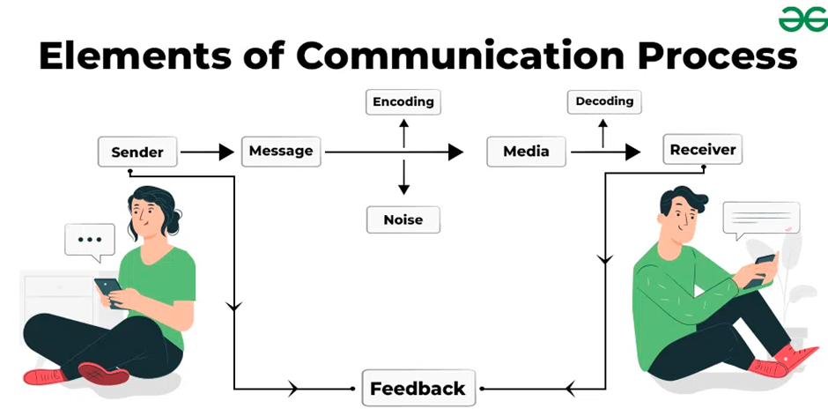
(GeeksforGeeks, 2022)
Understanding the Communication Cycle
The ongoing process of information exchange between a sender and a recipient is referred to as the communication cycle. The following steps are usually involved:
- Original message - sender formulates a message.
- Encoding: The message is translated into verbal or non-verbal symbols.
- Transmission: The message travels through a chosen channel - WhatsApp, email, phone call, etc.

- Decoding: The receiver interprets the message.
- Feedback: The receiver responds, completing the cycle.
- Noise: Any interference that distorts the message (e.g., distractions, jargon, emotional barriers).
This repeated process ensures that communication is not static but iterative, allowing for clarification and adjustment as needed (Mastering the Effective Communication Cycle | ProfileTree, 2024).
To further understand the communication cycle, two influential models are examined: the Shannon-Weaver Model and Berlo’s SMCR Model.

Shannon-Weaver Model (1949)
Originally developed for technical communication, Weaver was a scientist and electrical engineer, while Shannon was a mathematician. The aim of this model was to help engineers working for the Bell Telephone Company. The Shannon-Weaver model outlines six strong components:
- Sender: Originator of the message.
- Encoder: Converts the message into signals.
- Channel: Medium through which the message travels.
- Decoder: Converts signals back into a message.
- Receiver: Target of the message.
- Noise: Any disruption that affects message clarity.
This model emphasises what is referred to as the linear transmission of information and highlights the impact of noise, making it particularly appropriate in environments where clarity is critical, such as remote work or cross-cultural teams (Drew, 2023)

Berlo’s SMCR Model (1960)
Berlo’s model expands on the communication process by focusing on four elements:
- Source: Includes communication skills, attitudes, and knowledge.
- Message: Content, structure, and code.
- Channel: Sensory channels (e.g., hearing, seeing).
- Receiver: Similar attributes to the source.
Berlo's (Berlo, 1960) approach, in contrast to Shannon-Weaver's, emphasises the human elements, such as emotional state and cultural background, which affect communication. It is especially helpful in managerial settings when empathy is important and there are a variety of factors at play. (Preeti, 2017)

Schramm’s Model of Communication (1954)
By adding the idea of shared fields of experience between sender and recipient, Schramm's model expands upon a linear model once again. It underlines that communication involves more than merely sending a message; it also entails deciphering its meaning in light of context, feelings, and past knowledge.
- Source: Initiates the message.
- Message: The content being communicated.
- Channel: The medium used (e.g., speech, writing).
- Decoder/Receiver: Interprets the message.
- Feedback: Response from the receiver.
- Field of Experience: Shared understanding or background that influences interpretation.
Schramm's concept is extremely useful in management communication, particularly within ethnic or cross-functional teams. It encourages managers to consider employees' backgrounds, experiences, and emotional states while delivering messages, which is important for motivation and engagement. (Schramm & Roberts, 1971)
The Shannon-Weaver, Berlo's SMCR, and Schramm models all provide unique but complementary insights into how communication works, particularly in management situations where clarity, feedback, and comprehension are critical. The Shannon-Weaver Model (1949) has importance in management: It helps managers detect and resolve communication impediments such as technological difficulties, semantic misunderstandings, and poor messages. It emphasises the importance of noise, or anything that affects the message, which is critical in digital and cyber communication, remote work, and cross-functional teams. It encourages management to reduce channels and communicate effectively. Here's an example. A manager providing instructions by email must ensure that the message is clear and free of jargon, and that the recipient has the necessary tools and context to understand it effectively.
The human components of communication skills, attitudes, knowledge, and cultural context are the main emphasis of Berlo's SMCR Model (1960). By encouraging managers to modify communications according to the recipient's background, the strategy raises motivation and engagement. It emphasises how crucial it is to carefully compose the message and use the appropriate medium, such as in-person, email, or video. For instance, a manager should take into account an employee's communication style, emotional state, and cultural background while providing one-on-one feedback to make sure the message is received positively.
Finally, feedback is included as a fundamental element in Schramm's Model (1954), which turns communication into a two-way process. This emphasises the value of common areas of experience and the notion that comprehension is reliant on shared information, context, and emotional tone. Encourages managers to assess their comprehension and modify their communications in response to comments. For instance, managers might use Schramm's approach to guide the conversation at team meetings in order to resolve conflicts and foster respect and understanding between participants.

ELEMENTS | SHANNON & WEAVER | BERLO’S SMCR | SCHRAMM’S MODEL
KEY FOCUS | Technical clarity & noise | Human factors & message formulation | Feedback & shared experiences
MANAGEMENT RELEVANCE | Reduces miscommunication in digital channels | Enhances motivation and engagement | Builds trust and ensures mutual understanding
STRENGTHS | Highlights the role of noise in disrupting communication  Linear framework for message transmission  Introduces feedback in later versions, making it more dynamic  Useful for analysing digital and remote communication | Emphasises human factors like attitudes, knowledge, and culture  Encourages modifying messages to the receiver’s background  Useful for message design and channel selection  Promotes awareness of emotional and social systems | Introduces feedback as a core element, making communication a two-way cycle  Recognises the importance of shared context and interpretation  Encourages modified communication based on the receiver’s background  Highly relevant for interpersonal and team communication
WEAKNESS | Originally designed for technical communication, not interpersonal.  Oversimplifies human interaction; lacks emotional and cultural context  Treats the receiver as calm in early versions  Doesn’t account for nonverbal cues or power dynamics | No feedback loop in communication  Doesn’t address noise or barriers to communication  Assumes the sender and receiver must be alike for effective communication  Lacks understanding of contextual dynamics and nonverbal feedback | Assumes a relatively equal field of experience  Less emphasis on external noise  Doesn’t fully address power dynamics or mass communication  May oversimplify complex organisational structures

Communicating with Purpose

Transmitting information is only one aspect of effective management communication (Clampitt, 2016). It involves creating messages that are in line with corporate objectives and that inspire, encourage, and motivate action. To make sure that the message is not only heard but also understood, it is crucial to choose the right language, tone, and degree of formality. These components, which affect both intelligibility and emotional reception, must be customised for particular audiences and situational settings.
Tone may change how a communication is understood since it conveys the communicator's attitude and intent. Formality conveys the seriousness of the subject matter and the nature of the connection, yet language should be appropriate for the listener's emotional state and cognitive level. Every element is essential in determining how successful the message is. When an office manager says, "I need a Finance Report by Friday morning for a client presentation," for instance, the language is straightforward, the formality level is suitable for the workplace, and the tone is direct and professional. The manager's polite yet authoritative style encourages responsibility and motivation (Robbins & Judge, 2019).
In contrast, consider a military leader working in a high-risk or hostile situation. Communication in such contexts must be clear and actionable. A directive like "Black Ops team, secure the building exit immediately" uses decisive language and a strong tone that values speed and clarity. Nonverbal cues, like as hand gestures, can also be used to preserve operational quiet or give guidance discreetly. The structure is tight and concentrated, and the communication medium may alter depending on the scenario, from face-to-face briefings to radio directives, each chosen to meet environmental needs and mission urgency (Hargie, 2006).
Nurses must interact with patients, families, and other medical professionals in a healthcare context, such as A&E. A combination of verbal and nonverbal communication conveys professionalism and certainty. In addition to providing accurate clinical information to a colleague, a nurse may use a soothing tone to reassure a patient or family member by saying, "Don't worry, you're in good hands" or “Mr. Jones had five milligrams of morphine two hours ago." The listener's emotional condition and the urgency of their medical demands are taken into consideration while designing the mode, structure, and content. The message's urgency and empathy are further reinforced with rapid motions, light touch, and eye contact.
Formality must also be approached with caution. Formal language serves to emphasise seriousness and authority in hierarchical or legal settings, such as the military or boardroom presentations. In contrast, casual communication promotes relatability in situations such as team meetings and schools. For example, an infant schoolteacher would say, "Let's all sit down for story time," employing a warm and welcoming tone to influence conduct. The same instructor may use a more disciplined and methodical approach when discussing student progress with a parent or colleague, varying the tone and formality depending on the audience.
In order to achieve mutual understanding, language is essential. To avoid misunderstandings, military commanders frequently use exact, technical terminology. A&E nurses simplify explanations for family members while tailoring their wording to medical experts. To encourage inclusivity and participation, office managers modify their language to account for cultural variety and team members' varying comprehension levels.

Structure aids in directing how information is interpreted. While a nurse uses organised handover formats like SBAR (Situation, Background, Assessment, Recommendation) to promote clarity in medical transfers (NHS England, 2017), a military leader may prefer briefings that are quick, and bullet pointed. While managers create organised agendas for meetings to keep focus and transparency, teachers frequently employ narrative frameworks for young children to help with attention and recall.
The content should be relevant, courteous, and purposeful. Office managers send task-oriented messages, military personnel focus on mission-critical information, while nurses give both clinical and compassionate care. A schoolteacher organises information to improve learning through simplicity and engagement, while talking more professionally when addressing staff or parents.
Tone has an emotional impact on listeners and affects motivation. An authoritative tone fosters hierarchy and discipline in military settings. A caring tone fosters confidence in healthcare settings. A neutral-professional tone promotes inclusion and objectivity in business settings (Adler & Jeanne Marquardt Elmhorst, 2023). Misjudging tone may lead to misinterpretation, uncertainty, and even confrontation, so managers must be aware of how their communications will be interpreted.
Different means of communication, whether spoken, written, visual, or digital, all play important roles in facilitating comprehension. Military leaders may use tactical hand signals or encrypted radios; medics use face-to-face communication along with urgent gestures; and office managers alternate between emails for official documentation and in-person meetings for relationship depth. Teachers use verbal narrative, physical hints, and visual assistance to successfully interact with young students.
In summary, dynamic flexibility in tone, language, formality, structure, topic, and delivery method is essential for effective management communication. These components must be carefully chosen depending on who is being addressed and under what circumstances; they are not universally applicable. The capacity of the communicator to modify their method affects not just the immediate message but also long-term motivation, trust, and operational efficiency, whether they are teaching young minds, leading in high-pressure situations, or providing medical care during emergencies.

Evaluation of Verbal and Written Communication Methods within the Finance Service Centre

The finance service centre has recently been formed as a brand-new central centre within the business, consolidating accounting functions previously dispersed across international teams. Staff have inherited responsibilities from departments facing redundancy, leading to a working environment shaped by rapid change, heightened pressure, and the necessity for strong, motivational communication practices.
Verbal communication is mainly conducted through Microsoft Teams meetings and unarranged voice calls. These methods are instrumental in establishing trust and clarifying operational priorities. Structured meetings foster inclusivity and connection, two elements central to Maslow’s Hierarchy of Needs (1943), particularly the social and esteem levels. Yet, when meetings lack clear agendas or are poorly attended due to time conflicts or a lack of understanding of the subject matter, the result is ambiguity and disengagement. This can undermine motivation by failing to provide the reassurance and recognition employees require.
Ad-hoc verbal exchanges, informal calls or check-ins offer immediacy and responsiveness. They allow managers to address challenges, offer encouragement, and validate contributions. According to Herzberg’s Two-Factor Theory (1959), such exchanges can serve as ‘motivators’ by fostering achievement and interpersonal relationships. However, the absence of documentation or consistency can impact ‘hygiene factors,’ such as clarity in procedures and security in role expectations. McClelland’s Theory of Needs (1961) provides additional insight. Individuals driven by association benefit most from frequent, positive verbal engagement, whereas those motivated by achievement or power may require structured conversations that affirm their influence and contributions.
Written communication supports the verbal methods, offering permanence and traceability. Formal messaging is conducted through email, which remains a preferred tool for delivering instructions, confirming actions, and documenting key decisions. While email supports communication across diverse time zones, excessive volumes create stress and confusion, challenges that conflict with Maslow’s physiological and safety needs. Herzberg would identify this overload as a hygiene factor contributing to dissatisfaction if left unmanaged.
Microsoft Teams chat offers informal messaging that supports collaboration. This method is well-suited to McGregor’s Theory Y (1960), which suggests that employees are self-motivated and seek responsibility. Informal written communication aligns with this by empowering staff to resolve queries and exchange ideas with minimal supervision. However, when relied on excessively or without complementary formal methods, it can lead to misunderstandings, especially in environments where miscommunication leads to mistakes and necessitates tighter controls.
Finally, SharePoint provides a centralised system for document management and resource sharing. When designed effectively, it offers independence, clarity, and empowerment, key themes in Herzberg’s motivators and McClelland’s achievement need. However, current feedback suggests that disorganised content, difficulty navigating the platform, and inconsistent version control are hindering its potential. These issues may compromise employees’ sense of procedural clarity, reducing job satisfaction and impairing motivation, particularly among those who value structure and independence.
While the finance service centre employs a comprehensive array of verbal and written communication strategies, their impact on motivation varies. Herzberg’s model underscores the importance of reducing procedural noise while enhancing interpersonal drivers; Maslow’s hierarchy reminds us to satisfy psychological and safety needs through clarity and affirmation; McClelland’s framework encourages managers to consider individual motivational styles; and McGregor’s theory guides leadership assumptions that shape communication style. By refining these communication methods with both operational efficiency and motivational nuance, the service centre can create a work environment that supports resilience, satisfaction, and growth through continued transition.

Advantages of the Current Service Centre Setup

Centralised Operations: The consolidation of international teams fosters standardisation and efficiency in accounting practices.
Multi-Modal Communication: Use of Microsoft Teams (calls, chat), email, and SharePoint ensures flexibility and reach across global teams.
Theory-Aligned Practices: Communication strategies echo core motivational frameworks (Maslow, Herzberg, McClelland), offering opportunities for deeper employee engagement.

Disadvantages and Challenges of the Service Centre

ISSUE | IMPACT
Unstructured meetings | Ambiguity, disengagement, missed opportunities for recognition
Excessive email volume | Cognitive overload, reduced responsiveness, undermining safety needs
Inconsistent use of ad-hoc calls | Lack of traceability and role clarity
Disorganised SharePoint content | Impaired efficiency, frustration, reduced independence
Varied Motivational needs not addressed | Feeling of being underappreciated or misunderstood
Lack of Handover of Duties | Lack of preparation and handover leaves employees uncertain and overwhelmed, leading to duplicated efforts, elevated stress, and reduced productivity.
Rising Frustration and Emotional Fatigue | Staff face relentless change with little recognition or psychological safety, eroding morale and triggering burnout as core emotional needs go unmet. Maslow's safety and esteem levels remain unmet.
Rushed Implementation Without Strategic Planning | The rushed changeover lacked planning and clarity, leaving staff feeling confused, unsupported, and detached from the centre’s purpose. Missing training, documentation, and role definition have heightened anxiety and undermined motivation. A breakdown in both Herzberg’s hygiene factors and Maslow’s safety and esteem needs.
Elevated Staff Sickness and Welfare Strain | The rushed transition and insufficient support have led to increased staff sickness and widespread burnout. Beyond operational impact, this signals a serious welfare concern, with Maslow’s safety needs unmet, Herzberg’s hygiene factors compromised, and McClelland’s affiliation drivers weakened by poor interpersonal dynamics.

Recommendations for Improvement

- Structure verbal communication with clear meeting templates, agendas, and follow-ups to reduce ambiguity and improve engagement.
- Adapt meeting formats and timings, including rotating schedules and “focus huddles,” to suit availability and minimise disruption.
- Optimise email usage through inbox management training, action-driven formats, and weekly bulletins to reduce overload.
- Document informal exchanges, ensuring verbal updates and ad-hoc calls are logged for transparency and accountability.
- Strengthen managerial communication by training leaders in active listening, empathetic supervision, and motivational reinforcement.
- Enhance SharePoint functionality with intuitive navigation, naming conventions, version control, and quick-access dashboards.
- Boost morale through recognition and autonomy, such as peer-to-peer appreciation channels, celebration calls, and shoutouts.
- Delegate roles with motivational alignment, matching tasks to individual drivers (achievement, affiliation, or influence).
- Provide development opportunities, including mentoring, shadowing, and ownership of meaningful projects.
- Implement robust handover protocols, with transition documents, checklists, and scheduled handover windows to ensure continuity.
- Introduce well-being check-ins and morale boosters, fostering safe spaces for emotional support and immediate engagement.
- Enable escalation and feedback, training leaders to act constructively and creating defined channels for issue resolution.
- Conduct retrospective workshops, capturing lessons learned to improve future transitions and organisational learning.
- Map and address operational gaps, prioritising fixes for missing training, workflows, and support systems.
- Recommunicate the centre’s strategic purpose, helping teams reconnect with the vision behind the change.
- Establish a representative transition task force, ensuring staff voices guide reform and implementation.
- Launch a staff well-being programme, offering mental health support, stress management workshops, and wellness days.
- Monitor staff welfare metrics, using sickness trends to guide targeted interventions and prevent burnout.
- Develop peer support systems, such as buddy programmes to foster affiliation, trust, and emotional safety.
- Create a culture of open feedback, using anonymous surveys, listening forums, and inclusive action planning.

Conclusions of findings for Finance Service Centre

The establishment of the finance service centre is a bold and ambitious move towards overall operational alignment across the business. Centralising functions has resulted in chances for standardisation, improved collaboration tools, and common knowledge, all of which may be built upon for future success. Teams demonstrated resilience and professionalism by adapting to new positions under duress, embracing unexpected tools, and managing a fast-changing environment.
However, the change has revealed significant gaps in planning, communication, and emotional support. A lack of planned handovers, inconsistent leadership communication, and a hasty implementation have undoubtedly resulted in uncertainty, stress, and an increase in staff sickness, indicating that functional change must be accompanied with empathic management and psychological safety. Recognising these shortcomings is not a blame exercise, but rather a necessary reflection that provides room to recalibrate, re-engage, and strengthen trust.
From a theoretical perspective, if one were to apply Maslow’s Hierarchy of Needs to the current state of the service centre, it becomes evident that staff remain largely at the foundational levels, grappling with physiological and safety needs rather than progressing toward belonging, esteem, or self-actualisation. The surge in stress and sickness, coupled with inconsistent support structures, illustrates how fundamental well-being and security must be prioritised before any meaningful growth in morale or productivity can be expected. This Service centre is still only meeting the basic needs of both it’s employees and the business.
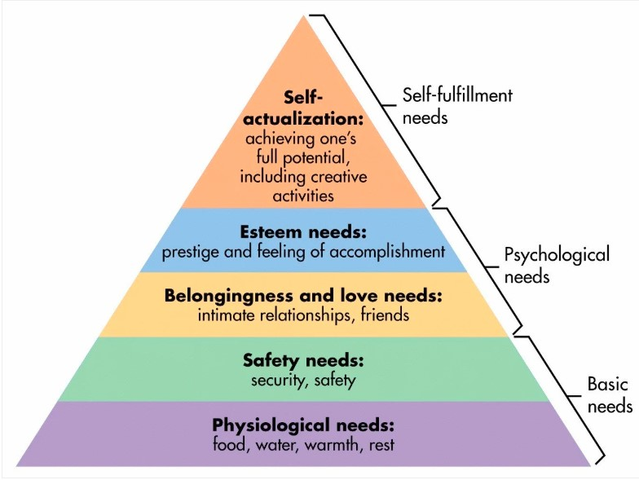
The service centre is currently at a critical juncture. With a proactive rather than reactive mindset and a focus on clear communication, smart handovers, meaningful recognition, and staff well-being, it is possible to create a vibrant, resilient environment in which people feel valued and empowered. What began as a structural revamp can become a transformative journey for not only systems and procedures, but also the team's culture and morale.

Theories of motivation
What Constitutes Motivation? People are motivated to act, persevere, and accomplish their goals by internal or external influences. It affects involvement, productivity, and general morale at work. It's not just about doing chores; it's also about why people do them and how they feel about it.
Let's see how intrinsic versus extrinsic motivation is defined.
Intrinsic: Motivation derived from enjoyment, personal development, or internal fulfilment
For instance, employees that take delight in learning new financial software or resolving difficult reconciliation issues
Extrinsic motivation is fuelled by incentives from outside sources or avoiding penalties.
For instance, workers may put in extra hours to achieve deadlines out of concern for criticism or to be eligible for a yearly bonus.
While extrinsic motivators (e.g., money, job security) might spur action, intrinsic motivators (e.g., autonomy, purpose) promote long-term engagement and resilience, which is especially important in a high-pressure workplace such as a newly consolidated finance service centre.
Maslow's Hierarchy of Needs is a five-tiered model of human needs that includes physiological, safety, love/belonging, esteem, and self-actualisation. Lower needs must be addressed before higher ones may motivate. Staff are currently operating at the lower tiers (physiological and safety), dealing with stress, confusing procedures, and increasing sickness. Without psychological safety and belonging, development towards esteem or self-actualisation is hampered. Maslow's hierarchy is important for diagnosing morale concerns, but extremely ambitious staff may pursue higher demands even if lower ones are not addressed. It does not take into consideration individual or cultural differences in the need to prioritise.
Herzberg's Theory makes a distinction between hygienic elements (such as pay and working circumstances) that are meant to keep people happy and those that don't inspire. Here, performance and enjoyment are driven by motivators (such as accountability and acknowledgement). Poor hygiene elements are reflected in the hasty implementation and lack of planned handovers, while motivators are limited by a lack of possibilities for growth and recognition. It demonstrates why merely making things better won't raise spirits. However, depending on the situation, certain elements (like pay) may serve as both a motivator and a hygienic measure.
McClelland's Theory focusses on three learnt needs. Achievement is the ambition to excel and overcome challenges, whereas affiliation is the urge for social connection. Finally, Power represents a desire to influence and lead. High performers may feel restricted by a lack of control or feedback. Affiliative personnel may have fractured communication and low team spirit. Those seeking power may be demotivated by ambiguous leadership arrangements. McClelland provides a flexible, personalised approach. Managers must identify and adjust methods to each employee's main demand challenging in large or transitory teams..
McGregor's theory is interesting since it assumes that idea X theory employees seek control and dislike their jobs. Employees who follow the Y Theory are self-motivated and eager for accountability. The current reactive culture and top-down communication reflects a X Theory mentality. A shift in leadership's understanding of what is really going on with the mental health of the new employees at the newly established service centre, as well as the implementation of appropriate measures, would be more consistent with Y Theory workers establishing autonomy, trust, and recognition, which may spur creativity and intrinsic drive. However, McGregor's theory does not support a hybrid approach and oversimplifies human behaviour into two extremes, whilst encouraging reflection on managerial assumptions.
At the moment, reactive leadership, unfulfilled basic needs, and a lack of recognition limit motivation in the workplace. Maslow (Mcleod, 2025) diagnoses the extent of unfulfilled demands by applying these theories. Herzberg (Herzberg, 1959) explains why, in spite of structural changes, morale is still poor. McClelland (McClelland, 1988) provides a unique engagement road map. McGregor (McGregor, 1960) pushes management to reconsider presumptions and give employees more authority.
An Evaluation of the Principal Factors Affecting Performance and Motivation in a Centralised Finance Service Centre
Individual psychological profiles, organisational frameworks, and interpersonal dynamics all have an impact on performance and motivation in a centralised finance service centre. Drawing on known motivational theory, such as McClelland's Theory of Needs (McClelland, 1988) and Maslow's Hierarchy of Needs (Mcleod, 2025), this review examines important elements that influence participation and recommends specific solutions to promote a diverse workforce.
Motivational Profiles
Style | Core Drive | Motivators | Challenges
Affiliator | Relationships, inclusion, emotional safety | Personal recognition, being needed, team belonging | Over-sensitivity, discomfort with isolation or conflict
Achiever | Excellence, goal setting, feedback | Clear targets, autonomy, measurable progress | Frustration with ambiguity or lack of challenge
Power-Oriented | Influence, leadership, control | Status, decision-making authority, responsibility | Resistance to collaborative or flat organisational structures

According to a recent motivational analysis based on McClelland and Atkinson's theory, this author has a dominant affiliative style with secondary achiever traits. In addition to a high desire for goal clarity and meaningful advancement, this profile indicates a strong orientation towards interpersonal harmony, emotional inclusiveness, and appreciation. Therefore, ambiguity and unclear guidance are likely to lead to a great deal of irritation, especially in settings that are going through structural change.
Maslow’s Hierarchy of Needs and Organisational Change
According to Maslow's theory, a hierarchy of needs physiological, safety, belonging, esteem, and self-actualisation are what drive people. Many lower-level personnel in the finance service centre have been stopped by the effects of centralisation. Psychological safety has been compromised by hurried implementation and inconsistent communication, which has led to reactive leadership, broken handovers, and high stress and absence levels. Such environmental instability damages Affiliators' emotional health and can lead to presenteeism, retreat, and a reduction in performance.
Motivators Across the Workforce
Understanding the diverse motivational drivers across the team enables targeted engagement strategies.
Motivator | Target Group | Rationale
Achievement & Challenge | Goal-oriented, high-achievers | Thrive on measurable progress and recognition
Autonomy & Control | Independent or power-oriented individuals | Enhances ownership and stimulates innovation
Recognition & Status | Affiliators, power-driven staff | Reinforces morale, visibility, and appreciation
Security & Stability | Change-fatigued or risk-averse employees | Reduces anxiety, improves cognitive focus
Growth & Development | Career-focused individuals | Promotes long-term engagement and retention
Purpose & meaning | Values-led staff | Aligns work with personal significance and pride
Social Connection | Affiliators, collaborative individuals | Cultivates emotional resilience and teamwork
Competition & Influence | Ambitious, power-motivated individuals | Stimulates strategic thinking and engagement
Flexibility & Well-Being | Caregivers, wellness-oriented employees | Supports sustainable performance and reduces burnout

Implications for Leadership and Team Engagement
Due to loneliness or a lack of emotional support, people with affiliative tendencies may be especially susceptible to demotivation in the finance service facility. Lack of clear goals may cause achievers to disengage, and staff members who are power-oriented may feel limited in their ability to exert influence. Rapid organisational change may be difficult for workers who value stability, particularly if there is a lack of clarity or fragmented communication.
To solve these problems, leadership must identify these drivers among team members in order to better understand individual strengths and weaknesses and implement inclusive engagement tactics that are tailored to each motivating style. These could include recognition programs, structured development pathways, emotionally intelligent supervision, and communication strategies that promote psychological safety. By matching organisational support with individual motivators, the centre can foster resilience, productivity, and long-term staff sustainability.

Theory of motivation, apply it to the Centralised Finance Service Centre

A comprehensive understanding of employee motivation is critical for effective organisational change management. Motivational tactics are especially important in the setting of a finance service centre going through a structural shift. This investigation examines the applicability and limitations of Herzberg's Two-Factor Theory, contrasting it with alternative methods such as McGregor's Theory X and McClelland's Theory of Needs.

Herzberg’s Two-Factor Theory in Practice

Herzberg categorised workplace influences into two groups:
Hygiene factors: Conditions that prevent dissatisfaction, including salary, job security, and physical work environment.
Motivators: Elements that drive satisfaction and performance, such as recognition, autonomy, and personal achievement.
Hygiene factors seem to be managed inconsistently within the finance service centre. Stress, confusion, and sick leave have increased as a result of the quick implementation of new systems, disjointed handovers, and unclear communication. These symptoms point to a lack of foundational stability and psychological safety, which are essential for maintaining worker well-being and performance.
Additionally worrisome is the absence of motivating factors. Limited acknowledgement has been given to employees who have shown perseverance in the face of adversity, and there are still few organised possibilities for growth or autonomy. People with affiliative inclinations, who find motivation in affirmation, inclusion, and emotional connection, are especially harmed by this lack.

Prevailing Culture: Signs of Theory X

McGregor's Theory X assumes that employees are innately disengaged and need management and external incentive to perform. This approach is evident in the existing leadership culture: reactive decision-making, top-down commands, and little concern for employee well-being. Although hygiene-related rules such as standardised pay and basic role description may exist, they are not strategically leveraged to promote motivation or morale.

Evaluating Herzberg’s Effectiveness in This Context

While Herzberg's approach provides useful insight into workplace unhappiness, its relevance in this financial context is limited. The hypothesis helps explain present low morale, but its two-fold classification ignores the emotional and relational intricacies of a varied workforce. Motivation for affiliators cannot be sustained solely through job design; relationship support and emotional appreciation are also required.

Furthermore, Herzberg's division between motivators and cleanliness can be strictive. For instance, depending on individual values and outside factors, job stability may serve as a motivator for certain people; this is something that the theory does not adequately account for.

A More Adaptive Alternative: McClelland’s Theory of Needs

McClelland proposed a more flexible framework based on three learned motivational drivers:
- Affiliation: The desire for connection and inclusion.
- Achievement: The drive for excellence, autonomy, and feedback.
- Power: The need to influence and lead.
This approach recognises that staff are not universally motivated their engagement depends on individual psychological profiles. In the finance service centre:
Affiliators need emotional connection, recognition, and approachable leadership.
Achievers require clear goals, autonomy, and development pathways.
Power-driven individuals seek decision-making responsibilities and opportunities to shape outcomes.
McClelland's theory, in contrast to Herzberg's model, encourages diverse engagement tactics, which are crucial in a transitional setting where role expectations, professional goals, and emotional needs differ greatly.
Although Herzberg's Two-Factor Theory is a fantastic starting point for evaluating workplace dissatisfaction, its two-dynamical nature and lack of emotional complexity limit its applicability in a centralised finance service centre. A shift to McClelland's Theory of Needs, supported by emotionally intelligent leadership and tailored motivational strategies, could provide a more sustainable and inclusive framework to support employee engagement, well-being, and performance during times of transition.

Evaluative Summary of Communication Style Based on Peer Feedback

To assess communication capability, the author created a custom evaluative questionnaire based on five core dimensions of effective communication: (1) tone and emotional climate, (2) adaptability and audience awareness, (3) professionalism and approachability, (4) clarity and structure, and (5) overall effectiveness and impact. These criteria demonstrated a comprehensive awareness of interpersonal dynamics, emotional intelligence, and organisational context. This was sent to peers in the form of an email. See example:
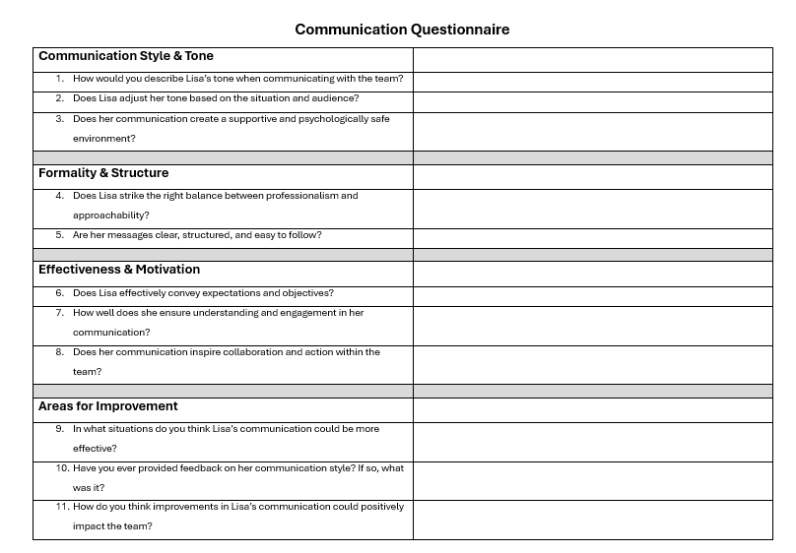
Analysis of Peer Feedback
Tone and Emotion Feedback repeatedly described the communicator's tone as calm, courteous, and welcome. Respondents underlined that this method fosters trust and psychological safety, which is especially important in a newly centralised service centre undergoing structural restructuring. Affiliative characteristics such as empathy, climate sensitivity, and approachability were commonly mentioned. These characteristics were viewed as creating belonging and emotional resilience among coworkers handling uncertainty and transition..
Adaptability and Audience Awareness. Peers praised the communicator's strong situational awareness and emotional intelligence, as well as her ability to modulate her manner to appeal to different audiences. Whether dealing with top stakeholders or assisting junior colleagues, the individual displayed responsiveness and versatility, allowing for inclusive and successful discourse across hierarchies.
Professionality and Approachability this subject was widely regarded as finding an effective balance between professionalism and relational warmth. Colleagues saw the communicator as a trustworthy team player who maintains clarity and precision without sacrificing accessibility or human connection..
Clarity & Structure both verbal and written communication were rated as clear, well-structured, and intelligently planned. Respondents noted that individual contributions improve collective understanding and cohesion, especially during team meetings or collaborative planning sessions.
Impact and Effectiveness characteristics of communication were motivation, teamwork, and action oriented. Peers observed that the subject regularly started thought-provoking conversations, provided illuminating queries, and subtly led the team to success. It was acknowledged that the style served as a uniting factor, subtly influencing rather than explicitly directing.
Insights and Development Opportunities lent to a remarkable moment of introspection occurred regarding self-perception when the respondent voiced surprise at the overwhelmingly positive peer ratings. This discrepancy shows a degree of internalised doubt that is not reflected by external perceptions, showing that the communicator's outward appearance conveys confidence, emotional attention, and implicit leadership.
While feedback was largely affirming, three developmental themes surfaced:
- Conciseness: A few peers suggested refining detailed or expansive messages for greater brevity, particularly in high-pressure or time-sensitive contexts.
- Visibility: The communicator was encouraged to participate more visibly in strategic or cross-team discussions, given their proven relational influence.
- Delegation: As organisational structures stabilise, leveraging affirming communication to delegate with greater confidence was identified as a growth area.
These recommendations highlight the person's Achiever profile, which values thoroughness and accuracy but might use some adaptive brevity in operational contexts.
The subject's reputation as a subtly effective communicator whose presence fosters team cohesion, psychological safety, and strategic clarity is confirmed by the general response. The person was repeatedly defined by observers as someone who actively listens, speaks with intention, and encourages teamwork. The communicator exhibits emotional intelligence and consistency, which are characteristics of trustworthy, values-driven leadership in action, whether they are facilitating meetings, settling conflicts, or coordinating teamwork.

Conclusion and personal reflection

The peer appraisal of my communication style provided more than just affirmation; it highlighted a quiet effect that I had previously overlooked. While I frequently doubt my impact, the comments revealed a constant view of emotional intelligence, adaptability, and team cohesion. This discrepancy between self-perception and external appraisal spurred increased self-awareness, confirming that my affiliative strengths are not only valued, but also contribute to team atmosphere. Constructive ideas regarding brevity, visibility, and confidence delegating provide great counsel for growth, aligning with my Achiever tendencies and dedication to continuous improvement within a changing organisational landscape.

Personal Development Plan
NAME: Lisa James
STUDENT NUMBER: 2115847
Planned Outcome
To enhance the clarity, confidence, and leadership presence in verbal and written communication. Foster greater visibility in wider team forums and delegate more effectively, while maintaining a calm and inclusive tone.
Development Objectives Table
What do I want/need to learn? | What will I do to achieve this? | Resources or support needed | Success criteria | Target dates for review & completion
Refine brevity and clarity in verbal and written messaging | Practise summarising key points in meetings and emails; use bullet points and structured messaging | Peer feedback and examples from leadership communications | Feedback indicates improved clarity and responsiveness | Within 4–6 weeks
Increase visibility in wider team discussions | Volunteer to present in cross-team or service-wide forums; share insights or reflections | Support from line manager and access to suitable meeting opportunities | Contributions are observed, and feedback is received from wider teams | Within 6–8 weeks
Strengthen delegation and workflow communication | Clarify responsibilities with manager; begin assigning tasks with outcome-focused guidance | One-to-one with manager and templates for delegation | Team reports improved understanding and role clarity | Within 2 months
Build reflective habits using peer feedback | Write journal entries on communication themes; set monthly reflection prompts | Quiet space and academic resources on reflective practice | Reflection entries demonstrate critical analysis and self-awareness | End of module

.

References
Adler, R. B., & Jeanne Marquardt Elmhorst. (2023). Communicating at work : strategies for success in business and the professions. Mcgraw Hill.
Berlo, D. K. (1960). The Process of Communication. New York : Holt, Rinehart and Winston.
Clampitt, P. G. (2016). Communicating for Managerial Effectiveness. SAGE Publications.
Drew, C. (2023, March 20). 7 Key Concepts | the Shannon-Weaver Model of Communication. The Helpful Professor. https://helpfulprofessor.com/shannon-weaver-model/
GeeksforGeeks. (2022, August 28). Elements of Communication Process. GeeksforGeeks. https://www.geeksforgeeks.org/business-studies/elements-of-communication-process/
Hargie, O. (2006). The Handbook of Communication Skills. Routledge.
Herzberg, F. (1959). The motivation to work. Transaction Publishers.
Mastering the Effective Communication Cycle | ProfileTree. (2024, January 6). ProfileTree Web Design and Digital Marketing. https://profiletree.com/mastering-the-effective-communication-cycle/
McClelland, D. C. (1988). Human Motivation. Cambridge University Press.
McGregor, D. (1960). The Human Side of Enterprise. Administrative Science Quarterly, 5(3), 464.
Mcleod, S. (2025). Maslow’s Hierarchy of Needs. Simply Psychology, 1(1-18). https://www.simplypsychology.org/maslow.html?ez_vid=2cae626a2fe896279da43d587baa3eb663083817
NHS England. (2017). Safer Care SBAR Situation • Background • Assessment • Recommendation Implementation and Training Guide. In NHS England. NHS England. https://www.england.nhs.uk/improvement-hub/wp-content/uploads/sites/44/2017/11/SBAR-Implementation-and-Training-Guide.pdf
Preeti. (2017, February 28). Communication Models - Type, Advantages and Disadvantages. Simplynotes - Online Notes for MBA, BBA, MCA, BCA, MCOM, BCOM, MSc., BSc., Bio Technology Engineering, Medical Notes, Projects, Last Year Papers, PPt, Entrance Exam Study Material, Vocab Builder, MBA Syllabus and MBA Collages | Simplynotes. https://www.simplynotes.in/communication-models-2/2/
Robbins, S. P., & Judge, T. A. (2019). Organizational behavior (19th ed.). Harlow, England Pearson.
Schramm, W., & Roberts, D. F. (1971). The Process and Effects of Mass Communication. Urbana : University of Illinois Press.

