Individual Reflection

Student Name: Mahmuder rahaman

Student ID: 1605850
Table of Contents
Introduction 3
Group formation 4
Idea generation 4
Organisation of work 4
Develop understanding 5
What went well? 5
What not so well? 6
My contribution 6
Personal Skill 7
Team work skill 8
Other members’ contribution 9
Conclusion 10
Reference 11

Introduction
This individual reflection report is being prepared for the purpose of showing how my skill is developed through this project of business plan what we developed in a group. This report will focus on the skill which I develop form this business plan as well as my fellow group member. For doing business prepare plan is very important. Without a proper plan it will be difficult for anyone to achieve success in business. While doing this business plan I found that working in a group is very helpful to do task successfully. For developing this business plan at first, we have to find out a business for which the customers of that region have attraction.

Group formation
As this is a group work, which is why forming a group is very essential in order to complete this task successfully. The group member of our group is selected by our honourable teacher. Among all the group member I was selected as the group leader. The task of group leader is very important to complete the task successfully (Woerkom, 2013).

Idea generation
Generating a proper idea for the business plan is very important for developing a successful business plan. But it was one of the toughest tasks for the group member to decide to develop business plan on what sector. All of us have many ideas regarding which business we can do and develop business plan on that business. But we have to select one specific sector to develop the business plan (Verstraeten et al, 2010). In here we have to think various other factor like the customer attraction to that project, the project cost, suitable location for the business, availability of raw material etc. after considering all the factor we take the decision to take my idea to develop the business plan.

Organisation of work
The first problem we face while preparing the group presentation was organisation of work. It was difficult to understand the process in which we need to approach to complete the work. For solving this problem, we divided our work among four of us. We also fixed time during which the work which is assigned to every one of the groups need to be completed. Then every member of the group knows what their responsibility was. And these help the member of the group to do each task efficiently (Silva and Philips, 2011).
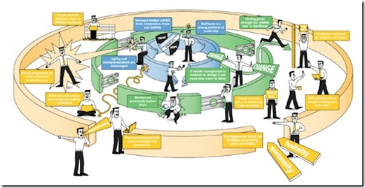
Figure: Work Organisation
Source: Dynamic Work (2015)

Develop understanding
Developing the understanding among group member was very important for doing the work properly. If the understanding among group member was not good then it was impossible to work efficiently. For developing understanding among us we follow some process (Newman and Nezlek, 2017). Those are:
- We gave enough chance to every group member to perform and the opportunity of present in every meeting and discussion.
- Before each meeting I as a group leader gave a brief to the group member of what we want to accomplish at the end of each meeting.
- A member of our group writes down all the discussion we had and also record it.
- Every one of our group had the right to speak in the meeting and tell what he thinks about it.

What went well?
In the time of doing something there will be some matter which will be goes well and some matter which will not go well. This was also happened to us. There was some matter that goes well for us. At first to do this task to do this task we have to understand what is business? Any legal activity for the purpose of earning profit is known as business. This part is easily understood by us as this part was discussed by our teacher in class well. The group formation is also an easy part for us as the teacher selects the member of the group (Owens et al, 2010). We had to do nothing about these two matters. Idea generation was also an easy part for us. We came up with various idea but all of us agreed to a specific idea on which we decided to develop the project.

What not so well?
I said it earlier that while doing something everything will not go as plan. We were working in a group so it is obvious that everyone is not same. There will be some issue like:
Floundering: For doing this presentation we first need to decide how to do the work and what were the roles of each team member. When we were deciding these, we take much time that was why our work was delayed a little bit and we compelled to postpone some of our work.
Dominating: A member of our group tried to dominate another member of our group. He tried to impose his idea above all other group member idea. This caused a hindrance in our work (Norman and Nezlek, 2017).
Getting stuck: At some point we were get stuck because of the reason that some of our group member didn’t submit their respective work in time. That is why our progress was hindered a little bit.

My contribution
As a member and leader of the group I had to play the most important role in this project. I have to play the role as a member of the group and in the same time I also needed to play the role of team leader. As a team leader my first task was to getting all the team member at the same page. It means that deciding the sector on which we want to develop the plan. Everyone came up with their unique set of ideas. But we have to select one. That is why I as leader evaluate the pros and cons of all the ideas which were presented. After evaluating the ideas, I communicate with my fellow team mate and discuss about the idea which I chosen and also discuss the fact why this idea is best for us to develop a business plan. My team mates agreed with the findings of mine (Gudjonsson, 2016). Then I called several meetings to accomplish the task. Then I divided the task among the member of the group including me and also specified the time of the completion of the work. After dividing the task, I routinely communicate with team member to know the progress of their work and if there were any problem, I try to solve them and where I can’t I take the help of other member to solve the problem. All of our group members except one submit their work. Without that we can’t complete the task. That was we have to find out why he was not able to finish the assigned task in time. We found out that his mother was sick and it was the reason he was not able to finish the work in time. So, to finish the task all of our group member helps him. After finishing the work, I assigned a member of our group to find out whether all the task is in order or not. He reports that all the task is in order and then we gather all those tasks together and finish the task of developing a business plan. In this I work as a member, leader, co-ordinator, monitor, advisor etc. of group (Bialek and Sawicki, 2018). While doing this I have developed many personal skills regarding this business plan. Some of this skill are:

Personal Skill
Financial management skill: Form starting to end a business needs finance. Without finance no work related to business can be accomplished. That is why while doing this project I as team leader develop a financial plan including form where to collect money and where to expend. This improves my financial management skill.
Marketing and customer service skill: While doing business knowledge about marketing and customer service is very important to become successful. That was why I have to do plan of marketing of the business and had to develop a plan of how satisfy the customer and these develop my customer service and marketing skill (Du and Xu, 2012).
Communication: Communication is one of most important factors to achieve success. I had to communicate with my team member about various matter like what was the progress of their work, what I decided and why etc. when I have done this type of work I learned how to communicate with other effectively and sharpen this skill.
Leadership: Leadership is the ability of leading a group of people for the purpose of achieving success. As I was the leader of the group I had to lead them to do the plan. Form this I learned how to lead people properly.
Time management and delegation: Managing time is one of the key elements of success. At first, I delegate the task to the team member according to their skill and specified the time of the completion of the task (Du and Xu, 2012).

Problem solving: While working in a group there will arose many problems. As I was the leader of the group it was my responsibility to solve those problem. Where I alone can’t solve problem, I take the help of my other team member help and this help me to develop my problem-solving skill.
Networking: Building relationship among the member of the team is very important. Not all the member of the group had the same mentality. That was why I give them some time to put aside their differences including me so that all of us can come to same page.
Monitor and control: As the leader of the group I have monitor the progress of the work and if there were any problems then I had to take control measure to solve the problem (Omar and Mehdi, 2014).
These are the personal skill which I have developed form working in the group. Apart from personal skill development I have also developed some team work skill.

Team work skill
Project management skill: This skill is very important for managing a project successfully. This skill includes scheduling, estimation, task management and basic analysis.
Problem solving: Problem solving is one of the most important team work skill. When working in a team there arose many problems regarding the team. And we all had to face those problem.
Conflict resolution: When people work together it is natural that there will be some conflict. That is why every member of the team need have the mentality and skill to solve the conflict (Hede, 2010).
Transformative conversation: People of the team do not have the same expertise. Transformative conversation helps to cover those gaps and improve the skill.
Documentation: The idea what we had come with, how we select the best one, how do we accomplish the project all of this is documented. This will help the member of the team to improve their documentation skill.
Risk management: By completing this business plan our team member know how to management risk effectively as risk can’t be avoided while doing business (Payo, 2015).
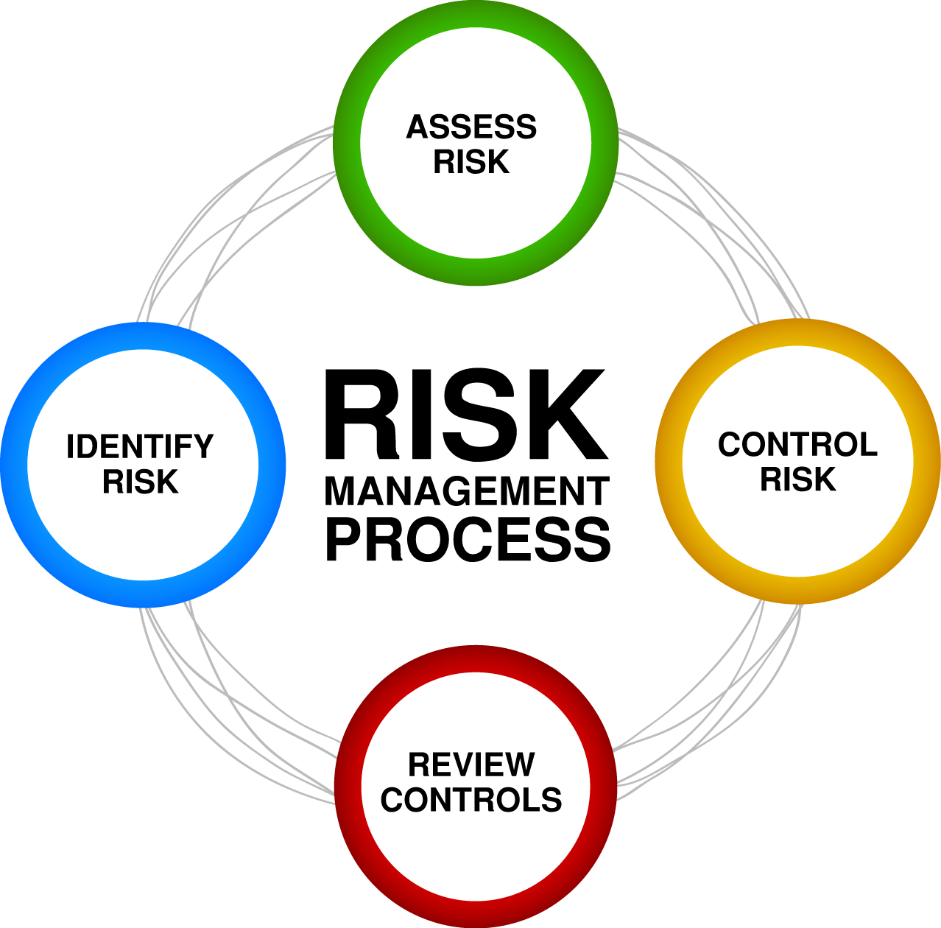
Figure: Risk Management
Source: PIRLO (2015)

Customer management: Customer is the king of the market. This project helped the member of our team to manage the customer properly so that the customer is satisfied and improve this skill.

Other members’ contribution
Every member of our group is important. If one of the members of the group refuse or didn’t do his part properly then it will be difficult for us to complete the work. Every member of our group contributed their part. At first, we assigned specific task to each member with a time limit. Every member of our group apart from one did their task within due time.

Conclusion
I think that this project on developing business plan help me develop a set of personal skill by working in a group. Without working in a team as the leader of the team it may not be possible for to acquire those skills. By working in group, I have I developed skill like financial management, communication, leadership, customer management, time management and delegation, problem solving, monitor and control skills? All of this skill I have developed by working in group about developing a business plan.

Reference
Białek, M. and Sawicki, P. (2018). Cognitive Reflection Effects on Time Discounting. Journal of Individual Differences, 39(2), pp.99-106.
Du, Y. and Xu, X. (2012). Application Research of Personal Learning Curve in Staff Skill Testing. Advanced Materials Research, 433-440, pp.3200-3205.
Gudjonsson, G. (2016). Hans Eysenck's theory on the ‘causes’ and ‘cures’ of criminality: A personal reflection. Personality and Individual Differences, 103, pp.105-112.
Hede, K. (2010). Making Team Science Work: Advice from a Team. Science.
Murniati, N., Handayani, A. and Mahmudah, M. (2018). Peningkatan Bodily Kinesthetic dan Intra Personal Skill melalui Pendekatan Saintifik pada Pembelajaran IPA. JP3 (Jurnal Pendidikan dan Profesi Pendidik), 3(1).
Newman, D. and Nezlek, J. (2017). Private self-consciousness in daily life: Relationships between rumination and reflection and well-being and meaning in daily life. Personality and Individual Differences.
Omar, S. and Mehdi, M. (2014). DEPARTMENTAL EXERCISE BASED ON MICROTEACHING AND ITS UTILITY IN PERSONAL TEACHING SKILL DEVELOPMENT OF TRAINEE TEACHERS. Journal of Evidence Based Medicine and Healthcare, 1(2), pp.65-68.
Owens, T., Allen, M. and Spangler, D. (2010). An fMRI study of self-reflection about body image: Sex differences. Personality and Individual Differences, 48(7), pp.849-854.
Payo, S. (2015). What does skill mix mean to your practice? BDJ Team, 1(1).
Silvia, P. and Phillips, A. (2011). Evaluating self-reflection and insight as self-conscious traits. Personality and Individual Differences, 50(2), pp.234-237.
Verstraeten, K., Vasey, M., Raes, F. and Bijttebier, P. (2010). Brooding and reflection as components of rumination in late childhood. Personality and Individual Differences, 48(4), pp.367-372.
Woerkom, M. (2013). Critical reflection at work. [The Netherlands]: Twente University Press.

