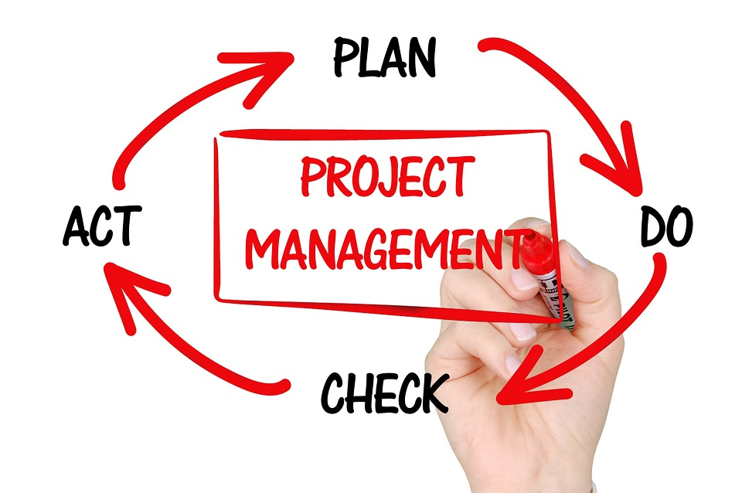
Business Management
Project Management
LCBB 5005
Assessment 2

Student name: Anca Mirela Dula  Student ID: 2112863 | Date: 05/04/2023 | Lecturer name: Anupam Mazumdar

Contents
Introduction 2
Brief of Project 2
Report on Evaluation 2
Management of Project Integration 3
Manage the scope of project 3
Time management for project 3
Cost Management for Project 4
Quality Control for Project 4
Resource Management for Project 4
Communication Management for Project 4
Risk Management for Project 5
Management of Project Procurement 5
Monitoring Project Stakeholders 5
Conclusion 5
References 7

Introduction

Effective and efficient management of an organization's or a project's resources is what we mean when we talk about management. This accomplishes the aims of the project. As part of the management process, it is also important to assess how well the project's progress has been coordinated with the overarching strategy laid out for it. The following research describes as an estimate report on the Hinkley Point C project and will consequently give an evaluation of the project's chronological events. This paper details the project's delays, the development process, and the successes that resulted from those problems. This assessment will employ the 10 most crucial elements of the project management knowledge areas. Following an analysis of the project's successes, the report will go over the various takeaways. These insights will form the cornerstone of subsequent endeavours. Thus, future projects of a similar scale and complexity will benefit from this effort's lessons learned. This, in turn, will guarantee the excellence of future initiatives and the effective use of available resources.

Brief of Project

Hinkley Point C, one of the most expensive nuclear power facilities in the world, is the subject of this project's debate. The plant in Somerset, United Kingdom, was constructed with the intention of providing electricity to every single house in the nation while simultaneously generating negligible amounts of carbon dioxide. The dual HPC EPR, which was first announced in 2010, has the potential to generate 3,260MW of zero carbon power over a 60-year period. Preliminary estimates suggested that 25.000 employees would be needed to complete the project. Over the course of the project's 60-year lifespan, it is expected that carbon emissions will be reduced by more than 9 million tonnes per year, or more than 600 million tonnes in total. In 2012, the entire cost of the project was expected to be about £16 billion. The new estimate is more than £25–£26 billion. However, current findings suggest that the total cost of the project will exceed £ 32.7 billion, mainly because of schedule overruns. The outcome is a 30% increase in the project's overall cost. The lengthy approval and licencing processes for such a massive undertaking caused the setbacks. The COVID–19 pandemic and later advances in earth science also contributed to the delay. This includes the present war raging in Eastern European countries like Russia and Ukraine. Consequently, the project is still aiming for a June 2027 launch, while a 15-month delay buffer is being considered in case of any setbacks. The United Kingdom government could not have completed this undertaking on its alone, therefore they have sought the help of other interested parties. China General Nuclear Power Group, a Chinese energy firm, and Electricity de France (EDF), a French utility backed by the French government, are two of these parties.

Report on Evaluation
An evaluation of the Hinkley Point C project has been provided below, and it is based on the 10 most important knowledge areas related to project management.

Management of Project Integration

The management of project integration is an important area of study since it is the one that evaluates the whole process of how the various parts of the project were brought together. This might include both material resources and people who will play a vital role in the process of developing the entire project. 2010 was the year when the government gave its first permission for the idea of the project. However, the entirety of the project was put on hold for a period of seven years since to obtain the necessary permits and approvals, the process took much longer than was originally anticipated. The licence for the project was finally acquired in the year 2012. Despite this, the plant's developers are positive that it will begin operations in 2027 at the latest. However, recent environmental developments caused problems with resource integration for the project because resources had to be redirected to other initiatives because of occurrences such as the COVID 19 epidemic and the ongoing conflict in Eastern Europe. These occurrences caused problems with resource integration.

Manage the scope of project

The management of the project's scope and the use of any available resources are what guarantee that a project's objectives will be met within the allocated amount of time. The project has been plagued by several difficulties due to the many delays caused by the company's timelines. The completion of the project's sea wall was originally scheduled for March 2018; however, it was pushed back to December 2018. The digging of the cooling water tunnel was another significant step that ran well beyond schedule. According to the most recent information that was supplied by the governments, this was initially anticipated to be finished in the month of September in 2019. The appearance of previously unanticipated conditions, such as a pandemic on a worldwide scale, is a potential source of all these delays. The price for the project has also increased substantially over time; when it was first anticipated, the budget was 16 billion dollars, but it has now increased to more over 32.7 billion dollars, the original budget planning did not consider the full scope of the project or the amount of space that it would want. Because of this, the process of developing the project has been delayed, which has produced both financial and time-related issues.

Time management for project

When it comes to managing time for projects, the starting date of the project and the many milestones that it must reach are two of the most important factors to consider. Both a licence and approval to go forward with the Hinkley Point C project were granted in the years 2012 and 2017, respectively. The early estimations indicate that the whole plant will be operational by the month of June in the year 2027. The schedule for the plant has not been changed, and the project has moved forward according to plan despite the many challenges that have been encountered, such as delays and financial issues. Many of the developing parts, such as the installation of sea water cooling pipes and the construction of the nuclear island common raft, were completed within the allocated amounts of time for them.

Cost Management for Project

Examining the way, the project has managed the budget that was allotted to it and determining whether there are any discrepancies that have been found in the project are the two aspects that make up the project cost management parameter. As was indicated before, the preliminary budget for the project was anticipated to be somewhere around £ 16 billion. However, this was later changed to $ 18 billion in 2015, and then again in July 2017 when the project was inaugurated; at that time, the expenditures were projected to be between £ 19.6 and £ 20.3 billion. In the past, the total cost of the project was estimated to be anywhere between £25 and £26 billion. After the epidemic, this number was revised upwards to more than £32.7 billion. The initial budget of the project, which was 16 billion pounds, has more than quadrupled over the course of its duration, reaching more than 32.7 billion pounds. Because of this, it is feasible to draw the conclusion that the original budget was not established in line with the estimates of the amount that would be required for a project of this kind that is both reasonable and essential. Furthermore, it may be argued that the original budget did not take into consideration all the possible environmental changes and contingencies that could arise during the project.

Quality Control for Project

Project quality management evaluates all outputs and procedures to ensure they fulfil the standards established by the project's various constituents. This may be checked using the quality assurance procedures. The French energy company EDF and the Chinese nuclear power company China General Nuclear Power Group are both strong contributors to the project. These parties' financial and intellectual contributions are essential to the success of a project of this scale. One of the plant's deliverables is a reduction in carbon emissions of more than 9 million tonnes in its first year of operation and more than 60 million tonnes during the plant's lifetime. Additionally, the facility will provide 7 percent of the nation's energy needs. More than 80% reductions in carbon emissions are projected by 2050. The European Commission must also approve the proposal to use nuclear energy in industrial processes. The national audit agency will also assess the project's overall quality.

Resource Management for Project

This examination of project management skills includes the control of all project resources. Project expenditures are expected to exceed £ 32.7 billion. It is estimated that 25,000 people will be needed for the project, and that all the necessary supplies will also be on hand. If the project is to be completed on schedule and with the anticipated outcomes, then all these resources must be handled efficiently and effectively.

Communication Management for Project

When a project is being managed, its communications component checks to see whether everyone involved is keeping everyone else in the loop about the project's progress. Since the main players in this endeavour are the government of the United Kingdom, EDF energy, the government of France, China General Nuclear Power Group, and the citizens of the host country. They must all be kept up to date on the development of the project. The local community is the most sceptical stakeholder since the increased disposal of nuclear waste in residential areas is one of the primary concerns that has had to be addressed to earn their confidence and support for this project.

Risk Management for Project

The term "risk" is used to describe any potential negative outcomes that might arise during a project's execution. The COVID 19 epidemic added to the risks of the work being done. Because to the continued lockdowns, the project's completion time has been extended and the budget has climbed by more than 30 percent compared to figures seen before the outbreak. The original completion date of June 2027 is still on track, notwithstanding the setback.

Management of Project Procurement

The following figure represents the cost of purchasing materials and labour required to complete the project in full. Funding for the project came from the following sources. The company UK, which contributed the bulk of the project's funds and resources, was able to get the requisite skill set and financing thanks to its collaboration with French and Chinese businesses. The combined effect of these collaborations proved fruitful, and the project was completed on time. The first holdup was caused by problems in acquiring necessary licences due to red tape.

Monitoring Project Stakeholders

Understanding who the project's stakeholders are and how satisfied they are with the project's outcome is a crucial part of determining the project's success. Not only did the project's stakeholders alleviate the concerns of the locals, but they also reached or exceeded all the agreed-upon performance indicators. Despite financial constraints, the project successfully accommodated the wide range of requirements presented by its constituents.

Conclusion
The project had run into several obstacles, such as an increase in cost, a delay in the schedule, and criticism from the local community. Despite the unknowns, the project has produced high-quality deliverables and is on track to be completed in time to aid the country in cutting carbon emissions from energy production. The following advice may be used to improve the quality of similar initiatives in the future. This might be a sign of more flexible spending and an ability to go forward with the necessary permits and licences. In addition, the leadership may have a contingency plan ready in case anything unforeseen happens that threatens to ruin the project. Effective communication between the various parties and the resolution of public issues are other important considerations that should be given early attention. Future projects may be more likely to meet their deadlines and make optimal use of available resources because of all the considerations.
Previous research using Hinkley Point C as an example concluded with a review of the project's development through time and an evaluation of its success. The report provides a high-level summary of the project's development from its inception to the present, including an analysis of the project's evolving budget and schedule. The project's success or failure may be gauged in part by comparing the results against the 10 core competencies of project management. In the last section of the study, the lessons learned and recommendations for future initiatives of a similar scale and scope are summarised and discussed. The following recommendations are applicable to future endeavours that share features with current one.
• The many worries of the locals concerning the project's usage of dangerous materials have been taken into consideration as well. This will make sure that everyone involved has access to enough information to eliminate any potential worries.
• Managers must ensure that all possible and expected delays are considered when designing a project, since they may have a significant impact on the quality of the final product.
Deliverables of the highest quality should be at the forefront of every project planning and execution. Because their input is vital to the project's success or failure.
• Good communication among various stakeholders and addressing their concerns are also crucial early in the project's development.

References

Blackridge (2022(. Hinkley Point C Nuclear Power Station Set To Become UK's Largest Nuclear Power Project. [Online]
Available at: https://www.blackridgeresearch.com/project-profiles/hinkley-point-c-nuclear-power-station-the-largest-nuclear-project-in-united-kingdom
[Accessed 02 05 2023].
EDF (ND). Working together to deliver Hinkley Point C. [Online]
Available at: https://www.edfenergy.com/energy/nuclear-new-build-projects/hinkley-point-c/for-suppliers-and-local-businesses
[Accessed 02 05 2023].
Mcintyre, F. (2018). Hinkley Point C quality management needs improvement, says nuclear regulator. [Online]
Available at: https://www.newcivilengineer.com/archive/hinkley-point-c-quality-management-needs-improvement-says-nuclear-regulator-16-03-2018/
[Accessed 02 05 2023].
ND (ND). Developing our workforce. [Online]
Available at: https://www.edfenergy.com/energy/nuclear-new-build-projects/hinkley-point-c/local-community/developing-our-workforce
[Accessed 02 05 2023].
News, W. N. (2022). EDF revises Hinkley Point C schedule and costs. [Online]
Available at: https://www.world-nuclear-news.org/Articles/EDF-revises-Hinkley-Point-C-schedule-and-costs
[Accessed 03 05 2023].
Paul, J. (2022). UK's nuclear dreams face obstacle as Hinkley Point C plant at risk of 11-year delay. [Online]
Available at: https://www.express.co.uk/news/science/1703400/uk-nuclear-hinkley-point-c-delay-edf-contract
[Accessed 04 05 2023].
Resources, E. &. (2021). Project Controls for Hinkley Point C Engineering. [Online]
Available at: https://www.migso-pcubed.com/case-studies/project-controls-for-hinkley-point-c-engineering/
[Accessed 05 05 2023].
Watt, H. (2017). Hinkley Point: the ‘dreadful deal’ behind the world’s most expensive power plant. [Online]
Available at: https://www.theguardian.com/news/2017/dec/21/hinkley-point-c-dreadful-deal-behind-worlds-most-expensive-power-plant
[Accessed 05 05 2023].
Zhong, A. and Dockweiler, D. (2020), October. Learning Cycle-based Project Management and its Application. In SPE Annual Technical Conference and Exhibition. OnePetro

