UNIVERSITY OF WALES:  TRINITY SAINT DAVID |  |  | PRIFYSGOL CYMRU:  Y DRINDOD DEWI SANT
LOCATION: LAMPETER |  | LLEOLIAD: LLAMBED
LEVEL 6 |  | LEFEL 6
EXAMINATION PERIOD |  | CYFNOD ARHOLIADAU
January 2015 |  | Ionawr 2015

CLAH6007
West meets East:
At the Borders of the Oikoumene and Beyond

TIME: 2 HOURS
answer THREE OUT OF SIX QUESTIONS IN section A

answer ONE out of FOUR QUESTIONs in section B

Candidates should ensure that they avoid repetition of material in their answers to different sections, and between their answers and their coursework essays.

SECTION A (50 MARKS)

ANSWER THREE OUT OF SIX QUESTIONS IN SECTION A

Analyse the context and content of three of the following six passages/artefacts:

1. “Other Indians dwell near the town of Caspatyrus and the Pactyic country, north of the rest of India; these live like the Bactrians; they are of all Indians the most warlike, and it is they who are sent for the gold; for in these parts all is desolate because of the sand. In this sandy desert are ants, not as big as dogs but bigger than foxes; the Persian king has some of these, which have been caught there. These ants live underground, digging out the sand in the same way as the ants in Greece, to which they are very similar in shape, and the sand which they carry from the holes is full of gold. It is for this sand that the Indians set forth into the desert. They harness three camels apiece, males on either side sharing the drawing, and a female in the middle: the man himself rides on the female, that when harnessed has been taken away from as young an offspring as may be. Their camels are as swift as horses, and much better able to bear burdens besides... Thus and with teams so harnessed the Indians ride after the gold, being careful to be engaged in taking it when the heat is greatest; for the ants are then out of sight underground... So when the Indians come to the place with their sacks, they fill these with the sand and drive back as fast as possible; for the ants at once scent them out, the Persians say, and give chase. They say nothing is equal to them for speed, so that unless the Indians have a head-start while the ants were gathering, not one of them would get away.” – Herodotus 3.102-105 (trans. from A. D. Godley 1920).

2. “Now it so happened, the story continues, that a certain Indian was brought to the king by the coast-guards of the recess of the Arabian Gulf, who said that they had found him half-dead and alone on a stranded ship, but that they did not know who he was or where he came from, since they did not understand his language; and the king gave the Indian into the charge of men who would teach him Greek; and when the Indian had learned Greek, he related that on his voyage from India he by a strange mischance mistook his course and reached Egypt in safety, but only after having lost all his companions by starvation; and when his story was doubted, he promised to act as guide on the trip to India for the men who had been previously selected by the King; and of this party Eudoxus, also, became a member.” – Strabo Geography 2.3.4. (Trans. from H. L. Jones 1917).

3. ‘And it will not be amiss to set out the whole of the voyage from Egypt, now that reliable knowledge of it is for the first time accessible. It is an important subject, in view of the fact that in no year does India absorb less than fifty million sesterces of our empire’s wealth, sending back merchandise to be sold with us at a hundred times its prime cost.’ Pliny Natural History 6.26.101 (trans. from Rackham 1942).

[AND]

‘But the title ‘happy’ belongs still more to the Arabian Sea, for from it come the pearls which that country sends us. And at the lowest reckoning, India, China, and the Arabian peninsula take from our empire 100 million sesterces every year - this is the sum which our luxuries and our women cost us.’ – Pliny Natural History 12.41.84 (trans. from Rackham 1945).

4.
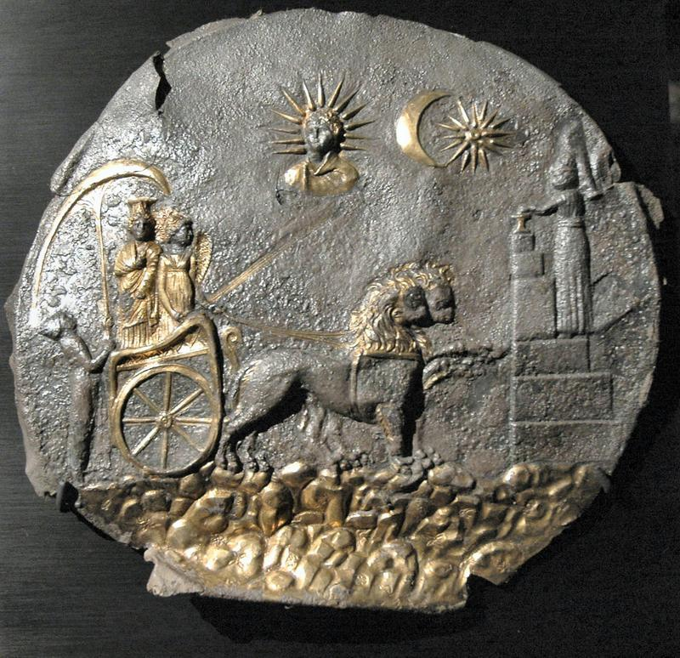

5.
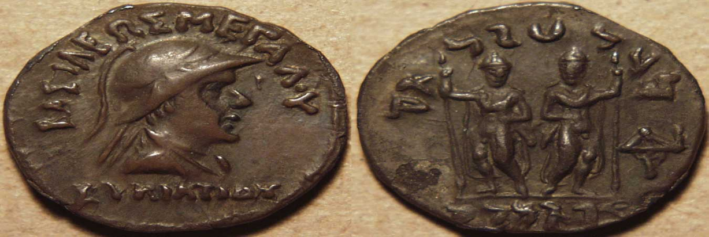
Helmeted and diademed bust of king facing right, bead and reel border around, the helmet plumed and decorated with the ear and horn of a bull, Greek legend: BAΣIΛEΩΣ MEΓAΛOY EYKPATIΔOY (of Great King Eucratides) Dioscuri standing facing, nude, holding spears and palms Kharoshthi legend: rajasa mahatakasa / evukratidasa (of Great King Eucratides).

6.
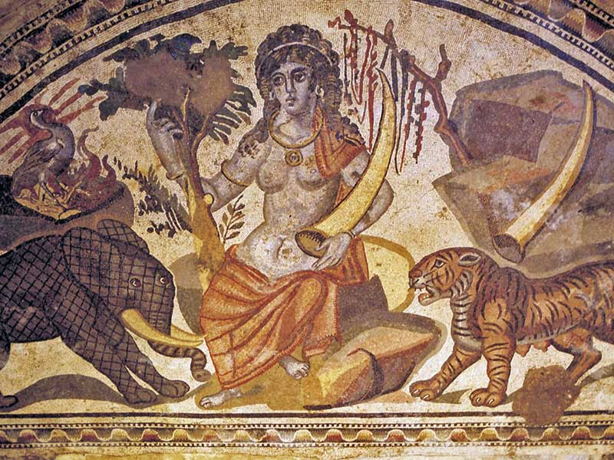
SECTION B (50 MARKS)

answer ONE out of FOUR QUESTIONs in section B

Write an essay on one of the following titles. You must ensure that you do not choose questions which will involve your repeating a significant amount of material from any of your answers in Section A.

1. To what extent can we discern a legacy of the Greek cultural influence in central Asia and the northwest Indian subcontinent (c.100 BC-AD 400)? [discuss in depth at least two examples]

2. How much credibility can be placed in the theory that Augustus’ annexation of Egypt ushered in a new phase in the Indian Ocean trade?

3. Critically analyse Sidebotham’s position that for many of the elites in Roman society aromatics and spices were seen as “necessities” not “luxuries”.

4. Discuss the factors which may have led to an increase in conflict between the indigenous populations of the Eastern Desert of Egypt and the Roman military.

