Delta Hotels by Marriott Swansea: Analysis

Executive Summary
This report considered the analysis of the company Delta Hotels by Marriott Swansea. The internal capabilities and resources of the company were considered for the research, along with the feedback that has been obtained from the customers of the company from various sources. It was found that the company has been afflicted by issues regarding inefficient housekeeping, inadequate infrastructure, high pricing issues, and an ineffective accessibility system for the people with disabilities. The motivation of the employees has been low and they have not been able to complete their tasks effectively, and it is important to find the ability of the organisation to motivate and lead the employees so that they are able to complete their tasks with efficiency. This can help the company in being able to manage the tasks and resources so that the company would be able to optimise the performance while actively using the strategies of the organisation. The organisation would need to be able to use the strategies so that the objectives can be reached for the company. The company would also need to use teamwork and organisational citizenship behaviour, which can help the company in being able to retain more of the staff members. The company needs to retain the employees in order to improve its performance. The company would need to improve the housekeeping services so that the customer satisfaction score, net promoter score, and the employee performance feedback can be improved for the organisation.
Table of Contents
Introduction 4
Scope and Analysis 4
Main Body 10
Issues identified from the analysis 10
Findings 14
Action Plan 18
Recommendations 20
Conclusion 21
References 22

Introduction
This report is going to be a consulting report regarding the problems faced by Delta Hotels Swansea by Marriot which is one of the most recognised as well as top-notch hospitality organisations in Wales, UK. The report is going to demonstrate the opportunities that are present for the organisation to resolve issues faced by them. Thus this report will be helpful to recognise the way through which the organisation will be able to resolve issues and gain a competitive advantage in future. The major issue faced by Delta hotels Swansea is the problems related to the employees as the company does not involve proper training programs for their employees and they did not provide support to their employees which increases dissatisfaction among them. The lack of support from the management created issues for the company as it causes a turnover of the employees (Kurniawaty, Ramly and Ramlawati 2019). The working condition is really very poor within the company. Flexibility at the workplace and support from the management is very important for any organisation to increase the willingness of the employees to stay within the organisation. The management needs to make their employees valuable to retain them but there is a lack of management which increase issues for the company (Yao, Qiu and Wei 2019). There are also infrastructure-related issues due to which the company faced bad feedback from their customers. The hotel businesses need to manage their infrastructure to increase the willingness of the people to visit the organisation again. Thus these issues need to be addressed by the company majorly. To analyse the issues the research is going to use PESTLE and SWOT matrix which will help to recognise the current issues faced by the company. The reason behind using SWOT analysis is that it helps to analyse the internal environment of a business and PESTLE analysis will be helpful to represent the external environment (Christodoulou and Cullinane 2019). Thus the SWOT and PESTLE analysis is the fundamental tool to analyse issues faced by the company currently.

Scope and Analysis
The selected hotel for this report is Delta Hotels by Marriott Swansea. It is established in Swansea, Wales in the United Kingdom. Delta Hotels Swansea is one of the most stylish hotels in the city centre of the UK. The hotel is family-friendly, that has offered efficient spacious accommodations, and efficient customer service that has helped the organisation to gain a competitive advantage in the market of UK. The spacious accommodation has included plush bedding with large windows, flat-screen TV, free Wi-Fi and ample workstations. The selection of the location of the hotel is the main reason for the increasing profitability of the company as, it is near the Swansea Train Stations and the most compelling attraction of Wales is the M4 motorway, University of Swansea, Liberty Stadium and Swansea Beach. The hotel offers traditional British cuisine, a delicious Cast Iron Bar and Grills with waterfront views. The hotel has lush gardens that can manage 250 numbers of guests. The sophisticated Gower suite also is an ideal space for arranging celebrations. There are three categories of rooms offered by Delta Hotels by Marriott Swansea, such as Deluxe room, double and Deluxe King. The waterfront family hotel rooms are the core competitive advantage of the company (Marriott 2023). For weddings and occasions, Delta hotels have a total of five rooms, with around 330 sqm, which has the largest capacity space. The categories of the suits have included, the oyster suite, tellin suite, Caswell suite, Langland suite, port eynon and Gower suite. The suites has consisted of a theatre, conference room with U-Shape, reception, banquet hall, school room etc (Marriott 2023a).
The current negative customer review on the customer service offered by Delta Hotels Marriott Swansea has revealed that the décor or infrastructure of the hotel is too much outdated that should be refurbished to get customer satisfaction. However, the behaviour of the hotel staff has been able to gain customer trust. The value-added service provided by the company is too weak for attracting modern consumers. For an instance, according to a customer review, the view from the room was very beautiful, but the bed was not good as it was too bad, the carpets, walls, and kettles were so outdated and the accessories also were very basic opt worth for the money they have claimed against the customer service.
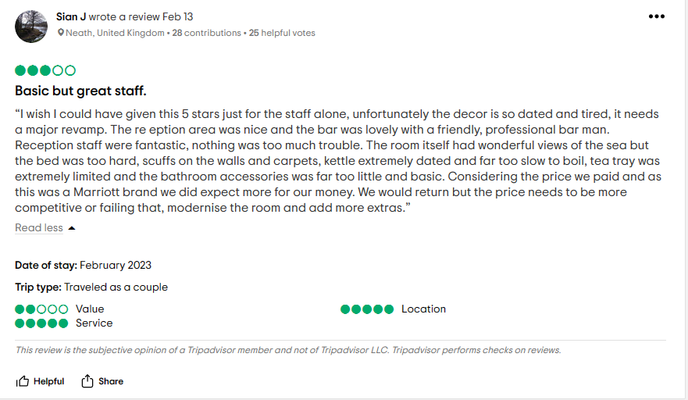
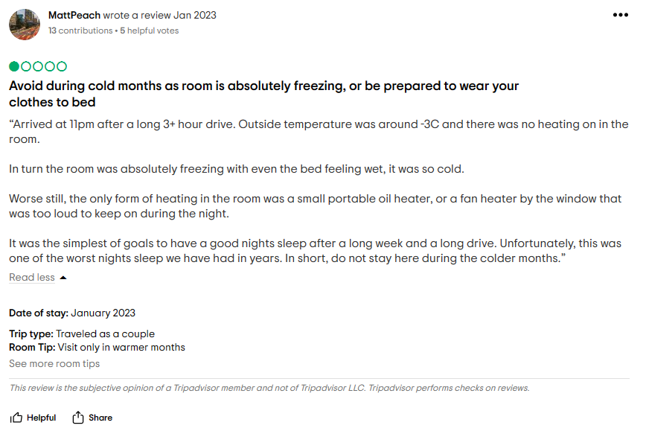
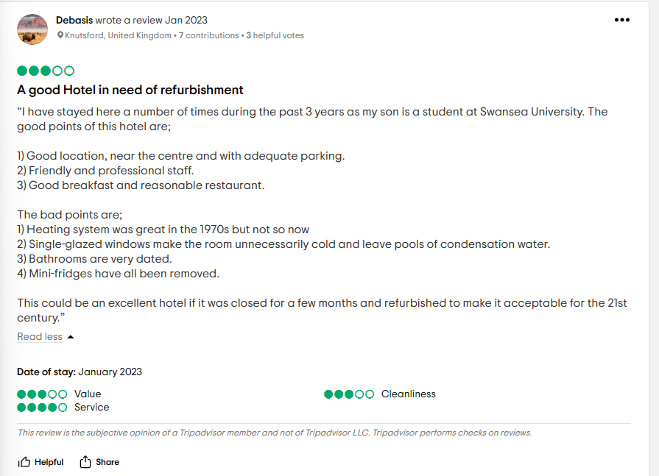
Figure: Customer Review
Source: (https://www.tripadvisor.com/Hotel_Review-g186466-d192327-Reviews-Delta_Hotels_Swansea-Swansea_Swansea_County_South_Wales_Wales.html)

Another customer review also stated that Delta Hotels has infrastructure issues, as the customer has claimed that, the room heating service during the winter was so bad that, the customer had to wear winter clothes during sleeping in bed.
Similar feedback has been given by another customer, as, according to the customer experience, the hotel was good and has professional and friendly staff. But, the bad points included, an ineffective heating system as the system is too old, single-glazed windows are one of the major causes of unnecessary cold in the rooms, the bathrooms also are very old modelled and there were no mini-fridges.
However, the organisational management has targeted to provide the customers with efficient service to establish a direct relationship with the customers. Despite of inefficient infrastructure of the hotels, the customers have stated that the behaviour of the staff was very efficient and friendly.
PESTEL Analysis
Factors | Impacts on organisation
Political | The political stability of the UK has ensured the growth of the organisation, by supporting the business development process. The modern parliamentary democracy and legislative approaches by the government of the UK have extended the opportunities for business extensions (Amankwah et al., 2021). The UK is known as one of the most powerful countries in the world, which has motivated international investors for investing in business in the UK. However, Brexit has caused uncertainty in the business due to political conflicts. A good relationship with other powerful countries like the US has motivated business investors.
Economic | The country has been placed as the sixth-largest economy with nominal GDP growth. It has created opportunities for the company for gaining profitability. The GDP growth of the country has been impacted by the Brexit and global pandemic. The GDP of the country has reached around 2.2 trillion British pounds within the year 2021, but, it has increased by around 152.3 billion to previous years (Statista 2023a).
Social | The multicultural community of the UK has increased the potentiality of the consumer market for any business. According to Statista (2023b), in the year 2021, the population of the UK has increased by around 67 million, which has become doubled from the year 1871 so, it will help Delta Hotels to increase the customer rate.
Technological | It has been analysed that, the UK is the most technologically advanced country as the government of the country has increased the investment in the technological development of the country that would support the digital transformation of the company from the hotel sector to change the infrastructure of the company effectively.
Environmental | According to Statista (2023c), the statistics have represented that, the rate of carbon emission by the food service and accommodation industry of the UK from the year 2006 to 2019 has increased. The increasing interest by the government and public in the UK has influenced businesses from the hospitality industry to use sustainability strategies for reducing carbon emissions from their supply chain management.
Legal | The legal system of the UK has focused to follow the regulations related to labour rights protection and civil liberties (Salhi et al., 2020) so, the organisation should incorporate human resource management policies according to the laws.

SWOT analysis
Strengths
- Strong brand image
- Efficient employee behaviour
- Selection of the location
- Customer-centric marketing strategies
Weaknesses
- Poor outdated infrastructure
- Poor training and development programs
- Ineffective operational management
Opportunities
- The company has to focus on effective training and development programs to support the employees to enhance the quality and performance of customer service
- The company should enhance the infrastructure for gaining customer loyalty
Threats
- Increasing market competition can impact the profitability of the company.
- Digital diversification could impact the financial performance of the company

Main Body

Issues identified from the analysis
The analysis of the customers' reviews reflects that the company has the strength of good staff. The behaviour of the staff is very nice and thus helped the company to serve their customers in a better way. One of the reviews of the customers about one of the staff members reflects the activeness of the employee and dedication towards the job. The dedication of the employees towards the organisation is important to meet the entire goals of the company (Chanana 2021). The good behaviour of the employee helped the company to provide the best service to the customers thus able to satisfy their needs and make them happy. But despite having good staff, the company faced issues due to the high prices and bad infrastructure as one of the employees reviewed that the room service and infrastructure of the company are not good (Tripadvisor 2022). It means the housekeeping department needs to be improved more. The major problem seen in the case of the organisation is majorly based on the internal environment. The guest stated that the room service is the worst at the organisation and they have to wait for a lot of time to get their food thus they got disappointed. Customer disappointment is not good for the reputation of the company (Xu 2019). The customers also complained about the slow services at the hotel compared to the other similar hotels and according to them, the services are not good enough compared to the price they charged. The infrastructure at the organisation needs to be proper to satisfy customers’ needs (Nunkoo et al. 2020). But one of the customers reviewed that the rooms are small and the fridge is not there to keep cold drinks which is usually seen at the Marriott hotels. They also complained about the Wi-Fi service of the company which is really expensive and they could not get the service due to not signing up for the loyalty program. They also complain about the TV and other services of the hotel which may impact the reputation of the company hugely. But they praised the staff members at the hotel and the location of the hotel. Thus the infrastructural issues need to be resolved by the company as early as possible to stop reputation damage further. The majority of the customers are complaint regarding the infrastructure in the hotel as one of the customers also reflected that the hotel was scaffolding when they arrived which made all the rooms dark. They cannot even open the window due to the scaffoldings and there was no AC at the hotel which made the room suffocating for them. They also complained about the infrastructure in the bathroom as these are cracked and there was no support provided to the customers when they asked for a walk-in shower for one of their disabled friends (Tripadvisor 2018). One of the customers stated that the hotel is tired as well as dated and required modernization though they praised the staff of the hotel. Thus it can be stated that the majority of the issues faced by the company in their customer service are due to having poor infrastructure.
The company needs to improve their infrastructure which will increase the satisfaction level of the customers. Thus to improve infrastructure and provide great services to the customers the company should provide training to their staff and make this a daily priority and not just a one-time event. They also need to create a checklist and encourage a performance management system through which they can get updates regarding what modification needs to be done in the organisation (Mone and London 2022). The feedback from the customers should be encouraged by the company and take further steps to resolve issues faced by them (Newman and Ford 2021). They can personalise the service provided to the customers to feel valuable. The performance support technologies can be used by the company to provide personalised service to the customers to the highest degree. They can use information technology through which knowledge, as well as information, can be accessed easily and thus the staff will be able to engage with the customers on their personal level and resolve issues faced by them. They need to invest more in improving facilities and infrastructure so that the customers can be happy and satisfied in future.
From the analysis, it has been found that the company face issues due to ineffective employee management. Delta hotels are alleged to the hostile working conditions. The reviews from the employees revealed the awful working conditions. The reviews also shed light on the lack of organization, communication, leadership, respect and direction. Even though the department is not properly trained which caused challenges for the management to micromanage. The management blamed the employees for the unsuccessful attempts made by the management. Lack of motivation and appraisal have been found in this case which affected the overall employee management and human resource management. Therefore, poor employee management causes several challenges for managers to ensure employee engagement and retention (Patro, C.S. and Kumar, 2019). The effect of bad management is high employee turnover. Reportedly, 79% of the respondents opined that they quit their jobs due to poor management (Theodorou, 2020). Hence, the present issue in Delta Hotels influences employee turnover. Furthermore, employees feel deflated within the organization and have low morale. It becomes complex to manage a high level of energy when the employees receive constant criticism or negative remarks. It is often found that managers find it difficult to understand that the employees need an appraisal for their work and recognition for their efforts in order to fuel confidence and increase enjoyment at the workplace. The reviews of the employees indicated that even after making efforts, the employees feel deflated and require positivity to remain motivated (Ho, and Kuvaas, 2020). The decrease in employee morale not only affects productivity but also creates problems to improve work quality. Moreover, poor management can cause a turnover of employees. As a result of which companies need to hire an employee to fill the vacant position. This requires additional resources such as the cost of recruiting, interviews and training the new joiners. Hence, the budget of the hotels increases due to poor management. This implies the importance of employee engagement for Delta Hotels. Again, from past experiences, the employees get demotivated and lack enthusiasm. When the employee's hard work but did not receive rewards in return. Consequently, this creates a sense of lack of engagement and retract in the workplace. The team members also feel disengaged which suggests the issues in the management style of the businesses led to demotivated employees within the organization (Charles, Francis, and Zirra, 2021). Further, depending on the nature and environment of the workplace, performance reviews and behaviour, the employees may decide to take legal actions when they feel unfair treatment or lack of engagement efforts. Poor management often results in unsatisfied employees and can be a significant problem for the business that costs the reputation of the company. Undeniably, an ineffective work environment negatively impacts the physical and mental health of the employees. Research carried out by Walsh (2018) revealed that negative workplaces have a detrimental effect on the health of employees. Lack of confidence is another consequence of poor management at the workplace. Effective leadership enables a great workplace for employees. It helps the organization to ensure appreciation for each employee. If employees are constantly criticized or bullied, they are more likely to feel less productive and disengaging about the work. Therefore, it is important to review the management in order to ensure the creation of an effective environment with the imposition of favourable HR policies within the organization. Another important factor that can affect the overall reputation of the organization. With the company reviews available on the websites and travel agencies such as Glassdoor and Tripadvisor, it is easy to unravel the internal environment of the company. In this fast-paced employment market, employees are applying and interviewing for vacant roles and are checking the reputation and image of the company before making decisions. Hence, negative reviews on websites can have serious consequences when it comes to acquiring and retaining talent. There can be a lasting impact on the talent of the organization. Whereas, poor management also affects profitability (Tian et al. 2020). When the employees do not work to their full potential, they are not able to make sales and improve profits for the organization. Therefore, it is optimum to say that poor management can cause a decline in sales and business failure.
However, Delta Hotels need to focus on measures or strategy to cut the cord of poor management within the organization (Chanana, 2021). The company should concern about the effects of poor management on the organization. Therefore, the company needs to review the management to identify issues. Again, it should review the managerial positions to ensure the good fit of the individuals to the positions and the required training to lead teams, encourage them and lead to positive results (Knight, Patterson, and Dawson, 2019). It is also important for Delta Hotel to review the HR policies and culture of the firm because of ineffective management. In this case, the HR department of Delta Hotels needs to focus on employee satisfaction and equal treatment by providing effective training programs. The management team needs to consider the development of employee wellness programs, reward management and additional benefits like bonus and office treatment that is relevant to the business and employees (Decuypere, and Schaufeli, 2020). The benefits of HR policies can help the business to retain productive staff. Additionally, Delta Hotels need to remain organized and keep the employees updated about the changes in the organization (Lai et al. 2020). Monthly meetings, shared calendars and minutes can help in sharing important information with the employees. This in turn will boost the morale of the employees and will constantly motivate the employees. The transformation from a poor working environment to a good one is to develop trust with the employees. Trust helps in staying loyal to the company. Thereby, positive feedback can contribute to a positive environment.

Findings
Table 1: TOWS Analysis
 | Strengths | Weaknesses
Opportunities  Improved Performance Management  Motivation of Employees  Training and Development of Employees  Pricing Management  Expansion of Customer Base | Strong workforce  Good Location | Poor Infrastructure  Poor Housekeeping  Lack of Accessibility Features  Lack of Modernisation
 | S-O Strategies  The workforce could be trained and developed so that they become even stronger and thus show better performance as a part of the organisation.  Having a strong workforce can help with them being motivated towards proving themselves while competing within the organisation.  The location of the hotel helps it in demanding top prices for its services to preserve its premium image. | W-O Strategies  The incorporation of accessibility features into the organisation is important for ensuring that the company is able to improve the customer base.  The lack of modernisation can be mitigated by the training and development being used for upskilling the employees according to the current skill requirements.
Threats
Hostile Working Conditions
Lack of Employee Motivation
High Turnover of Employees
High Prices
 | S-T Strategies  The strong workforce can be motivated due to their skills being highly effective. | W-T Strategies  The hostile working conditions in the organisation can be improved through the infrastructure being made better within the organisation  The turnover of the employees can be reduced and more staff members retained with technologies being used for efficient modernization in the organisation.
(Source: Author-made)
Housekeeping: The housekeeping services provided by the company have been criticized due to the lack of timely delivery, which has caused there to be threats to the company due to the customer dissatisfaction that this may have led to. Poor housekeeping can cause there to be risks to the company, and may also lead to potential hazards in the rooms if the company. Cleaning and maintenance can be of primary value to the customers as far as their services are concerned. It is important that the guests feel comfortable when they are at their hotels, which can contribute to them having a more comfortable experience at the hotels. The service failures in the hotels considering the housekeeping services could cause the perceived image of the hotel to the customer to be influenced negatively due to the effects of the poor service on the guest service. The travellers have been seeing increasing dependence on the online reviews or opinions as they decide to book hotels, and negative reviews from the customers could cause them to be discouraged in their choice of this hotel, which could be responsible for them not selecting this hotel, thus causing the hotel to lose revenues due to the poor reviews that they receive. The online opinions regarding the housekeeping services can disparage the reputation of the company and can cause there to be issues with the hotelier looking to grow the business in the region (Sann and Lai 2020). The hotel operators have to invest a large amount of resources for satisfying the customers in the organisation. Since the customer satisfaction is an important metric for the assessment of the performance of the hotels, since the factors could contribute to the satisfaction or the dissatisfaction of the customers. The satisfied customers from the hotel are also likely to recommend their services to their peers, which could help in the revenues of the company being improved. The negative reviews from individual unhappy customers could be responsible for the decrease in the revenues from the hotels due to the image being tarnished and the potential customers being deterred from the requirements of the customers (Li et al. 2020). Hygiene and cleanliness operations in the organisation have become the priority of the organisations in the hospitality industry, due to the need for operational efficiency increasing in the company. The operational efficiency could be affected by these issues in the organisation. Housekeeping faults has caused the customers to feel significant discomfort during their stay in the organisation, which may cause there to be issues in the organisation with respect to the view that the customers have regarding the company. The Covid 19 pandemic has caused the hygiene and cleanliness of the hotels to become even more important, since the past pandemics have identified the hygiene and cleanliness to be important factors, which explore the role of technology so that cleanliness and hygiene can be improved in the organisation. The Industry 5.0 design principles are used by the companies so that the technologies can be used for improving the hygiene and cleanliness in the different touchpoints of the journey of the customers in the hotels. The cleaning and disinfecting measures being used in the rooms can help with the company being able to appeal to the customers. The Covid 19 pandemic caused the hotels to have to suspend their food and beverage services and also close a few of their properties temporarily due to the issues with covering the fixed costs of the assets of the hotels, like water, electricity, and gas. The suspension of these services imply that the company has to further improve its offerings in the other segments. This includes better cleaning and disinfection which are required for the post recovery situation. The hotel environmental hygiene and the hygiene of the personal staff members in the hotels need to be given additional concentration so that the customers have their needs for cleanliness abided by (Pillai et al. 2021).
Human Resources: The human resources management department of the hotel has also been found to have issues in the operations. These include the employees not being adequately motivated or having their performances monitored, which could have caused them to lose their ability to cater to the interests of the company. The hostile working conditions in the organisation could be causing the employees to be further demotivated. Along with the physical workload from the hotel, the employees also had to regulate and monitor their expressions and moods when engaging in interactions with the customers. This self control would require the employees to engage in deep acting or surface acting, which may require the employees to provide emotional labour as well. Surface acting is used predominantly in the organisation, especially as the employees need to deal with aggressive customers, which can cause the resources to be depleted for the organisation (Simillidou et al. 2020). The employees need to deal with the lack of civil behaviour from the customers which can cause them to lose their ability to perform effectively due to the stress that may be caused. The workload of the employees being excessive could cause them to also be demotivated due to the lack of support from the top management regarding the kind of issues that they have been facing in the current circumstances. The leadership being ineffective could be responsible for the employees being subjected to the hostile working conditions and frequent conflicts due to the stress that they have to deal with in the organisation. Talent retention strategies in the luxury hotels include the use of a friendly, open access, and familial culture with adequate compensation and efficient teamwork. There also needs to be unbiased succession planning and training and development in the organisation. The succession planning, opportunities for self actualization, and participation of the employees in the talent management operations can be instrumental in retaining the employees in the organisations (Marinakou and Giousmpasoglou 2019). These features not being concentrated on may have caused the company to have to face problems with the staff turnover that needs to be catered to in the organisation.
Infrastructure: Since the people with disabilities have special needs, they require physically accessible accommodation to be available to them, which can determine the degree to which they are able to engage in the offerings of the company. The selection of the hotel by the people with disabilities would depend on the facilities of accommodation that they are able to find which can satisfy their needs for physical accessibility in the organisations. Universal design can help with designing the products and services so that all people can use the services irrespective of the kind of needs that they have. There are seven principles involved in the universal design in the hotels. These include:
- Equitable use
- Simple and Intuitive use
- Flexible use
- Tolerance for Error
- Perceptible Information
- Low physical effort required for operation
- Appropriate size and space for use and approach
These seven principles can contribute to the development in the organisation through the use of better individual accessibility. This can provide the company with the ability to include the features that will help in making the services easily accessible by the people disabilities. The lack of a universal design can cause the company to lack the ability to be accessible for the customers. The frontline staff members in the hotel also lack the training and education that would help them in being able to deal with the people with disabilities. This can cause the company to also have its image tarnished due to the inaccessibility of its services to the visitors in general (Swanepoel, Spencer and Draper 2020).
As the time changes, so do the perceptions of the customers regarding the attributes in the hotels and the way in which they classify the attributes. The major attributes that the customers perceive reflect the kind of technological innovations that the hotels should incorporate into their services in future. The lack of modernization causes the company to not be able to cater to the new requirements of the customers, due to their needs having changed with time. The regulation of temperatures and lighting in each of the rooms of the guests can help with the service quality and operational efficiency in the organisation being improved while still reducing the costs of the company. This can contribute to the latest technologies being used by the customers which can help the company in being able to improve the management while increasing the customer satisfaction as well. The technological innovation would thus be used for improving the efficiency in the organisation (Chiang, Chen and Hsu 2019). This way, the company would be able to improve their management while increasing the operational efficiency of the employees through the increase in adaptability.
Prices: The prices of the hotel services being high can cause the company to have to face issues with appealing to the general public. This is because of the public not being interested in the products and services that cost more than they are worth. Value for money is important for the consumers, considering the benefit of the combination of cost, sustainability, and quality that are required for meeting the requirements of the customers. The food, facilities, hospitality, and cleanliness are the most significant elements that are responsible for driving the selection of the hotels as seen in the decisions and in the expert opinions on the basis of the prioritization of the customers and the feedback that they give. The hotel management has not been able to provide the customers with value for their money, which may have caused the people to be affected by the attributes that they are provided (Sharma et al. 2022).

Action Plan
The SOSTAC Model can be used for planning the future actions for the company.
Figure 1: SOSTAC Model

(Source: Author-made)
- Situational Analysis
The situational analysis proves that the customers have been looking for improvement in the infrastructure of the hospitality services that are provided to them, so that they have greater comfort during their stay at the hotel. The employees have been looking for better management so that they can stay at the hotel. They have been looking for motivation from the management and the opportunities to advance their career. This will help them in being motivated so that the performance can be improved in the organisation.
- Objectives
The objectives of the actions being taken include:
- To reduce the staff turnover rate in the organisation
- To increase the customer satisfaction score in the organisation
- To increase the accessibility of the organisation with respect to the accommodation for people with disabilities
- To manage the prices so that the customers are more likely to choose this company
- Strategy
The company has been attempting to engage a wider customer base, with customers are diverse in their needs. The customer relationship management system in the organisation will be improved so that the needs of the customers are catered to better. Trust needs to be increased for the consumers in the company so that they have the ability to improve their management in the organisation, so that the changes can be established in the organisation. The company needs to be positioned as being able to provide comfort and high quality services to the customers, which can help the company in being able to improve the image that is formed for the customers. The company also needs to improve the leader follower exchange so that the employees are well versed with the requirements of the organisation and are motivated to do their part.
- Tactics
The company needs to have an efficient communications mix which will help the company in having the ability to improve the information exchange among the employees and the employers. The organisational citizenship behaviour being developed by the employees can help them with having the ability to perform their actions actively. For this, the company can use team activities and exchanges that can contribute to the organisation having better access to the employees and their needs in the organisation. Budget would need to be allocated for improving the experience of the employees as well as the visitors in the hotel. This would require the use of particular strategies that could contribute to the development of content that can help with appropriately communicating with the employees in the organisation. Accessibility would need to be improved by implementing new measures that cater to the specific requirements of the people with disabilities. Housekeeping services would need to be improved according to the requirements of the customers which can contribute to the image of the company improving.
- Actions
The company can arrange for brainstorming sessions with the employees which would help in learning about their requirements so that the employees can be engaged in the company with the processes and the decisions that are taken by the organisation. The organisation can also use team activities like vacations or sessions together which can help them in being able to find the opportunity to improve their management in the organisation. The content can help with the management of the organisation, with the development of a positive organisational citizenship behaviour, which can help with the management of the organisation in terms of the use of the resources and skills appropriately. Enterprise resource management systems can be used for managing the resources of the organisation, which can help the company in being able to improve its finances and its management, thus improving the housekeeping services and the customer service improvement in the organisation.
- Control
The KPIs of the company include the customer satisfaction score, the net promoter score, the employee satisfaction score, and the conversion rate of the customers.

Recommendations
The company can use its internal resources and capabilities in order to be able to complete its tasks effectively through efficient management of the resources in the enterprises. The company needs to be able to understand the competition and engage the employees so that maximum value can be derived from the company. The conversion rate of the customers also would need to be considered so that the management of the organisation can be improved through the use of websites and social media platforms. The company will engage in teamwork of the employees which can contribute to the employees showing better performance outcomes in the organisation.

Conclusion
In conclusion, the company would need to use situational analysis regarding the trends in the market, which can help the company in being able to learn about the changes that are required in the company. The use of appropriate change management can help the company in being able to improve its abilities in the current hospitality environment. The employees will be motivated and engaged through the use of the right operations which can contribute to optimised operations in the organisation.

References
Amankwah-Amoah, J., Khan, Z. and Wood, G., 2021. COVID-19 and business failures: The paradoxes of experience, scale, and scope for theory and practice. European Management Journal, 39(2), pp.179-184.
Chanana, N., 2021. Employee engagement practices during COVID‐19 lockdown. Journal of public affairs, 21(4), p.e2508.
Chanana, N., 2021. Employee engagement practices during COVID‐19 lockdown. Journal of public affairs, 21(4), p.e2508.
Charles, J., Francis, F. and Zirra, C.T.O.P., 2021. Effect of employee involvement in decision making and organization productivity. Archives of Business Research (ABR), 9(3), pp.28-34.
Chiang, C.F., Chen, W.Y. and Hsu, C.Y., 2019. Classifying technological innovation attributes for hotels: an application of the Kano model. Journal of Travel & Tourism Marketing, 36(7), pp.796-807.
Christodoulou, A. and Cullinane, K., 2019. Identifying the main opportunities and challenges from the implementation of a port energy management system: A SWOT/PESTLE analysis. Sustainability, 11(21), p.6046.
Decuypere, A. and Schaufeli, W., 2020. Leadership and work engagement: Exploring explanatory mechanisms. German Journal of Human Resource Management, 34(1), pp.69-95.
Ho, H. and Kuvaas, B., 2020. Human resource management systems, employee well‐being, and firm performance from the mutual gains and critical perspectives: The well‐being paradox. Human Resource Management, 59(3), pp.235-253.
Knight, C., Patterson, M. and Dawson, J., 2019. Work engagement interventions can be effective: a systematic review. European Journal of Work and Organizational Psychology, 28(3), pp.348-372.
Kurniawaty, K., Ramly, M. and Ramlawati, R., 2019. The effect of work environment, stress, and job satisfaction on employee turnover intention. Management science letters, 9(6), pp.877-886.
Lai, F.Y., Tang, H.C., Lu, S.C., Lee, Y.C. and Lin, C.C., 2020. Transformational leadership and job performance: The mediating role of work engagement. Sage Open, 10(1), p.2158244019899085.
Li, H., Liu, Y., Tan, C.W. and Hu, F., 2020. Comprehending customer satisfaction with hotels: Data analysis of consumer-generated reviews. International Journal of Contemporary Hospitality Management, 32(5), pp.1713-1735.
Marinakou, E. and Giousmpasoglou, C., 2019. Talent management and retention strategies in luxury hotels: evidence from four countries. International Journal of Contemporary Hospitality Management.
Marriott (2023), Rooms, Available At:< https://www.marriott.co.uk/hotels/hotel-rooms/cwlsd-delta-hotels-swansea//>, [Accessed On: 22nd Feb 2023]
Marriott (2023a), Weddings and occasions, Available At:< https://www.marriott.co.uk/hotels/event-planning/wedding-planning/cwlsd-delta-hotels-swansea/>, [Accessed On: 22nd Feb 2023]
Mone, E.M. and London, M., 2018. Employee engagement through effective performance management: A practical guide for managers. Routledge.
Newman, S.A. and Ford, R.C., 2021. Five steps to leading your team in the virtual COVID-19 workplace. Organizational Dynamics, 50(1), p.100802.
Nunkoo, R., Teeroovengadum, V., Ringle, C.M. and Sunnassee, V., 2020. Service quality and customer satisfaction: The moderating effects of hotel star rating. International Journal of Hospitality Management, 91, p.102414.
Patro, C.S. and Kumar, K.S., 2019. Effect of workplace stress management strategies on employees’ efficiency. International Journal of Scientific Development and Research, 4(5), pp.412-418.
Pillai, S.G., Haldorai, K., Seo, W.S. and Kim, W.G., 2021. COVID-19 and hospitality 5.0: Redefining hospitality operations. International Journal of Hospitality Management, 94, p.102869.
Salhi, B., Riguen, R., Kachouri, M. and Jarboui, A., 2020. The mediating role of corporate social responsibility on the relationship between governance and tax avoidance: UK common law versus French civil law. Social Responsibility Journal, 16(8), pp.1149-1168.
Sann, R. and Lai, P.C., 2020. Understanding homophily of service failure within the hotel guest cycle: Applying NLP-aspect-based sentiment analysis to the hospitality industry. International Journal of Hospitality Management, 91, p.102678.
Sharma, H.K., Singh, A., Yadav, D. and Kar, S., 2022. Criteria selection and decision making of hotels using Dominance Based Rough Set Theory. Operational Research in Engineering Sciences: Theory and Applications, 5(1), pp.41-55.
Simillidou, A., Christofi, M., Glyptis, L., Papatheodorou, A. and Vrontis, D., 2020. Engaging in emotional labour when facing customer mistreatment in hospitality. Journal of Hospitality and Tourism Management, 45, pp.429-443.
Statista (2023a), GDP of the UK 1948-2021, Available At:< https://www.statista.com/statistics/281744/gdp-of-the-united-kingdom/>, [Accessed On: 22nd Feb 2023]
Statista (2023b), Population of the UK 1871-202, Available At:< https://www.statista.com/statistics/281296/uk-population/>, [Accessed On: 22nd Feb 2023]
Statista (2023c), Accommodation and food services carbon dioxide emissions in the UK 2006-2019, Available At:< https://www.statista.com/statistics/769991/accommodation-and-food-service-co2-emissions-united-kingdom-uk/>, [Accessed On: 22nd Feb 2023]
Swanepoel, L., Spencer, J.P. and Draper, D., 2020. Education and training for disability awareness of front line hospitality staff in selected hotels in the Cape Winelands. African Journal of Hospitality, Tourism and Leisure.
Theodorou. M., (2020). 9 Reasons Why Employees Quit Their Jobs (Infographic). Available at: https://www.careeraddict.com/why-employees-quit [Accessed on 22/2/2023]
Tian, H., Fonjong, B.B., Kongkuah, M. and Barfi, R., 2020. Impacts of job stress and overall compensation benefits on employees’ job satisfaction with moderation effect of leadership: an empirical study in the telecommunication industry of Cameroon. Open Journal of Business and Management, 9(1), pp.44-73.
Traipadvisor (2018), Delta Hotels Swansea, Available at: < https://www.tripadvisor.in/ShowUserReviews-g186466-d192327-r604933991-Delta_Hotels_Swansea-Swansea_Swansea_County_South_Wales_Wales.html> [Accessed 22 February 2023]
Traipadvisor (2022), Delta Hotels Swansea, Available at: <https://www.tripadvisor.com/Hotel_Review-g186466-d192327-Reviews-or10-Delta_Hotels_Swansea-Swansea_Swansea_County_South_Wales_Wales.html> [Accessed 22 February 2023]
Walsh. D. (2018). “The Workplace Is Killing People and Nobody Cares”. Available at: https://www.gsb.stanford.edu/insights/workplace-killing-people-nobody-cares [Accessed on 22/2/2023]
Xu, X., 2019. Examining the relevance of online customer textual reviews on hotels’ product and service attributes. Journal of Hospitality & Tourism Research, 43(1), pp.141-163.
Yao, T., Qiu, Q. and Wei, Y., 2019. Retaining hotel employees as internal customers: Effect of organizational commitment on attitudinal and behavioral loyalty of employees. International Journal of Hospitality Management, 76, pp.1-8.

