UNIVERSITY OF WALES TRINITY SAINT DAVID
LONDON CAMPUS
Assignment 2
Learning in the Digital Era
Video Link: https://studio.youtube.com/channel/UCOzVstu8nprHrFbCvPgCWQQ/videos/upload?filter=%5B%5D&sort=%7B%22columnType%22%3A%22date%22%2C%22sortOrder%22%

Module Name: Learning in the Digital Era
Module Code: ACCA 4025

Student Name: ALNATHIR HAMED
Student ID:2525499
Group:1

Lecturer’s Name: Koushik Modak

Table of Contents
Introduction 2
Main Body 2
Conclusion 9
References 9

Introduction
Three tasks are used to a self-evaluation, a personal development plan with smart targets, and a unit 4 topic summary, are used in this presentation to describe my learning and growth in the digital era. Gibbs reflective model is used to emphasises my strong points, like problem- solving and teamwork, as well as my areas for development, including decision making and public speaking. Steps for my ongoing professional and personal development are also outlined in the presentation.

Main Body
This presentation uses a self-evaluation, a personal development plan, and unit 4 summary to examine my learning and growth in the digital age. It outlines objectives for my future development while reflecting on my areas of strength and weaknesses.
Video Link: https: Video details - YouTube Studio
Slide 1 COVER PAGE

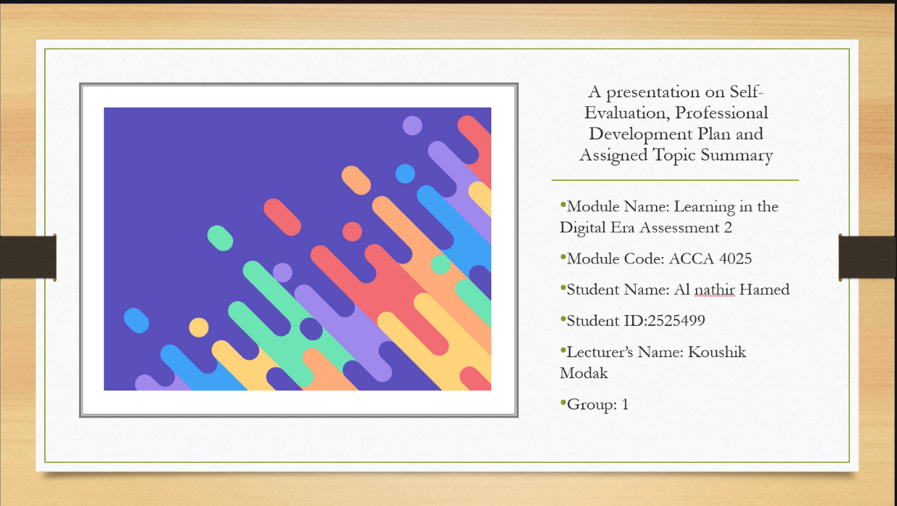

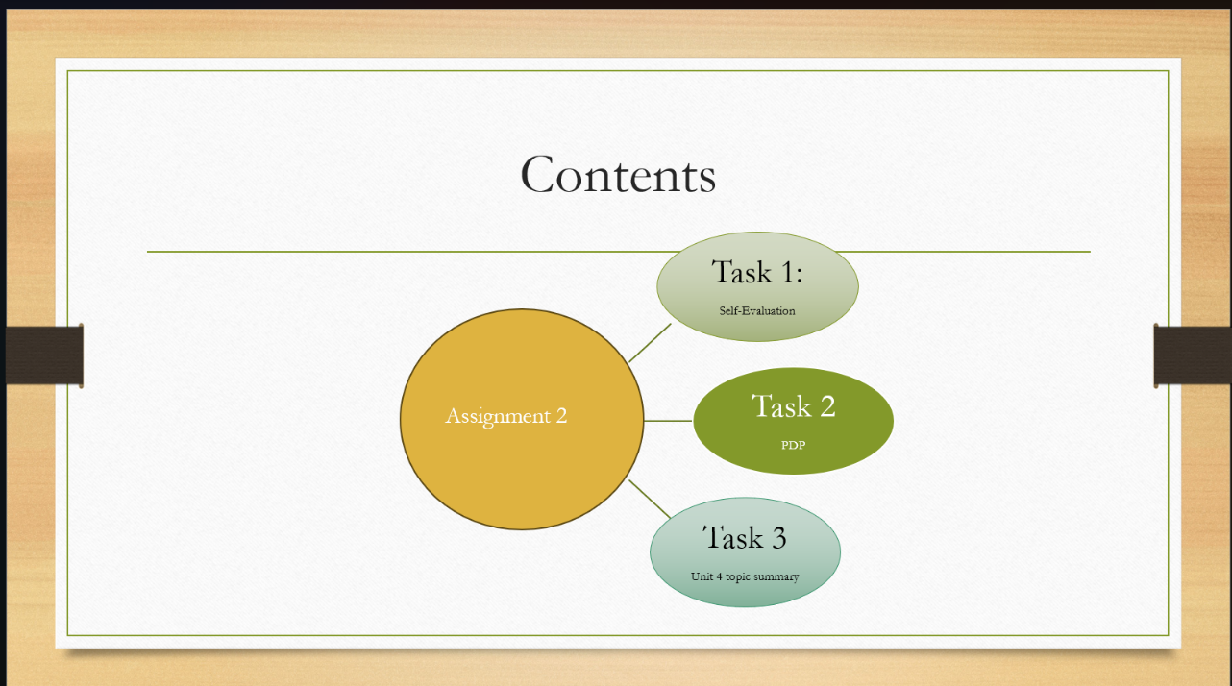
Slide 2 CONTENTS

Slide 3 INTRODUCTION

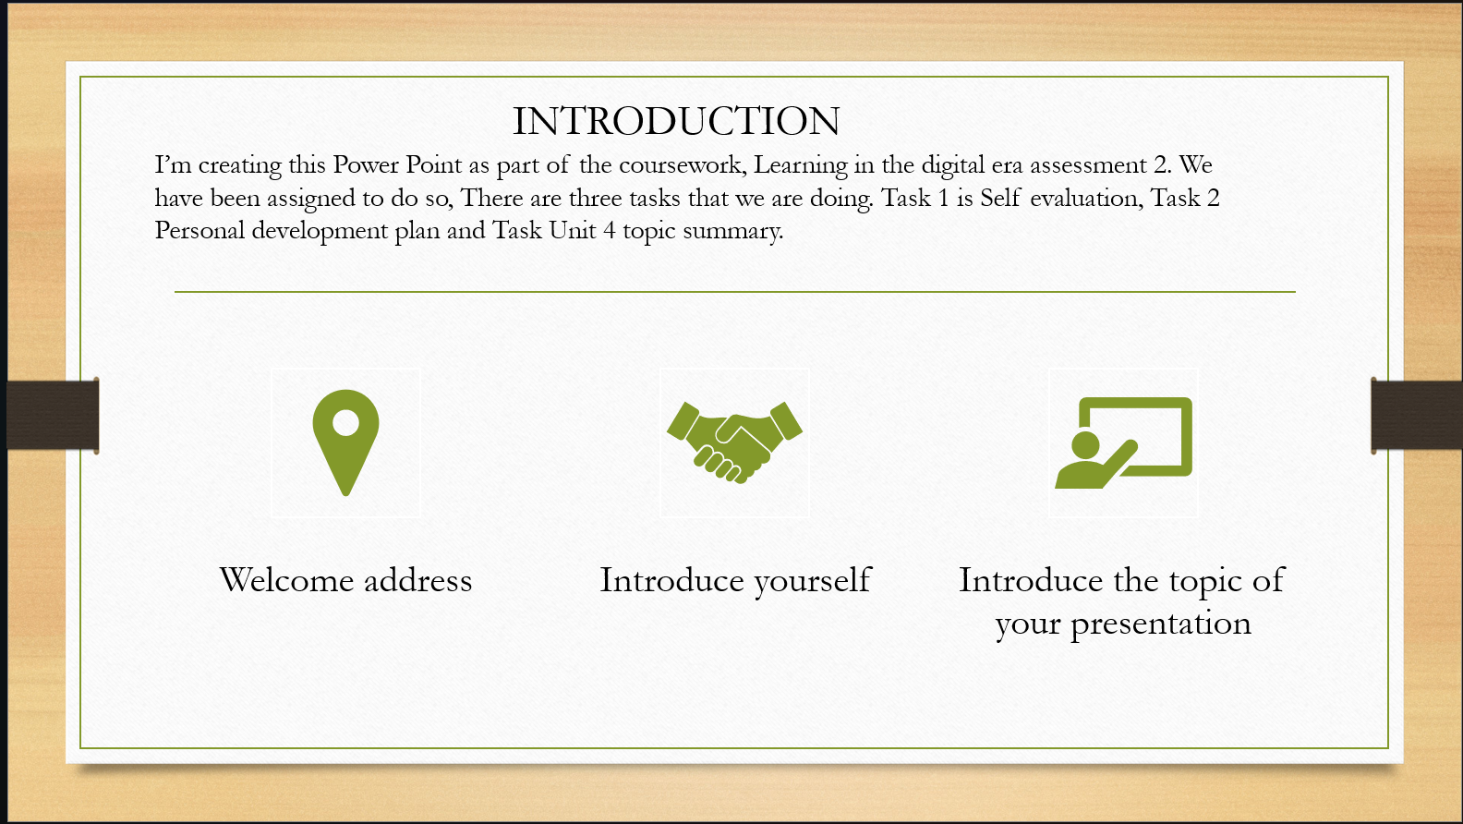
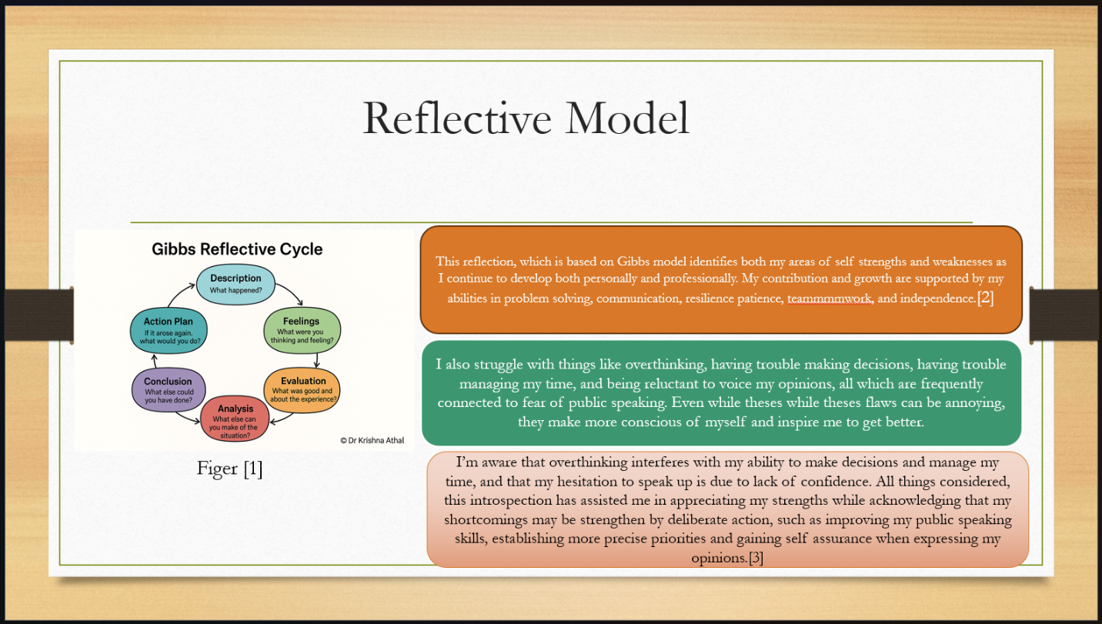
Slide 4 GIBB’s REFLECTIVE MODEL

Brief explanation: Graham Gibbs created the six stages Gibbs’s Reflective Cycle: description feelings, assessment, analysis, conclusion, and action plan, it enables people to back on their experiences and perform better in the future.
I’ll utilise this model in Assignment 2 to evaluate my strengths and weaknesses and develop a plan of an action to enhance abilities like confidence, public speaking, and time management.[1]
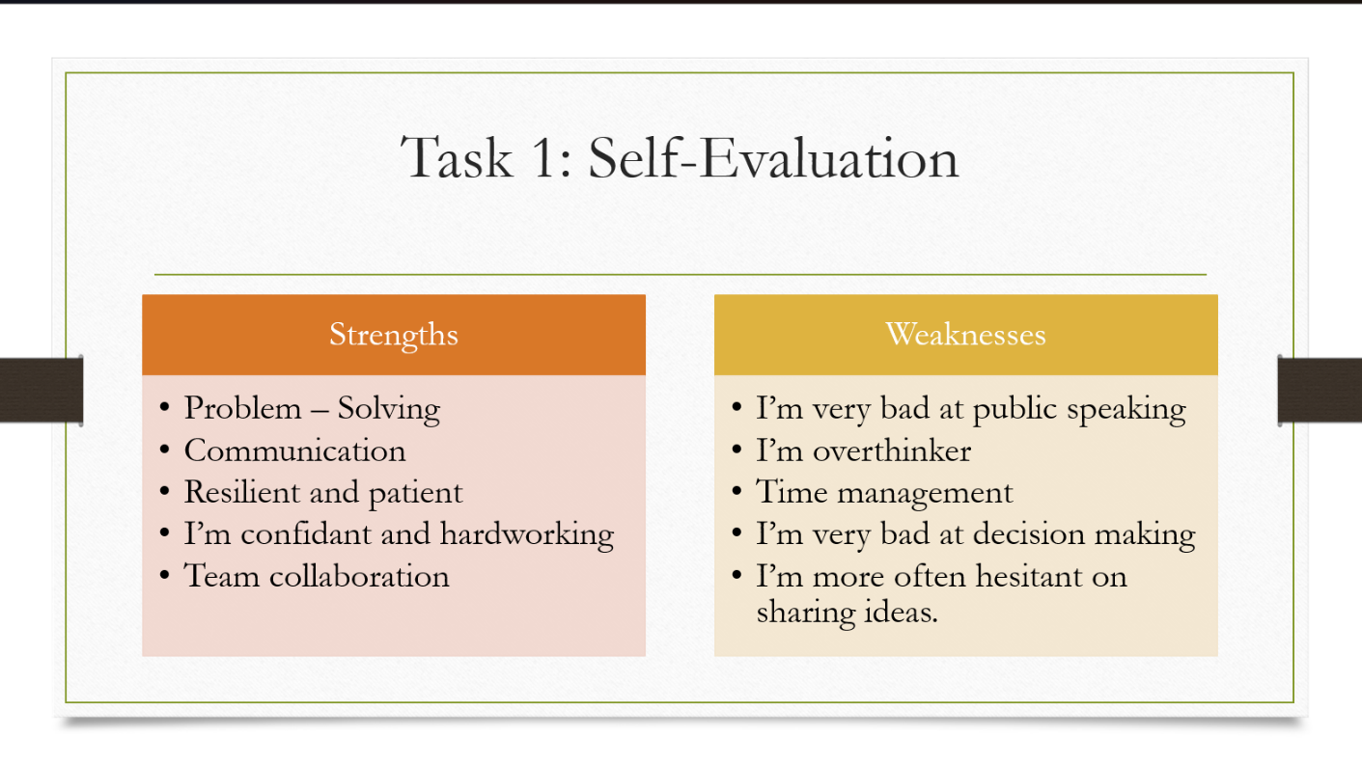
Slide 5 TASK 1: SELF EVALUATION

Brief explanation: one of my main strengths, according to my SWOT analysis, is my ability to think critically and deal with obstacles. However, public speaking is one my biggest weaknesses since I frequently feel uneasy and unconfident when expressing my opinions.
Slide 6 TRAITS GAINED FROM THE SELF EVALUATION
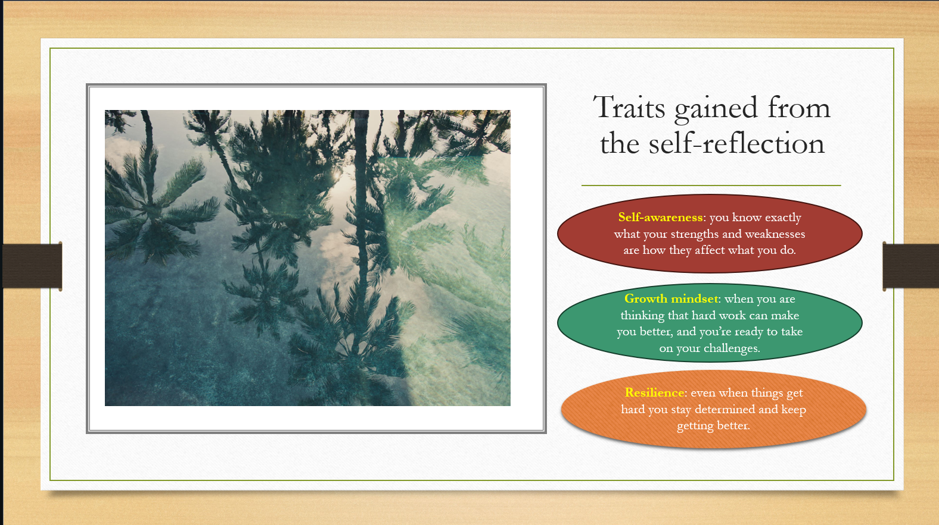
Brief explanation: by recognizing my strengths and weaknesses, self-reflection has assisted me in being more self-aware. It has also strengthened my resilience, which enables me to preserve in the face of difficulties, and my development mentality, which holds that I can advance hard work.
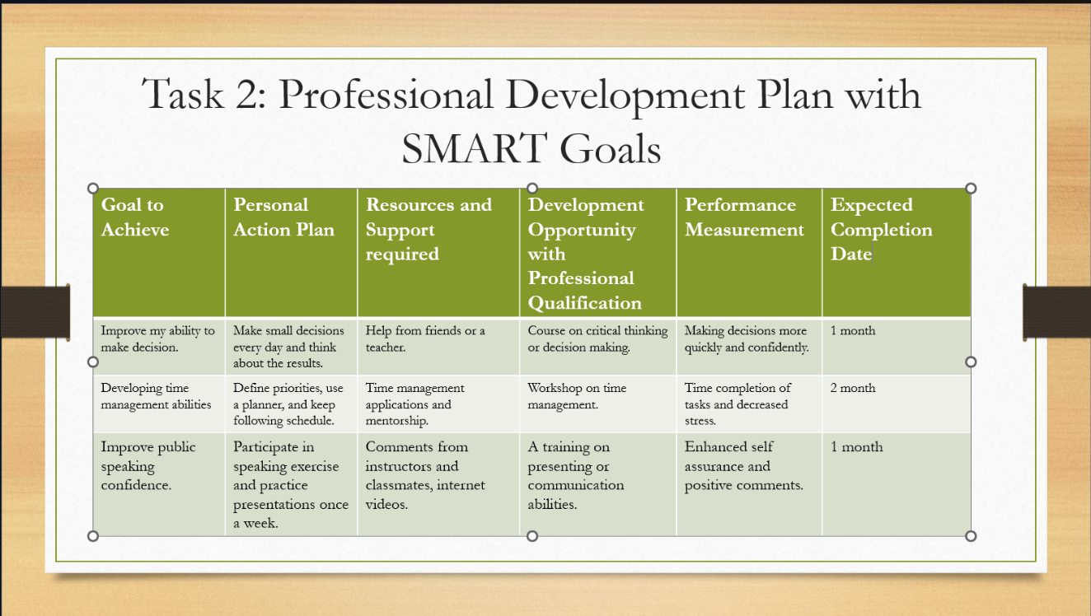
Slide 7 PROFESSIONAL DEVELOPMENT PL
Slide 8 UNIT 4 TOPIC SUMMARY
Brief explanation for Slide 7: a professional development with smart goals is an organised strategy that outlines the precise objectives, steps, and resources required for advancement. It may involve training or credentials, tracks advancement through performance, and establishes a deadline for completion to guarantee objectives are met.
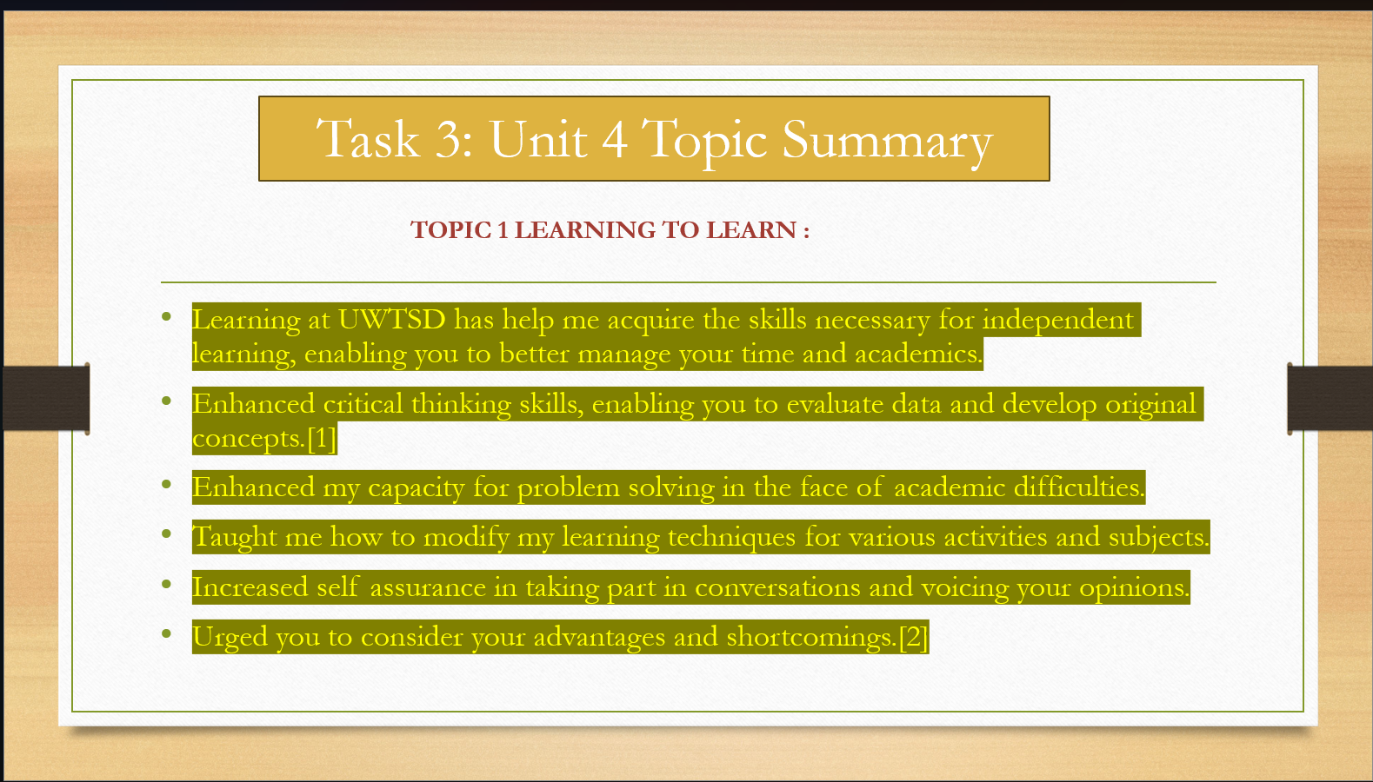
Brief explanation: my time management, critical thinking, problem solving, and independent learning skills have all increased because of my education at UWTSD. Additionally, it has improved my self- assurance in conversations, enabled me to modify my learning methods, and raised my awareness of my advantages and disadvantages.

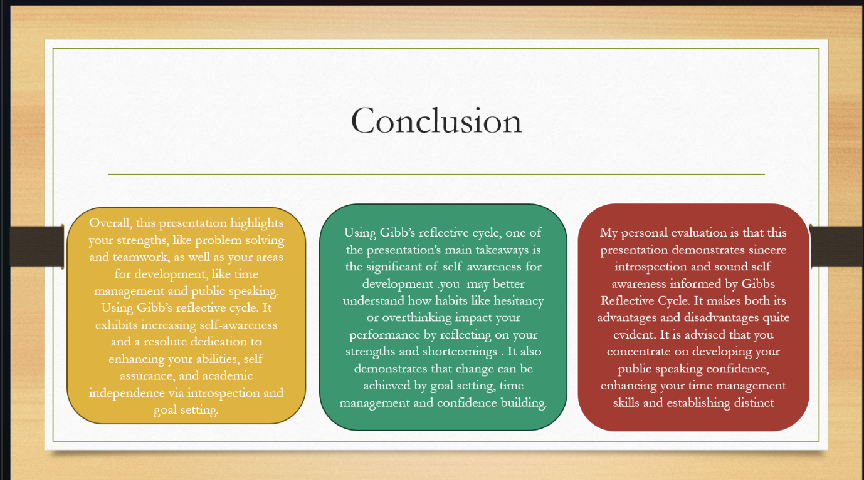
Slide 9 CONCLUSION

Brief explanation for Slide 9: Overall this presentation highlights my shortcomings in time management and public speaking as well as my abilities in problem solving and teamwork. It demonstrates self-awareness and a dedication to growing via introspection and goal – setting using Gibbs Reflective Cycle.

Slide 10
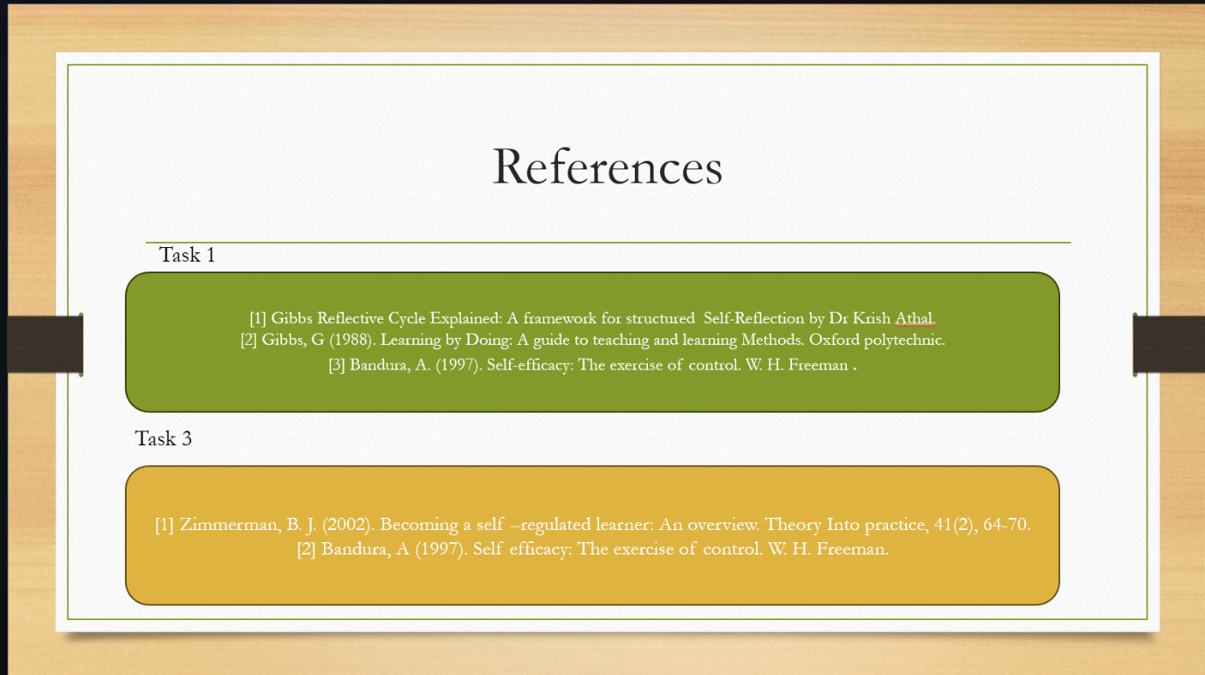

Conclusion
This presentation has offered a methodical analysis of my career and personal growths in the digital era; it has assisted me in determining my main areas of strengths as well as establishing precise smart objectives for my future development. All things considered, it helps me learn and progress continuously in both academic and professional settings.

References
1] Gibbs Reflective Cycle Explained: A framework for structured Self-Reflection by Dr Krish Athal.
[2] Gibbs, G (1988). Learning by Doing: A guide to teaching and learning Methods. Oxford polytechnic.
[3] Bandura, A. (1997). Self-efficacy: The exercise of control. W. H. Freeman .
1] Zimmerman, B. J. (2002). Becoming a self –regulated learner: An overview. Theory Into practice, 41(2), 64-70.
[2] Bandura, A (1997). Self efficacy: The exercise of control. W. H. Freeman.
[1] Gibb’s Reflective Cycle, developed by Graham Gibbs, (Gibbs 1988),

IEEE referencing style must be followed.
In-text citations need to be used in the slide as well as in brief explanation section in this report.

