ACCA5012 Application Development Assignment
Nathan Morgan 1801338
Software Engineering
11-12-2019

Abstract
In current times we are constantly being fed a vast amount of data, this report discusses research into single page applications by reducing the amount of communication with the server. The report then goes on to talk about the website created, libraries used, and future implementations and issues faced with testing.
Contents
Abstract 1
Application Development Concepts 1
Requirements 2
Design and implementation 3
Screenshots of the pages 5
Evaluation 8
References 10

Application Development Concepts
In this section I am going to discuss and list the current development trends relating to the module of study.
There are many fields of development trends and these require a large volume of developers with diverse knowledge in the concepts listed …
- Progressive Web Apps
- Chat bots (AI)
- Accelerated mobile pages
- Single page application
- Voice search optimization
- Motion UI
- Automation testing
- JavaScript
- Blockchain
- Internet of things [1]
I chose to write about the topic that interests me the most, Single-page ajax interfaces and I plan to learn a lot more about it in the coming weeks as I develop my website further.
A single page application is a web application or web site that does not reload the page to fetch new content from the server, instead it is done dynamically by loading the content with JavaScript [2].
The paper I have chosen to write about details the information behind the front-end of a single page E-Learning platform and how the user actions can define the content that they see on the page, this could be choosing a module of study or any other action that would typically result in a whole page being loaded to display the requested content. This method of utilizing the server to load all the content at once and then dynamically deliver the content with responsive web elements to reduce interaction with the server. With the client side JavaScript the potential for adoption of this development concept is quite large for portable applications and learning platforms as it will save the user loading many web pages to access the content.
  - Study summary
The paper aims to provide a new improved approach to the traditional E-Learning websites that use multiple pages, by providing a seamless experience of accessing and navigating content.
  - Key findings
A single web page application will be more user friendly for the end users and will reduce the time for navigation through the web page’s content by loading it all on the same page with JavaScript Frameworks [2]

Requirements
My website is called the Forex News Outlet and it sets out to deliver the most commonly traded contract for difference currencies, the website aims to deliver real time data of the current value of the currency and a news feed delivering related news articles that could cause the value to change. I see this to a whole new era of trading based on world events and the target audience stretches very wide as the Contract for difference trading community is very big in Europe.
Contract for difference trading has been growing rapidly in the United Kingdom with the launch of the trading 212 [3] platform that allows users to easily make trades from their mobile device. With time I hope to implement my own method of accessing the market for making purchases and sales. The websites room for growth is quite wide and I have a lot of planned content I wish to add to it, and I plan to further develop the website when the assignment is handed in. This website shows a lot of potential for growth in the technology it uses, and can grow to provide a more seamless approach to navigating the content with more intelligent use of AJAX, reducing the amount of pages for the client to request from the server, reducing the amount of API function calls.
When I drew my initial design concept I knew I wanted the website to look the same regardless of the device it was being used on so I started by building it around the smallest screen mode using media queries, with the intention of the content being displayed the same way just adjusting to be more accessible on smaller screens.
I planned to achieve this using Bootstrap 4’s flexible grid system. This Grid system allowed me to plan for the extra small screen sizes and define my content using breakpoints or “columns”.
I designed my breakpoints with the following scheme in mind, a full size header including logo and navigation, a 2/3s content box and a 1/3 content box to be displayed side by side, so for the 1/3 I used the aside parameter, and that allowed me to display my main content as desired. Then after the content I wanted to end the page with a footer, using JavaScript I display the date, time and time zone of the imported Alpha Vantage data [4] within the footer. Then I set out on the content of my pages, and achieving the first milestone of retrieving the alpha vantage data in a raw format and sorting it into arrays, and then using chartjs [5] I looked at the configuration of the library to implement a nice user friendly way of displaying the data.
My initial design concept was to just display a single currency per page, with a simple chart. I had originally planned for a hard-coded range, but with more experimenting I found I could use the smallest and largest numbers of the array to set the range.
Then I wished to implement the newsapi to further enhance the websites use by displaying Realtime news events in a side bar.
  - Interactive functionality
Mouse over events over the chart to display more accurate time stamps of the closing position.
Active page tag used to highlight the active page on the navigation bar.
A contact us page with a form.
A resizable message box within the contact us form.
Use of a live news feed API [5] to display real time world events relating to the currency that is being displayed with the use of the Alpha Vantage API [4].
Media Queries to aid in resizing the resolution to fit the viewport.
Media queries are a concept in CSS3 and the basis of them came from the CSS2 idea and approached it differently by looking at the capabilities of the device rather than the type of the device.

Design and implementation
  - JavaScript functions: Loading historical data and charting the data
First I used this line $function(){} to house all of the content of the page, to ensure it loaded after the DOM had finished loading, as in initial stages I was encountering issues where the API data was loading before the chart canvas was being displayed resulting in no data being shown in the chart.

Then I used $.ajax to perform an asynx AJAX request that called the Alpha Vantage API and fetches the content of the request in a json format. [6]

If the request fails, likely due the limitation of the API and having limits on function calls, display an error message.

On a successful request it will call the function that processes the data.

Get Alpha Vantage Data
This function stores data in a multi dimension array called setData.

Then I reduced the data into two arrays of usable data that I wished to display
I achieved this by looping through the first index in the array while keeping a constant in the second index, it looked like this setData[i][4] for the close data and setData[i][0] for the time stamps, this way I collected the 0 & 5th indexed items of the array and pushed it into two single dimension arrays.

Using this method of splitting the data, I can automatically label my chart with accurate prices and time stamps.

I soon realised that the chart was displaying the more recent items on the left so I used a method that reversed the order of the arrays [7] before I passed them into the chart, ensuring the most recent value is on the far right and pushing the old data left.
Then I wanted to do a quick validation check to ensure that the data of the chart was not equal to 0, and if it was to print an error message towards the top of the page in the designated html elements.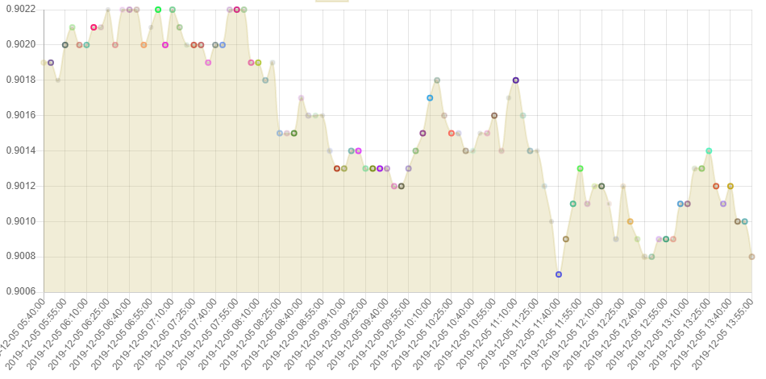
Figure 1 Screenshot of chart
I then wanted to add more variety into my chart by creating a random colour generator to randomly generate a number between [8] 0-255 3 times to give red blue green and a constant 1 for the alpha value. This allowed me to create a loop and randomly generate an array of random colours for the use of creating beautiful random index points on my chart. This can also be seen in the above screenshot.

  - JavaScript functions: Loading Currency Exchange Rate and displaying data
To load some of the additional details I want to display on my page I had to use a second call to the Alpha Vantage API but this time instead of calling the historical data I called the currency exchange rate and this is then displayed above the chart. This will also return some other useful information that I can display on the webpages, such as the last time the API was refreshed, the time zone and the currency titles.
I began in a similar fashion to the chart script, I started by calling the URL using $.ajax to perform an asynx AJAX request that called the Alpha Vantage API and fetches the content of the request in a json format. [6]
I then assigned the returned data to variables and then set the variables to update HTML elements on the web page with the newly acquired data.
  - JavaScript functions: Loading relevant business news to the side bar of the page
For my side bar I wanted to have a live news feed, so I found an API called newsapi.org [5] and using an ajax get query to pull the data, on success it populates a series of arrays with the title, description, URL for the article and an image, I then display 5 of these latest items per page, I could set as many as I want and pull a large amount of data but for the sake of load speeds and data usage I will hold it at 5 for now. This Can be further developed to use a drop-down menu or a list to change the number of items displayed or navigate through the pages.

Screenshots of the pages
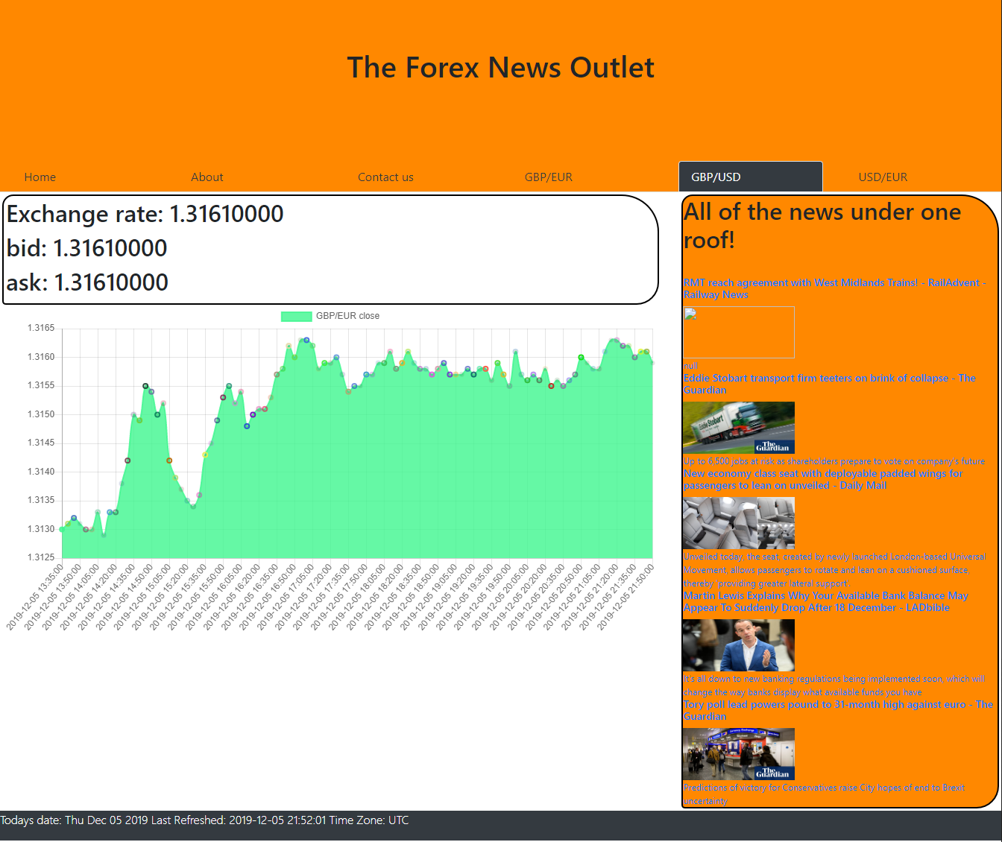
Figure 2 GBP to USD page
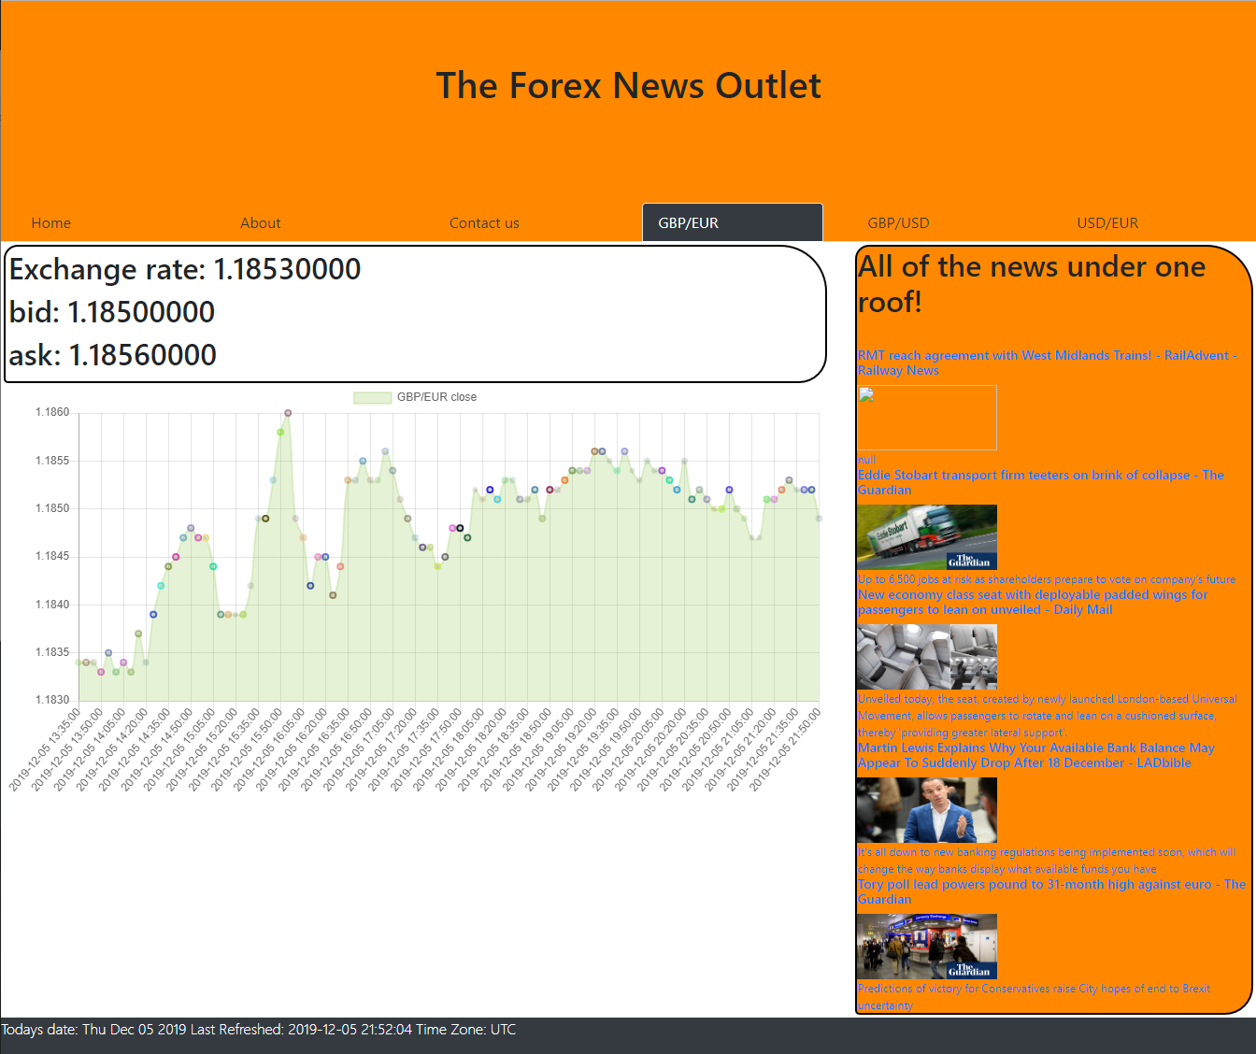
Figure 3 GBP To EUR page
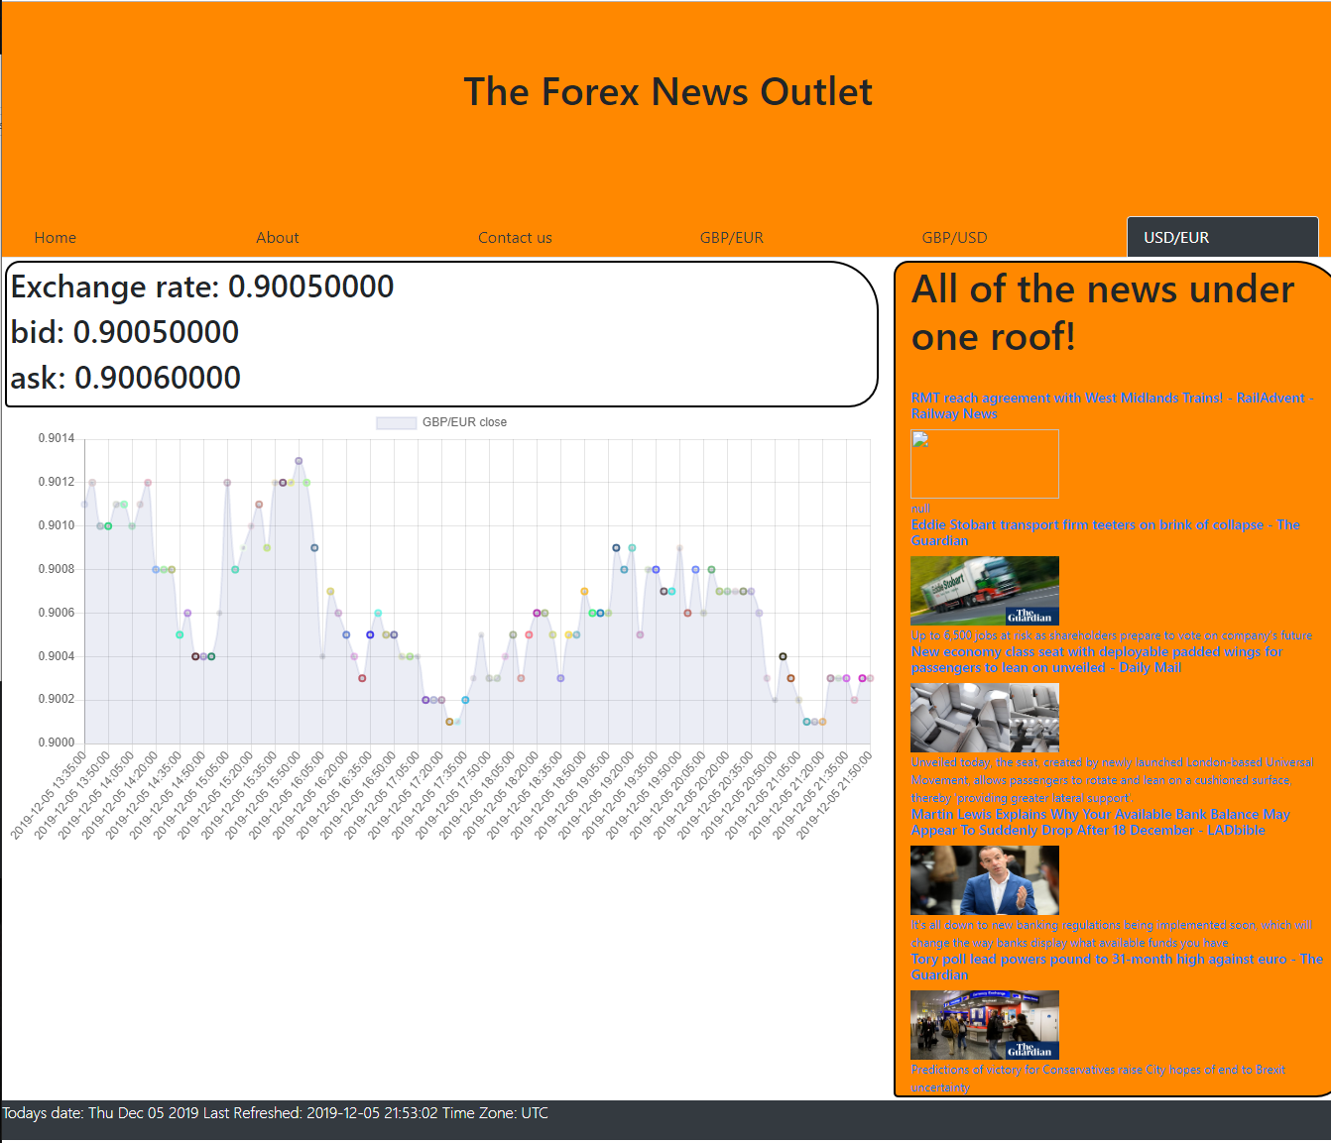
Figure 4 USD to EUR page
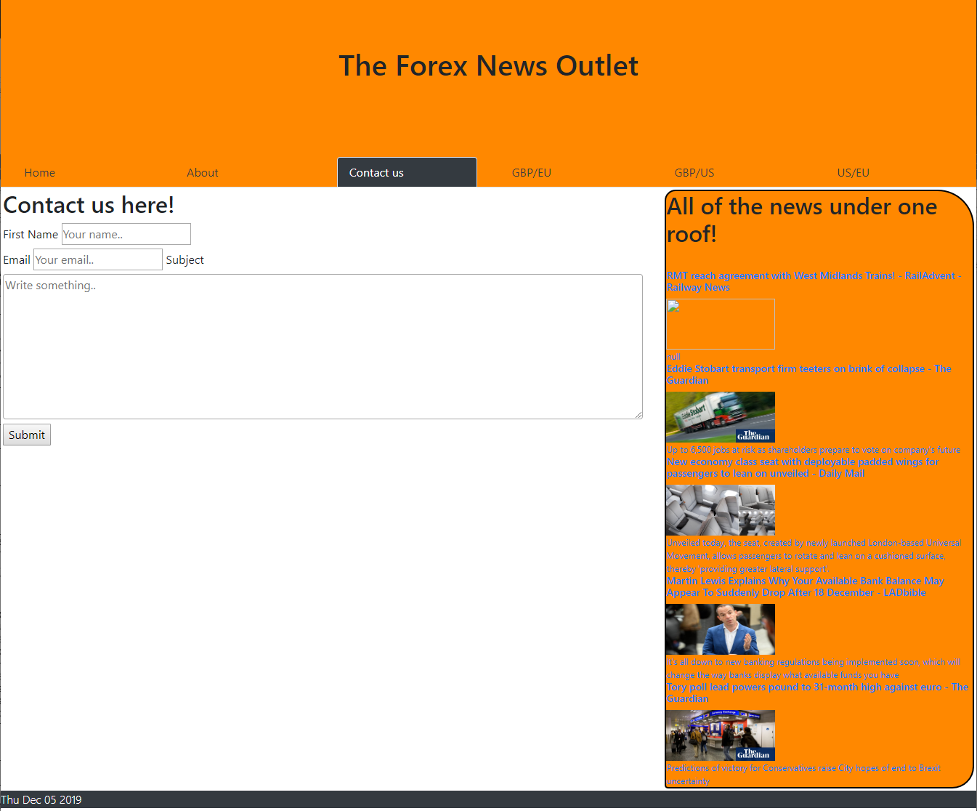
Figure 5 Contact us page
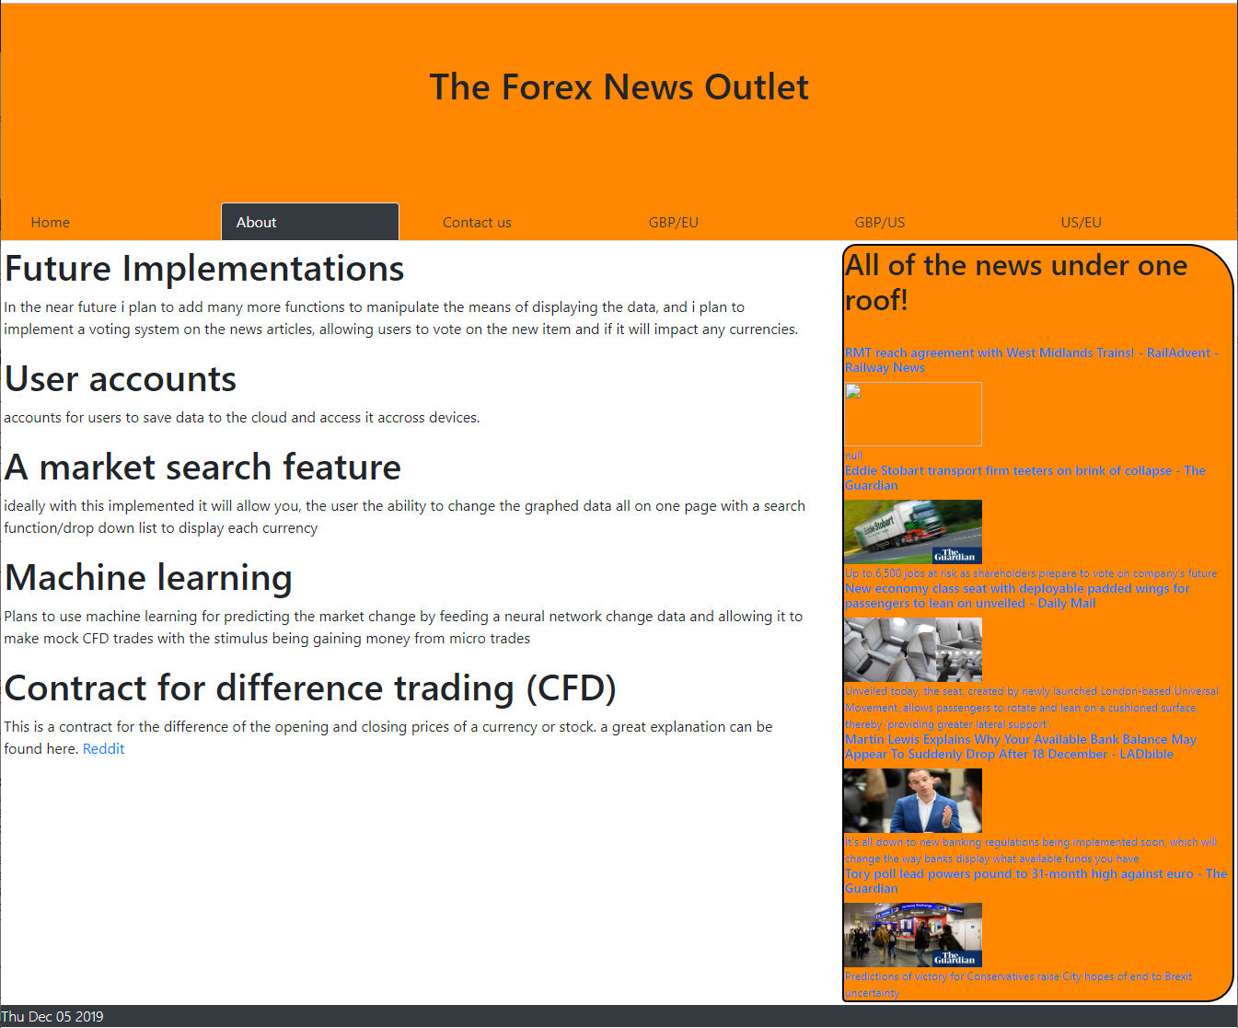
Figure 6 About Page
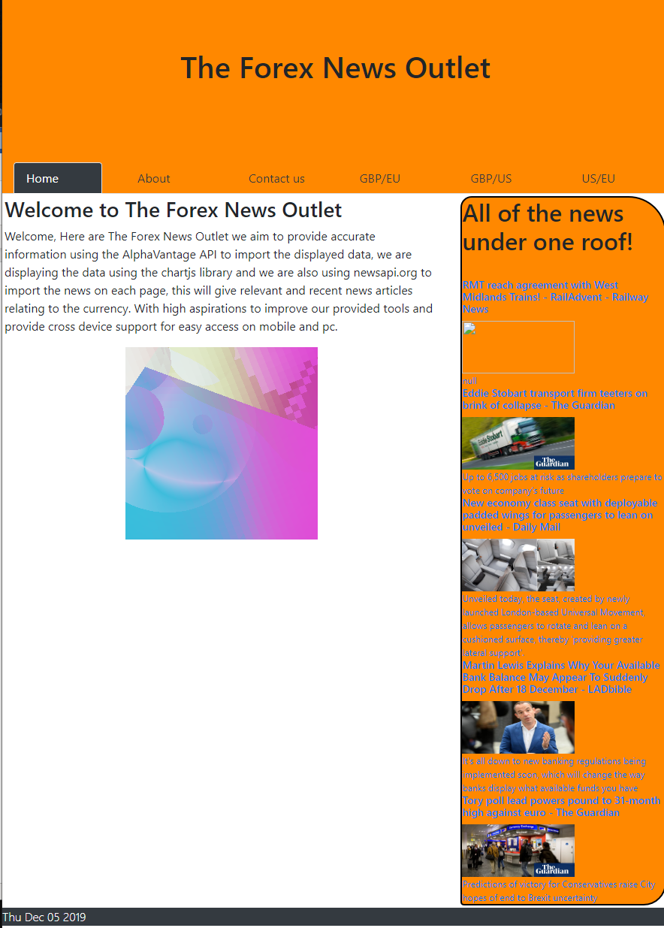
Figure 7 Home Page

Evaluation
  - Validation
Using w3 school’s validation page to check all the pages are too a standard.
  - https://validator.w3.org/
  - Website performance
Due to the nature of the API used I felt that It is a little slow to load, but this is down to using the parameter that adjusts the load to wait till the DOM elements are loaded and the limited amounts of function calls.
  - Future implementations
A more intelligent use of AJAX.
As time has gone by after the initial creation of my website and further reading has shown me the vast potential of using AJAX and the further reading I did on IEEE really confirmed that my knowledge barely scratches the surface of the potential of AJAX. This is very exciting, and I can’t wait to learn more about it.
The features of AJAX I could implement to further develop and increase the potential of my webpages.
- Single page application to deliver all the content on one page.
- Dynamic refreshing when the API return updates.
- Load specific parts of the page and reload them rather than full page reloads.
- Faster and more interactive pages.
  - More accessible content
What I would really like is a live audio feed of the changes in the charted data. This and options to change the colour theme and each individual element would be great, with the ability to save the details to the user account this would allow for some great cross platform functionality.

  - Premium alpha vantage account
As it stands alpha vantage has a free to use version of the API that you can see me using in my website, and this has a limited amount of calls per day, and only 1 per minute, but with a premium account those limits vanish. This makes it a necessity once out of the prototype phase, therefore I will avoid covering tests that are reliant on this, as the limitation will disappear once out of prototype.
  - User accounts
Accounts for users to save data to the cloud and access it across devices. This could be particularly handy with the market search feature, allowing the user to customize what markets are their favourites and creating groups of markets, or category’s such as FX, crypto, stocks, this will also go with the voting system I plan to implement limiting votes to one per account, and accounts must be verified to vote to avoid bot farm vote manipulation, other measures would have to be put in place to counter this also. Perhaps a cloud fare service could help with that.
  - Future Implementations
In the near future I plan to add many more functions to manipulate the means of displaying the data, and I plan to implement a voting system on the news articles, allowing users to vote on the new item and if it will impact any currencies.
  - A market search feature
ideally with this implemented it will allow you, the user the ability to change the graphed data all on one page with a search function/drop down list to display each currency. With this implemented this would reduce the page load and allow the user to limit the received data to what they require.

Tested on:  5/11/2019  Browser:  Chrome/firefox/edge |  |  |  | Preconditions or prerequisites
Test | Test Comment | Test steps | page | Expected result/Actual result | Status
FX-Alpha vantage |  | On load(after dom) | GBPEUR  USDEUR  GBPUSD | To load a chart with relevant closing data. | pass
Newsapi |  | On load | all | To load a wrapper containing title, description, URL and an image. | Pass
Exchange rate-Alpha vantage |  | On load(after dom) | GBPEUR  USDEUR  GBPUSD | To load headers displaying the current exchange rate, last update, | Pass
Resize:200/800px |  | On resize | all | Content compresses but remains usable and legible | pass
Resize:4000/2000px | beautiful | On resize | all | The screen stretches to fill the new view port,  On the pages with FXalphaVantage the chart looks better like this as you can see the data points clearly | pass
Alpha vantage accuracy | Tested against other popular marketplaces | Comparing the received data against found data | GBPEUR  USDEUR  GBPUSD | Identical results, although alpha vantage seems to be slower to retrieve, may be down to the free user experience. | pass

References

[1] | dzone, “AMP Websites Guides & Tutorials,” AMP, [Online]. Available: https://dzone.com/articles/top-10-web-development-trends-to-follow-in-2019.
[2] | M. D. M. A. R. Prof. Smita Deshmukh, “Building a Single Page Application Web Front-end for E-Learning site,” IEEE, 27-29 March 2019. [Online]. Available: https://ieeexplore-ieee-org.ezproxy.uwtsd.ac.uk/document/8819703.
[3] | T212. [Online]. Available: https://www.trading212.com/.
[4] | [Online]. Available: https://www.alphavantage.co/.
[5] | [Online]. Available: https://newsapi.org/.
[6] | w3Schools, “ajax,” [Online]. Available: https://www.w3schools.com/jquery/ajax_ajax.asp.
[7] | “javascript array reverse method,” JavaTpoint, [Online]. Available: https://www.javatpoint.com/javascript-array-reverse-method.
[8] | [Online]. Available: https://www.w3schools.com/js/js_math.asp.
[9] | [Online]. Available: http://gionkunz.github.io/chartist-js/.
[10] | amp. [Online]. Available: https://amp.dev/documentation/guides-and-tutorials/?referrer=ampproject.org.

