Module Name: Software Applications for Business
Assignment Title: Software Applications for Business
Student Name: MD Sadikur Rahman
Student number: 2229739
Course: digital skills

Contents
Task 01: E-Commerce Website builders & e-Portfolio creation 3
a) Contemporary e-Commerce website software solutions 3
b) E-portfolio 3
Task 02: Mind-map of contemporary software applications 4
Task 03: Office Applications for creating storing, analysing & presenting information/data 5
a) Contemporary Office applications 5
b) Business-related features of a freely available Office Application 6
Task 04: Poster of Digital Dashboard and Data Analytics software 8
a) ii) features of a freely available Digital Dashboard/Data Analytics software application 8
Task 05: Communication, Collaboration & Project Management applications 10
a) Contemporary Communication/Collaboration/Project Management applications 10
b) Freely available Communication/Collaboration/Project Management application 11
References: 13

Task 01: E-Commerce Website builders & e-Portfolio creation

a) Contemporary e-Commerce website software solutions
Shopify ranks among the most prominent e-commerce systems. Shopify is a cloud-based e-commerce service that allows businesses to easily construct an online store. The platform offers a variety of customisable themes that enable businesses to construct an appealing and professional-looking online marketplace (Hawlader, 2022). Shopify also includes services like managing inventory, order monitoring, and payment systems. Furthermore, Shopify provides an easy-to-use interface that involves no coding knowledge, allowing entrepreneurs to simply administer their online storefronts (El-sheikh et al., 2017). WooCommerce, a plugin for the WordPress website management system, is also another popular e-commerce platform. WooCommerce offers a variety of functionalities, including inventory management, payment services, and shipping integrations, making it a complete option for companies that wish to sell online (Dragomirov, 2020). Furthermore, WooCommerce is highly adaptable, with a vast database of plugin and extensions to extend its efficiency (Sims, 2018). Magento is robust e-commerce software that is perfect for large enterprises with sophisticated e-commerce needs including managing inventory, shipment tracking, and payment systems, making it a complete solution for companies of all kinds. Magento, on the other hand, necessitates technical knowledge to set things up and customise, making it unsuitable for small enterprises (Paul George, 2019; Pawar, 2022).
E-commerce website software solutions can integrate with other company tools such as customer relationship management (CRM) systems, accounting systems, and marketing test automation (Dhanalakshmi et al., 2020). Additionally, businesses can simplify their operations, eliminate duplicate work, and increase productivity as a result of this. E-commerce website platform can also provide real-time reporting and analysis capabilities.

b) E-portfolio
[https://22300596.wixsite.com/my-site-2]

Task 02: Mind-map of contemporary software applications
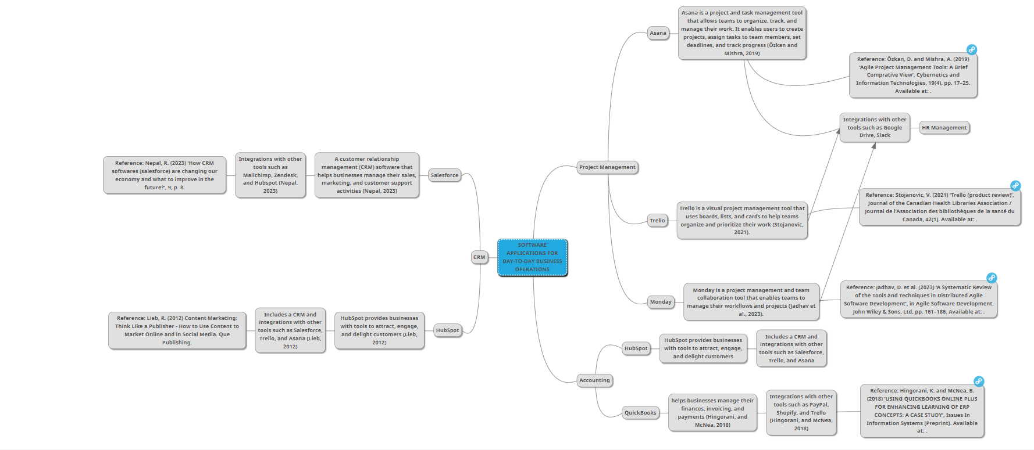

Task 03: Office Applications for creating storing, analysing & presenting information/data

a) Contemporary Office applications
Microsoft Word is the most popular word processing programme, with a variety of features for preparing and modifying documents. Some of its primary features include: different fonts and style features (Figure 01), collaboration features, integration with other Microsoft products, and cloud-based storage and sharing.
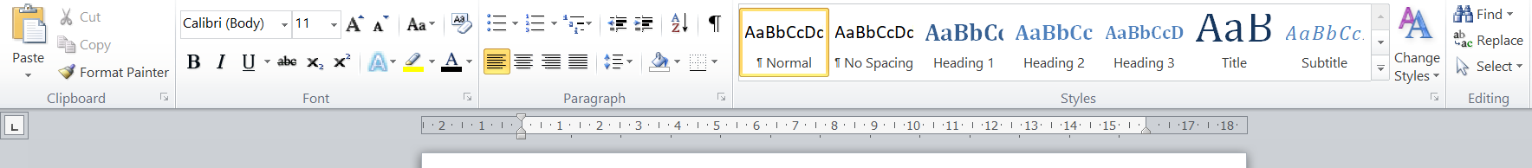
Figure 01: Font and style features of Microsoft word
Microsoft Excel is a robust spread sheet tool that can be used to analyse and manage data (Jusoh and Ahmad, 2019). Calculation and equation tools (Figure 02), data visualisation and graphing, integration with other Microsoft products, and cloud-based storage and sharing are some of its primary features.
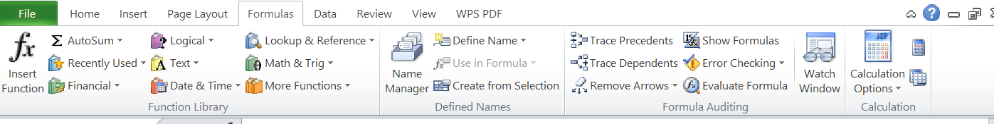
Figure 02: Calculation and equation tools of Microsoft excel
Google Sheets is a cloud-based spread sheet tool with capabilities that are comparable to Microsoft Excel. Its primary features include automatic recording and modification history, conversions and data analysis (Figure 03), and data sharing and collaboration, and cloud-based storage (Kunicki et al., 2019).
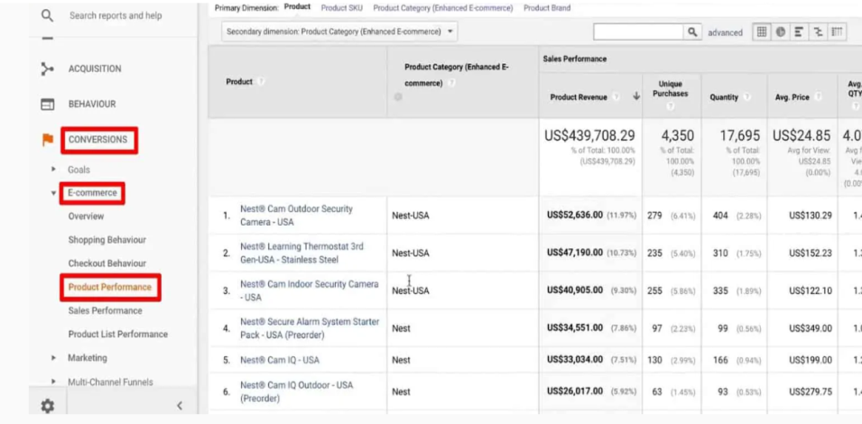
Figure 03: Conversions and data analysis feature of Google sheets

b) Business-related features of a freely available Office Application
I selected LibreOffice for this task because it is an open-source, free software solution that includes programmes for word processing, worksheets, presentations, and database. Mail Merge (Figure 04) enables the user to utilise a single template to deliver targeted messages or emails to multiple destinations.
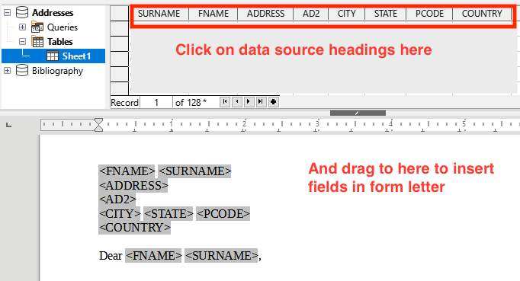
Figure 04: Mail merge feature of LibreOffice
Creating and formatting tables (Figure 05) is a typical operation in any office suite, and LibreOffice Writer makes it simple. A table can be inserted by clicking "Insert" from the options and then "Table."
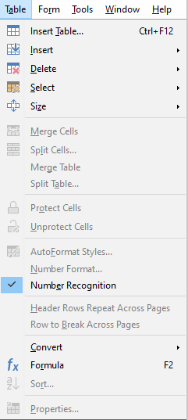
Figure 05: Creating and formatting tables with LibreOffice

LibreOffice Writer has outstanding compatibility with Word documents created by Microsoft and save the documents as word by default (Figure 06), allowing users to view, change, and also save Word documents with no formatting difficulties.

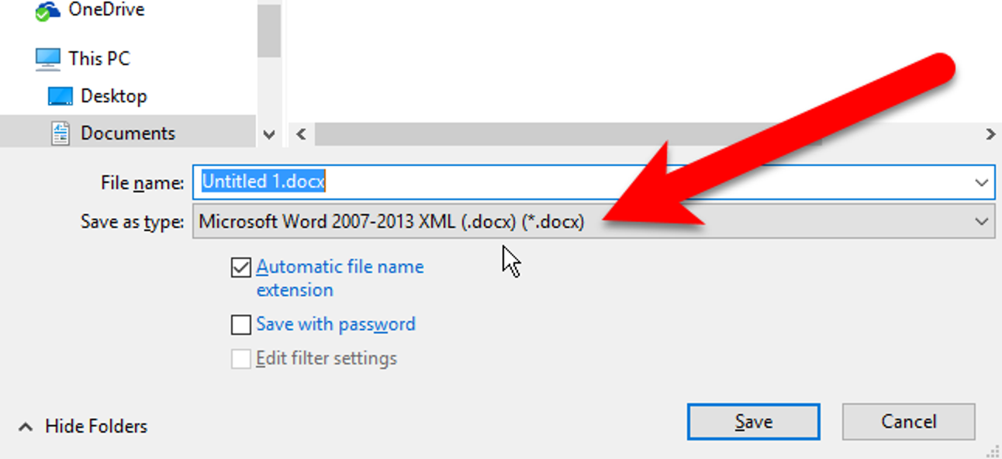
Figure 06: LibreOffice writer save the document as Microsoft word

Task 04: Data Analytics software

a) ii) Features of a freely available Digital Dashboard/Data Analytics software application
I have selected Microsoft Power BI for this work since it is a free data analytics and visualisation software product that enables individuals to link to numerous data sources, generate dashboards, and share insights with each other. I have tried certain Power BI capabilities and documenting multiple screenshots with brief comments to demonstrate practical use.
The capacity to connect to numerous data sources is a crucial aspect of any data analytics software. Power BI lets users connect to a variety of data sources, notably Excel, SQL Server, Oracle, and others. I have linked to an Excel file with sample data in the screenshot below.

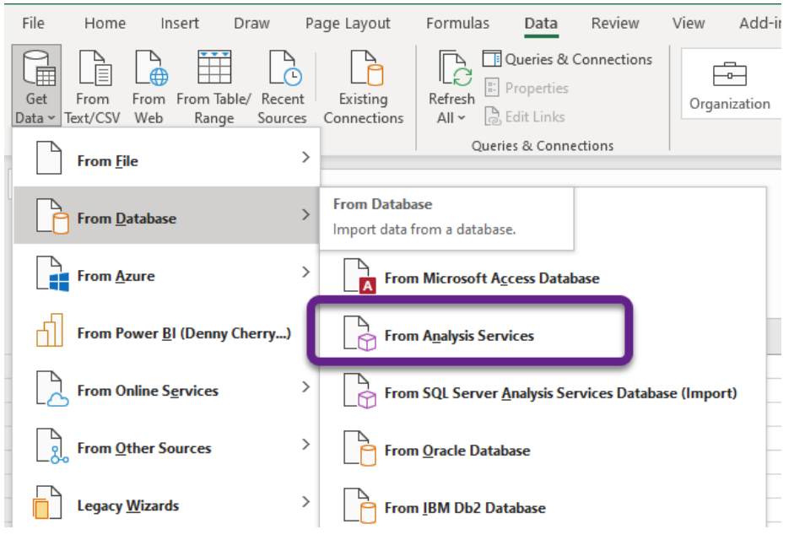
Figure 07: Linking Excel file with sample data
Power BI delivers a plethora of visualisation tools to assist users in creating interactive reporting and dashboards. The user can construct several forms of visualisations, such as tables, graphs, maps, and indicators. I have designed a bar graph that displays sales by sales territory in the screenshot (Figure 08) below.
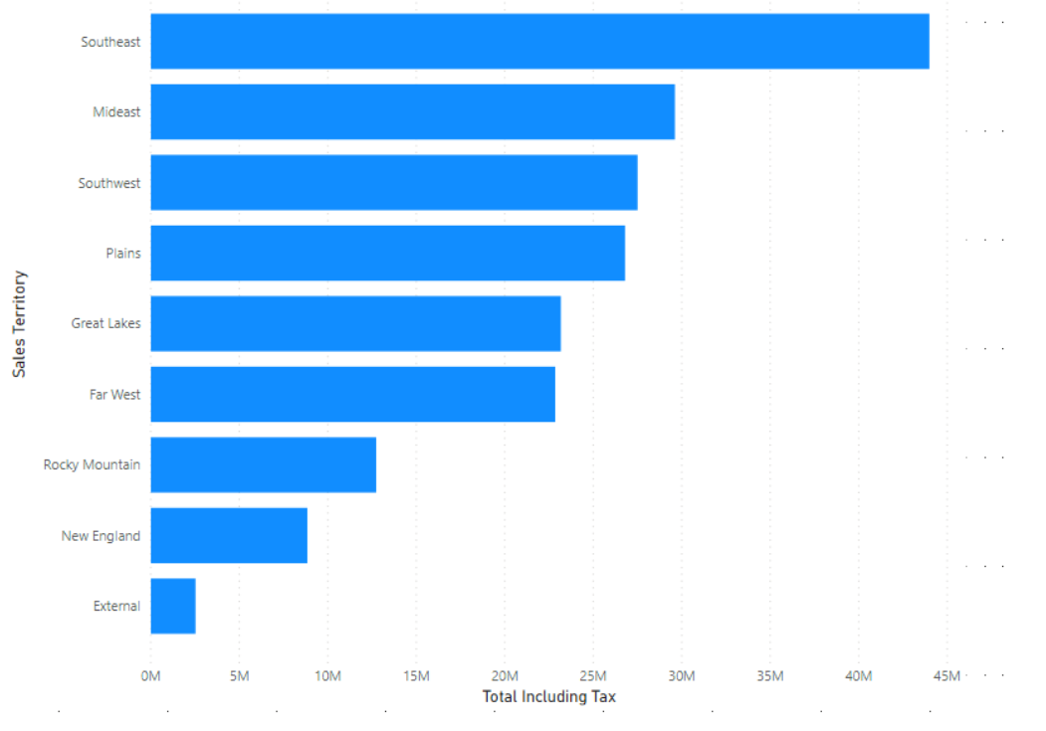
Figure 08: bar graph displays sales by sales territory drawn by Power BI

Power BI enables users to share the reports and dashboards with others by sending a link or integrating the dashboard in a website page. The users can also cooperate with others by granting them the ability to update or read the reports. I have shared the dashboard with a co-worker in the screenshot (Figure 09) below, and they can view it by clicking on the hyperlink (Figure 10).
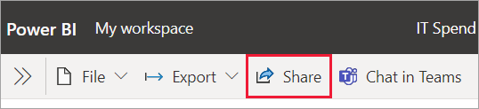
Figure 09: Sharing Dashboard with Power BI
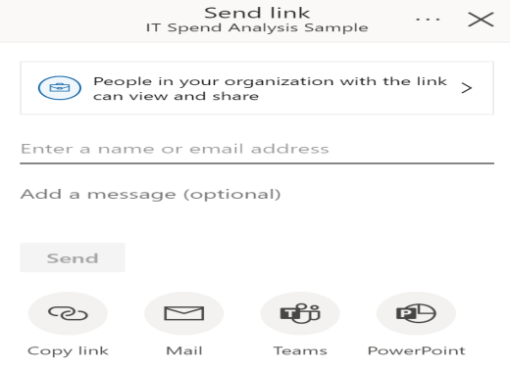
Figure 10: Sharing hyperlink to view the dashboard

Task 05: Communication, Collaboration & Project Management applications

a) Contemporary Communication/Collaboration/Project Management applications
Slack is a real-time communication program that enables teams to interact and work together on tasks. It has capabilities such as text messenger; document sharing (Figure 11), audio and video chats, and connection with other programmes (Montrief et al., 2020).
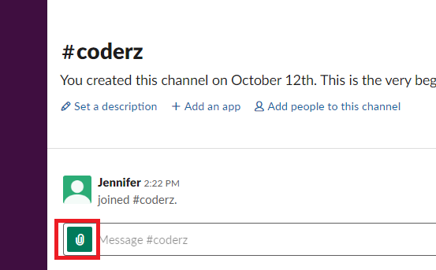
Figure 11: Document sharing with Slack
Source: (Slack, 2023)

Microsoft Teams is a communication and collaboration software and offers features including instant messenger (Figure 12) , audio and video calls, document sharing, and interaction with other Microsoft applications including Outlook, Powerpoint, and OneDrive (Ilag and Sabale, 2022).
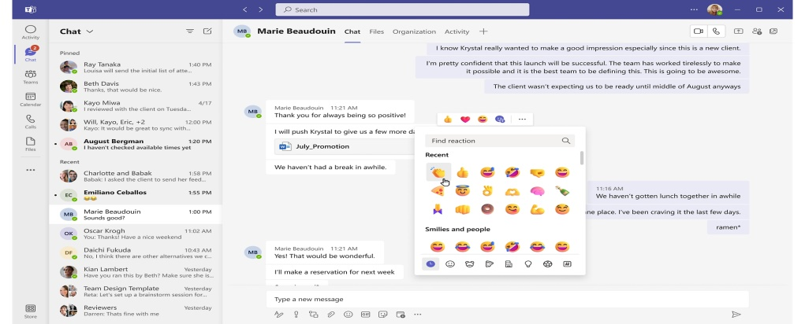
Figure 12: Instant messaging with Microsoft teams
Source: (Microsoft teams, 2023)

Asana is a project management platform that includes capabilities such as project management, work assignment, track progress, and team dynamics. Users may create tasks (Figure 13), distribute tasks to members of the team, establish deadlines, and monitor real-time progress (Özkan and Mishra, 2019; Ćirković et al., 2022).
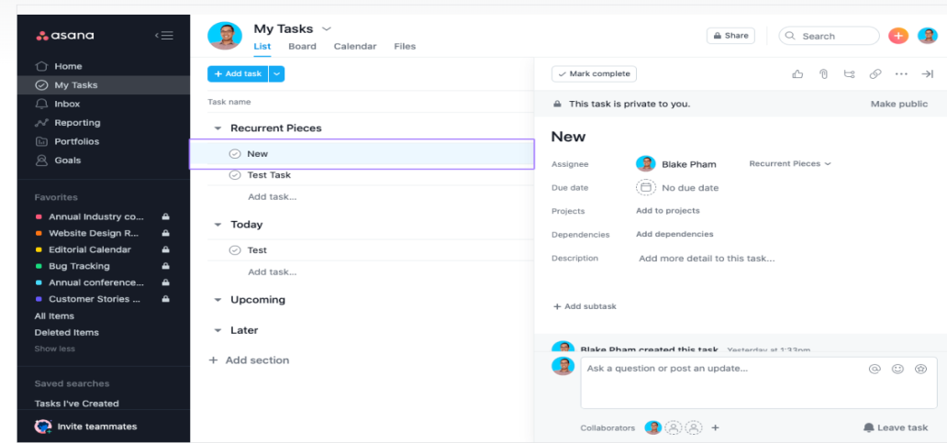
Figure 13: Creating tasks with Asana
Source: (Asana, 2023)

b) Freely available Communication/Collaboration/Project Management application
I have tested things like forming a new team, creating a channel, and uploading a file of Microsoft teams.
- To form a new team, go to the left-hand side panels and click the "Join or create a team" option, then select “Create a team" (Figure 14). There is the option of starting from start or using an established team as a foundation.
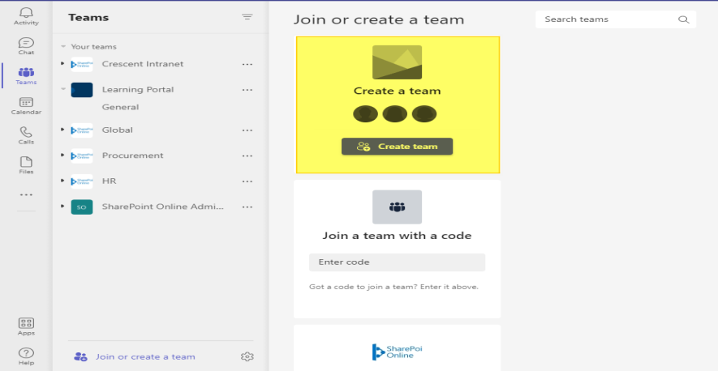
Figure 14: Creating a team with Microsoft teams

- To add a channel to a team, click the "..." symbol next to the team name and then select "Add channel" (Figure 15). The required information can then be entered, including the channel title and description.

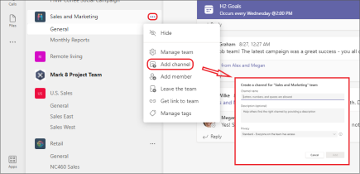
Figure 15: Adding a Channel to the team

- Select the channel to upload the file, next click the "Files" icon and choose the file to upload (Figure 16) and, when needed, a comment can also be added.
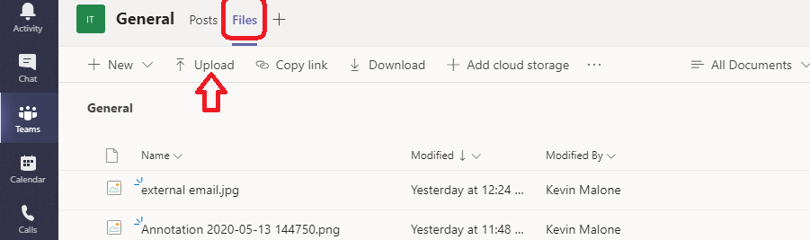
Figure 16: Uploading a file on the channel

References:
Asana (2023) Task actions: create, move, duplicate, and more | Product guide • Asana Product Guide, Asana Product Guide. Available at: https://asana.com/guide/help/tasks/actions (Accessed: 30 March 2023).
Ćirković, M., Čubrić, G. and Čubrić, I.S. (2022) ‘Project Management Tools for the Fashion and Apparel Industry’, ENTRENOVA - ENTerprise REsearch InNOVAtion, 8(1), pp. 40–47. Available at: https://doi.org/10.54820/entrenova-2022-0005.
Dhanalakshmi, A. et al. (2020) ‘Technological Advancements in E-Commerce and Customer Relationship Management’, International Journal of Engineering and Management Research, 10(6), pp. 9–20. Available at: https://doi.org/10.31033/ijemr.10.6.2.
Dragomirov, N. (2020) ‘E-Commerce Platforms and Supply Chain Management - Functionalities Study’. Available at: https://doi.org/10.37075/EA.2020.2.04.
El-sheikh, A.H., Ali, E.M. and Mergani, N.L. (2017) ‘E-COMMERCE PLATFORM IN SUDAN’. Available at: https://repository.sustech.edu/handle/123456789/21239 (Accessed: 30 March 2023).
Hawlader, A. (2022) ‘ESTABLISHING A DROPSHIPPING E-COMMERCE STORE’.
Ilag, B.N. and Sabale, A.M. (2022) ‘Microsoft Teams Overview’, in B.N. Ilag and A.M. Sabale (eds) Troubleshooting Microsoft Teams: Enlisting the Right Approach and Tools in Teams for Mapping and Troubleshooting Issues. Berkeley, CA: Apress, pp. 17–74. Available at: https://doi.org/10.1007/978-1-4842-8622-7_2.
Jusoh, S.N. and Ahmad, H. (2019) ‘USAGE OF MICROSOFT EXCEL SPREADSHEET AS ACCOUNTING TOOLS IN SME COMPANY’, INWASCON Technology Magazine, pp. 23–25. Available at: https://doi.org/10.26480/itechmag.01.2019.23.25.
Kunicki, Z.J. et al. (2019) ‘Keep Your Stats in the Cloud! Evaluating the Use of Google Sheets to Teach Quantitative Methods’, Journal of Statistics Education, 27(3), pp. 188–197. Available at: https://doi.org/10.1080/10691898.2019.1665485.
Microsoft teams (2023) Instant Messaging | Microsoft Teams. Available at: https://www.microsoft.com/en-us/microsoft-teams/instant-messaging (Accessed: 30 March 2023).
Montrief, T. et al. (2020) ‘Thinking Outside the Inbox: Use of Slack in Clinical Groups as a Collaborative Team Communication Platform’, AEM Education and Training, 5(1), pp. 121–129. Available at: https://doi.org/10.1002/aet2.10497.
Özkan, D. and Mishra, A. (2019) ‘Agile Project Management Tools: A Brief Comprative View’, Cybernetics and Information Technologies, 19(4), pp. 17–25. Available at: https://doi.org/10.2478/cait-2019-0033.
Paul George, O. (2019) ‘Influence of New Technologies in E-Commerce’, ECONOMY INFORMATICS JOURNAL, 19(1/2019), pp. 23–33. Available at: https://doi.org/10.12948/ei2019.01.03.
Pawar, R.R. (2022) ‘Application of TOPSIS for Selecting D2C Website Development Platform’.
Sims, L. (2018) Building Your Online Store With WordPress and WooCommerce: Learn to Leverage the Critical Role E-commerce Plays in Today’s Competitive Marketplace. Apress.
Slack (2023) File and Document Sharing, Slack. Available at: https://slack.com/document-sharing (Accessed: 30 March 2023).

