Owl Pellet Dissection Survey

Introduction

Owls are predators and prey on small mammals, however they are unable to digest their prey whole. As a result of this, they cough up what they can’t digest in the form of a pellet (The Barn Owl Trust, 2021) . This usually is consists of bones, fur and feathers.
Dissecting and analysing owl pellets can be used as a form of surveying land, this method allows the surveyor to understand what small mammals are in a region and their relative abundance. By analysing the contents the surveyor will gain an insight into the composition of small mammal communities in the region.
This will not be a full analysis of what mammals are habiting in the region but does have several benefits. Firstly, this is a non-invasive and cost effective way of surveying land as the surveyor will only require to collect samples without causing disturbance to the habitat, this can be done year round. This will also be a fairly cost effective as no specialist equipment is required.
While there are several advantages of owl pellet dissection there are also limitations to this surveying technique. This may include and underrepresentation of certain species as the owls that produced the pellets may have a preference on prey (Taylor, 2009). In addition, although from research on owl behaviour, owls tend to roost in one place and stay there for life (The Barn Owl Trust , 2021) this may not be completely indicative on the land that is being surveyed. Furthermore, due to the technique used there may be human error when identifying the species thus making the results less reliable. However, this may be a useful technique when used in conjunction with other surveying methods.
For this investigation two sites were surveyed, Parc Le Breos, Penmaen and Newport Wetlands, Newport. Parc Le Breos is located near several sites of special scientific interest (Parc-Le-Breos, 2016); this means there may be several protections in place for the habitat.
However, Newport wetlands is based in close proximity to Newport city, this is more urbanised and has a different land use to Parc-Le-Breos. However, it is noted that both regions are in close proximity to rivers.
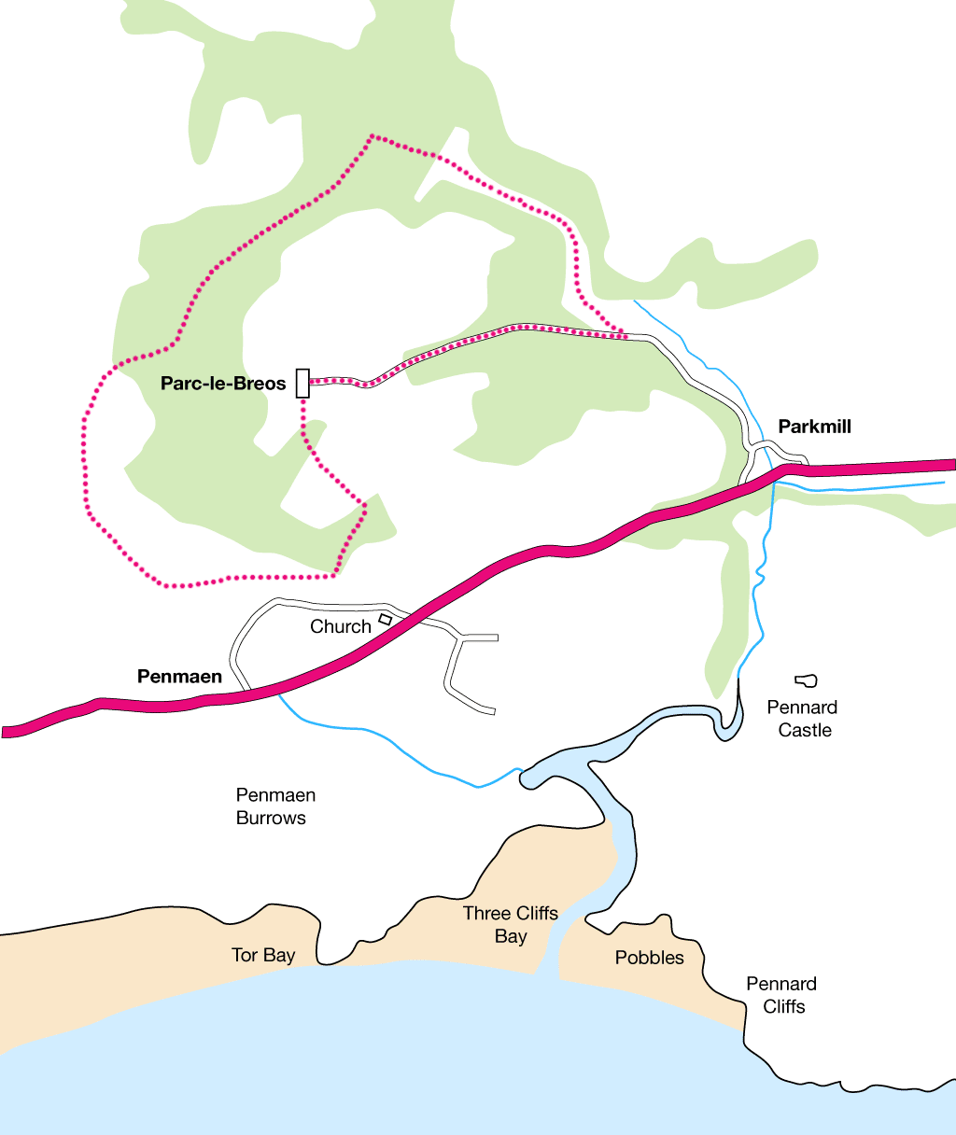
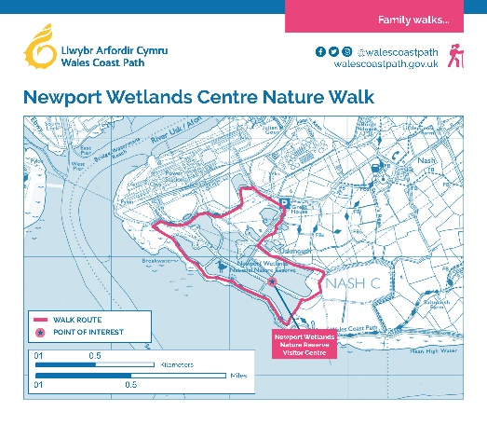
(Parc-Le-Breos, 2016)
(Wales Coast Path, 2020)

Methodology

To conduct this survey several pieces of lab equipment is required, these include:
- Tweezers
- Dissecting needle
- Dissecting tray or shallow dish
- Notebook and pen
- Light Microscope (optional)
- Lamp
- Digital Mass Balance
- Scoop
Once equipment is gathered PPE should also be prepared and worn, this includes disposable gloves and a lab coat. This will protect the wearer from the risk of contracting salmonella. This is a risk as the pellets are not fully digested and small mammals can carry salmonella (Grunberg, 2022).
The workspace will also need to be prepared ensuring it is clear of contaminants and all equipment is readily available.
The surveyor will have a bag of pellets from Parc Le Breos and a separate bag from Newport wetlands, these will also have corresponding waste bags to dispose of the pellets correctly one dissected.
Both the Newport Wetlands owl pellets and Parc Le Breos owl pellets were collected several years before the analysis of the samples. This means the pellets will have broken into fragments and lost their structural integrity. Due to this the average weight of an owl pellet, 5 grams with an uncertainty of +/- 1.8 grams, is weighed using the scoop, shallow dish and digital mass balance. This can be criticised as it may not be the sample will not be as representative as a newer pellet that still has its structure.
Once the sample is weighed all of the jaw bones and skulls are located and removed from the sample, they are then identified and results are annotated for each pellet sample. Each jaw bone or skull found is recorded as a separate specimen, the drawback to this is that it may lead to double counting of the same small mammal in the results.
If the bone sample is not clear immediately or needs identifying further then using the tweezers the teeth are plucked out of the jaw and the cavitation pattern is examined.
This is repeated five times for each site, resulting in a total of ten pellet samples. This is done by a group following the same methodology and procedure and results are shared centrally. This will ensure the data is more reliable as there will be a greater sample size (Andrade, 2020).
It is expected that as the landscape and land use of Parc Le Breos and Newport Wetlands is similar the Owl Pellet results will reflect this. However, due to the surrounding land use, a SSSI (Parc-Le-Breos, 2016) at Parc Le Breos and a city at Newport Wetlands, this may affect the health of the ecosystem and therefore its biodiversity. Because of this there may be an expectation of a higher range of species found in Parc Le Breos. Owls main prey is small mammals including shrew, voles, rats and mice; this is expected to be mirrored in the findings (Bales, 2022).

Results
In total there were 37 pellets sampled and 306 mammals identified, this was split into 174 mammals in 20 pellets in Parc Le Breos and 132 mammals in 17 pellets in Newport Wetlands. These were then identified as the following species:

Parc Le Breos

Common Name | Scientific Name | Number of specimens
Field Vole | Microtus agrestis | 150
Pygmy Shrew | Sorex minutus | 9
Common Shrew | Sorex araneus | 9
Wood Mouse | Apodemus sylvaticus | 1
House Mouse | Mus musculus | 5
Total Species | - | 174
(Keating, 2022)
A bar chat to show total number of each species found in the 20 Parc Le Breos pellets.

A pie chart to show the average composition of the Parc Le Breos Pellets.

Newport Wetlands

Common Name | Scientific Name | Number of specimens
Bank Vole | Myodes glareolus | 8
Field Vole | Microtus agrestis | 94
Pygmy Shrew | Sorex minutus | 5
Common Shrew | Sorex araneus | 5
Water Shrew | Neomys fodiens | 1
Wood Mouse | Apodemus sylvaticus | 16
Rat | Rattus rattus | 3
Water Vole | Arvicola | 1
Total Species | - | 132
(Keating, 2022)
A bar chart to show total number of each species found in the 17 Newport Wetlands pellets.

A pie chart to show the average composition of the Parc Le Breos Pellets.

Findings

After investigating owl pellets from both Parc Le Breos and Newport Wetlands, the results were all as expected. All small mammals found were rats, mice, shrews and voles (Bales, 2022).However, due to the proximity of Parc Le Breos to the Gower site of special scientific interest (Parc-Le-Breos, 2016) it is expected that there would be a greater biodiversity found there than the Newport Wetlands.
At 86% the Field Vole made up the largest proportion of species found in the Parc Le Breos pellets. Proceeding this was the Pygmy Shrew and Common Shrew, both at 5%. The species that least commonly found in the pellets were the House Mouse at 2% and Wood Mouse at 0.5%.
Similarly, in Newport Wetlands the field vole was in most abundance at 72%. After this, the Wood Mouse was most common at 12%, the Bank Vole at 6% and the Pygmy Shrew, Common Shrew, Water Shrew, Rat and Water Vole all less than 5% making up the remaining 10%.
This suggests that Newport Wetlands has a greater biodiversity of small mammal species than Parc Le Breos. This is because there is a greater range of species found in Newport Wetlands, with eight different species being observed compared to only five in Parc Le Breos. Additionally, the species in Newport Wetlands are more evenly distributed, with no single species making up more than 72% of the total, whereas in Parc Le Breos, the field Vole makes up 86% of the total. This suggests that the ecosystem in Newport Wetlands is healthier and more diverse than the ecosystem in Parc Le Breos (Cleland, 2011).
This may be due to the different landforms of Parc Le Breos and Newport Wetlands. This is because different pray will be found in different habitats (Benedeck , et al., 2021) and this is representative in the results. For example, Parc Le Breos is made up of mainly open farm land and grassland (Parc-Le-Breos, 2016) whereas, Newport Wetlands is comprised of a mixture of woodland, grassland and marshes (Wales Coast Path, 2020).
However, the drawback of comparing these data sets is that the pellets were collected from two different sites and therefore different owls. Even if the owls are the same species, they can may have different prey preferences (Taylor, 2009). This can be a result of many factors including age, sex and behavioural adaptations of the individual owls. Therefore, Parc Le Breos may appear to have less of a biodiversity but this could be a result of the owl having a prey preference over the field vole more so than the owl found in the Newport Wetlands.
On the other hand, there are many advantages to using this surveying technique. For example, from these results there is a better basic understanding of the small mammal biodiversity in both Parc Le Breos and Newport Wetlands. A land manager may compare this and see that they may need to apply more conservation efforts to the biodiversity in Parc Le Breos than in Newport Wetlands, which has a greater biodiversity.
Furthermore, from this, land managers may also be able to tailor their efforts specific to species. For example, the land manager of Newport Wetlands may put more efforts into the conservation of the Water Shrew as it makes up a low proportion (0.7%) of the species found in Newport Wetlands and is not found in Parc Le Breos. This highlights it may be more at risk than the more common Field Vole.
Contrastingly, it may not highlight other small mammals that require special conservation efforts as they weren’t found in the owl pellets but are at risk in the area.
In addition to this, there is not a great amount of historic owl pellet data in these regions. As a result of this it may be difficult for a land manager to trend the data and determine what species are declining and which species are in abundance. In this circumstance it would be useful to use this surveying technique in conjunction with others to determine more accurate data trends.

Conclusion
Overall, from this analysis it is clear that Parc Le Breos and Newport Wetlands have a similar ecosystem and small mammal community. It is also apparent that Newport Wetlands has a greater biodiversity in the small mammal community than Parc Le Breos.
The owl pellet dissection surveying technique is a valuable tool and can give a high level overview of the health of the biodiversity in the two areas and can therefore identify any specific conservation requirements. However, there are some limitations to this surveying technique and is recommended that this is to be used in conjunction with other surveying techniques to give the most beneficial biodiversity overview.

References
Andrade, C., 2020. Sample Size and its Importance in Research, Rockville Pike: National Library of Medicine.
Bales, R., 2022. What do owls eat?. [Online]
Available at: https://a-z-animals.com/blog/what-do-owls-eat/
[Accessed 2 12 2023].
Benedeck , A. M., Sirbu, I. & Lazar, A., 2021. Responses of small mammals to habitat characteristics in Southern Carpathian forests, s.l.: Sci Rep.
Cleland, E. E., 2011. Biodiversity and Ecosystem Stability , San Diego: Nature Education .
Grunberg, W., 2022. Salmonellosis in Animals, Rahway: Merck & Co.
Keating, H., 2022. House Mouse or Field Mouse? Easy guide to types of UK Mice, Voles and Shrews, Lincolnshire: Woodland Trust.
Parc-Le-Breos, 2016. Cefn Bryn, Long Oaks & Green Cwm Walk – Gower. [Online]
Available at: https://parc-le-breos.co.uk/walks-for-guests/cefn-bryn-long-oaks-green-cwm-walk/
[Accessed 2 12 2023].
Taylor, I. R., 2009. How Owls Select Their Prey: A Study of Barn Owls Tyto alba and Their Small Mammal Prey, s.l.: Bio One Digital Library.
The Barn Owl Trust , 2021. Barn Owl roosting and nesting places. [Online]
Available at: https://www.barnowltrust.org.uk/how-to-manage-land-for-barn-owls/roosting-nesting-places/#:~:text=Once%20settled%20into%20their%20home,they%20use%20and%20ignore%20others.
[Accessed 2 12 2023].
The Barn Owl Trust, 2021. Home › Barn Owl facts › Barn Owl pellet analysis. [Online]
Available at: https://www.barnowltrust.org.uk/barn-owl-facts/barn-owl-pellet-analysis/#:~:text=Barn%20Owls%20are%20unable%20to,form%20of%20an%20owl%20pellet.
[Accessed 2 12 2023].
Wales Coast Path, 2020. Newport Wetlands Centre Nature Walk. [Online]
Available at: https://www.walescoastpath.gov.uk/plan-your-visit/itineraries/family-walks/newport-wetlands-centre-nature-walk/?lang=en
[Accessed 2 12 2023].

