
BA (Hons) Business Management
LCBB5000: Data Handling and Business Intelligence
Lecture : Anupam Mazumdar
Student name : Elena -Mihaela Bucur
Student id : 2133670

Part 1

The Use of Microsoft Excel to Pre-processing, Analysing and Visualising the Data
Being a component of the Microsoft Office product, Microsoft Excel is a data formation, organisation, and analysis application that has been used by officials of all sorts of organisations for years (Gillis, 2021). Businesses use Microsoft Excel for a variety of reasons, such as collecting and verifying business data, analysing the data, accounting and budgeting, project management, office administration, and many more. The general application of Microsoft Excel is divided into three parts: pre-processing the data, analysing the data, and visualising it.
Data preprocessing is the primary step to make data ready for analysis, where the user has to import data based on historical records or findings from the primary sources (Adari, Raja and Vijaya, 2023). In this step, the information is input numerically by labelling it beforehand as per the needs. Alternatively, descriptive data is utilized for future understanding and application. Considering it a machine learning model, the pre-processing step helps to remove unnecessary words and spaces, make the format standardised, adjust the inconsistencies, enter the missing values, and remove the duplicates (Acheme and Vincent, 2021). These activities in the data preprocessing step help to make the data meaningful to both the users and the views. The benefits of data preprocessing also include improving accuracy and reliability while getting rid of unwanted errors. However, it is quite a time-consuming process since the work has to be done manually, and if any error remains, future analysis becomes difficult.
The data analysis step is useful to transform data in order to conduct research or interpret it to make informed decisions. In the data analysis process, trends, outliers, patterns, and other notable events in the data set are identified to gain insights from them. There are several ways to analyse the data based on the needs of the individual or the organisation. As it is important to all the functional areas of the businesses, such as finance, marketing, sales, R&D, human resources, etc., depending on the findings, the users can derive conclusions (“Step-by-step guide to analyze data with Excel: Expert insights,” 2021). While simple analyses such as what-if analysis, VLOOKUP, XLOOKUP, PIVOT table preparation, etc. can be done in Microsoft Excel, many difficult statistical analyses like p-test, t-test, f-test, z-test, linear and multiple regression analysis, significance analysis, and much more can be done using this software (Patel, 2021). The use of Microsoft Excel in data analysis makes it evident that this is one of the most important tools in the Microsoft Office suite.
The final step, data visualisation, refers to the process of presenting the data in the form of a graphic to assist the interested audience in better understanding the analysed information. Data visualisation can be done using various Excel templates, such as bar charts, pie charts, line graphs, scatter diagrams, etc. (Hati, 2023). Data visualisation is helpful to make faster decisions, as it provides a complete understanding of the data that makes sense to the audience. It generally strengthens the impact of the analysis and communicates the relevant information in a more comprehensive manner (Kalluri, 2020). All sorts of businesses require data visualisation to solve many business problems, for which Microsoft Excel is a useful tool.

Demonstration of the Use of VLOOKUP
VLOOKUP refers to the full form of ‘Vertical Lookup’, which is used in Microsoft Excel in order to find a certain value of something from the table array. Mainly, there are a few components: the value aimed at, the range of the value, and the number of the column. When the value is not found, it stands for 0 or ‘FALSE’, and when the value is found, it stands for 1 or ‘TRUE’ (What is VLOOKUP // Excel glossary // PerfectXL Spreadsheet Validation, 2020).
In order to determine the increase or decrease in the average price of room reservations over the years from 2017 to 2022, the data are first pre-processed according to the years.
The formula used of sorting the data of 2017 is:
$$=IFNA(VLOOKUP(2017,J2:Q2,8,FALSE),"NO")$$
For the years 2018 to 2022, the same formula is used, except that 2017, which refers to the years, is replaced by the respective years to sort the data for each of those years. In this case, the IF formula has been used to separate each year according to its prices. It is clearly visible that not all the data contains information about every year, so for the years where data is not available, it would show “NO” as used in the formula. More specifically, “NO” stands for “FALSE”, and the value shown in the dataset stands for “TRUE”. After using the above-mentioned formula, they are duplicated until the last cell contains the data for each of the years from 2018 to 2022.
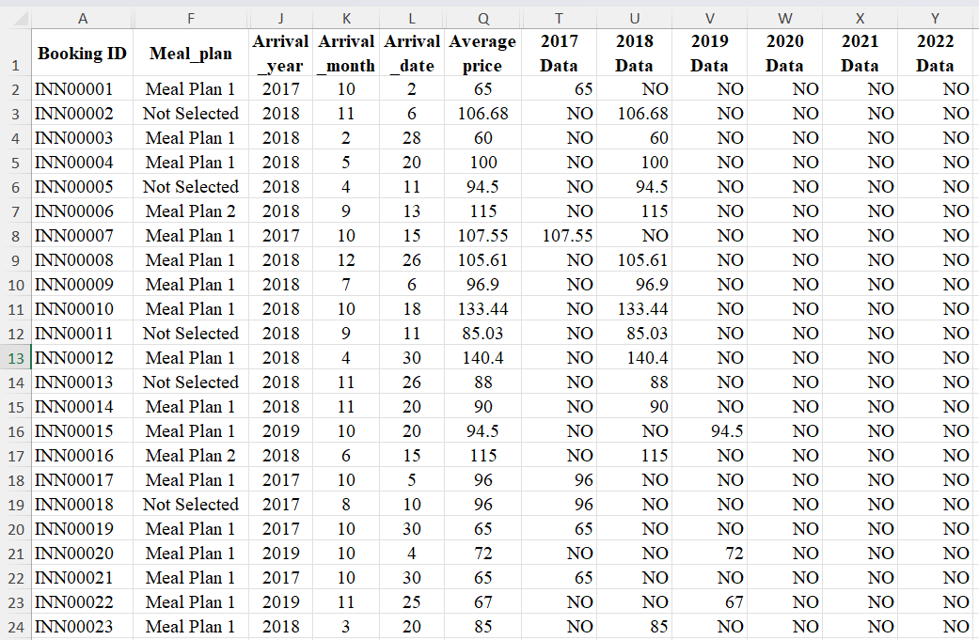
The dataset then looks like the above-shown image, where some unnecessary data is hidden. After the process is completed, the mean price of room reservations is calculated for each year.
The following formula is used for year 2017 $=AVERAGE(T2:T36276)$
The same formula is used for the years 2018–2022, while selecting their respective columns and cells for calculation. The following outcomes show up in the software:
Average Price of 2017 | Average Price of 2018 | Average Price of 2019 | Average Price of 2020 | Average Price of 2021 | Average Price of 2022
90.0498541 | 106.4527274 | 101.7812994 | 105.339899 | 101.2333333 | 101.499242

Demonstration of the Use of PIVOT TABLE
The pivot table is a tool to filter, sort, and group large volumes of data according to the selected metrics of dimensions (Explore Your Data with Pivot Tables, no date). The large dataset may often make the audience confused about the valuable data in the dataset as it is not presented in a concise manner (Gupta, 2023). The pivot table is used to bridge this gap and benefit both businesses and interested users.
In order to determine the increase or decrease in the average hotel room reservation price, all the data are selected together to create a pivot table in a new sheet in the same file. Then, from the PivotTable Fields options, the Arrival_year is selected and put in the “Row Fields” options, and the Arrival_price is selected and put in the “Value Fields” options. By doing so, the following results are found:
Sum of Average price
Arrival_year | Total
2017 | 549304.11
2018 | 2984721.6
2019 | 18015.29
2020 | 20857.3
2021 | 19436.8
2022 | 159353.81
Grand Total | 3751688.9
But since the purpose is to determine the changes in the average price, the sum of the average price will not be of any use. In order to mitigate this problem, the “Value Field Setting” option is selected by right-clicking on the mouse and choosing “Average of Average Price” from there. Now, the outcome shows something like the following, which helps to meet the primary objective of determining the decline or increase in the average price of room reservations in the hotels.
Average of Average price
Arrival_year | Total
2017 | 90.0498541
2018 | 106.4527274
2019 | 101.7812994
2020 | 105.339899
2021 | 101.2333333
2022 | 101.499242
Grand Total | 103.4235391

The values found are exactly the same as it was found by using VLOOKUP function.

Meaningful Chart Based on the Findings

The line chart shown above illustrates the average price of hotel room reservations from 2017 to 2022. As indicated by the graph, room reservation costs have fluctuated in the last six years’ data, with the least in 2017 and the highest in 2018. After 2018, the average room reservation price declined in 2019, but it increased in 2020. In 2021 and 2022, the average room reservation price was somewhat similar. Since the price of a room reservation did not vary much between 2021 and 2022, it can be said that the price in these two years was stable as compared to the previous few years. This can be considered a positive development by the price regulation authority.

Part 2
The IBM SPSS software is a software package that provides researchers with the opportunity to conduct advanced statistical analysis of big data with ease of use, flexibility, and scalability (SPSS software, no date). IBM SPSS 25.0 is used to produce the report evaluating the findings from meeting the given objectives from the given dataset. The data are first transferred from the Student_Score.csv file to the SPSS software ‘Data View’ section. For different attributes of the dataset, the level of measurement is selected in the ‘Variable View’ section.
The variables, such as school, School_setting, School_type, Classroom, Teaching_method, Student_ID, Gender, and Lunch are measured as nominal data, while Student_No, Pretest and Posttest are measured as scale data.

Number of Male and Female Students
In order to determine the number of male and female students, the “frequency distribution” of “descriptive statistics” is used. Here, in the data view section, females are depicted by the numerical value ‘1’ and males by the numerical value '2'.

Gender
 |  | Frequency | Percent | Valid Percent | Cumulative Percent
Valid | 1 | 1056 | 49.5 | 49.5 | 49.5
Valid | 2 | 1077 | 50.5 | 50.5 | 100.0
Valid | Total | 2133 | 100.0 | 100.0

The results suggest that, among the 2133 students, there are a total of 1056 female students, who make up 49.5% of the total students. On the other hand, 1077 students are male, consisting of the rest percentile of the students.

Number of Students Qualifying and Not Qualifying for Reduced/Free Lunch
For determining the students who qualify for reduced or free lunch and who do not, the “frequency distribution” of “descriptive statistics” will again be used. Here, in the variable view section, those who qualify for reduced or free lunch are depicted by the numerical value ‘1’, while those who do not qualify for free lunch are depicted by the numerical value '0'.

Lunch
 |  | Frequency | Percent | Valid Percent | Cumulative Percent
Valid | 0 | 1215 | 57.0 | 57.0 | 57.0
Valid | 1 | 918 | 43.0 | 43.0 | 100.0
Valid | Total | 2133 | 100.0 | 100.0

The findings suggest that 57.0% of the 2133, consisting of 1215 students, do not qualify for a reduced or free lunch. On the other hand, a total of 918 students, who are actually 43.0% of the total students, had the opportunity to get a reduced or free lunch from their schools.

Mean and Median of Students Qualifying or Not Qualifying for Reduced/Free Lunch
By definition, mean and median are the average of the dataset and the value that separates the highest and lowest values equally. The data of 2133 students are of similar categories, from whom it is not possible to determine the mean and median of students who either qualify or do not qualify for the reduced or free lunch. However, using the SPSS software, the following values can be found:
Statistics
Lunch
N | Valid | 2133
N | Missing | 0
Mean |  | .43
Median |  | .00

The table shows that the mean is.43, which actually means that 47% of the students qualify for free lunch. The median value is .00, meaning that there is no median value for the number of students. However, it would have been possible to calculate the mean and median if any particular attribute of the students were provided. For example, if the mean or median marks of students in their pretest and post-test were to be determined, it would have been possible.

Mean and Median Differences of Students Pre-test and Post-test Scores
As mentioned earlier, it is possible to determine the mean scores of the students in the pre-test and post-test. The following result is found from conducting the analysis in SPSS software:

Statistics
 |  | Pretest | Posttest
N | Valid | 2133 | 2133
N | Missing | 0 | 0
Mean |  | 54.96 | 67.10
Median |  | 56.00 | 68.00
As the result suggests, the mean value of students’ scores in the pre-test was 54.96, while the median was 56.00. On the other hand, the mean value of students’ scores in the post-test was 67.10, while the median was 68.00. This indicates that students performed better in post-tests than pre-tests. It is possible that there is a positive relationship between the post-test results and the students’ qualifying for a reduced or free lunch.
The difference in mean value between the pre-test score and post-test score:
$$67.10-54.96=12.14$$
The difference in median value between the Pre-test score and Post-test score:
$$68.00-56.00=12.00$$

Specific Example of Clustering (ex, K-Means Clustering)
K-means clustering refers to the process of finding a relatively homogeneous group of cases based on their characteristics (IBM documentation, 2021). In K-means clustering, the number of clusters is predetermined, and since there are similar data points, the companies can utilise the results more effectively to make any decision or devise any strategy (Sharma, 2023).
By using the dataset Student_Score.csv provided in conjunction with SPSS, the following steps shown in the figures are followed: Here, in order to conduct K-means clustering, the pre-test and post-test scores are used.
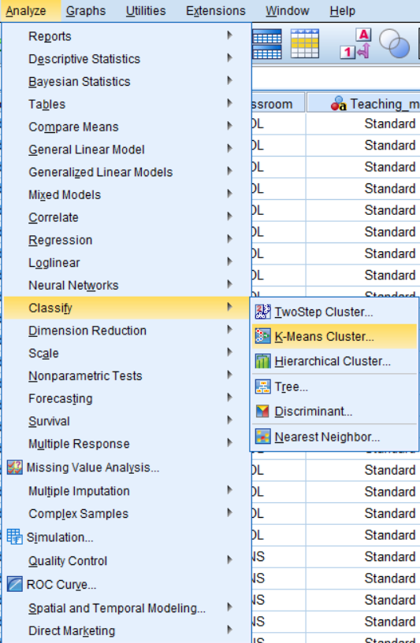
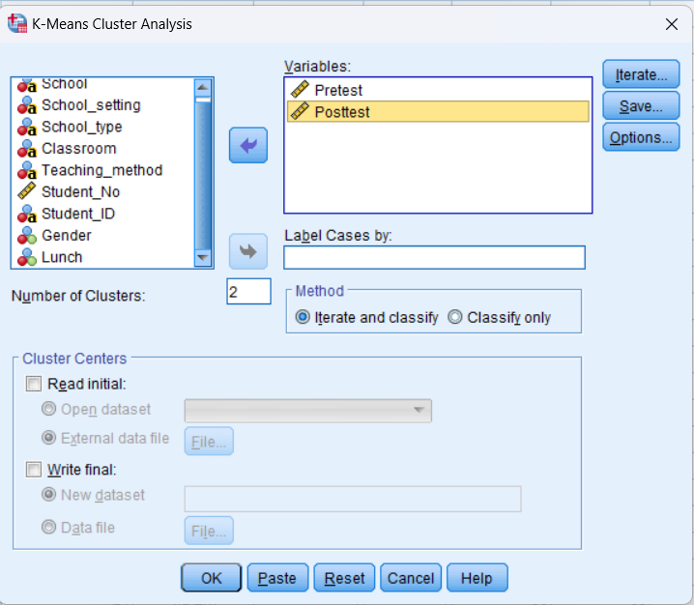
As shown in the screenshot, there will be 2 clusters in the K-Means cluster analysis, while the method selected is “Iterate and classify." The analysis shows the following results:
Initial Cluster Centers
 | Cluster
 | 1 | 2
Pretest | 23 | 93
Posttest | 35 | 100
The table above, “Initial Cluster Centers” shows the variable values of the k well-spaced observations.

Iteration Historyª
Iteration | Change in Cluster Centers
Iteration | 1 | 2
1 | 30.191 | 33.606
2 | .885 | .791
3 | .611 | .532
4 | .212 | .181
5 | .227 | .200
6 | .150 | .128
7 | .000 | .000
a. Convergence achieved due to no or small change in cluster centers. The maximum absolute coordinate change for any center is .000. The current iteration is 7. The minimum distance between initial centers is 95.525.

The table of iteration history highlights that in early iterations, the cluster centres shift quite a lot, but from the second iteration, they have settled down to the general area of their final location until the seventh iteration.
Final Cluster Centers
 | Cluster
 | 1 | 2
Pretest | 43 | 65
Posttest | 55 | 78

The final cluster centres are computed as the average for each variable within each final cluster, indicating that in the second cluster, the students’ scores in the pre-test and post-test were significantly higher than the first cluster.
Number of Cases in each Cluster
Cluster | 1 | 993.000
Cluster | 2 | 1140.000
Valid |  | 2133.000
Missing |  | .000

As the above table shows, a large number of cases were assigned to each of the clusters. It can be said that a higher number of clusters could have depicted better results for understanding.

5 Most Common Data Mining and Text Mining Methods with Real World Examples
Data Mining Methods
Method | Description | Real Life Example
Classification | Classifying large population of data into a model to sort them into a predetermined set of classes (Zuha and Achuthan, 2016) | Fraud detection.
Clustering Analysis | The process of grouping objects according to clusters with most similarities to less similarities (Papakyriakou and Barbounakis, 2022) | Listing customers’ characteristics based on household income.
Correlation Analysis | The strength of association between two or more variables (Tsui et al., 2006) | Monitoring the reaction of customers to different marketing tactics to increase or decrease sales.
Decision Tree Induction | The model based on classifying data in a form of tree structure (Papakyriakou and Barbounakis, 2022) | Partitioning the training set of employees based on their performances.
Regression Analysis | The model to identify the relationship between one or more independent and dependent variables in the dataset (Zuha and Achuthan, 2016) | Determining the relationship between employee performance and product sales.

Text Mining Methods
Method | Description | Real Life Example
Extraction of Information | Gathering in-depth and complete information that are relevant from a large amount of text (Talib et al., 2016) | Gathering information on sales numbers, purchasing costs, operating margins, etc.
Retrieval of Information | Extracting information and building structured knowledge based that are of higher precision (Thakur and Kumar, 2022). | Retrieving keywords for search engine optimisation from blog articles.
Text Summarisation | Summarising the text documents depending on sentence length, fixed phrase, paragraph, thematic word, etc. (Talib et al., 2016) | Summarising interview of a customer regarding a product of service.
Latent Dirichlet Allocation (LDA) | The process of synthesising the correlations between the topics and words presented in the collection of documents (Thakur and Kumar, 2022). | Building recommendation systems in business by understanding the areas of interest for users.
Text Clustering | Processing textual data into clusters to identify meaningful patterns (Thakur and Kumar, 2022). | Segmenting customers based on their common buying patterns.

Advantages and Disadvantages of Using SPSS and Excel in Practical Field
Advantages and Disadvantages of Using SPSS
No. | Advantage | Disadvantage
1 | The user interface of SPSS is very simple and intuitive. | In industries where a huge data set is required to analyse, it is not idea to use SPSS since it is difficult to find if there is any inconsistency.
2 | It can be used to analyse both qualitative and quantitative data. | Not all features of SPSS can be understood easily, additional training is required in some cases.
3 | The outputs can be customised by changing colours of the charts and fonts of the texts. | The price of SPSS is relatively higher than many other statistical software.
4 | The chances of errors are relatively low in SPSS. | There is no built-in data interpretation facility in the software.
5 | Data recoding and data cleaning facilities in the SPSS software reduces the efforts of the researchers. | The software cannot recognise it if any data is manipulated for the desired outcome.

Advantages and Disadvantages of Microsoft Excel
No. | Advantage | Disadvantage
1 | The interface of Microsoft Excel is quite simple to understand. | There are chances of errors and inconsistencies when complex formula in multiple worksheets are used.
2 | The calculations using Microsoft Excel is very fast and easy. | For large businesses, Microsoft Excel can be used for data storing, they may often require customised software other the Excel for their daily operations.
3 | Data visualisation by presenting them through graphs and charts is very easy. | Collaborative work cannot be done using Microsoft Excel.
4 | The use of Microsoft Excel increases efficiency and productivity in the employees. | The formula required to apply them in data analysis is not easy at all.
5 | Not much training is required to use Microsoft Excel. | Microsoft Excel is considered as vulnerable to fraud and corruption.

References
Adari, G.K., Raja, M. and Vijaya, P. (2023) “Machine learning in genomics: identification and modeling of anticancer peptides,” in Data Science for Genomics. Elsevier, pp. 25–68.
Explore Your Data with Pivot Tables (no date) Salesforce.com. Available at: https://trailhead.salesforce.com/content/learn/modules/datorama-reports-for-marketing-cloud/explore-your-data-with-pivot-tables (Accessed: December 11, 2023).
Gillis, A.S. (2021) Excel, Enterprise Desktop. TechTarget. Available at: https://www.techtarget.com/searchenterprisedesktop/definition/Excel (Accessed: December 11, 2023).
Gupta, A. (2023) An introduction to pivot table in excel, Simplilearn.com. Simplilearn. Available at: https://www.simplilearn.com/tutorials/excel-tutorial/pivot-table (Accessed: December 11, 2023).
Hati, S. (2023) Building Data Visualization in Excel, Knowledgehut.com. Available at: https://www.knowledgehut.com/blog/business-intelligence-and-visualization/data-visualization-excel (Accessed: December 11, 2023).
IBM documentation (2021) Ibm.com. Available at: https://www.ibm.com/docs/en/spss-statistics/beta?topic=features-k-means-cluster-analysis (Accessed: December 11, 2023).
Kalluri, K. (2020) “Importance, purpose, and benefit of Data Visualization tools!,” Business Analytics Platform with Pre-Built Insights | SplashBI. SplashBI, 14 August. Available at: https://splashbi.com/importance-purpose-benefit-of-data-visualization-tools/ (Accessed: December 11, 2023).
Papakyriakou, D. and Barbounakis, I.S. (2022) “Data mining methods: A review,” International journal of computer applications, 183(48), pp. 5–19. Available at: https://doi.org/10.5120/ijca2022921884.
Patel, H. (2021) A comprehensive guide on advanced Microsoft Excel for data analysis, Analytics Vidhya. Available at: https://www.analyticsvidhya.com/blog/2021/10/a-comprehensive-guide-on-advanced-microsoft-excel-for-data-analysis/ (Accessed: December 11, 2023).
Sharma, P. (2023) The ultimate guide to K-means clustering: Definition, methods and applications, Analytics Vidhya. Available at: https://www.analyticsvidhya.com/blog/2019/08/comprehensive-guide-k-means-clustering/ (Accessed: December 11, 2023).
SPSS software (no date) Ibm.com. Available at: https://www.ibm.com/spss (Accessed: December 11, 2023).
“Step-by-step guide to analyze data with Excel: Expert insights” (2021) Ppcexpo.com, 18 February. Available at: https://ppcexpo.com/blog/analyze-data-with-excel (Accessed: December 11, 2023).
Talib, R., Kashif, M., Ayesha, S. and Fatima, F. (2016) “Text Mining: Techniques, Applications and Issues,” International journal of advanced computer science and applications : IJACSA, 7(11). Available at: https://doi.org/10.14569/ijacsa.2016.071153.
Thakur, K. and Kumar, V. (2022) “Application of text mining techniques on scholarly research articles: Methods and tools,” New review of academic librarianship, 28(3), pp. 279–302. Available at: https://doi.org/10.1080/13614533.2021.1918190.
Tsui, K.-L., Chen, V., Jiang, W. and Aslandogan, Y. (2006) “Data Mining Methods and Applications,” in Springer Handbook of Engineering Statistics. London: Springer London, pp. 651–669.
What is VLOOKUP // Excel glossary // PerfectXL Spreadsheet Validation (2020) PerfectXL. Available at: https://www.perfectxl.com/excel-glossary/how-to-use-vlookup-excel/ (Accessed: December 11, 2023).
Zuha, F. and Achuthan, G. (2016) “Analysis of Data Mining Techniques and its Applications,” International journal of computer applications, 140(3), pp. 6–14. Available at: https://doi.org/10.5120/ijca2016909249.

