BLOGGING TO COMMUNICATE – ASSESSMENT 1

Table of Contents
Task 1A Blogs 3
Blog 1 Situation Analysis 3
Blog 2 Branding Strategy 5
Blog 3 STP Analysis 6
Blog 4 Marketing mix strategy 10
Blog 5 Competitor analysis 12
Blog 6 IMC strategy 15
References 17
Appendices 19
Appendix 1: Nike Joyride Fly knit Run 19

Task 1A Blogs

Blog 1 Situation Analysis
Student name : Costel Popovici
Student number : 1818042
Module title : Marketing Fundamentals
Assignment title : Group Blog
Module Lecturer’s name : Tushara Baladran

Nike takes wraps off new technology for running show, which is called as Joyride. Such new kind of cushioning does uses innovative approach for protecting feet, legs of runners. It also potentially delivering enhanced performance within context of effect absorption, through it also offers effective energy return. This translates towards faster legs and fresher upon long distance runs that need to help in preventing injuries with speed recovery (nike.com, 2019). On other hand, this did not take too long for new product for catching attention of the environmentalists, who has been asking quick questions regarding Nike’s micro plastic use, while creating the new product.
Nike on their quest of making sports shoe better, completely optimised and sleeker to meet demands of runners, they have released their current shoe innovation. Joyride shoes have new system of proprietary cushioning of Nike, starting from £106.92 (cnet.com, 2019). It seems to support in decreasing strain on ankles, feet and legs of runners. On contrary, though not designed explicitly for fresh runners, Nike commented that these shoes can easily make running appears as easy for all at each experience level.
Instead than the heel striking, runners land on balls of their feet to bounce forward. In addition to this, Joyride feels quite amazing in this speed with great combination regarding lightweights. It also feels bouncy, which made runners to feel as if they are flying (nike.com, 2019). These shoes have noticeable and springy feeling in ball of their foot, which made it quite easier to move to next step. The following are trends of Joyride shoes by Nike:
- Beads are fun, colourful
- Shoes feel like feather light
- Fly knit upper has been breathable, stretchy
- Bouncy feeling is great (nike.com, 2019)
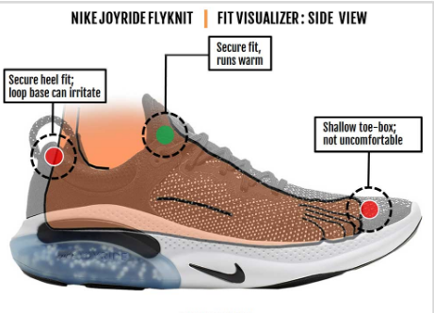
Figure 1: Nike Joyride Fly knit Run
(Source: nike.com, 2019)
Beads
They are bouncy, soft and form core of innovative and new system of cushioning that are designed to support by making all ways, which make runners to feel easy, while running.
Softer System of Cushioning
Nike has spent years by obsessing beads by finding right shape, feel and size to deliver comfortable and soft ride. Each time they take step and stride, about more than 10,000 (nike.com, 2019). Beads are shaped around their foot to serve support and personalised cushions, before bouncing back, responsively to propel forward.
Absorbs Impact
Such soft ride is not easy on runner’s foot, though it supports their whole body to feel good. Cushioning system of Nike Joyride offers about 14% of better influence absorption, while comparing with some of their most trusted running shoes for running. These are tested with Nike FK2 Epic React and Nike Pegasus 36 Air Zoom (nike.com, 2019).
Nike’s Joyride is result of iterative and intense trailing. About 150 materials are tested before its landing on TPE, which is copolymer of rubber, plastic for beads. Furthermore, engineering Pods also supported to solve issue of beads that are migrating very much around foot, leading to uncomforted. Thus, with Pods, designers of Nike are able to make zone tuning for Nike Joyride. Besides, these beads are quite dispersed within pods for matching zone tuning, which aligns with performance requirements of particular points within their stride (news.nike.com, 2019). For instance, in case, if there are about 8,000 overall beads in running shoe, then, about 50% of these beads can cover these heel strike, though about 5% can offer such cushioning for their toe.

Blog 2 Branding Strategy
Student name : Camelia Crainiceanu
Student number : 1816246
Module title : Marketing Fundamentals
Assignment title : Group Blog
Module Lecturer’s name : Tushara Baladran

Nike currently unveiled its cushioning system of Joyride shoes with detailed review, look on this debut shoe. It is sporting combination of neoplance with Fly knit featuring the upper layer; Nike Joyride offers stretchy build towards accommodation of more foot shapes. However, Nike Joyride sent them this shoe with size up of ½ from their usual size (weartesters.com, 2019). This can have any mistake, though it can also have it because of bit snug of this shoe as it is for running purpose. Even at size of ½, which is larger than their true size, this shoe has still been on snug size. Thus, wide footers can want to regard going up to size for ½. Joyride itself has wielded feeling, though Jarring primarily conforms to their foot as the time passes by. On other hand, such primary breakdown with review covers more lead Nike to perform with updated review upon shoe from casual perspective and performance running viewpoint. Henceforth, Nike Joyride is presently scheduled for release on 15th August at official website of Nike. It is also available to members of Nike+ from 1st August with price of £137.47 (weartesters.com, 2019).
Young athletes are Nike’s target market in future for Joyride shoes. With this brand, Nike has powerful position for impacting with these young customers by the launching of digital platform regarding engaging these customers for joining that. It helps to make good relationship along with customers. In case, if Nike creates best relationship along with their customers, then they can find out their requirements and demands of customers. As this organisation has conducted this by giving better consumer service, even when consumer fact such issue to send emails towards Nike to get rid of their issues, associated with buying. This firm can solve respective issues within three working days, while consumers can easily solve their issues with support of websites as well as sending emails to them (about.nike.com, 2020). Therefore, this made customers to have some positive picture of Nike within respective minds that can raise their buying decisions with their behaviour towards Nike commodities, especially Joyride shoes, as per Nike’s customer decision process. [Referred to Appendix 1]
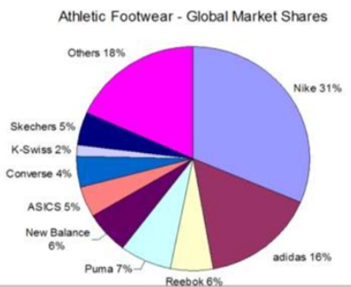
Figure 2: Nike’s Market Share as compared to its Rivals
(Source: nike.com, 2019)
Market share and status of Nike along with its rivals within athletic market represents their competitive analysis. This can be observed that Nike has the highest worldwide market share of 31%, while its key competitors have much less. Adidas have 16%, Reebok have 6% and Puma have 7% of market share (nike.com, 2019).

Blog 3 STP Analysis
Segmentation
Demographic Segmentation
Student name : Geanina Isabela Marica
Student number : 1817789
Module title : Marketing Fundamentals
Assignment title : Group Blog
Module Lecturer’s name : Tushara Baladran

Nike segmented gender group and age group, which has Joyride shoes that serve both genders with age range, such as 15 years to 55 years (about.nike.com, 2020).
Behavioural Segmentation and Psychographics Segmentation
Nike has such segmentation in order for answering a question that why customers require this new shoe and what customers are having interest with buying habits. Therefore, about such Nike segments, market is also included. Moreover, it also deals with athletic oriented and sports purposes with active lifestyle having interest in exercise along with fitness for recreation.
Geographic Segmentation
Depending on such segmentation, Nike has this for serving all target consumers all over globe. This has key markets within Europe, Asia Pacific, USA, Africa, though it have some continuous goal for catering markers within other nations (wired.co.uk, 2019). These nations involved China, Middle East, Japan, North America and many more.
Socioeconomic Segmentation
Commonly, education, occupation and income are interrelated because of fact that customers having higher levels of education enjoy higher revenue with more respective status. Therefore, segments market of Nike in upper middle class, upper class and lower class, where in last group, Nike serves sports equipment within limited editions (about.nike.com, 2020). That can be purchased only from customers having high income.

Figure 3: STP Analysis
(Source: blog.smalldogcreative.com, 2018)
Targeting
Regarding market segmentation, this firm has the niche market for serving based on focuses as well as targets of Nike. They have been targeting sports person and athlete segment and serves needed goods to them, such as apparel products and sports shoe products. These have quite unique and particular features, in comparison to the other sports shoe goods. Henceforth, following are certain Nike’s target strategies:
- Target strategies of Nike involve aggressive marketing for making aware for their target customers about Joyride shoes. However, Nike make their target customers are able to achieve their desired commodities by process of customisation (wired.co.uk, 2019). In addition to this, their own signed shoe has been offered to the athletes, which becomes enabled for Michael Jordan in order to have its name as Jordan shoes.
- In comparison to this, their targeting strategies involve sponsorship of Joyride shoes by celebrities and sports teams. They also have styling objectives for its products by psychological tactics upon target market. It can be done through linking triumph along with appeal, which leads their product to view as their victory, when the sponsorship has been conducted on behalf of athlete celebrities.
- Another strategy regarding targeting include cross training by Nike, which has been developed in year 1989 that caters overall athlete participants in whole world (news18.com, 2019). It trains various sports activities that also become way towards making their target market as satisfied.
Positioning
Nike has been positioning itself within mind of their target consumers as leader regarding sports products. This organisation has made Joyride shoes, which can satisfy respective niche market along with overall of their other products that are associated with sports. In addition, their slogans “Just Do It” have made appeal towards target customers for purchasing this product along with some sense of confidence along with inspiration. Furthermore, Joyride shoes also have made this as key competitor within athlete industry.
Nike’s positioning statement is “For each serious athlete, this firm serves perfect sports commodities and shoes, which provides confidence regarding each activity’ of sports (nike.com, 2019). Nike has following strategies for positioning:
- Appealing attitude with style
- Appealing valuable products and quality level
- Improving fantasy and athletic lifestyle in customer mind
- Positions itself being premium brand along with well designed goods

Figure 4: Just Do It
(Source: nike.com, 2019)
USP
USP is way that tells customers of Nike that how this company is different from competition. This is the ultimate benefit offered by this organisation, which they fail to do so, though they can make promises to deliver on such benefit. In addition to this, they also concentrate on commitment for communicating that this promise is for all those that Nike performed (blog.smalldogcreative.com, 2018). USP also appears as critical component for branding strategy of USP, as this can shift their brand to next level.
USP has been driving certain of most successful strategies for branding. For example, Nike took sale of regular and commoditised sneakers and products, such as Joyride shoes. It also focuses on building mystique all around them along with some innovative designs having high quality and durable sports shoe. Besides, famous slogan of Nike “Just Do It” with Nike’s distinctive and swoosh logo does differentiate this product from its rivals (blog.smalldogcreative.com, 2018). Moreover, Nike brand depend on philosophy that all is athlete and this firm has sports apparel and sports shoes to support customers to realise respective ambitions. Instead, premium prices of Nike, this company became iconic brand globally.

Blog 4 Marketing mix strategy
Student name : Laurentiu Marcel Gornic
Student number : 1817470
Module title : Marketing Fundamentals
Assignment title : Group Blog
Module Lecturer’s name : Tushara Baladran

Every new offering regarding products or services needs to have a comprehensive marketing. When product is offering high-level technology-orientation, analysis of marketing trends and respective components is an essential criterion. In this context, Nike is recognised for its tech-savvy product innovation and is able to utilise a consolidated platform of 4P’s of marketing mix for communicate or share information about new products and services to intended audience. In this view, specific strategy in product, price, place and promotion is integral for its innovation Nike Joyride Flyknit Run that is designed for providing comfort at extreme level to its end-users (nike.com, 2019).
Product
This shoe is a proprietary innovation of Nike that is engineered for keeping legs fresh through delivery of personalised underfoot experience such as featuring impact absorption technology in an energy-returning package. On outside, this product is having a look of usual lightweight and super-sleek running shoes of Nike. The upper part is looking like made of signature Flyknit material of Nike that is stretchable likewise a sock. However, inside part of Joyride shoes has features that are more interesting. Sole is composed of 3-4 layers based on selected size and filled with innumerable TPE (thermoplastic elastomer) beads which are compressible for absorbing shock as well as expandable when running so that a springy feeling can be there for individual (cnet.com, 2019).
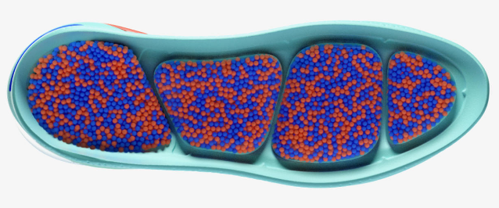
Figure 1: Joyride Flyknit Run
(Source: news.nike.com, 2019)
During contact with running surface, beads are shifted and compressed to mold according to foot size. The proprietary cushioning system being integrated with this footwear is placed within some zonally tuned pod systems, which are actually responsible for allowing TPE beads to expand to all directions (wired.co.uk, 2019). This multi-dimensional displacement technology is catering for a dynamic foot bed. In this context, it can be seen that the engineering technique being used in this product is offering pod scale that is allowing suitable striking of foot on the ground. For example, heel pod is facilitative for absorbing impact while pod scale present at forefoot is facilitating a smooth transition in forward direction.
Price
A competitive as well as value-based pricing strategy must be used for promoting suitably this product. This product is available in different sizes and in different color combinations. Starting price of Joyride shoes can be within the range of $140 USD to $180 USD (nike.com, 2019). However, based on market responses, there will be the chance for scooping the price up or down accordingly. Target customers must be considered as premium segment prior to strategise pricing models for this product.
Place
This Joyride Flyknit shoes can be sold worldwide exclusive Nike stores along with multi-brand stores. Nike has presence in more than 200 countries worldwide having tied up with innumerable retail accounts. Within context of international market, Nike has strengthened relationships with several licensees, franchises, independent distributors and subsidies and all can be approached for experiencing a higher sales rate for Joyride shoes. In this accordance, it can be argued here that Nike can do long-term plan for opening more personalised retail stores and franchises so that target customers can be reached easily with expansion in numbers of maximum potential buyers. Indeed, outsourcing strategy can be taken for reducing manufacturing cost of this product. Online platform will be a great place for increasing sales count of this new product of Nike and Nikeid is suitable for allowing most numbers of customers to interact about this product (about.nike.com, 2020). Alongside, Nike town shop, flagship stores and retail discount stores may also be approached for favoring sales prospects of this latest innovation.
Promotion
It is known to all that Nike has enough potential to attract new customer segments and keeping a balance between new customers and existing customers. In this context of promoting Joyride Flyknit shoes, Nike can use sensitive promotional media such as print advertisement media through which message regarding unique features can be sent strongly to intended audience (about.nike.com, 2020). Indeed, as this product is best fitted for athletes, a popular athlete may be used for promoting this product. In addition to social media marketing, Nike can utilise the advertisement potential of international fashion festivals and other sponsored events for promoting its product to a mass market such as London Fashion Week, The Golden West Invitational and Hoop It Up.

Blog 5 Competitor analysis
Student name : Andrei Alexandru Caldarau
Student number : 1818674
Module title : Marketing Fundamentals
Assignment title : Group Blog
Module Lecturer’s name : Tushara Baladran

Introducing cushioning system in shoes and sneakers is not a new concept as several sneaker manufacturers are trying their feet in this concept for managing a better and comfortable experience for customers. Nike first introduced air cushioning in 1970. Asics has introduced gel technology in this regard while Adidas is the pioneer in bringing in the concept of foam cushioning when this company introduced its customers with Energy Boost in 2013 (forbes.com, 2018). From then on, Puma, Under Armour, New Balance, Reebok and many more are trying to upgrade this concept having their personalised take on cushioning technology for footwear.
Adidas has already made a remarkable position when consideration is maximising comfortability for traditional footwear customers. In making Energy Boost, this company tied up with an international chemical organisation namely BASF that enabled Adidas to capture comfort for individual users of Energy Boost. Several capsules are used by Adidas to combine EVA (ethyl-vinyl acetate) with thermoplastic polyurethane (TPU) that ensured great amount of energy return intrigued with temperature resistance and durability feature of TPU. This product is eventually changed foam cushioning concept in footwear manufacturing. Six years successful running of this product has encouraged Adidas to incorporate more innovative features in its latest product Boost Light in 2017 (forbes.com, 2018).
Asics is another strong competitor for Nike whether concern is using foam-cushioning technology in shoes. This company has researched well in this discipline for innovating new cushioning concept taking into account gel technology (news18.com, 2019). Research has enabled Asics to evolve this technology nine times that ultimately introduced fuzeGel in 2016 that is featured with ability to reduce overall weight of gel sneakers. Gel technology can be incorporated in all types regarding performance footwear as multiple styles of gel are allowing to be fitted in any area of foot. Enhanced resilience and shock absorption is leading fuzeGel to capture a huge portion of the comfort footwear market and thus, pretending to be a strong competitor for Joyride shoes of Nike (forbes.com, 2018). Apart from that, Asics has debuted FlyteFoam recently that merged gel technology with foam technology for better market penetration and as evident, this product is offering greater ankle stabilisation that is a prime need for athletes.
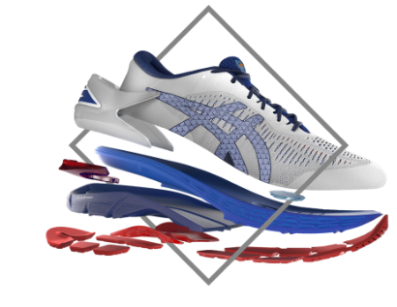
Figure : fuzeGel
(Source: forbes.com, 2018)
Under Armour debuted its Hovr technology in 2017 featuring a new way for constructing foam-based cushioning. The midsole being utilised in this product is integrated with a technological intervention namely super-soft durometer that is combining shock absorption and cushioning metrics (forbes.com, 2018). Alongside, an energy web system is also included that is purposively wrapping cushioning core for retaining energy return.
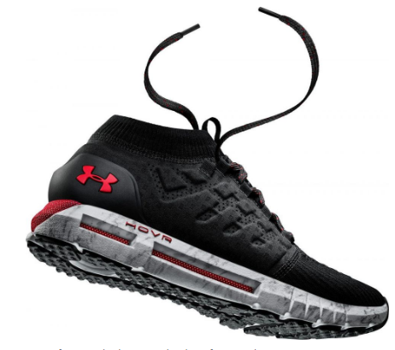
Figure : Hovr
(Source: forbes.com, 2018)
Retention of energy return is also introduced in famous brand Puma’s product namely Ignite that hit contemporary market in 2015. This product has offered TPU technology for meeting the need of combining immediate step-in comfort and superior energy return. This enabled Puma to inject more durability in its Ignite models (forbes.com, 2018).
Indeed, for surviving in this competitive market position, Nike has to evaluate and identify strengths and opportunities underlying with its product channels. Facilitative position of Nike in terms of worldwide consumer brand awareness is stating in favor of its brand power that cannot be replaced easily by its strong competitors such as Reebok and Adidas.
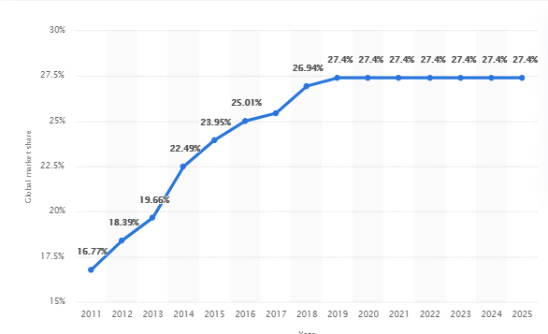
Figure : Forecast of Nike's global market share in athletic footwear from 2011 to 2025
(Source: statista.com, 2020)
In this view, it is arguable that sports icons being associated with Nike can raise voice in favor of strengthened competitive force introduced by Nike that, in other words, is attracting target audience. Brand images and resources as achieved by Nike is also implying for coming up with inimitable promotional strategies that is further consolidated with its motivational slogan Just Do It being used in all marketing campaigns (about.nike.com, 2020). This is implying that this new product Joyride will also be able to win trustworthiness of its loyal customers by virtue of enhanced sportsmanship and competition.

Blog 6 IMC strategy
Student name : Adrian Calancea
Student number : 1817790
Module title : Marketing Fundamentals
Assignment title : Group report
Module Lecturer’s name : Tushara Baladran

IMC (Integrated Marketing Communication) strategy can bring forth positive influences in communicating marketing approaches with intended audience and that may also be true with marketing strategy of Nike’s new product Joyride Flyknit Run. Different platforms can be used in this regard by Nike.
Nike’s target will be achievement of greatest possible impacts onto a large population attached with the target audience for Joyride shoes. Influential image of celebrities and popular personalities can be used in this regard as target audience are generally acquainted with imitating behavior of celebrities (forbes.com, 2017). In previous instances, it can be seen that Nike has contracted Tiger Woods, Lance Armstrong, Robarto Carlos and Ronaldo of Brazilian football team for promoting their different products which resulted in positive outcomes with better market penetration with respective products. A similar celebrity endorsement strategy can be adopted for marketing Joyride Flyknit shoes. As such, as this product is specific for benefitting during running, Nike can approach any globally recognised face of athletics such as Shelly-Ann Fraser-Pryse who is recognised as one of the best women sprinters of all time.
Personal selling may be another way-out for competing worthfully with its priced competitors. For this, in-store personal sales can manage positive impacts as such attempt can offer learning opportunities to customers regarding personalised services and products of Nike. A feel good environment for every individual coming to purchase Joyride Flyknit shoes is important for which it is mandatory that staff are well trained about particular features of this product so that they can answer about every aspect of customers’ curiosity regarding that product (forbes.com, 2017). Such effort will be also usual with managing marketing communication for Joyride shoes as this can promote this product, elevate customer experience with positive relationship building and engage customers in making purchasing decisions with less hesitation.
However, for Nike, introducing this brand new product to target audience can be most facilitative when direct marketing channels are used. In this regard, some third party individuals or organisations may be used which are close to seller in target market. Sales promotional strategies likewise special discount offers to first 1000 purchase is also utilisable as this can attract middle class buyers as well irrespective of high price of Joyride shoes. Getting associated with public relations will be a better approach for better market penetration and in this juncture, international fashion festivals or global athletics events can be utilised by Nike (forbes.com, 2017). Nevertheless, social media is most influential platform for creating a buzz around IMC strategy and Nike has pioneered in this area.

References
Websites
about.nike.com, 2020, ABOUT NIKE, viewed on 28/12/2019 from https://about.nike.com/
blog.smalldogcreative.com, 2018. How to Build Your Brand: 5 Steps for Creating a Killer Unique Selling Proposition (USP). viewed on 28/12/2019 from https://blog.smalldogcreative.com/blog-how-to-build-your-brand-5-steps-for-creating-a-killer-unique-selling-proposition-usp/
cnet.com, 2019, To The Test: Nike Joyride shoes review, viewed on 28/12/2019 from https://www.cnet.com/news/ces-2020-preview/
forbes.com, 2017, Seven Steps To A Better Integrated Marketing Communications Strategy, viewed on 28/12/2019 from https://www.forbes.com/sites/forbesagencycouncil/2017/03/16/seven-steps-to-a-better-integrated-marketing-communications-strategy/#516e0c777841
forbes.com, 2018, The Technologies That Define Sneaker Cushioning, viewed on 28/12/2019 from https://www.forbes.com/sites/timnewcomb/2018/11/05/the-technologies-that-define-sneaker-cushioning/#148bf7d4356e
news.nike.com, 2019, What is Nike Joyride? viewed on 28/12/2019 from https://news.nike.com/news/nike-joyride-cushioning
news18.com, 2019, Nike's New Joyride is Not The Only Running Shoe to Use a Bridge Between Rubber And Plastic, https://www.news18.com/news/tech/nike-joyride-tech-for-running-shoes-is-not-the-only-one-to-use-a-bridge-between-rubber-and-plastic-2249923.html
nike.com, 2019, Nike Joyride, viewed on 28/12/2019 from https://www.nike.com/in/joyride
nike.com, 2019. Nike Joyride Run Flyknit. viewed on 28/12/2019 from https://www.nike.com/joyride
statista.com, 2020, Forecast of Nike's global market share in athletic footwear from 2011 to 2025, viewed on 28/12/2019 from https://www.statista.com/statistics/216821/forecast-for-nikes-global-market-share-in-athletic-footwear-until-2017/
weartesters.com, 2019. Nike Joyride Run Flyknit | Detailed Look and Review. viewed on 28/12/2019 from https://weartesters.com/nike-joyride-run-flyknit-detailed-look-and-review/
wired.co.uk, 2019, The science behind Nike's new shock absorbing running shoe, viewed on 28/12/2019 from https://www.wired.co.uk/article/nike-joyride-run-design-price-release

Appendices

Appendix 1: Nike Joyride Fly knit Run
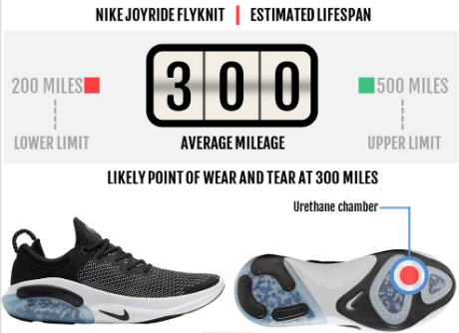
(Source: https://www.nike.com/in/joyride)

