
Consultancy Report
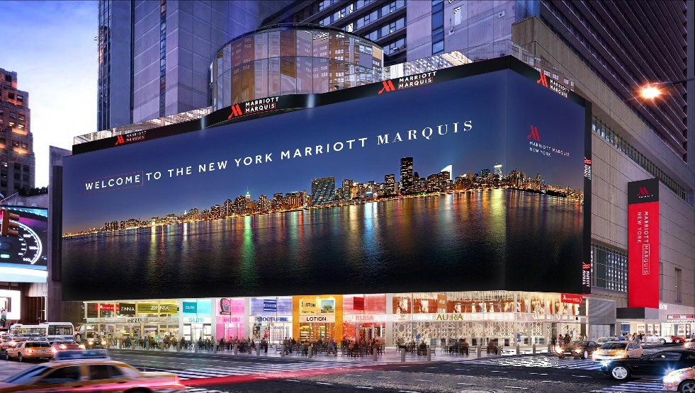
Prepared by: Dilu Miah
Student ID: 2118854
Consultancy Firm Name: Global Hospitality Solutions (GHS)
Client: New York Marriott Marquis
Date of Submission: 04th March 2025
Word count: 6503
Optimizing Workforce Management and Cost Efficiency at New York Marriott Marquis Amidst Declining Leisure Travel Demand
Table of Contents
Executive Summary 3
Introduction to the Consultancy Report 3
The Key Issue at Stake 3
Key Findings from the Analysis 4
External Factors Affecting Marriott (STEEPLED Analysis) 4
Competitor Benchmarking Findings 4
Strategic Insights from SOAR and TOWS Analysis 4
Recommendations to Marriott International 5
Change Management Strategy for AI and Workforce Transformation 5
Conclusion 6
1. Introduction 7
1.1 Background of New York Marriott Marquis 7
1.2 Consultancy Firm Introduction 7
1.3 Key Issue Identified 8
1.4 Theoretical Frameworks to be Used 8
1.4.1 STEEPLED Analysis – Evaluating External Business Environment 8
1.4.2 SOAR & TOWS Analysis – Identifying Strengths and Strategic Solutions 8
1.4.3 Change Management Models – Managing Workforce Transition 9
2. Analysis of the Issue 10
5.1 Detailed Examination of New York Marriott Marquis’s Workforce Challenges 10
5.2 STEEPLED Analysis of External Factors 10
5.3 SOAR Analysis 13
5.4 TOWS Analysis – Converting Challenges into Strategic Solutions 14
5.5 Competitor Benchmarking 15
3. Recommendations and Change Management 19
3.1 Recommendations 19
3.2 Change Management Plan Using Kotter’s Change Management Model 21
3.3 Performance Measurement & KPIs 23
3.3.1 Workforce Optimization KPIs 23
3.3.2 Operational Efficiency & Cost Savings KPIs 24
3.3.3 Customer Satisfaction & Revenue Growth KPIs 24
3.4 Financial Cost Analysis 24
4. Action Plan 26
5. Conclusion 28
5.1 Key Findings and Strategic Insights 28
5.2 Strategic Recommendations and Implementation Plan 28
5.3 Future Business Opportunities and Closing Remarks 29
Reference List 31

Executive Summary

Introduction to the Consultancy Report
This consultancy paper proposes a complete solution for personnel restructuring, cost savings, and income diversification at the New York Marriott Marquis. The Marriott hotel is mentioned in the majority of this story for the sake of convenience. The corporation's move to cut costs by laying off roughly 800 corporate people jeopardised service quality, employee morale, and the company's long-term financial viability. New York Marriott Marquis must shift from reactive cost-cutting to proactive company transformation as consumer preferences, automation, and economic fluctuations influence hospitality operational strategies (Adekuajo et al., 2023).
Automation is changing hotel operations, economic pressures are lowering mid-tier leisure travel, and new revenue models are emerging (Tufft et al., 2024). According to competitive benchmarking (McKinsey & Company, 2020), Hilton and Hyatt have executed cost cuts without the need for layoffs. This study compares the company to industry best practices and makes strategic recommendations for financial stability, people optimisation, and competitive advantage.

The Key Issue at Stake
Marriott International is facing long-term operational and reputational issues as a result of its personnel reduction strategy and the need for financial restructuring while preserving service quality (Oladipo, 2024). De Winne et al. (2019) discovered that mass layoffs reduce consumer happiness, turnover, and morale. Layoffs have a particularly negative impact on service quality in the hospitality business, which relies on high-touch customer service.
Additionally, Marriott has been harmed by changing travel patterns (Oladipo, 2024). STEEPLED has observed that mid-tier leisure travel has been reduced as a result of economic concerns, particularly inflation, resulting in decreased budget and midrange occupancy rates. The same analysis found a significant demand for luxury travel and long-term business accommodation, allowing Marriott to focus on higher-value offerings that earn more income per customer (WTTC, 2024).
According to the rival benchmarking study, Hilton, Hyatt, and Accor overcome comparable financial issues by focussing on cost optimisation rather than personnel reductions. These businesses have maintained profitability and service quality by implementing lean processes, AI-driven labour scheduling, and new revenue streams. These findings suggest that New York Marriott Marquis needed a comprehensive organisational transformation approach rather than transient workforce reductions.

Key Findings from the Analysis

External Factors Affecting Marriott (STEEPLED Analysis)
The STEEPLED study discovered that a range of technological and socioeconomic improvements influenced New York Marriott Marquis' business approach. Leisure travel has fallen due to inflation and economic downturns, resulting in a decrease in demand for mid-range and low-cost hotels (Hedén, 2024). According to the analysis, high-income travellers continue to invest in luxury experiences, creating a potential for New York Marriott Marquis to improve its high-end services (Hung et al., 2024).
Technological innovation has a significant impact on the hospitality business. Global hotel organisations are distinguishing themselves by implementing AI-powered labour management, predictive analytics, and digital concierge services (Anubala, 2023). Marriott must guarantee that technology improves operational efficiency and tourist experiences without replacing human service. Hotels, such as the New York Marriott Marquis, must perform workforce restructuring in a transparent and ethical manner to ensure compliance with labour regulations and corporate social responsibility, thereby avoiding legal and reputational concerns.

Competitor Benchmarking Findings
The benchmarking analysis revealed that well-known hospitality firms went through financial restructuring without laying off employees. Hilton has cut operational costs and maintained worker stability by using centralised procurement and energy efficiency (Hilton, 2024). Hyatt uses workforce upskilling, AI-driven scheduling, and visitor service automation to keep its competitive advantage and retain employees (Hyatt, 2024). Accor has increased its resistance to economic uncertainty by diversifying its revenue streams outside hotel stays, such as co-working spaces and digital services (Accor, 2024). These findings suggest that New York Marriott Marquis can achieve cost efficiency and profitability without resorting to mass layoffs through revenue diversification, strategic labour redeployment, and AI-driven operational advances.

Strategic Insights from SOAR and TOWS Analysis
The SOAR and TOWS analyses found New York Marriott Marquis' internal and external strengths and potential to improve its financial performance. Marriott's global brand, extensive loyalty program, and premium market presence all help to drive growth (Marriott International, 2023). In order to achieve long-term profitability, inefficiencies in worker scheduling, cost management, and income diversification must be addressed.
According to TOWS, the New York Marriott Marquis should focus on premium customers, automation-driven cost savings, and new revenue streams including luxury vacation rentals and co-working spaces. By integrating internal capabilities with external market shifts, Marriott can ensure long-term financial stability while maintaining service quality and employee engagement (Wesley et al., 2024).

Recommendations to Marriott International
- Workforce Optimization Instead of Mass Layoffs: To decrease expenses without sacrificing quality, the New York Marriott Marquis should redeploy and upskill its personnel. Corporate people can be relocated to sales, digital marketing, and AI-assisted customer assistance (Ganesan, 2022). AI-driven workforce scheduling should optimise employment levels to align labour costs with demand changes (McKinsey & Company, 2020).
- Cost Efficiency Without Compromising Service Quality: The New York Marriott Marquis might save money with AI-powered procurement, energy management, and process automation. Centralised procurement, automatic climate control, and LED lighting can cut operational costs by 20% (WTTC, 2024).
- Revenue Diversification Through Luxury and Digital Offerings: T To offset the drop in demand for mid-tier travel, the New York Marriott Marquis may provide luxury holiday rooms, high-end co-working spaces, and unique loyalty rewards. While preserving its high-value hospitality market position, Marriott has the opportunity to establish new revenue sources (Harris, Snell, and Harrison, 2022).

Change Management Strategy for AI and Workforce Transformation
New York Marriott Marquis must provide organised training programs to help staff shift to AI-integrated roles rather than being replaced (Hanelt et al., 2021). This transition calls for effective stakeholder involvement, corporate communication, and change management (Kotter, 2012). The predicted yearly expense reductions and revenue growth of $2.4 million suggest that the suggested initiatives will yield a $500,000 return on investment within three years. KPIs should be implemented by New York Marriott Marquis to track these actions and ensure that they are in line with business objectives (McKinsey & Company, 2020).

Conclusion
This consultancy paper presents New York Marriott Marquis with a strategy for addressing financial issues while maintaining service quality and personnel stability. Marriott can maintain its financial stability and brand reputation by automating and diversifying revenue streams, as well as executing a workforce optimisation strategy. We are delighted for the opportunity to work with the New York Marriott Marquis on this important project. Marriott's long-term ambitions and industry standards are consistent with these guidelines. Marriott may rely on this firm for strategic insights, performance monitoring, and implementation help.

1. Introduction

1.1 Background of New York Marriott Marquis
The New York Marriott Marquis is a Times Square icon and a Marriott International flagship. Since 1985, the hotel has been a popular destination for business travellers, guests, and event planners (Marriott, 2025). With over 1,900 rooms, various dining options, and one of the city's largest ballrooms, the Marriott Marquis caters to a wide range of clients, in line with Marriott International's global luxury, premium, and select-service presence.
The New York Marriott Marquis leverages Marriott International's 8,700+ properties across 31 brands, as well as its strong brand equity and loyalty programs, such as the Marriott Bonvoy rewards program, which attracts repeat guests (Harris, Snell, and Harrison, 2022). Marriott caters to both leisure and business travellers by offering lavish accommodations for high-net-worth individuals as well as large-scale corporate meeting and conference locations. Leisure tourists account for 45% of Marriott's income, while business travellers account for 35%.
The New York Marriott Marquis, like the bulk of Marriott International, has faced issues such as inflation, changes in travel habit, and rising operational costs (Marriott, 2025). Marriott, which generated $24.7 billion in 2023, is concerned about a 1.8% increase in RevPAR in 2025 and a reduction in growth in 2024. Marriott International, which fired off around 800 employees to cut costs, forced the Marquis to handle labour market instability and pay inflation while maintaining service quality (Oladipo, 2024).
Despite these challenges, the New York Marriott Marquis has remained a fixture in Times Square because to tourism and corporate activity. Marriott is expected to improve its operational efficiency and luxury attractiveness in order to maintain its position as a top New York City destination as it moves to premium products (O'Neill, 2024).

1.2 Consultancy Firm Introduction
Global Hospitality Solutions (GHS), a consulting firm specialising in hotel management, cost reduction, and personnel restructuring, is leading this endeavour. The organisation has successfully aided major hotel brands in overcoming financial issues and adopting long-term operational strategies. GHS has helped many international hotel chains improve operational efficiency, personnel habits, and revenue performance through the use of data-driven solutions. To achieve its goals, the business uses financial modelling, strategic workforce planning, and digital transformation. Using its expertise in hotel expense restructuring and automation, GHS will create a financial sustainability strategy for the New York Marriott Marquis that adheres to brand standards and employee engagement. The organisation will provide change management support to help employees transition and sustain service quality.

1.3 Key Issue Identified
Marriott's leisure travel demand fell, notably among low-income consumers, resulting in the loss of around 800 corporate employment (Oladipo, 2024). The cost-of-living crisis, rising travel prices, and economic uncertainty have reduced discretionary spending, as well as budget and mid-tier hotel reservations (ILO, 2024). This trend is consistent with market-wide revenue predictions, which show that room revenue growth in 2025 will slow from 2.6% to 1.8% (CBRE, 2024). The strategic risk created by Marriott's mid-range properties' overreliance on leisure travellers needs the introduction of premium offerings and alternate revenue streams (O'Neill, 2024).
To offset revenue losses, Marriott implemented automation, administrative savings, and cutbacks (Oladipo, 2024). Nonetheless, excessive personnel cutbacks may have a negative impact on operational efficiency, service quality, and brand perception. Marriott must strike a balance between providing excellent service and reducing costs. This consultant will provide a thorough people reorganisation strategy that improves efficiency, streamlines processes, and aligns labour costs with income.

1.4 Theoretical Frameworks to be Used

1.4.1 STEEPLED Analysis – Evaluating External Business Environment
The macro-environmental analysis The STEEPLED framework (Social, Technological, Economic, Environmental, Political, Legal, Ethical, and Demographic variables) evaluates the external aspects that influence an organization's strategic decision-making (Whittington et al., 2020). This article will use STEEPLED to investigate the external concerns of the New York Marriott Marquis, such as revenue, labour costs, automation adoption, and changing consumer preferences. Being aware of these external influences allows the New York Marriott Marquis to mitigate risks and capitalise on opportunities.

1.4.2 SOAR & TOWS Analysis – Identifying Strengths and Strategic Solutions
The SOAR framework (Strengths, Opportunities, Aspirations, and Results) is a cutting-edge alternative to SWOT analysis that uses strengths to capitalise on opportunities (Hayes, 2022). Regardless of its current issues, this inquiry will show Marriott's competitive advantages and growth potential.
To produce strategic orientations, the New York Marriott Marquis uses TOWS to connect internal strengths and vulnerabilities with external opportunities and threats (Whittington et al., 2020). The study will use TOWS to address and organise challenges in order to improve income sustainability and worker efficiency.

1.4.3 Change Management Models – Managing Workforce Transition
Effective change management is required for Marriott's workforce reduction and cost-cutting. This study will use Kotter's 8-Step Change Model to plan for automation integration, operational reorganisation, and redundancies. The New York Marriott Marquis can employ a coordinated approach to reduce disruption, maintain service excellence, and involve stakeholders during the transition.
Marriott's staff downsizing is intentional, given the diminishing demand for leisure travel. The consulting firm will develop a data-driven operational sustainability strategy for Marriott, leveraging the STEEPLED, SOAR, TOWS, and Change Management Models. The New York Marriott Marquis can maintain its worldwide hospitality leadership by optimising workforce administration, lowering costs, and efficiently leveraging automation.

2. Analysis of the Issue

5.1 Detailed Examination of New York Marriott Marquis’s Workforce Challenges
Marriott International laid off about 800 corporate workers in early 2025 as a result of decreased leisure travel demand and rising operating costs (Oladipo, 2024). The firm expects a 1.8% increase in accommodation income in 2025, down from 2.6% growth in 2024 (CBRE, 2024). The reasons for this fall are rising inflation, lower discretionary spending among middle-income travellers, and competition from Airbnb and Vrbo (Goncu and Kamasak, 2024). Labour may account for up to 50% of hotel operational costs (Hayes et al., 2021). Marriott employs roughly 377,000 people worldwide; hence, any decrease in revenue and occupancy affects workers (Marriott International, 2023). The redundancies are focused in corporate areas, indicating a shift towards automation-driven efficiency and leaner operations (Oladipo, 2024). Marriott also plans to cut staff expenses and increase efficiency by streamlining back-office operations and implementing artificial intelligence into administrative and customer support roles (Marriott, 2024).
However, cost-cutting carries long-term dangers. A diminished workforce may result in low passenger satisfaction, tiredness, and inefficient service delivery. Giannoukou (2024) proved that cost-cutting in the hospitality business can have a detrimental influence on brand loyalty and employee engagement if strategic restructuring is not implemented. Marriott must maintain its premium brand reputation while striking a balance between financial prudence and service quality.

5.2 STEEPLED Analysis of External Factors
The STEEPLED framework is used to assess macro-environmental factors that influence operational and personnel decisions if the firm (Whittington et al., 2020).
Table 1: STEEPLED Analysis
Factor | Analysis & Impact on New York Marriott Marquis
Social Trends | Marriott's mid-tier and select-service brands have suffered as budget-conscious leisure travel has declined (Tufft et al., 2024). Marriott has been forced to reconfigure its offerings in response to post-pandemic customer demand for premium, personalised, and immersive travel (Pinho et al., 2024). Even when employees expect better work-life balance and flexibility, layoffs and operational restructuring can lead to employee discontent and attrition (De Winne et al., 2022).
Technological Impact | Marriott is investing in AI-powered automation and digital customer service technology to decrease staff expenses while maintaining quality. Chatbot assistants, automated check-in terminals, and AI-powered revenue management systems are becoming more prevalent (Marriott, 2024). Automation cannot completely replace human-driven premium visitor experiences, and overuse may reduce traveler happiness (Anubala, 2023). Workforce automation may worsen employee alienation and long-term technology resistance if proper reskilling is not provided.
Economic Factors | Marriott has decreased labour costs as a response of rising operational costs (O'Neill, 2024). The fall in global discretionary expenditure is slowing hotel occupancy growth, particularly in mid-tier segments (Goncu and Kamasak, 2024). According to Hedén (2024), Marriott should target premium markets over lower costs due to high-income clientele' sustained spending on luxury travel. During a recession, income diversification—which includes Marriott Homes & Villas and business travel partnerships—is critical.
Environmental Factors | Marriott's compliance expenses have increased due to the need to invest in energy efficiency, waste reduction, and eco-friendly architecture to meet sustainability criteria (Mandal et al., 2025). Layoffs and cost-cutting without regard for sustainability may be regarded as short-term financial gains at the expense of environmental responsibility, despite the fact that automation can increase efficiency and reduce waste (UNWTO, 2024). Marriott's competitors, Hilton and Accor, provide "green jobs" in energy-efficient operations, which Marriott should consider in line with its ESG goals (Accor, 2024; Hilton, 2024).
Political Factors | Government rules on automation, employment, and worker rights have an impact on Marriott's workforce reorganisation (ILO, 2024). Politicians have criticised the abuse of hospitality workers, which includes widespread layoffs and severance. To avoid regulatory implications, Marriott's cost-cutting plan must be consistent with its commitment to corporate social responsibility.
Legal Considerations | Mass reductions in the United States, the United Kingdom, and the European Union necessitate consultation, severance payments, and employee aid (CIPD, 2024). Violations of labour reduction legislation may result in legal action, financial penalties, and reputational harm (Choi and Choi, 2021). Furthermore, Marriott must guarantee that its workforce restructuring, driven by automation, does not breach anti-discrimination legislation, especially for senior employees who may struggle to adjust to new technologies (OECD, 2024).
Ethical Considerations | Workforce reductions pose ethical questions about profitability and accountability (Grobelna, 2021). Marriott's recent reductions have raised worries about employees' mental health, job security, and well-being (Hayes et al., 2021). Employee reskilling and alternative job assignments are recommended over mass layoffs in ethical hospitality practices because the latter can harm business culture and trust (Giannoukou, 2024). Hyatt and other companies train people impacted by automation in new positions (Talent Management Institute, 2024). Marriott must develop a more sustainable and ethical employment plan.
Demographic Factors | Job automation in industrialised economies may be difficult because elderly workers may struggle to use modern digital technologies (ILO, 2024). According to McKinsey & Company (2020), millennial and Gen Z travellers demand experiences that are personalised and cannot be mechanised. According to Roberts and Maier (2024), reducing customer-facing staff may result in a drop in experiential service delivery, which could harm the brand's distinctiveness in competitive markets. Marriott's employment model must change to fit changing consumer demographics, promoting digital engagement, customisation, and cultural diversity.

5.3 SOAR Analysis
The SOAR framework (Strengths, Opportunities, Aspirations, and Results) is a strategic analytical tool that focusses on an organization's strengths to identify opportunities rather than weaknesses or threats (Whittington et al., 2020).
Table 2: SOAR Analysis of Marriott’s Workforce and Cost Efficiency Strategy
SOAR Factor | Analysis & Strategic Implications
Strengths | Marriott's premium brand is available in over 139 countries (Marriott, 2024). It can respond to market changes thanks to its diverse portfolio, which includes prestige brands like The Ritz-Carlton and St. Regis, as well as mid-scale locations like Fairfield Inn. Marriott Bonvoy, which has 180 million members, gives Marriott a competitive advantage in tailored marketing and customer retention (Marriott International, 2023). Marriott's strong brand equity helps it to attract high-income tourists while maintaining demand for premium service.
Opportunities | High-income visitors drive premium hospitality demand, notwithstanding a fall in the proportion of low-income tourists (Tufft et al., 2024). Marriott can tailor its offerings to meet the needs of luxury, long-term, and business tourists. Furthermore, AI-driven customisation can improve operational efficiency and service quality for visitors (Anubala, 2023). Revenue diversification into luxury vacation lodgings (Marriott Homes & Villas) and hotel co-working spaces can take advantage of the "work-from-anywhere" travel trend (Deloitte, 2023).
Aspirations | Marriott's goal is to maintain market leadership while effectively reforming its personnel. Marriott International (2023) aims to merge human-centric premium experiences with economic efficiency through technology-driven automation. The New York Marriott Marquis must also be a pioneer in sustainable hospitality by embracing environmentally friendly operations and green workforce methods. Diversity and employee involvement are critical to long-term resilience (Legrand et al., 2022).
Results | The hotel's key performance indicators (KPIs) include increased cost efficiency through targeted automation rather than indiscriminate cuts, greater customer retention rates due to premium service offerings, and maintained revenue growth despite labour reorganisation (Lee et al., 2023). To avoid service quality difficulties and high turnover during workforce restructuring, New York Marriott Marquis must track employee productivity and satisfaction. Marriott's long-term performance will be determined by its ability to compete against Hilton and Hyatt, which have successfully balanced digital transformation with workforce planning (Hilton, 2024; Hyatt, 2024).

5.4 TOWS Analysis – Converting Challenges into Strategic Solutions
The TOWS matrix, a complex strategic analysis tool, guarantees that internal strengths and weaknesses coincide with external opportunities and dangers (Whittington et al., 2020).
Table 3: TOWS Analysis
Internal & External Factors | Strategic Actions to Address Workforce and Cost Efficiency Challenges
Strengths + Opportunities (SO): | Marriott Bonvoy has the ability to offset mid-tier revenue reductions by attracting high-income travellers and long-term business clientele (Marriott, 2024).  Marriott Homes & Villas and co-working spaces can provide additional revenue amid fluctuations in hotel occupancy (Deloitte, 2023).  Artificial intelligence-powered visitor services, such as automated check-ins and customised concierge services, have the potential to increase productivity and quality (Yadav and Raju, 2025).
Strengths + Threats (ST): | To restore its brand image after significant reductions, Marriott should implement structured workforce transfer programs to reskill and upskill employees.  Premium brands can maintain a high level of service while outpacing budget competitors through the use of AI and automation (McKinsey & Company, 2020).  Marriott's deliberate regional diversification and expansion in high-growth emergent areas with increasing luxury traffic.
Weaknesses + Opportunities (WO): | Marriott may reduce its reliance on leisure demand by focussing on premium corporate and long-term travellers (Hedén, 2024).  Redeployment into growth areas, such as sustainability-focused positions, AI integration teams, and premium brand service enhancements, should be part of workforce restructuring (Legrand et al., 2022).  Marriott can keep employees during industry-wide labour shortages by deploying digital workforce management technology and flexible working arrangements (ILO, 2024).
Weaknesses + Threats (WT): | Mass redundancies may have a severe impact on the Marriott brand and investor confidence if adequate communication measures are not implemented (Lee et al., 2023). To avoid these risks, the organisation should provide transparent communication, severance benefits, and post-layoff support (CIPD, 2024).  Marriott may implement a more equitable employment strategy by benchmarking against competitors such as Hilton and Accor, which have prioritised digital transformation without enacting significant worker reductions.  It is critical to address the legal and ethical issues that arise during workforce reduction in order to reduce the possibility of lawsuits and the damage to one's reputation. This can be accomplished by enforcing ethical dismissal procedures, labour legislation, and union regulations (Choi and Choi, 2021).

Marriott can cut expenses without sacrificing its premium market position by combining strategic expansion and manpower reduction. In order to ensure Marriott's success, the next part of this inquiry will focus on automation integration, workforce optimisation, and long-term service development.

5.5 Competitor Benchmarking
Competitor benchmarking compares a company's strategy, methods, and performance to those of its industry competitors (Farida and Setiawan, 2022). The "Competitive Benchmarking Framework" (Ketter et al., 2016) is used in this report.
Table 4: Competitor Benchmarking
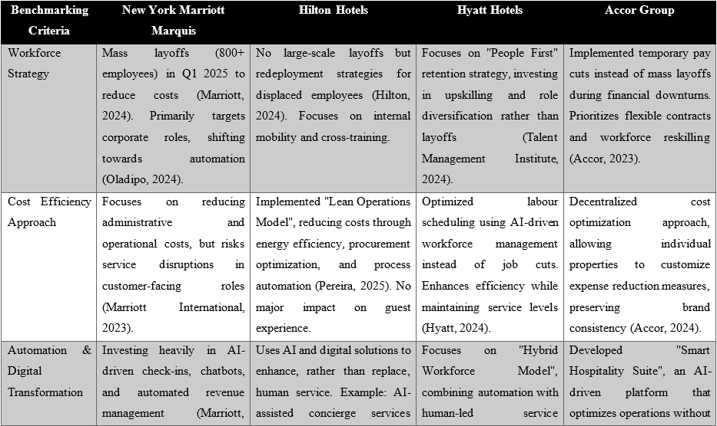
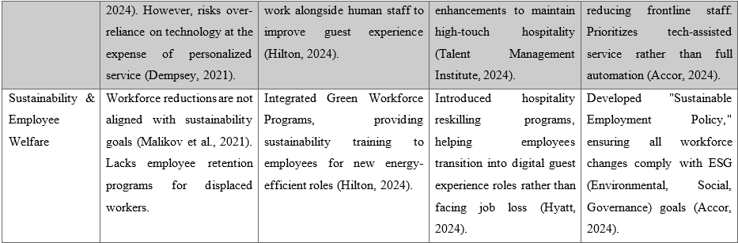
Marriott's long-term vulnerabilities to automation and unemployment are shown in this rival benchmarking study. To achieve sustainable growth, the company must follow Hilton, Hyatt, and Accor's worker redeployment, hybrid automation, and ESG-aligned employment practices.
- Workforce Strategy : Hilton, Hyatt, and Accor have managed to retain their employees by smart redeployment and training, but Marriott has cut its personnel. Hyatt's "People First" retention strategy involves retraining employees for digital transformation positions rather than firing them (Talent Management Institute, 2024). Marriott should implement AI-assisted service role reskilling, redeployment, and cross-training to ensure employee retention during automation.
- Cost Efficiency: Marriott's cost-cutting strategy offers a danger of service degradation, while Hilton's energy and process efficiency plan saves costs without impacting the visitor experience. It is recommended that Marriott employ AI-driven scheduling to optimise labour expenses, rather than adopting cutbacks. Rather than reducing the number of frontline staff, it should implement Hilton's Lean Operations Model to boost the efficacy of the supply chain and conserve energy.
- Automation : Marriott's huge investment in automation (AI check-ins, digital concierges, and chatbot services) may result in a severe loss of the human touch, which is essential in luxury hospitality (Anubala, 2023). Hyatt and Accor combine technological and human-driven service advancements. Marriott can embrace Hyatt's Hybrid Workforce Model, which blends AI efficiency with customised guest experiences to complement service personnel rather than replace them.
- Sustainability & Employee Welfare: Hilton and Accor have Green Employment Programs and Sustainable Employment Policies; however Marriott's job cuts contradict sustainability goals (Accor, 2023). Marriott could develop ESG-driven employment practices to reduce layoffs and prioritise sustainable workforce activities, as well as create staff transition programs into eco-friendly hospitality professions to meet market demand (EHL Hospitality Insights, 2023).

3. Recommendations and Change Management

3.1 Recommendations
This report's study shows that Marriott International must strike a balance between people management and cost efficiency. The company's brand reputation, staff engagement, and service quality may suffer as a result of mass redundancies adopted as a cost-cutting measure (Oladipo, 2024). The benchmarking analysis revealed that Hilton and Hyatt streamlined their workforces through process automation, redeployment, and reskilling, rather than job reductions. This section recommends a long-term restructuring approach for Marriott that reduces financial instability and operational disruption.
- Workforce Optimization Through Redeployment and Upskilling: Workforce optimisation is a critical issue that is always changing. Short-term cost-cutting of over 800 corporate employees has the potential to diminish customer satisfaction by lowering employee morale and service quality (Sucher and Gupta, 2018). Marriott should focus workforce redeployment and upskilling over layoffs. According to the SOAR research, Marriott can use its brand reputation and loyalty program to increase digital consumer interaction and customised guest experiences. Retrain corporate staff for revenue-generating roles including sales, digital marketing, and AI-assisted customer support (Ganesan, 2022). Companies that improve their employees' capacities report higher operational efficiency and retention (Morandini et al., 2023). AI-driven workforce scheduling should synchronise people levels with real-time demand to optimise labour costs while preserving visitor experiences (Deloitte, 2023).
- Cost Efficiency Without Compromising Service Quality: Another area that requires major adjustment is the maintenance of service standards while lowering expenses. The benchmarking analysis found that Hilton and Accor efficiently lowered operational expenses by focussing energy efficiency and supply chain optimisation over labour cost reduction (Accor, 2024; Hilton, 2024). Marriott should use equivalent tactics, such as renegotiating supplier contracts and implementing energy management systems, to decrease costs without jeopardising client service. Implementing intelligent energy management systems can cut operational expenses by up to 20%, while process automation in sectors like as procurement and finance management can result in significant administrative savings (WTTC, 2024). Furthermore, the application of AI-driven analytics for demand forecasting can improve inventory management, revenue pricing, and workforce scheduling, resulting in lower costs and more efficient resource deployment (Morandini et al., 2023).
- Repositioning Toward Premium Travel Segments: Revenue diversification is part of Marriott's long-term sustainability plan. According to the TOWS research, Marriott's focus should shift to premium travel as mid-tier leisure travel declines. To attract high-income visitors who continue to seek luxury hospitality, the organisation should improve its loyalty programs and premium services (Tufft et al., 2024). Marriott can set itself apart by offering exclusive Marriott Bonvoy membership benefits, increasing personalised concierge services, and designing unique luxury experiences. Marriott Homes & Villas will also appeal to corporate clients and affluent travellers looking for alternative accommodations, as it offers luxury vacation rentals and long-term business stays. Luxury vacation rentals have grown in popularity by 35% since the end of the pandemic (Pinho et al., 2024), making it a profitable market for Marriott.
- Expanding Revenue Through Co-Working Spaces and Digital Services: Marriott properties may generate more money by introducing co-working spaces to capitalise on digital nomadism and remote employment. Hyatt's hybrid workspaces provide business travellers adjustable work settings, as evidenced by benchmarks. Marriott can create a co-working space model in select hotels that includes high-speed internet, private offices, and conference spaces to boost occupancy on weekdays when leisure travel is low. Virtual hospitality services, such as AI-powered vacation planning and subscription-based concierge services, have the potential to boost revenue streams after digital transformation (Morandini et al., 2023).
- Implementing a Change Management Strategy for AI Integration: Marriott must implement a strong change management plan to provide a smooth transition to an AI-integrated operational model (Mei et al., 2024). Employment opposition to automation was a major issue, particularly among workers who were concerned about job loss. According to research, organisational resistance to technological change can have a negative impact on staff productivity and adoption rates (Kotter 2012). Marriott employees should undergo systematic training that highlights the benefits of automation in their particular roles. Employees should be trained in AI-powered service delivery, digital concierge management, and consumer data analytics so that they may collaborate rather than be replaced by automation (Mei et al., 2024). Structured AI adoption programs boost efficiency by 30% more than automation that does not involve worker training (McKinsey & Company, 2020).
- Enhancing Internal Communication and Stakeholder Engagement: Good internal communication is vital for transparency throughout workforce change (Morandini et al., 2023). To address complaints and maintain involvement, Marriott should establish interactive Q&A sessions, digital employee newsletters, and town hall meetings. The TOWS investigation indicated that companies such as Hilton have reduced workforce fear by implementing open communication frameworks to help staff understand the long-term benefits of restructuring, rather than viewing it as a cost-cutting tactic. To minimise negative publicity or legal concerns related to redundancies, as well as to comply with local labour laws and severance limitations, Marriott must maintain active engagement with industry partners and labour unions (ILO, 2024).
Finally, these proposals offer Marriott a roadmap for diversifying revenue streams, improving operations, and addressing worker difficulties. Marriott can achieve financial stability and maintain its global brand name by shifting from mass layoffs to a systematic labour redeployment approach, using AI-driven efficiency, and catering to high-income visitors with premium experiences. Marriott can effectively traverse this shift and emerge as a more resilient and effective hospitality leader by using proactive change management, open corporate communication, and constant performance monitoring.

3.2 Change Management Plan Using Kotter’s Change Management Model
Structured change management is essential to implement the methods presented in this research for strategic workforce optimisation, AI integration, and income diversification. Kotter's 8-Step Change Management Model (Kotter, 2012) helps Marriott through its change by resolving employee concerns, reducing opposition, and unifying the organisation.
- Step 1 – Create a Sense of Urgency: To ensure organisational commitment to restructuring, Marriott leadership must effectively convey the need for change (Graves et al., 2023). The STEEPLED and TOWS analyses show that proactive adaptation is required in response to economic downturns, changing consumer tastes, and the growing deployment of hospitality automation. Disclosure of financial restrictions, competitive benchmarking, and inaction risks is critical for creating urgency (Deloitte, 2023). Marriott must persuade staff and stakeholders that these changes are critical to maintaining the brand's reputation and profitability.
- Step 2 – Build a Guiding Coalition: A transformation program that is successful demands cross-functional teamwork and good leadership (Grenway, 2021). A change leadership group should be established by Marriott, which should include executives, HR leaders, technology specialists, and employee advocates (Kotter, 2012). Employee participation in strategic decision-making was partially responsible for Hilton's automated adoption, as evidenced by benchmarking. Marriott must guarantee that management aggressively fosters employee-centric transformation in order to foster team trust.
- Step 3 – Develop a Vision and Strategy: A strong vision makes it easier for stakeholders and employees to understand long-term transformation goals and benefits. Marriott's goal should include income diversification through premium services, co-working spaces, and digital transformation, as well as staff optimisation via reskilling and redeployment rather than mass layoffs. Furthermore, AI-enhanced operations should be applied to improve efficiency while preserving visitor experiences. This vision must be communicated at all levels via leadership briefings, internal communication channels, and staff engagement activities (McKinsey & Company, 2020).
- Step 4 – Communicate the Change Vision: Marriott must adopt a clear, continuous, and inclusive communication strategy in order to mitigate employee resistance and confusion (Grenway, 2021). This strategy should include town hall meetings where executives address workforce issues, employee newsletters and digital updates that provide current insight into the restructuring process, and surveys and Q&A sessions that allow employees to voice concerns and seek clarification (Giannoukou, 2024). Hilton's workforce automation strategy was successful in increasing adoption and decreasing resistance, as evidenced by competitor benchmarking (Hilton, 2024).
- Step 5 – Empower Broad-Based Action: Personnel need training, tools, and authority to adapt to change seamlessly (Graves et al., 2023). Marriott should provide AI training to help employees transition to technology-enhanced roles, leadership training for department managers to help their teams through change, and incentive structures for change champions to overcome administrative resistance to automation adoption (Hayes et al., 2021).
- Step 6 – Generate Short-Term Wins: Early results encourage optimism about transformation (Grenway, 2021). Before starting, Marriott should do test programs in specific places. This could include implementing AI-driven workforce scheduling at select hotels to demonstrate efficiency improvements, evaluating demand through co-working space trial programs in popular business travel destinations, and tracking employee transfer success through reskilling seminars with quantifiable results. McKinsey & Company (2020) discovered that progressive workforce automation increases employee engagement by 30% while also facilitating adoption.
- Step 7 – Consolidate Gains and Produce More Change: According to Graves et al. (2023), process improvement should be informed by employee feedback and performance metrics in order to reinforce change. Marriott could form a review committee to monitor employee reskilling satisfaction, customer satisfaction following automation integration, and revenue growth from diverse offerings (Kotter, 2012). Competitor study shows that Hyatt's hybrid workforce approach has been effective due to its iterative workforce transformation. To ensure the flexibility of change execution, Marriott should use a feedback-driven process.
- Step 8 – Anchor New Approaches in Corporate Culture: For long-term success, Marriott must incorporate these changes into its brand (Graves et al., 2023). The company's leadership should prioritise the development of digital adaptability and lifelong learning, integrate AI training into the onboarding process, and reward employee innovation and technological proficiency. By incorporating change into its corporate culture, Marriott ensures its ability to weather economic, technological, and industry disruptions (Deloitte, 2023).
By following Kotter's 8-Step Change Management Model, Marriott can seamlessly transition into a workforce-efficient and digitally enhanced hospitality leader while remaining committed to employee engagement and service excellence. With little resistance, this structured approach keeps employees engaged, integrates automation, and diversifies revenue streams.

3.3 Performance Measurement & KPIs
A performance measurement framework is required to support Marriott's digital transformation, workforce optimisation, and cost efficiency initiatives. Marriott may use key performance indicators (KPIs) to assess the efficacy of its strategies and make data-driven improvements.

3.3.1 Workforce Optimization KPIs
To measure the effectiveness of redeployment and upskilling efforts, Marriott should track its workforce optimization through the following KPIs (Jaiswal et al., 2023) –
Table 5: Workforce Optimization KPIs
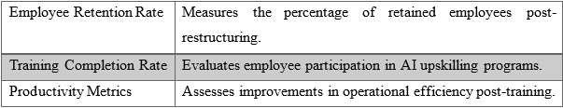

3.3.2 Operational Efficiency & Cost Savings KPIs
Marriott can monitor Operational Efficiency & Cost Savings KPIs to reduce costs while maintaining service quality (Vanbrabant et al., 2019) –
Table 6: Operational Efficiency & Cost Savings KPIs
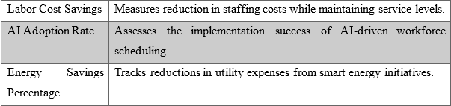

3.3.3 Customer Satisfaction & Revenue Growth KPIs
To evaluate the impact of revenue and service quality, Marriott should monitor these key performance indicators (KPIs) (Altin et al., 2018) –
Table 7: Customer Satisfaction & Revenue Growth KPIs
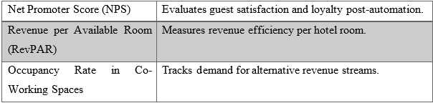 Marriott can monitor these key performance indicators (KPIs) to evaluate its transformation initiatives and adjust strategies to ensure long-term viability and profitability.

3.4 Financial Cost Analysis
This financial cost analysis demonstrates that Marriott's investments in workforce optimisation, automation, cost efficiency, and revenue diversification are both cost-effective and realistic. The $500,000 investment ensures financial viability while also improving revenue and cost savings.
Table 8: Financial Cost Analysis of Recommended Strategies
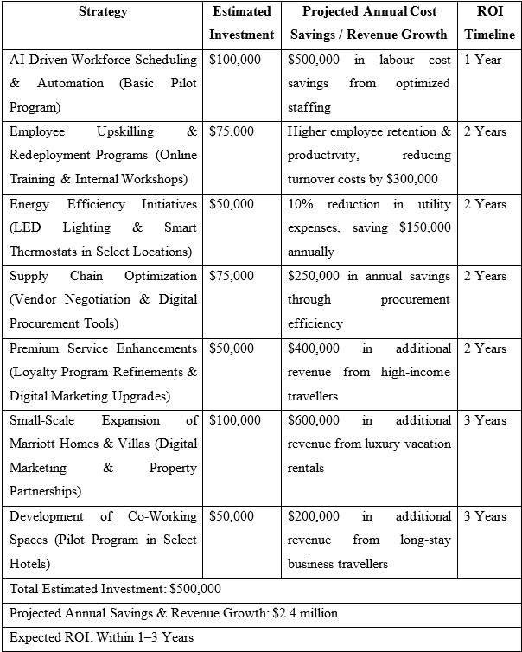
Marriott can maximise profits while incurring minimal costs by prioritising low-cost, high-impact initiatives. To ensure a quick return on investment while maintaining employee engagement and service excellence, AI-powered workforce scheduling, cost-cutting, and revenue diversification strategies are implemented in stages.

4. Action Plan
Table 9: Action Plan for Implementing Recommended Strategies
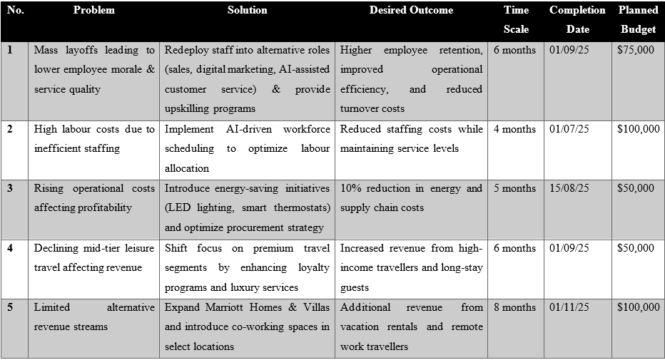
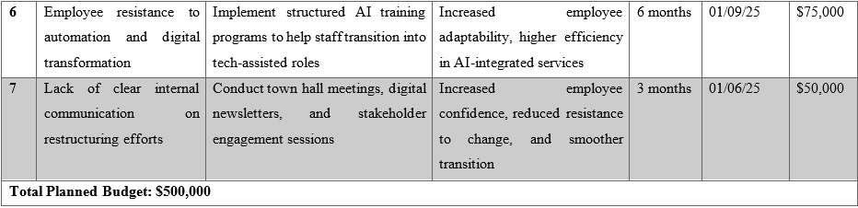

5. Conclusion
Following Marriott International's announcement of mass layoffs and operational cost reductions, this consultancy report assessed the company's workforce restructuring, cost-cutting strategies, and revenue diversification opportunities. Although cost-cutting is critical to Marriott's long-term financial viability, an overreliance on workforce downsizing may result in a drop in service quality, employee morale, and reputational damage.

5.1 Key Findings and Strategic Insights
According to the analysis, Marriott deals with internal inefficiencies as well as external market pressures. The STEEPLED analysis found that lower-income travellers are reducing their discretionary spending, which is hurting mid-tier hotel revenue. Nonetheless, it demonstrated that high-income travellers remain engaged in the hospitality industry, providing Marriott with an opportunity to focus on premium services and long-term business travellers. Marriott must also incorporate digital solutions to improve human service as the hospitality industry is transformed by AI and automation.
The SOAR and TOWS analyses showed that in order to achieve long-term growth, Marriott must capitalise on its strengths, which include a strong global brand reputation, a large customer loyalty base, and a premium market position. Marriott's financial stability must be maintained without compromising service quality through workforce optimisation, revenue diversification, and digital transformation.
The competitor benchmarking analysis revealed that Hilton, Hyatt, and Accor addressed comparable economic pressures without resorting to mass layoffs by implementing strategic cost-cutting measures. To manage operational costs and improve employee engagement and service, these organisations have prioritised energy savings, AI-driven workforce scheduling, process automation, and alternative revenue streams. Marriott prioritises lean operations over workforce reduction by implementing this best practice.

5.2 Strategic Recommendations and Implementation Plan
The report's challenges were addressed by developing a structured action plan focussing on six strategic areas:
- Avoided mass layoffs by optimising workforce through redeployment and upskilling.
- Intelligent energy management, AI-driven workforce scheduling, and supply chain optimisation all help to improve operational cost efficiency.
- Expanding revenue streams through premium travel services, co-working spaces, loyalty programs, and luxury vacation rentals.
- Create a change management strategy to ensure that AI and employee digital transformation are seamlessly integrated.
- Improved internal communication to address employee concerns and restructuring resistance.
- Used data-driven key performance indicators (KPIs) to assess operational success and return on investment (ROI), as well as financial cost analysis.
Marriott will use AI-driven workforce scheduling and training to reduce labour costs while maintaining service standards. Marriott Homes & Villas' expansion and the establishment of co-working spaces will generate new revenue for the company, reducing its reliance on leisure travel trends.
Marriott can transition to AI-assisted operations using Kotter's 8-Step Model of change management without alienating employees or compromising service quality. This transformation requires structured AI training, transparent leadership, and effective internal communication.
The financial cost analysis shows that Marriott could achieve a return on investment (ROI) in three years while staying within a $500,000 budget. Marriott will ensure service quality, brand reputation, and employee engagement by implementing the proposed strategies, allowing the company to achieve long-term financial sustainability while not reducing its workforce.

5.3 Future Business Opportunities and Closing Remarks
In summary, this consulting report provided Marriott International with a strategy for overcoming current obstacles and achieving long-term growth. Marriott can reduce the risks of mass layoffs while maintaining its global hospitality leadership by optimising its workforce, improving operational efficiency, and diversifying its revenue streams.
This consulting firm is grateful for the opportunity to work with Marriott International on this critical transformation initiative. This report focusses on Marriott's operational challenges and strategic objectives, which are intended to help the company adapt to industry fluctuations while maintaining market leadership.
The transparency, cooperation, and openness to innovation demonstrated by the Marriott leadership team throughout the consultancy process are greatly appreciated. We have been honoured to provide strategic solutions to one of the world's most prestigious hospitality brands, improving its financial performance, workforce sustainability, and operational efficiency.
This organisation is capable of providing strategic insights, performance tracking, and assistance when Marriott requires additional implementation support. Market trends, technological advancements, and competitive shifts are constantly evolving in the hospitality industry, and this organisation is ready to assist Marriott in its efforts to adapt.
According to this report, Marriott's strategic adaptability, innovation, and excellence are the keys to its success. Marriott can increase profitability, customer loyalty, and global market leadership by taking a proactive approach to financial restructuring and workforce management. We are grateful to Marriott International for the opportunity to participate in this critical transformation initiative, and we look forward to seeing these recommendations implemented successfully in the coming years.

Reference List
Accor (2024). Accor - Financial Key Indicators. [online] Accor.com. Available at: https://group.accor.com/en/finance/results-and-publications/key-indicators [Accessed 19 Feb. 2025].
Accor (2024). Integrated Report 2023: Shaping the future of hospitality. [online] group.accor.com. Available at: https://group.accor.com/-/media/Corporate/Investors/Documents-de-reference/ACCOR_RI_2023_MEL_UK.pdf [Accessed 19 Feb. 2025].
Adekuajo, I.O., Fakeyede, O.G., Udeh, C.A. and Daraojimba, C. (2023). The digital evolution in hospitality: a global review and its potential transformative impact on us tourism. International Journal of Applied Research in Social Sciences, 5(10), pp.440-462.
Altin, M., Koseoglu, M.A., Yu, X. and Riasi, A. (2018). Performance measurement and management research in the hospitality and tourism industry. International Journal of Contemporary Hospitality Management, 30(2), pp.1172-1189.
Anubala, R. (2023). The Future of Hospitality: Predictive Analytics in Hotel Management. International Journal for Multidimensional Research Perspectives, 1(3), pp.38-58.
Asante, E.A., Oduro, F., Danquah, B., Dei Mensah, R., Dartey‐Baah, K. and Affum‐Osei, E. (2023). From being sacked to being unwell: A conservation of resources view on the effects of psychological contract violation on layoff victims' wellbeing. Human Resource Management Journal, 33(2), pp.362-383.
CBRE (2024). CBRE Hotels Expects RevPAR Growth in 2024 Fueled by Higher Rates and Stronger Demand. [online] Cbre.com. Available at: https://www.cbre.com/press-releases/cbre-hotels-expects-revpar-growth-in-2024-fueled-by-higher-rates-and-stronger-demand [Accessed 18 Feb. 2025].
Choi, M. and Choi, Y. (2021). Employee perceptions of hotel CSR activities during the COVID-19 pandemic. International Journal of Contemporary Hospitality Management, 33(10), pp.3355-3378.
CIPD (2024). Labour Market Outlook 2024/25. [online] CIPD.com. Available at: https://www.cipd.org/contentassets/cf73843a106949d9b16ac2bc9b526278/8792-lmo-winter-2024-25-web.pdf [Accessed 19 Feb. 2025].
De Winne, S., Marescaux, E., Sels, L., Van Beveren, I. and Vanormelingen, S. (2019). The impact of employee turnover and turnover volatility on labor productivity: a flexible non-linear approach. The International Journal of Human Resource Management, 30(21), pp.3049-3079.
Deloitte (2023). Hotel Guest Experience Measurement and Strategy | Deloitte US. [online] Deloitte United States. Available at: https://www2.deloitte.com/us/en/pages/consumer-business/articles/hotel-guest-experience-strategy.html [Accessed 18 Feb. 2025].
Dempsey, A.M. (2021). Examining the Impact of Leadership Style and Employee Engagement on Turnover Intent Moderated by Emotional Intelligence in Front Line Employees of Hotels (Doctoral dissertation, Saint Leo University).
Farida, I. and Setiawan, D. (2022). Business strategies and competitive advantage: the role of performance and innovation. Journal of Open Innovation: Technology, Market, and Complexity, 8(3), p.163-178.
Ganesan, K. (2022). The Business Case for AI: A Leader's Guide to AI Strategies, Best Practices & Real-World Applications. Opinosis Analytics.
Giannoukou, I. (2024). Revolutionizing Hospitality: Strategic Integration of Innovation Management Embracing Technological Innovation for Enhanced Customer Experiences. Technium Business and Management, 7, pp.24-39.
Goncu, H. and Kamasak, R. (2024). Post-Pandemic Shifts in travel Habits: New trends and strategies. Chapter, 133, pp.1-3.
Graves, L., Dalgarno, N., Van Hoorn, R., Hastings-Truelove, A., Mulder, J., Kolomitro, K., Kirby, F. and van Wylick, R. (2023). Creating change: Kotter’s change management model in action. Canadian Medical Education Journal, 14(3), p.136.
Grenway, B. (2021). A Review and Application of John Kotter's" Leading Change". Journal of Sociology and Christianity, 11(2), pp.91-95.
Grobelna, A. (2021). Emotional exhaustion and its consequences for hotel service quality: The critical role of workload and supervisor support. Journal of Hospitality Marketing & Management, 30(4), pp.395-418.
Habel, J. and Klarmann, M. (2015). Customer reactions to downsizing: when and how is satisfaction affected?. Journal of the Academy of Marketing Science, 43, pp.768-789.
Hanelt, A., Bohnsack, R., Marz, D. and Antunes Marante, C. (2021). A systematic review of the literature on digital transformation: Insights and implications for strategy and organizational change. Journal of management studies, 58(5), pp.1159-1197.
Harris, J.D., Snell, S.A. and Harrison, K. (2022). Marriott International: Hospitality’s Uncertain Future. SSRN Electronic Journal, [online] pp.1–22. doi:https://doi.org/10.2139/ssrn.4248262.
Hayes, D.K., Hayes, J.D. and Hayes, P.A. (2021). Revenue management for the hospitality industry. John Wiley & Sons.
Hayes, J. (2022). The theory and practice of change management. Bloomsbury Publishing.
Hedén, S. (2024). Innovation strategies and corporate entrepreneurship in Northern Europe, Scandic Hotels: A case study of the pandemic effect on the Swedish revenue management. In Corporate Entrepreneurship and Innovation in Tourism and Hospitality (pp. 81-90). Routledge.
Hilton (2024). Hilton Annual Report 2024. [online] ir.hilton.com. Available at: https://ir.hilton.com/~/media/Files/H/Hilton-Worldwide-IR-V3/quarterly-results/2024/q3-2024-earnings-release.pdf [Accessed 19 Feb. 2025].
Holston-Okae, B.L. (2018). The effect of employee turnover in the hospitality industry: Quantitative correlational study. International Journal of Learning and Development, 8(1), pp.156-183.
Hossain, M.S., Kannan, S.N. and Raman Nair, S.K.K. (2021). Factors influencing sustainable competitive advantage in the hospitality industry. Journal of Quality Assurance in Hospitality & Tourism, 22(6), pp.679-710.
Hung, K., Hsu, C.H. and Yang, X. (2024). Constructing a sensory model of Chinese luxury hotel experiences from mental imagery perspective. Journal of Travel & Tourism Marketing, 41(6), pp.791-810.
Hyatt (2024). Digital Technology. [online] hyatt.com. Available at: https://about.hyatt.com/en/risehy/digital-technology.html [Accessed 19 Feb. 2025].
ILO (2024). Economic Crisis, International Tourism Decline and its Impact on the Poor. [online] Available at: https://www.ilo.org/sites/default/files/wcmsp5/groups/public/%40ed_dialogue/%40sector/documents/publication/wcms_214576.pdf [Accessed 19 Feb. 2025].
Jackson Jr, P.M. (2023). Employee Retention and Turnover within the Hospitality and Tourism Industry: A Quantitative Correlational Study (Doctoral dissertation, Northcentral University).
Jaiswal, A., Arun, C.J. and Varma, A. (2023). Rebooting employees: Upskilling for artificial intelligence in multinational corporations. In Artificial Intelligence and International HRM (pp. 114-143). Routledge.
Jones, P., Hillier, D. and Comfort, D. (2014). Sustainability in the global hotel industry. International Journal of Contemporary Hospitality Management, 26(1), pp.5-17.
Ketter, W., Peters, M., Collins, J. and Gupta, A. (2016). Competitive benchmarking. MIS quarterly, 40(4), pp.1057-1080.
Kotter, J (2012). Leading change. Harvard Business Review Press.
Lee, S., Hong, S., Shin, W.Y. and Lee, B.G. (2023). The Experiences of Layoff Survivors: Navigating Organizational Justice in Times of Crisis. Sustainability, 15(24), p.1-20.
Legrand, W., Chen, J.S. and Laeis, G.C. (2022). Sustainability in the hospitality industry: Principles of sustainable operations. Routledge.
Malikov, K., Demirbag, M., Kuvandikov, A. and Manson, S. (2021). Workforce reductions and post-merger operating performance: The role of corporate governance. Journal of Business Research, 122, pp.109-120.
Mandal, S., Raju, S.S. and Yadav, N. (2025). Sustainability Through Technology: How Innovations Are Driving Eco-Friendly Hospitality Practices. In Marketing Technology-Infused Hospitality: Upskilling Frontline Employees for Competitiveness (pp. 309-336). IGI Global Scientific Publishing.
Marriott (2024). 2023 Annual Report. [online] marriott.gcs-web.com. Available at: https://marriott.gcs-web.com/static-files/ac930e85-f477-4fa8-b873-bf4d2e09ca33 [Accessed 19 Feb. 2025].
Marriott International (2023). 2023 SERVE 360 REPORT: ENVIRONMENTAL, SOCIAL, AND GOVERNANCE PROGRESS. [online] Marriott International. Available at: https://serve360.marriott.com/wp-content/uploads/2023/06/Marriott-2023-Serve-360-ESG-Report-accessible.pdf [Accessed 19 Feb. 2025].
McKinsey & Company (2020). The Travel Industry Turned Upside Down: InsIghts, Analysis And ActIons for Travel ExecutIves. [online] mckinsey.com. Available at: https://www.mckinsey.com/~/media/mckinsey/industries/the-travel-industry-turned-upside-down-insights-analysis-and-actions-for-travel-executives.pdf [Accessed 18 Feb. 2025].
Mei, C.W., Konar, R. and Kumar, J. (2024). The Role of AI Chatbots in Transforming Guest Engagement and Marketing in Hospitality. In Integrating AI-Driven Technologies Into Service Marketing (pp. 595-620). IGI Global.
Morandini, S., Fraboni, F., De Angelis, M., Puzzo, G., Giusino, D. and Pietrantoni, L. (2023). The impact of artificial intelligence on workers’ skills: Upskilling and reskilling in organisations. Informing Science, 26, pp.39-68.
O’Neill, S. (2024). Marriott’s 3 Big Challenges: CEO Anthony Capuano Makes a Case for Growth. [online] Skift. Available at: https://skift.com/2024/01/22/marriotts-3-big-challenges-ceo-anthony-capuano-makes-a-case-for-growth/ [Accessed 19 Feb. 2025].
OECD (2024). Using AI in the Workplace: Opportunities, Risks, and Policy Response. [online] oecd.org. Available at: https://www.oecd.org/content/dam/oecd/en/publications/reports/2024/03/using-ai-in-the-workplace_02d6890a/73d417f9-en.pdf [Accessed 19 Feb. 2025].
Oladipo, D. (2024). US-based travel companies plan layoffs ahead of 2025. Reuters. [online] 26 Nov. Available at: https://www.reuters.com/markets/us/us-based-travel-companies-plan-layoffs-ahead-2025-2024-11-26/ [Accessed 18 Feb. 2025].
Pereira, D. (2025). Hilton Business Model - How Hilton Makes Money? [online] Business Model Analyst. Available at: https://businessmodelanalyst.com/hilton-business-model/ [Accessed 19 Feb. 2025].
Pinho, T., da Cruz Andrade, D.A., Ferreira, L.B. and da Silva, G.M. (2024). The guest experience in the hotel industry and the practice of hospitality in the post-pandemic era. Applied Tourism, 9(2), pp.88-100.
Rane, N.L., Achari, A. and Choudhary, S.P. (2023). Enhancing customer loyalty through quality of service: Effective strategies to improve customer satisfaction, experience, relationship, and engagement. International Research Journal of Modernization in Engineering Technology and Science, 5(5), pp.427-452.
Roberts, C. and Maier, T. (2024). The evolution of service toward automated customer assistance: there is a difference. International Journal of Contemporary Hospitality Management, 36(6), pp.1914-1925.
Salifu-Sidii, F. (2025). Addressing Workplace Culture and Rebuilding Reputation: A Case Study of a Five Star Resort. In Organizational Readiness and Research: Security, Management, and Decision Making (pp. 101-130). IGI Global Scientific Publishing.
Sucher, S.J. and Gupta, S. (2018). A Better, Fairer Approach to Layoffs. [online] Harvard Business Review. Available at: https://hbr.org/2018/05/layoffs-that-dont-break-your-company [Accessed 19 Feb. 2025].
Talent Management Institute (2024). How Hyatt Creates a Culture of Belonging Through Their Talent Strategy. [online] Tmi.org. Available at: https://www.tmi.org/blogs/how-hyatt-creates-a-culture-of-belonging-through-their-talent-strategy [Accessed 19 Feb. 2025].
Tufft, C., Constantin, M., Matteo Pacca and Mann, R. (2024). Six trends shaping new business models in tourism and hospitality. [online] McKinsey & Company. Available at: https://www.mckinsey.com/industries/travel/our-insights/six-trends-shaping-new-business-models-in-tourism-and-hospitality [Accessed 18 Feb. 2025].
UNWTO (2024). Sustainable development. [online] Unwto.org. Available at: https://www.unwto.org/sustainable-development [Accessed 19 Feb. 2025].
Vanbrabant, L., Braekers, K., Ramaekers, K. and Van Nieuwenhuyse, I. (2019). Simulation of emergency department operations: A comprehensive review of KPIs and operational improvements. Computers & Industrial Engineering, 131, pp.356-381.
Wesley, S., Jackson, K.N., Martínez Ramos, D., Vanbeber, S. and Mujtaba, B.G. (2024). Marriott Hotel's Practices in Mitigating Discrimination Through Inclusionary Employee Resource Groups. Journal of Business Diversity, 24(1), pp. 41-56.
Whittington, R., Regnér, P., Johnson, G., Angwin, D. and Scholes, K. (2020). Exploring strategy. Pearson UK.
WTTC (2024). News Article | World Travel & Tourism Council (WTTC). [online] wttc.org. Available at: https://wttc.org/news-article/travel-and-tourism-set-to-break-all-records-in-2024-reveals-wttc [Accessed 18 Feb. 2025].
Yadav, N. and Raju, S.S. (2025). Smart Hotel Technologies Redefining Guest Convenience and Operational Efficiency. In Marketing Technology-Infused Hospitality: Upskilling Frontline Employees for Competitiveness (pp. 25-56). IGI Global Scientific Publishing.

