
financial management for the hotel industry
Alexandru Cosmin Stancu 2025077
October 19, 2022
University of Wales Trinity Saint David

Table of Contents
Executive Summary 1
1. Introduction 3
2. 500 words Analysis of Grand hotel budget planner 4
3. Task 2 4
3.1 Importance of budgeting 4
3.2 understanding of incremental budgeting 4
3.3 Activity based 4
3.4 Value proposition based 4
3.5 zero based budgeting 4
3.6 How budgeting control can support sustainability 4
3. Conclusion 5
4. Reference List 6
5. Appendix with Excel Budget planner…………………..………………………………………………………………………7

Introduction

The research highlights the positive aspects of the Budgeting technique for commercial organizations. This exemplifies the necessity of developing a budget as well as the financial relevance that budgeting plays in the overall management of a company's finances. Additionally, the ideas of incremental budgeting, activity-based budgeting, value propositions, and zero-based budgeting are discussed in this part of the article. In addition, the study investigated how ZBB may be incorporated into the budgeting process of a corporation. In addition, this study describes how an effective budgeting plan can improve a company's control as well as its capacity to remain in business.

500-words analysis of Grand hotel budget planner

In the Excel provided below it is shown the Grand Hotel Budget Planer for a year from April until March. First thing to talk about it is the total of the receipts which means all the money the hotel received from all the sources without subtracting any costs or expenses. The Grand Hotel started with the amount of 194,305 and going to increase every month until it reaches the amount of 2.151,509. The hotel had to make a lot of payments during a year so he could carry out his activity .This includes restaurant which was paid every month with the amount of 27,800, Wardrobe paid four months 3,500, Laundry every month 1,625, Wages for the employees which reaches the amount of 57,500 per month, Mini bar 7,000 per month, Virgin pass 2,500 per month, Vehicles lease 2,750 per month, Utility bills 2,000 per month, Petrol and diesel 1,000 per month, Valeting 540 per month, Overtime 3,400 per month ,etc which ended up with a total cost of 1.404,280 at the end of the year so a very good organization of the budget was crucial for the success of the business. At the beginning of the year the Hotel was in credit by 13,500 with a major improvement by the end of the year of 4.320,283. Regarding the profit The Hotel started with 77,740 in April and ended up with 747,229 by the end of the year which is very good and shows the fact the Grand Hotel knows how to run a business, how to organize and prioritise his expenses and costs in order to make profit and have success.

Task 2

Importance of budgeting

Budgeting is the process of planning and regulating one's financial resources (such as income and expenses) over a specific period to create a budget. Budgeting is a critical ability for business owners, executives, and managers at all levels to ensure that their companies and teams have the resources they need to carry out initiatives and achieve their goals. The primary goal of any budget is to provide an organization with enough resources to enable it to achieve its objectives. When management has access to this information, they are better positioned to direct financing to the departments and projects that require it the most, as well as uncover possibilities to save costs. The capacity to properly forecast the amount of money that will be received throughout the fiscal year is critical for budgeting for the upcoming fiscal year (Wegmann, 2019). Budgeting allows a firm's entire financial strategy to be applied to define financial goals for the company as a whole and specific teams. Even if you do not use an activity-based budgeting strategy, this knowledge is essential. A company's financial objectives must be attainable to serve as the foundation for subsequent budgeting decisions. To put it another way, the company's goals determine the resources that must be allocated to attain them. Setting aside funds in advance could assist ease the strain of competing for financial commitments, for example, if the company wants to hire a new employee to develop its operations. It is much easier to establish which projects and activities should take precedence when a plan of action is accompanied by a plan of financial action. Projects should be prioritized based on their alignment with the organization's basic values and their potential influence on the bottom line (Haj Kassem & Halilic, 2022). The availability of data reflecting budgeted and actual expenditures from previous periods illustrates the ability to manage finances, allocate them where they are needed, and change course as needed. Shareholders who want a better knowledge of the company's long-term aims and financial expectations may request the most recent budget (Wegmann, 2019). A "budget" is a plan for allocating and spending money over a set period that specifies how much of each revenue category should be spent on each cost category. This is referred to as a "budget." In contrast, the business world is infamous for its insecurity. Unexpected external circumstances may have an impact on revenue, forcing on-the-fly modifications to priorities. Consider the COVID-19 coronavirus pandemic, which is expected to occur in 2020. Travel restrictions, lockdowns, and other preventative safety measures have unanticipated and far-reaching economic consequences. Given the large losses and the growing number of safety issues, the executives felt compelled to make quick but appropriate budget changes. Even after more than two years, top management is still evaluating budgeting procedures to make sudden shifts in strategy easier and less disruptive. According to McKinsey, zero-based planning is becoming more popular as a technique for businesses to prepare for the most catastrophic outcomes. A budget can help you focus, but mental agility is what will propel your company to financial success by allowing you to adapt your strategy to changing conditions (White, 2020).

Understanding of incremental budgeting

3.3 Incremental Budgeting

The most common method of budgeting is known as incremental budgeting, and it entails establishing the budget for the subsequent period by adding a predetermined amount to either the budget or the actual performance of the previous period. In other words, the incremental method of budgeting is the standard method. These additional figures will include modifications, such as those for inflation or those projected changes in sales prices and expenses. These modifications will be incorporated. The notion that incremental budgeting does not take inflation into account is widely held. On the contrary, this is true. Since "an increase" is what "increment" means according to the dictionary, it stands to reason that this is the situation (White, 2020). The budget for the current year as well as the results are just the beginning of the process.

3.4 Activity based

Activity-based budgeting, often known as ABB, is a strategy for producing realistic financial projections that entail categorizing predicted expenditures according to the activities for which they will be employed. ABB does not take the previous spending into account while creating budgets. In contrast to traditional budgeting, which may adjust previous expenditures for inflation or changes in business activity, activity-based planning provides a more comprehensive perspective of all expenditures. Developed in the 1960s, activity-based planning is an alternative to standard budgeting (Maulana & Asmeri, 2020). Activity-based budgeting is a viable alternative to conventional budgeting. The budget will be analyzed to identify potential areas for cost reductions and operational efficiency enhancements. It may include making something easier to do, or it may involve removing something entirely from the equation. The purpose of the cost analysis performed by ABB is to allow the organization's fulfilment of its full profit potential (Mujennah et al., 2019).

3.5 Value proposition based

The evaluation and justification of every spending are necessary for priority-based budgeting, which is also referred to as value-based budgeting. In the end, it is an attempt to zero in on the most alluring investment prospects a company may pursue. This way of budgeting can be helpful for both established companies as well as new companies in the process of assessing the true value of their most important products and services. Businesses can boost their earnings by focusing their efforts on high-return investments, such as the services and products that are experiencing an increase in demand. Business owners and certified public accountants can use value proposition budgeting to determine whether or not a project will be profitable. The next thing that the model does is figure out whether or not the investment in the product, service or education was justified (Pereira, 2018).

Zero based budgeting

To put it another way, "zero-based budgeting" refers to a method that builds a financial plan by starting with nothing. A zero-based budget, as opposed to a typical budget, which is constructed by looking at previous budgets, is developed from the ground up. When using this strategy, every expense is required to be rationalized in depth for it to be qualified to be added to the final tally. The primary objective of adopting a zero-based budgeting approach is to cut down on unnecessary expenditures by analyzing possible methods of saving money. Developing a budget with a zero-based baseline requires the cooperation of all employees (Phung, 2022).

How budgeting control can support sustainability

A fair distribution of public resources is vital for guaranteeing long-term viability. Enhanced national policy responses to sustainable development have probably emerged as a direct result of the widespread ratification of the Paris Agreement on Climate Change and the Sustainable Development Goals (SDGs) over the past few decades. The objective of the Organization for Economic Cooperation and Development (OECD) is to convince national governments to make their spending strategies and plans more accessible to public scrutiny, to solicit the views of their constituents on matters about the national budget, and to evaluate the effectiveness of spending policies using objective criteria (Schick, 2018). The Paris Collaborative on Green Budgeting has created strong relationships with several nations to facilitate the alignment of government budgets with environmental and climate change goals. By employing green budgeting, politicians, legislators, and the general public can have a better awareness of how their spending decisions affect the natural environment (Ho, 2018). When making decisions on how to increase income and allocate resources, it is possible to reach more informed judgments if one considers the influence of policies on future generations and the long-term viability of present resources. There is a high likelihood that information on how various spending decisions impact the environment is either unavailable or not being utilized systematically. To align incentives and develop a manner of policymaking that is consistent, all financial decisions should be made with the environment in mind. This encompasses, among other things, the environment and climate, transportation, health, and finances. Every nation that is a member of the OECD has its ministry in charge of climate change preparations, and the bulk of these ministries have their funding sources (e.g., the Ministry of Environment). Canada, Finland, and Ireland are examples of nations that have incorporated climate change adaptation and mitigation spending into their overall budget policies. Consequently, a more scientific approach to sustainability might be formed through the use of performance measurements tied to a government's budget (Kenno et al., 2018).

Conclusion

According to the aforementioned research, it can be said that Budgeting is very important for any company from the financial management point of view and in this case Zero-Based Budgeting (ZBB) offers significantly more flexibility in terms of expenditures when compared to Traditional Budgeting. The use of zero-based budgeting at the Grand Hotel has the potential to improve the organization's efficiency in all facets, including areas such as finances, controls, and sustainability. This is because zero-based budgeting takes into account all possible outcomes.

Reference List

Al Breiki, M. and Nobanee, H., 2019. The role of financial management in promoting sustainable business practices and development. Available at SSRN 3472404.
Al-attara, H.A., Mashkourb, S.C. and Hassanc, M.G., 2020. Zero-based budget system and its active role in choosing the best alternative to rationalise government spending. International Journal of Innovation, Creativity and Change, 13(9), pp.244-265.
Beredugo, S.B., Azubike, J.U. and Okon, E.E., 2019. Comparative analysis of zero-based budgeting and incremental budgeting techniques of government performance in Nigeria. International Journal of Research and Innovation in Social Science, 3(6), pp.238-243.
Douglas, S. and Overmans, T., 2020. Public value budgeting: propositions for the future of budgeting. Journal of Public Budgeting, Accounting & Financial Management.
Haj Kassem, R. and Halilic, M., 2022. Traditional budgeting, why does it persist?: A case study of Värmlandstrafik.
Ho, A.T.K., 2018. From performance budgeting to performance budget management: theory and practice. Public Administration Review, 78(5), pp.748-758.
Kenno, S., Lau, M., Sainty, B. and Boles, B., 2021. Budgeting, strategic planning and institutional diversity in higher education. Studies in Higher Education, 46(9), pp.1919-1933.
Kenno, S.A., Lau, M.C. and Sainty, B.J., 2018. In search of a theory of budgeting: A literature review. Accounting perspectives, 17(4), pp.507-553.
Maulana, M.R. and Asmeri, R., 2020. Analisis Pengaruh Penerapan Activity Based Budgeting Terhadap Anggaran Belanja Dinas Perkebunan Kabupaten Tebo. Pareso Jurnal, 2(3), pp.111-122.
Mujennah, M., Artinah, B. and Safriansyah, S., 2019. PERFORMANCE-BASED BUDGETING AS SURVEILLANCE FOR THE ACCOUNTABILITY OF LOCAL GOVERNMENTS. Asia Proceedings of Social Sciences, 4(3), pp.125-128.
Pereira, C.L., 2018. A package of controls for traditional budgeting replacement and organizational alignment: a case study of Corticeira Amorim (Doctoral dissertation).
Phung, T.M., 2022. Parental roles, financial literacy and budgeting behaviour: a survey during the COVID-19 pandemic. Journal of Applied Research in Higher Education, (ahead-of-print).
Schick, A., 2018. Budgeting for results: recent developments in five industrialized countries. Performance-based budgeting, pp.129-146.
Talmon, N. and Faliszewski, P., 2019, July. A framework for approval-based budgeting methods. In Proceedings of the AAAI Conference on Artificial Intelligence (Vol. 33, No. 01, pp. 2181-2188).
Wegmann, G., 2019. A typology of cost accounting practices based on activity-based costing-a strategic cost management approach. Asia-Pacific Management Accounting Journal, 14, pp.161-184.
White, J., 2020. (Almost) Nothing New Under the Sun: Why the Work of Budgeting Remains Incremental. In Budgeting, Policy, Politics (pp. 111-132). Routledge.

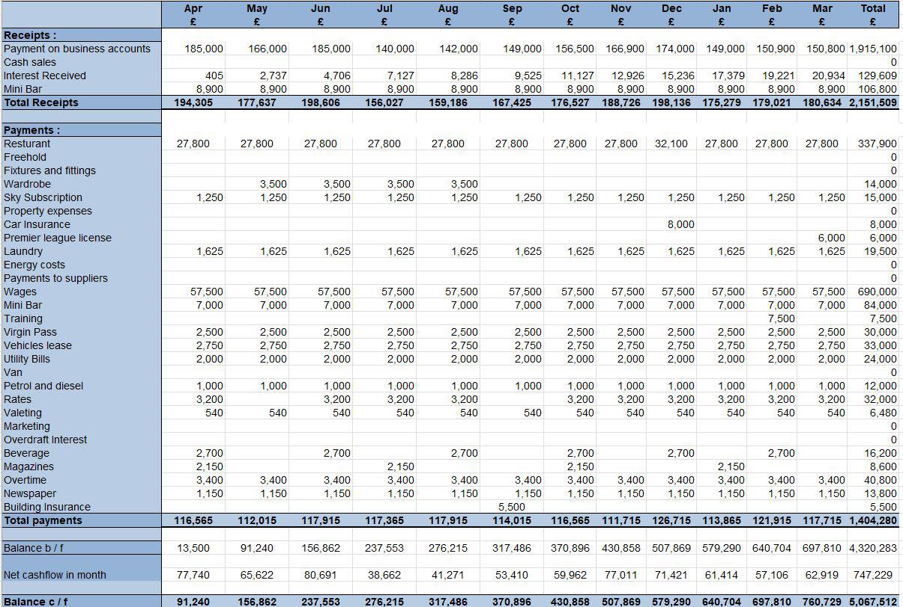4.Appendix Budget Calculations

